TEXT RECOGNITION IN IMAGES AND CONVERTING RECOGNIZED TEXT TO SPEECH
Image Processing Project
Text recognition in images and converting recognized text to speech
- Installing Dependencies
This prepares Google Colab with all the required tools:
- Kagglehub -> Used to download datasets directly from Kaggle.
- Pytesseract -> Python wrapper for Tesseract OCR engine which extracts text from images
- Gtts (Google Text-to-Speech) -> Converts extracted text into spoken audio
- Playsound -> Plays generated speech
- Tesseract-ocr ->The actual OCR engine required by pytesseract
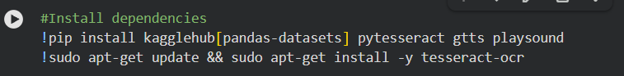

- Importing Required Libraries
- os -> File and directory handling
- cv2 -> Image reading and preprocessing
- matplotlib -> For displaying images
- pytesseract -> Extracts text from processed images
- kagglehub -> Download Kaggle datasets
- gTTS -> Convert text output into speech
- Audio & display -> Play audio from within Jupyter Notebook
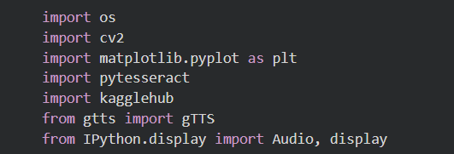
- Downloading the Dataset from Kaggle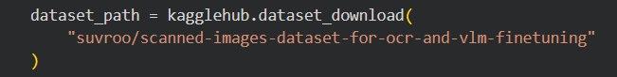This function returns the local path where the dataset is stored
- Selecting Sample Images
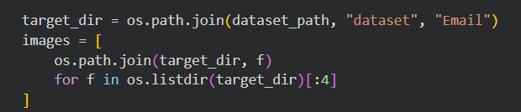
-Navigates to the “Email” folder inside the dataset
-Selects the first 4 images for testing
-Stores full path in a list

- OCR Function
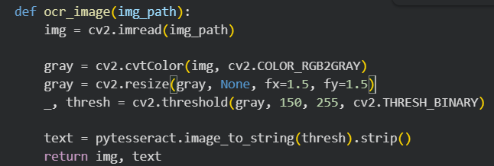
- Read Image
Loads the scanned image from disk
- Convert to Grayscale
Simplifies the image and improves OCR accuracy

- Resize Image
Enlarges text so Tesseract can recognize characters more easily

- Thresholding
Converts image to pure black & white to reduce noise

- OCR Extraction
Extracts readable text from the processed image
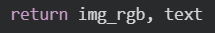
- Output
Return original image and extracted text

- Text-to-Speech Function
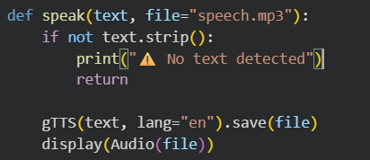
Checks if text is empty
Uses Google Text-to-Speech to convert text into spoken English audio
Saves the audio as an MP3 file
Plays it directly in the notebook

- Main Function
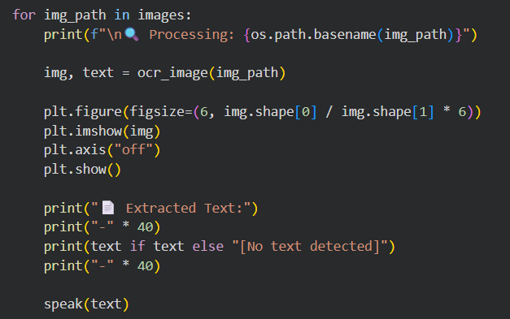
For each scanned image:
Runs OCR to extract text (Calls ocr_image function)
Displays the image
Prints extracted text
Converts the text into speech (Calls speak function)

