Safe chain



University of Umm Al-Qura
College of Computing
Department of Computer Science

Proposal by
Authors:

Supervisors
Dr. Ali Alzubaidi
aakzubaidi@uqu.edu.sa

Content
Chapter1: Introduction 2
1.1 Introduction 3
1.2 The research problem 3
1.3 The purpose of the project 3
1.3.1 Main Objective of the Project 3
1.3.2 Beneficiaries and Users 4
1.3.3 How the Project Helps Beneficiaries 5
1.4 Purpose of this Document 5
1.4.1 Reason for Creation: 5
1.4.2 Contents: 6
1.4.3 Audience: 6
1.4.4 Usage: 6
1.5 Existing System 6
1.5.1 Cooltrax-cold chain management and control system 6
1.5.2 DicksonOne-cloud-based environmental monitoring system 9
1.5.3 TempTale GEO Ultra-cold 14
1.5.4 Sonicu-cold chain monitoring system 18
1.5.5 shortcomings of the current systems versus the advantages of the proposed project 20
1.5.5 Comparison table between current systems and the proposed project 22
1.6 Methodology 25
1.6.1 Selected Methodology: Scrum (Agile) 25
1.6.2 Reasons for Selection 25
1.6.3 Objectives of Using Scrum 26
1.6.4 Comparison with Other Methodologies 26
1.6.5 Project Plan 26
1.6.6 Project Timeline Summary 29
1.7 Summery 30
Chapter2: SYSTEM ANALYSIS 31
2.1 Introduction 32
2.2 Stakeholders 32
2.2.1 Food transport and distribution companies: 32
2.2.2 Restaurants and food storage facilities: 32
2.2.3 Regulatory Authorities: 32
2.2.4 Consumers: 33
2.3 Requirements Elicitation and Analysis Methodology 33
2.3.1 Interviews: 33
2.3.2 Questionnaires: 34
2.3 Functional Requirements 41
2.3.1 User Login (FR_001): 41
2.3.2 Sensor Data Monitoring (FR_002): 42
2.3.3 Instant Alerts System (FR_003): 43
2.3.4 Records and Reports Management (FR_004): 44
2.3.5 New User Registration Requirement (FR_005) 45
2.3.6 Password Reset Requirement (FR_006) 46
2.3.5 IoT Device Requirements 47
2.3.6 Web & Mobile App Requirements 50
2.3.7. Account–Device Binding Requirements 58
2.3.8 . Post-Login Data Fetch Requirements 60
2.4 Dependencies 62
2.5 None- Functional Requirements 63
2.5.1 Security 63
2.5.2 Privacy 63
2.5.3 Performance and Reliability Requirements 63
2.5.4 Usability and Compatibility Requirements 64
Requirements Modelling UML 65
Use Case Diagram 65
Sequence Diagram 65
Activity Diagram 66
Class Diagram 67
Summary 67
DESIGN CONSIDERATIONS 67
Introduction 68
Architectural Strategy 68
Presentation Layer (User Interface Layer): 68
Business Logic Layer (Processing and Notifications): 68
Data Layer (Storage and Synchronization): 68
Development Requirements 69
Hardware Requirements 69
Software Requirements 69
Graphic User Interface Design and wireframe 69
Summary 70
CONCLUISON 72
Introdction 72
Challenges and learning experiences 72
Timeline 72
Furture work 73
Conclusion 73
Reference: 73

List of figures
Figure 1 Cooltrax-cold chain management and control system 6
Figure 2 DicksonOne-cloud-based environmental monitoring 9
Figure 3 interactive web in DicksonOne
Figure 4 Device TempTale GEO Ultra
Figure 5 Cloud Platform TempTale GEO Ultra-cold 15
Figure 6 SoniCloud monitoring 18
Figure 7 stakeholders in SafeChain 32
Figure 8 Distribution of the main roles of the survey participants 35
Figure 9 The influence of quality and safety factors on the consumer's choice of product 35
Figure 10 The most important factors that guide the consumer's decision when buying food 35
Figure 11 Statistics on food spoilage / diseases caused by poor storage 36
Figure 12 The extent to which the safety guarantee affects the consumer's purchase decision 36
Figure 13 The extent to which the consumer is willing to pay for ensuring the safety of the product. 37
Figure 14 The consumer's preferred way to obtain product safety information 37
Figure 15 : How frequent are problems with cold chain control 37
Figure 16 : How frequent are problems with cold chain control 38
Figure 17 How important is the ease of installation and use of the system without the need for high technical expertise 38
Figure 18 How important is the ease of installation and use of the system without the need for high technical expertise 39
Figure 19 The most important variables that the operational entities deem necessary for monitoring in trucks/warehouses 39
Figure 20 How important it is to receive measurement data and alerts instantly (within seconds). 39
Figure 21 Preferred channels for operators to receive System Notifications 40
Figure 22 How important is the integration of the monitoring system with logistics management systems (ERP/TMS). 40
Figure 23 The preferences of the operating entities for a payment model based on the low cost of hardware and a cloud service subscription 41
Figure 24– School System Login 65
Figure 25 Sequence Diagram – User Login 66
Figure 26 Activity diagram - User Login
Figure 27 Activity diagram - Generate Custom Report
Figure 28 Activity diagram - Sensor Data Lifecycle (Iot)
Figure 29 Class diagram - User and Permissions Management System
Figure 30 Class diagram - Monitoring System and Basic Data
Figure 31 Example of product wireframe and UI

List of TABLE
Table 1 Technical Comparison Table of Cold Chain Monitoring System 22
Table 2:Comparison with Other Methodologies 26
Table 3 Timeline & Weekly Activities: Phase 1 27
Table 4 Timeline & Weekly Activities: phase 2 28
Table 5 Project Timeline (Gantt style) 30
Table 6 Functional Requirement – User Login 41
Table 7 Functional Requirement – Sensor Data Monitoring 42
Table 8 Functional Requirement – Instant Alerts System 43
Table 9 Functional Requirement – Records and Reports Management 44
Table 10 Functional Requirement – New User Registration Requirement 45
Table 11 Functional Requirement – Password Reset Requirement 46
Table 12 Functional Requirement – IoT Device Requirements 47
Table 13 Functional Requirement – Data Buffering 48
Table 14 Functional Requirement – Data Transmission to the Cloud 49
Table 15 Functional Requirement – GPS Tracking 49
Table 16 Functional Requirement – Login/Logout 50
Table 17 Functional Requirement – Dashboard 51
Table 18 Functional Requirement – Real-time monitoring 52
Table 19 Functional Requirement – Threshold settings management 53
Table 20 Functional Requirement – Alert log 54
Table 21 Functional Requirement – Report generation 54
Table 22 Functional Requirement – Instant notifications 55
Table 23 Functional Requirement – Historical data filtering 56
Table 24 Functional Requirement – User and role management 57
Table 25 Functional Requirement – Device pairing 58
Table 26 Functional Requirement – Device status verification 59
Table 27 Functional Requirement – Device unpairing 59
Table 28 Functional Requirement – Automatic data fetch 60
Table 29 Functional Requirement – Live data update 61
Table 30 Functional Requirement – Account-specific alerts 62

Abstract
This project, titled Safe chain, aims to develop an intelligent system based on Internet of Things (IoT) technology to monitor and ensure food safety during transportation and storage. The proposed system integrates multiple environmental sensors to measure temperature, humidity, gas emissions (NH₃, CO₂, H₂S), and truck door status, providing real-time data to a central platform or mobile application.
The system utilizes a Raspberry Pi as the main controller, which collects and transmits sensor data to a cloud database for visualization and analysis. Through an intuitive dashboard, users can track live readings, receive instant alerts when conditions exceed predefined safety thresholds, and view historical reports summarizing key environmental trends.
The main objective of Safe chain is to minimize food spoilage, enhance transparency in the cold supply chain, and support food safety and security by enabling immediate intervention when abnormal conditions occur. By offering a low-cost, user-friendly, and scalable solution, the system addresses major shortcomings of existing commercial systems, making it suitable for food transport companies, restaurants, and regulatory authorities.

Chapter1: Introduction

1.1 Introduction
This project aims to develop a system based on the Internet of Things (IoT) to monitor and track food safety during transportation.
The system measures key factors such as temperature, humidity, and gas emissions inside the trucks, and then sends the data instantly to a simple platform or application to track it.
This project belongs to the field of Information Technology and the Internet of things with direct application in the food, transport and distribution sector.
The importance of the project lies in its role in ensuring the quality and safety of food, reducing spoilage and losses during transportation and storage, which supports food security and increases consumer confidence in food products.

1.2 The research problem
A Hungarian study published in the journal Foods in 2024 found that up to 30% to 50% of perishable food transported without proper temperature control can arrive at its destination spoiled or lost [1]. Upon further analysis of the underlying causes, one of the most critical issues identified in the food transportation chain is the failure to maintain proper temperature control, which significantly accelerates food spoilage.
Additionally, the lack of transparency in shipment tracking poses a major challenge, as many transportation systems lack accurate and real-time data regarding temperature and truck location. This makes it difficult to take timely action to prevent food deterioration.
Inspired by Islamic values that emphasize preserving blessings and valuing resources, this project aims to reduce food waste by designing a smart device equipped with sensors. This device is installed inside trucks to monitor temperature, humidity, and emitted gases, while also providing real-time tracking of location and internal conditions. The solution is intended to ensure better food preservation during transportation and reduce overall losses.

1.3 The purpose of the project
This project aims to develop a smart experimental system based on Internet of Things (IoT) technologies to monitor and track food safety during storage or transportation. The goal is to ensure food product quality, reduce the likelihood of spoilage, and support food security.

1.3.1 Main Objective of the Project
1.3.1.1 a prototype that enables reading of basic data such as temperature, humidity, and gas emissions
• Temperature and humidity are among the most critical factors affecting food quality. According to the Food and Agriculture Organization (FAO), about 70% of refrigerated food spoilage is caused by uncontrolled fluctuations in temperature and humidity.
• The emission of gases such as ammonia (NH3) and hydrogen sulfide (H2S) serves as an early indicator of meat and dairy product spoilage.
• Therefore, this prototype provides a practical tool for accurately monitoring these indicators.
1.3.1.2 Transmit data in real-time to a simple platform or application for visualization
• Real- Develop time monitoring reduces delays in problem detection.
• Studies in the field of cold chain monitoring show that delays in detecting temperature deviations may lead to losses of up to 35% of transported food products.
• Sending data directly to a platform or mobile application enhances responsiveness and immediate problem-solving.
1.3.1.3 Generate instant alerts when thresholds are exceeded
• Early alerts help in making timely decisions before losses occur.
• A study published in the Journal of Food Protection indicated that instant alert systems contributed to reducing refrigerated food losses by about 25%.
• This feature makes the system practical and economically valuable.
1.3.1.4 Test the system on a small-scale model to validate effectiveness
• Small-scale testing reduces risks and reveals errors before large-scale implementation.
• Prototypes are an essential step in developing any system, as they allow verification of hardware and software performance in a controlled environment.
• This increases the likelihood of success when scaling the project in the future.

1.3.2 Beneficiaries and Users
1.3.2.1 Food transport and distribution companies
• These companies face significant losses due to food spoilage during transportation.
• According to the World Bank, nearly 30% of food products worldwide are lost due to weak transport and storage systems.
• The proposed system helps these companies reduce losses through continuous monitoring.
1.3.2.2 Restaurants and food storage facilities
• Restaurants rely heavily on fresh ingredients, and their quality is directly tied to temperature and humidity conditions.
• Health reports indicate that one-third of food poisoning cases each year are linked to poor storage practices.
• By using the system, they can monitor inventory and protect customers from foodborne risks.

1.3.2.3 Regulatory authorities such as the Food and Drug Authority
• These authorities need accurate data to evaluate companies’ compliance with health standards.
• Traditional systems often rely on periodic manual inspections, while this system provides real-time and reliable data.
• This enhances regulatory efficiency and makes monitoring more proactive.

1.3.2.4 Consumers indirectly, by gaining access to safe products
• Consumers are the ultimate beneficiaries.
• The World Health Organization (WHO) reports that 600 million people fall ill every year due to contaminated food.
• Smart monitoring systems reduce the likelihood of unsafe products reaching consumers.

1.3.3 How the Project Helps Beneficiaries
1.3.3.1 Enable companies to monitor storage and transport conditions accurately and reduce losses
• The system provides companies with real-time intervention capability, which helps minimize financial losses caused by food spoilage.
1.3.3.2 Provide regulatory authorities with real-time and reliable data to support effective oversight
• Real-time data increases transparency and enhances authorities’ ability to make swift, informed decisions.
1.3.3.3 Enhance consumer confidence in the quality and safety of food products
• Smart monitoring systems build customer trust and provide companies with a competitive advantage in the market.
1.3.3.4 Support the community by reducing food waste and strengthening food security
• Reducing food waste directly contributes to global food security.
• According to the United Nations, about 14% of food is lost between harvest and retail, and this system can help reduce that percentage.

1.4 Purpose of this Document

1.4.1 Reason for Creation:
This document exists to outline the objectives, scope, and expected results of the smart food monitoring and tracking system project. It defines the purpose of the project and explains its importance in improving food quality, reducing waste, and supporting food safety.

1.4.2 Contents:
It contains details about the project goals, system functionalities, expected outcomes, and benefits. It also describes the technical and practical aspects of the prototype, as well as the target problems it aims to solve.

1.4.3 Audience:
The intended audience includes supervisors, academic instructors, project developers, stakeholders in the food supply chain, and regulatory authorities interested in food quality and safety.

1.4.4 Usage:
This document should be used as a reference throughout the project lifecycle. It guides the development process, supports evaluation and assessment, and provides a clear framework for understanding the project’s objectives, benefits, and applications.

1.5 Existing System
Currently, there are several systems and applications for monitoring food during transportation and storage, including intelligent refrigeration systems and heat and humidity sensors used in some major companies.

1.5.1 Cooltrax-cold chain management and control system

1.5.1.1 General description and mode of action
Cooltrax is an integrated system focused on monitoring refrigerated transport conditions and real-time Cold Chain Management. It offers a “Fresh InTransit " solution that allows monitoring trucks and refrigerated containers during their movement through wireless sensors connected to a communication module (Gateway) connected to a GPS tracking system. The system collects accurate temperature data inside the truck or container and sends it to the Cooltrax cloud servers. Users can follow the status of shipments moment by moment via a web dashboard or through phone applications. In addition, the system enables the creation of automated reports that support compliance with food safety standards such as HACCP and international regulations (As shown Figure 1 , Illustrates the application logo ).

Figure 1 Cooltrax-cold chain management and control system

1.5.1.2 Basic Techniques and Components

1.5.1.2.1 Wireless Temperature Sensors:
Installed inside the refrigerated truck or container to measure and record temperature data precisely. Multiple sensors may be used to cover all internal areas and detect uneven cooling.
1.5.1.2.2 Gateway (Communication Module):
Collects data from sensors and pairs it with GPS signals. It timestamps the data and transmits it to the cloud via Wi-Fi or 4G networks.
1.5.1.2.3 GPS Tracking System:
Provides real-time location information of the vehicle. Combining temperature data with GPS coordinates helps identify where and when a temperature deviation occurs.
1.5.1.2.4 Cloud Platform (Cooltrax Cloud):
Responsible for receiving, analyzing, and securely storing all collected data. It provides dashboards, alerts, and downloadable reports.
1.5.1.2.5 Dashboard and Mobile Applications:
Offers visualized graphs, historical data, and color-coded alerts. The dashboard helps users easily interpret trends and respond quickly to abnormalities.
1.5.1.2.6 ERP/TMS Integration:
Allows Cooltrax to synchronize with Enterprise Resource Planning or Transport Management Systems for broader logistics control and operational automation.

1.5.1.3 Common Areas of use
The Cooltrax cold chain management and control system operates through an integrated process that ensures continuous monitoring and precise control of temperature-sensitive goods throughout the supply chain.
The system workflow can be summarized as follows:
- Installation of Devices: Wireless temperature sensors and GPS-enabled tracking modules are installed inside refrigerated trucks, containers, or storage units to monitor environmental conditions in real time.
- Configuration of Parameters: Users define acceptable thresholds for each variable (such as minimum and maximum temperature levels) according to the type of product being transported or stored.
- Data Collection and Transmission: The sensors continuously measure temperature and humidity levels. These readings are transmitted via the communication gateway to the Cooltrax cloud platform using Wi-Fi or 4G networks.
- Data Visualization and Monitoring: The collected data is displayed instantly on the Cooltrax dashboard and mobile applications. Users can view live readings, analyze graphical trends, and detect irregular patterns in the system performance.
- Alert Management: If any value exceeds the pre-set limits, the system automatically generates instant alerts via e-mail or SMS, allowing users to respond quickly to prevent product spoilage or safety violations.
- Data Storage and Analysis: All collected data is securely stored in the Cooltrax cloud database. Authorized users can access historical records, generate analytical reports, and review environmental trends to ensure long-term compliance and quality control.

1.5.1.4 Strengths
- Integration of Environmental and Location DataCooltrax combines GPS and temperature readings, providing both “where” and “what happened.”
This allows rapid root-cause analysis (e.g., identifying that a rise in temperature occurred at a specific stop) and increases transparency and trust with customers and authorities.
- Global Real-Time Monitoring: Through its cloud-based infrastructure, users can access shipment data anytime and anywhere.
This enables centralized monitoring and quick responses to abnormalities in large-scale logistics.
- Automated Compliance Reporting: Generates HACCP-ready reports automatically, saving time on manual documentation and ensuring continuous compliance with international standards.
- Instant Multi-Channel Alerts: When temperature thresholds are exceeded, the system sends immediate alerts via email or SMS, shortening response times and preventing product loss.
- Interoperability with Other Systems: The system integrates with ERP or TMS software, ensuring smooth data sharing and improving operational efficiency.
- Customer Confidence: By providing transparent and verified data on shipment conditions, Cooltrax helps companies build long-term credibility and enhance client satisfaction.

1.5.1.5 Weaknesses
- Limited Scope (Temperature Focus Only):
Cooltrax only monitors temperature and does not detect other spoilage indicators such as humidity or gases (NH₃, CO₂, H₂S). This limitation reduces its ability to identify early stages of food spoilage.
- High Initial and Operating Costs: The system’s use of GPS, cloud subscriptions, and advanced sensors makes it costly for small and medium enterprises.
- Dependence on Network Coverage: Requires strong and continuous internet connectivity (Wi-Fi or cellular). In remote or cross-border areas, data loss may occur, reducing reliability.
- Operational Complexity for Small Businesses: Its advanced functions (like ERP integration) may be unnecessary or difficult to manage for small operators.
- Low Flexibility in Customization: Companies may find it difficult to adapt the system’s setup or interface for specific needs since it is built for large-scale operations.

1.5.1.6 Brief Analysis
Cooltrax is one of the most recognized systems in refrigerated transport monitoring, integrating temperature and GPS tracking for precise visibility and control.
It is ideal for large enterprises that require compliance, reliability, and international-level performance.

1.5.2 DicksonOne-cloud-based environmental monitoring system

1.5.2.1 General description and mode of action
DicksonOne is an integrated cloud-based system used to monitor environmental conditions (especially temperature and humidity) in sensitive environments such as hospitals, laboratories, food warehouses, and pharmaceutical industries. Based on data loggers connected to the internet via Wi-Fi or Ethernet, these devices continuously collect data and send it to a centralized cloud platform. Through this platform, users can view real-time readings, retrieve historical data, and adjust the settings of alerts and reports. The system also provides multi-user access, which allows administrative and technical teams to work simultaneously (As shown Figure 2 , Illustrates the application logo ).
.
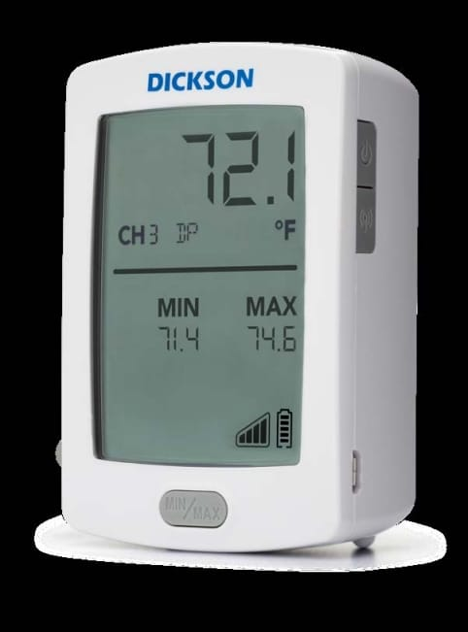
Figure 2 DicksonOne-cloud-based environmental monitoring

1.5.2.2 Basic techniques and components
1.5.2.2.1 Sensors:
Sensors are the key element of the system, continuously measuring environmental values such as temperature and humidity. DicksonOne sensors are characterized by high accuracy and the possibility of calibration according to international standards such as NIST or ISO/IEC 17025 to ensure the reliability of readings.
1.5.2.2.2 Data Loggers:
These devices are used to receive and temporarily store sensor data before sending it to the cloud system. They have a backup internal memory to store data when the internet connection is interrupted, in addition to an internal battery that ensures continued operation in the event of a power outage.

1.5.2.2.3 Network Connectivity
The system supports several connection methods to facilitate connecting devices to the cloud:
- Wi-Fi for indoor environments.
- Ethernet for fixed networks, which is highly reliable.
- LoRaWAN for remote places or those with limited coverage.
- Bluetooth in some devices for quick setup purposes.
This flexibility in communication makes the system applicable in different environments, both small and distributed over several sites.

1.5.2.2.4 Cloud Platform
The cloud platform is the central heart of the system. It stores all the data sent from the sensors, from which the analysis, monitoring, and alarm management processes are managed. Users can access it via an interactive web interface (Web Dashboard) without the need to install any local software. There are also companion applications for smartphones that provide a simplified view of data and instant alerts, but they are not the platform itself (As shown Figure 3 , interactive web interface)
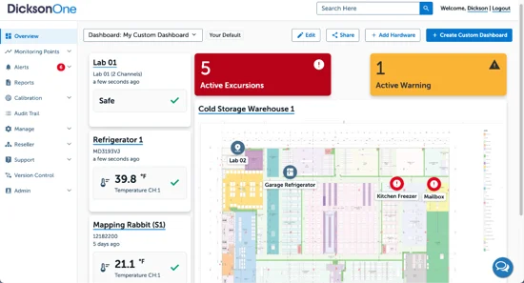
Figure 3 interactive web in DicksonOne

1.5.2.2.5 Alert System
DicksonOne allows you to create custom alerts for each environmental variable. When the temperature or humidity exceeds the set values, the system sends instant notifications via e-mail, text messages, or phone notifications. This feature reduces the likelihood of damage to products or loss of samples due to sudden environmental changes.

1.5.2.2.6 Reporting and Analysis:
The system enables the creation of periodic or on-demand reports that include historical data, graphs, and time trends. Reports can also be exported in multiple formats (PDF, Excel) to meet the requirements of internal audits or regulatory authorities.

1.5.2.3 common Areas of Use
- Sensors and recording devices are installed in the required locations such as cold rooms or laboratories.
- Sets the allowable thresholds for each variable (e.g. maximum and minimum temperature).
- Recording devices periodically send data to the cloud platform via the internet.
- The readings in the dashboard are displayed instantaneously and can be tracked graphically.
- If any value exceeds the specified limits, the system issues instant alerts.
- The data is stored in a secure cloud database that allows historical records to be consulted when needed.

1.5.2.4 System Integration in Dickson Security One:
The DicksonOne system emphasizes the importance of security and controlled system integration due to the sensitivity of the data it handles, including medical and food-related information. The system is designed following a multi-layer security approach (Defense in Depth) to protect data during transmission, storage, and access. Additionally, it provides limited but structured methods to integrate with external systems.

1.5.2.4.1 Data Encryption in Transit:
All data transmitted from sensors to the cloud platform is encrypted using SSL/TLS protocols. This prevents unauthorized interception and ensures secure communication across the network.

1.5.2.4.2 Data Encryption at Rest:
Data stored on DicksonOne cloud servers is encrypted with strong algorithms such as AES-256. Even in the event of unauthorized physical access to servers, data cannot be read without encryption keys.

1.5.2.4.3 User Access Control:
The system uses role-based access control (RBAC), assigning each user permissions according to their role. Passwords are encrypted and cannot be viewed by any user.

1.5.2.4.4 Audit Trail:
All user activities, including logins, data modifications, and system changes, are automatically logged. These records are immutable and support security audits and investigations.

1.5.2.4.5 Regulatory Compliance
DicksonOne complies with standards such as FDA 21 CFR Part 11 and GxP, ensuring data integrity and suitability for pharmaceutical and food industries.

1.5.2.4.6 Data Backup and Recovery
Automatic backups are performed across multiple geographic locations (redundant data centers), allowing seamless data recovery in case of server failures.

1.5.2.4.7 Secure Authentication
The system supports two-factor authentication (2FA) and strong password policies, including complexity requirements and periodic updates.

1.5.2.4.8 Security Monitoring
Continuous monitoring detects abnormal activities, such as failed logins or unexpected configuration changes, ensuring proactive threat management.

1.5.2.4 Strengths

1.5.2.4.1 integrated cloud system
The fact that the system is cloud-based means that the user can access data from anywhere and at any time, without the need for local storage or maintenance of internal servers.

1.5.2.4.2 high flexibility of communication
The system supports more than one communication protocol (Wi-Fi, Ethernet, LoRaWAN), which makes it applicable in different environments in terms of infrastructure.

1.5.2.4.3 instant monitoring and smart alerts
The system is characterized by its ability to send instant notifications when any deviation in the readings occurs, which ensures a quick response and minimizes losses.

1.5.2.4.4 compliance with international standards
The system is compliant with FDA 21 CFR Part 11 data integrity requirements, making it suitable for controlled medical and industrial facilities.

1.5.2.4.5 scalability
The system can be started using a limited number of devices and later expanded to several sites or branches without the need for radical changes in the architecture. 4.6 advanced reporting and analysis It provides sophisticated graphical analysis tools that help track environmental performance and detect long-term trends or recurring problems. 4.7 security and user management the system has a tiered permissions system that determines who can access data or modify settings, with an Audit Trail to track any changes. 4.8 backup storage and data loss protection the data is kept in cloud servers with periodic backups, as well as local memory inside the devices that protects against information loss when the connection is interrupted.

1.5.2.5 Weaknesses and challenges

1.5.2.5.1 full dependence on internet connection
The system is based on data transfer to the cloud, which means that any interruption in the internet may delay updates or alerts. Although some devices have local memory, an immediate alert may not be sent until the connection is returned.

1.5.2.5.2 subscription and hardware cost
High-resolution hardware and cloud service licenses require a relatively high physical cost, which can be a burden for small or budget-limited projects.

1.5.2.5.3 cyber security challenges
The fact that the system is connected to the cloud makes it vulnerable – like any other networked system – to possible cyber-attacks if it is not adequately secured. This requires constant security updates, and the application of strict access policies.

1.5.2.5.4 the need for periodic calibration of sensors
Over time, the sensors may lose their accuracy due to environmental factors, which requires regular calibration to ensure the reliability of the recorded data.

1.5.2.5.5 alarm delay in some cases
When setting sampling intervals (Sampling Interval) over long time intervals, a noticeable delay may occur between the actual occurrence of the change in values and the reception of the alarm in the system.

1.5.2.5.6 complexity of setup in large networks
If the system is applied to multiple installations or different geographical locations, careful management of settings and distribution of permissions may be required to avoid data conflicts or operational errors.

1.5.2.5.7 challenges in integration with other systems
Despite the existence of a software interface (API), the system faces limitations that limit the flexibility of integration, such as limited access to some types of data, the absence of real-time integration, the absence of Webhooks, as well as the absence of support for standard industrial protocols such as Modbus and MQTT, which makes it difficult to integrate the system in advanced industrial environments.

1.5.2.6 Brief summary of the DicksonOne system
The DicksonOne system is a reliable cloud solution for monitoring temperature and humidity in sensitive environments such as hospitals, laboratories and the pharmaceutical industry. It features accurate measurement, instant alerts, and accessibility from anywhere. But the system is focused only on limited environmental factors, and is completely dependent on the internet connection, which can cause a delay in alerts when interrupted. Subscription and hardware costs may also be high for some. Integration with industrial plant management systems is limited due to the lack of support for common industrial protocols, which limits the capabilities of automatic control

1.5.3 TempTale GEO Ultra-cold

1.5.3.1 General description and mode of action
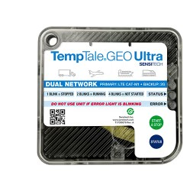
TempTale GEO Ultra is an integrated real-time Cold Chain Monitoring and management system, widely used in the food and pharmaceutical industries. Developed by Sensitech, it combines advanced sensors, GPS tracking technology and a global network connection (GSM/4G LTE), allowing users to track their shipments during transportation anywhere in the world. The system works via smart data recorders placed with products inside trucks or refrigerated containers, these devices collect accurate data about temperature, humidity and geographical location, and then send it instantly to a centralized cloud platform. This platform enables users to track shipments moment by moment and receive instant notifications in case of exceeding the allowed limits or any malfunction during the trip.

Figure 4 Device TempTale GEO Ultra

1.5.3.2 Basic techniques and components

1.5.3.2.1 Sensors
The TempTale GEO Ultra system relies on advanced temperature and humidity sensors capable of measuring from −80°C to +70°C with high accuracy. These sensors continuously collect data about the environment surrounding the shipment. The sensors are factory-calibrated and designed to maintain precision over long operational periods, ensuring that any temperature deviation is quickly detected during transport.

1.5.3.2.2 Data Loggers
Each shipment includes a smart data logger that records the sensor readings in real time. The device features an internal memory for data storage when there is no network connection, and an internal alkaline battery that allows continuous operation for several weeks. Once the connection is restored, all stored data is automatically uploaded to the cloud platform.

1.5.3.2.3 Network Connectivity
The device transmits data through global cellular networks, using:
a. GSM (2G) for basic coverage in most regions.
b. 4G LTE for high-speed data transmission and global roaming.
The system can automatically switch between available networks depending on signal strength. Each device contains a multi-network SIM card, ensuring stable and continuous communication during international shipments.

1.5.3.2.4 Cloud Platform
All collected data is sent to the ColdStream Cloud Platform, which acts as the system’s central management interface.
The platform stores, analyzes, and displays data through an interactive web dashboard accessible from any browser, as well as through mobile applications (iOS and Android) for real-time tracking. The platform also provides smart analytics to predict potential risks and generate detailed compliance reports.
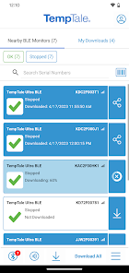 | 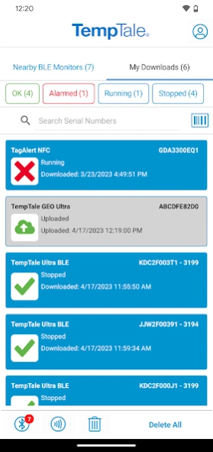 | 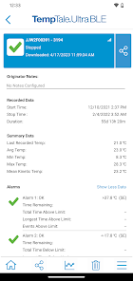
Figure 5 Cloud Platform TempTale GEO Ultra-cold

1.5.3.2.5 Alert System
TempTale GEO Ultra provides multi-channel alerts that notify users instantly when temperature or humidity readings exceed preset thresholds. Notifications can be received through email, SMS, or mobile app alerts, allowing quick corrective action to prevent product damage during transport.

1.5.3.3 Common areas of use
TempTale GEO Ultra is mainly used in the transportation of heat-sensitive products, such as medicines, vaccines, and fresh food products. Major logistics companies rely on it to ensure the safety of their products during global distribution, especially when dealing with long distances or shipments need very precise conditions. It is also used in the agricultural and food industries to track products from farms to stores, enhancing transparency in the supply chain.

1.5.3.4 Security and System Integration in TempTale GEO Ultra

1.5.3.4.1 Data Encryption in Transit
All transmitted data is protected using SSL/TLS encryption, ensuring that the information cannot be intercepted or altered during transmission.

1.5.3.4.2 Data Encryption at Rest
Data stored on the ColdStream servers is encrypted using AES-256 algorithms, protecting sensitive information even if physical access to servers occurs.

1.5.3.4.3 Data Backup and Recovery
The platform performs automatic backups in multiple geographic locations to ensure data availability and recovery in case of failure or data loss.

1.5.3.5 Strengths

1.5.3.5.1 Real-Time Global Monitoring
The integration of GPS, GSM, and 4G enables continuous global tracking of temperature, humidity, and location in real time.

1.5.3.5.2 Smart Multi-Channel Alerts
Provides instant notifications via email, SMS, or app, allowing rapid intervention before damage occurs.

1.5.3.5.3 Reliable Data Storage and Reporting
Automatic cloud storage and FDA-compliant reports simplify auditing and reduce manual documentation.

1.5.3.5.4 Scalability and Multi-Shipment Management
Supports monitoring hundreds of shipments simultaneously, suitable for global logistics companies.

1.5.3.6 Weaknesses

1.5.3.6.1 High Cost
Device and cloud subscription fees are expensive, limiting access to the system for small and medium-sized enterprises.

1.5.3.6.2 Reliance on Cellular Networks
It relies entirely on GSM/4G connectivity, which can cause data delays or gaps in remote areas with poor coverage.
This means that the device requires cellular network coverage in the area where it is charging to choose whether to transmit temperature, humidity, and geographic location information in real-time.
If charging is scheduled in areas where cellular coverage is not available (such as certain mileage zones or during air travel), the data is temporarily allocated, and the device automatically stores the data until indoor coverage is restored, then sends it all at once to the cloud client.
This heavy reliance on cellular networks is a weakness due to poor coverage or network connectivity, which can lead to:
- Delayed data or alerts.
- Temporary effectiveness with in-flight charging.
- Possibility of losing some readers if the project fails.
Therefore, system performance and monitoring continuity depend on the extent of the communications network in the areas where the shipment is being processed.

1.5.3.6.3 Limited Environmental Range
Measures only temperature and humidity, without detecting other important indicators such as gas emissions or vibrations.

1.5.3.6.4 Device Size and Placement
Some models are relatively large, which may be unsuitable for small parcels or sensitive shipments.

1.5.3.6.5 Limited System Customization
Customization or integration with third-party systems requires contacting the manufacturer, which increases cost and time.

1.5.3.6 Brief analysis
TempTale GEO Ultra is one of the most powerful commercial systems in tracking refrigerated shipments globally and is an ideal option for large companies with huge budgets and dealing with large-scale distribution. However, it mainly focuses on temperature, humidity and geographical location, and does not touch on other factors such as gases (NH3, CO2, H2S) that are an early indicator of food spoilage. In addition, the high cost makes this system unsuitable for small and medium-sized businesses. Here your proposed project has the advantage of being low-cost, more flexible, combining heat, humidity and gas monitoring with real-time notifications via a simple application, which makes it a practical and effective solution for a wider segment of users.

1.5.4 Sonicu-cold chain monitoring system

1.5.4.1 General description and mode of action
The SoniShield Duo by Sonicu is an advanced wireless environmental monitoring system designed to accurately measure, record, and analyze critical environmental parameters in real time.
The system operates through two NIST-certified digital sensors connected to the main monitoring unit, continuously collecting data on temperature, humidity, air flow, and door activity.
This data is temporarily stored in the device’s internal memory and then automatically transmitted via wireless network to the SoniCloud platform, which performs analysis, report generation, and real-time alerting when any threshold is exceeded.
The system also supports integration with other facility management or monitoring systems (e.g., hospital or laboratory networks) using standard communication protocols such as HTTPS and MQTT.
This enables seamless data exchange between devices and platforms, allowing unified environmental monitoring across multiple locations.
Thus, SoniShield Duo functions as part of an interconnected digital ecosystem, enhancing both operational efficiency and monitoring accuracy.
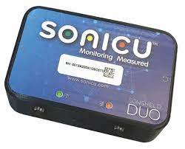
Figure 6 SoniCloud monitoring

1.5.4.2 Basic techniques and components

1.5.4.2.1 Sensors
High-accuracy NIST-certified digital sensors for temperature and humidity with fast response and long-term stability.

1.5.4.2.2 Connectivity Module:
Supports Wi-Fi, Ethernet, or LoRa with strong data encryption to ensure security during transmission.

1.5.4.2.3 Storage and Power:
Built-in memory for local data storage during network outages, and an internal backup battery for uninterrupted operation.

1.5.4.2.4 Cloud Platform:
SoniCloud handles data processing, storage, analytics, and visualization through a user-friendly online dashboard.

1.5.4.2.5 Software Integration:
Offers limited integration with other systems through restricted APIs; software customization or adding new sensors is not allowed.
Allows real-time and historical data access, customizable alerts (email, SMS, or push), and report generation.

1.5.4.3 Common areas of use
The SoniShield Duo is used across multiple sectors that require precise environmental monitoring, including:
- Hospitals, operating rooms, and medical laboratories.
- Pharmacies, drug storage facilities, and cold chain warehouses.
- Restaurants, industrial kitchens, and food logistics.
- Museums and archives for sensitive material preservation.
- Research centers and university laboratories.

1.5.4.4 Strengths
- High Measurement Accuracy: NIST-certified sensors provide reliable and precise environmental readings suitable for sensitive conditions.
- Operational Continuity: Backup battery and internal memory ensure data collection even during power or network failures.
- Integrated Cloud Platform: SoniCloud offers real-time data tracking, automatic analysis, and regulatory-compliant reporting.
- Multi-Channel Alerts: Supports alerts via email, SMS, phone calls, or push notifications, minimizing response time in emergencies.
- System Integration: Compatible with enterprise-level facility systems using modern communication protocols, enabling smooth interoperability.
- User-Friendly Interface: Provides quick data access and analysis tools for technicians and administrators without requiring deep technical expertise.

Weaknesses
- Lack of Gas Detection: Does not include gas sensors (e.g., NH₃, H₂S), which are important for detecting food spoilage.
- High Cloud Dependency: Relies heavily on the SoniCloud server connection; data delays may occur if internet access is unstable.
- High Cost: Designed primarily for healthcare and laboratory environments, making it more expensive than simpler or open-source solutions.
- Limited Customization: The system is closed-source, preventing modifications or the addition of new hardware modules.
- Restricted External Integration: Although it supports certain protocols, full interoperability with other systems requires vendor support.

1.5.4.6 Brief analysis
The SoniShield Duo demonstrates several valuable design principles that can be applied to the SafeChain project, as it ensures reliable operation with continuous monitoring even during outages, provides a secure cloud-based system for data collection and analysis, and utilizes smart multi-channel alert management to maintain efficiency and safety.

1.5.5 shortcomings of the current systems versus the advantages of the proposed project

1.5.5.1 Integration Interfaces (API and Webhooks)
API (Application Programming Interface): An API is a digital contract that allows other systems to request data or trigger specific functions from the proposed system when needed.
Model: Request / Pull
Function: Allows external systems (such as analytics or monitoring software) to fetch historical or real-time data on demand.
Example: “Retrieve all active temperature readings from sensor X.”
Advantage: Essential for enabling wide integration and providing centralized control of data by the client.
Webhooks: Webhooks are automated triggers that enable the system to push information directly to an external platform when specific events occur.
Model: Push / Notification
Function: When a temperature threshold is exceeded, the system automatically sends an instant alert message to the client without requiring a manual data request.
Advantage: Eliminates the need for repeated queries and makes the system more efficient, as the client receives updates in real time only when necessary.
This integration mechanism enhances the proposed system’s responsiveness and connectivity, ensuring seamless communication between devices and external platforms.

1.5.5.2 cost factor
The problem: most of the current systems are expensive, both in terms of the price of devices and monthly subscription fees to cloud platforms, making them difficult to access for companies with limited budgets or in developing countries.
The solution in our project: providing a low-cost solution based on available commercial sensors and open source platforms, which reduces the overall cost and makes the system available to a wider segment of users.

1.5.5.3 comprehensiveness of follow-up
The problem: most systems are limited to monitoring only temperature and humidity, while some systems such as TempTale GEO Ultra add geo-tracking, which makes their ability to detect problems early limited.
The solution in our project: the system integrates a wide range of sensors that cover several basic aspects of cold chain monitoring, namely:
Sensitive to temperature and humidity: to strictly follow the storage and transportation conditions.
Door sensor: to detect any unauthorized opening of the door, which contributes to the Prevention of theft or the ingress of external pollutants such as dust or unclean air.
Geographic tracking (GPS): to track the location of the truck in real time and document its route.
Gas sensors (NH3, CO2, H2S): for early detection of food spoilage by monitoring the emission of biogas.
This integration makes the system more comprehensive and integrated compared to commercial systems, gives it a predictive and proactive ability to protect food products and ensure their safety during transportation and storage.

1.5.5.4 ease of Use and integration
Problem: many systems are oriented to large companies and require special training or technical experience for operation and management. Also, some of them mainly rely on email or periodic reports for alerting.
The solution in our project: to present a simple and easy-to-use application that works on smartphones or the web, with instant alerts sent via notifications, making the response faster and more practical.

1.5.5.5 contribute to food security and reducing losses
The problem: trading systems are often focused on achieving compliance and increasing the profits of large companies.
The solution in our project focuses on serving the wider community by reducing food waste, enhancing food security, and increasing consumer confidence in products.

1.5.5.6 conclusion
It can be said that our project not only aims to imitate existing systems, but also seeks to fill their gaps by providing an integrated solution that combines: low cost, comprehensiveness of measurements (temperature, humidity, door, tracking, gases), ease of Use, and future flexibility, making it a more effective and sustainable option for different categories of users.

Comparison table between current systems and the proposed project

Table 1 Technical Comparison Table of Cold Chain Monitoring System
Technology | Cooltrax | DicksonOne | TempTale GEO Ultra | Sonicu | SafeChain
Sensors | Long-range Bluetooth micro-sensors + thermistor and RTD for temperature + capacitive sensors for humidity + magnetic reed switch for door + GPS for tracking | RTD for temperature + digital IC sensors + fast-response thermistor + thermocouple for wide temperature ranges + capacitive sensors for humidity + piezoresistive MEMS sensors for pressure + NDIR sensor for infrared detection | High-accuracy thermistor + diode-based IC sensors + capacitive humidity | RTD (e.g., Pt100) for high-accuracy temperature + capacitive humidity sensors + condenser/electroacoustic microphone + capacitive pressure sensors with flexible plate + hot-wire anemometer measuring airflow cooling + magnetic reed switch for door | Commercial sensors (digital thermistors for temperature, digital MEMS capacitive sensors for humidity, MEMS MOx sensors for gas detection + magnetic reed switch for door status + GNSS/GPS module for tracking
Controllers | Cooltrax Telematics Unit includes a microcontroller for data processing and system control + dual-mode cellular/satellite modem + GPS module for location tracking | DicksonOne Data Logger includes a powerful microprocessor for local data processing and analysis + Wi-Fi/Ethernet module for network or cloud transmission + non-volatile memory to retain data during power loss | TempTale Ultra/Geo (Embedded CPU) records sensitive shipment data like temperature and humidity independently + low-power microcontroller for long battery operation + secure flash memory for protected data storage | SoniLink Hub/Duo Gateway includes a processor for receiving and initially processing sensor data + multi-mode communication module (RF/Wi-Fi/Cellular) for flexible connectivity | Teltonika FMM130 Unit for trucks: RS232/RS485/1-Wire for IC temperature, MEMS humidity, and MOx gas sensors + LTE Cat M1/NB-IoT network  LoRaWAN Gateway for warehouses: ESP32-S3 processor for MEMS MOx processing + LoRa SX1262 + Wi-Fi/Ethernet for MQTT/HTTPSMQTT/HTTPS data transfer
Location Technology | Built-in GPS | Not available | Built-in GPS with 5-10 meter accuracy | Not available | GPS Module (optional)
Network Type | Cellular networks (GSM/3G/4G) + Wi-Fi | Wi-Fi / Ethernet | Cellular networks (GSM/4G LTE) with international roaming + multi-carrier SIM cards | Cellular networks / Wi-Fi / Radio communication | LoRaWAN (for remote and rural areas)
Communication Protocols | 4G+  Wi-Fi | Ethernet+  LoRaWAN  Wi-Fi | GSM(2G)+  LTE(LTE4 Cat-M1) | Wi-Fi + Ethernet  + LoRa+4G +HTTPS+MQTT | Hybrid Model:  LoRaWAN +MQTT/  WiFi/Ethernet+HTTPS
Cloud Platform | Proprietary cloud platform | DicksonOne cloud platform | ColdStream cloud platform | SoniCloud cloud platform | Firebase / AWS / Azure (customizable)
Database | Cloud database  Time-Series/  NoSQL+GPS | SQL database in the cloud | Distributed cloud database  Time-Series/SQL | Cloud database  Time-Series | Time-Series Database/  SQL
Power Source | Uses rechargeable batteries or external power. It can also work wirelessly without a fixed power source, making it suitable for transportation and mobile applications. It supports long-range wireless communication such as LoRa and ZigBee, and can operate for long periods without maintenance. | Operates on main AC power. If electricity fails, it automatically switches to rechargeable battery mode. It can be reused many times, making it ideal for labs and industrial environments | Works on a built-in non-rechargeable battery (single-use). After usage, data is retrieved externally and analyzed. | Operates on both AC and DC power sources. Has an automatic system that switches to battery mode in case of power outage, allowing up to 24 hours of data logging. | Uses low-voltage DC power from rechargeable batteries or USB. Has a smart power management system for overcharge and discharge protection.
Measured Parameters | Measures temperature , humidity, and door status (open/closed). Includes GPS for location tracking, and data is sent to the cloud platform for analysis. | Measures temperature using RTD sensors with accuracy and humidity with RH accuracy. It can also record environmental conditions and upload data to cloud platforms for monitoring. | Measures temperature using RTD sensors and humidity. Also provides GPS location tracking for shipments. | Measures temperature and humidity, optionally includes GPS for location tracking. Provides stable and accurate readings for short-range sensors. | Measures temperature and humidity using DHT22 sensor. Detects gases (CO2, NH3, H2S) using MQ-series sensors (MQ-135 for NH3 and CO2, MQ-7 for CO, MQ-2 for H2S). Optionally includes GPS for location tracking and supports cloud data synchronization
Supported Metrics | Temperature only | Temperature and humidity | Temperature and humidity | Temperature, humidity, air flow, and door status | Temperature, humidity, and gas levels (NH₃, CO₂, H₂S) and door status

Observation:
It should be noted that the current comparison reflects the basic characteristics of the most common systems, however, some companies may introduce upgraded versions or models that include additional advantages such as wider measurements or advanced technical integrations. These versions are usually aimed at groups with special needs and come at a higher cost compared to the basic platforms.

1.5.5.1 Reason for Choosing the Technologies

- GPS (Location Technology):
GPS was chosen because it enables accurate real-time tracking of the truck or container’s geographical location.
This helps identify the exact place and time where any temperature deviation or cooling failure occurs.
It also enhances transparency during transportation and allows regulatory authorities to monitor the food’s journey from the source to the point of sale.
- LoRa (Network Type):
LoRa Network was selected because it is a long-range, low-power communication technology,
making it ideal for remote areas or routes with weak internet or cellular coverage.
It allows reliable and continuous transmission of sensor data (such as temperature, humidity, and gas levels) at very low cost,
reducing dependence on constant internet connectivity and ensuring the system remains stable and energy-efficient during transportation and storage.
- Cloud Platform
Free or low-cost cloud platforms were selected because they provide centralized and secure data storage, and allow instant access to information from anywhere via the internet.
They also enable real-time tracking of shipment status, and issue immediate alerts in case of any temperature or humidity disruptions, which enhances response speed and ensures compliance with quality standards.
- Supported Metrics
The metrics vary according to system requirements, and temperature, humidity, and gas levels were selected for measurement because they represent the most important factors affecting the quality and safety of refrigerated products.
Analyzing these values helps in the early detection of failures or potential damage in the storage or transportation environment.

1.6 Methodology
1.6.1 Selected Methodology: Scrum (Agile)
The project will adopt the Scrum (Agile) methodology, which is one of the most widely used iterative and incremental software development approaches. It emphasizes flexibility, continuous improvement, and delivering functional prototypes in short cycles (sprints).

1.6.2 Reasons for Selection
- Flexibility in dealing with hardware and software integration
  - The project combines sensors (hardware) with IoT platforms and a mobile/web application (software). Agile allows step-by-step testing of each component and smooth integration.
- Incremental delivery of a working prototype
  - The ability to test and validate a small-scale version before large-scale deployment reduces risks and ensures higher success.
- Rapid response to changes
  - Since the project may face unexpected issues (sensor calibration, connectivity problems, or application design adjustments), Agile allows continuous updates without disrupting the entire plan.
- Stakeholder engagement
  - Regular sprint reviews and demonstrations allow food industry stakeholders, supervisors, and academic instructors to provide feedback early.
- Support for future expansion
  - Agile makes it easier to integrate predictive analytics and AI in later phases without redesigning the entire system.

1.6.3 Objectives of Using Scrum
- To ensure that the system is developed iteratively, minimizing risks.
- To guarantee that user requirements (food companies, restaurants, regulators) are continuously considered and validated.
- To allow prototyping and testing of sensors, mobile application, and cloud integration at each sprint stage.
- To achieve a balance between time, cost, and quality while maintaining transparency and traceability of progress.

1.6.4 Comparison with Other Methodologies
Methodology | Strengths | Weaknesses | Suitability for This Project
Waterfall | Clear stages, structured, good for fixed requirements | Rigid, hard to adapt if requirements change, testing comes late | Not suitable because IoT projects need frequent testing and adjustments
Agile (Scrum) | Flexible, iterative, frequent feedback, supports hardware+software integration | Requires active collaboration and discipline | Most suitable because the project involves experimental prototypes, feedback, and gradual improvements
Table 2:Comparison with Other Methodologies

1.6.5 Project Plan
The Safe chain project is aimed at developing an intelligent food safety monitoring system using IoT sensors, cloud integration, and mobile applications. The project will be executed over 10 months (40 weeks), divided into 20 sprints of 2 weeks each. Each sprint delivers a functional increment that can be tested and validated.
The plan is structured into six main phases, each addressing critical components of the system: hardware (sensors + Raspberry Pi), software (dashboard and mobile app), and cloud integration.

1.6.5.1 Phase 1: Preparation & Setup
(Sprint 1–2, Month 1)
Week | Dates | Activities | Objective / Deliverable
Week 2 | 31/08/2025 – 04/09/2025 | Team formation, brainstorm project ideas, initial supervisor meeting, assign roles | Organize team and define roles
Week 3 | 07/09/2025 – 11/09/2025 | Refine project idea, ensure feasibility, start progress tracking | Confirm feasibility and progress system setup
Week 4 | 14/09/2025 – 18/09/2025 | Finalize project idea and roles, draft initial project plan, get supervisor feedback | Approved initial project plan
Table 3 Timeline & Weekly Activities: Phase 1
Activities:
- Set up development environment (IDE, GitHub repository, Trello board).
- Install and configure databases (Firebase/MongoDB).
- Connect and calibrate temperature & humidity sensors using Raspberry Pi.
- Define system requirements and assign tasks to team members.
Deliverable:
- Initial development setup + working sensor prototype.
Raspberry Pi Role:
- Central controller for sensor data acquisition and initial processing.
- Chosen for low cost, ease of IoT integration, Python/Node.js support, and rapid prototyping.

1.6.5.2 Phase 2: Basic Monitoring System
(Sprint 3–6, Months 2–3)
Week | Dates | Activities | Deliverable
Week 5 | 21/09/2025 – 25/09/2025 | Define problem statement, objectives, outcomes, select development methodology, get supervisor feedback | Clear project scope and methodology
Week 6 | 28/09/2025 – 02/10/2025 | Literature review and project uniqueness analysis | Ensure originality and research grounding
Week 7 | 05/10/2025 – 09/10/2025 | Submit Chapter 1 draft; begin research and gather requirements (Chapter 2) | Chapter 1 submission & initial requirements collection
Week 8 | 12/10/2025 – 16/10/2025 | Continue research and gather requirements (Chapter 2) | Complete initial requirements collection
Table 4 Timeline & Weekly Activities: phase 2
Activities:
- Connect sensors to MQTT broker via Raspberry Pi.
- Develop a basic dashboard (Grafana/React) to display real-time temperature and humidity.
- Implement simple alert thresholds (email/console logs).
- Conduct initial testing with small data samples.
Deliverable:
- Dashboard prototype displaying live sensor data with basic alerting.

1.6.5.3 Phase 3: Cloud Integration & Alerts
(Sprint 7–10, Months 4–5)
Activities:
- Integrate system with cloud database (Firebase/AWS IoT).
- Develop real-time alerting system (SMS/push notifications).
- Improve dashboard with historical data tracking.
- Optimize sensor connectivity and reduce latency.
Deliverable:
- Cloud-connected monitoring system with instant alerts.

1.6.5.4 Phase 4: Mobile Application Development
(Sprint 11–14, Months 6–7)
Activities:
- Develop Flutter mobile app (Android/iOS).
- Connect app with cloud database for live updates.
- Implement alert notifications on mobile devices.
- Conduct usability testing with food transport staff.
Deliverable:
- Mobile app prototype with real-time data visualization and alerts.

1.6.5.5 Phase 5: System Enhancement & Analytics
(Sprint 15–18, Months 8–9)
Activities:
- Enhance dashboard visualization (graphs, charts, reports).
- Add multi-user access (admins, transport companies, regulators).
- Optimize system performance for reliability during long transport.
- Conduct integration testing (hardware + software).
Deliverable:
- Enhanced monitoring system with advanced analytics and role-based access.

1.6.5.6 Phase 6: Testing, Security & Final Delivery
(Sprint 19–20, Month 10)
Activities:
- Conduct load and stress testing for real transport scenarios.
- Implement data security measures (encryption, access control).
- Prepare documentation, user manual, and training guide.
- Deploy final system and present to stakeholders.
Deliverable:
- Fully tested, secured, and documented Safe chain system ready for deployment.

1.6.6 Project Timeline Summary
Phase | Sprint(s) | Month | Deliverable
Preparation & Setup | 1–2 | 1 | Initial setup + sensor prototype
Basic Monitoring System | 3–6 | 2–3 | Dashboard prototype
Cloud Integration & Alerts | 7–10 | 4–5 | Cloud-connected system with alerts
Mobile App Development | 11–14 | 6–7 | Mobile app prototype
System Enhancement & Analytics | 15–18 | 8–9 | Enhanced monitoring system
Testing, Security & Final Delivery | 19–20 | 10 | Fully tested and deployed system
Table 5 Project Timeline (Gantt style)

1.6.7 Conclusion
In summary, this chapter has outlined a comprehensive and robust roadmap for the development of the Safe chain project. The selection of the Scrum (Agile) methodology is a strategic decision, directly aligned with the project's inherent complexities involving hardware-software integration, evolving requirements, and the need for continuous stakeholder feedback. The detailed project plan, segmented into six distinct phases and twenty sprints, provides a clear, iterative, and manageable pathway from initial concept to final deployment. This structured yet flexible approach ensures that the project minimizes risks through incremental prototyping, validates functionality at every stage, and remains adaptable to changes and unforeseen challenges. By adhering to this plan, the project is well-positioned to deliver a fully tested, secure, and effective intelligent food safety monitoring system that meets its core objectives and provides a solid foundation for future enhancements.

1.7 Summery
In this chapter, the idea of the project, its goals and importance in monitoring food safety during transportation were presented, while clarifying the research problem related to the impact of food on environmental factors inside trucks. The purpose of the project and its detailed objectives were also determined, the beneficiary categories and the expected benefits of the system were reviewed. An overview of the current systems used in food control was also presented, with their advantages and disadvantages, and what distinguishes our project from them. Finally, the methodology followed in the development of the project and its implementation time plan were briefly presented.

Chapter2: SYSTEM ANALYSIS

2.1 Introduction
This chapter provides a comprehensive analysis of the system's functional and non-functional requirements. It outlines the features and functionalities of the application and presents the technical specifications needed for development

2.2 Stakeholders
The SafeChain project includes a group of stakeholders who benefit from its results. They were identified as follows (As show Figer 7):
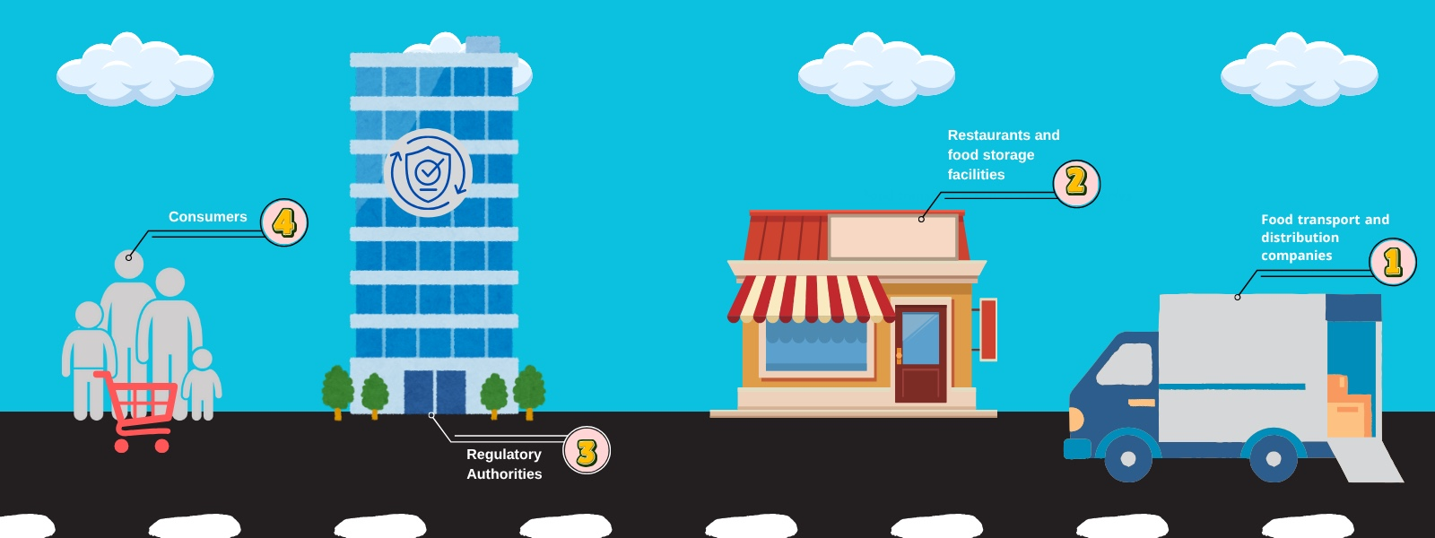
Figure 7 stakeholders in SafeChain

2.2.1 Food transport and distribution companies:
It is one of the most important stakeholders because they will actually use the system to monitor trucks while transporting food. The project helps them reduce damage and waste and improve operational efficiency.

2.2.2 Restaurants and food storage facilities:
They are interested in the system to follow the condition of stored food and ensure their quality. The system provides them with immediate reports and alerts that help maintain the safety of products.

2.2.3 Regulatory Authorities:
It takes advantage of the system to follow up on companies' commitment to food safety standards through immediate and accurate data, which improves the quality of censorship.

2.2.4 Consumers:
They represent the owners of the unequivocal interest because they are the final beneficiary of the system, as the project guarantees them safe and sound food products.

2.3 Requirements Elicitation and Analysis Methodology
To ensure that the SafeChain system is built that meets the actual needs of its core users, the requirements collection process is designed based on direct interaction with the stakeholders that most influence the functionality of the system. A set of tools was used to collect and analyze the requirements, each tool was oriented towards a specific segment of stakeholders identified in Section 2.2 to get the most out of it.

2.3.1 Interviews:
Interviews are the main qualitative tool used to collect detailed requirements for the SafeChain system. The main objective of these interviews was to delve deeper into understanding the current workflow and cold chain challenges, identify pain points, and derive operational requirements that represent an actual need for the user.

2.3.1.1 Interview Details:
An organized consulting interview was conducted with an expert in the field of transport and logistics, Mr. Mohammed Salim, who holds the position of (Business Development Supervisor) at Al Wefaq National Transport Company. The conversation focused on the challenges of preserving and transporting food and the requirements of the control system for refrigerated trucks.

2.3.1.2 Key operational challenges identified:
The expert's answers revolved around seven main questions in addition to introductory questions, and the main challenges facing the process of preserving and transporting food can be summarized:
- Cooling readiness: it must be ensured that the cooling box is sealed and its temperature is ready to the desired degree before loading.
- Loading time: loading should not take a long time to avoid the box losing its temperature.
- Driver behavior: the driver's driving style is an influential and determining factor for the safety of the load.
- Damage to the refrigeration unit: loading food that should be frozen and is "fresh" (not frozen) tires and destroys the refrigeration machine.

2.3.1.3 Basic requirements for the system:
A set of functional and non-functional requirements and limitations necessary for the design of the proposed system were derived, namely:
1-Necessary monitoring data: the speaker stressed the importance of monitoring the following continuously:
- Temperature and humidity.
- Opening doors (the number of times they open and close).
- Driver behavior.
- Location and speed via GPS system.
2-User interfaces and alerts:
- The system should preferably be available via a mobile app (for follow-up outside the office) and a website (for office use).
- The need for a digital meter (digital thermometer) in front of the driver to monitor the temperature immediately.
- It is preferable to receive instant alerts when a malfunction occurs via text messages (SMS), Whatsapp, email, or an alarm from the application.
- Daily/weekly reports are very necessary to follow the status of food.
3-Reliability and data management:
- The system should save previous records for reference (in cases of customer complaints, damage, theft).
- The system must include a data logger device that accurately records the date and temperature of the flight.
- High security and protection of stored data should be provided.
4-Infrastructure requirements and restrictions (Non-Functional Constraints):
- Operation when the internet is interrupted: there must be an alternative solution to ensure the operation of the system in the event of an internet outage or poor coverage.
- Alternative power source: another source of electricity must be available (for the sensor, GPS, or data logger) in case the battery or Dynamo in the truck breaks down.
- The cost of cloud storage: the biggest challenge to optimize the system idea is the cost of cloud storage (Cloud), as they require data retention for long periods (one or two months)

2.3.2 Questionnaires:
Questionnaires are an essential and complementary quantitative tool for in-depth interviews. This tool was used to assess the general needs and feature priorities of a wider cross-section of stakeholders, providing statistically Measurable data on the extent to which users accept and prefer the proposed features in the SafeChain system.

2.3.2.1 Analysis of results:
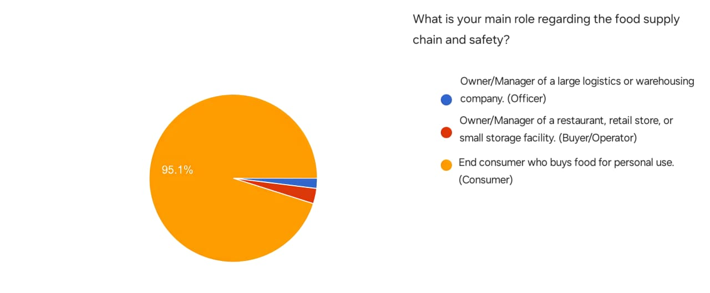
Figure 8 Distribution of the main roles of the survey participants
This figure shows the main role of participants in the supply chain and food safety. The results show that the vast majority of participants, at 95.1%, are end consumers who buy food for personal use, while managers or owners of restaurants and small shops made up a limited percentage, and the percentage of managers of large logistics or warehousing companies was the lowest among the participants.
These results indicate that the questionnaire sample is predominantly consumer-oriented, reflecting the interest of individuals as end consumers in food safety issues more than actors at other stages of the supply chain.
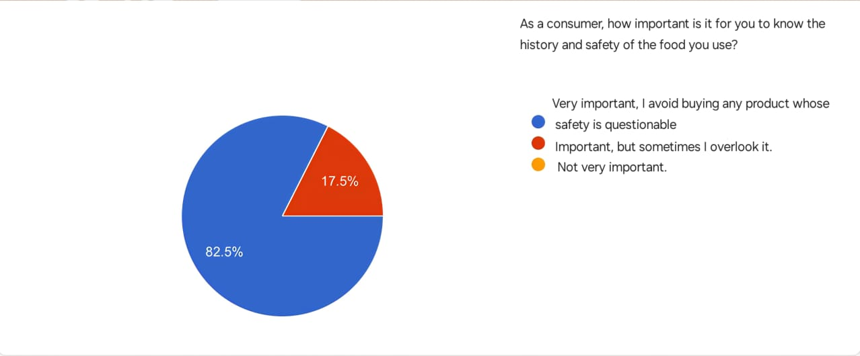
Figure 9 The influence of quality and safety factors on the consumer's choice of product
This figure shows how important it is for consumers to know the history and safety of the food they use. It turns out that 82.5% of respondents consider this very important and avoid buying any product whose safety is in doubt, while only 17.5% consider it important but may sometimes overlook it, while no one seemed unimportant.
These results indicate that the majority of consumers pay great attention to safety and quality aspects before making a purchase decision.
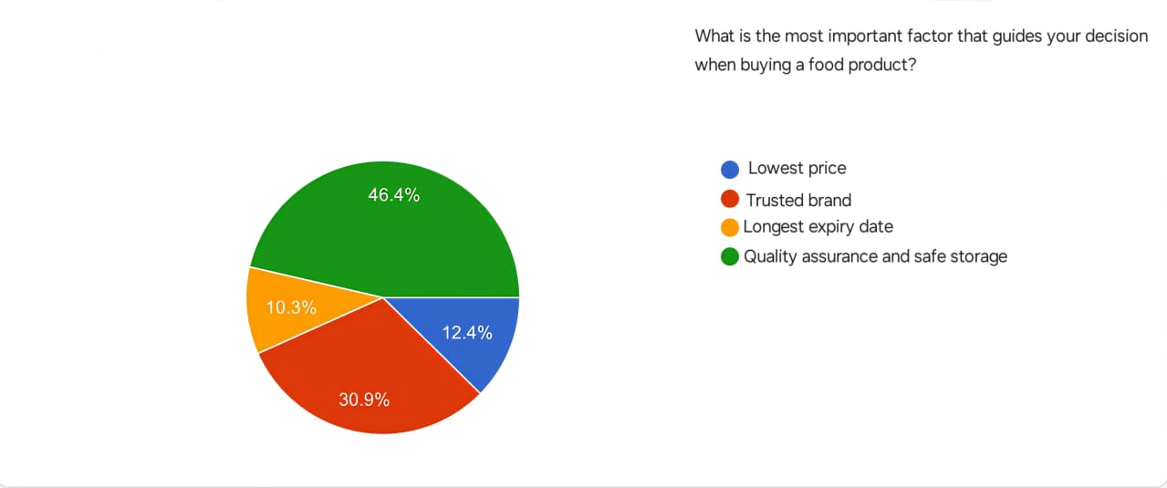
Figure 10 The most important factors that guide the consumer's decision when buying food
This figure shows the factors that most influence the decision of consumers when buying food products. The survey showed that the factor of quality assurance and safe storage came in first place with 46.4%, followed by the trusted brand with 30.9%, then the low price with 12.4%, and finally the longest shelf life with 10.3%.
The results show that consumers prefer quality and safety over price or shelf life, reflecting a growing awareness of the importance of food safety.
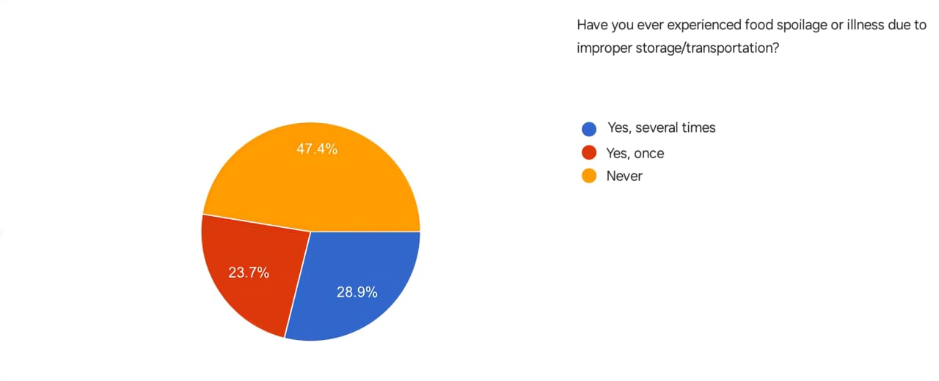
Figure 11 Statistics on food spoilage / diseases caused by poor storage
This figure shows the extent to which consumers are exposed to food spoilage or disease as a result of poor storage or transportation. The survey showed that 28.9% of respondents have experienced this several times, while 23.7% of them have encountered this problem only once, while 47.4% have never experienced it.

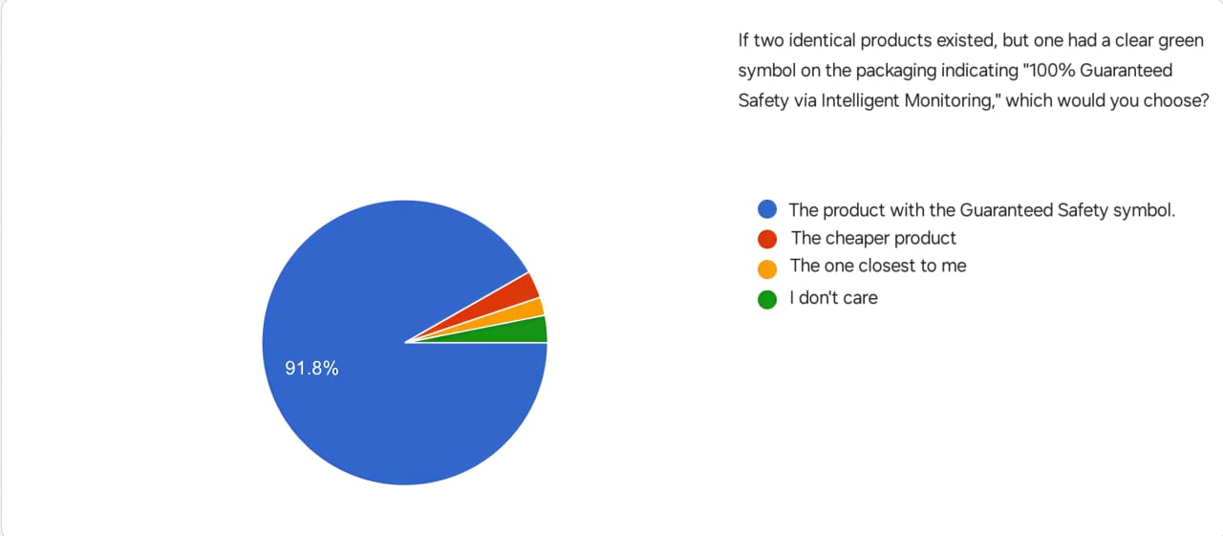
Figure 12 The extent to which the safety guarantee affects the consumer's purchase decision
This figure shows the preferences of consumers when choosing between two identical products, one of which has a green symbol indicating "100% safety guarantee via smart monitoring". The survey showed that 91.8% of respondents prefer the product with the warranty code, while 4% chose the cheapest product, 2% the closest one, and 2.2% do not care about the difference.
The results show that consumers attach great importance to safety and quality factors when buying, reflecting a strong confidence in products that clearly highlight safety standards.
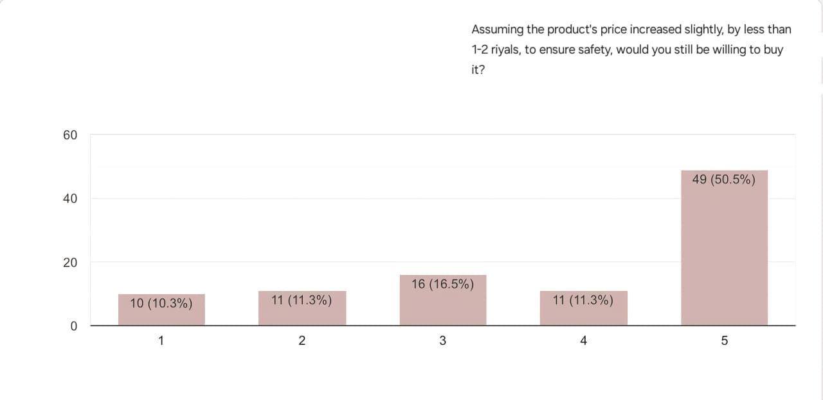
Figure 13 The extent to which the consumer is willing to pay for ensuring the safety of the product.
This figure shows the extent to which consumers are willing to buy the product if its price rises slightly (from 1 to 2 riyals) in exchange for ensuring its safety. The results showed that 50.5% of the participants showed a strong willingness to buy despite the price increase, while 16.5% showed an average degree of acceptance, and the rejection or hesitation rates were 10.3%, 11.3% and 11.3%, respectively.
The results show that the majority of consumers are willing to pay a little extra for a food safety guarantee, which confirms the importance of the safety factor in purchasing decisions.
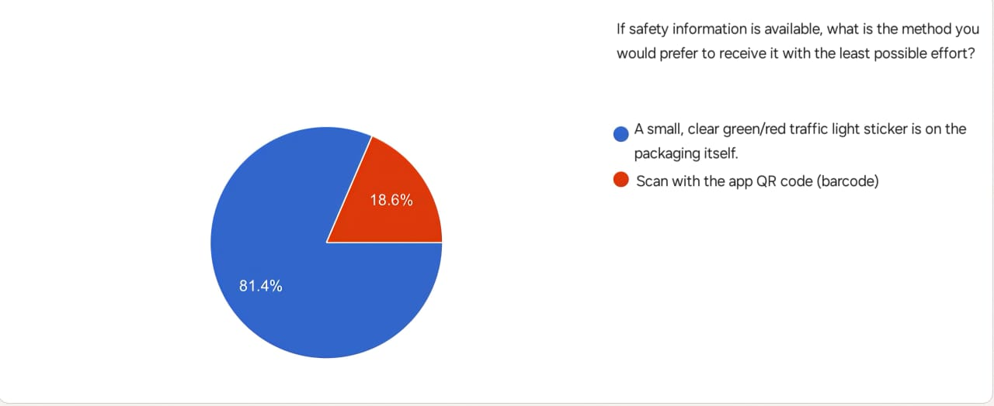
Figure 14 The consumer's preferred way to obtain product safety information
This figure shows the preferred way for consumers to receive safety information for food products. The survey showed that 81.4% of respondents prefer a simple and clear label on the package with a color code (green/red) indicating the level of security, while only 18.6% prefer to use a QR code to access information.
The results indicate that consumers prefer easy and straightforward ways of viewing safety information without the need to use additional applications or tools.
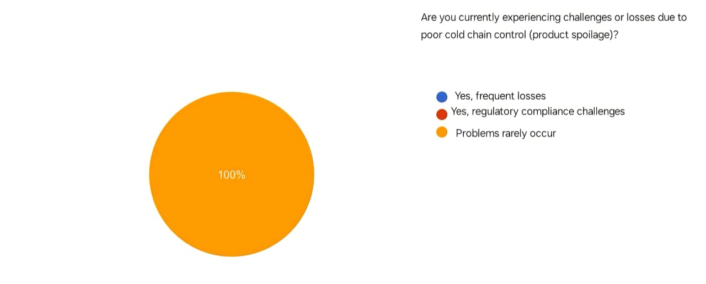
Figure 15 : How frequent are problems with cold chain control

This figure shows the extent to which participants suffer from challenges or losses resulting from poor control of the cold chain of food products. The results showed that 100% of all participants reported that problems rarely occur, which indicates that their food preservation and storage processes are running very efficiently and do not face significant challenges related to product corruption.
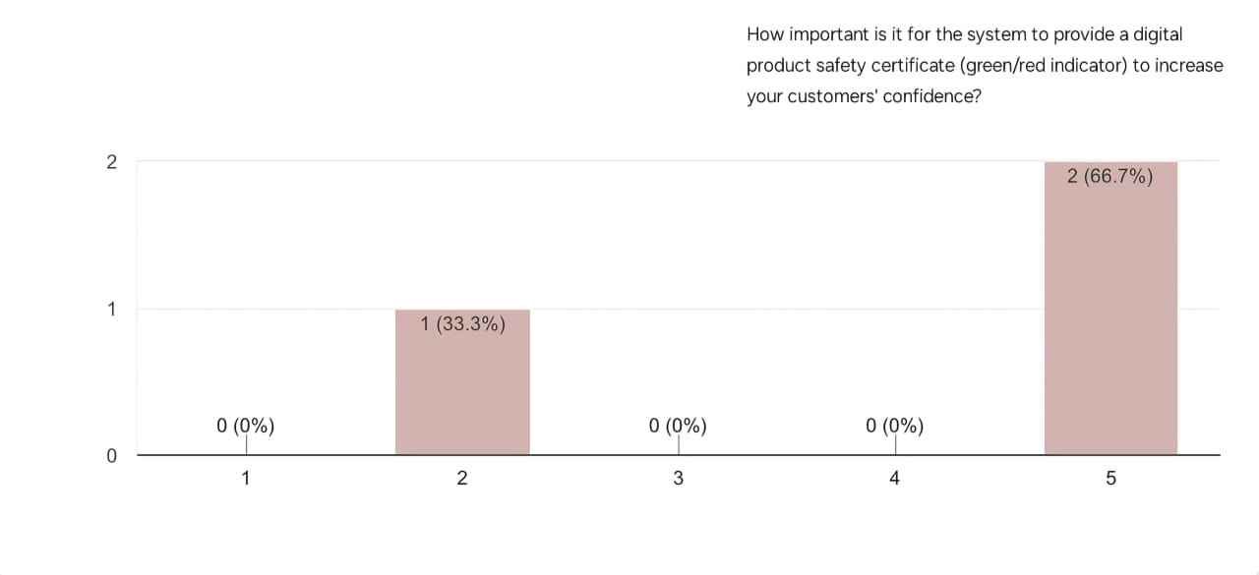
Figure 16 : How frequent are problems with cold chain control
This figure shows how important it is for the system to provide a digital certificate of Product Safety that includes a color indicator (green/red) in order to enhance customer confidence. The results indicate that 66.7% of the participants consider this to be of very high importance, while 33.3% expressed that it is of relatively low importance, while none of the participants expressed a neutral position.
These results indicate that the majority of participants recognize the importance of digital visual indicators in enhancing consumer confidence in Product Safety and quality.
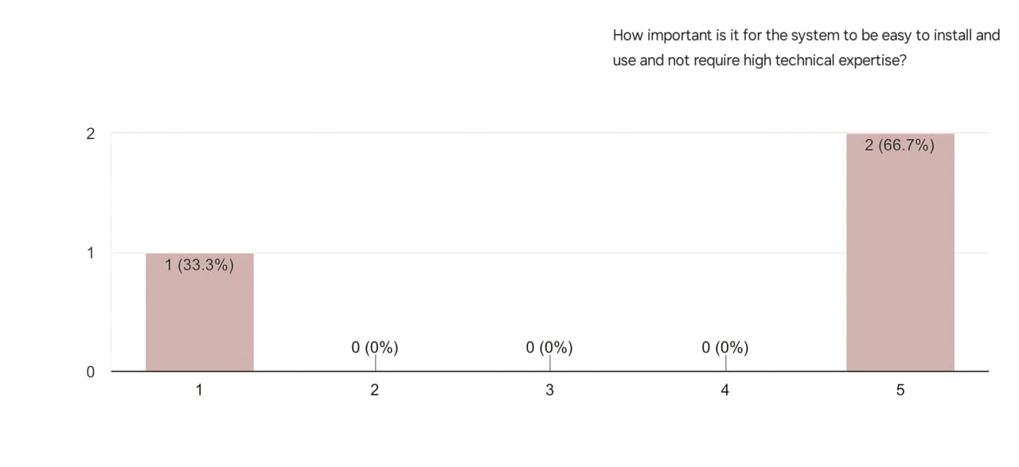
Figure 17 How important is the ease of installation and use of the system without the need for high technical expertise
This figure shows how important the ease of installation and use of the proposed system for operators is. The results showed that 66.7% of the participants expressed the highest importance (Grade 5) for the ease of the system and its lack of high technical expertise, while 33.3% of the participants indicated less importance (Grade 1). These results clearly indicate that the overwhelming majority of operators attach the utmost importance to the flexibility and ease of handling of the system as a key factor for its adoption.

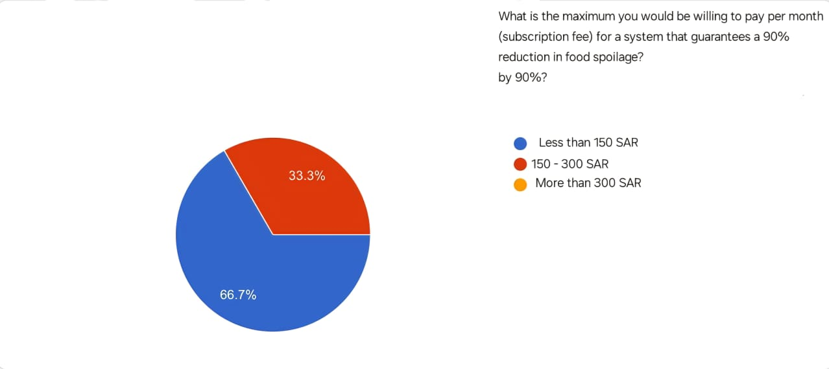
Figure 18 How important is the ease of installation and use of the system without the need for high technical expertise
This figure shows how much participants are willing to pay per month for a system that ensures a 90% reduction in food spoilage. The results showed that 66.7% of the participants prefer to pay less than 150 Saudi riyals per month, while 33.3% expressed their willingness to pay an amount between 150 and 300 riyals. These results indicate the tendency of the majority of participants to adopt effective solutions to reduce food spoilage, provided that they are low-cost and economically suitable.
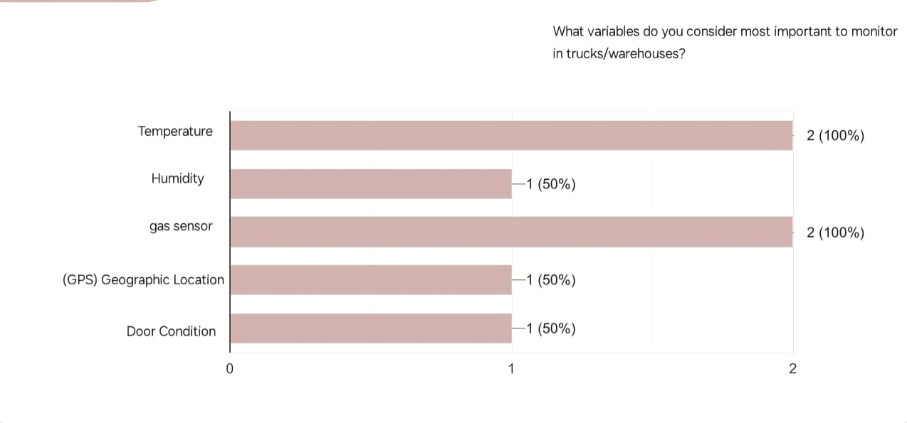
Figure 19 The most important variables that the operational entities deem necessary for monitoring in trucks/warehouses
This figure shows which variables participants consider the most important for observation inside trucks or warehouses. The results indicate that 100% of the participants stressed the importance of monitoring both temperature and gas sensors, while 50% of them felt that monitoring humidity, geographical location (GPS) and the condition of the doors are also important elements to follow. These results highlight the participants ' awareness of the importance of controlling key environmental factors to ensure food safety during transportation and storage, in particular temperature and gases that may directly affect product quality.
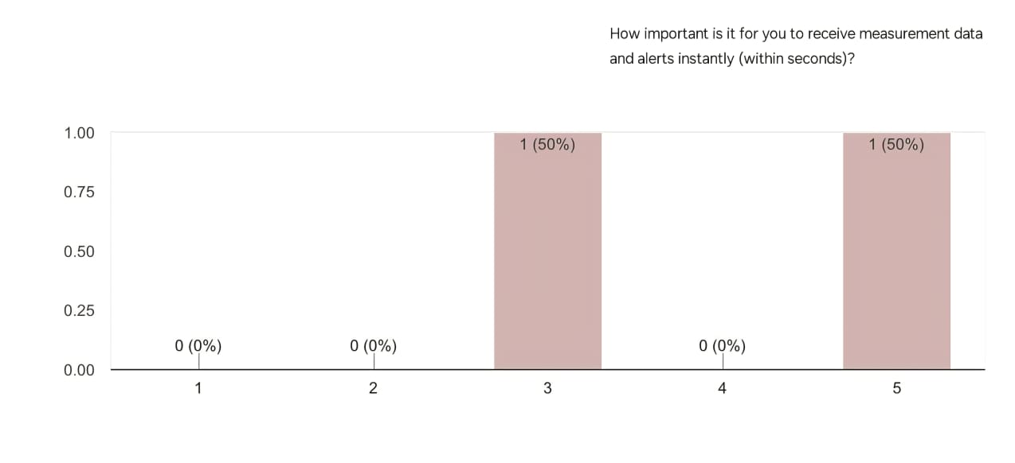
Figure 20 How important it is to receive measurement data and alerts instantly (within seconds).
This figure shows how important it is to receive measurement data and alerts instantly (within seconds). The results showed that 50% of the participants considered the immediate response to be very important, while another 50% considered it to be of medium importance. These results indicate that there is a general agreement on the importance of the speed of the system in sending alerts and data, because of its essential role in avoiding errors and taking preventive measures in a timely manner.
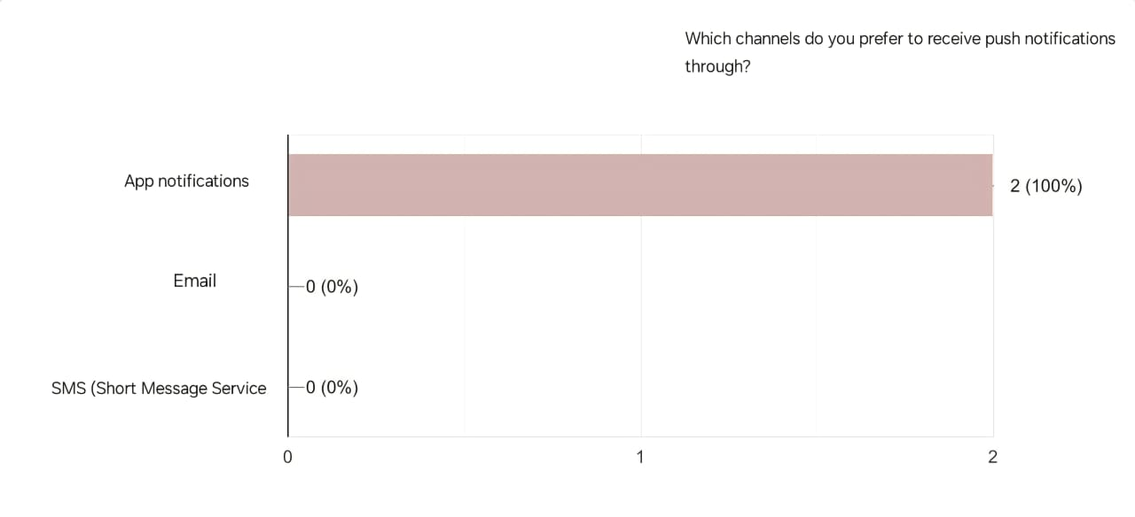
Figure 21 Preferred channels for operators to receive System Notifications
This figure shows the preferences of participants about the channel for receiving push notifications related to the status of the system and monitoring. The results showed an absolute preference for app notifications by 100%, while no participants chose to receive notifications via email or SMS. This result indicates that participants prefer to receive immediate and direct alerts within the application environment of the system, which indicates that they rely on the system to follow up on logistics operations in real-time, and that application notifications are the most effective tool to ensure quick access to information and take the necessary action in a timely manner.
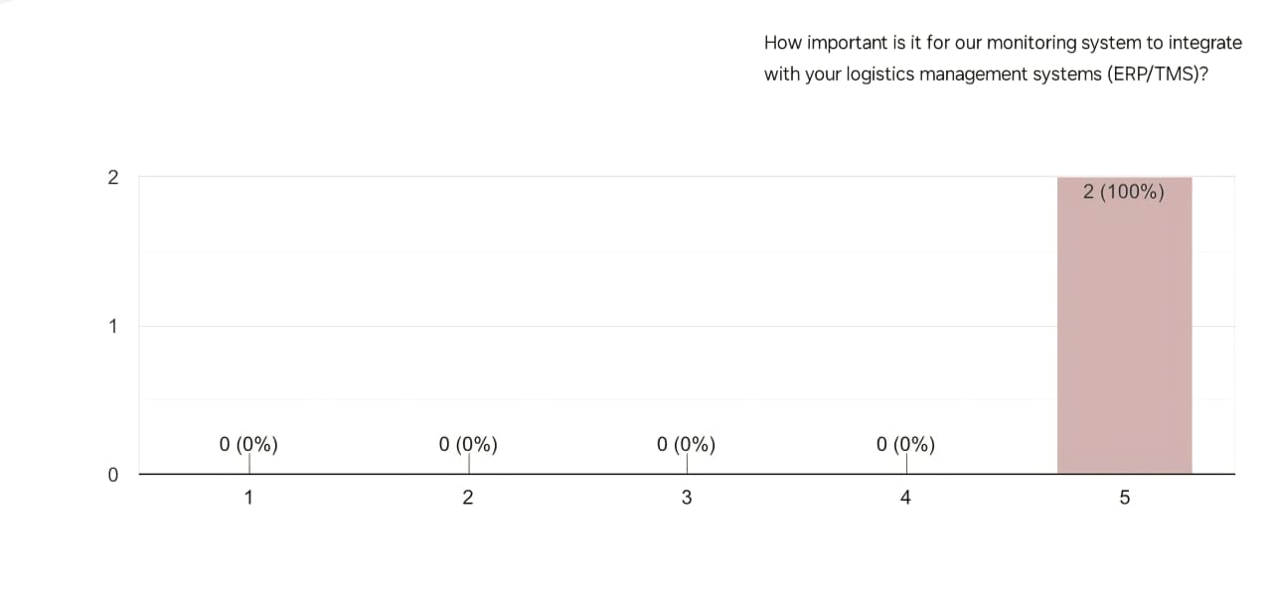
Figure 22 How important is the integration of the monitoring system with logistics management systems (ERP/TMS).
This figure shows how important it is to integrate the proposed monitoring system with the participants’ existing logistics management systems (e.g. ERP systems ERP and TMS transport management systems). The results indicate that integration is of the utmost importance, with 100% of respondents (on a scale of 5) indicating that such integration is very necessary. This result indicates that users in the logistics sector do not want a monitoring system that works in isolation from the platforms they use, but rather they consider that the maximum use of the new system requires a smooth flow of data between the monitoring system and operational systems, which ensures higher efficiency and avoids duplication of data entry.

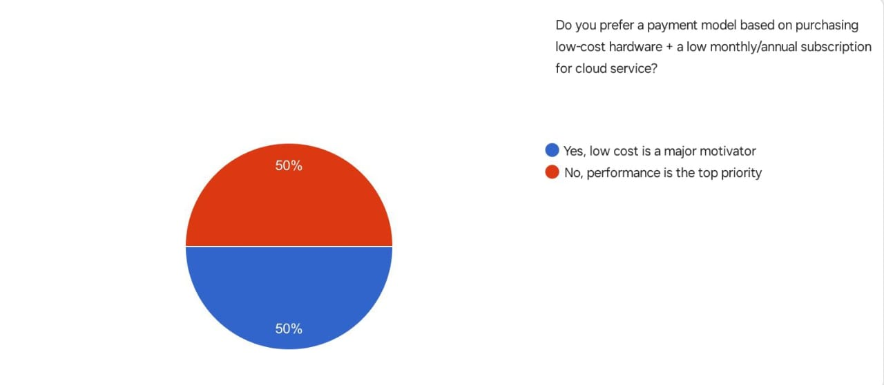
Figure 23 The preferences of the operating entities for a payment model based on the low cost of hardware and a cloud service subscription
This figure shows the preferences of participants regarding the payment model of the system, whether it is based on the purchase of low-cost devices with a low monthly or annual subscription for a cloud service, or performance is the main priority. The results indicate an even split among the participants, with 50% of them seeing low cost as a major motivating factor, while the other 50% confirmed that performance is the most important factor in decision-making. These results indicate that users ' priorities differ between the desire to reduce costs on the one hand, and ensuring the efficiency of the system and its high performance on the other hand, which indicates the need to balance both sides in the design of the pricing model.

2.3 Functional Requirements
Functional requirements involve clearly describing what the system should do — the specific behaviors, features, and functions it must support. The following provides description the system functional requirements.

2.3.1 User Login (FR_001):
The User Login functionality allows registered users to access the platform securely using their email and password. This requirement supports session management, error handling for invalid credentials, and account security through lockout mechanisms. It is a core feature of the authentication module and integrates with user registration and password reset functionalities.
Table 6 Functional Requirement – User Login
Field | Details
ID | FR_001
Title | User Login
Description | The system shall allow registered users to log in using their email and password.
Priority | Must-Have
Actors | Registered User, System
Inputs | Email address, password, "Login" button click
Outputs | - Authenticated user is redirected to the dashboard  - Error message displayed for invalid credentials
Pre-conditions | - The user is registered with a valid email and password  - The system is online and accessible
Post-conditions | - Valid credentials: user is logged in and redirected  - Invalid credentials: error message shown  - Locked account: user is notified to contact support
Flow | 1. User navigates to login page  2. Enters email and password  3. Clicks "Login"  4. System validates credentials  5. Redirects or shows error message
Acceptance Criteria | - Valid credentials grant access within 2 seconds  - Invalid credentials show error without redirect  - 5 failed attempts lock account  - Failed attempts are logged  - Login page handles up to 5s latency

2.3.2 Sensor Data Monitoring (FR_002):
Description:
The system shall continuously collect and display live readings of temperature, humidity, gas concentration (NH₃, CO₂, H₂S), and truck door status through the connected IoT sensors.
Table 7 Functional Requirement – Sensor Data Monitoring
Field | Details
ID | FR_002
Title | Sensor Data Monitoring
Description | The system must monitor and display real-time environmental data (temperature, humidity, gases, and door status) collected from IoT sensors.
Priority | Must-Have
Actors | System, Transport Company User
Inputs | Sensor readings sent via Raspberry Pi or IoT gateway
Outputs | Updated dashboard with live data visualization
Pre-conditions | Sensors must be calibrated and connected to the network
Post-conditions | Data is stored securely in the cloud and visible on the dashboard
Flow | - Sensors collect data  - Raspberry Pi sends data  - Cloud stores it  - Dashboard updates instantly
Acceptance Criteria | - Data updates every ≤5 seconds  - Displayed readings match sensor accuracy ±2%  - Data loss < 1% during normal operation

2.3.3 Instant Alerts System (FR_003):
Description: The system must generate and send instant alerts to relevant users when any sensor reading (temperature, humidity, gases, or door status) exceeds predefined safe limits. These notifications are sent via multiple channels (in-app, email, SMS) to ensure immediate corrective action and protect the shipment from damage, thereby minimizing loss and maintaining quality control.

Table 8 Functional Requirement – Instant Alerts System
Field | Details
ID | FR_003
Title | Instant Alerts System
Description | The system must generate and send instant alerts when any of the measured values (temperature, humidity, gas concentrations, door status, or network connection) exceeds the predefined safe limits. Alerts are sent automatically through multiple channels (in-app notification, email, or text message) to enable the user to take corrective action immediately.
Priority | Must-Have
Actors | The system, the company's transport user, the supervisor
Inputs | Sensor readings coming from a Raspberry Pi unit or IoT Gateway when they exceed or fall below the permitted values.
Outputs | Instant notifications via the app, email, or text messages, plus a visual alert on the dashboard.
Pre-conditions | 1. That the sensors are active and calibrated.  2. That the user is registered and activated for the alerts service.  3. Availability of cloud connection to the internet.
Post-conditions | 1. Register the alert in the database with the time and sensor identifier.  2. Send the notification to the specified users.  3. Keep the alert visible until it is confirmed or the values return to normal
Flow | 1. The sensors send data continuously.  2. The system compares the values with the specified limits.  3. Upon exceeding, the instant alerts engine is activated.  4. The user receives an immediate notification inside the app and an email or text message.  5. The system logs the event in the database for review and reporting purposes.
Acceptance Criteria | - Detection of abnormal values and sending the alert within ≤ 5 seconds.  - Alert delivery via at least one channel (app, email, text messages).  - Alert message containing the sensor name, measured value, time, and location.  - Ability to confirm the alert to remove it from the active alerts list.  - Saving all alerts in the database for use in subsequent reports.

2.3.4 Records and Reports Management (FR_004):
Description: This requirement focuses on the secure management and storage of all historical sensor data and GPS locations in a dedicated cloud database. The system must also generate detailed periodic reports(daily/weekly/monthly) in standard export formats (PDF/Excel) and perform automatic data backup to ensure data integrity and business continuity over the long term for auditing purposes.

Table 9 Functional Requirement – Records and Reports Management
Field | Details
ID | FR_004
Title | Records and Reports Management
Description | This part of the system focuses on managing historical data and generating periodic reports in an organized and secure manner. The system shall store all sensor readings (temperature, humidity, gas levels, door status, and GPS location) in a secure cloud database that allows users to retrieve the information when needed. The system shall also generate daily, weekly, and monthly reports, enable searching through historical records, and perform automatic data backup to ensure data safety and continuity.
Priority | Must-Have
Actors | System, Transport Company User, Supervisor, Administrator
Inputs | All periodic sensor readings (temperature, gases, location...etc.) transmitted from the Internet of Things unit.
Outputs | Stored data in the cloud database.- Generated reports (daily, weekly, or monthly) in PDF or Excel format.- Displayed search results from historical records.- Automatically saved backup copies of the data.
Pre-conditions | - Sensors are properly connected and calibrated  - Cloud database is active and accessible  - User has authorized access permissions
Post-conditions | 1. Data is successfully stored with timestamp and location information  2. Reports are successfully generated and available for viewing or download  3. User can access and review previous reports and search results  4. Backup process is successfully completed without data loss
Flow | 1. Sensors collect and transmit data to the system  2. The system stores the data periodically in the cloud database.  3. The user requests report generation or historical search.  4. The system retrieves the requested data and displays or exports it.  5. The system performs an automatic backup every 24 hours to ensure data protection.
Acceptance Criteria | 1. Data storage success rate shall be at least 99%  2. Historical data and records shall be displayed within 5 seconds  3. Reports shall be generated within 10 seconds  4. Reports shall include minimum, maximum, and average values for each parameter  5. The user shall be able to export search results in CSV format  6. The system shall automatically perform data backup every 24 hours without manual intervention  7. The system shall be capable of restoring data within 2 minutes  8. The system shall retain historical data for a minimum of 12 months, extendable up to 3 years

2.3.5 New User Registration Requirement (FR_005)
Description: The system must allow new users to securely create their accounts by entering basic information like name, email, and password. This function requires validation of input data integrity and ensuring the uniqueness of the email address. It is a fundamental step for authentication and authorization before users are granted access to the platform's core features.

Table 10 Functional Requirement – New User Registration Requirement
Field | Details
ID | FR_005
Title | User Registration (New Account Creation)
Description | The system must allow new users to create an account by securely submitting basic information (Name, Email, Password), validating data integrity, and ensuring email uniqueness.
Priority | Must-Have
Actors | New User, System, Administrator (for potential final activation)
Inputs | Full Name, Email address, Password, Password Confirmation, "Register" button click.
Outputs | - Confirmation email sent to the user's address. - Error message displayed for invalid or duplicate email credentials. - User redirection to the login page.
Pre-conditions | - The user is not already registered in the system. - The system's database and email service (SMTP) are operational.
Post-conditions | - A new user record is created in the database. - An initial role (e.g., Driver/Manager) is assigned. - The account creation attempt is logged.
Flow | 1. The user navigates to the "Create New Account" interface.  2. The user enters the required details.  3. The user clicks "Register".  4. The system validates the data and checks for email uniqueness.  5. The account is created, and an account activation link is sent via email.
Acceptance Criteria | 1. Account creation must be successfully completed within $\le 3$ seconds.  2. Clear instructions for password strength (e.g., minimum 8 characters) must be provided.  3. An immediate error message must be shown if the email address is already registered.

2.3.6 Password Reset Requirement (FR_006)
Description: The system must provide a secure and verifiable mechanism for registered users to recover or change a lost or forgotten password. This process is typically handled through email verification, where a unique and temporary reset link is sent to the registered address. This mechanism is essential for ensuring users maintain access to their accounts while upholding strict security standards.

Table 11 Functional Requirement – Password Reset Requirement
Field | Details
ID | FR_006
Title | Password Reset/Recovery
Description | The system must provide a secure and verifiable mechanism for registered users to recover or change their password in case of loss, typically through email verification.
Priority | Must-Have
Actors | Registered User, System
Inputs | Email address (in the request step), New Password and Confirmation (in the reset step).
Outputs | - A secure, temporary password reset link sent to the provided email address. - A confirmation message upon successful password change.
Pre-conditions | - The user is registered with a valid, accessible email address. - The system's email service is active.
Post-conditions | - The user's password (hashed/encrypted) is updated in the database. - The temporary reset link is invalidated immediately after use or upon expiration.
Flow | 1. The user clicks "Forgot Password".  2. The user enters their registered email address.  3. The system sends a unique, time-sensitive reset link to the email  . 4. The user clicks the link and submits a new password.  5. The system logs the user out and directs them to the login page.
Acceptance Criteria | 1. The reset link must arrive in the user's inbox within $\le 10$ seconds.  2. The password reset link must remain valid for a maximum duration of $\le 60$ minutes.  3. The password must be successfully updated in the database within $\le 2$ seconds of confirmation.

2.3.5 IoT Device Requirements

2.3.5.1 IoT Device Requirements
Description: The Internet of Things (IoT) device must collect readings for temperature, humidity, and gas concentrations (CO₂, NH₃, H₂S) at fixed and regular time intervals, not exceeding 30 seconds. This continuous data collection is essential for effective environmental monitoring and aggregating accurate data required for transmission to the cloud server for further analysis and real-time display.
Table 12 Functional Requirement – IoT Device Requirements
Field | Details
ID | FR_101
Title | Sensor Data Collection
Description | The device must collect readings at specific intervals (e.g., every 30 seconds) for temperature, humidity, and gases (CO₂, NH₃, H₂S).
Priority | Must-Have
Actors | System (Device)
Inputs | Internal System Timer signal.
Outputs | Raw sensor readings (Temperature, Humidity, Gases) with a Timestamp.
Pre-conditions | - The IoT Device is powered on. - Sensors are properly connected and calibrated.
Post-conditions | Data is collected and stored locally or prepared for cloud transmission.
Flow | 1. The System Timer triggers  . 2. The device reads all connected sensors.  3. Data is aggregated and timestamped.  4. Data is stored temporarily (Buffering).
Acceptance Criteria | 1. Readings must be taken at intervals no greater than 30 seconds.  2. All specified parameters (T, H, CO₂, NH₃, H₂S) must be included.  3. Successful aggregation and local storage of data.

2.3.5.2 Data Buffering - FR_102
Description: The IoT device must locally store all collected sensor readings in its internal memory in case of any network disconnection (whether LoRa or 4G). This data buffering mechanism is crucial for preventing the loss of valuable shipment data and ensuring the completeness of historical trip records once the network connection is successfully restored, guaranteeing data integrity.
Table 13 Functional Requirement – Data Buffering
Field | Details
ID | FR_102
Title | Data Buffering
Description | The device must store all readings locally in case of network disconnection (LoRa/4G).
Priority | Must-Have
Actors | System (Device)
Inputs | Raw Sensor Data, Network Disconnection Notification.
Outputs | Data stored locally in the device's memory (Local Storage).
Pre-conditions | - Sufficient storage memory is available on the device. - Network connection attempt fails (LoRa/4G).
Post-conditions | Readings are secured locally to prevent data loss.
Flow | 1. The device attempts to send data to the cloud.  2. Transmission fails due to network outage.  3. The device diverts the data to the local Buffer.
Acceptance Criteria | 1. There shall be no data loss during network disconnection.  2. Data is stored chronologically while maintaining the Timestamp.  3. Data must be retained until connection is restored.

2.3.5.3 Data Transmission to the Cloud - FR_103
Description: The device must completely and immediately send all locally stored data, including data buffered during the outage, to the cloud server once the network connection is restored. This requirement ensures that the cloud database is consistently updated with all historical and real-time information necessary for continuous monitoring and detailed retrospective analysis of the shipment's conditions.

Table 14 Functional Requirement – Data Transmission to the Cloud
Field | Details
ID | FR_103
Title | Data Transmission to the Cloud
Description | The device must send all stored data (including buffered data) to the cloud server once the connection is restored.
Priority | Must-Have
Actors | System (Device)
Inputs | Newly collected data, Buffered Data, Network Connection Restoration Notification.
Outputs | - Successful transmission to the cloud server. - Clearing of the local Buffer upon confirmation.
Pre-conditions | - Network connection is restored (LoRa/4G). - Data is ready to be sent in the local storage or newly collected.
Post-conditions | - The cloud database is updated with historical and real-time data. - The local Buffer is cleared successfully.
Flow | 1. Network connection is restored.  2. The device flushes the buffer and sends the stored data sequentially.  3. Any new data is sent immediately after the buffered data.  4. The device receives a successful storage confirmation from the cloud.
Acceptance Criteria | 1. Buffered data must be sent successfully at a 100% rate after connection is restored.  2. The buffer must be cleared only after receiving cloud storage confirmation.

2.3.5.4 GPS Tracking - FR_104
Description: The device must continuously determine its current geographical location (longitude and latitude) and send these coordinates bundled with the other sensor readings. This GPS tracking function enables linking environmental data directly to the truck's precise location throughout the entire duration of the shipment, which is vital for route compliance and geo-fencing requirements.
Table 15 Functional Requirement – GPS Tracking
Field | Details
ID | FR_104
Title | GPS Tracking
Description | The device must continuously determine its current geographical location and send it with sensor readings.
Priority | Must-Have
Actors | System (Device)
Inputs | Satellite signals (GPS/GNSS Signals).
Outputs | Location Coordinates (Longitude, Latitude).
Pre-conditions | - The GPS receiver is connected and running. - The device must be in an area with GPS signal coverage.
Post-conditions | Location coordinates are recorded with every sensor reading.
Flow | 1. The device receives GPS signals.  2. The device calculates the location coordinates.  3. The coordinates are bundled with the sensor data.  4. The combined data is sent to the cloud.
Acceptance Criteria | 1. Location accuracy must be within $\le 5$ meters.  2. GPS coordinates must be sent with every set of sensor readings.

2.3.6 Web & Mobile App Requirements

2.3.6.1 Login/Logout - FR_201
Description: The web and mobile application must provide secure login and logout functionalities using the user's credentials (email and password). This function ensures proper user session management, where a secure session is established upon valid login and immediately terminated and its data cleared upon clicking the "Logout" button, adhering to best security practices.

Table 16 Functional Requirement – Login/Logout
Field | Details
ID | FR_201
Title | Login/Logout
Description | The application and website must allow users to securely log in using their credentials.
Priority | Must-Have
Actors | User, Web & Mobile App
Inputs | Credentials (Email and Password), Clicking the "Login" button, Clicking the "Logout" button.
Outputs | - Login: Access to the dashboard. - Logout: Redirection to the login page.
Pre-conditions | - The user is registered in the system. - The system is connected to the internet and available.
Post-conditions | - Login: A secure user session is started. - Logout: The session is terminated, and its data is removed.
Flow | 1. The user navigates to the login interface.  2. Enters credentials and clicks "Login".  3. The system verifies the credentials.  4. If valid, login proceeds; otherwise, an error message is displayed.
Acceptance Criteria | 1. Login and logout must be successful in less than 2 seconds.  2. SSL/TLS encryption must be used for data transmission.

2.3.6.2 Dashboard - FR_202
Description: The main dashboard must display a comprehensive visual summary of all active shipments currently under surveillance. This summary prominently includes the total number of electronically tracked trucks and the current count of active alerts. This overview aims to provide supervisory users with an immediate and quick snapshot of the operational status and any immediate alarms that require attention.
Table 17 Functional Requirement – Dashboard
Field | Details
ID | FR_202
Title | Dashboard
Description | The main dashboard must display a summary of all active shipments, including the number of monitored trucks and the number of alerts.
Priority | Must-Have
Actors | System, Web & Mobile App
Inputs | Successful user login, Active shipments data, Recent alerts data.
Outputs | Visual summary (Widgets/Cards) displaying: Active Shipments, Trucks Under Monitoring, Current Number of Alerts.
Pre-conditions | - User is logged in. - Updated shipment data is available in the database.
Post-conditions | The user sees a comprehensive and immediate summary of shipment status.
Flow | 1. After logging in, the system requests shipment and alert summary data.  2. The application interface displays the data in visual elements (Widgets).  3. The alert count is updated immediately upon a new alert (Push).
Acceptance Criteria | 1. The dashboard must load and display the summary in less than 5 seconds.  2. The displayed truck and alert counts must match the actual data in the database.

2.3.6.3 Real-time monitoring - FR_203
Description: The system must display the current sensor readings and the truck's geographical location on a detailed, interactive interface that is continuously updated. This real-time monitoring allows users to track environmental conditions and truck movement moment-by-moment, supporting rapid decision-making and effective response to any sudden environmental changes during the transport phase.
Table 18 Functional Requirement – Real-time monitoring
Field | Details
ID | FR_203
Title | Real-time monitoring
Description | The system must display current sensor readings and truck location on a detailed interface.
Priority | Must-Have
Actors | System, Web & Mobile App
Inputs | Live Sensor Data, GPS Coordinates.
Outputs | - Graphical display of temperature, gas, and humidity readings. - Interactive map displaying the current truck location.
Pre-conditions | - The IoT device is continuously sending data. - The user is monitoring a specific truck.
Post-conditions | The interface is continuously updated in real-time.
Flow | 1. The user displays the truck monitoring interface.  2. The system receives data streams from the cloud.  3. Reading counters and the truck's location on the map are updated.
Acceptance Criteria | 1. Live data must be continuously updated (FR_214).  2. There must be a delay of no more than 5 seconds between the sensor reading time and the data display time.

2.3.6.4 Threshold settings management - FR_204
Description: The system must enable authorized users (Supervisor/Admin) to define and modify the maximum and minimum safety limits for each specific shipment type (e.g., meat or vegetables, fresh produce). These configurable safety settings are directly applied as reference points to the instant alert system (FR_003) to ensure the accuracy and effectiveness of notifications based on product-specific quality standards.
Table 19 Functional Requirement – Threshold settings management
Field | Details
ID | FR_204
Title | Threshold settings management
Description | The system must allow the user (Admin/Supervisor) to define and modify safety limits for each shipment type (e.g., fruits, meat).
Priority | Must-Have
Actors | User (Admin/Supervisor), Web (mainly)
Inputs | Selecting shipment type, Minimum and maximum threshold values (e.g., $2^\circ C$ to $8^\circ C$), Clicking the "Save" button.
Outputs | - Storage of new safety limits in the database. - Success confirmation message.
Pre-conditions | - The user has the "Admin" or "Supervisor" role. - Shipment types are predefined in the system.
Post-conditions | New safety limits are applied to the instant alert system (FR_003).
Flow | 1. The user (Admin) navigates to the settings page.  2. Selects the shipment type and enters the required values.  3. Clicks "Save".  4. The system updates the reference table for limits in the database.
Acceptance Criteria | 1. Limits must be modified and applied successfully in less than 5 seconds.  2. No user without the Supervisor or Admin role can modify these limits.

2.3.6.5 Alert log - FR_205
Description: The system must display a detailed, scrollable list of all recorded historical alerts that have occurred previously. This log must include critical details for each alert, such as the alert type, the causative reading, the time and date of occurrence, and its duration, which greatly facilitates the process of reviewing past incidents for historical analysis and regulatory auditing purposes.
Table 20 Functional Requirement – Alert log
Field | Details
ID | FR_205
Title | Alert log
Description | The system must display a detailed list of all alerts (alert type, reading, occurrence time, and duration).
Priority | Must-Have
Actors | System, Web & Mobile App
Inputs | User request to view the alert log, Alert data stored in the database.
Outputs | Scrollable List displaying the details of each alert.
Pre-conditions | - User is logged in. - Alerts are previously recorded in the database (FR_003).
Post-conditions | The user can review historical incidents and take necessary actions.
Flow | 1. The user requests to view the alert log.  2. The system retrieves data from the database.  3. Alerts are displayed chronologically on the interface.
Acceptance Criteria | 1. The alert log must be displayed within 5 seconds.  2. The alert list must include the minimum required details (FR_003).

2.3.6.6 Report generation - FR_206
Description: The system must allow the user to generate comprehensive full-trip reports in exportable formats like PDF or Excel. These reports must show the shipment's compliance with required cold chain standards and provide summaries of minimum, maximum, and average values, which are essential documents for auditing, quality assurance, and dispute resolution procedures.
Table 21 Functional Requirement – Report generation
Field | Details
ID | FR_206
Title | Report generation
Description | The system must allow generating complete trip reports (PDF/Excel) showing cold chain compliance.
Priority | Must-Have
Actors | User, Web & Mobile App
Inputs | Report Request, Specifying the report period (trip start and end), Selecting the export format (PDF/Excel).
Outputs | Generated report file in PDF or Excel format.
Pre-conditions | - Historical data is recorded for the requested trip (FR_004). - The user has authorized access to generate reports.
Post-conditions | The report is available for the user to view or download.
Flow | 1. The user defines the report criteria (trip, format).  2. The system retrieves the required data from the database (FR_004).  3. Data is processed and formatted into the required file.  4. The file is presented for download or viewing.
Acceptance Criteria | 1. The report must be generated within 10 seconds.  2. The report must include minimum, maximum, and average values for each parameter.  3. Reports must be accurate and exportable in both PDF/Excel formats.

2.3.6.7 Instant notifications - FR_207
Description: Relevant users, such as the transport manager or supervisor, must receive instant Push Notifications on their mobile applications when predefined safety limits are exceeded. This ensures the user is immediately aware of the issue, enabling them to take necessary corrective actions within seconds of anomaly detection, which is crucial for sensitive and perishable cargo during transit.
Table 22 Functional Requirement – Instant notifications
Field | Details
ID | FR_207
Title | Instant notifications
Description | Relevant users (e.g., transport manager) must receive push notifications when thresholds are exceeded.
Priority | Must-Have
Actors | System, Mobile App
Inputs | Alert engine activation (FR_003), Alert data.
Outputs | Push Notification on the user's phone.
Pre-conditions | - Predefined safety limits are exceeded (FR_003). - The user has installed the app and enabled notifications.
Post-conditions | The user is immediately aware of the issue to take corrective actions.
Flow | 1. The alert engine (FR_003) identifies the relevant users.  2. The system sends the instant push notification to the user's application.  3. The alert message is displayed on the phone screen.
Acceptance Criteria | 1. The notification must be sent within $\le 5$ seconds of anomaly detection (FR_003).  2. The notification must include the required alert content (sensor name, value, time, and location).

2.3.6.8 Historical data filtering - FR_208
Description: :The system must provide an interface that allows searching and filtering historical records and alerts. Users can specify filtering criteria based on the truck's ID, a defined date and time range, or the shipment type, thereby significantly enhancing the efficiency of searching and analyzing historical data for detailed investigation and reporting (FR_004).

Table 23 Functional Requirement – Historical data filtering
Field | Details
ID | FR_208
Title | Historical data filtering
Description | The system must allow searching and filtering historical records and alerts by truck, date, or shipment type.
Priority | Must-Have
Actors | User, Web & Mobile App
Inputs | Search criteria (Truck name, Date range, Shipment type), Clicking the "Search" button.
Outputs | Filtered Data Set displaying the matching records or alerts.
Pre-conditions | - A large amount of historical data exists (FR_004). - The user is on the search or records interface.
Post-conditions | Relevant results are displayed to the user for review or export.
Flow | 1. The user enters one or more search criteria.  2. The application sends the query to the database.  3. Matching records are retrieved and displayed in a table or list format.
Acceptance Criteria | 1. Search results must be displayed within 5 seconds.  2. The search operation must support at least three criteria (Truck, Date, Type).  3. The user must be able to export search results in CSV format (FR_004).

2.3.6.9 User and role management - FR_209
Description: The Administrator (Admin) must have full authority to create, delete, and modify other user accounts and assign different predefined roles to them (e.g., Driver, Manager, Supervisor). This crucial function ensures the proper implementation of access control policies and the precise management of user permissions within the overall system architecture, supporting security compliance.
Table 24 Functional Requirement – User and role management
Field | Details
ID | FR_209
Title | User and role management
Description | The system must allow the Admin to create, delete, and modify user accounts and assign roles (Driver, Manager, Supervisor).
Priority | Must-Have
Actors | User (Admin), Web
Inputs | New user data (Name, Email, Password), Assigned role (Driver, Manager, Supervisor), Account modification/deletion request.
Outputs | - Successful user account creation/modification/deletion. - New role applied to the user.
Pre-conditions | - User is logged in with the "Admin" role. - The system is connected to the user database.
Post-conditions | The user record and database are updated with new roles and permissions.
Flow | 1. The Admin navigates to the user management interface.  2. Selects an action (Create/Modify/Delete).  3. Enters the required data and assigns the role.  4. The system confirms the change and displays a success message.
Acceptance Criteria | 1. Only the Admin can perform these modifications.  2. New roles must be applied immediately to users' access permissions.

2.3.7. Account–Device Binding Requirements

2.3.7.1 Device pairing - FR_210
Description: The website must enable the process of linking a new IoT device to a specific truck or user using a unique device ID or by scanning a device-specific QR code. This operation is necessary to electronically connect the physical monitoring unit to the digital truck record in the database and immediately initiate the flow of real-time monitoring data.

Table 25 Functional Requirement – Device pairing
Field | Details
ID | FR_210
Title | Device pairing
Description | The website must allow linking a new IoT device to a specific user/truck using a unique Device ID or QR code.
Priority | Must-Have
Actors | User (Manager/Supervisor), Web
Inputs | Device ID or QR code scan, Specifying the truck/user to link the device to.
Outputs | Recording the new device/truck link in the database.
Pre-conditions | - The user has the "Manager" or "Supervisor" role. - The IoT device is not currently paired.
Post-conditions | The device is considered part of the company's assets, and monitoring can begin.
Flow | 1. The Manager enters the Device ID (or scans QR).  2. Selects the truck.  3. The system sends the pairing request to the database.  4. A success confirmation message is displayed.
Acceptance Criteria | 1. The same device cannot be linked to more than one truck at the same time.  2. The pairing process must be completed successfully within 3 seconds.

2.3.7.2 Device status verification - FR_211
Description: The system must display the current connection status of the paired device (Connected, Disconnected, Last Seen) on the main dashboard. This provides users with clear and immediate visibility into the connection health and operational status of all monitoring units installed on the tracked trucks, which is essential for identifying potential communication failures promptly.

Table 26 Functional Requirement – Device status verification
Field | Details
ID | FR_211
Title | Device status verification
Description | The system must display the paired device’s connection status (Connected, Disconnected, Last Seen) on the dashboard.
Priority | Must-Have
Actors | System, Web & Mobile App
Inputs | Last Seen Timestamp data from the device.
Outputs | Visual status display (Connected, Disconnected, Last Seen).
Pre-conditions | - The device is already paired (FR_210). - The device is attempting to send data periodically (FR_103).
Post-conditions | The user has clear visibility of any device connectivity issues.
Flow | 1. The system receives periodic update data from the device.  2. If updates stop for a defined period, the status changes to "Disconnected".  3. The status is updated on the user interface (FR_202).
Acceptance Criteria | 1. The status display must accurately reflect the actual connection state.  2. The "Last Seen" indicator must be updated periodically ( every 60 seconds).

2.3.7.3 Device unpairing - FR_212
Description: The system must allow an authorized user (Admin or Supervisor) to unpair a device from a specific truck. This function is necessary when a shipment trip is fully concluded or the truck is replaced, making the device available to be reassigned to a new shipment or vehicle, ensuring efficient asset management.

Table 27 Functional Requirement – Device unpairing
Field | Details
ID | FR_212
Title | Device unpairing
Description | The system must allow the admin to unpair the device when the trip ends or the truck is replaced.
Priority | Must-Have
Actors | User (Manager/Supervisor), Web
Inputs | Unpairing request, Specifying the Device ID to unpair.
Outputs | Removal of the device link from the truck/account in the database.
Pre-conditions | - The device is currently paired (FR_210). - The user has the "Manager" or "Supervisor" role.
Post-conditions | The device becomes available for pairing with a new truck or shipment.
Flow | 1. The Admin identifies the device to unpair.  2. The Admin confirms the unpairing process.  3. The system removes the pairing record from the database.  4. Real-time monitoring for the device stops.
Acceptance Criteria | 1. The unpairing process must be completed in less than 3 seconds.  2. After unpairing, the truck/user must stop seeing this device's data on the dashboard (FR_215).

2.3.8 . Post-Login Data Fetch Requirements

2.3.8.1 Automatic data fetch - FR_213
Description: Upon successful user login to the system, the platform must automatically fetch and display a list of all trucks and devices currently linked to that specific user's account. This ensures that the user immediately sees all assets they are responsible for monitoring directly on the dashboard upon entry, significantly streamlining the workflow and improving efficiency.
Table 28 Functional Requirement – Automatic data fetch
Field | Details
ID | FR_213
Title | Automatic data fetch
Description | Upon successful login, the system must automatically fetch and display all trucks linked to the user’s account.
Priority | Must-Have
Actors | System, Web & Mobile App
Inputs | Successful user login, User ID.
Outputs | List of all trucks (and devices) linked to the account.
Pre-conditions | - The user is logged in (FR_001). - A binding exists between the user and at least one truck (FR_210).
Post-conditions | The user is directed to the Dashboard, displaying all their assets.
Flow | 1. The system verifies login credentials.  2. The system queries for trucks linked to the User ID.  3. The list is fetched and displayed on the Dashboard (FR_202).
Acceptance Criteria | 1. The list of trucks must be fetched and displayed within 5 seconds.  2. The displayed list must exactly match the trucks linked to the user's profile.

2.3.8.2 Live data update - FR_214
Description:

Table 29 Functional Requirement – Live data update
Field | Details
ID | FR_214
Title | Live data update
Description | The monitoring interface must continuously update in real-time to reflect the latest sensor readings and location.
Priority | Must-Have
Actors | System, Web & Mobile App
Inputs | Real-time Data Stream of sensor data and location from the cloud.
Outputs | Instant visual update of measurement values and location on the interface (FR_203).
Pre-conditions | - The monitoring interface is open. - The IoT device is sending data (FR_103).
Post-conditions | The user sees the latest truck status without needing to manually refresh the page.
Flow | 1. The interface establishes a Persistent Connection with the data server.  2. Upon new data arrival, the server pushes it to the interface.  3. UI Elements update automatically.
Acceptance Criteria | 1. Updates must occur within a defined time frame consistent with the sensor's transmission rate ($\le 10$ seconds) (FR_002).  2. Data loss during live transmission must not exceed $1\%$ (FR_002).

2.3.8.3 Account-specific alerts - FR_215
Description:

Table 30 Functional Requirement – Account-specific alerts
Field | Details
ID | FR_215
Title | Account-specific alerts
Description | The system must show only the alerts related to the devices linked to the logged-in account.
Priority | Must-Have
Actors | System, Web & Mobile App
Inputs | User ID, Alert data stored in the system (FR_003), Account-Device binding records (FR_210).
Outputs | Filtered Alert List specific to the user's devices.
Pre-conditions | - The user is logged in. - Active or historical alerts exist in the system.
Post-conditions | The user sees alerts relevant only to their assets, improving focus and security.
Flow | 1. The user requests to view alerts (FR_205).  2. The system uses the User ID to filter alerts, displaying only those matching the linked devices (FR_210).  3. The filtered list is displayed to the user.
Acceptance Criteria | 1. No alert for an unlinked device must be displayed to the current user.  2. Filtering must work effectively for all user roles.

2.4 Dependencies
User Registration (FR_002): Users must be registered to have valid credentials.
Password Reset (FR_003): Users with locked accounts may need to reset their password.
Security Logging (FR_004): Failed login attempts are logged for monitoring

2.5 None- Functional Requirements
This section outlines the non-functional requirements that define the quality attributes of the system. These requirements ensure the system is secure, user-friendly, and compliant with modern web standards.

2.5.1 Security
These requirements ensure the protection of the system and data from unauthorized access and potential threats:
NFR_306 (Communication Encryption): All data transmitted between the IoT device and the cloud, as well as between the application/website and the cloud, must be encrypted using secure protocols (TLS/SSL).
NFR_307 (Physical Device Security): The IoT device must have a design that limits unauthorized physical access .
NFR_308 (Backup): A full daily backup of all stored data in the database must be performed, with a data restoration plan within 2 hours

2.5.2 Privacy
These requirements define how personal user data is collected, stored, and processed to ensure compliance with regulations and to protect users' rights:
NFR_004: The system must provide a clear and accessible privacy policy outlining how user data is collected, stored, and used.
NFR_005: Users must be able to view, update, or delete their personal data in compliance with data protection regulations.

2.5.3 Performance and Reliability Requirements
These requirements define the speed, stability, and capacity of the system to operate under load:
NFR_301 (Interface Response Time): The loading time for the Dashboard or the detailed monitoring interface on the website and application must not exceed 3 seconds.
NFR_302 (Availability Rate): The cloud server and supporting services must be available at a rate of no less than 99.9% monthly.
NFR_303 (Max Latency): The data arrival time from the IoT device to the database must be less than 60 seconds under in the worst circumstances.
NFR_304 (Capacity/Scalability): The system must be able to handle at least 500,000 sensor readings daily without deterioration in response time.
NFR_305 (Connection Recovery): The device must automatically and quickly resume the accumulated data transmission process once network connectivity is restored.
NFR_306 (Processing Latency): The system should process and display new sensor data within 2 seconds of transmission.
NFR_307 (Concurrent Users): The system should handle up to 100 concurrent users without performance degradation.
NFR_308 (Target Latency): The data transmission latency between the IoT device and cloud must not exceed 5 seconds under normal circumstances.
NFR_309 (Network Resilience ): The system must recover from temporary network interruptions automatically without data loss.

2.5.4 Usability and Compatibility Requirements
These requirements ensure the system is easy to use and compatible with various user environments and devices.
NFR_310 (Browser Compatibility): The website must function fully and without errors on the latest versions of browsers Google Chrome, Safari, and Firefox.

NFR_311 (OS Compatibility): The mobile application must operate efficiently on the latest three major releases of systems iOS and Android.

NFR_312 (Ease of Use): A new user must be able to understand the basic Dashboard functionalities and use them effectively after 15 minutes of initial interaction.

NFR_313 (Responsive Design): The website must function correctly on all screen sizes (desktop, tablets, smartphones) to ensure access from any device.

NFR_314 (Interface Languages): Support for both Arabic and English languages must be provided in the user interfaces (application and website).

Requirements Modelling UML
Unified Modelling Language (UML) is a standardized modelling language used in software engineering to visualize, specify, construct, and document the structure and behavior of software systems. UML diagrams help simplify complex system designs by providing a clear and structured representation of system components and their interactions. This section presents the key UML diagrams used to model the School System Login Module.

Use Case Diagram
The Use Case Diagram provides a high-level overview of the login functionality in the school system. Figure 1 shows interactions between actors such as Students, Teachers, and Administrators with the system. Key use cases include Login, Password Recovery, and View Dashboard.

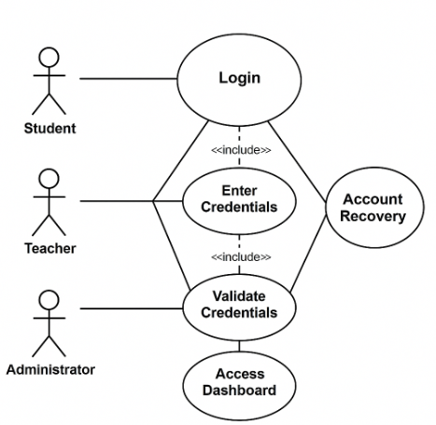
Figure 24– School System Login

Sequence Diagram
The Sequence Diagram illustrates the step-by-step interaction between a user and the system during the login process. Figure 2 shows how the user inputs credentials, how the system validates them, and what happens based on the result.

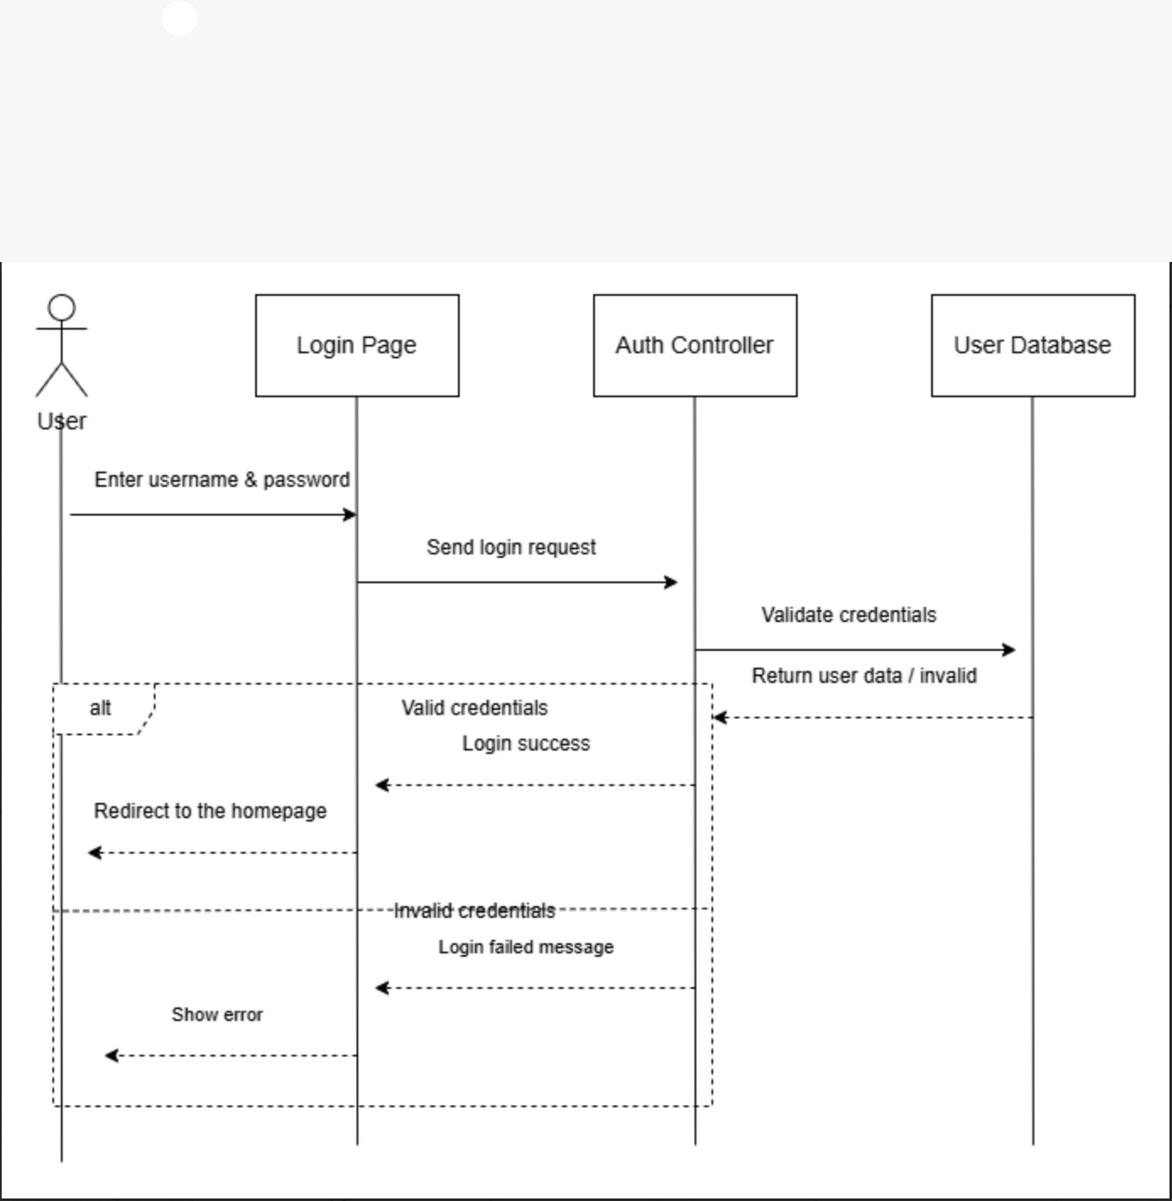

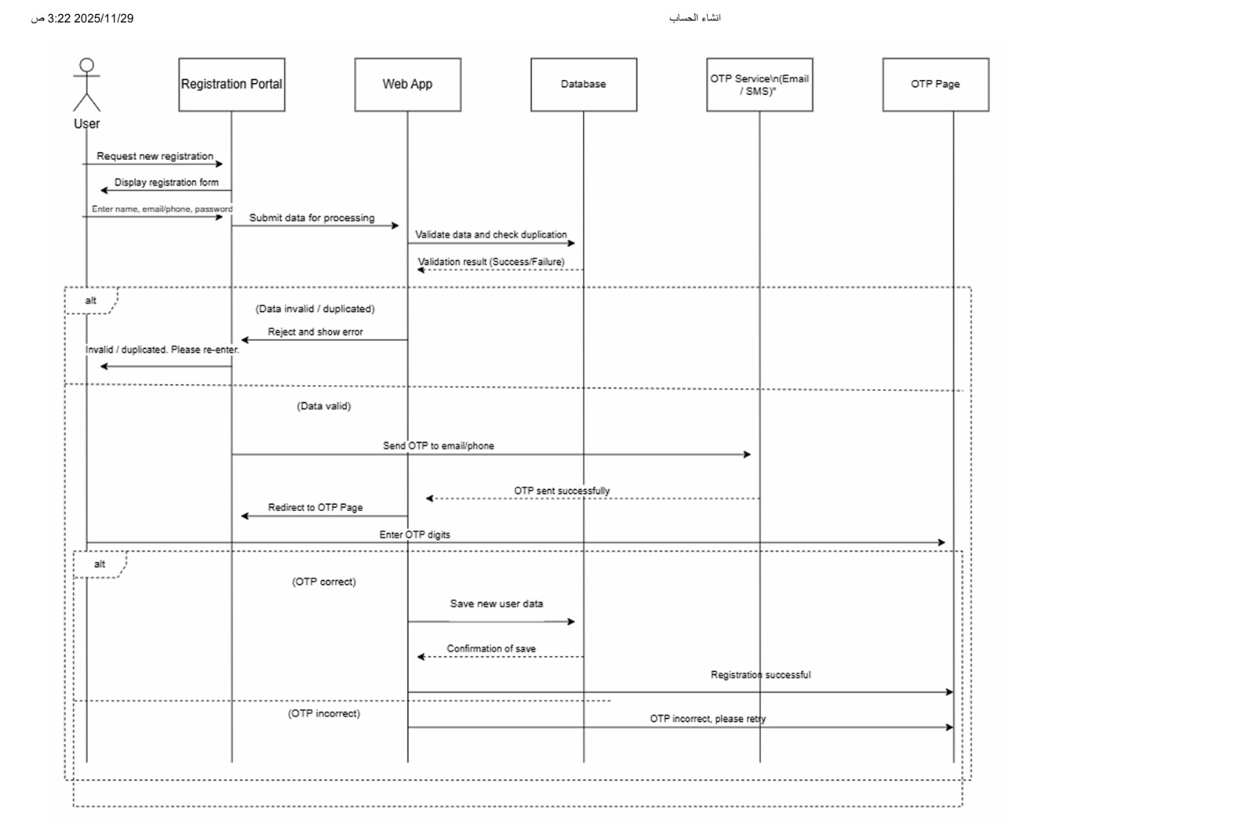

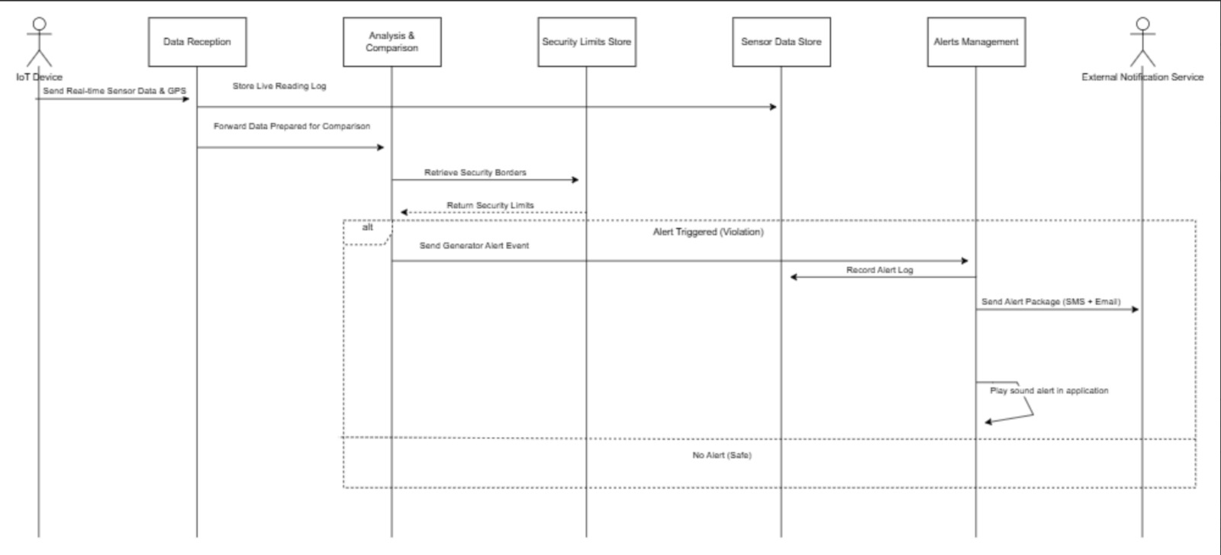

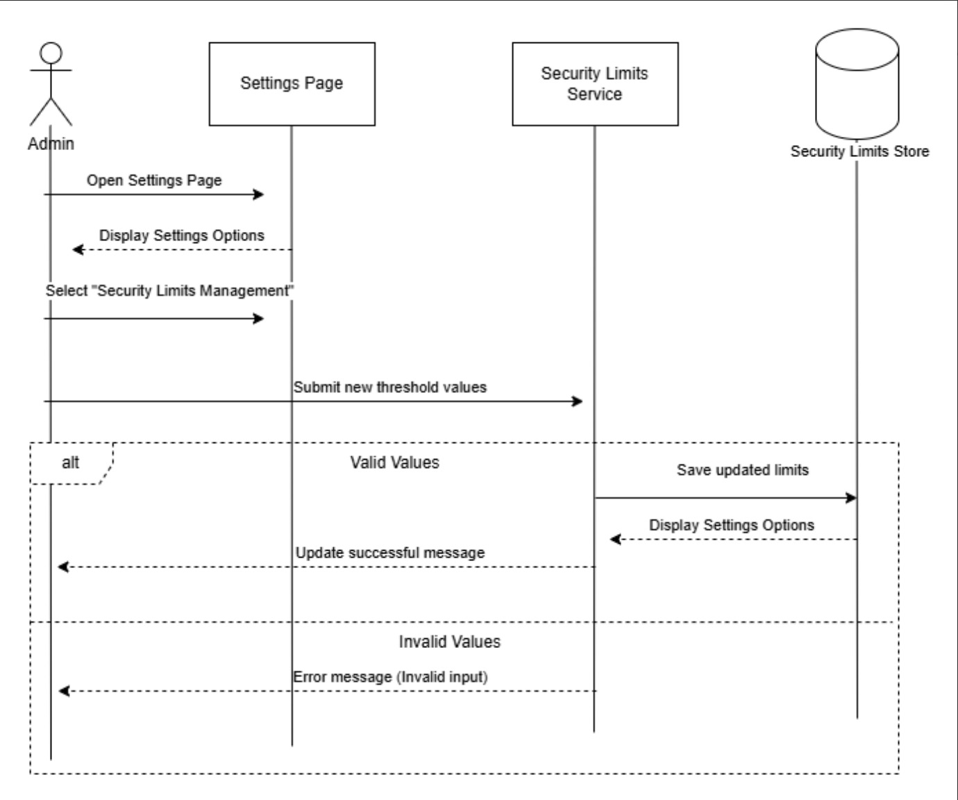

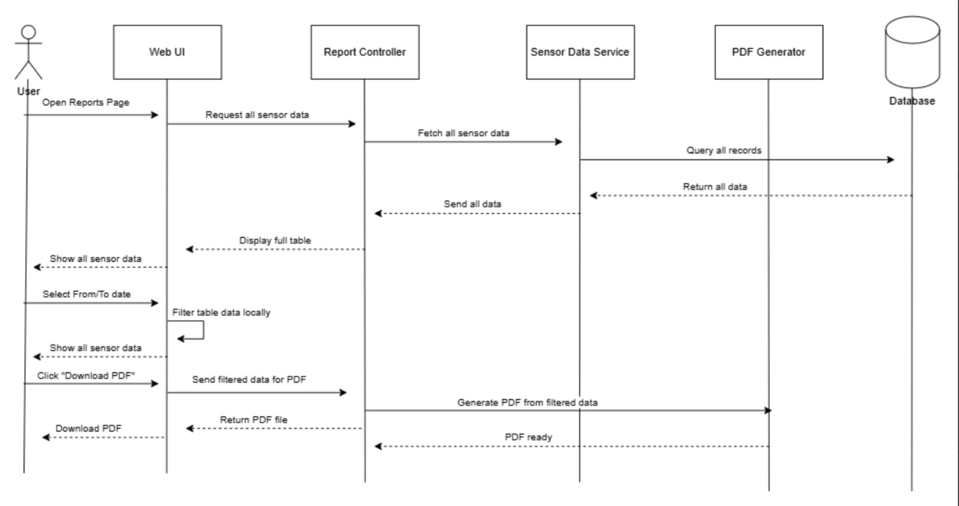

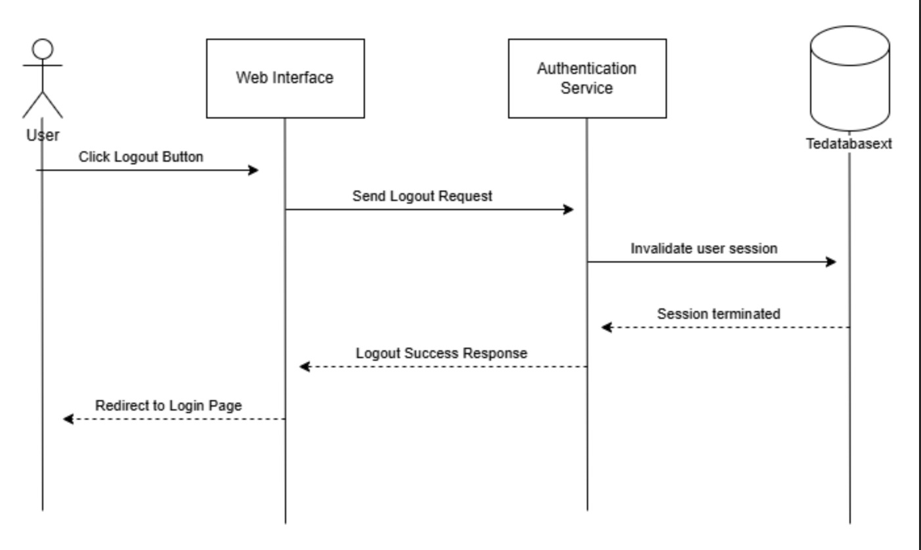

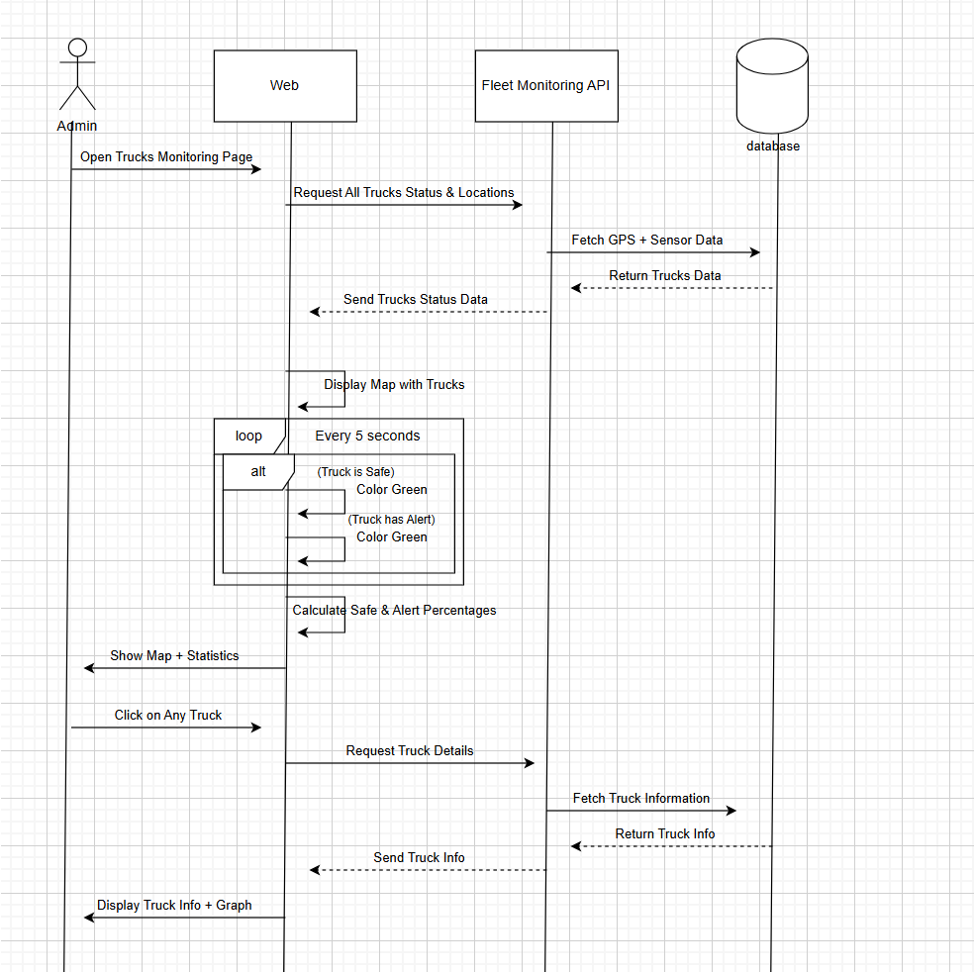

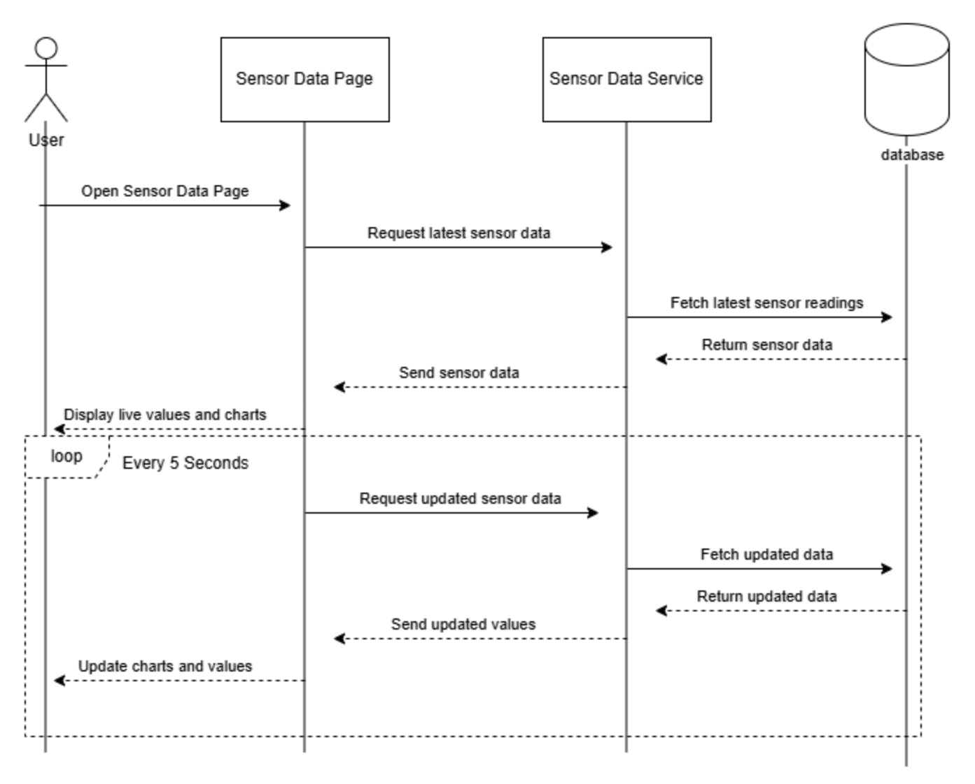

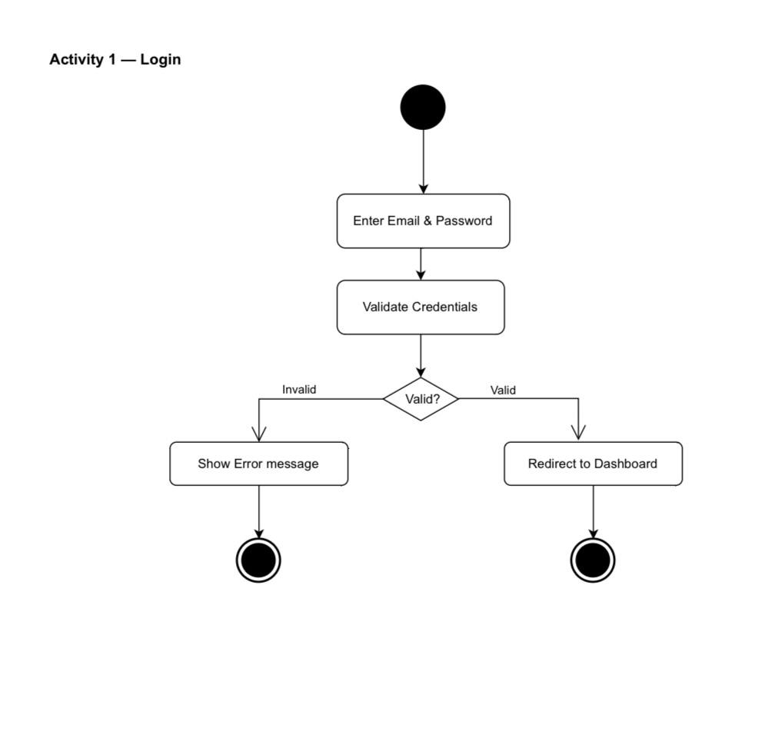
Activity Diagram
Figure 26 Activity diagram - User Login

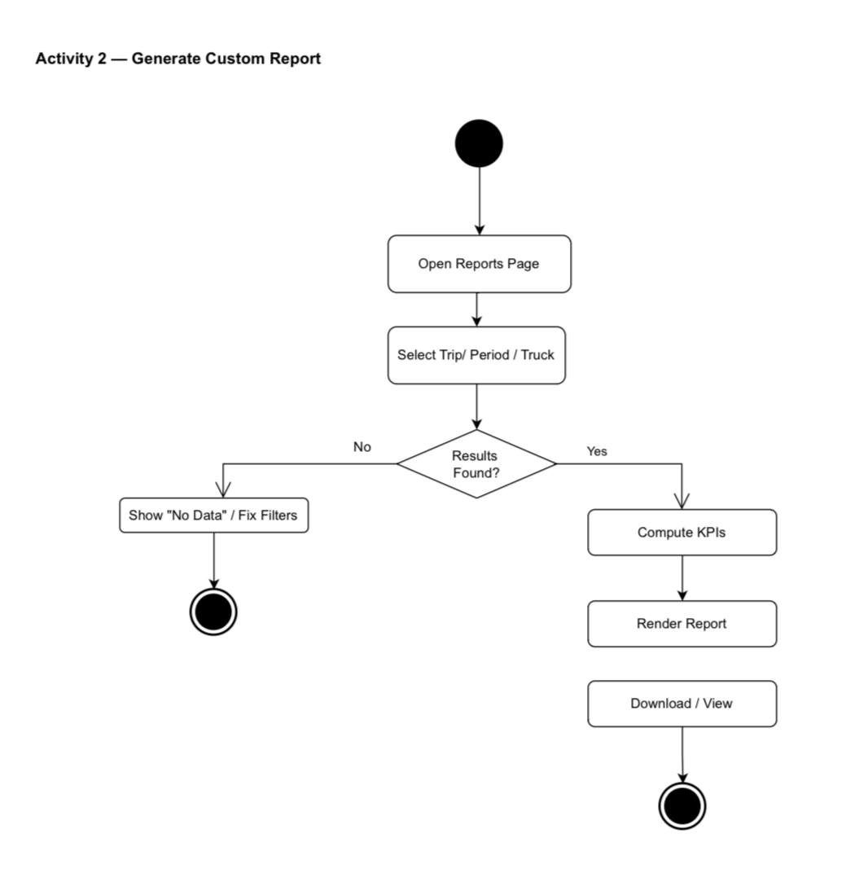
Figure 27 Activity diagram - Generate Custom Report

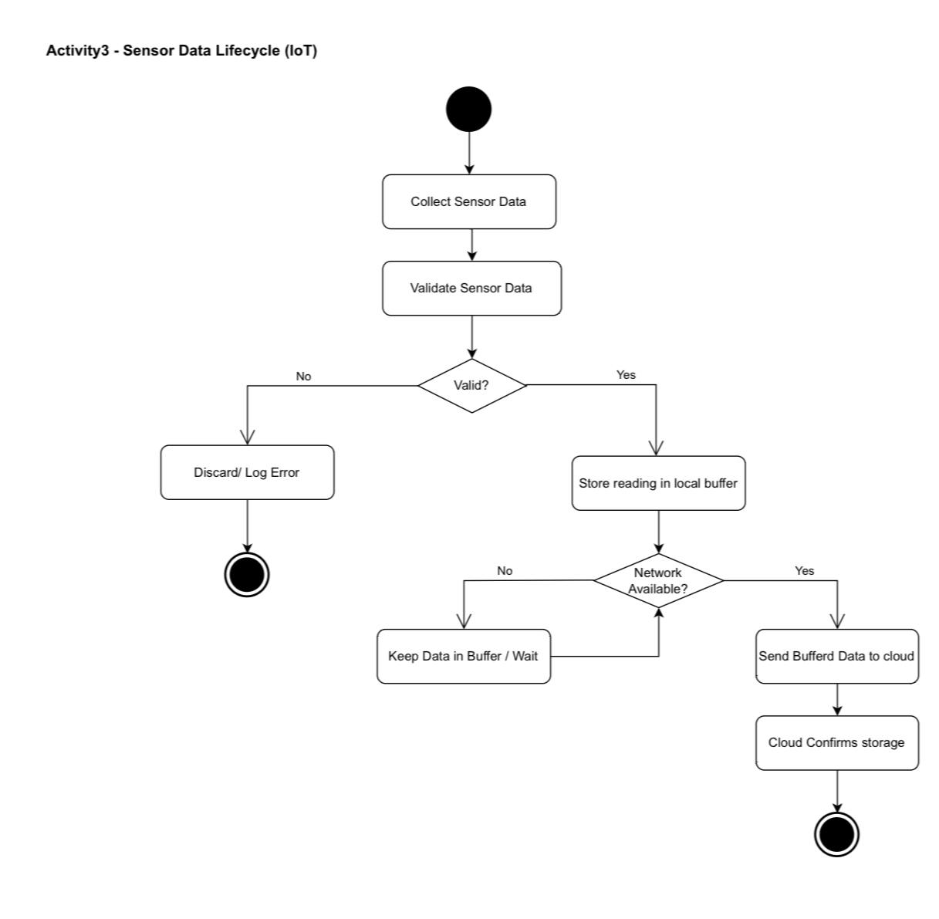
Figure 28 Activity diagram - Sensor Data Lifecycle (Iot)

Class Diagram
- Class diagram - User and Permissions Management System

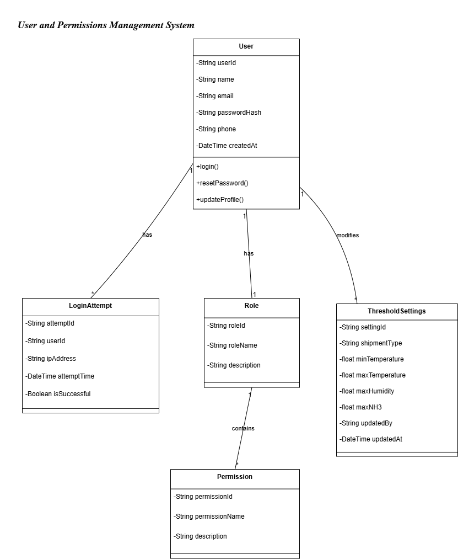
Figure 29 Class diagram - User and Permissions Management System

- class diagram- Monitoring System and Basic Data

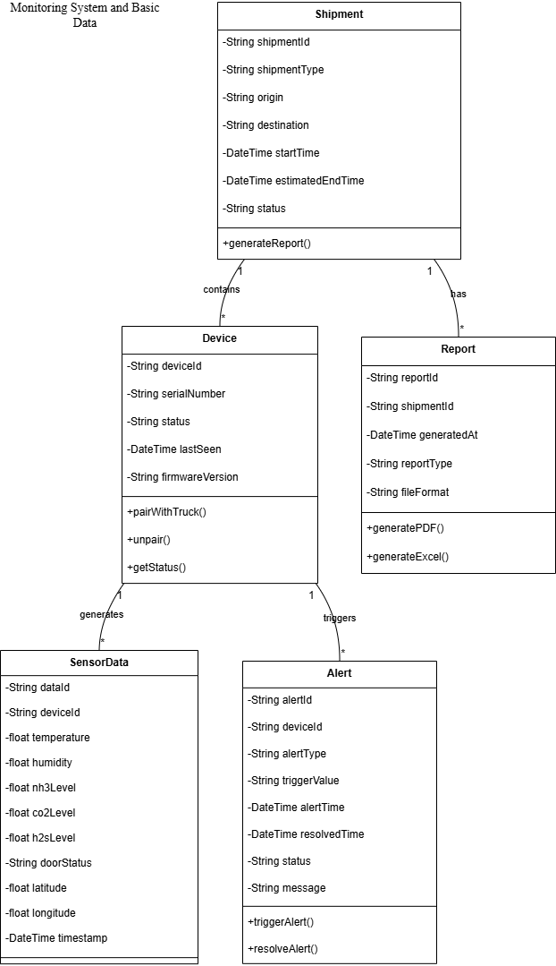
Figure 30 Class diagram - Monitoring System and Basic Data

Summary

DESIGN CONSIDERATIONS

Introduction
Design considerations include various elements such as functionality, usability, scalability, performance, maintainability, security, compatibility, and cost. we will create high-quality software that meets the needs of the users, while also meeting the requirements and specifications of the project.

Architectural Strategy
A well-defined architectural strategy is a foundational element of any software system. It encompasses the core components and services that collectively deliver the system’s functionality, performance, and user experience.In a typical application, when a user performs an action (e.g., submitting data), the system processes the input, stores it securely, and provides real-time feedback or updates based on predefined logic and rules. The architecture is commonly structured into three main layers which promotes scalability and maintainability.

Presentation Layer (User Interface Layer):
This is the front-facing part of the system where users interact with the application. It provides an intuitive and responsive interface for performing tasks such as data entry, navigation, and viewing reports or analytics.

Business Logic Layer (Processing and Notifications):
This layer handles the core logic of the application. It processes user inputs, enforces business rules, performs calculations, and triggers system responses such as alerts, validations, or automated actions. It ensures that the application behaves as expected under various conditions.

Data Layer (Storage and Synchronization):
This layer is responsible for storing and managing application data. It ensures data consistency, security, and availability across devices and sessions. It may involve cloud databases, local storage, or hybrid solutions, and supports real-time synchronization when needed.

Development Requirements

Hardware Requirements
Explain the hardware that you will use to develop the project
  - Computer/laptop for development (PC, Acer Laptop).
  - Stable internet connectivity.
  - Development server for testing.
  - Standard peripherals like keyboard, mouse, and monitor.
  - Backup solutions for data protection.

Software Requirements
To develop the system, the following software components are needed:
- Operating System: Windows 11
- A Server: A web server such as Apache or Nginx is required to manage the application content (XAMPP).
- Back-end development programing languages and frameworks: required for the system development- Backend.
- Lang1
- Lang2
- Lang3
- Frontend programing languages and frameworks: Required for the system development- Frontend
- Lang1
- Lang2
- Lang3

Graphic User Interface Design and wireframe
Show the UI interface design of the product. Also explain the wireframe is how the app or the site move from one page to another.
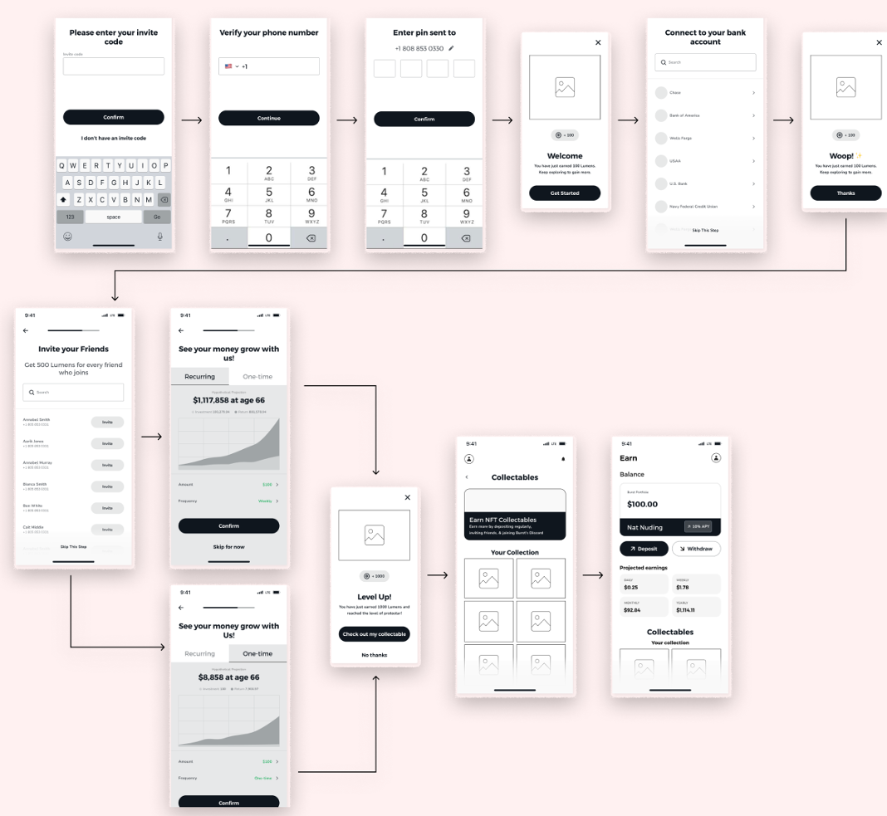

Figure 31 Example of product wireframe and UI

Summary
Summry of the chapter

CONCLUISON

Introdction

This chapter provides a comprehensive overview of our project, highlighting the challenges we encountered, the timeline of our work, and insights into future development. It concludes with a summary of the entire report.

Challenges and learning experiences
Expalin the challenges that your team faced during the project, and what have learnd form this project

Timeline
Illustrate the project time line

Furture work
Here your explain what will your team do In project 2

Conclusion
Provide a full summary of this project report

Reference:
[1] Eleonora Mercier, Stefanie Villeneuve, Mary Mondor, Ilker Uysal, Impact of Food Waste on Society, Specifically at Retail and Foodservice Levels, Foods, 2024.
[2] Food and Agriculture Organization of the United Nations (FAO). Food Loss and Waste Platform. Available at: https://www.fao.org/platform-food-loss-waste/en/
[3] Aung, M. M., & Chang, Y. S. (2014). Temperature management for the quality assurance of a perishable food supply chain. Food Control, 40, 198–207. https://doi.org/10.1016/j.foodcont.2013.11.016
[4] Liu, L., Chen, H., & Yang, H. (2019). Real-time monitoring system for cold chain logistics of perishable food based on wireless sensor networks. Journal of Food Protection, 82(4), 604–611. https://doi.org/10.4315/0362-028X.JFP-18-123
[5] World Bank. Food Loss and Waste. Available at: https://www.worldbank.org/en/topic/food-loss-and-waste
[6] World Health Organization (WHO). Food Safety Fact Sheet. Available at: https://www.who.int/news-room/fact-sheets/detail/food-safety
[7] United Nations. The Sustainable Development Goals Report 2019. Available at: https://unstats.un.org/sdgs/report/2019/
[8] Sensitech. (n.d.). TempTale GEO Ultra: Real-time temperature and location monitoring [PDF].
[9] Sensitech. (n.d.). Real-time temperature monitors. Retrieved from https://www.sensitech.com
[10] Maquimsa. (n.d.). DicksonOne data logger: Temperature, humidity, and differential pressure monitoring [PDF].
[11] Sonicu. (n.d.). Temperature monitoring systems. Retrieved from https://www.sonicu.com/temperature-monitoring
[12] Cooltrax. (n.d.). Cold chain monitoring solutions. Retrieved from https://cooltrax.com/
[13] Dickson. (n.d.). DicksonOne: Environmental monitoring solution. Retrieved from https://www.dicksonone.com/

