Assignment 2 - Case Study
Completed Stage 3 Lab Activities | SmartCare Domain Modelling

A - Requirements Review
Nouns / concepts identified: Patient, Practitioner, Appointment, patient name, practitioner name, appointment time, schedule and status.
Verbs / behaviours identified: store, search, book, display, manage, view schedule and cancel.
Business rules used: each Appointment is linked to one Patient and one Practitioner; a Patient can have multiple appointments; a Practitioner can have multiple appointments; appointment management, patient search and practitioner scheduling remain in scope. Unsupported ideas such as AI diagnosis, facial recognition, payments, insurance processing and automatic treatment generation remain out of scope.

B - Candidate Classes
Selected candidate classes: Patient, Practitioner and Appointment.
Patient - state: patient_id, name. Behaviour: update details / support search / retrieve appointments.
Practitioner - state: practitioner_id, name. Behaviour: view schedule / retrieve appointments.
Appointment - state: appointment_id, appointment_time, status. Behaviour: book, cancel and display details.
Rejected as classes: Name and Status (attributes), Cancellation (Appointment behaviour/state), Database (implementation detail), and Clinic (not required as an owning class for the current scope).

C - CRC Cards
Patient
Responsibilities: maintain patient details; support patient search; participate in appointments.
Collaborator: Appointment.
Practitioner
Responsibilities: maintain practitioner details; view schedule; participate in appointments.
Collaborator: Appointment.
Appointment
Responsibilities: store appointment time/status; connect a patient and practitioner; support booking/cancellation.
Collaborators: Patient, Practitioner.

D - UML Model
The UML model below uses three core classes and association multiplicities. No inheritance is used.
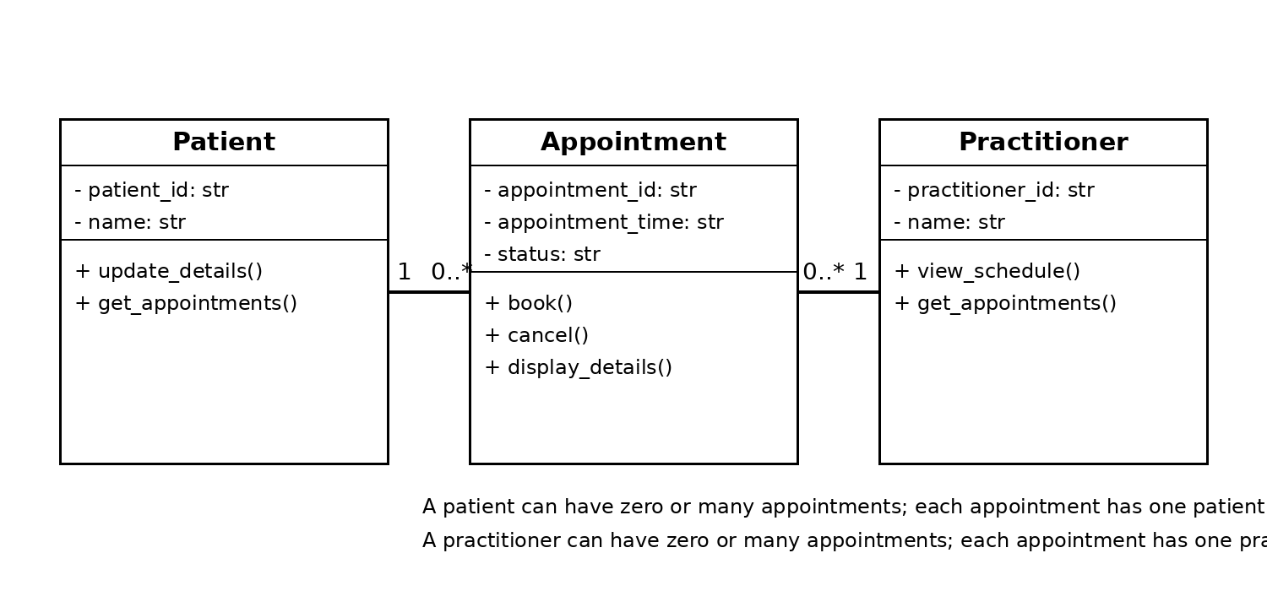

E - AI Design Review
AI suggestions were reviewed only against the confirmed SmartCare scope. The review focused on whether each proposed class represented a real domain concept or unnecessary software architecture.
Suggestion | Evidence | Decision
Patient / Practitioner / Appointment | Directly supported by confirmed SmartCare scope | Accept
AppointmentManager | Appointment management is required, but Manager is not a domain concept | Modify
ClinicController | No confirmed domain requirement for a controller | Reject
ScheduleEngine | Scheduling is relevant, but a separate engine is not yet justified | Modify
NotificationManager | No confirmed notification requirement | Reject

F - Compare and Decide
Accepted: Patient, Practitioner and Appointment as the core domain classes.
Modified: AppointmentManager -> Appointment with booking/cancellation responsibilities; ScheduleEngine -> schedule behaviour represented through Practitioner and Appointment.
Rejected: ClinicController and NotificationManager because they are not supported by the confirmed requirements and would over-design the model.

G - Python Skeletons
class Patient:
def __init__(self, patient_id, name):
self.patient_id = patient_id
self.name = name
def update_details(self):
pass
def get_appointments(self):
pass
class Practitioner:
def __init__(self, practitioner_id, name):
self.practitioner_id = practitioner_id
self.name = name
def view_schedule(self):
pass
def get_appointments(self):
pass
class Appointment:
def __init__(self, appointment_id, patient, practitioner, appointment_time, status="Booked"):
self.appointment_id = appointment_id
self.patient = patient
self.practitioner = practitioner
self.appointment_time = appointment_time
self.status = status
def book(self):
pass
def cancel(self):
pass
def display_details(self):
pass

H - Consistency Check
Model element | Python skeleton | Consistent?
Patient class | Patient | Yes
Practitioner class | Practitioner | Yes
Appointment class | Appointment | Yes
Patient identity/name | patient_id, name | Yes
Practitioner identity/name | practitioner_id, name | Yes
Appointment time/status | appointment_time, status | Yes
Patient-Appointment relationship | patient reference in Appointment | Yes
Practitioner-Appointment relationship | practitioner reference in Appointment | Yes

Full behaviour is intentionally not implemented yet, matching the Stage 3 instruction to create skeletons and check model-code consistency.

Reflection
The hardest modelling decision was deciding which ideas should become classes and which should remain attributes or behaviours. For example, Cancellation could have been modelled as its own class, but the confirmed requirements support treating it as behaviour and status within Appointment. AI tended to over-design the solution by suggesting manager, controller and engine classes such as AppointmentManager, ClinicController and ScheduleEngine. These ideas may be useful in a later software design stage, but they are not necessary for the current domain model. The final choices were supported by the existing SmartCare prototype and confirmed scope: patient information, practitioner scheduling and appointment management. This kept the model simple, traceable to requirements and consistent with the Python skeletons.

