SmartCare v0.3
Completed Domain Model Workbook | Week 6
Note: the exact Stage 2 requirement IDs were not present in the supplied Stage 3 files. To avoid inventing official IDs, the labels R1-R5 below are working trace labels for the confirmed requirements used in this workbook.

Requirement-to-Concept Trace
Requirement | Concept | State / behaviour | Decision
R1 - Store patient details | Patient | patient_id, name; update_details() | Keep as class
R2 - Search patient information | Patient | name / patient_id; search supported by patient data | Keep as class
R3 - Store practitioner details | Practitioner | practitioner_id, name | Keep as class
R4 - Manage practitioner schedule | Practitioner + Appointment | view_schedule(); appointment_time | Keep across related classes
R5 - Manage appointments | Appointment | appointment_id, appointment_time, status; book(), cancel() | Keep as class
R5 - Link patient to appointment | Patient + Appointment | association | 1 Patient to 0..* Appointments
R5 - Link practitioner to appointment | Practitioner + Appointment | association | 1 Practitioner to 0..* Appointments
R5 - Cancellation | Appointment | cancel(); status | Behaviour/state, not separate class
R1/R3 - Name | Patient / Practitioner | name attribute | Attribute, not class
Storage implementation | Database | Persistence mechanism | Exclude from domain model

CRC Cards

Patient
Responsibilities | Collaborators
Maintain patient identity/details; support patient search; participate in appointments | Appointment

Practitioner
Responsibilities | Collaborators
Maintain practitioner identity/details; view schedule; participate in appointments | Appointment

Appointment
Responsibilities | Collaborators
Store time/status; link patient and practitioner; support booking/cancellation | Patient, Practitioner

Optional class - Clinic
Responsibilities | Collaborators
Provide organisational context only if later requirements require clinic-level ownership or data | Patient, Practitioner, Appointment

UML Class Diagram
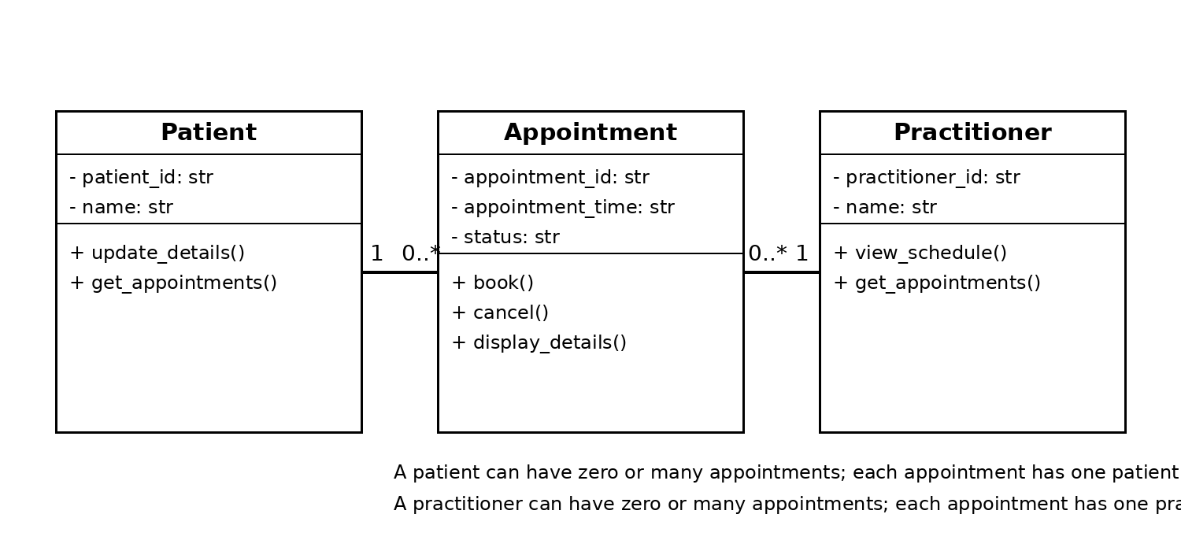

Design Rationale
Patient, Practitioner and Appointment were selected because they are the clearest real-world concepts supported by the confirmed SmartCare scope. Appointment is the central linking class because the existing prototype already records patient name, practitioner name and appointment time. Patient and Practitioner each have a one-to-many association with Appointment: one patient or practitioner may be involved in many appointments, while each appointment refers to one patient and one practitioner. Name and Status are modelled as attributes, while Cancellation is modelled as Appointment behaviour/state. Database and controller/manager concepts are excluded because they are implementation/design mechanisms rather than domain concepts. No inheritance is used because Appointment is not a specialised form of Patient or Practitioner.

AI Design Review Record
AI suggestion | Evidence | Decision | Reason | Model change
Use Patient, Practitioner and Appointment classes | Confirmed appointment management, patient search and practitioner scheduling scope | Accepted | Directly supported by the domain requirements | Retained all three core classes
Create AppointmentManager | Appointment management is required | Modified | The responsibility is valid, but a Manager class is not necessary in the domain model | Kept Appointment with book/cancel responsibilities
Create ClinicController | No confirmed controller requirement | Rejected | Controller is a software architecture concern and over-designs the domain model | No controller class added
Create ScheduleEngine | Practitioner scheduling is in scope | Modified | A separate engine is not justified yet | Schedule behaviour represented through Practitioner and Appointment
Create NotificationManager | No confirmed notification requirement in supplied Stage 3/recent scope | Rejected | Would add unsupported functionality | No notification class added

