Theory :

Weka

Waikato Environment for Knowledge Analysis (Weka) is a suite of machine learning software written in Java, developed at the University of Waikato, New Zealand. It is free software licensed under the GNU General Public License.

Weka contains a collection of visualization tools and algorithms for data analysis and predictive modeling, together with graphical user interfaces for easy access to these functions.The original non-Java version of Weka was a Tcl/Tk front-end to (mostly third-party) modeling algorithms implemented in other programming languages, plus data preprocessing utilities in C, and a Makefile-based system for running machine learning experiments. This original version was primarily designed as a tool for analyzing data from agricultural domains,but the more recent fully Java-based version (Weka 3), for which development started in 1997, is now used in many different application areas, in particular for educational purposes and research. Advantages of Weka include:
- Free availability under the GNU General Public License.
- Portability, since it is fully implemented in the Java programming language and thus runs on almost any modern computing platform.
- A comprehensive collection of data preprocessing and modeling techniques.
- Ease of use due to its graphical user interfaces.
Cross Validation
Cross-validation, sometimes called rotation estimation, or out-of-sample testing is any of various similar model validation techniques for assessing how the results of a statistical analysis will generalize to an independent data set. It is mainly used in settings where the goal is prediction, and one wants to estimate how accurately a predictive model will perform in practice. In a prediction problem, a model is usually given a dataset of known data on which training is run (training dataset), and a dataset of unknown data (or first seen data) against which the model is tested (called the validation dataset or testing set).The goal of cross-validation is to test the model’s ability to predict new data that was not used in estimating it, in order to flag problems like overfitting or selection bias and to give an insight on how the model will generalize to an independent dataset (i.e., an unknown dataset, for instance from a real problem).
One round of cross-validation involves partitioning a sample of data into complementary subsets, performing the analysis on one subset (called the training set), and validating the analysis on the other subset (called the validation set or testing set). To reduce variability, in most methods multiple rounds of cross-validation are performed using different partitions, and the validation results are combined (e.g. averaged) over the rounds to give an estimate of the model’s predictive performance.
In summary, cross-validation combines (averages) measures of fitness in prediction to derive a more accurate estimate of model prediction performance.
Confusion Matrix
A confusion matrix is a table that is often used to describe the performance of a
classification model (or “classifier”) on a set of test data for which the true values are
known. It allows the visualization of the performance of an algorithm. It allows easy
identification of confusion between classes e.g. one class is commonly mislabelled as
the other. Most performance measures are computed from the confusion matrix.
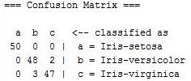

For example, from the above table we can say that the actual class was a i.e Iris-setosa
and predicted class a count was 50, b is 0 and c is 0.similaryly the actual class was c i.e
Iris-virginica and predicted class a count was 0 b is 3 and c is 47 (using CV 2 fold)

True Positive (Recall)
Sensitivity (also called the true positive rate, the recall, or probability of detection in some fields) measures the proportion of actual positives that are correctly identified as such (e.g., the percentage of sick people who are correctly identified as having the condition).

True Negative ()
Specificity (also called the true negative rate) measures the proportion of actual negatives that are correctly identified as such (e.g., the percentage of healthy people who are correctly identified as not having the condition).

Sensitivity, Specificity, significance
True positive rate (sensitivity) - measures the proportion of actual positives that are
correctly identified as such
True negative rate (Specificity) - measures the proportion of actual negatives that are correctly identified as such
False positive rate (significance) - proportion of all negatives that still yield positive
test outcomes, i.e., the conditional probability of a positive test result given an event
that was not present.
Precision and Recall
Precision tries to answer such type of queries:
What proportion of positive identifications was actually correct?
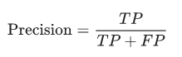

Recall tries to answer such type of queries:
What proportion of actual positives was identified correctly?

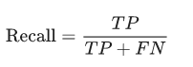

Output :
- Visualization

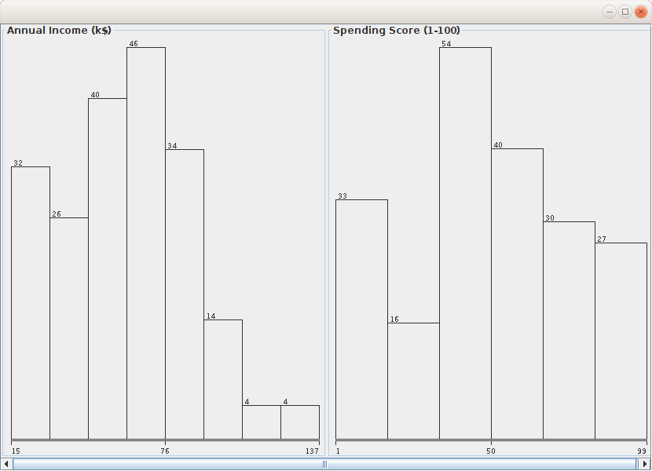
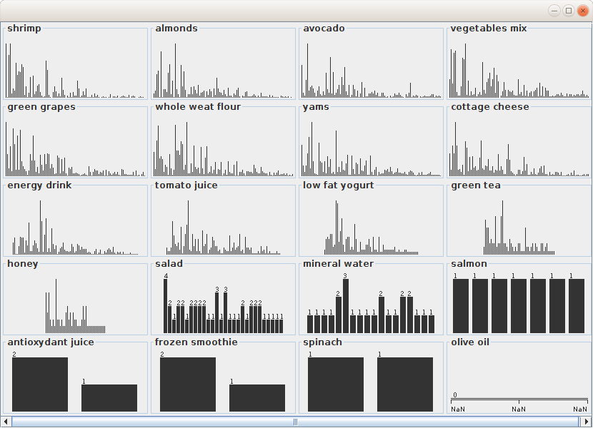
- K-Means Clustering

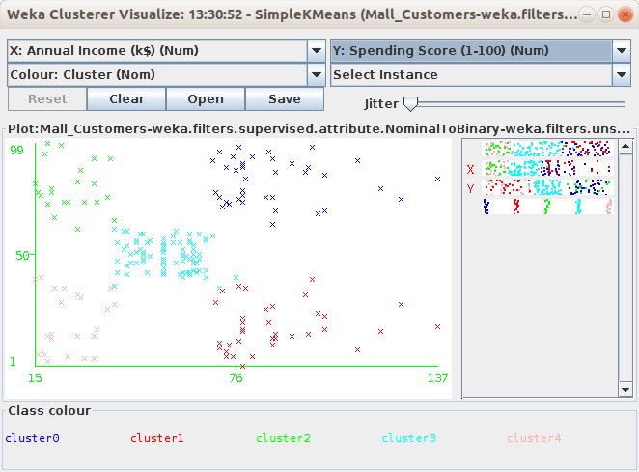
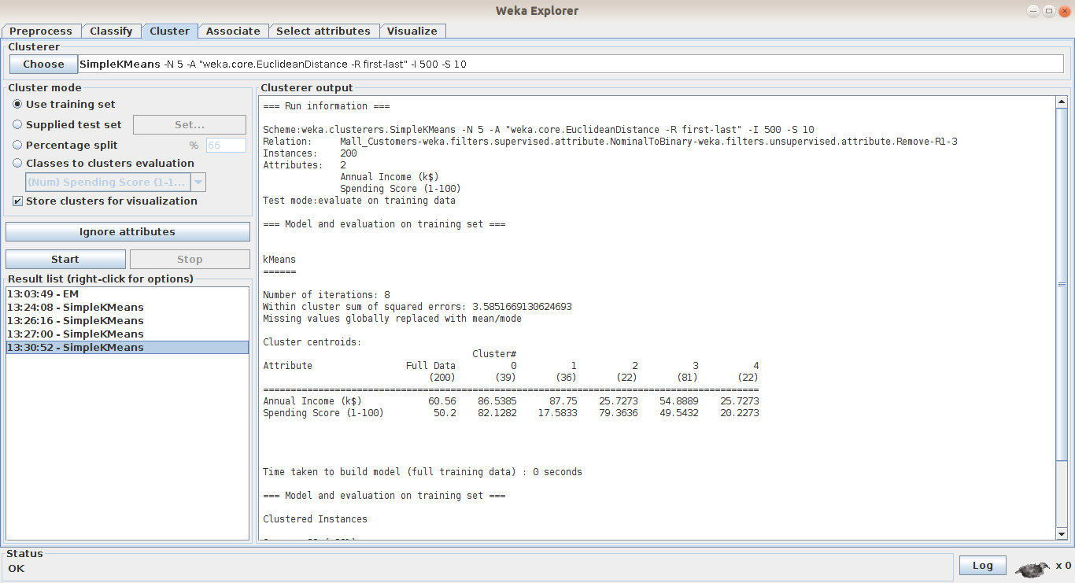
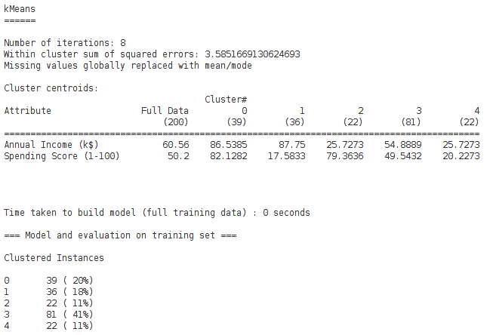
- Linear Regression

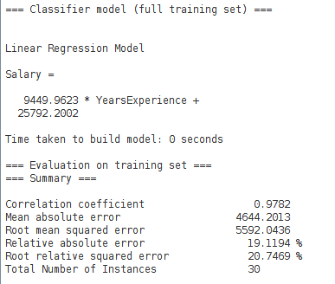

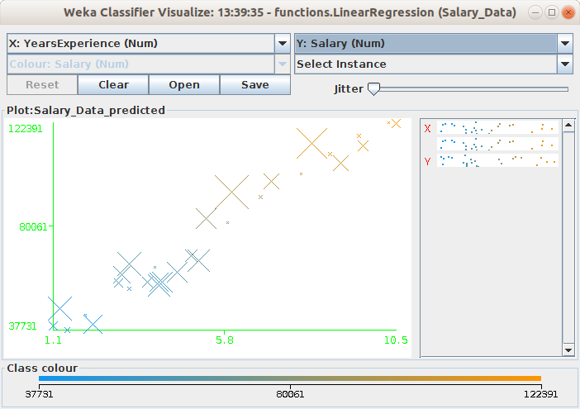
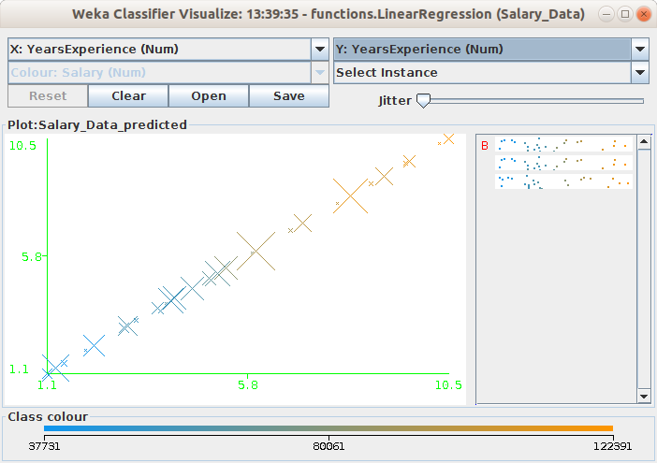
- Apriori

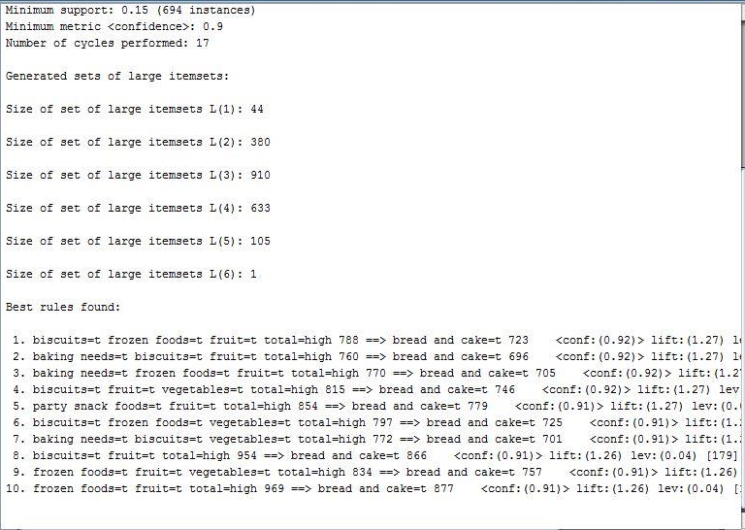

Conclusion
From this experiment we learned some very essential concept related to any data mining process. For data pre-processing we used an open source weka tool which provides every result and ample of GUI based so the work task for data analysis becomes easier. Lastly, we implemented classification, clustering, and association using this tool and visualised it
appropriately.

