**Analyze MBTA API data**

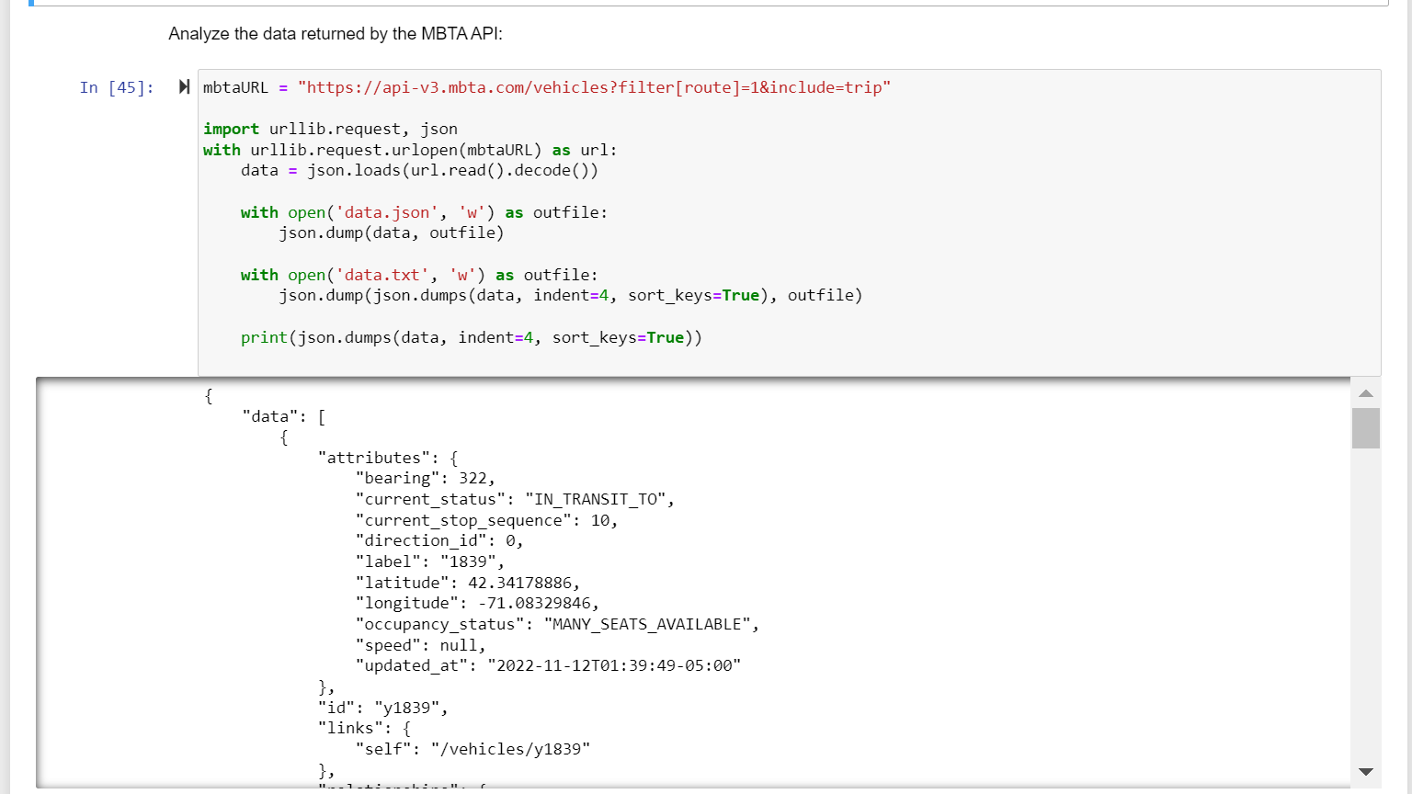

**Docker deployment for creating mysql server:**

1.Created ‘MBTANetwork’ network.

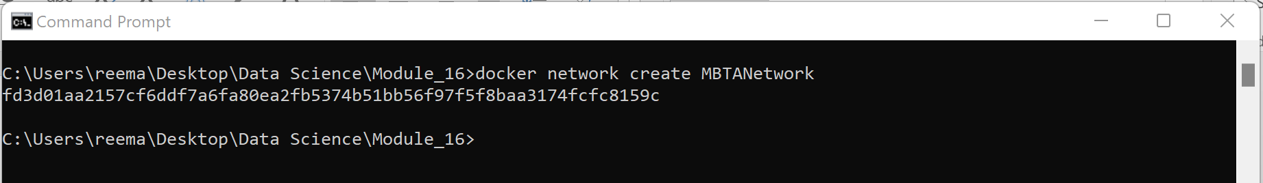

2. MySQLDOCKER folder has 2 files:

a)Below is the image of Dockerfile which has been used for creating docker image 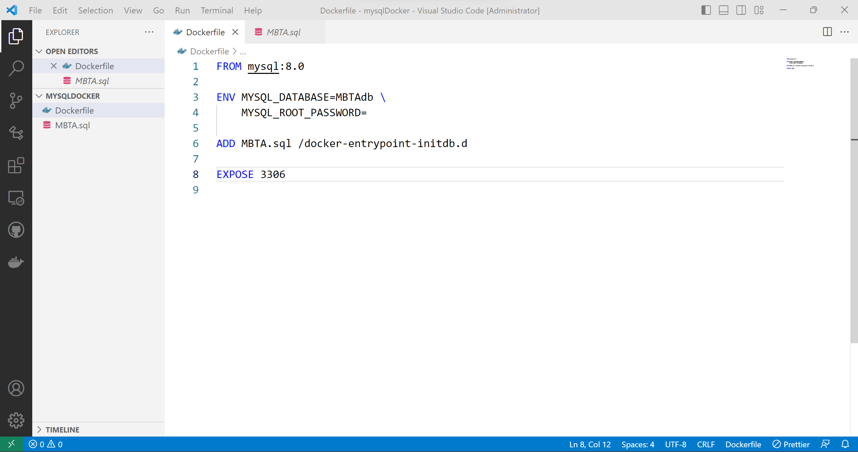

b) Below is the image of MBTA.sql for creating Database ‘MBTAdb’ & table ‘mbta_buses’

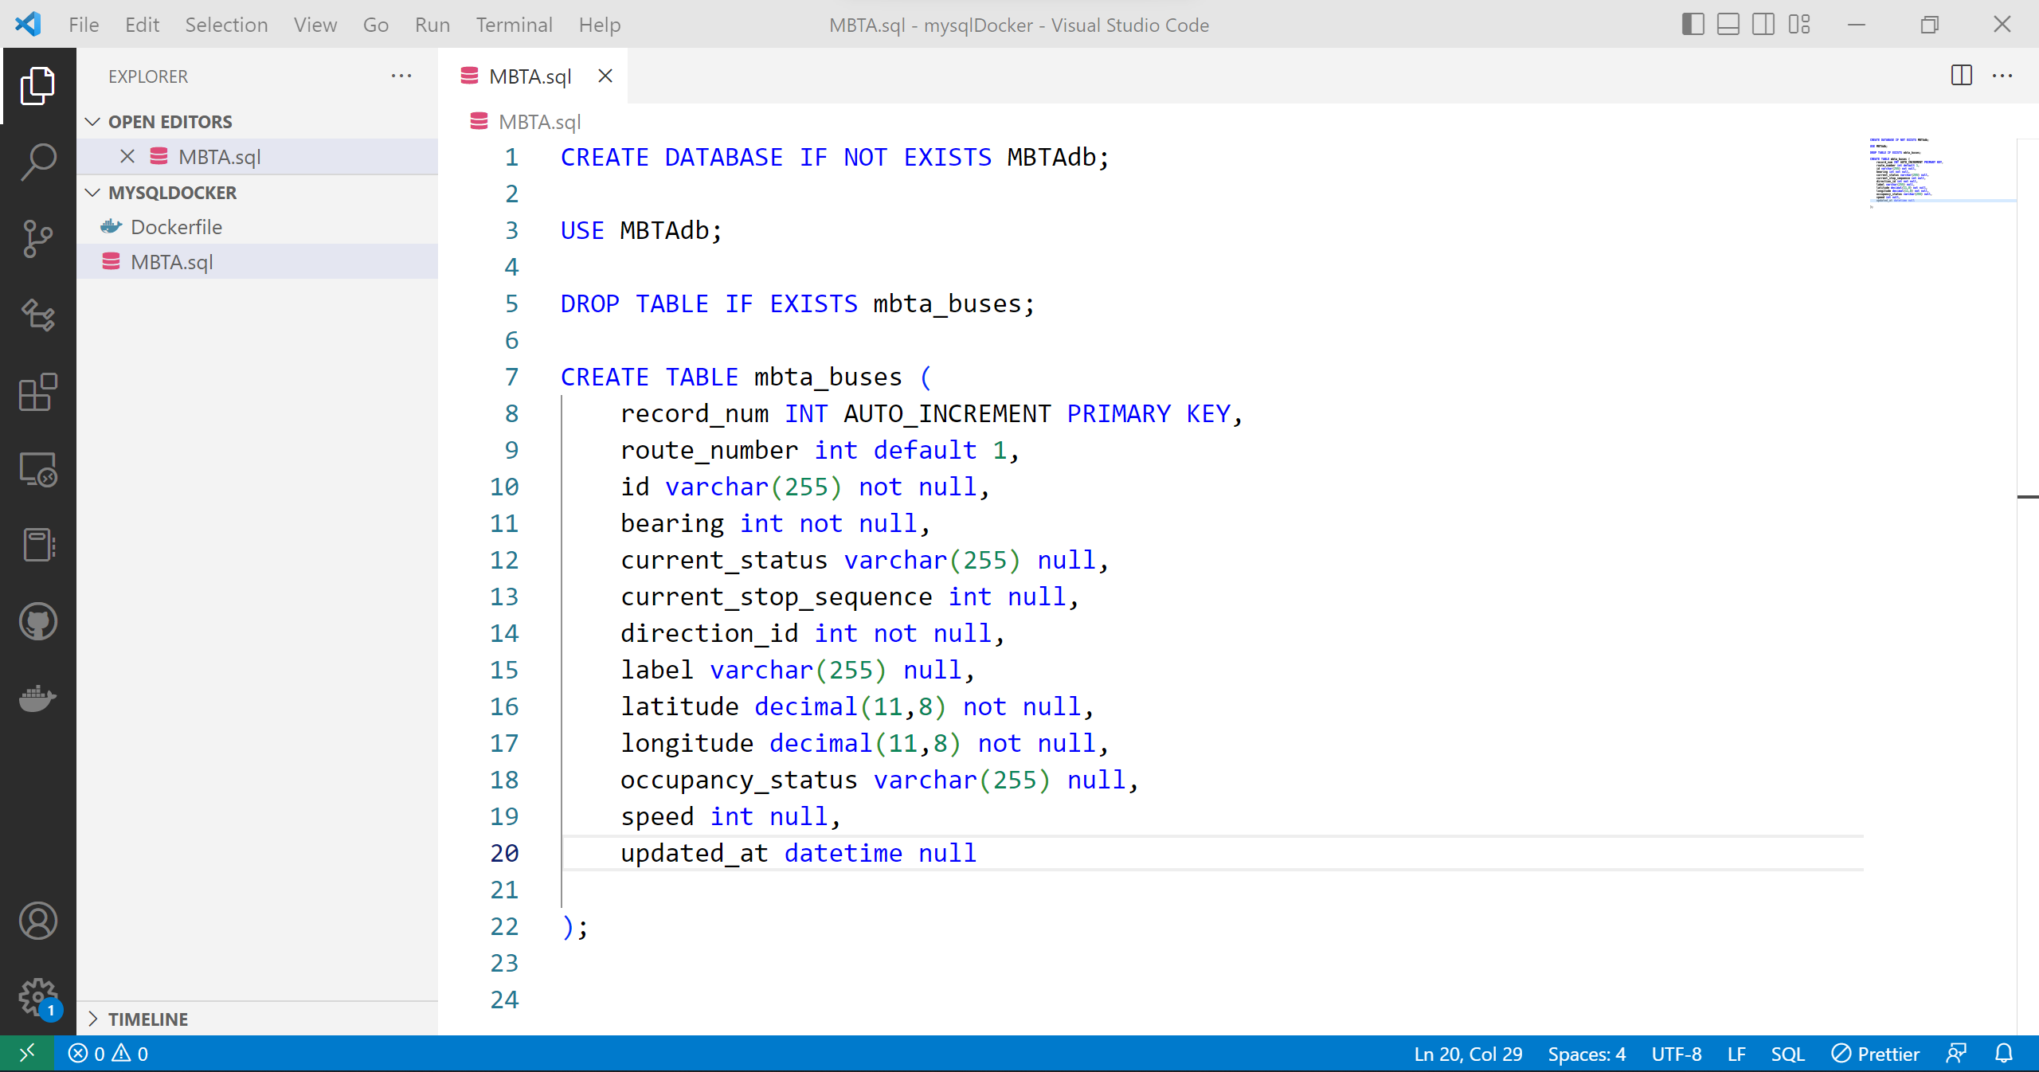

3. Build ‘mysqlmbtamasterimg’ Docker *image* from dockerfile under folder ‘mysqlDocker’

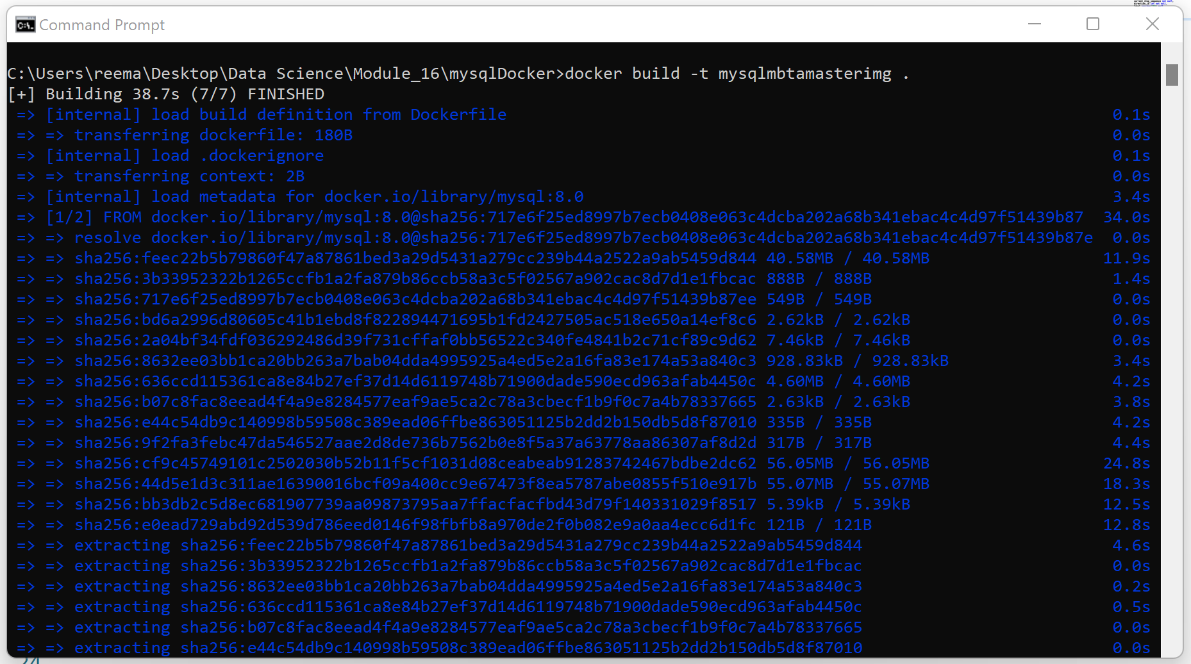

4. Successfully creation of ‘mysqlserver’ Docker *container*

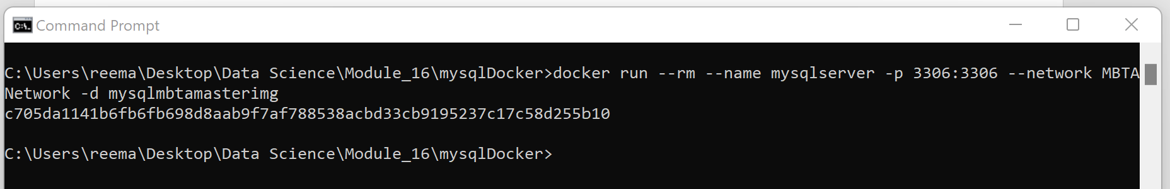



5. a) Defining function to insert data into table ‘mbta_buses’

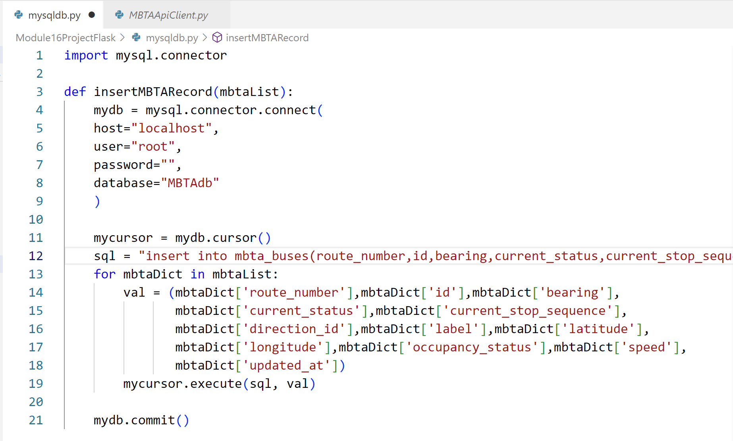

b) Reading data from MBTA API, calling function from mysqldb.py to insert values into table ‘mbta_buses’

