Non-Primitive Data Type or Reference Data Types 1
Single-Dimensional Arrays 1
Demonstrate Array 4
Strings 5
Demonstrate Strings 8

Non-Primitive Data Type or Reference Data Types
The Reference Data Types will contain a memory address of variable values because the reference types won’t store the variable value directly in memory. They are strings, objects, arrays, etc.
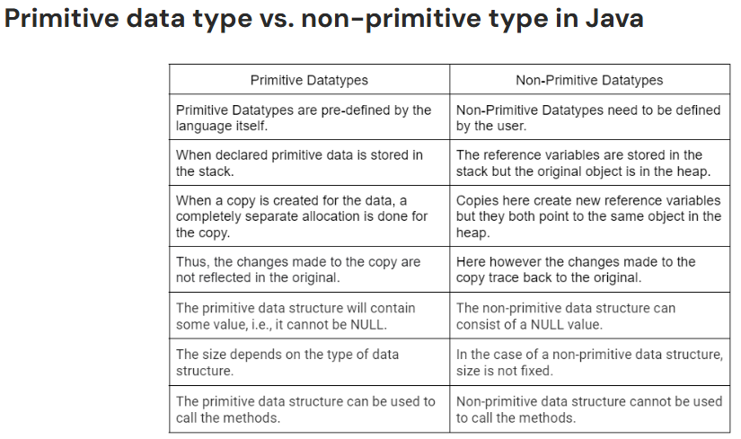

Single-Dimensional Arrays
Lesson link: https://www.w3schools.com/java/java_arrays.asp

- An array is an ordered, fixed-size container that allows you to store multiple values of the same data type inside a single variable name.
- Instead of creating ten separate variables to hold ten student test scores (score1, score2, etc.), you create one single array variable named scores that holds all ten values together in a neat list.
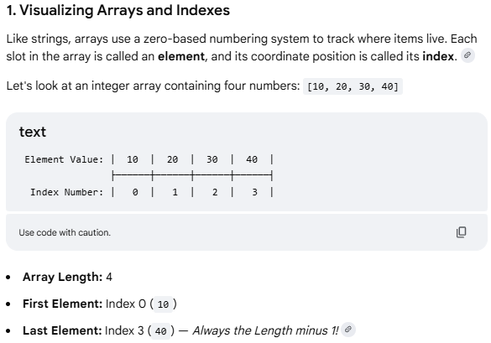

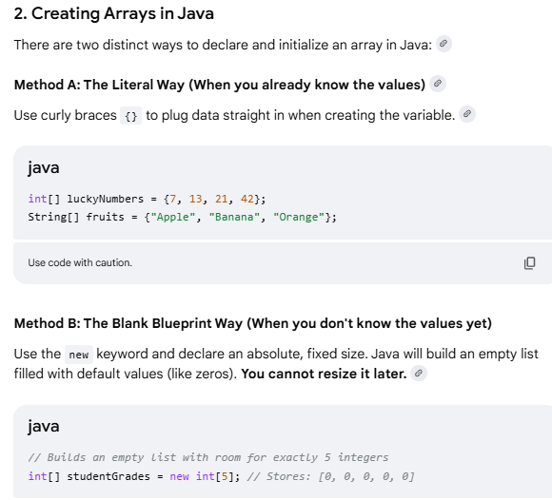
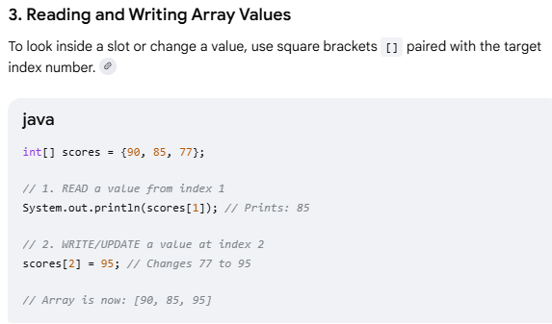
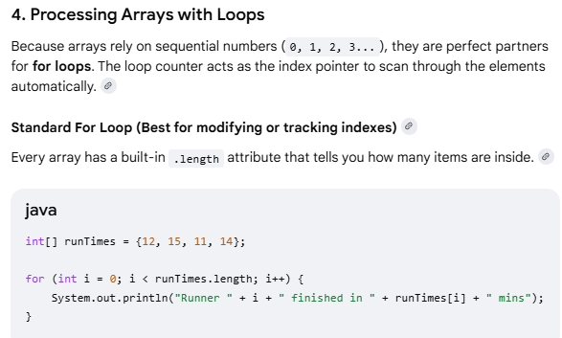
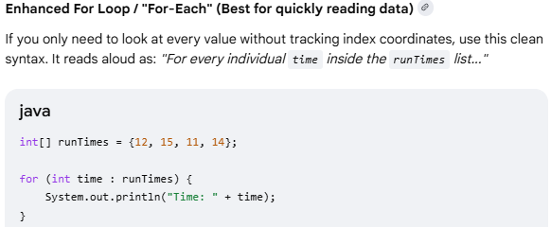

Demonstrate Array
Example demonstrating how to declare, initialize, and loop through an array in Java.

public class ArrayDemo {
public static void main(String[] args) {
// 1. Declare and initialize an array of Strings with a size of 4
String[] fruits = {"Apple", "Banana", "Cherry", "Mango"};

// 2. Access elements using an index (Note: Java arrays start at index 0)
System.out.println("First fruit: " + fruits[0]); // Outputs: Apple
System.out.println("Third fruit: " + fruits[2]); // Outputs: Cherry

// 3. Modify an existing element
fruits[1] = "Blueberry"; // Changes "Banana" to "Blueberry"

// 4. Get the size of the array
System.out.println("\nTotal items in array: " + fruits.length);

// 5. Loop through the array using an enhanced 'for-each' loop
System.out.println("--- Current Fruit List ---");
for (String fruit : fruits) {
System.out.println("- " + fruit);
}
}
}
Expected Output

First fruit: Apple
Third fruit: Cherry

Total items in array: 4
--- Current Fruit List ---
- Apple
- Blueberry
- Cherry

Strings
Lesson link
https://www.w3schools.com/java/java_strings.asp
- Strings are defined as an array of characters / sequence of characters that is held in single variable. Used to represent text (like names, passwords, or sentences).
- Character array (not String) is a collection of separate char-type entities accessed by indexing.
- Unlike C/C++, Java strings are not terminated with null characters.
- Syntax: Declaring a string
- <String_Type> <string_variable> = “<sequence_of_string>”;
- String s1 = "Hello"; // Stored in String Pool
- String s2 = "Hello"; // Reuses the same object from the String Pool
- String s3 = new String("Hello"); // Creates a new String object outside the Pool
- The Key Rule: Strings are Immutable
That is once String is created, it can never be changed in memory.
String manipulation methods that "modify" text, Java doesn't alter the original word. Instead, it quietly creates a brand-new String in the background and hands you fresh copy.
- Strings is object and provides built-in function (methods) to search, cut, clean, and modify text.
- Built-in String operation functions are, such as finding length, extracting substrings, replacing characters, and more.
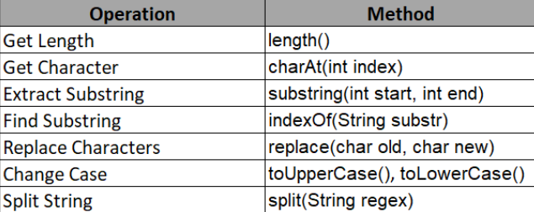

- Built-in String comparing functions
Golden Rule of Comparison, use equals() Instead of ==. The == operator compares references, not the actual content of the strings, whereas equals() compares the values.
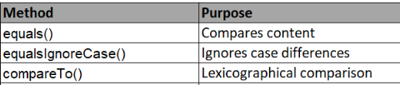

- Substring functions
Extracts a smaller piece of text out of a larger String. It takes a starting index and an optional ending index. Note: The ending index is exclusive (Java stops right before that number).

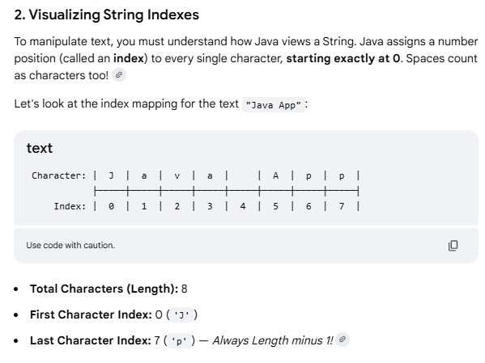
String phrase = "Superstar";

// Cut from index 5 all the way to the end String
endPiece = phrase.substring(5); // "star"

// Cut from index 0 up to (but not including) index 5
String frontPiece = phrase.substring(0, 5); // "Super"

- Advance methods
String.format() allows you to create formatted strings dynamically.
String formatted = String.format("Name: %s, Age: %d", "Alice", 30);
System.out.println(formatted); // "Name: Alice, Age: 30"

String joined = String.join("-", "2023", "12", "31"); // "2023-12-31"

String s = " Hello ";
System.out.println(s.strip()); // "Hello" Removes leading and trailing whitespace.
System.out.println(" ".isBlank()); // true
System.out.println("Hi".repeat(3)); // "HiHiHi"

Regular Expressions & Pattern Matching
String email = "user@example.com";
boolean isValid = email.matches("^[\\w.-]+@[\\w.-]+\\.[a-zA-Z]{2,6}$");
- Built-in Java methods used to modify
String CSVData = "Pizza,Burgers,Tacos";
String[] foodList = CSVData.split(",");

// foodList[0] is now "Pizza"
// foodList[1] is now "Burgers"
// foodList[2] is now "Tacos"

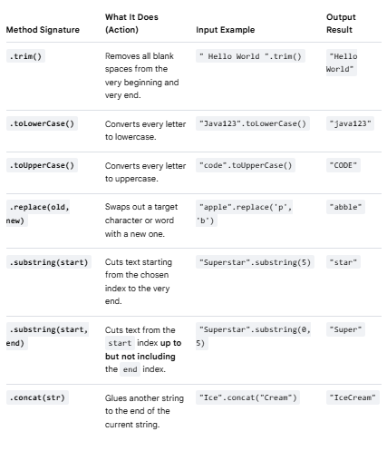

Demonstrate Strings
Example demonstrating how to use Java Strings, showcasing common operations like finding length, changing case, checking contents, and joining text.
public class StringDemo {
public static void main(String[] args) {
// 1. Declare and initialize a String
String text = " Hello, Java Learners! ";
// 2. Get the length of the string
System.out.println("Original length: " + text.length());
// 3. Remove leading and trailing whitespace using trim()
String cleanText = text.trim();
System.out.println("Cleaned text: '" + cleanText + "'");
// 4. Convert case (Uppercase / Lowercase)
System.out.println("Uppercase: " + cleanText.toUpperCase());

// 5. Extract a portion of the text using substring(startIndex, endIndex)
// Extracts characters from index 7 up to (but not including) index 11
String word = cleanText.substring(7, 11);
System.out.println("Extracted word: " + word); // Outputs: Java

// 6. Check if the string contains a specific word
boolean hasJava = cleanText.contains("Java");
System.out.println("Contains 'Java'?: " + hasJava);

// 7. Replace characters or words
String newText = cleanText.replace("Learners", "Experts");
System.out.println("Replaced text: " + newText);

String s1 = new String("Apple");
String s2 = new String("Apple");
System.out.println(s1 == s2); // ❌ Prints false (different memory objects)
System.out.println(s1.equals(s2)); // Prints true (same characters)
}
}

Expected Output

Original length: 25
Cleaned text: 'Hello, Java Learners!'
Uppercase: HELLO, JAVA LEARNERS!
Extracted word: Java
Contains 'Java'?: true
Replaced text: Hello, Java Experts!
Crucial Tip for Beginners: Comparing Strings
In Java, never use == to compare the text content of two Strings. Always use the .equals() method.
- == checks if the strings are the exact same object in memory.
- .equals() checks if the characters inside the strings match.

