Non-Primitive Data Type or Reference Data Types 1
Single-Dimensional Arrays 2
Strings 4
Objects Oriented Programming 7
Class and Object 10
Example Blueprint 11
Instantiating: Making Objects from Your Class 11
What Happens in Computer Memory During Instantiation? 11
Inheritance 12
Abstract Class 14
Polymorphism 16
Polymorphism in Action (Code Example) 16
Variable scope 18
Project - Build a Student Grade & Honor Roll Tracker 20

Type Casting in Java
In Java, type casting is a method or process that converts a data type into another data type in both ways manually and automatically. The automatic conversion is done by the compiler and manual conversion is performed by the programmer. In this section, we will discuss type casting and its types with proper examples.
Converting a value from one data type to another data type is known as type casting.

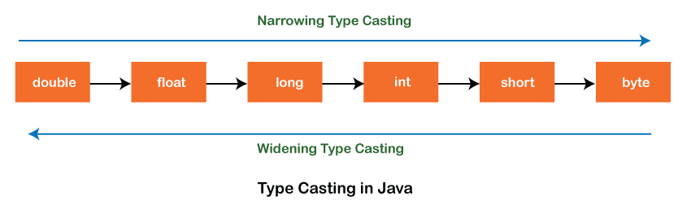 | Types of Type Casting  There are two types of type casting:  1. Widening Type Casting  2. Narrowing Type Casting

Widening Type Casting
Converting a lower data type into a higher one is called widening type casting. It is also known as implicit conversion or casting down. It is done automatically. It is safe because there is no chance to lose data. It takes place when:
o Both data types must be compatible with each other.
o The target type must be larger than the source type
byte -> short -> char -> int -> long -> float -> double

For example, the conversion between numeric data types to char or Boolean is not done automatically. Also, the char and Boolean data types are not compatible with each other. Let’s see an example.
public class WideningTypeCastingExample { public static void main(String[] args) { int x = 7; //automatically converts the integer type into long type long y = x; //automatically converts the long type into float type float z = y; System.out.println(“Before conversion, int value “+x); System.out.println(“After conversion, long value “+y); System.out.println(“After conversion, float value “+z); } }
Output:
Before conversion, the value is: 7After conversion, the long value is: 7After conversion, the float value is: 7.0

Narrowing Type Casting
Converting a higher data type into a lower one is called narrowing type casting. It is also known as explicit conversion or casting up. It is done manually by the programmer. If we do not perform casting then the compiler reports a compile-time error.
double -> float -> long -> int -> char -> short -> byte
Let’s see an example of narrowing type casting.
In the following example, we performed the narrowing type casting two times. First, we have converted the double type into a long data type after that long data type is converted into an int type.
public class NarrowingTypeCastingExample {
public static void main(String args[]) {
double d = 166.66;
//converting double data type into long data type
long l = (long)d;
//converting long data type into int data type
int i = (int)l;
System.out.println(“Before conversion: “+d);
//fractional part lost
System.out.println(“After conversion into long type: “+l);
//fractional part lost
System.out.println(“After conversion into int type: “+i);
}
}
Output:
Before conversion: 166.66
After conversion into long type: 166
After conversion into int type: 166

