1 What is WPI 2
2 Git installs 2
2.1 Create GitHub account 2
2.2 Download and install 2
3 Working with Git Bash commands 3
4 VS code and Git 4
5 Getting Started 4
6 System Installation 4
7 WPI Library 4
7.1 How to install WPLib 4
8 Hardware introduction 6
9 Software components for 2025 7
9.1 Download and install Gaming tool 7
9.2 FRC Driver station 7
9.3 VSCode that comes with WpiLib 7
9.4 LabView (optional) 7
9.5 Python (optional) 7
10 Robo code 2025 7
11 Imaging RoboRio and setting Team number 8
12 Building and Deploying Robot Code 8
13 Programming your Robot 8
14 Running your Test Program 8

What is WPI
* The Worcester Polytechnic Institute is a private research university in Worcester, Massachusetts, United States. Founded in 1865, WPI was one of the United States' first engineering and technology universities and now has 14 academic departments with over 50 bachelor's, master's, and Ph.D. degree programs.
The FIRST Robotics Competition (FRC) at WPI (Worcester Polytechnic Institute) refers to WPI's deep involvement in hosting and supporting the national FRC program for high school students, where teams build and compete with industrial-sized robots, fostering STEM skills, teamwork, and leadership, with WPI providing resources like their WARP preseason event and hosting competitions. It's a hands-on experience where students learn engineering, programming, and business, guided by mentors, all while aiming for scholarships and championship events.

Git installs

Create GitHub account
Signing up for a new personal
- Navigate to https://github.com/.
- Click Sign up.
- Alternatively, click on Continue with Google to sign up using social login.
- Follow the prompts to create your personal account.
During signing up, you'll be asked to verify your email address. Without a verified email address, you won't be able to complete some basic GitHub tasks, such as creating a repository.
Getting started: https://docs.github.com/en/get-started/start-your-journey/creating-an-account-on-github
Tutorial: How to Create a GitHub Account : https://www.youtube.com/watch?v=RnWDKWmaQ8s

Download and install
- Git and Git Bash command line interface.
Download and install: https://git-scm.com/
Tutorial to install Git: https://www.youtube.com/watch?v=tRZGeaHPoaw
The Ultimate GitHub SSH Key Tutorial: https://www.youtube.com/watch?v=6U53fsMiPm0&t=7s
Generate ssh key commands: https://docs.github.com/en/authentication/connecting-to-github-with-ssh/generating-a-new-ssh-key-and-adding-it-to-the-ssh-agent
Getting started: https://docs.github.com/en/get-started/learning-to-code/getting-started-with-git
Working with Git and GitHub: https://www.youtube.com/watch?v=d3FkIA9RtlA
OR
2> GitHub Desktop Client
Instead of using Git from command line, GitHub Desktop Client allows us to use Git from graphical interface. If you have GitHub Desktop installed, you can use it to clone repositories and not deal with SSH keys.
Download and install: https://github.com/apps/desktop
Tutorial link: https://www.youtube.com/watch?v=8Dd7KRpKeaE
https://www.youtube.com/watch?v=MaqVvXv6zrU
Getting started: https://docs.github.com/en/get-started/learning-to-code/getting-started-with-git#learning-git-basics-with-github-desktop

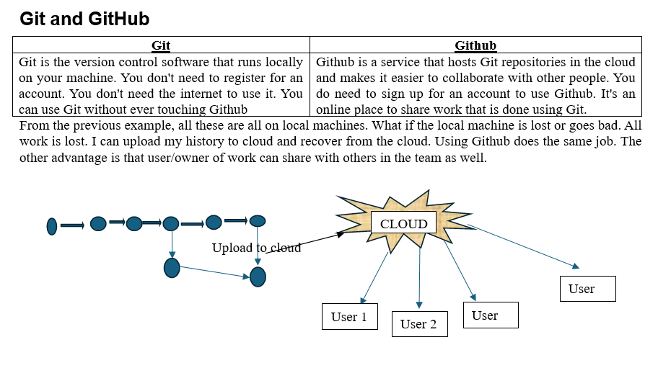

Working with Git Bash commands
Getting Started: https://typoapp.io/blog/git-bash-commands

To get and use Git Bash inside GitHub Desktop, you need to download Git for Windows separately and then select it as your default shell inside the GitHub Desktop settings.
Follow this quick setup process to link them together:
Step 1: Install Git Bash on Your PC
- Go to the official Git for Windows Download Page.
- Click Download to get the installer package.
- Run the downloaded installer file (exe).
- Click Next through the setup prompt windows to accept the default settings, then click Install.
Step 2: Set Git Bash as Default in GitHub Desktop
- Open your GitHub Desktop client.
- In the top-left menu bar, click on File and select Options (on Mac, click GitHub Desktop > Settings).
- Click on the Integrations tab on the left sidebar.
- Look for the Shell dropdown menu.
- Select Git Bash from the list of available terminal choices.
- Click Save to apply the configuration.
Step 3: Open Git Bash Instantly
Once configured, you can launch Git Bash directly from your active project repository using either of these quick methods:
- The Shortcut: Press `Ctrl + `` (Control + Backtick) on your keyboard.
- The Menu: Click on Repository in the top menu bar, then click Open in Git Bash.

VS code and Git
Tutorial: How To Use Git In VS Code Like A Pro!
https://www.youtube.com/watch?v=twsYxYaQikI

Getting Started
Introduction — FIRST Robotics Competition documentation
https://docs.wpilib.org/en/2020/docs/getting-started/getting-started-frc-control-system/intro.html

System Installation
FGR Startup notes (link): Byting Irish Programming 2023 - HackMD
https://hackmd.io/ZvN70XOzRyG9hFiyX5rgEA#System-Installation

WPI Library
More info: WPILib https://wpilib.org/
The WPI Robotics Library (WPILib) is the standard software library provided for teams to write code for their FRC® robots. WPILib contains a set of useful classes and subroutines for interfacing with various parts of the FRC control system (such as sensors, motor controllers, and the driver station), as well as an assortment of other utility functions.

How to install WPLib
Download and Install WPILib from
WPILib Installation Guide — FIRST Robotics Competition documentation
https://docs.wpilib.org/en/latest/docs/zero-to-robot/step-2/wpilib-setup.html?_gl=1*18rjkx7*_ga*MzIzNDY2MTg2LjE3NjQ5NjAwMjA.*_ga_RE35PKQB7J*czE3NjQ5NjAwMTkkbzEkZzEkdDE3NjQ5NjAxNTgkajYwJGwwJGgw*_gcl_au*MTEwNTA2ODEyNy4xNzY0OTYwMDE5
From the above steps followed

WPLib comes with customized VSCode. It is not required to uninstall if another VSCode exist until SYNC is disabled.
The WPILib extension provides the FRC® specific functionality related to creating projects and project components, building, and downloading code to the roboRIO and more. You can access the WPILib commands one of two ways:
- By typing “WPILib” into the Command Palette
- By clicking on the WPILib icon in the top right of most windows. This will open the Command Palette with “WPILib” pre-entered

Here is link to understand the WPLib’s features/WPI Extensions/Commands/Create project etc in VSCode.
Link : Visual Studio Code Basics and the WPILib Extension — FIRST Robotics Competition documentation https://docs.wpilib.org/en/stable/docs/software/vscode-overview/vscode-basics.html#visual-studio-code-basics-and-the-wpilib-extension
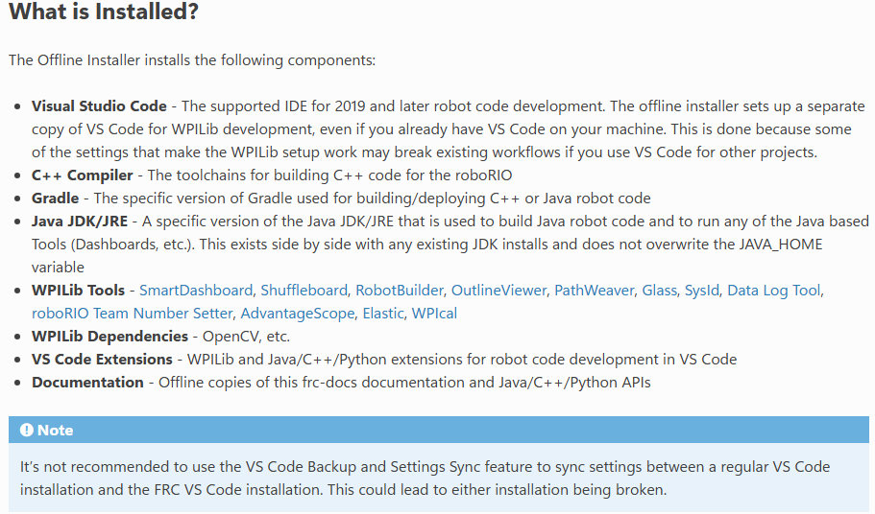

Hardware introduction
Hardware Component Overview — FIRST Robotics Competition documentation
https://docs.wpilib.org/en/stable/docs/controls-overviews/control-system-hardware.html
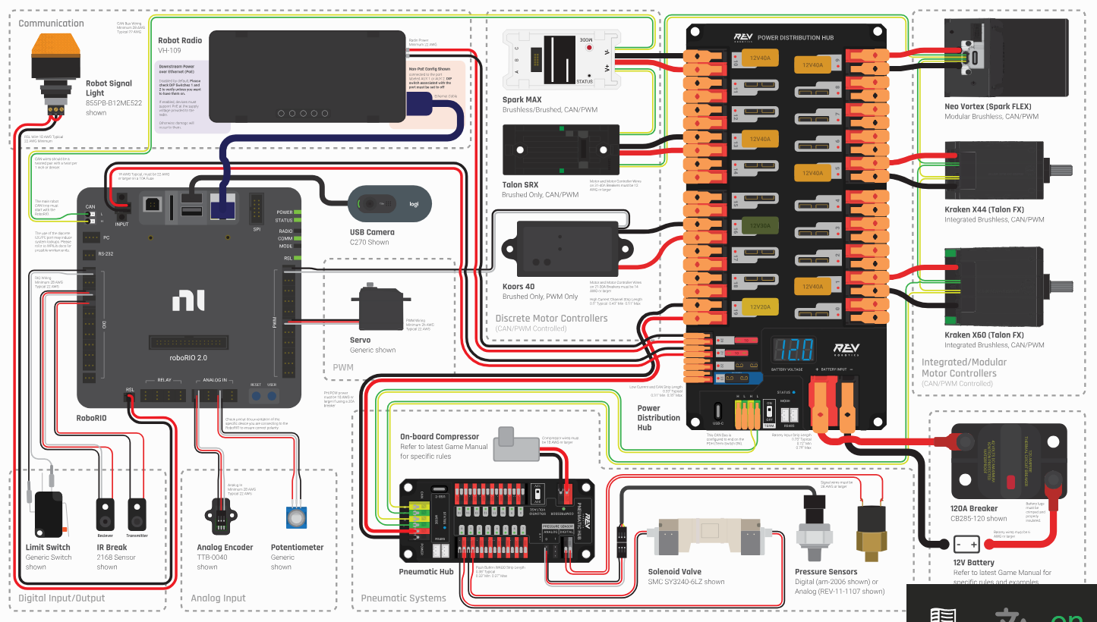

Software components for 2025
List of software components here - Software Component Overview — FIRST Robotics Competition documentation https://docs.wpilib.org/en/stable/docs/controls-overviews/control-system-software.html
Installing guide of software - Step 2: Installing Software — FIRST Robotics Competition documentation https://docs.wpilib.org/en/stable/docs/zero-to-robot/step-2/index.html

Download and install Gaming tool
Installing the FRC Game Tools — FIRST Robotics Competition documentation https://docs.wpilib.org/en/stable/docs/zero-to-robot/step-2/frc-game-tools.html
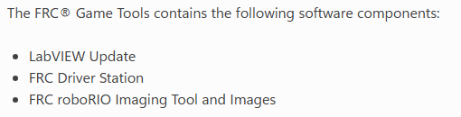

FRC Driver Station
Understand more on Driver station here
FRC Driver Station Powered by NI LabVIEW — FIRST Robotics Competition documentation https://docs.wpilib.org/en/stable/docs/software/driverstation/driver-station.html#frc-driver-station-powered-by-ni-labview

VSCode comes with WpiLib

LabView (optional)
- What is NI LabVIEW?
- Basics of LabVIEW Programming Environment Tutorial
- Beginners LabVIEW Tutorial 1: Getting Started with LabVIEW

Python (optional)
Install python 3.13 from microsoft store and install RobotPy package
($python3 -m pip install robotpy)
Python Installation Guide — FIRST Robotics Competition documentation

Robo code 2025
Clone: FRC7660/robot-2025 https://github.com/FRC7660/robot-2025
<path>$ git clone https://github.com/FRC7660/robot-2025.git

Imaging RoboRio and setting Team number
Imaging your roboRIO 2 — FIRST Robotics Competition documentation https://docs.wpilib.org/en/stable/docs/zero-to-robot/step-3/roborio2-imaging.html

Building and Deploying Robot Code
For more details on how to build and deploy the code on RoboRio, Check this link
Building and Deploying Robot Code — FIRST Robotics Competition documentation https://docs.wpilib.org/en/stable/docs/software/vscode-overview/deploying-robot-code.html

Programming your Robot
Creating your Test Drivetrain Program (Java/C++/Python) — FIRST Robotics Competition documentation https://docs.wpilib.org/en/stable/docs/zero-to-robot/step-4/creating-test-drivetrain-program-cpp-java-python.html

Running your Test Program
Running your Test Program — FIRST Robotics Competition documentation https://docs.wpilib.org/en/stable/docs/zero-to-robot/step-4/running-test-program.html

