Objects Oriented Programming
OOP, we can create modular, reusable, and maintainable code, making programming more efficient.
- In Procedural programming, it is difficult to secure data. Data is global and all functions have access to data.
- Fundamental concept of OOP is Class and Object. Classes serve as blueprints for creating objects.
- Each idea is modeled s class. Objects of classes interact to solve the problem.
- Other class does not have access to data of another ideas class. Data is protected and only member functions have access to data.
Procedural programming  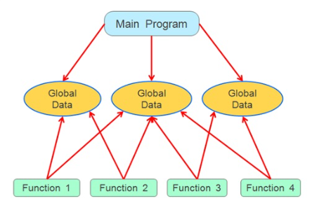 | 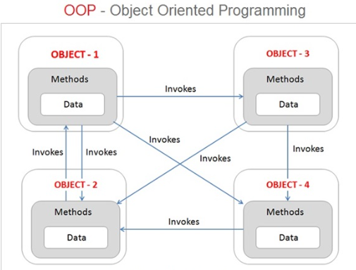
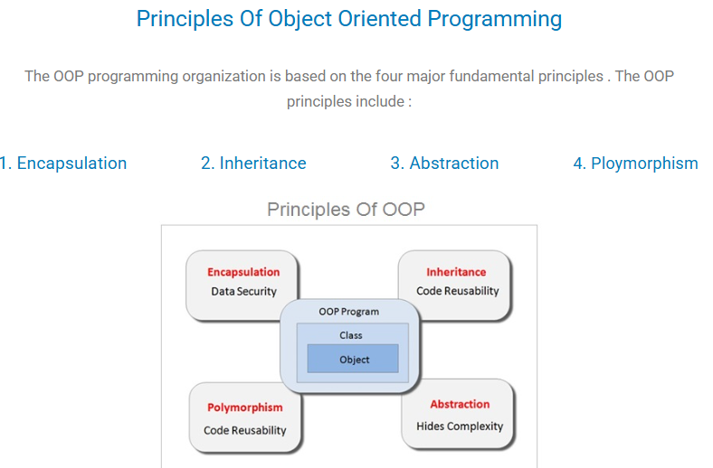
- Abstraction  Abstraction: Simplifying Complexity by proving blueprint for expected behaviors and attributes.  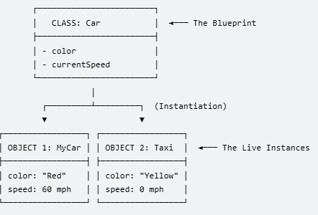 | 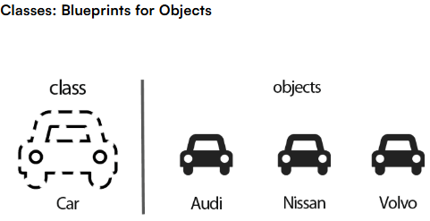
2. Encapsulation: Bundling Data and Logic  *Powerful concept that combines data and logic into cohesive units.  * Data hiding: Encapsulation safeguards the inner workings of objects, ensuring that they are accessible only through defined interfaces while hiding the intricate complexities.  This is done by providing access modifier like Public, Private, Protected to data and methods
  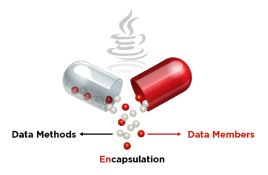 | 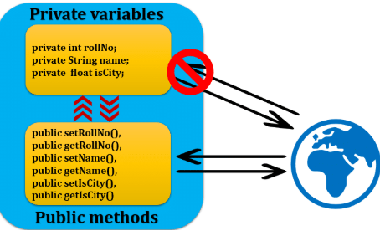
3. Inheritance  *Inheritance allows you to create new classes based on existing ones.  * This helps reduce code duplication (reuse) and makes extending the code easier.  *The new class (child) inherits all properties and methods from the parent class but can also add its own. | 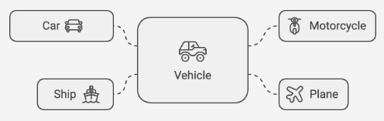
- Polymorphism  Polymorphism allows objects of different classes to be treated as objects of a common superclass. It enables methods to do different things based on the object they are acting upon. It’s like a universal remote control where one button can perform different functions depending on which device you're using. | 