Class and Object
The Core Concept: Class and Object  A Class is the Blueprint: It is the conceptual design, a template, or a factory mold. It does not physically exist; it just describes what something will look like and what it will do.  An Object is the Instance: It is the actual, physical item built directly from that blueprint. You can use one blueprint class to stamp out hundreds of individual objects | 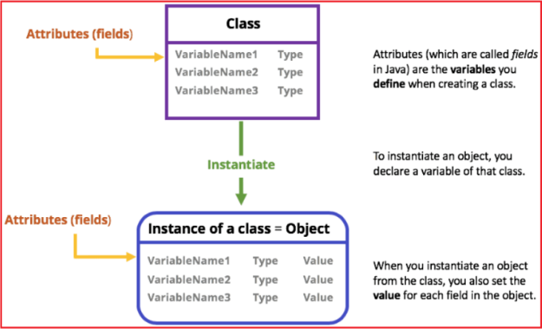
Anatomy of Class  - Attributes (Fields / Instance Variables): What the object knows or remembers about itself (its data). Properties define the characteristics or attributes of an object.  - Methods: What the object can do (its functional actions).  - Constructor: The initialization engine that assigns starting values to an object's fields upon birth. | 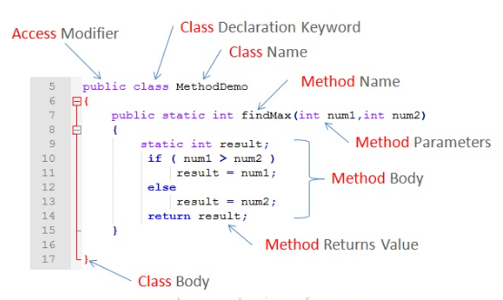
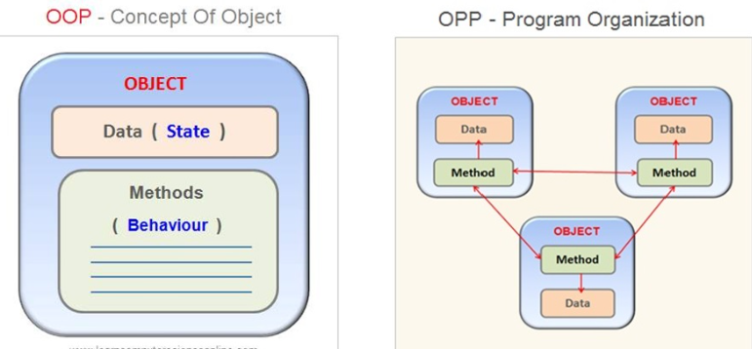

Example Blueprint
