Instantiating: Making Objects from Your Class
new keyword in main( ) triggers the class constructor to build a live object in your computer's memory.
instantiate and configure a object cleanly in a single line.
Dot Notation (.): The syntax syntax operator used to dig inside an object to access its variables or trigger its methods (e.g., p1.name).
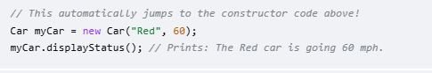

What Happens in Computer Memory During Instantiation?
When Java executes the line Car genericCar = new Car("Red", 55);, it performs three distinct steps under the hood:
- new Car(...): Java allocates a brand-new chunk of blank memory big enough to hold a Car object.
- Car("Red", 55): The constructor function wakes up, takes your values, and writes "Red" into the color slot and 55 into the speed slot inside that fresh memory space.
- Car genericCar = ...: Java assigns a variable pointer named genericCar to reference (point directly to) that specific spot in memory so you can find it later using dot notation.

