Polymorphism
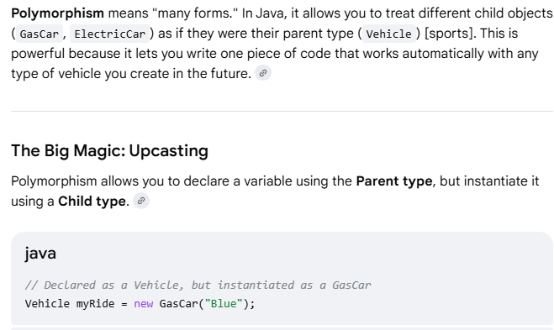
Even though the variable type on the left is Vehicle, Java looks at the real object on the right (GasCar) at runtime and executes the GasCar version of your methods.

Polymorphism in Action (Code Example)
Let's look at how polymorphism allows us to manage all our cars inside a single array loop and pass them into a single function.

Why is this so useful?
Imagine you are building a video game with 100 different types of cars. Without polymorphism, you would have to write 100 separate functions to start a race (startGasCarRace(), startElectricCarRace(), etc.). With polymorphism, you write one single function that accepts Vehicle, and it handles all 100 car types perfectly.

What Prints to the Console?
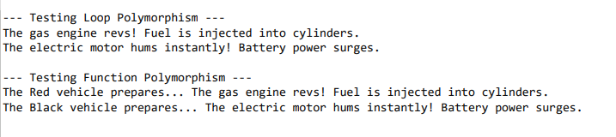
Polymorphism in Action (Code Example)

