Task 1: Read messy Student Names from user
- Concept: Strings and String Manipulation (.trim(), .substring(), .toUpperCase())  - Goal: Capture a messy text string from the keyboard, clean it, and format it properly. | 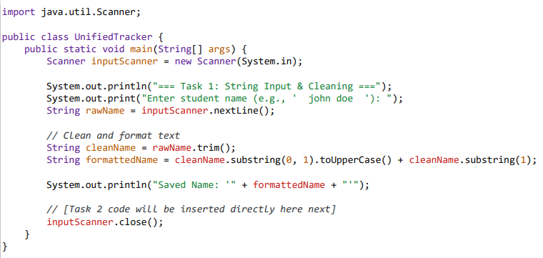
Step B: Use the Object inside your Main Runner program  Update your main running file (GradeTracker.java) to make a live instance from your blueprint: | public class GradeTracker {  public static void main(String[] args) {  // 1. Prepare data variables  String processedName = "Alex Smith";  int[] scores = {95, 88, 91, 94};  // 2. OOP Concept: Instantiate a real Student object container from our blueprint  Student currentStudent = new Student(processedName, scores);  // 3. Ask the object to execute its embedded logic method  System.out.println("=== Final Report Card ===");  System.out.println("Student Profile Name: " + currentStudent.name);  if (currentStudent.qualifiesForHonorRoll()) {  System.out.println("Status: CONGRATULATIONS! Placed on the Academic Honor Roll.");  } else {  System.out.println("Status: Satisfactory standing.");  }  }  }

