Task 7: OOPs – Inheritance and overridding
- Create a child class called GraduateStudent that extends your base Student. This allows the child class to automatically reuse the fields, getters, array logic, and validation rules from the parent class without rewriting a single line of that code.
- Add Unique Child Traits: We add a new private attribute unique to graduate students: private String thesisTitle, along with its own public getter (getThesisTitle()).
- introduce an status metric called qualifiesForHonorRoll() inside the parent class, which checks if a student has an average of 90.0% or higher. Then, using Method Overriding, the GraduateStudent child class will rewrite this exact method to enforce a stricter rule: graduate students must maintain a 95.0% or higher to make the honor roll.
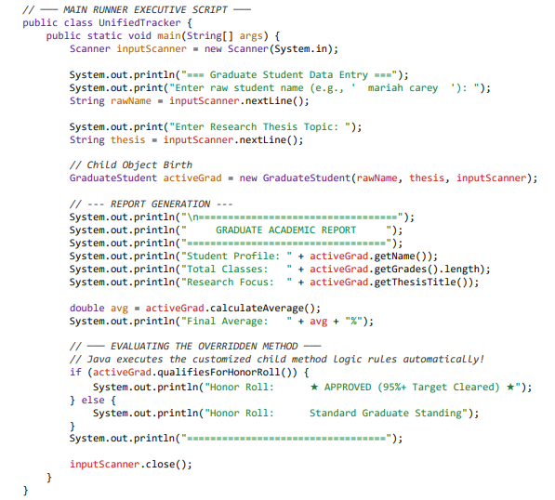

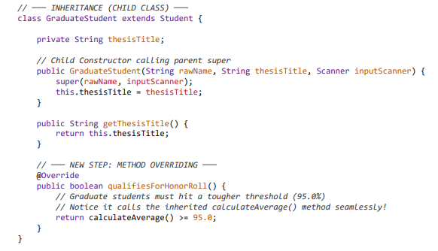
- Parent Method: We add public boolean qualifiesForHonorRoll() inside the Student class with a base threshold of >= 90.0.

- Method Overriding: We copy the exact same method signature inside GraduateStudent, use the @Override annotation tag, and change the logic check to >= 95.0.
