Non-Primitive Data Type or Reference Data Types 2
Single-Dimensional Arrays 3
Demonstrate Array 5
Strings 6
Demonstrate Strings 9
Objects Oriented Programming 11
Class and Object 13
Example Blueprint 14
Instantiating: Making Objects from Your Class 14
What Happens in Computer Memory During Instantiation? 14
Encapsulation 15
Here is a complete, working example 16
Run the code and see how the modifiers react. 18
Getter and Setter method 20
This keyword 22
Visualizing this in Memory 23
Is this mandatory in Getters? 23
Inheritance 24
Abstract Class 26
Polymorphism 28
Polymorphism in Action (Code Example) 28
Variable scope 30
Project - Build a Student Grade & Honor Roll Tracker 32
Task 1: Read messy Student Names from user 32
Task 2: Request user to input Math and Science grade and calculate the average 34
Task 3: Scale Up to a Full Schedule. 35
Task 4: Clean the Main Architecture (Introducing Multiple Functions) 36
Task 5: OOPs concepts – class, encapsulation 38
Task 6: OOPs concepts – Data hiding 40
Task 7: OOPs – Inheritance and overridding 43
Task 8: OOPS – Polymorphism 46
Task 9: File Input Output 49
Task 10: Read back from on start-up. 52

Non-Primitive Data Type or Reference Data Types
The Reference Data Types will contain a memory address of variable values because the reference types won’t store the variable value directly in memory. They are strings, objects, arrays, etc.
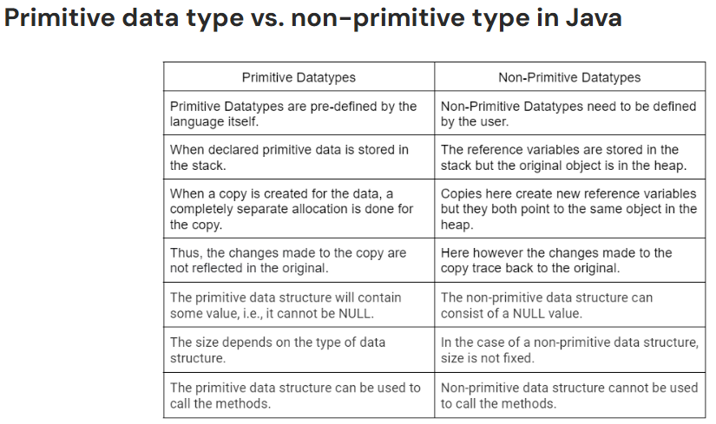

Single-Dimensional Arrays
Lesson link: https://www.w3schools.com/java/java_arrays.asp

- An array is an ordered, fixed-size container that allows you to store multiple values of the same data type inside a single variable name.
- Instead of creating ten separate variables to hold ten student test scores (score1, score2, etc.), you create one single array variable named scores that holds all ten values together in a neat list.
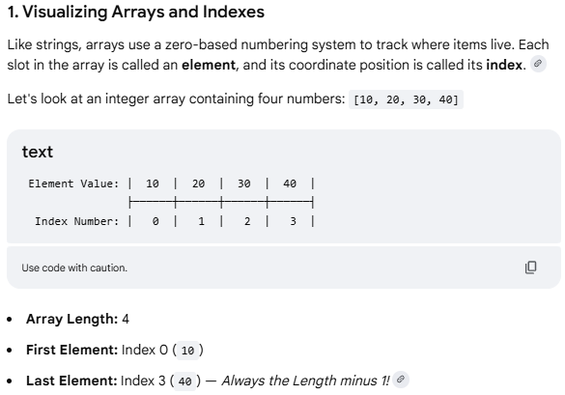

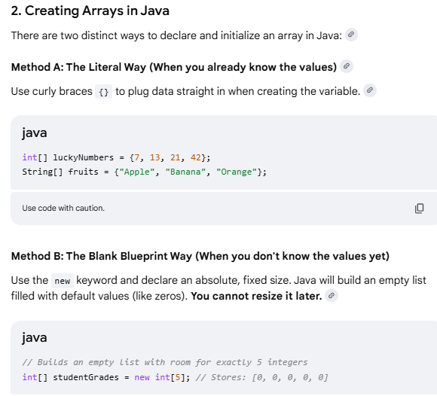
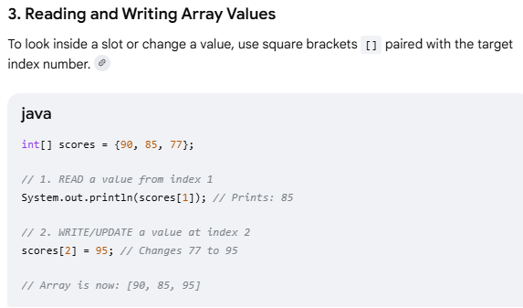
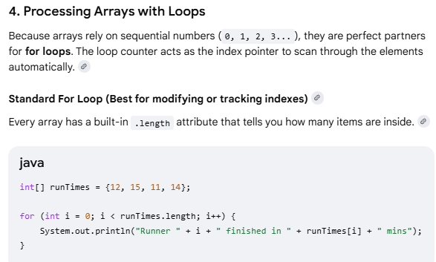
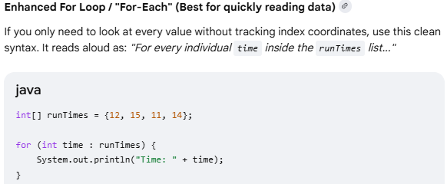

Demonstrate Array
Example demonstrating how to declare, initialize, and loop through an array in Java.

public class ArrayDemo {
public static void main(String[] args) {
// 1. Declare and initialize an array of Strings with a size of 4
String[] fruits = {"Apple", "Banana", "Cherry", "Mango"};

// 2. Access elements using an index (Note: Java arrays start at index 0)
System.out.println("First fruit: " + fruits[0]); // Outputs: Apple
System.out.println("Third fruit: " + fruits[2]); // Outputs: Cherry

// 3. Modify an existing element
fruits[1] = "Blueberry"; // Changes "Banana" to "Blueberry"

// 4. Get the size of the array
System.out.println("\nTotal items in array: " + fruits.length);

// 5. Loop through the array using an enhanced 'for-each' loop
System.out.println("--- Current Fruit List ---");
for (String fruit : fruits) {
System.out.println("- " + fruit);
}
}
}
Expected Output

First fruit: Apple
Third fruit: Cherry

Total items in array: 4
--- Current Fruit List ---
- Apple
- Blueberry
- Cherry

Strings
Lesson link
https://www.w3schools.com/java/java_strings.asp
- Strings are defined as an array of characters / sequence of characters that is held in single variable. Used to represent text (like names, passwords, or sentences).
- Character array (not String) is a collection of separate char-type entities accessed by indexing.
- Unlike C/C++, Java strings are not terminated with null characters.
- Syntax: Declaring a string
- <String_Type> <string_variable> = “<sequence_of_string>”;
- String s1 = "Hello"; // Stored in String Pool
- String s2 = "Hello"; // Reuses the same object from the String Pool
- String s3 = new String("Hello"); // Creates a new String object outside the Pool
- The Key Rule: Strings are Immutable
That is once String is created, it can never be changed in memory.
String manipulation methods that "modify" text, Java doesn't alter the original word. Instead, it quietly creates a brand-new String in the background and hands you fresh copy.
- Strings is object and provides built-in function (methods) to search, cut, clean, and modify text.
- Built-in String operation functions are, such as finding length, extracting substrings, replacing characters, and more.
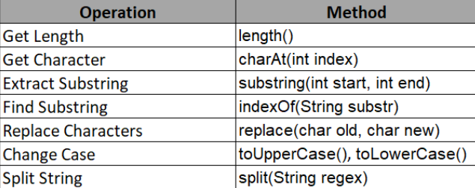

- Built-in String comparing functions
Golden Rule of Comparison, use equals() Instead of ==. The == operator compares references, not the actual content of the strings, whereas equals() compares the values.
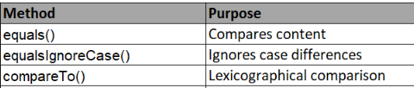

- Substring functions
Extracts a smaller piece of text out of a larger String. It takes a starting index and an optional ending index. Note: The ending index is exclusive (Java stops right before that number).

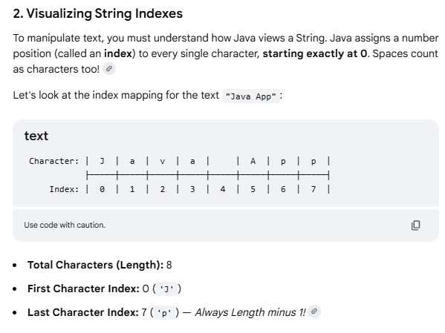
String phrase = "Superstar";

// Cut from index 5 all the way to the end String
endPiece = phrase.substring(5); // "star"

// Cut from index 0 up to (but not including) index 5
String frontPiece = phrase.substring(0, 5); // "Super"

- Advance methods
String.format() allows you to create formatted strings dynamically.
String formatted = String.format("Name: %s, Age: %d", "Alice", 30);
System.out.println(formatted); // "Name: Alice, Age: 30"

String joined = String.join("-", "2023", "12", "31"); // "2023-12-31"

String s = " Hello ";
System.out.println(s.strip()); // "Hello" Removes leading and trailing whitespace.
System.out.println(" ".isBlank()); // true
System.out.println("Hi".repeat(3)); // "HiHiHi"

Regular Expressions & Pattern Matching
String email = "user@example.com";
boolean isValid = email.matches("^[\\w.-]+@[\\w.-]+\\.[a-zA-Z]{2,6}$");
- Built-in Java methods used to modify
String CSVData = "Pizza,Burgers,Tacos";
String[] foodList = CSVData.split(",");

// foodList[0] is now "Pizza"
// foodList[1] is now "Burgers"
// foodList[2] is now "Tacos"

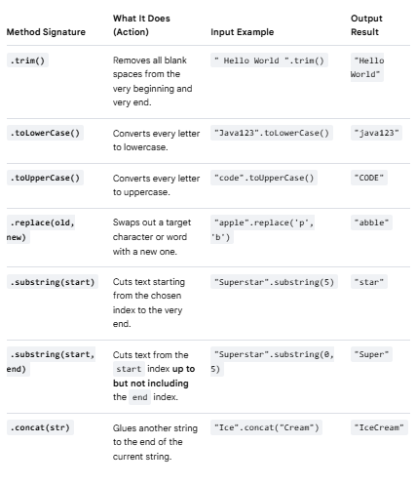

Demonstrate Strings
Example demonstrating how to use Java Strings, showcasing common operations like finding length, changing case, checking contents, and joining text.
public class StringDemo {
public static void main(String[] args) {
// 1. Declare and initialize a String
String text = " Hello, Java Learners! ";

// 2. Get the length of the string
System.out.println("Original length: " + text.length());

// 3. Remove leading and trailing whitespace using trim()
String cleanText = text.trim();
System.out.println("Cleaned text: '" + cleanText + "'");

// 4. Convert case (Uppercase / Lowercase)
System.out.println("Uppercase: " + cleanText.toUpperCase());

// 5. Extract a portion of the text using substring(startIndex, endIndex)
// Extracts characters from index 7 up to (but not including) index 11
String word = cleanText.substring(7, 11);
System.out.println("Extracted word: " + word); // Outputs: Java

// 6. Check if the string contains a specific word
boolean hasJava = cleanText.contains("Java");
System.out.println("Contains 'Java'?: " + hasJava);

// 7. Replace characters or words
String newText = cleanText.replace("Learners", "Experts");
System.out.println("Replaced text: " + newText);

String s1 = new String("Apple");
String s2 = new String("Apple");

System.out.println(s1 == s2); // ❌ Prints false (different memory objects)
System.out.println(s1.equals(s2)); // Prints true (same characters)
}
}

Expected Output

Original length: 25
Cleaned text: 'Hello, Java Learners!'
Uppercase: HELLO, JAVA LEARNERS!
Extracted word: Java
Contains 'Java'?: true
Replaced text: Hello, Java Experts!

Crucial Tip for Beginners: Comparing Strings
In Java, never use == to compare the text content of two Strings. Always use the .equals() method.
- == checks if the strings are the exact same object in memory.
- .equals() checks if the characters inside the strings match.

Objects Oriented Programming
OOP, we can create modular, reusable, and maintainable code, making programming more efficient.
- In Procedural programming, it is difficult to secure data. Data is global and all functions have access to data.
- Fundamental concept of OOP is Class and Object. Classes serve as blueprints for creating objects.
- Each idea is modeled s class. Objects of classes interact to solve the problem.
- Other class does not have access to data of another ideas class. Data is protected and only member functions have access to data.
Procedural programming  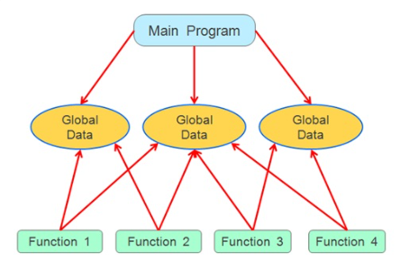 | 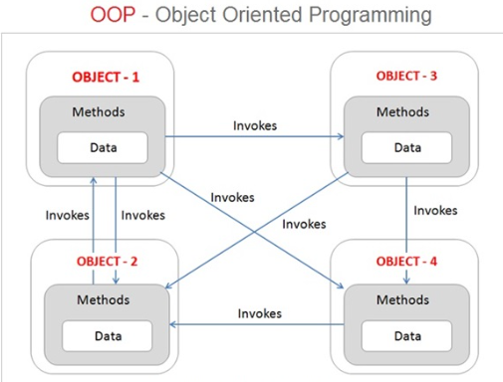
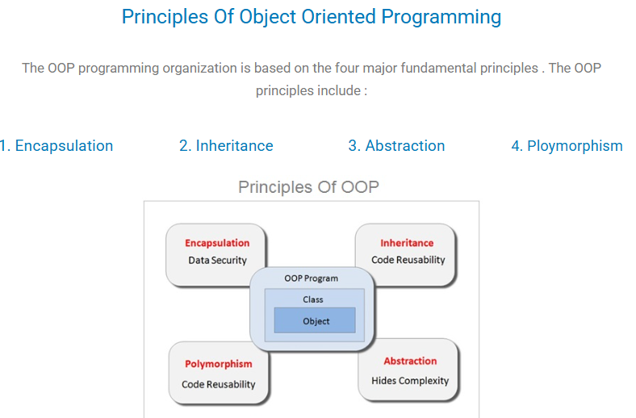
- Abstraction  Abstraction: Simplifying Complexity by proving blueprint for expected behaviors and attributes.  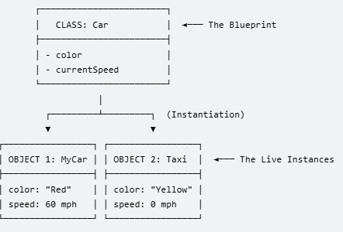 | 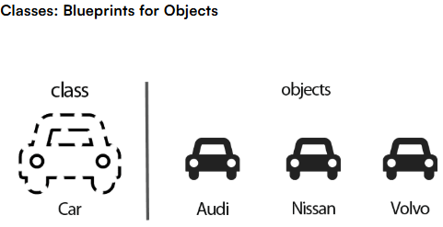
2. Encapsulation: Bundling Data and Logic  *Powerful concept that combines data and logic into cohesive units.  * Data hiding: Encapsulation safeguards the inner workings of objects, ensuring that they are accessible only through defined interfaces while hiding the intricate complexities.  This is done by providing access modifier like Public, Private, Protected to data and methods
  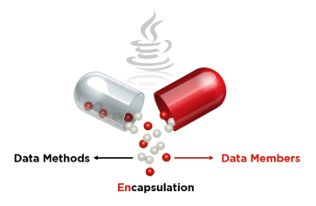 | 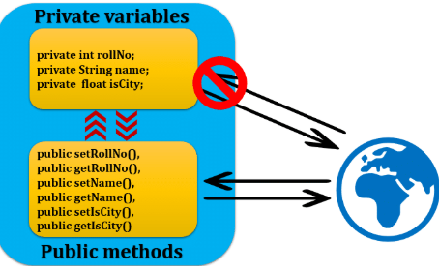
3. Inheritance  *Inheritance allows you to create new classes based on existing ones.  * This helps reduce code duplication (reuse) and makes extending the code easier.  *The new class (child) inherits all properties and methods from the parent class but can also add its own. | 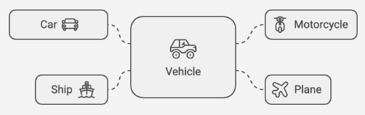
- Polymorphism  Polymorphism allows objects of different classes to be treated as objects of a common superclass. It enables methods to do different things based on the object they are acting upon. It’s like a universal remote control where one button can perform different functions depending on which device you're using. | 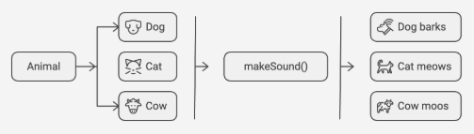

Class and Object
The Core Concept: Class and Object  A Class is the Blueprint: It is the conceptual design, a template, or a factory mold. It does not physically exist; it just describes what something will look like and what it will do.  An Object is the Instance: It is the actual, physical item built directly from that blueprint. You can use one blueprint class to stamp out hundreds of individual objects | 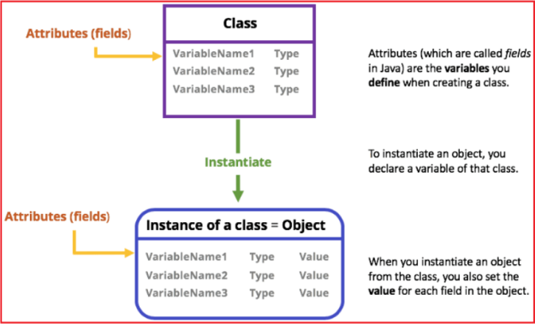
Anatomy of Class  - Attributes (Fields / Instance Variables): What the object knows or remembers about itself (its data). Properties define the characteristics or attributes of an object.  - Methods: What the object can do (its functional actions).  - Constructor: The initialization engine that assigns starting values to an object's fields upon birth. | 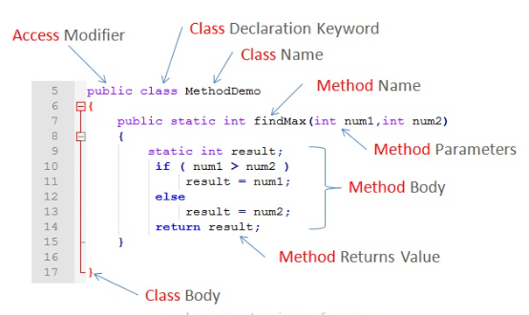
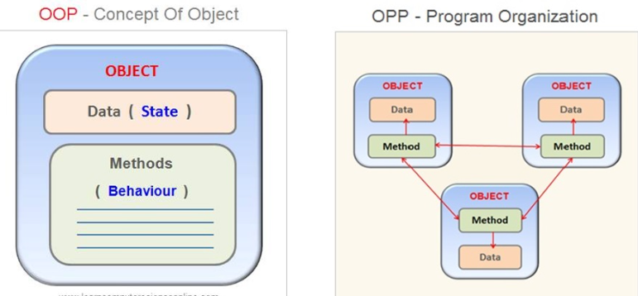

Example Blueprint
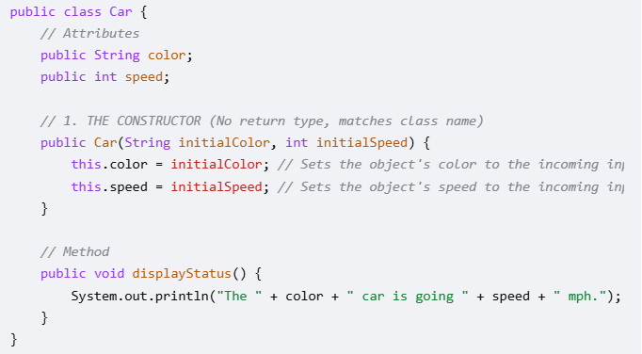

Instantiating: Making Objects from Your Class
new keyword in main( ) triggers the class constructor to build a live object in your computer's memory.
instantiate and configure a object cleanly in a single line.
Dot Notation (.): The syntax syntax operator used to dig inside an object to access its variables or trigger its methods (e.g., p1.name).
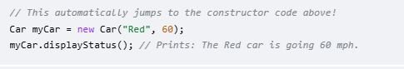

What Happens in Computer Memory During Instantiation?
When Java executes the line Car genericCar = new Car("Red", 55);, it performs three distinct steps under the hood:
- new Car(...): Java allocates a brand-new chunk of blank memory big enough to hold a Car object.
- Car("Red", 55): The constructor function wakes up, takes your values, and writes "Red" into the color slot and 55 into the speed slot inside that fresh memory space.
- Car genericCar = ...: Java assigns a variable pointer named genericCar to reference (point directly to) that specific spot in memory so you can find it later using dot notation.

Encapsulation
In Java, access modifiers control the visibility and accessibility of your classes, methods, variables, and constructors. They are the foundation of encapsulation, which allows you to secure your data and hide the inner workings of your code.
Here is a quick overview of how the three main modifiers, plus the "default" behavior, restrict access:

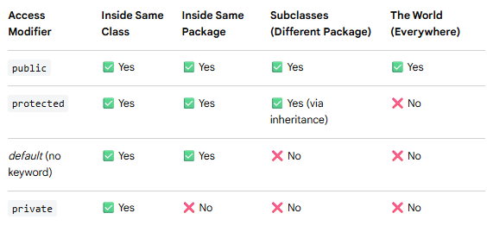

Public (public)
The public modifier provides the least restrictive level of access. Anything declared as public can be seen and used by any other class in your entire project. [1, 2]
- When to use: Use this for your main API endpoints, major application services, helper utilities, or anything designed to be shared globally across packages.
Private (private)
The private modifier provides the highest level of restriction. Variables or methods marked private are hidden from every other class in your project—even classes inside the exact same folder (package). They can only be accessed within the specific class where they are defined. [1, 2, 3]
- When to use: Use this by default for almost all of your class variables (fields). You then expose them safely using public "getter" and "setter" methods if other classes need to read or change them.
Protected (protected)
The protected modifier is tailored specifically for inheritance. It allows a parent class to share its components with its children (subclasses), even if those child classes are located in completely different folders or packages. Additionally, any other class inside the same package can also see it.
- When to use: Use this when building a framework or class hierarchy where child classes genuinely need direct access to a parent's methods or data to extend its functionality.

Note on "Default" (Package-Private)
If you do not type public, private, or protected next to a variable or method, Java automatically assigns it default access. This means the code is visible to everything inside the same package, but entirely hidden from the outside world. [1, 2, 3]
Would you like to see a practical example of how these modifiers interact across different packages, or do you want to explore how getters and setters protect private fields? [1]

Here is a complete, working example
Using two different packages (animals and zoo) to show exactly how all four access levels behave across your project
Package 1: animals
First, let's create a base class named Animal that defines a variable for each of the four access levels. And look another class inside that same package to see what it can access.

package animals;

public class Animal {
// 1. Public: Accessible from anywhere in the project
public String publicName = "Global Lion";

// 2. Protected: Accessible in the same package AND by subclasses
protected String protectedSound = "Roar";
// 3. Default (No modifier): Accessible ONLY in the same package

String defaultColor = "Golden";
// 4. Private: Accessible ONLY inside this Animal class

private String privateId = "ID-9942";

public void testInsideClass() {
// All of these work perfectly inside the same class
System.out.println(publicName); // ✅ Success
System.out.println(protectedSound); // ✅ Success
System.out.println(defaultColor); // ✅ Success
System.out.println(privateId); // ✅ Success
}

// 🟢 The Getter Method: Anyone can call this to READ the ID
public String getPrivateId() {
return this.privateId;

}
package animals;

public class PackageCompanion {

public void testSamePackage() {
Animal animal = new Animal();
System.out.println(animal.publicName); // ✅ Success
System.out.println(animal.protectedSound); // ✅ Success
System.out.println(animal.defaultColor); // ✅ Success

// System.out.println(animal.privateId); // ❌ COMPILE ERROR: privateId is private to Animal
}
}

Package 2: zoo
Now, let's move outside the animals package to see how inheritance and external access restrictions work.
package zoo;
import animals.Animal; // Must import since it's a different package

public class Lion extends Animal {
public void testSubclass() {
// 1. Public works everywhere
System.out.println(publicName); // ✅ Success

// 2. Protected works because Lion EXTENDS Animal (Inheritance)
System.out.println(protectedSound); // ✅ Success

// 3. Default fails because Lion is in a DIFFERENT package
// System.out.println(defaultColor); // ❌ COMPILE ERROR: Not visible outside package
// 4. Private fails because it belongs exclusively to Animal
// System.out.println(privateId); // ❌ COMPILE ERROR: Not visible outside Animal
}

Run the code and see how the modifiers react.
This Main class in a completely separate package named mainrunner to simulate "the rest of the world" looking into your code.
package mainrunner;

import animals.Animal; // Import the base class
import zoo.Lion; // Import the subclass

public class Main {
public static void main(String[] args) {
System.out.println("--- Testing from an unrelated Main Class ---");
Animal genericAnimal = new Animal();

// 1. Public works everywhere
System.out.println("Public Field: " + genericAnimal.publicName); // ✅ Success

// 2. Protected fails here (Main is not a subclass of Animal)
// System.out.println(genericAnimal.protectedSound); // ❌ COMPILE ERROR

// 3. Default fails here (Main is in a different package)
// System.out.println(genericAnimal.defaultColor); // ❌ COMPILE ERROR

// 4. Private fails completely
// System.out.println(genericAnimal.privateId); // ❌ COMPILE ERROR

System.out.println("\n--- Testing via the Lion Subclass ---");
Lion simba = new Lion();

// This triggers the method inside Lion, which can safely
// read the public and protected fields due to inheritance
simba.testSubclass();
}
}

What Happens When You Run This?
If you uncomment any of the red-marked lines (❌), your code will refuse to compile. Left as it is above, it compiles flawlessly and prints out:
text
--- Testing from an unrelated Main Class ---
Public Field: Global Lion

--- Testing via the Lion Subclass ---
Global Lion
Roar

Getter and Setter method
A getter method is a public method used to safely retrieve (get) the value of a hidden, private variable from outside its class.
By making class variables private, you prevent outside classes from accidentally changing or corrupting your data. The getter method acts as a controlled, read-only window to the world.
package mainrunner;
import animals.Animal;

public class Main {
public static void main(String[] args) {
Animal genericAnimal = new Animal();

// ❌ This still causes a compile error:
// System.out.println(genericAnimal.privateId);

// ✅ This works perfectly!
String idValue = genericAnimal.getPrivateId();
System.out.println("Accessed via Getter: " + idValue);
}
}

Why do this instead of just making the variable public?
- Read-Only Protection: By providing only a getter (and no setter), you make the variable completely immutable to the outside world. Other classes can see it, but they can never change it.
- Data Logging & Control: You can add logic inside the getter. For example, you could log a message every time a sensitive piece of data is accessed:

A setter method is a public method used to safely update or change (set) the value of a hidden, private variable from outside its class.
While getters provide read-only access, setters provide write-only access. By routing all changes through a setter method, your class can inspect, validate, or reject new values before updating the actual variable.
Why use a Setter instead of a public variable?
- Data Validation: You can block bad inputs (like preventing a setAge(int age) method from accepting negative numbers).
- Encapsulation: The internal storage logic is hidden. If you later decide to change how IDs are structured (e.g., adding a prefix automatically), you only change the code inside the setter, without breaking anyone else's code.
package animals;
public class Animal {
…….
// 🟢 The Setter Method: Anyone can call this to CHANGE the ID
public void setPrivateId(String newId) {
// Validation: Ensure the new ID isn't empty or null
if (newId != null && !newId.trim().isEmpty()) {
this.privateId = newId; // 'this.privateId' refers to the private field above
} else {
System.out.println("Error: Invalid ID provided. Update rejected.");
} } }
package mainrunner;
import animals.Animal;
public class Main {
public static void main(String[] args) {
Animal genericAnimal = new Animal();
// ❌ This causes a compile error:
// genericAnimal.privateId = "NEW-ID-123";

// ✅ This works perfectly!
genericAnimal.setPrivateId("NEW-ID-123");

// ❌ This will trigger our validation rule and keep the old ID
genericAnimal.setPrivateId("");
} }

This keyword
How this keyword works inside getters and setters
In Java, the this keyword is a reference variable that refers directly to the current object instance you are working inside.
Inside getters and setters, its primary job is to resolve naming conflicts (called variable shadowing) and clarify exactly which variable you mean.
The Problem: Variable Shadowing
When you write a setter method, you usually name the incoming parameter the exact same name as the class variable.
public class Animal {  private String name; // 1. Instance variable (Class level)  public void setName(String name) { // 2. Local parameter (Method level)  // If you write:  name = name; | Without this, Java gets confused. It assumes both name references mean the local parameter (number 2) because it is closer in scope. This means the code effectively does nothing—it assigns the parameter to itself, leaving the actual class variable blank. This is called variable shadowing.
public class Animal {  private String name;  // 🟢 Inside a Setter  public void setName(String name) {  this.name = name; // "this.name" is the class variable. "name" is the parameter.  }  // 🟢 Inside a Getter  public String getName() {  return this.name; // Refers directly to the class variable  }  } | The Solution: Using this  To fix this, you prepend this. to the class variable. This explicitly tells Java: "Hey, set the class-level variable belonging to this specific object equal to the local parameter value."

Visualizing this in Memory
Imagine you create two separate Animal objects in your Main class:
Animal dog = new Animal();
Animal cat = new Animal();

dog.setName("Buddy"); // Inside setName(), 'this' points to 'dog'
cat.setName("Whiskers"); // Inside setName(), 'this' points to 'cat'

When dog.setName("Buddy") runs:
- this automatically binds itself to the dog object.
- this.name = name; translates behind the scenes to: dog.name = "Buddy";
When cat.setName("Whiskers") runs:
- this automatically binds itself to the cat object.
- this.name = name; translates behind the scenes to: cat.name = "Whiskers";

Is this mandatory in Getters?
No. In the getName() method above, there is no parameter named name causing a conflict. Therefore, writing return name; works perfectly fine. However, many developers still write return this.name; because it makes it immediately obvious to anyone reading the code that name is a class-level variable.

Inheritance
Inheritance is one of the pillars of Object-Oriented Programming. It allows a new class to inherit (absorb) all the attributes and methods of an existing class automatically.
Think of inheritance like genetic traits. A child inherits traits from their parent, but the child can also have unique traits of their own.
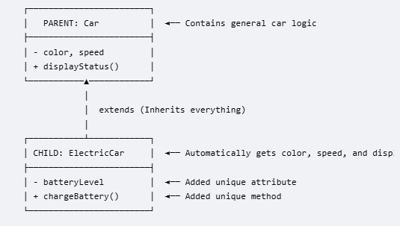 | - Parent Class (Superclass): The general, base class that holds common traits (e.g., Car).  - Child Class (Subclass): The specialized class that inherits everything from the parent but adds unique twists (e.g., an ElectricCar).  - The Keyword: extends  In Java, you use the extends keyword to establish an inheritance relationship.  - @Override Annotation: You place this helper tag right above the child method. It tells Java to double-check your code to ensure you didn't accidentally typo the name or parameters.
Why Use Inheritance?
- Code Reusability: You don't have to rewrite code for color, speed, or displayStatus() if you decide to build a GasCar, a Truck, or a RaceCar later. You just extend Car.
- While inheritance gives the child class all the parent’s methods automatically, sometimes the default parent behavior isn't quite right for the child. Method Overriding occurs when a child class rewrites a method it inherited from its parent class to give it a new, specialized behavior. Child keep the exact same method name and inputs, but change what happens inside the execution brackets { }.
• Same Name: The method name in the child class must exactly match the parent class.
• Same Parameters: The inputs (arguments) must match exactly.
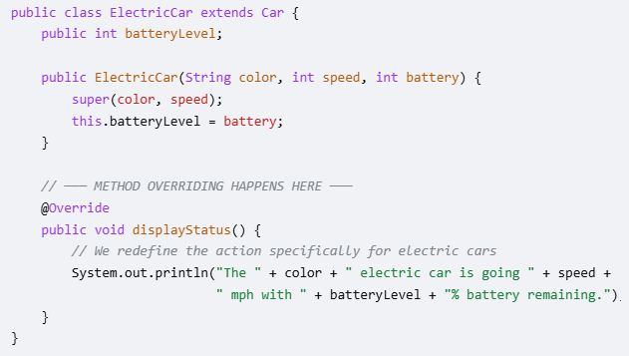

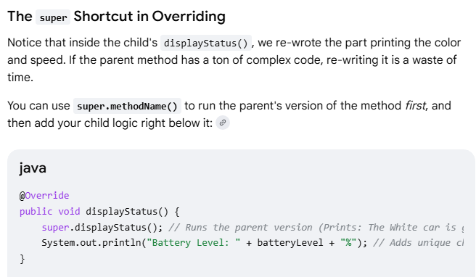

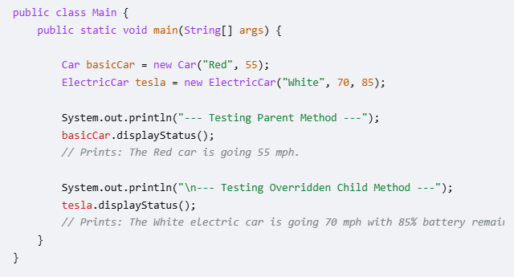
- Java is smart under the hood. Even though both objects are used. displayStatus(), Java looks at the specific object type at runtime and executes the customized version for the ElectricCar.
- If not Override, Java fall back to base class function.

Abstract Class
The Rules of Abstract Methods
- No Body: Abstract methods end with a semicolon ; instead of curly braces {}.
- The abstract Keyword: You must place the word abstract before the method name.
- Abstract Class Requirement: If a class contains even one abstract method, the entire class must be declared as abstract. You cannot instantiate (create a new) abstract class directly.
- Child Obligation: Any normal child class that inherits from an abstract parent must override and write the body for all abstract methods, or your code will fail to compile.
The Abstract Parent Class
Traditional gas car accelerates by burning fuel, while an electric car accelerates by pulling power from a battery pack. Instead of writing a generic, useless default method in the parent class, we make it abstract.

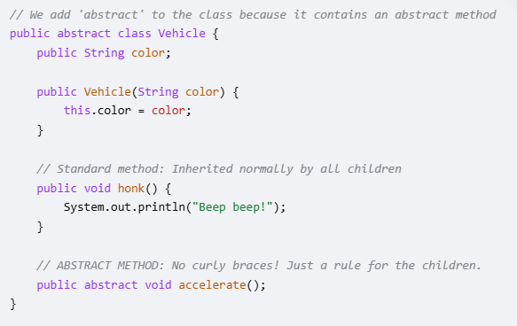
The Child Classes (Fulfilling the Contract)
Now, any child class that extends Vehicle is forced by Java to implement accelerate(). If you forget to add it, Java will give you a compilation error.

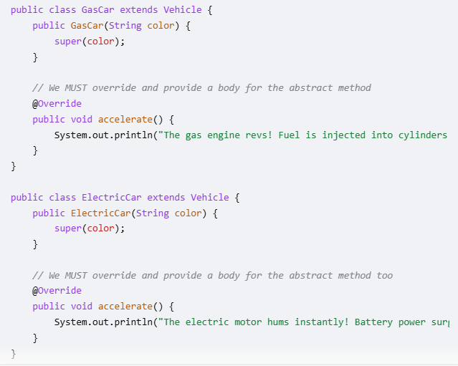

Running the Code in Main
Remember, you cannot do Vehicle v = new Vehicle("Red"); because abstract classes are incomplete blueprints. You can only instantiate the concrete children.
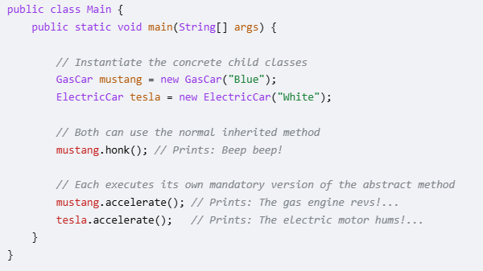
Why Use Abstract Methods?
Abstract methods allow you to enforce a standard design structure across multiple different classes. It guarantees that no matter what kind of vehicle someone programs in the future, it is guaranteed to have an accelerate() action built into it.

Polymorphism
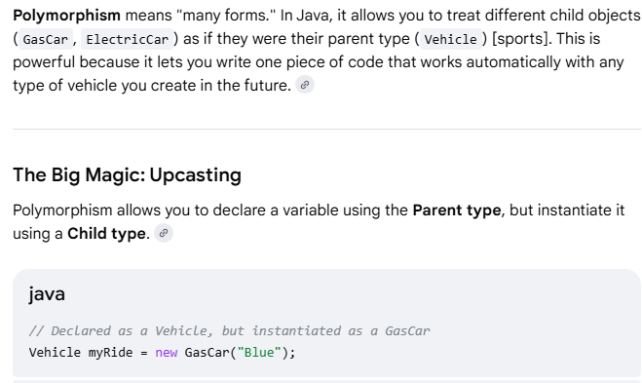
Even though the variable type on the left is Vehicle, Java looks at the real object on the right (GasCar) at runtime and executes the GasCar version of your methods.

Polymorphism in Action (Code Example)
Let's look at how polymorphism allows us to manage all our cars inside a single array loop and pass them into a single function.

Why is this so useful?
Imagine you are building a video game with 100 different types of cars. Without polymorphism, you would have to write 100 separate functions to start a race (startGasCarRace(), startElectricCarRace(), etc.). With polymorphism, you write one single function that accepts Vehicle, and it handles all 100 car types perfectly.

What Prints to the Console?
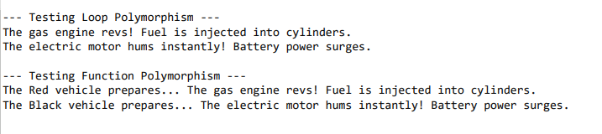
Polymorphism in Action (Code Example)

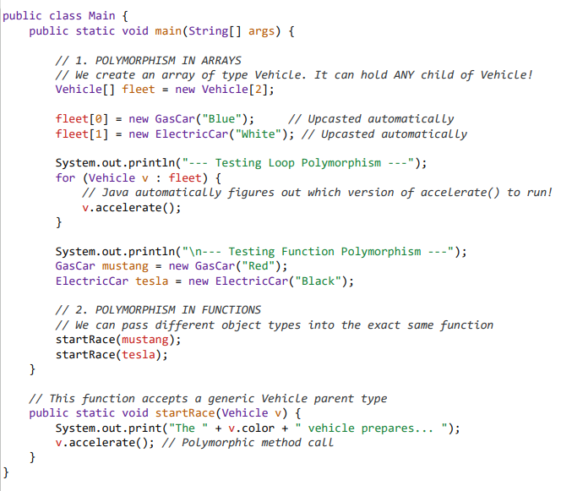

Variable scope
Different types of variables are
- Local Variables
- Instance Variables
- Static Variables

Local Variables  A variable defined within a block or method or constructor is called a local variable.  - These variables are created when the block is entered, or the function is called and destroyed after exiting from the block or when the call returns from the function.  - The scope of these variables exists only within the block in which the variables are declared, i.e., we can access these variables only within that block.  - Initialization of the local variable is mandatory before using it in the defined scope. | Class hcl guvi {  public static void main(String[] args)  {  // Declared a Local Variable  int var = 10;  // This variable is local to this main method only  System.out.println(“Local Variable: ” + var);  }  }
Instance variables are non-static variables and are declared in a class outside of any method, constructor, or block.  - As instance variables are declared in a class, these variables are created when an object of the class is created and destroyed when the object is destroyed.  - Unlike local variables, we may use access specifiers for instance variables. If we do not specify any access specifier, then the default access specifier will be used.  - Initialization of an instance variable is not mandatory. Its default value is dependent on the data type of variable.  - Instance variables can be accessed only by creating objects.  - We initialize instance variables using constructors while creating an object. We can also use instance blocks to initialize the instance variables. | // Java Program to demonstrateclass  hcl guvi {  // Declared instance variable  String student = “Shubham Jain”;  public static void main(String[] args) {  HCL Guvi Zen=new HCLGuvi();  // geek variable can be accessed by creating object  System.out.print(Zen. student);  }  }
Static Variables  Static variables are also known as class variables.  - These variables are declared similarly to instance variables. The difference is that static variables are declared using the static keyword within a class outside of any method, constructor, or block.  - Unlike instance variables, we can only have one copy of a static variable per class, irrespective of how many objects we create.  - Static variables are created at the start of program execution and destroyed automatically when execution ends.  - Initialization of a static variable is not mandatory. Its default value is dependent on the data type of variable | // Java Program to demonstrateclass  hcl guvi {  // Declared instance variable Public  static String student = “Shubham Jain”;  public static void main(String[] args)  {  // student variable can be accessed without object  // static variable  System.out.print(hclguvi. student);  }  }

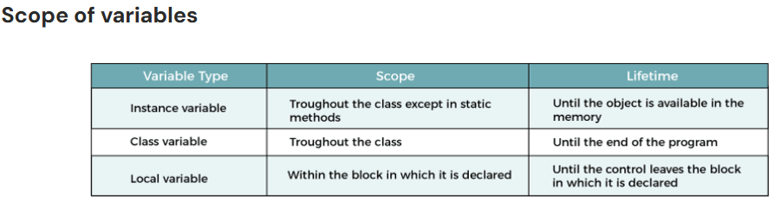

Project - Build a Student Grade & Honor Roll Tracker
This project bridges your fundamental knowledge (I/O, logic, and functions) with the next set of essential Java concepts: Strings, Arrays, Wrapper Classes/Type Casting, and Basic Classes/Objects, inheritance and Polymorphism.
The Goal
Build an application that reads a student's raw data string from user.
Extracts their numeric grades into an array, calculates their average, and generates an automated report profile card.
This UnifiedTracker.java step-by-step evolution of GradeTracker application.

Task 1: Read messy Student Names from user
- Concept: Strings and String Manipulation (.trim(), .substring(), .toUpperCase())  - Goal: Capture a messy text string from the keyboard, clean it, and format it properly. | 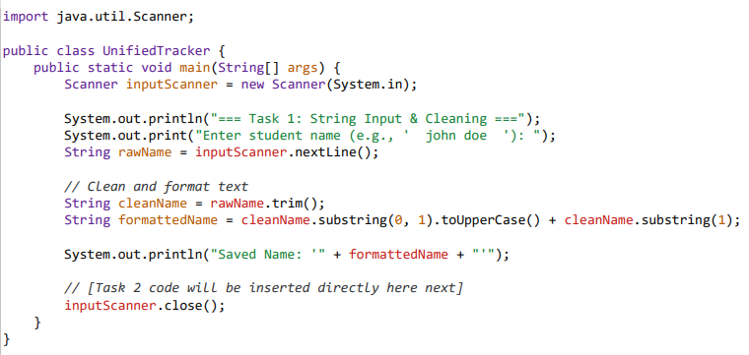
Step B: Use the Object inside your Main Runner program  Update your main running file (GradeTracker.java) to make a live instance from your blueprint: | public class GradeTracker {  public static void main(String[] args) {  // 1. Prepare data variables  String processedName = "Alex Smith";  int[] scores = {95, 88, 91, 94};  // 2. OOP Concept: Instantiate a real Student object container from our blueprint  Student currentStudent = new Student(processedName, scores);  // 3. Ask the object to execute its embedded logic method  System.out.println("=== Final Report Card ===");  System.out.println("Student Profile Name: " + currentStudent.name);  if (currentStudent.qualifiesForHonorRoll()) {  System.out.println("Status: CONGRATULATIONS! Placed on the Academic Honor Roll.");  } else {  System.out.println("Status: Satisfactory standing.");  }  }  }

Task 2: Request user to input Math and Science grade and calculate the average
New Concepts: Type Casting & Wrapper Classes (Integer.parseInt())
Parse the use given math integers, and use type casting for a precise decimal average.

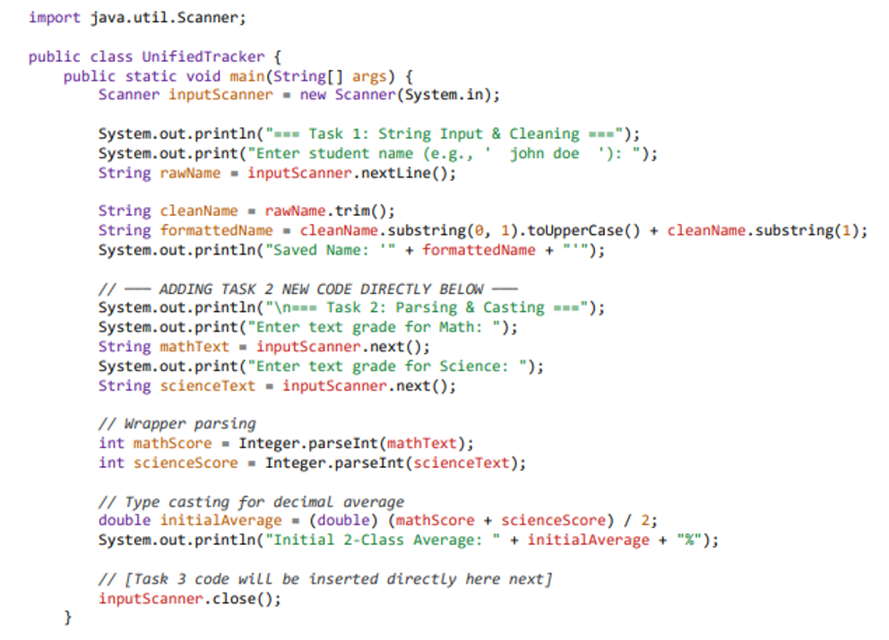

Task 3: Scale Up to a Full Schedule.
- Concept: (Arrays & Loops)
- Goal: Instead of calculating just Math and Science as loose variables.
Ask how many total classes they have, create an Array of that size, and use a for loop to capture everything dynamically.
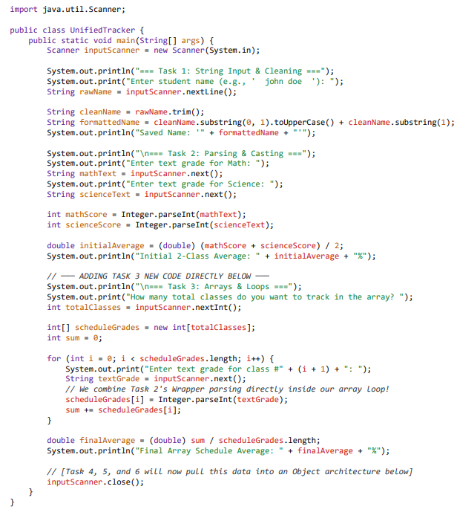

Task 4: Clean the Main Architecture (Introducing Multiple Functions)
Introduce 4 helper functions outside of main. We then update main to pass its data straight into these functions, keeping the execution flow clean and readable.

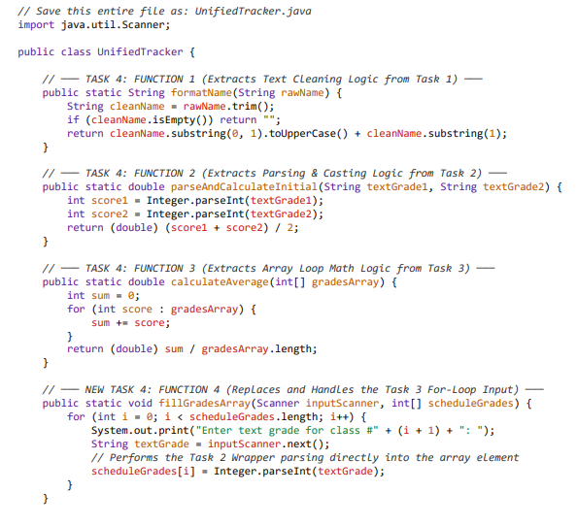

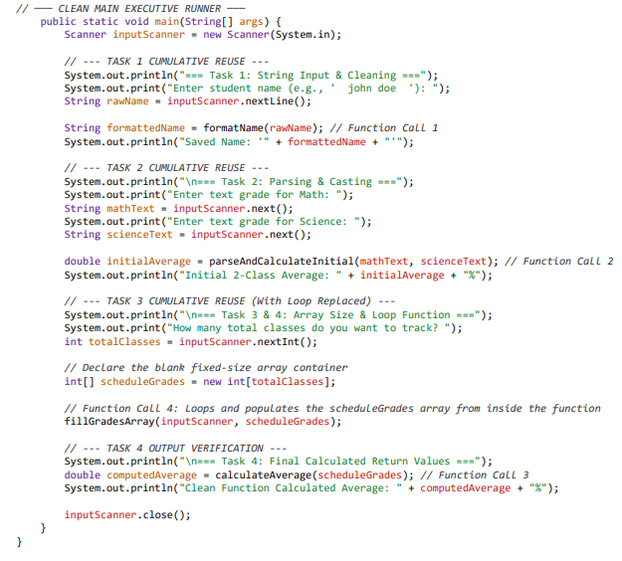

Task 5: OOPs concepts – class, encapsulation
- Concept: OOP - Encapsulation
- Goal: Instead of loose data and method. Create a Class Student with
Data: | Student name, grades
Subject list | static String[]containing your subject names: Math, Science, Social, English, and French
Constructor | In Constructor, ask user to input grades for above subjects.
Private Method | fillGradesArray( )  Instead of asking the user for a raw total number of classes, the program automatically loops through these specific subjects, prompts for each one by name, and maps them to their respective positions in the array.
Private Method | Instead of formatting in Class Main. Format here.  private String formatName(String rawName)
Public Method | calculateAverage()  Loop through data: grades[] and calculate grade.

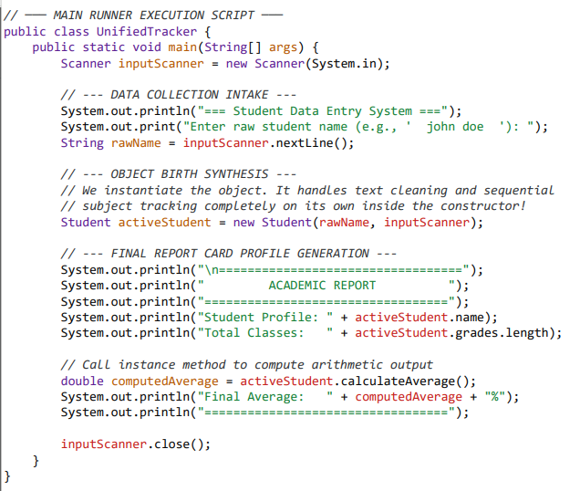

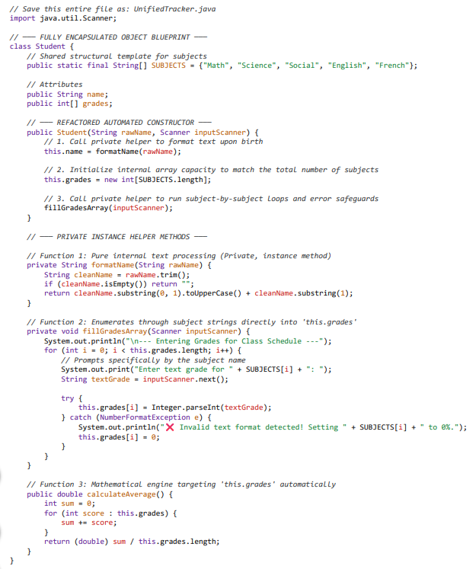

Task 6: OOPs concepts – Data hiding
Now that your fundamental structural framework is locked down, let me know if you would like to proceed with The Data Hiding Step: Converting public String name to private String name and creating an official Getter Method (public String getName()) to implement proper professional Java security standards.
- Private Fields: name and grades fields are changed to private. The main method can no longer access activeStudent.name or activeStudent.grades.length directly without causing a compilation error.
- Getter Methods: We introduce getName() and getGrades() to allow controlled, read-only access to our private fields. By using Getters, your main program gets the variables it needs, but the object maintains absolute authority over its internal state.
- Zero Code Discarded: The fixed SUBJECTS array layout, error-trapping inputs, and formatting mechanics remain fully intact

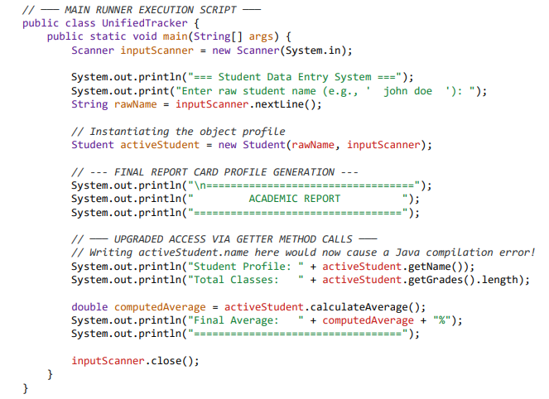

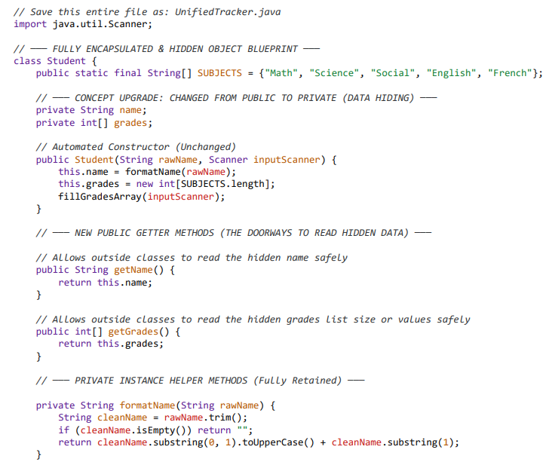
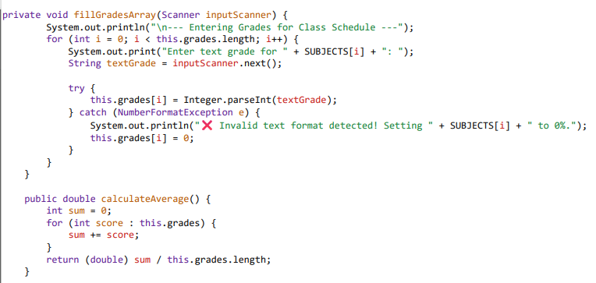

Task 7: OOPs – Inheritance and overridding
- Create a child class called GraduateStudent that extends your base Student. This allows the child class to automatically reuse the fields, getters, array logic, and validation rules from the parent class without rewriting a single line of that code.
- Add Unique Child Traits: We add a new private attribute unique to graduate students: private String thesisTitle, along with its own public getter (getThesisTitle()).
- introduce an status metric called qualifiesForHonorRoll() inside the parent class, which checks if a student has an average of 90.0% or higher. Then, using Method Overriding, the GraduateStudent child class will rewrite this exact method to enforce a stricter rule: graduate students must maintain a 95.0% or higher to make the honor roll.

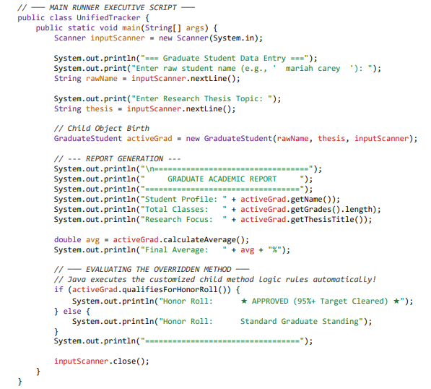

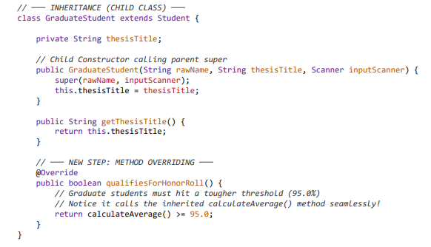

- Parent Method: We add public boolean qualifiesForHonorRoll() inside the Student class with a base threshold of >= 90.0.
- Method Overriding: We copy the exact same method signature inside GraduateStudent, use the @Override annotation tag, and change the logic check to >= 95.0.
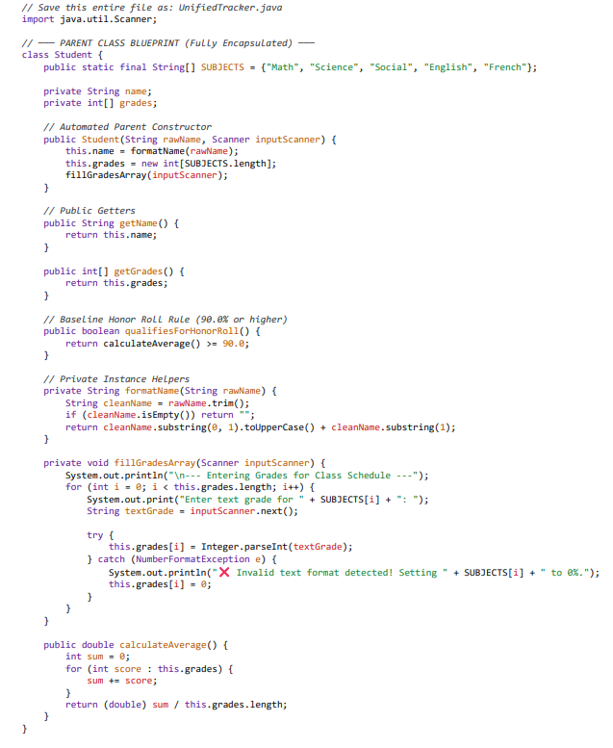

Task 8: OOPS – Polymorphism
Instead of creating separate, rigid code streams for each student type, polymorphism lets you treat both regular Student objects and GraduateStudent objects as if they belong to the same parent type Student.
- Adjust our main method to instantiate a mix of profiles and store them inside a single Parent Array. We will then use a single loop to scan the directory, and Java will automatically figure out which honor roll logic rules to apply to each student at runtime.
- We have wrapped the entire application inside an infinite loop (while (true)), which allows it to run dynamically for as many students as you want. At the start of each turn, the program asks if you want to add a Regular Student, a Graduate Student, or Exit the system. If you choose to exit, the program safely terminates the loop using the break keyword.
What Changes in This Step:
- Dynamic Program Loop (while (true)): The application runs continuously until explicitly stopped.
- User-Driven Object Decisions: An interactive selection menu lets the user choose the specific object type to manufacture on the fly.
- Parent Polymorphic Array: We build a directory array using the parent blueprint type: Student[] schoolRoll = new Student[2];.
- Dynamic Slots: Slot 0 is assigned a regular Student object, and slot 1 is assigned a GraduateStudent child object. Java allows this because a graduate student is a student. [1]
- Runtime Magic: Inside our processing loop, the exact same method call (current.qualifiesForHonorRoll()) switches its underlying engine automatically—applying the 90.0% rule to slot 0 and the stricter 95.0% rule to slot 1 break: Instantly destroys the infinite loop the millisecond choice 3 is entered.
- continue: Safely throws the application back to the menu start if the user inputs an unexpected integer.
- instanceof: A new helper keyword used at the end to check: "Is the student currently passing through the engine a graduate student?" If yes, it safely unlocks and displays their hidden thesis title.
This seems like production-grade console application! Congratulation on First project.

Note:
No changes to class Student and class GraduateStudent for adding polymorphism.
Only adjust main method to instantiate a mix of profiles and store them inside a single Parent Array.

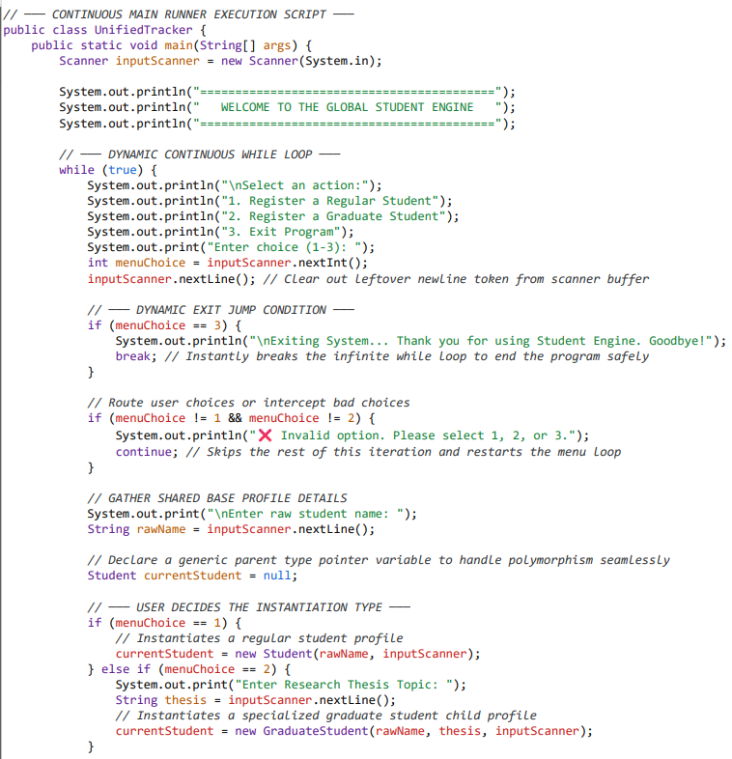

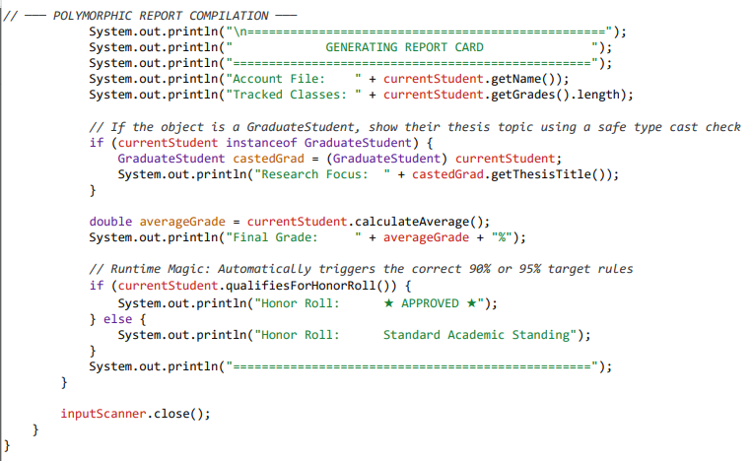

Task 9: File Input Output
Instead of just printing the final report card text to your screen using System.out, we will simultaneously write that exact text data to a permanent file named report_cards.txt. Each time you add a new student, the program will append (add onto) the bottom of that file so your history is never lost.
Note:
No changes to class Student and class GraduateStudent for adding File Input Output.
Only adjust main method to automatically save these report cards to your hard drive, we will introduce File I/O (Input/Output) using Java's built-in FileWriter and IOException error handling.

What We Are Adding in This Final Step:
- New Package Imports: We add import java.io.FileWriter; and import java.io.IOException; to the very top of our file to pull Java's file-writing tools off the digital library shelf.
- The FileWriter Tool: We open a writer channel inside our report generation segment. By passing true as a configuration parameter (new FileWriter("report_cards.txt", true)), we tell Java to update and append to the text file rather than wiping it clean every loop cycle.
- Mandatory File Try-Catch: Writing files to a hard drive carries real-world risks (like your hard drive running out of space or being locked). Java forces us to wrap our file-writing code inside a try-catch block to handle an IOException safely without crashing.

Verifying Your Work

Once you compile and run this program, add a couple of student records, and select option 3 to exit.
Look inside your project's main folder—you will see a brand-new file named report_cards.txt created entirely by your code. If you open it with Notepad or any basic text editor, you will find your clean academic records saved exactly as specified on your disk [local].

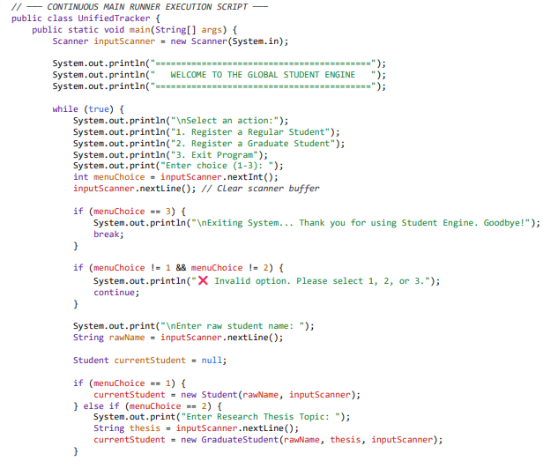

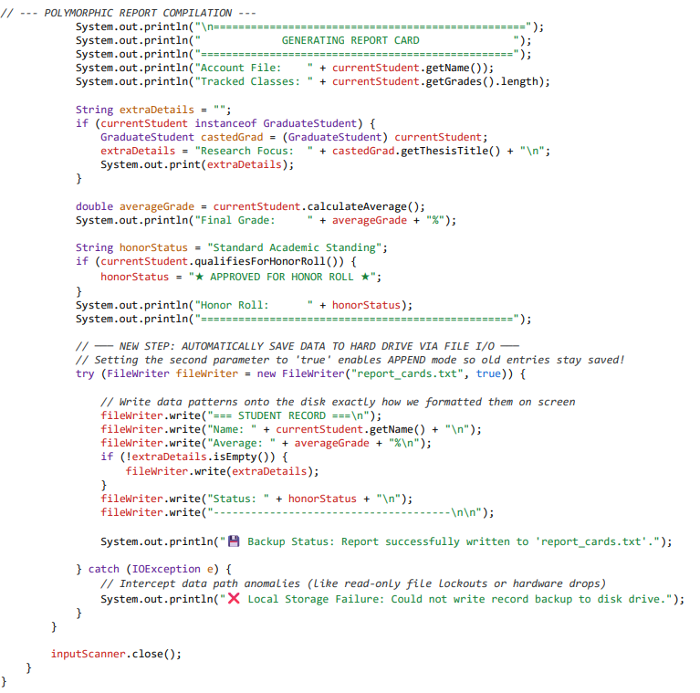

Task 10: Read back from on start-up.
- Read your saved records back into the program when the application boots up, use Java's built-in File and Scanner tools.
- Instead of jumping straight into the interactive loop, the program will look for report_cards.txt the exact moment it starts. If the file exists, the program should open it, read it line-by-line, and print the historical records directly to the screen before presenting the registration menu.

What We Are Adding in This Step:
- New Package Import: We add import java.io.File; to manage file path lookups on your operating system.
- Boot-Up Initializer Function: We introduce a new public static method called loadPastRecords() outside of main.
- The File Reading Process: We pass a File object into a new Scanner. The scanner uses a while (fileScanner.hasNextLine()) loop to read every single line of text from the file until it hits the very end.
- Zero Code Discarded: The FileWriter append logic, object structure, and error-handling mechanics remain completely active.

How to Test this Evolution:
- Compile and run the code. If it's your very first time running it with this updated logic, it will say
“No historical database found”
- Add a student (e.g., "Sam Wilson") and let the program log their grades to disk.
- Exit the application using choice 3.
- Run the program a second time. Notice what happens instantly on boot-up! The loadPastRecords() block finds the file and outputs Sam's entire profile right back onto your console interface before asking you for new inputs.

Future improvements
- Learn about ArrayLists: Upgrade UnifiedTracker.java so that instead of just flashing reports on screen, the system keeps an active in-memory list tracking every student registered during that loop cycle.
- Log error for duplicate entry.
- Add student member variables for student ID, Second name etc.
- Add UI for user interaction.

