Non-Primitive Data Type or Reference Data Types
The Reference Data Types will contain a memory address of variable values because the reference types won’t store the variable value directly in memory. They are strings, objects, arrays, etc.
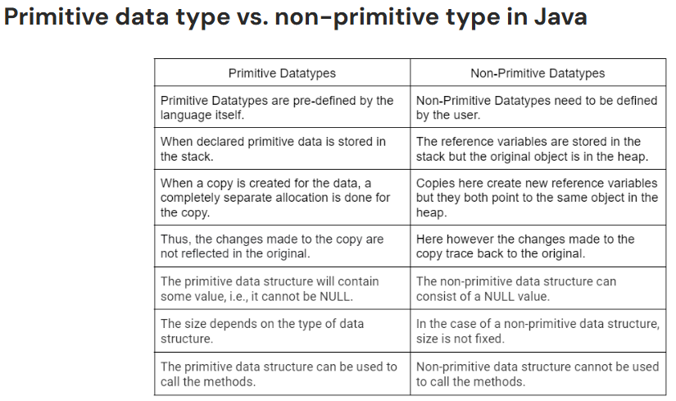

Single-Dimensional Arrays
Lesson link: https://www.w3schools.com/java/java_arrays.asp

- An array is an ordered, fixed-size container that allows you to store multiple values of the same data type inside a single variable name.
- Instead of creating ten separate variables to hold ten student test scores (score1, score2, etc.), you create one single array variable named scores that holds all ten values together in a neat list.
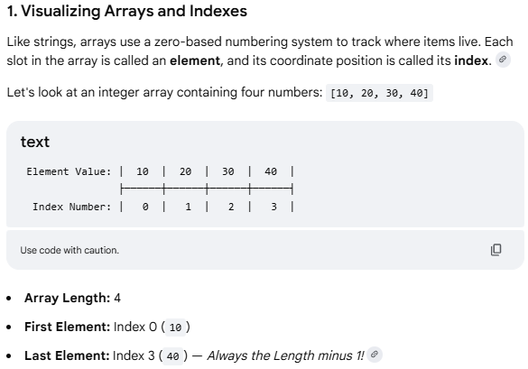

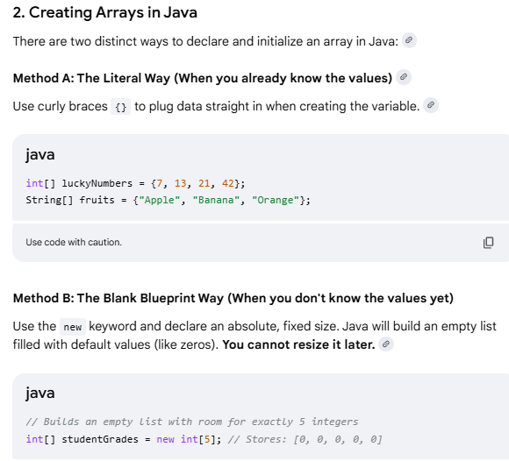
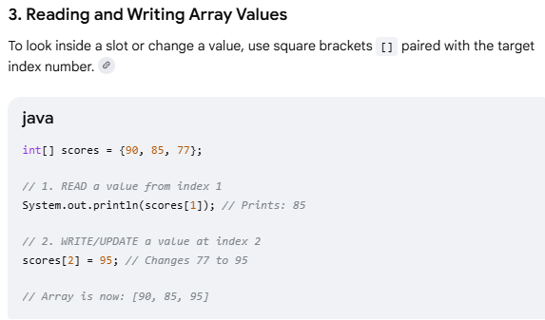
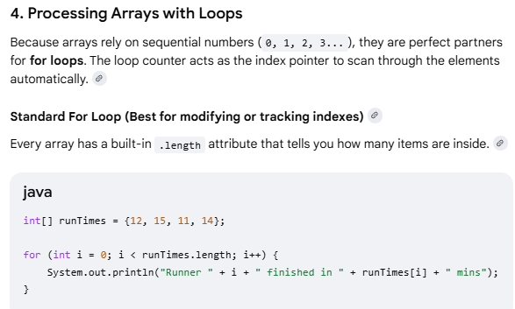
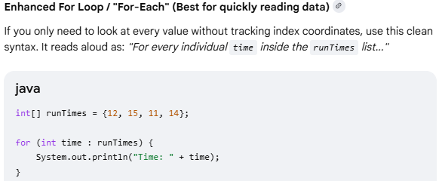

Strings
Lesson link
https://www.w3schools.com/java/java_strings.asp
- Strings are defined as an array of characters / sequence of characters that is held in single variable. Used to represent text (like names, passwords, or sentences).
- Character array (not String) is a collection of separate char-type entities accessed by indexing.
- Unlike C/C++, Java strings are not terminated with null characters.
- Syntax: Declaring a string
- <String_Type> <string_variable> = “<sequence_of_string>”;
- String s1 = "Hello"; // Stored in String Pool
- String s2 = "Hello"; // Reuses the same object from the String Pool
- String s3 = new String("Hello"); // Creates a new String object outside the Pool
- The Key Rule: Strings are Immutable
That is once String is created, it can never be changed in memory.
String manipulation methods that "modify" text, Java doesn't alter the original word. Instead, it quietly creates a brand-new String in the background and hands you fresh copy.
- Strings is object and provides built-in function (methods) to search, cut, clean, and modify text.
- Built-in String operation functions are, such as finding length, extracting substrings, replacing characters, and more.
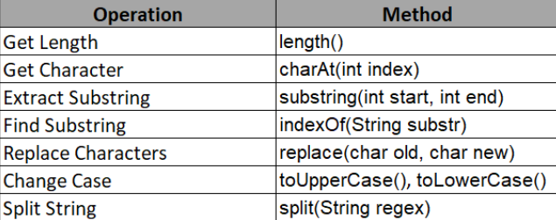

- Built-in String comparing functions
Golden Rule of Comparison, use equals() Instead of ==. The == operator compares references, not the actual content of the strings, whereas equals() compares the values.
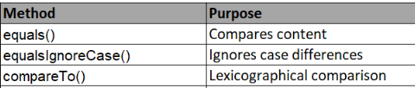

- Substring functions
Extracts a smaller piece of text out of a larger String. It takes a starting index and an optional ending index. Note: The ending index is exclusive (Java stops right before that number).

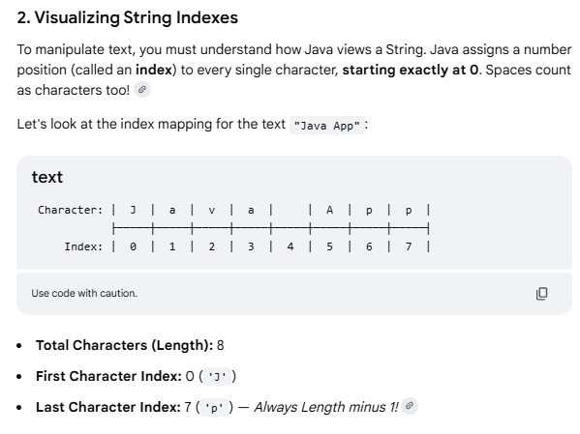
String phrase = "Superstar";

// Cut from index 5 all the way to the end String
endPiece = phrase.substring(5); // "star"

// Cut from index 0 up to (but not including) index 5
String frontPiece = phrase.substring(0, 5); // "Super"

- Advance methods
String.format() allows you to create formatted strings dynamically.
String formatted = String.format("Name: %s, Age: %d", "Alice", 30);
System.out.println(formatted); // "Name: Alice, Age: 30"

String joined = String.join("-", "2023", "12", "31"); // "2023-12-31"

String s = " Hello ";
System.out.println(s.strip()); // "Hello" Removes leading and trailing whitespace.
System.out.println(" ".isBlank()); // true
System.out.println("Hi".repeat(3)); // "HiHiHi"

Regular Expressions & Pattern Matching
String email = "user@example.com";
boolean isValid = email.matches("^[\\w.-]+@[\\w.-]+\\.[a-zA-Z]{2,6}$");
- Built-in Java methods used to modify
String CSVData = "Pizza,Burgers,Tacos";
String[] foodList = CSVData.split(",");

// foodList[0] is now "Pizza"
// foodList[1] is now "Burgers"
// foodList[2] is now "Tacos"

