Project - Build a Student Grade & Honor Roll Tracker 20
Task 1: Read messy Student Names from user 20
Task 2: Request user to input Math and Science grade and calculate the average 22
Task 3: Scale Up to a Full Schedule. 23
Task 4: Clean the Main Architecture (Introducing Multiple Functions) 24
Task 5: OOPs concepts – class, encapsulation 26
Task 6: OOPs concepts – Data hiding 28
Task 7: OOPs – Inheritance and overridding 31
Task 8: OOPS – Polymorphism 34
Task 9: File Input Output 37
Task 10: Read back from on start-up. 40

Project - Build a Student Grade & Honor Roll Tracker
This project bridges your fundamental knowledge (I/O, logic, and functions) with the next set of essential Java concepts: Strings, Arrays, Wrapper Classes/Type Casting, and Basic Classes/Objects, inheritance and Polymorphism.
The Goal
Build an application that reads a student's raw data string from user.
Extracts their numeric grades into an array, calculates their average, and generates an automated report profile card.
This UnifiedTracker.java step-by-step evolution of GradeTracker application.

Task 1: Read messy Student Names from user
- Concept: Strings and String Manipulation (.trim(), .substring(), .toUpperCase())  - Goal: Capture a messy text string from the keyboard, clean it, and format it properly. | 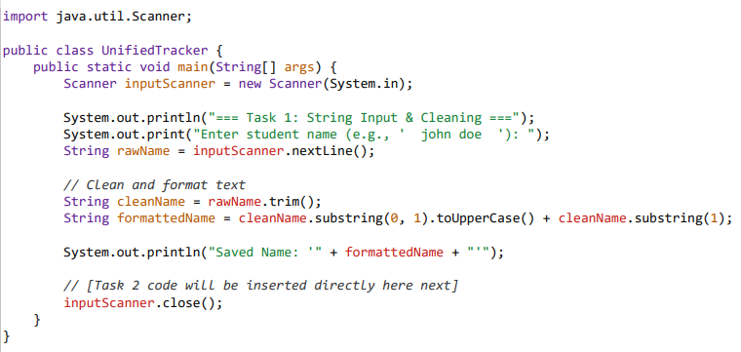
Step B: Use the Object inside your Main Runner program  Update your main running file (GradeTracker.java) to make a live instance from your blueprint: | public class GradeTracker {  public static void main(String[] args) {  // 1. Prepare data variables  String processedName = "Alex Smith";  int[] scores = {95, 88, 91, 94};  // 2. OOP Concept: Instantiate a real Student object container from our blueprint  Student currentStudent = new Student(processedName, scores);  // 3. Ask the object to execute its embedded logic method  System.out.println("=== Final Report Card ===");  System.out.println("Student Profile Name: " + currentStudent.name);  if (currentStudent.qualifiesForHonorRoll()) {  System.out.println("Status: CONGRATULATIONS! Placed on the Academic Honor Roll.");  } else {  System.out.println("Status: Satisfactory standing.");  }  }  }

Task 2: Request user to input Math and Science grade and calculate the average
New Concepts: Type Casting & Wrapper Classes (Integer.parseInt())
Parse the use given math integers, and use type casting for a precise decimal average.

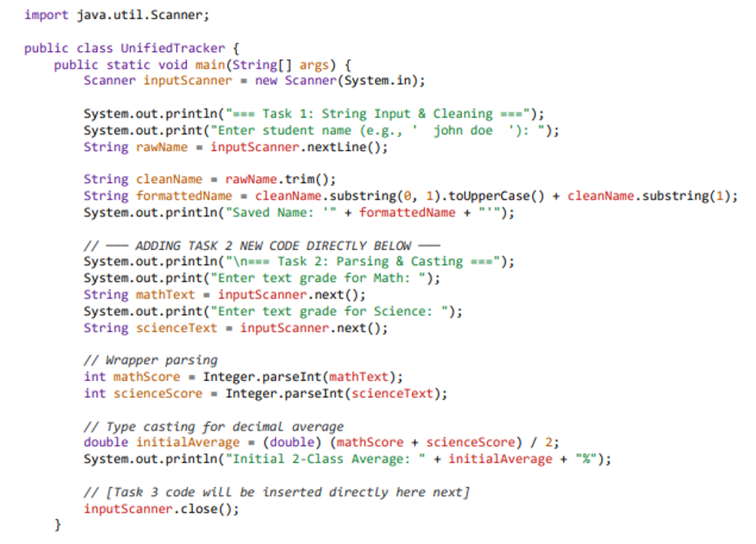

Task 3: Scale Up to a Full Schedule.
- Concept: (Arrays & Loops)
- Goal: Instead of calculating just Math and Science as loose variables.
Ask how many total classes they have, create an Array of that size, and use a for loop to capture everything dynamically.
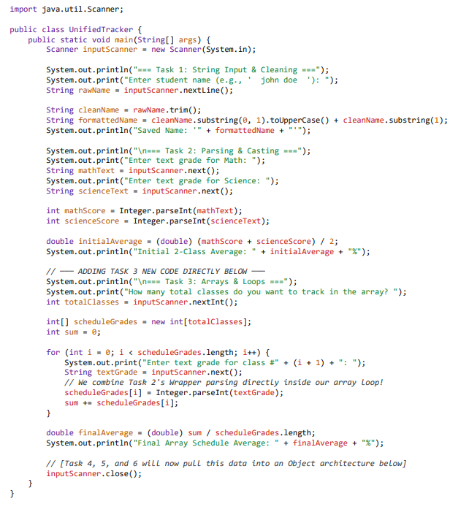

Task 4: Clean the Main Architecture (Introducing Multiple Functions)
Introduce 4 helper functions outside of main. We then update main to pass its data straight into these functions, keeping the execution flow clean and readable.

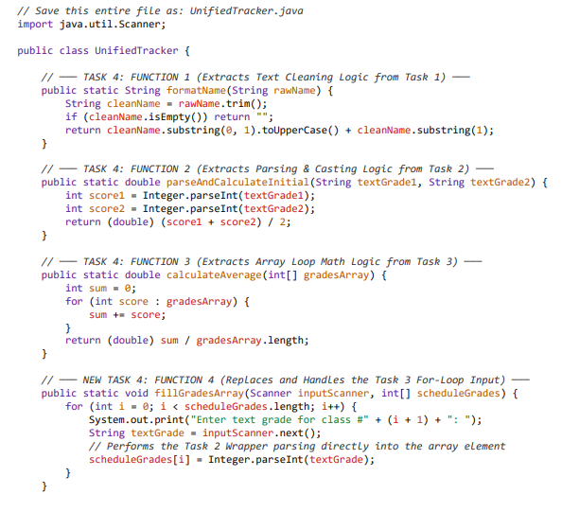

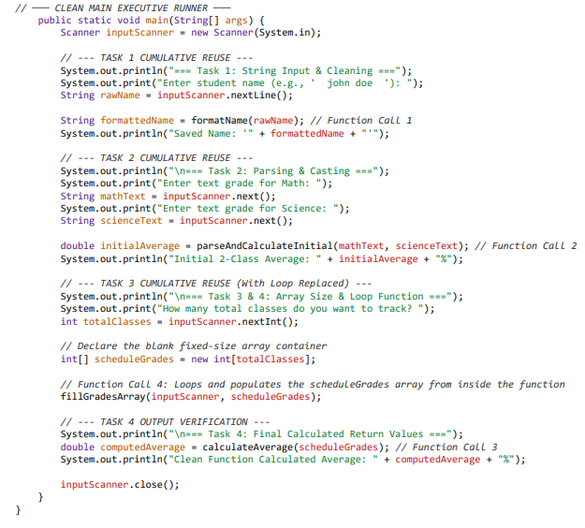

Task 5: OOPs concepts – class, encapsulation
- Concept: OOP - Encapsulation
- Goal: Instead of loose data and method. Create a Class Student with
Data: | Student name, grades
Subject list | static String[]containing your subject names: Math, Science, Social, English, and French
Constructor | In Constructor, ask user to input grades for above subjects.
Private Method | fillGradesArray( )  Instead of asking the user for a raw total number of classes, the program automatically loops through these specific subjects, prompts for each one by name, and maps them to their respective positions in the array.
Private Method | Instead of formatting in Class Main. Format here.  private String formatName(String rawName)
Public Method | calculateAverage()  Loop through data: grades[] and calculate grade.

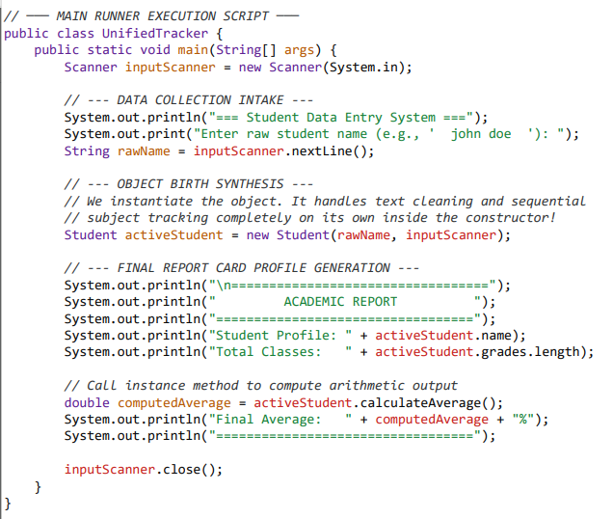

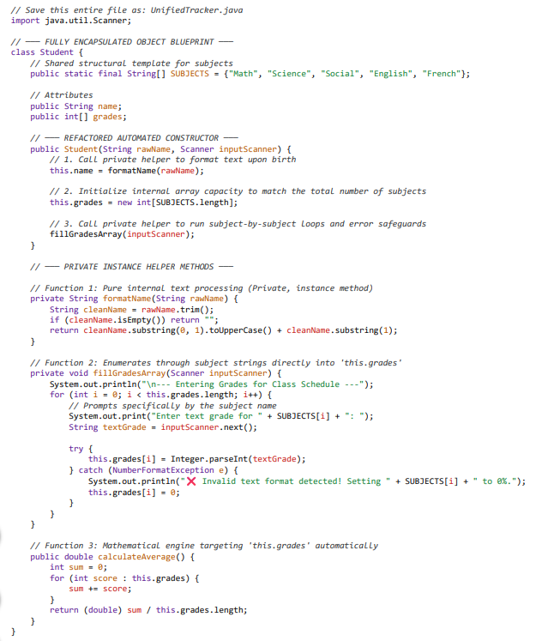

Task 6: OOPs concepts – Data hiding
Now that your fundamental structural framework is locked down, let me know if you would like to proceed with The Data Hiding Step: Converting public String name to private String name and creating an official Getter Method (public String getName()) to implement proper professional Java security standards.
- Private Fields: name and grades fields are changed to private. The main method can no longer access activeStudent.name or activeStudent.grades.length directly without causing a compilation error.
- Getter Methods: We introduce getName() and getGrades() to allow controlled, read-only access to our private fields. By using Getters, your main program gets the variables it needs, but the object maintains absolute authority over its internal state.
- Zero Code Discarded: The fixed SUBJECTS array layout, error-trapping inputs, and formatting mechanics remain fully intact

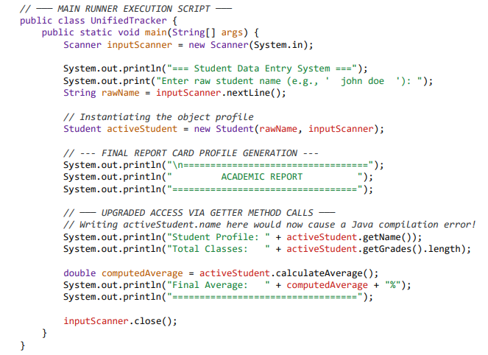

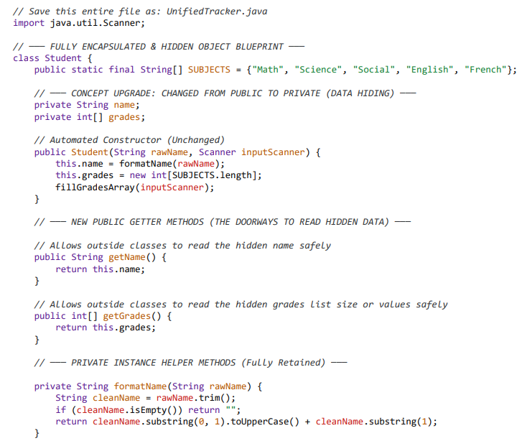
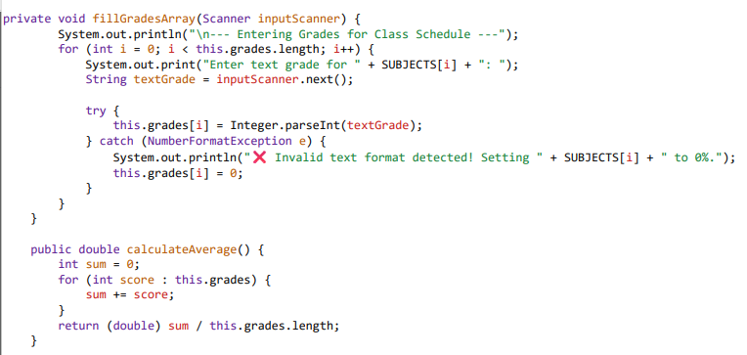

Task 7: OOPs – Inheritance and overridding
- Create a child class called GraduateStudent that extends your base Student. This allows the child class to automatically reuse the fields, getters, array logic, and validation rules from the parent class without rewriting a single line of that code.
- Add Unique Child Traits: We add a new private attribute unique to graduate students: private String thesisTitle, along with its own public getter (getThesisTitle()).
- introduce an status metric called qualifiesForHonorRoll() inside the parent class, which checks if a student has an average of 90.0% or higher. Then, using Method Overriding, the GraduateStudent child class will rewrite this exact method to enforce a stricter rule: graduate students must maintain a 95.0% or higher to make the honor roll.
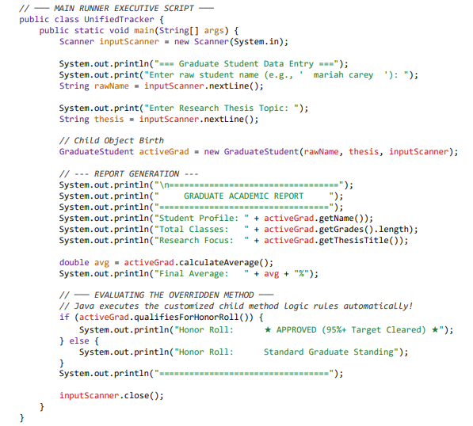

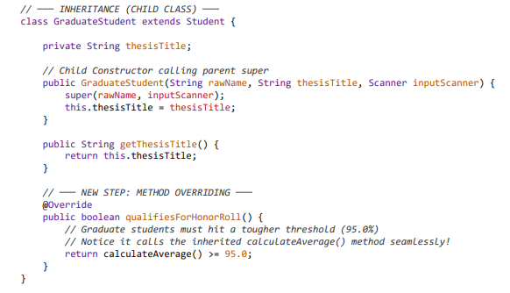
- Parent Method: We add public boolean qualifiesForHonorRoll() inside the Student class with a base threshold of >= 90.0.

- Method Overriding: We copy the exact same method signature inside GraduateStudent, use the @Override annotation tag, and change the logic check to >= 95.0.
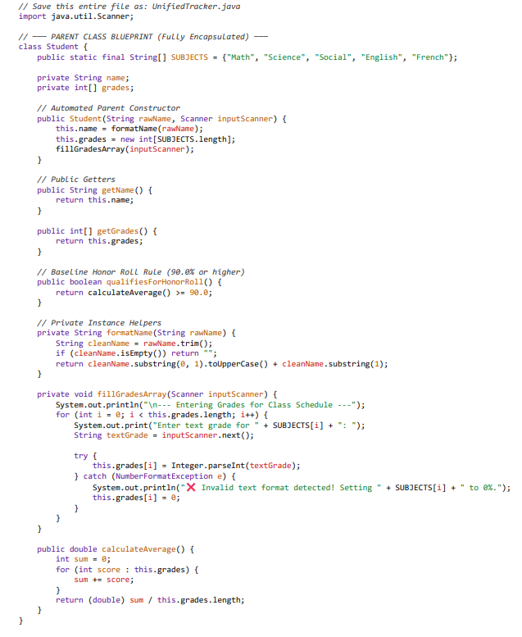

Task 8: OOPS – Polymorphism
Instead of creating separate, rigid code streams for each student type, polymorphism lets you treat both regular Student objects and GraduateStudent objects as if they belong to the same parent type Student.
- Adjust our main method to instantiate a mix of profiles and store them inside a single Parent Array. We will then use a single loop to scan the directory, and Java will automatically figure out which honor roll logic rules to apply to each student at runtime.
- We have wrapped the entire application inside an infinite loop (while (true)), which allows it to run dynamically for as many students as you want. At the start of each turn, the program asks if you want to add a Regular Student, a Graduate Student, or Exit the system. If you choose to exit, the program safely terminates the loop using the break keyword.
What Changes in This Step:
- Dynamic Program Loop (while (true)): The application runs continuously until explicitly stopped.
- User-Driven Object Decisions: An interactive selection menu lets the user choose the specific object type to manufacture on the fly.
- Parent Polymorphic Array: We build a directory array using the parent blueprint type: Student[] schoolRoll = new Student[2];.
- Dynamic Slots: Slot 0 is assigned a regular Student object, and slot 1 is assigned a GraduateStudent child object. Java allows this because a graduate student is a student. [1]
- Runtime Magic: Inside our processing loop, the exact same method call (current.qualifiesForHonorRoll()) switches its underlying engine automatically—applying the 90.0% rule to slot 0 and the stricter 95.0% rule to slot 1 break: Instantly destroys the infinite loop the millisecond choice 3 is entered.
- continue: Safely throws the application back to the menu start if the user inputs an unexpected integer.
- instanceof: A new helper keyword used at the end to check: "Is the student currently passing through the engine a graduate student?" If yes, it safely unlocks and displays their hidden thesis title.
This seems like production-grade console application! Congratulation on First project.

Note:
No changes to class Student and class GraduateStudent for adding polymorphism.
Only adjust main method to instantiate a mix of profiles and store them inside a single Parent Array.

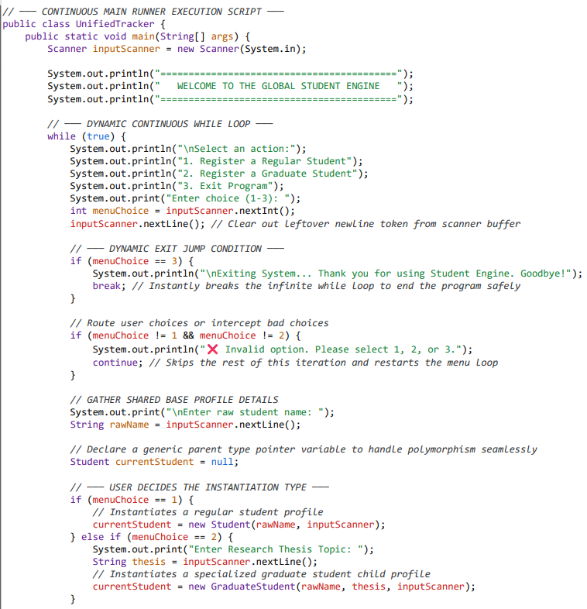

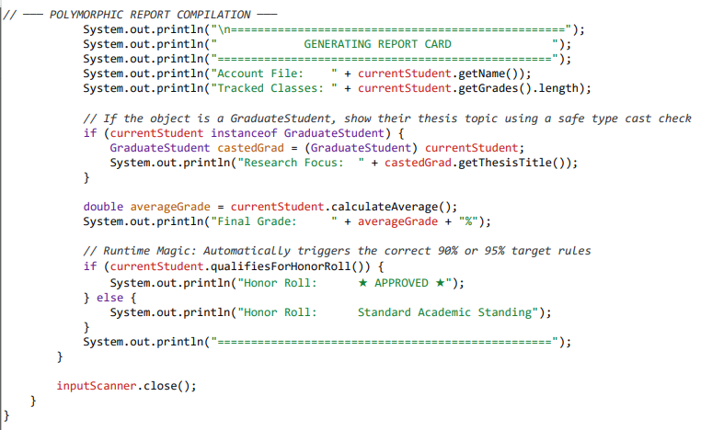

Task 9: File Input Output
Instead of just printing the final report card text to your screen using System.out, we will simultaneously write that exact text data to a permanent file named report_cards.txt. Each time you add a new student, the program will append (add onto) the bottom of that file so your history is never lost.
Note:
No changes to class Student and class GraduateStudent for adding File Input Output.
Only adjust main method to automatically save these report cards to your hard drive, we will introduce File I/O (Input/Output) using Java's built-in FileWriter and IOException error handling.

What We Are Adding in This Final Step:
- New Package Imports: We add import java.io.FileWriter; and import java.io.IOException; to the very top of our file to pull Java's file-writing tools off the digital library shelf.
- The FileWriter Tool: We open a writer channel inside our report generation segment. By passing true as a configuration parameter (new FileWriter("report_cards.txt", true)), we tell Java to update and append to the text file rather than wiping it clean every loop cycle.
- Mandatory File Try-Catch: Writing files to a hard drive carries real-world risks (like your hard drive running out of space or being locked). Java forces us to wrap our file-writing code inside a try-catch block to handle an IOException safely without crashing.

Verifying Your Work

Once you compile and run this program, add a couple of student records, and select option 3 to exit.
Look inside your project's main folder—you will see a brand-new file named report_cards.txt created entirely by your code. If you open it with Notepad or any basic text editor, you will find your clean academic records saved exactly as specified on your disk [local].

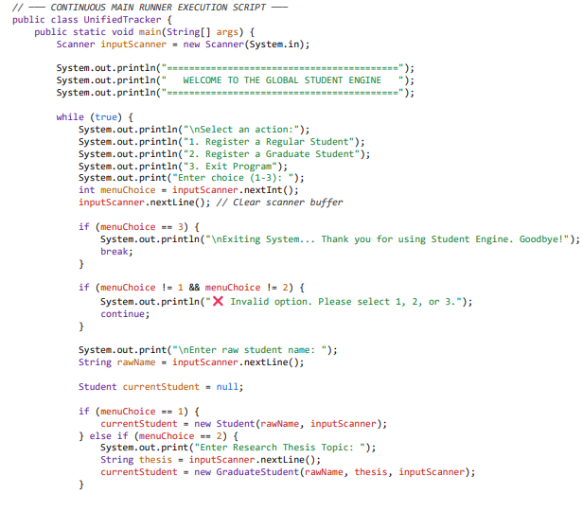

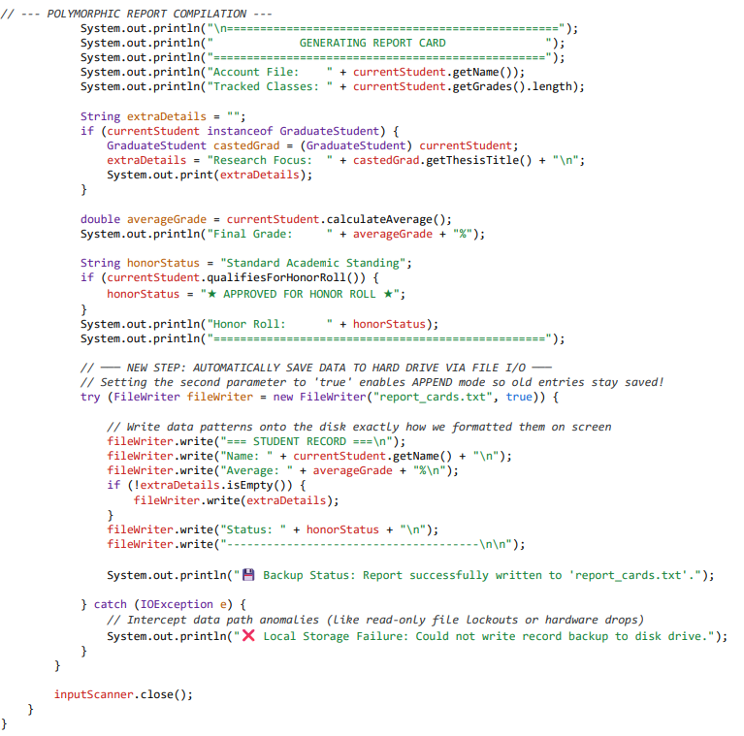

Task 10: Read back from on start-up.
- Read your saved records back into the program when the application boots up, use Java's built-in File and Scanner tools.
- Instead of jumping straight into the interactive loop, the program will look for report_cards.txt the exact moment it starts. If the file exists, the program should open it, read it line-by-line, and print the historical records directly to the screen before presenting the registration menu.

What We Are Adding in This Step:
- New Package Import: We add import java.io.File; to manage file path lookups on your operating system.
- Boot-Up Initializer Function: We introduce a new public static method called loadPastRecords() outside of main.
- The File Reading Process: We pass a File object into a new Scanner. The scanner uses a while (fileScanner.hasNextLine()) loop to read every single line of text from the file until it hits the very end.
- Zero Code Discarded: The FileWriter append logic, object structure, and error-handling mechanics remain completely active.

How to Test this Evolution:
- Compile and run the code. If it's your very first time running it with this updated logic, it will say
“No historical database found”
- Add a student (e.g., "Sam Wilson") and let the program log their grades to disk.
- Exit the application using choice 3.
- Run the program a second time. Notice what happens instantly on boot-up! The loadPastRecords() block finds the file and outputs Sam's entire profile right back onto your console interface before asking you for new inputs.

Future improvements
- Learn about ArrayLists: Upgrade UnifiedTracker.java so that instead of just flashing reports on screen, the system keeps an active in-memory list tracking every student registered during that loop cycle.
- Log error for duplicate entry.
- Add student member variables for student ID, Second name etc.
- Add UI for user interaction.

