Inheritance
Inheritance is one of the pillars of Object-Oriented Programming. It allows a new class to inherit (absorb) all the attributes and methods of an existing class automatically.
Think of inheritance like genetic traits. A child inherits traits from their parent, but the child can also have unique traits of their own.

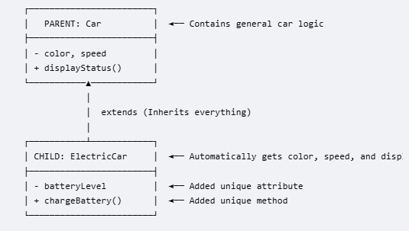 | - Parent Class (Superclass): The general, base class that holds common traits (e.g., Car).  - Child Class (Subclass): The specialized class that inherits everything from the parent but adds unique twists (e.g., an ElectricCar).  - The Keyword: extends  In Java, you use the extends keyword to establish an inheritance relationship.  - @Override Annotation: You place this helper tag right above the child method. It tells Java to double-check your code to ensure you didn't accidentally typo the name or parameters.
Why Use Inheritance?
- Code Reusability: You don't have to rewrite code for color, speed, or displayStatus() if you decide to build a GasCar, a Truck, or a RaceCar later. You just extend Car.
- While inheritance gives the child class all the parent’s methods automatically, sometimes the default parent behavior isn't quite right for the child. Method Overriding occurs when a child class rewrites a method it inherited from its parent class to give it a new, specialized behavior. Child keep the exact same method name and inputs, but change what happens inside the execution brackets { }.
• Same Name: The method name in the child class must exactly match the parent class.
• Same Parameters: The inputs (arguments) must match exactly.
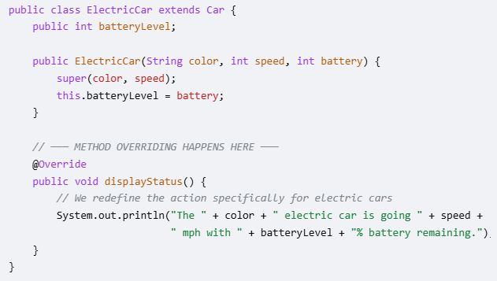

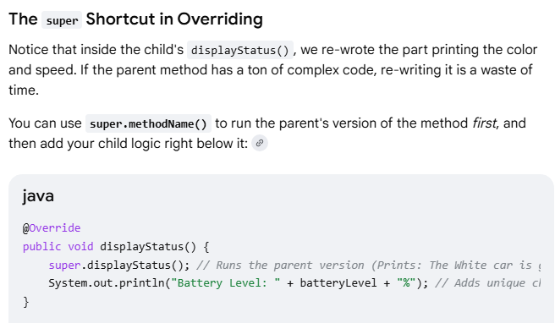

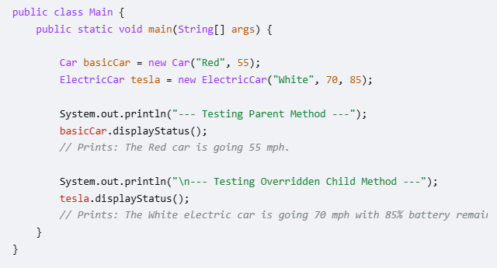
- Java is smart under the hood. Even though both objects are used. displayStatus(), Java looks at the specific object type at runtime and executes the customized version for the ElectricCar.
- If not Override, Java fall back to base class function.

