Task 3: OOPs concepts – class, encapsulation, package
- Concept: OOP – Encapsulation
- The package structure is now in place: Student is public in Student.java, and the runner imports Student.Student. I’m compiling from the source root and running the main class now; this confirms the package link and also catches stale old classes.
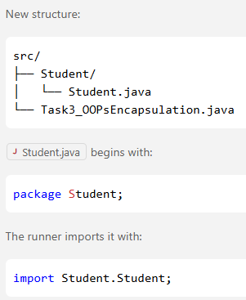
- Goal: Instead of loose data and method. Create a Class Student with
Data: | Student name, grades
Subject list | static String[]containing your subject names: Math, Science, Social, English, and French
Constructor | In Constructor, ask user to input grades for above subjects.
Private Method | fillGradesArray( )  Instead of asking the user for a raw total number of classes, the program automatically loops through these specific subjects, prompts for each one by name, and maps them to their respective positions in the array.
Private Method | Instead of formatting in Class Main. Format here.  private String formatName(String rawName)
Public Method | calculateAverage()  Loop through data: grades[] and calculate grade.

package Student;

import java.util.Scanner;

public class Student {
public static final String[] SUBJECTS = {"Math", "Science", "Social", "English", "French"};

public String name;
public int[] grades;

public Student(String rawName, Scanner inputScanner) {
this.name = formatName(rawName);
this.grades = new int[SUBJECTS.length];
fillGradesArray(inputScanner);
}

private String formatName(String rawName) {
String cleanName = rawName.trim();
if (cleanName.isEmpty()) return "";
return cleanName.substring(0, 1).toUpperCase() + cleanName.substring(1);
}

private void fillGradesArray(Scanner inputScanner) {
System.out.println("\n--- Entering Grades for Class Schedule ---");
for (int i = 0; i < this.grades.length; i++) {
System.out.print("Enter text grade for " + SUBJECTS[i] + ": ");
String textGrade = inputScanner.next();
try {
this.grades[i] = Integer.parseInt(textGrade);
} catch (NumberFormatException e) {
System.out.println("Invalid text format detected! Setting " + SUBJECTS[i] + " to 0%.");
this.grades[i] = 0;
}
}
}

public double calculateAverage() {
int sum = 0;
for (int score : this.grades) {
sum += score;
}
return (double) sum / this.grades.length;
}
}
import java.util.Scanner;
import Student.Student;

// ─── MAIN RUNNER EXECUTION SCRIPT ───
public class Task3_OOPsEncapsulation {
public static void main(String[] args) {
Scanner inputScanner = new Scanner(System.in);

// --- DATA COLLECTION INTAKE ---
System.out.println("=== Student Data Entry System ===");
System.out.print("Enter raw student name (e.g., ' john doe '): ");
String rawName = inputScanner.nextLine();

// --- OBJECT BIRTH SYNTHESIS ---
// We instantiate the object. It handles text cleaning and sequential
// subject tracking completely on its own inside the constructor!
Student activeStudent = new Student(rawName, inputScanner);

// --- FINAL REPORT CARD PROFILE GENERATION ---
System.out.println("\n==================================");
System.out.println(" ACADEMIC REPORT ");
System.out.println("==================================");
System.out.println("Student Profile: " + activeStudent.name);
System.out.println("Total Classes: " + activeStudent.grades.length);

// Call instance method to compute arithmetic output
double computedAverage = activeStudent.calculateAverage();
System.out.println("Final Average: " + computedAverage + "%");
System.out.println("==================================");

inputScanner.close();
}
}

