**EE5321, Spring 2019**

**Homework 4: Free Final Time Optimal Control – Due Mar 28**

**Rodrigues Reema Carolene Ronald**

**Student ID : 1001386598**

**Problem 1**

Simulation:

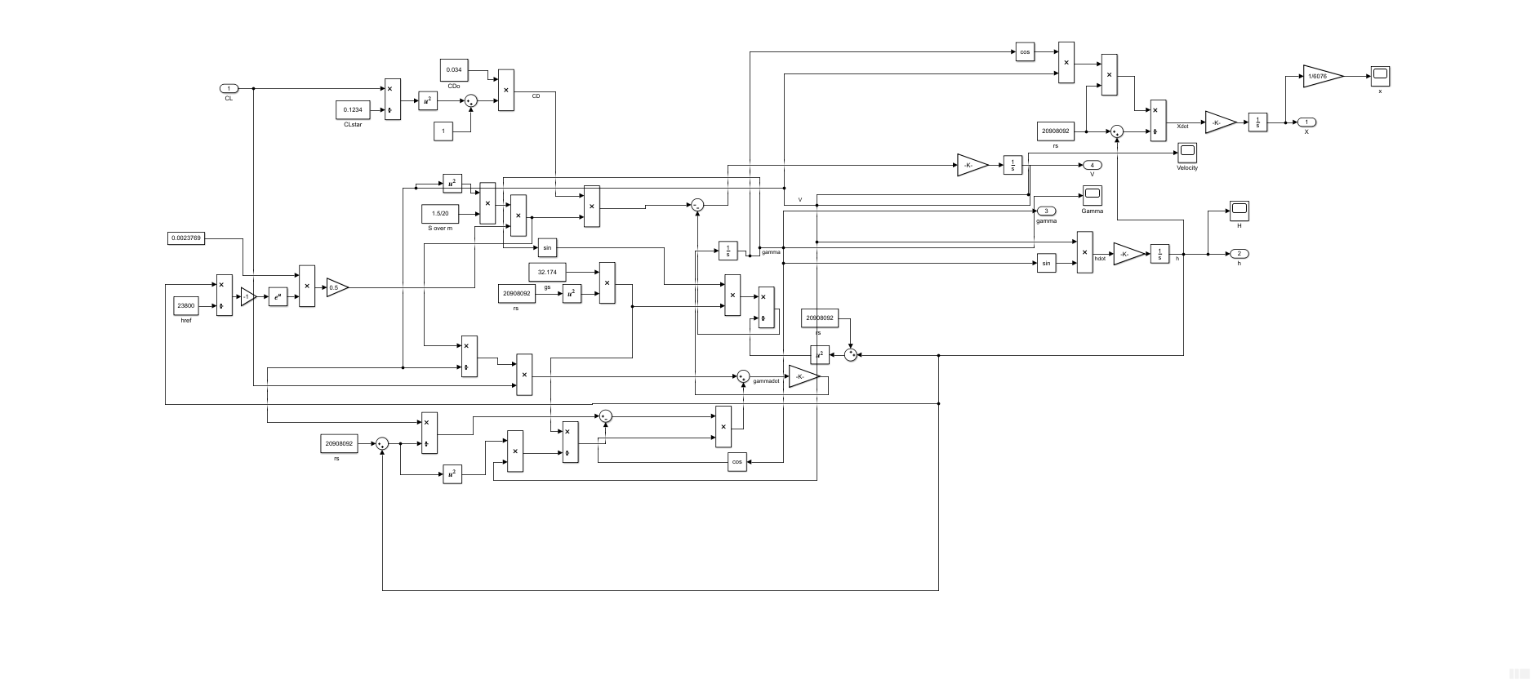

**a) MATLAB Code:**

**Main Code:**

clc

clear all

close all

tfinal = 40 / 100;

tp = 0:0.02:1;

CL=ones(length(tp),1)*(-0.2);

CL(end+1) = tfinal;

lower_limit=ones(length(tp),1)*(-pi);

upper_limit=ones(length(tp),1)*pi;

lower_limit(end+1)=0.01;

upper_limit(end+1)=1;

options = optimset('Display','iter','TolCon',1e-3,'Algorithm','interior-point','PlotFcns','optimplotx','MaxFunEvals',2500);

[CL_final, cost] = fmincon('numcost',CL,[],[],[],[],lower_limit,upper_limit,'constraint',options);

tfinal=CL_final(end);

[tout,yout]=sim('SRAM2',1,[],[tp' CL_final(1:end-1)]);

figure

plot(yout(:,1)/6076,yout(:,2));

grid

xlabel('X (in nm)');

ylabel('h');

figure

plot(tp*CL_final(end)*100,CL_final(1:end-1));

xlabel('Time period(in sec)');

ylabel('Velocity (in ft/sec)');

grid

figure

plot(tp*CL_final(end)*100,yout(1:51,4));

xlabel('Time period(in sec)');

ylabel('Velocity (in ft/sec)');

grid

disp('The final velocity in ft/sec')

velocity=yout(:,4);

disp(velocity(end));

disp('Final time in sec is');

disp(tfinal*100);

**Constraint File:**

function [cineq, ceq] =constraint(p)

cineq = [];

assignin('base', 'tfinal', p(end));

tau=[0:0.02:1]';

u=[p(1:end-1)];

[tout,yout]=sim('SRAM2',1,[],[tau u]);

ceq(1) = (yout(end,1) - 72*6076) / 500000;

ceq(2) = yout(end,2) / 100000;

**Cost File:**

function y = numcost(p)

assignin('base', 'tfinal', p(end));

tp=[0:0.02:1]';

u=[p(1:end-1)];

[tout,yout]=sim('SRAM2',1,[],[tp u]);

y = 0.0 - yout(end,4) / 11000;

end

**Output:**

First-order Norm of

Iter F-count f(x) Feasibility optimality step

0 53 -8.526078e-01 4.422e-01 6.318e-02

1 106 -5.111482e-01 8.039e-02 1.537e+00 8.091e-01

2 159 -7.635424e-01 9.868e-02 2.342e-01 6.068e-01

3 212 -7.144909e-01 5.912e-03 1.978e-01 2.105e-01

4 265 -7.285628e-01 7.253e-03 5.967e-02 2.512e-01

5 318 -7.316890e-01 1.500e-03 5.650e-02 1.011e-01

6 371 -7.324401e-01 2.891e-04 6.172e-02 4.871e-02

7 424 -7.349029e-01 1.652e-03 5.256e-02 1.180e-01

8 477 -7.352612e-01 7.672e-04 1.372e-02 7.889e-02

9 530 -7.355619e-01 4.190e-04 9.938e-03 6.012e-02

10 583 -7.356747e-01 1.288e-04 8.229e-03 3.683e-02

11 636 -7.359038e-01 1.590e-04 1.015e-02 4.136e-02

12 689 -7.359887e-01 9.023e-05 8.087e-03 3.038e-02

13 742 -7.360402e-01 4.634e-05 2.109e-03 2.367e-02

14 795 -7.360939e-01 3.830e-05 1.806e-03 2.285e-02

15 848 -7.361306e-01 2.858e-05 1.683e-03 1.957e-02

16 901 -7.361530e-01 1.743e-05 1.454e-03 1.514e-02

17 954 -7.361699e-01 1.087e-05 1.355e-03 1.272e-02

18 1007 -7.361863e-01 9.649e-06 1.252e-03 1.289e-02

19 1060 -7.362000e-01 8.995e-06 1.132e-03 1.282e-02

20 1113 -7.362101e-01 7.009e-06 1.035e-03 1.174e-02

21 1166 -7.362190e-01 5.503e-06 9.320e-04 1.121e-02

22 1219 -7.362279e-01 5.283e-06 8.212e-04 1.175e-02

23 1272 -7.362361e-01 5.203e-06 7.192e-04 1.193e-02

24 1325 -7.362431e-01 4.536e-06 7.357e-04 1.131e-02

25 1378 -7.362493e-01 3.857e-06 7.955e-04 1.088e-02

26 1431 -7.362553e-01 3.655e-06 6.559e-04 1.102e-02

27 1484 -7.362606e-01 3.443e-06 6.011e-04 1.072e-02

28 1537 -7.362648e-01 2.813e-06 6.167e-04 9.544e-03

29 1590 -7.362681e-01 2.146e-06 5.768e-04 8.314e-03

30 1643 -7.362710e-01 1.771e-06 4.478e-04 7.474e-03

First-order Norm of

Iter F-count f(x) Feasibility optimality step

31 1696 -7.362733e-01 1.496e-06 3.914e-04 6.546e-03

32 1749 -7.362749e-01 1.101e-06 4.144e-04 5.323e-03

33 1802 -7.362761e-01 7.642e-07 3.493e-04 4.360e-03

34 1855 -7.362770e-01 5.823e-07 2.873e-04 3.782e-03

35 1908 -7.362778e-01 4.569e-07 2.369e-04 3.231e-03

36 1961 -7.362782e-01 3.195e-07 2.311e-04 2.602e-03

37 2014 -7.362786e-01 2.182e-07 2.083e-04 2.141e-03

38 2067 -7.362789e-01 1.683e-07 1.473e-04 1.863e-03

39 2120 -7.362791e-01 1.316e-07 1.338e-04 1.593e-03

40 2173 -7.362792e-01 9.080e-08 1.174e-04 1.298e-03

41 2226 -7.362793e-01 6.284e-08 1.158e-04 1.099e-03

42 2279 -7.362794e-01 4.851e-08 7.988e-05 9.748e-04

43 2332 -7.362795e-01 3.724e-08 7.564e-05 8.370e-04

44 2385 -7.362795e-01 2.549e-08 6.806e-05 6.875e-04

45 2438 -7.362795e-01 1.802e-08 5.883e-05 5.882e-04

46 2491 -7.362796e-01 1.393e-08 4.701e-05 5.146e-04

47 2544 -7.362796e-01 1.046e-08 4.239e-05 4.371e-04

Solver stopped prematurely.

fmincon stopped because it exceeded the function evaluation limit,

options.MaxFunctionEvaluations = 2500 (the selected value).

The final velocity in ft/sec

8.0991e+03

Final time in sec is

46.9574

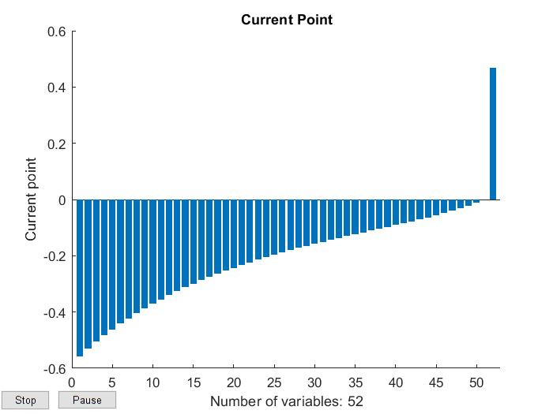

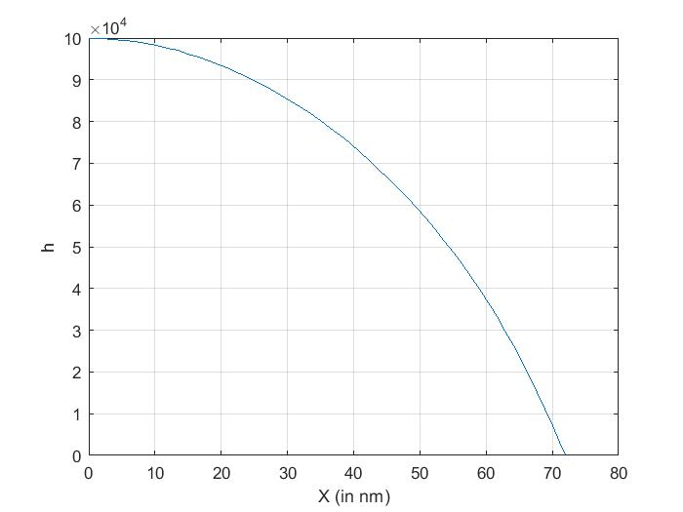

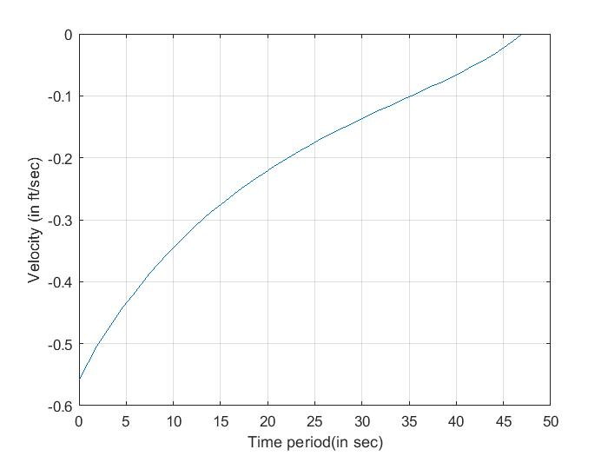

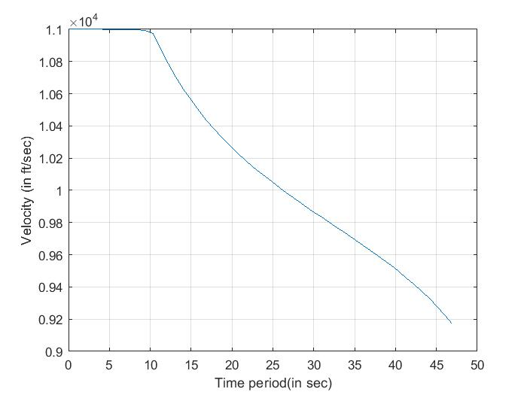

**b)** **MATLAB Code:**

**Main Code:**

clc

clear all

close all

tfinal = 40 / 100;

tp = 0:0.02:1;

CL=ones(length(tp),1)*(-0.2);

CL(end+1) = tfinal;

lower_limit=ones(length(tp),1)*(-pi);

upper_limit=ones(length(tp),1)*pi;

lower_limit(end+1)=0.01;

upper_limit(end+1)=1;

options = optimset('Display','iter','TolCon',1e-3,'Algorithm','interior-point','PlotFcns','optimplotx','MaxFunEvals',2500);

[CL_final, cost] = fmincon('numcost',CL,[],[],[],[],lower_limit,upper_limit,'constraint',options);

tfinal=CL_final(end);

[tout,yout]=sim('SRAM2',1,[],[tp' CL_final(1:end-1)]);

figure

plot(yout(:,1)/6076,yout(:,2));

grid

xlabel('X (in nm)');

ylabel('h');

figure

plot(tp*CL_final(end)*100,CL_final(1:end-1));

xlabel('Time period(in sec)');

ylabel('Velocity (in ft/sec)');

grid

figure

plot(tp*CL_final(end)*100,yout(1:51,4));

xlabel('Time period(in sec)');

ylabel('Velocity (in ft/sec)');

grid

disp('The final velocity in ft/sec')

velocity=yout(:,4);

disp(velocity(end));

disp('Final time in sec is');

disp(tfinal*100);

**Constraint File:**

function [cineq, ceq] =constraint(p)

cineq = [];

assignin('base', 'tfinal', p(end));

tau=[0:0.02:1]';

u=[p(1:end-1)];

[tout,yout]=sim('SRAM2',1,[],[tau u]);

ceq(1) = (yout(end,1) - 72*6076) / 500000;

ceq(2) = yout(end,2) / 100000;

**Cost File:**

function y = numcost(p)

assignin('base', 'tfinal', p(end));

tp=[0:0.02:1]';

u=[p(1:end-1)];

[tout,yout]=sim('SRAM2',1,[],[tp u]);

y = p(end);

end

**Output**:

First-order Norm of

Iter F-count f(x) Feasibility optimality step

0 53 4.000000e-01 4.422e-01 7.718e-04

1 106 4.607457e-01 8.291e-02 5.135e-01 7.965e-01

2 159 4.589238e-01 6.360e-02 1.395e-01 5.049e-01

3 212 4.668968e-01 1.008e-03 1.948e-01 7.294e-02

4 265 4.669377e-01 3.462e-05 1.000e-01 1.478e-02

5 318 4.664907e-01 2.713e-04 2.049e-02 4.776e-02

6 371 4.649030e-01 5.076e-03 2.000e-02 2.027e-01

7 424 4.654750e-01 2.072e-04 1.991e-02 4.124e-02

8 477 4.654945e-01 8.696e-06 3.074e-03 8.104e-03

9 530 4.654845e-01 2.190e-05 1.207e-03 1.286e-02

10 583 4.654726e-01 2.490e-05 2.373e-03 1.426e-02

11 636 4.654565e-01 3.784e-05 2.529e-03 1.886e-02

12 689 4.654522e-01 2.258e-05 1.231e-03 1.481e-02

13 742 4.654527e-01 7.638e-06 6.162e-04 8.144e-03

14 795 4.654520e-01 2.602e-06 6.081e-04 4.800e-03

15 848 4.654483e-01 6.335e-06 1.324e-03 8.680e-03

16 901 4.654417e-01 1.045e-05 1.920e-03 1.486e-02

17 954 4.654324e-01 1.592e-05 1.777e-03 2.285e-02

18 1007 4.654271e-01 1.693e-05 6.509e-04 2.053e-02

19 1060 4.654269e-01 8.140e-06 2.587e-04 9.348e-03

20 1113 4.654272e-01 1.490e-06 6.519e-04 3.409e-03

21 1166 4.654265e-01 1.267e-06 9.199e-04 3.305e-03

22 1219 4.654248e-01 2.649e-06 1.205e-03 5.481e-03

23 1272 4.654227e-01 3.974e-06 1.159e-03 8.708e-03

24 1325 4.654214e-01 4.168e-06 6.727e-04 9.710e-03

25 1378 4.654214e-01 1.736e-06 2.000e-04 5.268e-03

26 1431 4.654215e-01 2.578e-07 1.070e-04 2.027e-03

27 1484 4.654214e-01 1.929e-07 1.347e-04 1.703e-03

28 1537 4.654211e-01 4.578e-07 2.166e-04 2.752e-03

29 1590 4.654207e-01 7.113e-07 2.249e-04 3.675e-03

30 1643 4.654204e-01 7.410e-07 1.166e-04 3.647e-03

First-order Norm of

Iter F-count f(x) Feasibility optimality step

31 1696 4.654204e-01 3.085e-07 4.000e-05 2.071e-03

32 1749 4.654204e-01 4.999e-08 3.461e-05 7.111e-04

33 1802 4.654204e-01 2.232e-08 3.043e-05 4.570e-04

34 1855 4.654204e-01 6.294e-08 5.100e-05 8.103e-04

35 1908 4.654203e-01 9.688e-08 5.824e-05 1.205e-03

36 1961 4.654203e-01 1.116e-07 2.351e-05 1.473e-03

37 2014 4.654203e-01 5.402e-08 2.369e-05 9.430e-04

38 2067 4.654203e-01 1.094e-08 3.763e-05 3.439e-04

39 2120 4.654203e-01 4.759e-09 4.727e-05 2.142e-04

40 2173 4.654202e-01 1.356e-08 5.386e-05 4.075e-04

41 2226 4.654202e-01 2.353e-08 4.230e-05 6.853e-04

42 2279 4.654202e-01 3.698e-08 2.135e-05 1.006e-03

43 2332 4.654202e-01 2.684e-08 2.660e-05 7.910e-04

44 2385 4.654202e-01 9.139e-09 4.277e-05 3.584e-04

45 2438 4.654202e-01 3.641e-09 5.037e-05 2.131e-04

46 2491 4.654202e-01 8.374e-09 5.839e-05 3.964e-04

47 2544 4.654202e-01 1.720e-08 6.315e-05 7.906e-04

Solver stopped prematurely.

fmincon stopped because it exceeded the function evaluation limit,

options.MaxFunctionEvaluations = 2500 (the selected value).

The final velocity in ft/sec

7.7189e+03

Final time in sec is

46.5420









**c)**

|  |  |  |
| --- | --- | --- |
| Sr. No | Velocity | Time |
| a) | 8.0991e+03 | 46.9574 |
| b) | 7.7189e+03 | 46.5420 |

From the table, we can see that that the velocity decreases when we minimize the performance index whereas it is higher when we maximize the performance index. There is not much of a difference in the final time for both the cases.