**EE5321, Spring 2019**

**Homework Assignment 5: Min Time Constrained Input**

**Due 4/11/2019**

**Rodrigues Reema Carolene Ronald**

**Student ID : 1001386598**

**Problem 1**

Simulation:

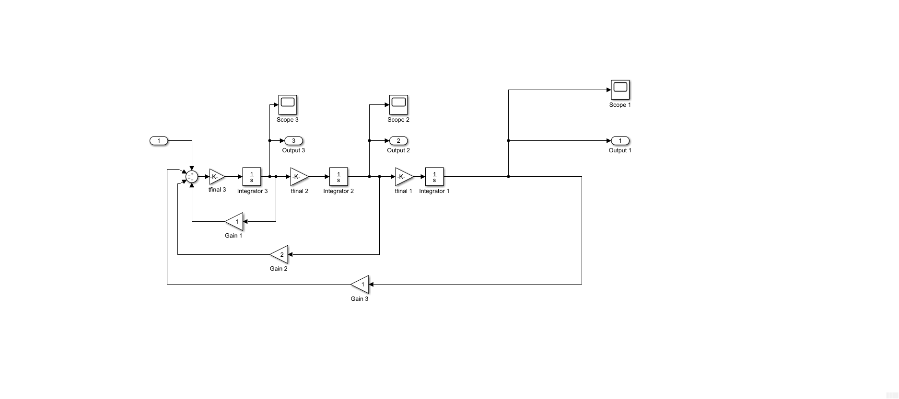

**a) MATLAB Code:**

**Main Code:**

clc;

close all;

clear all;

tfinal = 8;

tp = 0:0.025:1;

initialstate1= 1;

initialstate2= 0;

initialstate3= 0;

CL=ones(length(tp),1)*(0.01);

CL(end+1) = tfinal;

lower_limit=ones(length(tp),1)*(-1);

upper_limit=ones(length(tp),1)*(1);

lower_limit(end+1)=1;

upper_limit(end+1)=10;

options = optimset('Display', 'iter', 'TolCon', 1e-5,'TolFun', 1e-5,'PlotFcns', 'optimplotx', 'MaxFunEvals', 4400,'Algorithm','interior-point');

[CL_final, cost] = fmincon('num1_cost', CL,[],[],[],[],lower_limit,upper_limit,'num1_constraint',options);

tfinal=CL_final(end);

[tout,yout]=sim('num1new',1,[],[tp' CL_final(1:end-1)]);

figure;

plot3(yout(:,1),yout(:,2),yout(:,3));

grid;

xlabel('Final State 1');

ylabel('Final State 2');

zlabel('Final State 3');

figure;

plot(tp*tfinal, CL_final(1:end-1));

xlabel('Time(in sec)');

ylabel('Final optimal trajectory (in rads)');

grid;

disp('Final time in sec is');

disp(tfinal);

disp('Final Optimal Cost value is:');

disp(cost);

**Constraint File:**

function [cineq, ceq] = num1_constraint(p)

cineq = [];

assignin('base', 'tfinal', p(end));

tp=[0:0.025:1];

u=p(1:end-1);

[tout,x_state,yout]=sim('num1new',1,[],[tp' u]);

ceq(1) = yout(end,1);

ceq(2) = yout(end,2);

ceq(3) = yout(end,3);

end

**Cost File:**

function y = num1_cost(p)

y = p(end);

end

**Output:**

First-order Norm of

Iter F-count f(x) Feasibility optimality step

0 43 8.000000e+00 1.339e-01 6.400e-01

1 86 7.302676e+00 1.728e-02 7.496e-01 9.094e-01

2 129 4.854887e+00 1.907e-01 8.689e-01 2.596e+00

3 172 4.344712e+00 2.786e-02 3.357e-01 1.290e+00

4 215 3.762758e+00 4.133e-02 4.601e-01 8.875e-01

5 258 3.672388e+00 6.893e-03 1.529e-01 5.734e-01

6 301 3.585559e+00 2.722e-03 1.000e-01 3.960e-01

7 344 3.433166e+00 7.192e-03 7.042e-02 5.855e-01

8 387 3.213987e+00 1.550e-02 3.584e-02 9.503e-01

9 430 3.224197e+00 1.616e-04 3.581e-02 9.525e-02

10 473 3.218905e+00 1.546e-05 2.000e-02 7.756e-02

11 516 3.059118e+00 8.825e-03 3.286e-02 8.611e-01

12 559 2.986321e+00 3.164e-03 4.214e-02 6.155e-01

13 602 2.984063e+00 1.445e-05 4.569e-02 1.119e-01

14 645 2.969519e+00 1.360e-04 1.950e-02 2.024e-01

15 688 2.965043e+00 2.053e-05 1.947e-02 1.722e-01

16 731 2.958946e+00 2.824e-05 1.015e-02 1.729e-01

17 774 2.955078e+00 8.987e-06 1.033e-02 1.231e-01

18 817 2.952863e+00 2.861e-06 8.664e-03 9.686e-02

19 860 2.951485e+00 1.496e-06 5.801e-03 8.287e-02

20 903 2.949891e+00 2.143e-06 5.758e-03 1.004e-01

21 946 2.949147e+00 5.272e-07 5.249e-03 7.668e-02

22 989 2.948249e+00 5.613e-07 4.000e-03 6.141e-02

23 1032 2.881288e+00 2.007e-03 2.776e-02 6.152e-01

24 1075 2.869273e+00 9.930e-05 1.431e-02 1.709e-01

25 1118 2.865293e+00 8.498e-06 1.154e-02 1.214e-01

26 1161 2.863086e+00 2.830e-06 1.345e-02 1.058e-01

27 1204 2.861031e+00 2.268e-06 7.003e-03 9.317e-02

28 1247 2.860975e+00 2.744e-09 7.006e-03 3.916e-02

29 1290 2.859661e+00 8.784e-07 7.056e-03 9.528e-02

30 1333 2.858184e+00 1.153e-06 5.027e-03 1.210e-01

First-order Norm of

Iter F-count f(x) Feasibility optimality step

31 1376 2.857958e+00 2.747e-08 4.582e-03 5.010e-02

32 1419 2.857770e+00 2.181e-08 3.927e-03 3.713e-02

33 1462 2.857312e+00 1.197e-07 3.942e-03 5.865e-02

34 1505 2.856743e+00 1.918e-07 3.960e-03 8.759e-02

35 1548 2.856235e+00 1.727e-07 3.481e-03 9.477e-02

36 1591 2.855768e+00 1.523e-07 3.474e-03 7.851e-02

37 1634 2.855343e+00 1.084e-07 2.817e-03 6.096e-02

38 1677 2.855087e+00 3.653e-08 2.286e-03 3.917e-02

39 1720 2.854957e+00 9.103e-09 1.426e-03 2.324e-02

40 1763 2.854877e+00 3.334e-09 1.016e-03 1.638e-02

41 1806 2.854830e+00 1.376e-09 1.015e-03 1.409e-02

42 1849 2.854794e+00 9.646e-10 9.355e-04 1.464e-02

43 1892 2.854758e+00 1.069e-09 9.061e-04 1.549e-02

44 1935 2.854724e+00 1.036e-09 8.732e-04 1.592e-02

45 1978 2.854689e+00 9.656e-10 8.448e-04 1.850e-02

46 2021 2.854651e+00 1.224e-09 8.441e-04 2.580e-02

47 2064 2.854617e+00 6.569e-10 8.888e-04 3.458e-02

48 2107 2.854600e+00 5.320e-10 9.349e-04 3.546e-02

49 2150 2.854583e+00 2.509e-10 9.590e-04 3.125e-02

50 2193 2.854539e+00 1.403e-09 9.592e-04 3.568e-02

51 2236 2.854468e+00 2.587e-09 9.474e-04 4.291e-02

52 2279 2.854418e+00 1.951e-09 9.103e-04 3.256e-02

53 2322 2.854379e+00 8.379e-10 8.847e-04 2.008e-02

54 2365 2.854346e+00 6.902e-10 8.000e-04 1.467e-02

55 2408 2.833070e+00 2.156e-04 9.557e-03 3.984e-01

56 2451 2.832402e+00 4.738e-07 3.321e-03 7.958e-02

57 2494 2.832148e+00 3.647e-08 3.059e-03 2.991e-02

58 2537 2.831908e+00 3.325e-08 2.165e-03 5.108e-02

59 2580 2.831846e+00 3.244e-09 1.521e-03 3.493e-02

60 2623 2.831753e+00 5.037e-09 1.522e-03 3.614e-02

First-order Norm of

Iter F-count f(x) Feasibility optimality step

61 2666 2.831640e+00 6.732e-09 1.523e-03 4.760e-02

62 2709 2.831482e+00 1.323e-08 1.526e-03 6.304e-02

63 2752 2.831198e+00 4.326e-08 1.530e-03 9.063e-02

64 2795 2.831136e+00 2.212e-09 1.530e-03 3.750e-02

65 2838 2.831109e+00 5.511e-10 1.347e-03 1.772e-02

66 2881 2.831052e+00 2.312e-09 1.346e-03 1.999e-02

67 2924 2.830965e+00 4.238e-09 1.344e-03 3.204e-02

68 2967 2.830861e+00 5.693e-09 1.271e-03 3.933e-02

69 3010 2.830822e+00 1.019e-09 1.181e-03 1.749e-02

70 3053 2.830799e+00 4.503e-10 8.683e-04 9.667e-03

71 3096 2.830787e+00 1.548e-10 5.424e-04 7.348e-03

72 3139 2.830783e+00 8.438e-11 3.961e-04 4.850e-03

73 3182 2.830780e+00 2.745e-11 2.899e-04 3.678e-03

74 3225 2.830779e+00 6.738e-11 2.708e-04 3.209e-03

75 3268 2.830778e+00 3.200e-11 1.647e-04 3.360e-03

76 3311 2.830778e+00 8.326e-11 1.600e-04 2.421e-03

77 3354 2.825842e+00 1.202e-05 2.264e-04 1.499e-01

78 3397 2.825803e+00 1.396e-09 1.348e-04 1.051e-02

79 3440 2.825799e+00 1.352e-11 3.204e-05 9.587e-04

80 3483 2.824805e+00 4.858e-07 8.851e-05 2.519e-02

81 3526 2.824805e+00 1.000e-10 2.834e-05 5.083e-03

82 3569 2.824805e+00 5.281e-13 6.400e-06 3.092e-05

Local minimum found that satisfies the constraints.

Optimization completed because the objective function is non-decreasing in

feasible directions, to within the selected value of the optimality tolerance,

and constraints are satisfied to within the selected value of the constraint tolerance.

<stopping criteria details>

Final time in sec is

2.8248

Final Optimal Cost value is:

2.8248

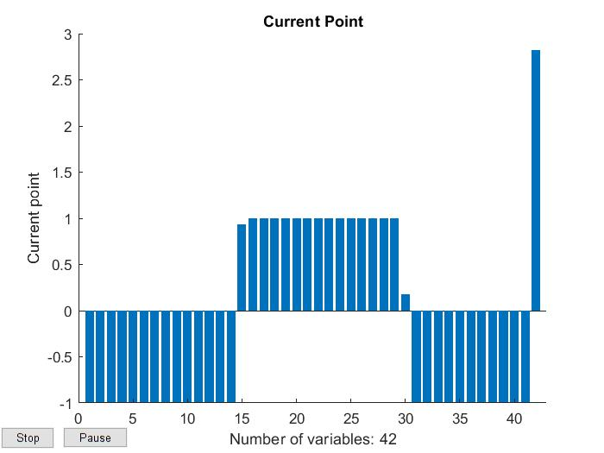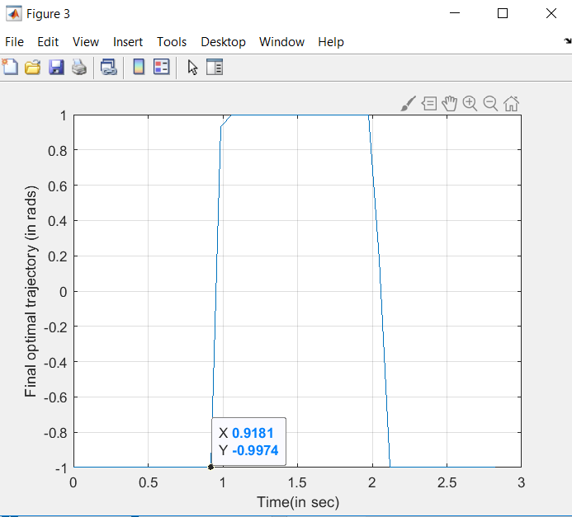

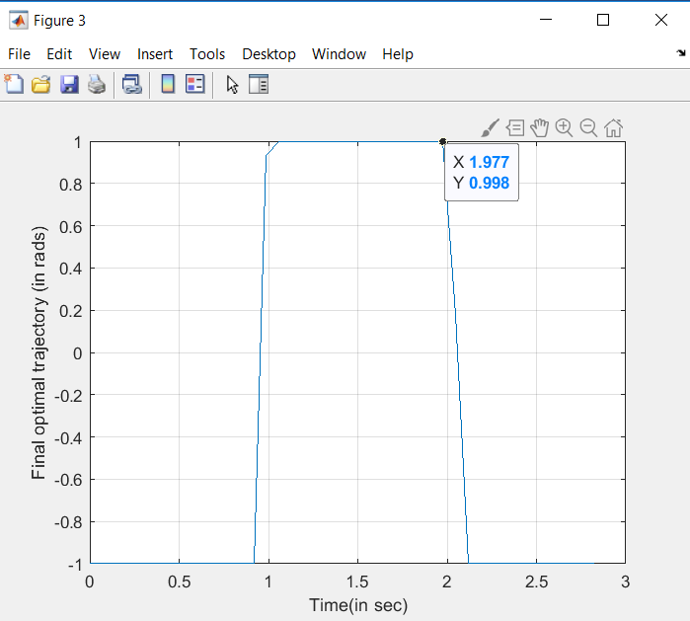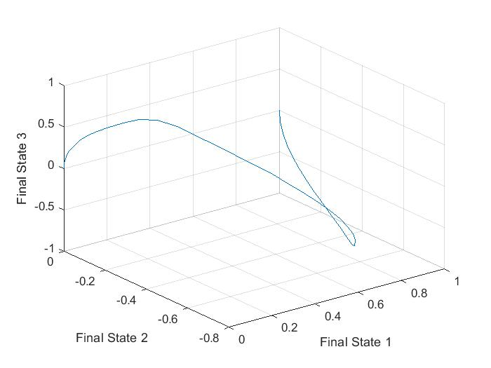

Therefore, there are two switches needed.

**b)** **MATLAB Code:**

**Main Code:**

clc;

close all;

clear all;

tfinal = 8;

tp = 0:0.025:1;

initialstate1= 1;

initialstate2= 0;

initialstate3= 0;

CL=ones(length(tp),1)*(0.01);

CL(end+1) = tfinal;

lower_limit=ones(length(tp),1)*(-0.75);

upper_limit=ones(length(tp),1)*(0.75);

lower_limit(end+1)=1;

upper_limit(end+1)=10;

options = optimset('Display', 'iter', 'TolCon', 1e-5,'TolFun', 1e-5,'PlotFcns', 'optimplotx', 'MaxFunEvals', 4400,'Algorithm','interior-point');

[CL_final, cost] = fmincon('num1_cost', CL,[],[],[],[],lower_limit,upper_limit,'num1_constraint',options);

tfinal=CL_final(end);

[tout,yout]=sim('num1new',1,[],[tp' CL_final(1:end-1)]);

figure;

plot3(yout(:,1),yout(:,2),yout(:,3));

grid;

xlabel('Final State1');

ylabel('Final State2');

zlabel('Final State3');

figure;

plot(tp*tfinal, CL_final(1:end-1));

xlabel('Time period(in sec)');

ylabel('Final optimal trajectory in (rads)');

grid;

disp('Final time in sec is');

disp(tfinal);

disp('Final Optimal Cost value is:');

disp(cost);

**Constraint File:**

function [cineq, ceq] = num1_constraint(p)

cineq = [];

assignin('base', 'tfinal', p(end));

tp=[0:0.025:1];

u=p(1:end-1);

[tout,x_state,yout]=sim('num1new',1,[],[tp' u]);

ceq(1) = yout(end,1);

ceq(2) = yout(end,2);

ceq(3) = yout(end,3);

end

**Cost File:**

function y = num1_cost(p)

y = p(end);

end

**Output**:

First-order Norm of

Iter F-count f(x) Feasibility optimality step

0 43 8.000000e+00 1.339e-01 5.372e-01

1 86 7.330245e+00 1.654e-02 6.720e-01 8.813e-01

2 129 5.096860e+00 1.625e-01 1.015e+00 2.370e+00

3 172 4.355656e+00 2.418e-02 6.758e-01 1.346e+00

4 215 3.889476e+00 3.114e-02 5.935e-01 7.624e-01

5 258 3.835981e+00 2.564e-03 1.261e-01 4.098e-01

6 301 3.785292e+00 9.091e-04 1.000e-01 2.618e-01

7 344 3.664450e+00 4.003e-03 1.095e-01 3.671e-01

8 387 3.400066e+00 1.822e-02 2.762e-02 8.136e-01

9 430 3.436055e+00 3.699e-04 2.947e-02 5.007e-02

10 473 3.425420e+00 4.981e-05 2.000e-02 7.966e-02

11 516 3.271432e+00 7.749e-03 2.122e-02 6.434e-01

12 559 3.178722e+00 4.157e-03 6.535e-02 5.663e-01

13 602 3.182291e+00 1.239e-05 2.762e-02 7.379e-02

14 645 3.169729e+00 9.394e-05 1.343e-02 1.797e-01

15 688 3.164551e+00 2.067e-05 1.369e-02 1.515e-01

16 731 3.161174e+00 7.573e-06 9.421e-03 1.053e-01

17 774 3.158469e+00 3.909e-06 6.242e-03 8.470e-02

18 817 3.157084e+00 1.214e-06 5.714e-03 7.210e-02

19 860 3.155978e+00 9.789e-07 4.082e-03 7.107e-02

20 903 3.155274e+00 4.577e-07 4.000e-03 6.169e-02

21 946 3.087191e+00 1.953e-03 1.896e-02 4.830e-01

22 989 3.073801e+00 1.064e-04 1.175e-02 1.607e-01

23 1032 3.070112e+00 6.288e-06 1.170e-02 1.048e-01

24 1075 3.068156e+00 2.072e-06 1.058e-02 8.347e-02

25 1118 3.067232e+00 4.458e-07 1.062e-02 5.638e-02

26 1161 3.065874e+00 8.639e-07 1.032e-02 8.219e-02

27 1204 3.064663e+00 6.941e-07 4.248e-03 8.090e-02

28 1247 3.064486e+00 1.532e-08 2.724e-03 3.294e-02

29 1290 3.064318e+00 1.297e-08 2.718e-03 3.384e-02

30 1333 3.064092e+00 2.566e-08 2.710e-03 4.140e-02

First-order Norm of

Iter F-count f(x) Feasibility optimality step

31 1376 3.063605e+00 1.259e-07 2.693e-03 6.853e-02

32 1419 3.063130e+00 1.210e-07 2.676e-03 6.998e-02

33 1462 3.063001e+00 1.000e-08 2.465e-03 3.145e-02

34 1505 3.062805e+00 2.116e-08 2.460e-03 3.397e-02

35 1548 3.062523e+00 4.442e-08 2.454e-03 4.755e-02

36 1591 3.062311e+00 2.698e-08 2.136e-03 4.290e-02

37 1634 3.062178e+00 1.105e-08 2.126e-03 3.186e-02

38 1677 3.062112e+00 3.200e-09 1.398e-03 2.324e-02

39 1720 3.062060e+00 1.764e-09 1.387e-03 2.067e-02

40 1763 3.062001e+00 1.867e-09 1.263e-03 2.248e-02

41 1806 3.061940e+00 1.740e-09 1.265e-03 2.403e-02

42 1849 3.061882e+00 1.694e-09 1.119e-03 2.347e-02

43 1892 3.061842e+00 5.619e-10 8.000e-04 1.852e-02

44 1935 3.040384e+00 2.089e-04 8.772e-03 3.222e-01

45 1979 3.040160e+00 1.045e-04 3.860e-03 1.355e-02

46 2022 3.039371e+00 3.715e-07 3.835e-03 4.754e-02

47 2065 3.038856e+00 1.299e-07 3.818e-03 9.279e-02

48 2108 3.038663e+00 1.645e-08 3.812e-03 3.891e-02

49 2151 3.038410e+00 3.589e-08 3.207e-03 3.554e-02

50 2194 3.038206e+00 2.359e-08 3.203e-03 3.605e-02

51 2237 3.038086e+00 8.446e-09 2.297e-03 3.134e-02

52 2280 3.038077e+00 1.514e-10 1.186e-03 1.147e-02

53 2323 3.038057e+00 2.723e-10 1.117e-03 9.247e-03

54 2366 3.038044e+00 6.011e-11 8.316e-04 8.396e-03

55 2409 3.038029e+00 6.507e-11 8.133e-04 9.763e-03

56 2452 3.038006e+00 4.830e-10 8.137e-04 1.433e-02

57 2495 3.037976e+00 5.110e-10 8.143e-04 1.963e-02

58 2538 3.037950e+00 7.437e-10 8.148e-04 1.847e-02

59 2581 3.037942e+00 1.360e-10 5.899e-04 8.839e-03

60 2624 3.037941e+00 6.210e-11 2.446e-04 3.840e-03

First-order Norm of

Iter F-count f(x) Feasibility optimality step

61 2667 3.037941e+00 4.332e-12 1.600e-04 1.332e-03

62 2710 3.032948e+00 1.159e-05 1.881e-04 1.118e-01

63 2753 3.032899e+00 1.952e-09 1.024e-04 3.193e-03

64 2796 3.032900e+00 1.013e-12 3.201e-05 2.685e-04

65 2839 3.031942e+00 4.293e-07 3.323e-04 2.037e-02

66 2882 3.031901e+00 9.226e-10 2.731e-05 3.351e-03

67 2925 3.031898e+00 4.278e-12 8.320e-06 3.008e-04

Local minimum found that satisfies the constraints.

Optimization completed because the objective function is non-decreasing in

feasible directions, to within the selected value of the optimality tolerance,

and constraints are satisfied to within the selected value of the constraint tolerance.

<stopping criteria details>

Final time in sec is

3.0319

Final Optimal Cost value is:

3.0319

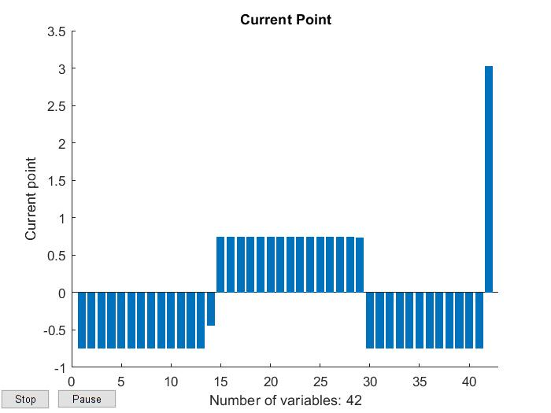

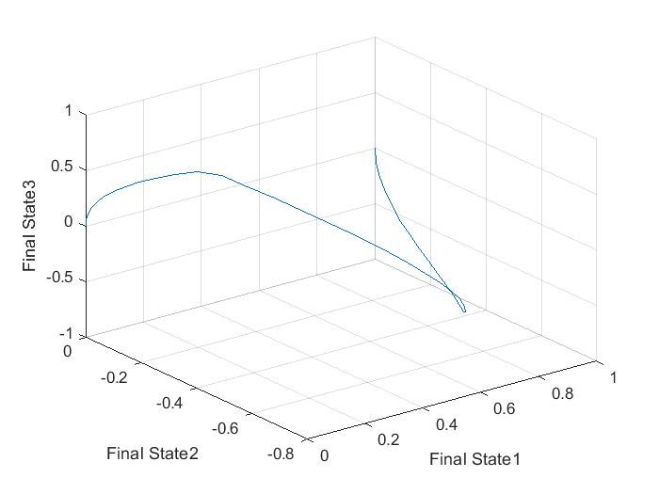

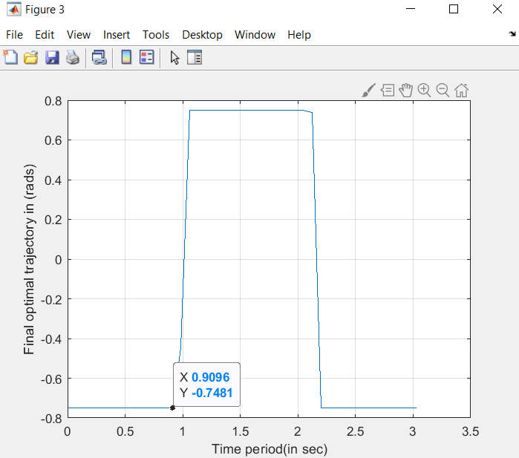

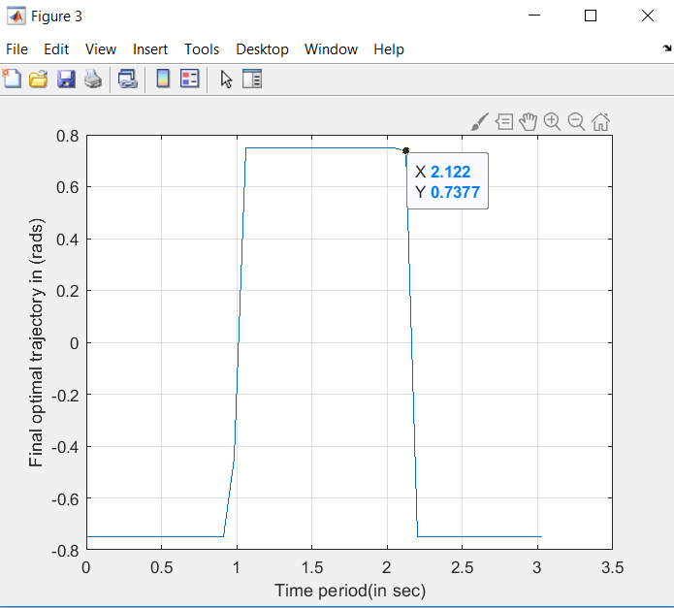

Two switches were needed again.

Yes, the switch time changes. The difference between the switch times is as follows:

3.0318-2.8248= 0.2071 seconds.

**c)**

**MATLAB Code:**

**Main Code:**

clc;

close all;

clear all;

tfinal = 8;

tp = 0:0.025:1;

initialstate1= 1;

initialstate2= 0;

initialstate3= 0;

CL=ones(length(tp),1)*(0.01);

CL(end+1) = tfinal;

lower_limit=ones(length(tp),1)*(-0.5);

upper_limit=ones(length(tp),1)*(0.5);

lower_limit(end+1)=1;

upper_limit(end+1)=10;

options = optimset('Display', 'iter', 'TolCon', 1e-5,'TolFun', 1e-5,'PlotFcns', 'optimplotx', 'MaxFunEvals', 4400,'Algorithm','interior-point');

[CL_final, cost] = fmincon('num1_cost', CL,[],[],[],[],lower_limit,upper_limit,'num1_constraint',options);

tfinal=CL_final(end);

[tout,yout]=sim('num1new',1,[],[tp' CL_final(1:end-1)]);

figure;

plot3(yout(:,1),yout(:,2),yout(:,3));

grid;

xlabel('Final State1');

ylabel('Final State2');

zlabel('Final State3');

figure;

plot(tp*tfinal, CL_final(1:end-1));

xlabel('Time period(in sec)');

ylabel('Final optimal trajectory in (rads)');

grid;

disp('Final time in sec is');

disp(tfinal);

disp('Final Optimal Cost value is:');

disp(cost);

**Constraint File:**

function [cineq, ceq] = num1_constraint(p)

cineq = [];

assignin('base', 'tfinal', p(end));

tp=[0:0.025:1];

u=p(1:end-1);

[tout,x_state,yout]=sim('num1new',1,[],[tp' u]);

ceq(1) = yout(end,1);

ceq(2) = yout(end,2);

ceq(3) = yout(end,3);

end

**Cost File:**

function y = num1_cost(p)

y = p(end);

end

**Output**:

First-order Norm of

Iter F-count f(x) Feasibility optimality step

0 43 8.000000e+00 1.339e-01 3.640e-01

1 86 7.400074e+00 1.501e-02 5.325e-01 8.110e-01

2 129 5.678878e+00 1.277e-01 1.273e+00 1.827e+00

3 172 4.696584e+00 2.978e-02 1.140e+00 1.327e+00

4 215 3.731970e+00 9.155e-02 4.035e-01 1.278e+00

5 258 4.065800e+00 1.628e-02 4.338e-01 3.703e-01

6 301 4.084026e+00 2.242e-04 1.000e-01 1.180e-01

7 344 3.960129e+00 3.052e-03 8.226e-02 2.312e-01

8 387 3.766630e+00 8.459e-03 7.779e-02 4.295e-01

9 430 3.765325e+00 1.220e-05 7.787e-02 8.210e-02

10 473 3.739014e+00 2.322e-04 2.993e-02 1.293e-01

11 516 3.715587e+00 2.021e-04 2.187e-02 1.389e-01

12 559 3.703095e+00 6.125e-05 2.000e-02 1.006e-01

13 602 3.568605e+00 5.292e-03 5.758e-02 4.465e-01

14 645 3.451955e+00 4.895e-03 2.291e-02 4.843e-01

15 688 3.466817e+00 5.717e-05 1.706e-02 5.776e-02

16 731 3.460377e+00 2.133e-05 8.877e-03 1.085e-01

17 774 3.458335e+00 2.353e-06 7.280e-03 6.603e-02

18 817 3.457175e+00 6.733e-07 4.875e-03 4.699e-02

19 860 3.456439e+00 2.665e-07 4.000e-03 3.989e-02

20 903 3.386737e+00 1.777e-03 1.716e-02 3.714e-01

21 946 3.373370e+00 9.486e-05 7.411e-03 1.310e-01

22 989 3.369476e+00 6.572e-06 7.312e-03 8.569e-02

23 1032 3.367498e+00 1.715e-06 7.262e-03 6.772e-02

24 1075 3.367326e+00 1.942e-08 7.258e-03 3.276e-02

25 1118 3.366422e+00 3.573e-07 5.600e-03 4.969e-02

26 1161 3.365467e+00 4.118e-07 4.170e-03 6.514e-02

27 1204 3.365178e+00 4.210e-08 3.622e-03 4.072e-02

28 1247 3.365068e+00 7.375e-09 2.457e-03 2.267e-02

29 1290 3.364919e+00 1.388e-08 1.917e-03 2.535e-02

30 1333 3.364813e+00 6.895e-09 1.922e-03 2.656e-02

First-order Norm of

Iter F-count f(x) Feasibility optimality step

31 1376 3.364695e+00 7.006e-09 1.928e-03 2.900e-02

32 1419 3.364499e+00 1.585e-08 1.937e-03 4.006e-02

33 1462 3.364338e+00 9.703e-09 1.893e-03 3.635e-02

34 1505 3.364226e+00 4.988e-09 1.896e-03 2.457e-02

35 1548 3.364122e+00 5.232e-09 1.325e-03 2.093e-02

36 1591 3.364086e+00 8.793e-10 8.178e-04 1.172e-02

37 1634 3.364074e+00 8.020e-11 8.000e-04 5.917e-03

38 1677 3.342266e+00 1.919e-04 8.090e-03 2.458e-01

39 1720 3.341365e+00 5.266e-07 4.382e-03 1.484e-02

40 1763 3.341172e+00 1.998e-08 3.767e-03 1.764e-02

41 1806 3.340891e+00 4.191e-08 2.123e-03 3.220e-02

42 1849 3.340745e+00 1.177e-08 2.128e-03 3.220e-02

43 1892 3.340682e+00 1.929e-09 2.130e-03 2.204e-02

44 1935 3.340662e+00 5.064e-10 1.805e-03 1.324e-02

45 1978 3.340612e+00 1.228e-09 1.647e-03 1.720e-02

46 2021 3.340548e+00 2.464e-09 8.329e-04 2.082e-02

47 2064 3.340539e+00 1.281e-10 5.615e-04 9.783e-03

48 2107 3.340542e+00 6.642e-11 2.666e-04 3.034e-03

49 2150 3.340544e+00 1.025e-11 1.600e-04 8.633e-04

50 2193 3.335672e+00 9.958e-06 4.061e-04 6.808e-02

51 2236 3.335649e+00 7.229e-10 3.747e-04 1.782e-02

52 2279 3.335635e+00 9.910e-11 1.434e-04 1.538e-03

53 2322 3.335636e+00 1.258e-12 3.200e-05 8.380e-05

54 2365 3.334646e+00 4.131e-07 2.879e-05 1.267e-02

55 2408 3.334643e+00 6.868e-12 8.059e-06 1.238e-03

Local minimum found that satisfies the constraints.

Optimization completed because the objective function is non-decreasing in

feasible directions, to within the selected value of the optimality tolerance,

and constraints are satisfied to within the selected value of the constraint tolerance.

<stopping criteria details>

Final time in sec is

3.3346

Final Optimal Cost value is:

3.3346



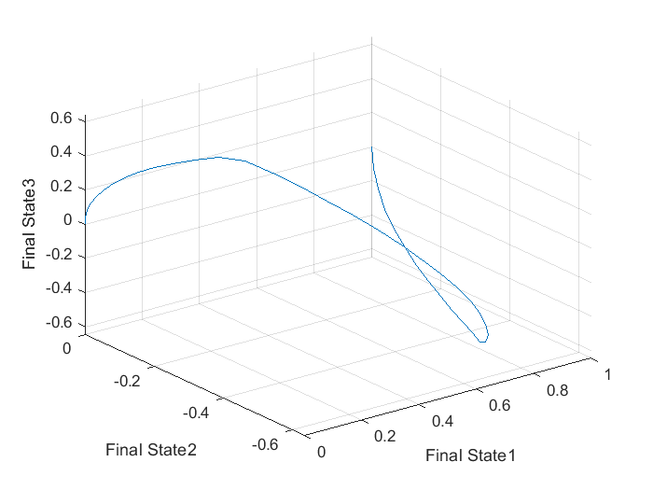

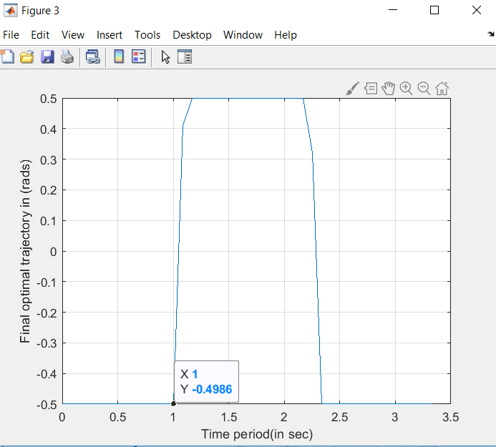

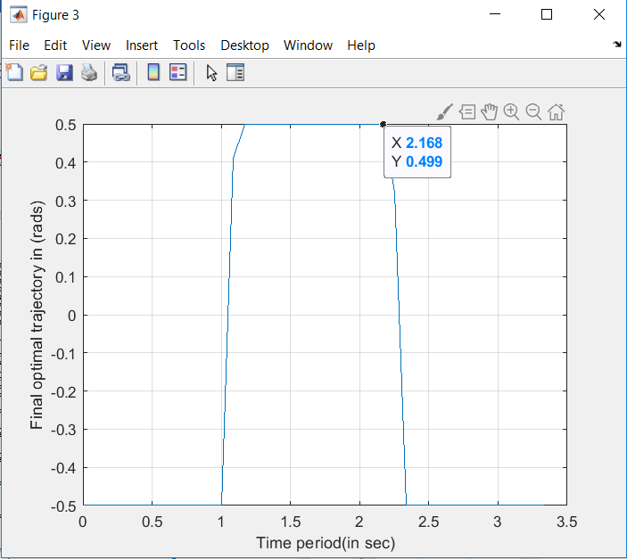

Two switches were needed again.

Yes, the switch time changes. The difference between the switch times is as follows:

3.3346- 3.0319= 0.3027 seconds.

**d)**

**MATLAB Code:**

**Main Code:**

clc;

close all;

clear all;

tfinal = 8;

tp = 0:0.025:1;

initialstate1= 1;

initialstate2= 1;

initialstate3= 1;

CL=ones(length(tp),1)*(0.01);

CL(end+1) = tfinal;

lower_limit=ones(length(tp),1)*(-1);

upper_limit=ones(length(tp),1)*(1);

lower_limit(end+1)=1;

upper_limit(end+1)=10;

options = optimset('Display', 'iter', 'TolCon', 1e-5,'TolFun', 1e-5,'PlotFcns', 'optimplotx', 'MaxFunEvals', 4400,'Algorithm','interior-point');

[CL_final, cost] = fmincon('num1_cost', CL,[],[],[],[],lower_limit,upper_limit,'num1_constraint',options);

tfinal=CL_final(end);

[tout,yout]=sim('num1new',1,[],[tp' CL_final(1:end-1)]);

figure;

plot3(yout(:,1),yout(:,2),yout(:,3));

grid;

xlabel('Final State1');

ylabel('Final State2');

zlabel('Final State3');

figure;

plot(tp*tfinal, CL_final(1:end-1));

xlabel('Time period(in sec)');

ylabel('Final optimal trajectory in (rads)');

grid;

disp('Final time in sec is');

disp(tfinal);

disp('Final Optimal Cost value is:');

disp(cost);

**Constraint File:**

function [cineq, ceq] = num1_constraint(p)

cineq = [];

assignin('base', 'tfinal', p(end));

tp=[0:0.025:1];

u=p(1:end-1);

[tout,x_state,yout]=sim('num1new',1,[],[tp' u]);

ceq(1) = yout(end,1);

ceq(2) = yout(end,2);

ceq(3) = yout(end,3);

end

**Cost File:**

function y = num1_cost(p)

y = p(end);

end

**Output**:

First-order Norm of

Iter F-count f(x) Feasibility optimality step

0 43 8.000000e+00 3.818e-01 1.444e-01

1 86 7.970282e+00 5.995e-03 4.044e-01 1.402e+00

2 129 7.599656e+00 2.295e-02 5.710e-01 5.467e-01

3 172 6.679199e+00 1.411e-01 9.885e-01 1.362e+00

4 215 6.343181e+00 3.106e-02 7.039e-01 1.193e+00

5 258 5.897281e+00 2.905e-02 2.817e-01 1.198e+00

6 301 5.803069e+00 9.399e-04 1.269e-01 3.550e-01

7 344 5.578400e+00 1.336e-02 3.660e-01 5.641e-01

8 387 5.398810e+00 1.047e-02 3.354e-01 4.403e-01

9 430 5.243560e+00 8.563e-03 2.256e-01 3.800e-01

10 473 5.101511e+00 7.500e-03 1.228e-01 3.555e-01

11 516 4.984419e+00 5.276e-03 2.658e-01 3.217e-01

12 559 4.890631e+00 3.450e-03 5.413e-01 2.980e-01

13 602 4.808713e+00 2.691e-03 8.147e-01 3.060e-01

14 645 4.740418e+00 2.133e-03 1.073e+00 3.076e-01

15 688 4.689143e+00 1.556e-03 9.762e-01 3.094e-01

16 731 4.629137e+00 2.344e-03 5.919e-01 4.564e-01

17 774 4.582533e+00 1.403e-03 4.460e-01 3.887e-01

18 817 4.562911e+00 2.313e-04 2.453e-01 1.414e-01

19 860 4.545302e+00 1.385e-04 1.000e-01 9.527e-02

20 903 4.457287e+00 3.059e-03 1.522e-01 3.684e-01

21 946 4.278182e+00 1.236e-02 8.437e-02 8.621e-01

22 989 4.253083e+00 5.168e-04 7.385e-02 2.719e-01

23 1032 4.225968e+00 3.447e-04 7.485e-02 1.952e-01

24 1075 4.212891e+00 8.891e-05 3.797e-02 1.634e-01

25 1118 4.208664e+00 1.149e-05 3.936e-02 1.427e-01

26 1161 4.206921e+00 2.298e-06 3.202e-02 7.958e-02

27 1204 4.204642e+00 3.421e-06 2.000e-02 4.577e-02

28 1247 4.066254e+00 8.962e-03 3.452e-02 8.510e-01

29 1290 3.968438e+00 5.537e-03 5.621e-02 7.335e-01

30 1333 3.975664e+00 8.895e-06 5.140e-02 1.092e-01

First-order Norm of

Iter F-count f(x) Feasibility optimality step

31 1376 3.964442e+00 7.779e-05 5.440e-02 1.198e-01

32 1419 3.955404e+00 6.387e-05 4.485e-02 1.695e-01

33 1462 3.952535e+00 8.267e-06 1.200e-02 1.091e-01

34 1505 3.950555e+00 3.098e-06 8.679e-03 7.263e-02

35 1548 3.948038e+00 4.340e-06 8.224e-03 8.719e-02

36 1591 3.946209e+00 2.431e-06 7.862e-03 8.628e-02

37 1634 3.945094e+00 1.006e-06 5.380e-03 6.888e-02

38 1677 3.944532e+00 3.137e-07 4.000e-03 4.908e-02

39 1720 3.880515e+00 2.399e-03 4.811e-03 5.911e-01

40 1763 3.865153e+00 1.546e-04 6.881e-03 1.544e-01

41 1806 3.852880e+00 1.135e-04 9.113e-03 3.205e-01

42 1849 3.856726e+00 1.015e-05 8.602e-03 1.256e-01

43 1892 3.852685e+00 1.227e-05 8.964e-03 1.135e-01

44 1935 3.849968e+00 6.037e-06 8.750e-03 1.139e-01

45 1978 3.848377e+00 2.206e-06 6.607e-03 1.149e-01

46 2021 3.847099e+00 1.393e-06 5.230e-03 1.090e-01

47 2064 3.846522e+00 2.527e-07 4.960e-03 6.341e-02

48 2107 3.846143e+00 8.921e-08 4.405e-03 4.603e-02

49 2150 3.846017e+00 9.810e-09 3.835e-03 3.284e-02

50 2193 3.845924e+00 9.773e-09 3.669e-03 3.595e-02

51 2236 3.845810e+00 1.374e-08 2.303e-03 4.396e-02

52 2279 3.845757e+00 2.787e-09 2.302e-03 3.486e-02

53 2322 3.845706e+00 3.275e-09 2.211e-03 2.198e-02

54 2365 3.845629e+00 7.253e-09 1.895e-03 1.880e-02

55 2408 3.845508e+00 1.098e-08 1.621e-03 2.692e-02

56 2451 3.845348e+00 1.784e-08 1.616e-03 3.973e-02

57 2494 3.845209e+00 1.265e-08 1.612e-03 4.324e-02

58 2537 3.845048e+00 1.666e-08 1.607e-03 4.940e-02

59 2580 3.844846e+00 2.611e-08 1.601e-03 6.111e-02

60 2623 3.844730e+00 8.351e-09 1.598e-03 4.785e-02

First-order Norm of

Iter F-count f(x) Feasibility optimality step

61 2666 3.844670e+00 3.805e-09 1.530e-03 2.952e-02

62 2709 3.844602e+00 4.779e-09 1.532e-03 2.733e-02

63 2752 3.844536e+00 4.259e-09 1.534e-03 3.057e-02

64 2795 3.844479e+00 2.192e-09 1.247e-03 3.150e-02

65 2838 3.844435e+00 1.639e-09 1.246e-03 2.845e-02

66 2881 3.844391e+00 1.275e-09 1.245e-03 2.601e-02

67 2924 3.844340e+00 1.663e-09 1.245e-03 2.631e-02

68 2967 3.844303e+00 1.506e-09 1.009e-03 2.198e-02

69 3010 3.844278e+00 6.365e-10 8.000e-04 1.736e-02

70 3053 3.823192e+00 2.848e-04 2.736e-03 3.729e-01

71 3096 3.821734e+00 1.716e-06 3.195e-03 6.879e-02

72 3139 3.821360e+00 1.128e-07 3.146e-03 5.006e-02

73 3182 3.821294e+00 3.769e-09 2.108e-03 2.645e-02

74 3225 3.821118e+00 2.920e-08 2.111e-03 6.565e-02

75 3268 3.820948e+00 2.769e-08 2.114e-03 5.646e-02

76 3311 3.820858e+00 6.827e-09 2.116e-03 3.044e-02

77 3354 3.820717e+00 1.437e-08 2.118e-03 2.969e-02

78 3397 3.820701e+00 8.180e-10 6.187e-04 1.144e-02

79 3440 3.820705e+00 2.382e-11 1.600e-04 1.517e-03

80 3483 3.815862e+00 1.546e-05 1.010e-03 8.393e-02

81 3526 3.815791e+00 5.194e-09 8.020e-04 1.593e-02

82 3569 3.815793e+00 7.115e-12 4.621e-05 2.330e-04

83 3612 3.815793e+00 1.397e-13 3.200e-05 1.125e-05

84 3655 3.814800e+00 6.541e-07 1.205e-05 2.002e-02

85 3698 3.814798e+00 6.477e-12 6.401e-06 3.891e-04

Local minimum found that satisfies the constraints.

Optimization completed because the objective function is non-decreasing in

feasible directions, to within the selected value of the optimality tolerance,

and constraints are satisfied to within the selected value of the constraint tolerance.

<stopping criteria details>

Final time in sec is

3.8148

Final Optimal Cost value is:

3.8148



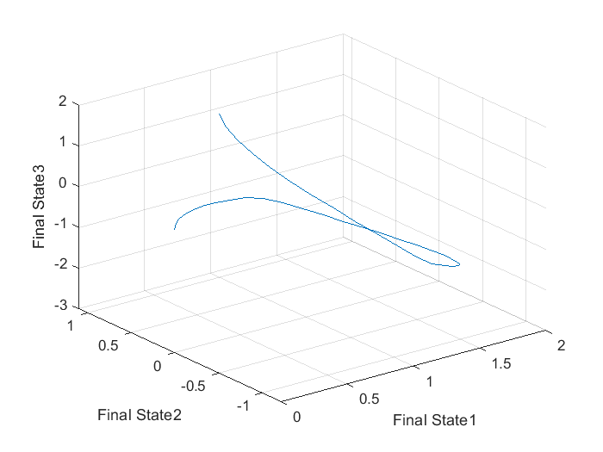

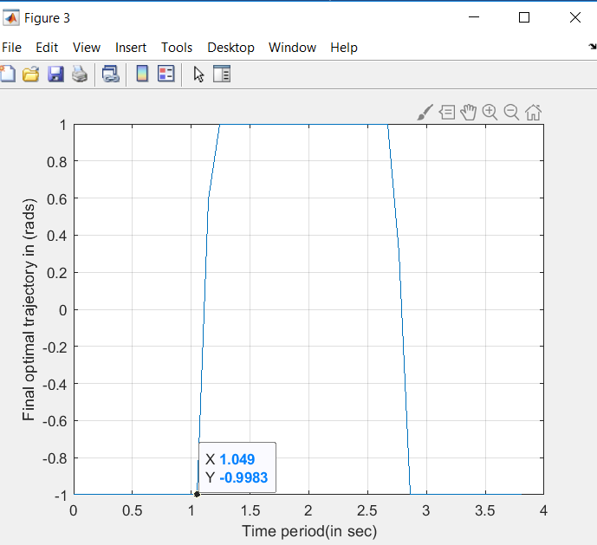

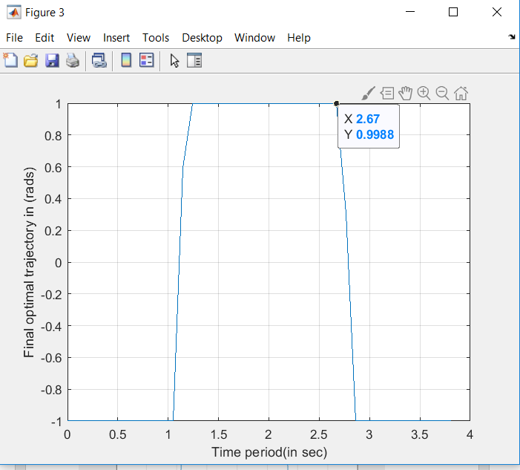

Two switches were needed again.

The switch time changes. The difference between the switch times is as follows:

3.8148-3.3346= 0.4802 seconds.

**Problem 2**

**Simulation:**

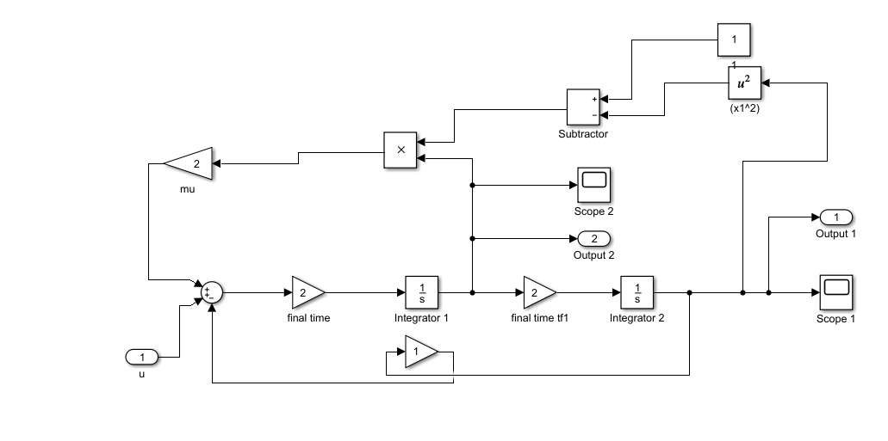

**a)**

**MATLAB Code**

**Main Code:**

clc;

close all;

clear all;

tfinal = 2;

tp = 0:0.02:1;

mu =2;

CL=ones(length(tp),1)*(0.01);

CL(end+1) = tfinal;

lower_limit=ones(length(tp),1)*(-10);

upper_limit=ones(length(tp),1)*(10);

lower_limit(end+1)=1;

upper_limit(end+1)=10;

options = optimset('Display','iter','TolCon',1e-4,'TolFun',1e-4,'PlotFcns','optimplotx', 'MaxFunEvals',5000,'Algorithm','interior-point');

[CL_final, cost] = fmincon('num2_cost', CL,[],[],[],[],lower_limit,upper_limit,'num2_constraint',options);

tfinal=CL_final(end);

[tout,yout]=sim('num2',1,[],[tp' CL_final(1:end-1)]);

figure;

plot(yout(:,1),yout(:,2));

grid;

xlabel('Final State1');

ylabel('Final State2');

figure;

plot(tp*tfinal, CL_final(1:end-1));

xlabel('Time (in sec)');

ylabel('Final optimal trajectory in (rads)');

grid;

disp('Final time in sec is');

disp(tfinal);

disp('Final Optimal Cost value is:');

disp(cost);

**Cost File:**

function y = num2_cost(p)

y = p(end);

end

**Constraint File:**

function [cineq, ceq] = num2_constraint(p)

cineq = [];

assignin('base', 'tfinal', p(end));

tp=[0:0.02:1];

u=p(1:end-1);

[tout,x_state,yout]=sim('num2',1,[],[tp' u]);

ceq(1) = 3-yout(end,1); ;

ceq(2) = yout(end,2);

end

**Output:**

**First-order Norm of**

**Iter F-count f(x) Feasibility optimality step**

**0 53 2.000000e+00 2.916e+00 5.039e-01**

**1 109 1.854253e+00 2.462e+00 5.039e-01 4.491e+00**

**2 164 1.486423e+00 2.150e+00 5.039e-01 4.015e+00**

**3 217 1.002432e+00 1.799e+00 5.039e-01 3.636e+00**

**4 270 1.043177e+00 1.173e+00 5.039e-01 2.723e+01**

**5 323 1.030007e+00 5.711e-01 5.039e-01 2.925e+01**

**6 376 1.031143e+00 5.478e-01 5.039e-01 9.133e-01**

**7 429 1.036959e+00 4.699e-01 5.039e-01 3.334e+00**

**8 482 1.046117e+00 3.841e-01 5.039e-01 4.109e+00**

**9 535 1.058313e+00 2.996e-01 5.039e-01 4.902e+00**

**10 588 1.068973e+00 2.281e-01 5.039e-01 4.479e+00**

**11 641 1.079239e+00 1.592e-01 5.039e-01 4.403e+00**

**12 694 1.086665e+00 1.078e-01 5.039e-01 3.633e+00**

**13 747 1.091648e+00 7.140e-02 5.039e-01 2.988e+00**

**14 800 1.095144e+00 4.385e-02 5.039e-01 2.580e+00**

**15 853 1.097358e+00 2.424e-02 5.039e-01 2.170e+00**

**16 906 1.098594e+00 1.108e-02 5.039e-01 1.834e+00**

**17 959 1.099129e+00 2.373e-03 5.039e-01 1.611e+00**

**18 1012 1.098913e+00 4.679e-06 5.039e-01 1.057e+00**

**19 1065 1.098597e+00 5.772e-06 2.552e-01 1.063e+00**

**20 1118 1.098668e+00 4.940e-06 2.334e-01 1.300e+00**

**21 1171 1.098578e+00 1.129e-07 1.953e-01 3.175e-01**

**22 1224 1.098581e+00 3.969e-06 1.176e-01 1.475e+00**

**23 1277 1.098655e+00 9.009e-06 9.960e-02 2.090e+00**

**24 1330 1.027413e+00 2.010e-08 6.745e-02 1.365e-01**

**25 1383 1.019165e+00 1.883e-07 2.016e-02 2.589e-01**

**26 1436 1.000480e+00 2.410e-10 4.094e-03 1.995e-02**

**27 1489 1.000199e+00 3.579e-10 2.008e-04 1.155e-02**

**28 1542 1.000002e+00 5.870e-12 7.142e-06 5.723e-04**

**Local minimum found that satisfies the constraints.**

**Optimization completed because the objective function is non-decreasing in**

**feasible directions, to within the selected value of the optimality tolerance,**

**and constraints are satisfied to within the selected value of the constraint tolerance.**

**<stopping criteria details>**

**Final time in sec is**

**1.0000**

**Final Optimal Cost value is:**

**1.0000 **





**b)**

**MATLAB Code**

**Main File:**

clc;

close all;

clear all;

tfinal = 2;

tp = 0:0.02:1;

mu =2;

CL=ones(length(tp),1)*(0.01);

CL(end+1) = tfinal;

lower_limit=ones(length(tp),1)*(-7);

upper_limit=ones(length(tp),1)*(7);

lower_limit(end+1)=1;

upper_limit(end+1)=10;

options = optimset('Display','iter','TolCon',1e-4,'TolFun',1e-4,'PlotFcns','optimplotx', 'MaxFunEvals',5000,'Algorithm','interior-point');

[CL_final, cost] = fmincon('num2_cost', CL,[],[],[],[],lower_limit,upper_limit,'num2_constraint',options);

tfinal=CL_final(end);

[tout,yout]=sim('num2',1,[],[tp' CL_final(1:end-1)]);

figure;

plot(yout(:,1),yout(:,2));

grid;

xlabel('Final State1');

ylabel('Final State2');

figure;

plot(tp*tfinal, CL_final(1:end-1));

xlabel('Time (in sec)');

ylabel('Final optimal trajectory in (rads)');

grid;

disp('Final time in sec is');

disp(tfinal);

disp('Final Optimal Cost value is:');

disp(cost);

**Cost File:**

function y = num2_cost(p)

y = p(end);

end

**Constraint File:**

function [cineq, ceq] = num2_constraint(p)

cineq = [];

assignin('base', 'tfinal', p(end));

tp=[0:0.02:1];

u=p(1:end-1);

[tout,x_state,yout]=sim('num2',1,[],[tp' u]);

ceq(1) = 3-yout(end,1); ;

ceq(2) = yout(end,2);

end

**Output:**

**First-order Norm of**

**Iter F-count f(x) Feasibility optimality step**

**0 53 2.000000e+00 2.916e+00 5.039e-01**

**1 108 1.854253e+00 2.462e+00 5.039e-01 4.491e+00**

**2 163 1.490180e+00 2.150e+00 5.039e-01 4.015e+00**

**3 216 1.002451e+00 1.805e+00 5.039e-01 3.453e+00**

**4 269 1.028843e+00 1.167e+00 5.039e-01 1.719e+01**

**5 322 1.036141e+00 6.837e-01 5.039e-01 2.256e+01**

**6 375 1.036573e+00 6.654e-01 5.039e-01 8.097e-01**

**7 428 1.038398e+00 6.183e-01 5.039e-01 2.382e+00**

**8 481 1.042195e+00 5.504e-01 5.039e-01 4.079e+00**

**9 534 1.045321e+00 5.011e-01 5.039e-01 3.434e+00**

**10 587 1.050523e+00 4.408e-01 5.039e-01 5.018e+00**

**11 640 1.053897e+00 4.029e-01 5.039e-01 3.661e+00**

**12 693 1.057271e+00 3.668e-01 5.039e-01 4.267e+00**

**13 746 1.059608e+00 3.433e-01 5.039e-01 3.614e+00**

**14 799 1.061058e+00 3.270e-01 5.039e-01 3.533e+00**

**15 852 1.061217e+00 3.197e-01 5.039e-01 2.062e+00**

**16 905 1.059812e+00 3.116e-01 5.039e-01 4.349e+00**

**17 958 1.059656e+00 3.102e-01 5.039e-01 1.342e+00**

**18 1011 1.059614e+00 3.071e-01 5.039e-01 3.388e+00**

**19 1064 1.060059e+00 3.062e-01 5.039e-01 8.015e-01**

**20 1117 1.064501e+00 2.973e-01 5.039e-01 9.963e+00**

**21 1170 1.064527e+00 2.972e-01 5.039e-01 5.008e-02**

**22 1223 1.064187e+00 2.971e-01 5.039e-01 2.806e-02**

**23 1276 1.000321e+00 2.796e-01 5.039e-01 1.200e+01**

**24 1329 1.001473e+00 2.757e-01 5.039e-01 1.920e+00**

**25 1382 1.001476e+00 2.757e-01 5.039e-01 9.621e-03**

**26 1436 1.001476e+00 2.757e-01 5.039e-01 7.042e-04**

**27 1489 1.001479e+00 2.757e-01 5.039e-01 3.483e-03**

**28 1542 1.004452e+00 2.651e-01 5.039e-01 5.460e+00**

**29 1595 1.005162e+00 2.636e-01 5.039e-01 7.021e-01**

**30 1648 1.019110e+00 2.557e-01 5.039e-01 3.750e+00**

**First-order Norm of**

**Iter F-count f(x) Feasibility optimality step**

**31 1701 1.019156e+00 2.556e-01 5.039e-01 3.397e-02**

**32 1754 1.019442e+00 2.551e-01 5.039e-01 2.439e-01**

**33 1808 1.019431e+00 2.551e-01 5.039e-01 7.285e-04**

**34 1861 1.007359e+00 2.547e-01 5.039e-01 2.146e-01**

**35 1914 1.000037e+00 2.528e-01 5.039e-01 1.072e+00**

**36 1967 1.000888e+00 2.476e-01 5.039e-01 2.600e+00**

**37 2020 1.000893e+00 2.476e-01 5.039e-01 1.401e-02**

**38 2073 1.001202e+00 2.460e-01 5.039e-01 7.477e-01**

**39 2126 1.006337e+00 2.197e-01 5.039e-01 1.318e+01**

**40 2179 1.006441e+00 2.195e-01 5.039e-01 6.602e-02**

**41 2232 1.000032e+00 2.195e-01 5.039e-01 2.050e-02**

**42 2285 1.045756e+00 2.075e-01 5.039e-01 1.097e+01**

**43 2338 1.000229e+00 2.060e-01 5.039e-01 1.324e+00**

**44 2391 1.000397e+00 2.043e-01 5.039e-01 1.479e+00**

**45 2444 1.000398e+00 2.043e-01 5.039e-01 7.409e-03**

**46 2497 1.000161e+00 2.034e-01 5.039e-01 1.016e-01**

**47 2550 1.000141e+00 2.033e-01 5.039e-01 4.274e-02**

**48 2603 1.000141e+00 2.030e-01 1.413e-04 2.484e-02**

**49 2660 1.000141e+00 2.027e-01 1.414e-04 3.017e-02**

**50 2713 1.000141e+00 2.027e-01 1.410e-04 1.317e-03**

**51 2766 1.000141e+00 2.027e-01 1.413e-04 4.394e-04**

**52 2819 1.000140e+00 2.027e-01 1.400e-04 1.973e-04**

**53 2872 1.000127e+00 2.025e-01 1.268e-04 8.492e-02**

**54 2925 1.000127e+00 2.024e-01 1.268e-04 1.153e-03**

**55 2978 1.000127e+00 2.024e-01 1.268e-04 1.127e-03**

**56 3031 1.000620e+00 2.024e-01 6.204e-04 4.940e-04**

**57 3084 1.007328e+00 2.024e-01 7.327e-03 6.707e-03**

**58 3137 1.007640e+00 2.024e-01 7.640e-03 3.130e-04**

**59 3190 1.019984e+00 2.024e-01 1.998e-02 1.234e-02**

**60 3243 1.019958e+00 2.024e-01 1.995e-02 2.653e-05**

**First-order Norm of**

**Iter F-count f(x) Feasibility optimality step**

**61 3296 1.019955e+00 2.024e-01 1.995e-02 3.845e-06**

**62 3349 1.019955e+00 2.024e-01 1.995e-02 1.936e-06**

**63 3402 1.019956e+00 2.024e-01 1.995e-02 1.231e-06**

**64 3455 1.019956e+00 2.024e-01 1.995e-02 7.172e-07**

**65 3508 1.019956e+00 2.024e-01 1.995e-02 4.107e-07**

**66 3561 1.019956e+00 2.024e-01 1.995e-02 2.261e-07**

**67 3614 1.019956e+00 2.024e-01 1.995e-02 1.239e-07**

**68 3667 1.019956e+00 2.024e-01 1.995e-02 6.644e-08**

**69 3720 1.019956e+00 2.024e-01 1.995e-02 3.561e-08**

**70 3773 1.019956e+00 2.024e-01 1.995e-02 1.882e-08**

**71 3826 1.019956e+00 2.024e-01 1.995e-02 9.951e-09**

**72 3879 1.019956e+00 2.024e-01 1.995e-02 5.209e-09**

**73 3932 1.019956e+00 2.024e-01 1.995e-02 2.730e-09**

**74 3985 1.019956e+00 2.024e-01 1.995e-02 1.419e-09**

**75 4038 1.019956e+00 2.024e-01 1.995e-02 7.392e-10**

**76 4091 1.019956e+00 2.024e-01 1.995e-02 3.825e-10**

**Converged to an infeasible point.**

**fmincon stopped because the size of the current step is less than**

**the default value of the step size tolerance but constraints are not**

**satisfied to within the selected value of the constraint tolerance.**

**<stopping criteria details>**

**Final time in sec is**

**1.0200**

**Final Optimal Cost value is:**

**1.0200**

**>> **





**c)**

**MATLAB Code**

**Main File:**

clc;

close all;

clear all;

tfinal = 2;

tp = 0:0.02:1;

mu =2;

CL=ones(length(tp),1)*(0.01);

CL(end+1) = tfinal;

lower_limit=ones(length(tp),1)*(-5);

upper_limit=ones(length(tp),1)*(5);

lower_limit(end+1)=1;

upper_limit(end+1)=10;

options = optimset('Display','iter','TolCon',1e-4,'TolFun',1e-4,'PlotFcns','optimplotx', 'MaxFunEvals',5000,'Algorithm','interior-point');

[CL_final, cost] = fmincon('num2_cost', CL,[],[],[],[],lower_limit,upper_limit,'num2_constraint',options);

tfinal=CL_final(end);

[tout,yout]=sim('num2',1,[],[tp' CL_final(1:end-1)]);

figure;

plot(yout(:,1),yout(:,2));

grid;

xlabel('Final State1');

ylabel('Final State2');

figure;

plot(tp*tfinal, CL_final(1:end-1));

xlabel('Time (in sec)');

ylabel('Final optimal trajectory in (rads)');

grid;

disp('Final time in sec is');

disp(tfinal);

disp('Final Optimal Cost value is:');

disp(cost);

**Cost File:**

function y = num2_cost(p)

y = p(end);

end

**Constraint File:**

function [cineq, ceq] = num2_constraint(p)

cineq = [];

assignin('base', 'tfinal', p(end));

tp=[0:0.02:1];

u=p(1:end-1);

[tout,x_state,yout]=sim('num2',1,[],[tp' u]);

ceq(1) = 3-yout(end,1); ;

ceq(2) = yout(end,2);

end

**Output:**

**First-order Norm of**

**Iter F-count f(x) Feasibility optimality step**

**0 53 2.000000e+00 2.916e+00 5.039e-01**

**1 108 1.854253e+00 2.462e+00 5.039e-01 4.491e+00**

**2 162 1.494133e+00 2.150e+00 5.039e-01 4.014e+00**

**3 215 1.002471e+00 1.807e+00 5.039e-01 3.350e+00**

**4 268 1.019814e+00 1.347e+00 5.039e-01 1.065e+01**

**5 321 1.025879e+00 1.099e+00 5.039e-01 6.953e+00**

**6 374 1.037063e+00 7.592e-01 5.039e-01 1.215e+01**

**7 428 1.037406e+00 7.470e-01 5.039e-01 5.429e-01**

**8 481 1.040284e+00 6.836e-01 5.039e-01 3.313e+00**

**9 534 1.041638e+00 6.511e-01 5.039e-01 2.065e+00**

**10 587 1.043932e+00 6.054e-01 5.039e-01 3.553e+00**

**11 640 1.046296e+00 5.648e-01 5.039e-01 4.212e+00**

**12 693 1.047363e+00 5.490e-01 5.039e-01 2.165e+00**

**13 746 1.048605e+00 5.319e-01 5.039e-01 4.042e+00**

**14 799 1.048409e+00 5.265e-01 5.039e-01 2.082e+00**

**15 852 1.047958e+00 5.232e-01 5.039e-01 2.552e+00**

**16 905 1.048131e+00 5.224e-01 5.039e-01 2.728e-01**

**17 958 1.051387e+00 5.175e-01 5.039e-01 5.635e+00**

**18 1011 1.051405e+00 5.175e-01 5.039e-01 2.822e-02**

**19 1064 1.000257e+00 5.155e-01 5.039e-01 6.351e-01**

**20 1117 1.142774e+00 5.051e-01 5.039e-01 9.281e+00**

**21 1170 1.142393e+00 5.050e-01 5.039e-01 4.667e-02**

**22 1223 1.143524e+00 5.050e-01 5.039e-01 6.633e-03**

**23 1276 1.531704e+00 4.996e-01 5.039e-01 3.385e+00**

**24 1329 2.385694e+00 4.885e-01 5.039e-01 6.355e+00**

**25 1382 2.390114e+00 4.885e-01 5.039e-01 3.193e-02**

**26 1435 1.256094e+00 4.875e-01 2.401e-01 1.156e+00**

**27 1488 1.249197e+00 4.868e-01 2.337e-01 1.348e-01**

**28 1541 1.241722e+00 4.847e-01 2.267e-01 5.415e-01**

**29 1594 1.239218e+00 4.836e-01 2.243e-01 5.534e-01**

**30 1647 1.239547e+00 4.836e-01 2.246e-01 1.432e-02**

**First-order Norm of**

**Iter F-count f(x) Feasibility optimality step**

**31 1700 1.245436e+00 4.779e-01 2.301e-01 3.394e+00**

**32 1753 1.244411e+00 4.681e-01 2.292e-01 5.306e+00**

**33 1806 1.244422e+00 4.680e-01 2.292e-01 2.753e-02**

**34 1859 1.267919e+00 4.667e-01 2.512e-01 9.845e-01**

**35 1912 1.322995e+00 4.567e-01 3.029e-01 8.430e+00**

**36 1965 1.326114e+00 4.566e-01 3.058e-01 4.229e-02**

**37 2018 2.125383e+00 4.566e-01 9.377e-01 7.999e-01**

**38 2071 9.960627e+00 4.561e-01 9.377e-01 7.841e+00**

**39 2124 9.999803e+00 4.557e-01 9.377e-01 2.610e-01**

**40 2178 9.999803e+00 4.557e-01 9.377e-01 1.012e-03**

**41 2231 9.999803e+00 4.553e-01 9.377e-01 2.544e-01**

**42 2284 9.999768e+00 4.553e-01 9.377e-01 1.135e-03**

**43 2338 9.999768e+00 4.553e-01 9.377e-01 3.464e-04**

**44 2391 9.999768e+00 4.553e-01 9.377e-01 7.887e-04**

**45 2444 9.999768e+00 4.553e-01 9.377e-01 6.285e-06**

**46 2497 9.999595e+00 4.553e-01 9.377e-01 1.736e-04**

**47 2550 9.999250e+00 4.553e-01 9.377e-01 3.445e-04**

**48 2603 9.998495e+00 4.553e-01 9.377e-01 7.553e-04**

**49 2656 9.996968e+00 4.553e-01 9.377e-01 1.527e-03**

**50 2709 9.993848e+00 4.553e-01 9.377e-01 3.120e-03**

**51 2762 9.987324e+00 4.553e-01 9.377e-01 6.524e-03**

**52 2815 9.973060e+00 4.553e-01 9.377e-01 1.426e-02**

**53 2868 9.938944e+00 4.553e-01 9.377e-01 3.412e-02**

**54 2921 9.840995e+00 4.553e-01 9.377e-01 9.795e-02**

**55 2974 9.432411e+00 4.553e-01 9.377e-01 4.086e-01**

**56 3027 5.706002e+00 4.553e-01 9.377e-01 3.726e+00**

**57 3080 1.023530e+00 4.553e-01 2.352e-02 4.682e+00**

**58 3133 1.098761e+00 4.553e-01 9.779e-02 7.523e-02**

**59 3186 1.098889e+00 4.553e-01 9.792e-02 1.279e-04**

**60 3239 1.098889e+00 4.553e-01 9.792e-02 1.862e-07**

**First-order Norm of**

**Iter F-count f(x) Feasibility optimality step**

**61 3292 1.098889e+00 4.553e-01 9.792e-02 1.333e-09**

**62 3345 1.098889e+00 4.553e-01 9.792e-02 6.071e-10**

**63 3398 1.098889e+00 4.553e-01 9.792e-02 2.577e-10**

**Converged to an infeasible point.**

**fmincon stopped because the size of the current step is less than**

**the default value of the step size tolerance but constraints are not**

**satisfied to within the selected value of the constraint tolerance.**

**<stopping criteria details>**

**Final time in sec is**

**1.0989**

**Final Optimal Cost value is:**

**1.0989**







**d)**

**MATLAB Code**

**Main File:**

clc;

close all;

clear all;

tfinal = 2;

tp = 0:0.02:1;

mu =2;

CL=ones(length(tp),1)*(0.01);

CL(end+1) = tfinal;

lower_limit=ones(length(tp),1)*(-3);

upper_limit=ones(length(tp),1)*(3);

lower_limit(end+1)=1;

upper_limit(end+1)=10;

options = optimset('Display','iter','TolCon',1e-4,'TolFun',1e-4,'PlotFcns','optimplotx', 'MaxFunEvals',5000,'Algorithm','interior-point');

[CL_final, cost] = fmincon('num2_cost', CL,[],[],[],[],lower_limit,upper_limit,'num2_constraint',options);

tfinal=CL_final(end);

[tout,yout]=sim('num2',1,[],[tp' CL_final(1:end-1)]);

figure;

plot(yout(:,1),yout(:,2));

grid;

xlabel('Final State1');

ylabel('Final State2');

figure;

plot(tp*tfinal, CL_final(1:end-1));

xlabel('Time (in sec)');

ylabel('Final optimal trajectory in (rads)');

grid;

disp('Final time in sec is');

disp(tfinal);

disp('Final Optimal Cost value is:');

disp(cost);

**Cost File:**

function y = num2_cost(p)

y = p(end);

end

**Constraint File:**

function [cineq, ceq] = num2_constraint(p)

cineq = [];

assignin('base', 'tfinal', p(end));

tp=[0:0.02:1];

u=p(1:end-1);

[tout,x_state,yout]=sim('num2',1,[],[tp' u]);

ceq(1) = 3-yout(end,1); ;

ceq(2) = yout(end,2);

end

**Output:**

**First-order Norm of**

**Iter F-count f(x) Feasibility optimality step**

**0 53 2.000000e+00 2.916e+00 5.039e-01**

**1 107 1.797984e+00 2.460e+00 5.039e-01 6.225e+00**

**2 160 1.411106e+00 2.131e+00 5.039e-01 4.067e+00**

**3 213 1.178535e+00 1.815e+00 5.039e-01 4.842e+00**

**4 266 1.173279e+00 1.765e+00 5.039e-01 9.453e-01**

**5 319 1.168686e+00 1.668e+00 5.039e-01 2.176e+00**

**6 372 1.167136e+00 1.638e+00 5.039e-01 7.285e-01**

**7 425 1.162713e+00 1.561e+00 5.039e-01 2.334e+00**

**8 478 1.158661e+00 1.516e+00 5.039e-01 1.531e+00**

**9 531 1.156222e+00 1.473e+00 5.039e-01 1.878e+00**

**10 584 1.153678e+00 1.442e+00 5.039e-01 1.576e+00**

**11 637 1.152401e+00 1.416e+00 5.039e-01 1.725e+00**

**12 690 1.148159e+00 1.391e+00 5.039e-01 1.813e+00**

**13 743 1.147778e+00 1.384e+00 5.039e-01 6.202e-01**

**14 796 1.147084e+00 1.366e+00 5.039e-01 2.461e+00**

**15 849 1.146904e+00 1.365e+00 5.039e-01 6.453e-02**

**16 902 1.147671e+00 1.312e+00 5.039e-01 5.894e+00**

**17 955 1.147304e+00 1.303e+00 5.039e-01 1.228e+00**

**18 1008 1.147298e+00 1.303e+00 5.039e-01 9.589e-02**

**19 1061 1.146776e+00 1.297e+00 5.039e-01 1.374e+00**

**20 1114 1.146817e+00 1.290e+00 5.039e-01 2.139e+00**

**21 1167 1.146772e+00 1.289e+00 5.039e-01 6.995e-01**

**22 1220 1.146706e+00 1.287e+00 5.039e-01 5.437e-01**

**23 1273 1.146341e+00 1.279e+00 5.039e-01 2.798e+00**

**24 1326 1.146133e+00 1.271e+00 5.039e-01 6.678e-01**

**25 1379 1.146090e+00 1.269e+00 5.039e-01 1.711e-01**

**26 1432 1.146087e+00 1.269e+00 5.039e-01 6.353e-03**

**27 1485 1.145888e+00 1.264e+00 5.039e-01 3.567e-01**

**28 1538 1.146328e+00 1.248e+00 5.039e-01 1.838e+00**

**29 1591 1.146338e+00 1.248e+00 5.039e-01 9.469e-03**

**30 1644 1.146320e+00 1.248e+00 5.039e-01 6.557e-03**

**First-order Norm of**

**Iter F-count f(x) Feasibility optimality step**

**31 1697 1.144112e+00 1.243e+00 5.039e-01 4.391e-01**

**32 1750 1.132776e+00 1.208e+00 5.039e-01 5.405e+00**

**33 1803 1.133169e+00 1.208e+00 5.039e-01 2.386e-02**

**34 1856 1.133157e+00 1.207e+00 1.308e-01 6.405e-02**

**35 1909 1.133053e+00 1.206e+00 1.307e-01 6.978e-02**

**36 1962 1.133041e+00 1.206e+00 1.307e-01 9.365e-03**

**37 2015 1.133047e+00 1.206e+00 1.307e-01 4.354e-02**

**38 2068 1.134027e+00 1.205e+00 1.317e-01 4.000e-01**

**39 2121 1.135547e+00 1.193e+00 1.332e-01 2.647e+00**

**40 2174 1.135956e+00 1.182e+00 1.336e-01 2.433e+00**

**41 2227 1.135956e+00 1.182e+00 1.336e-01 1.519e-02**

**42 2280 1.122194e+00 1.182e+00 1.200e-01 1.376e-02**

**43 2333 1.064805e+00 1.182e+00 6.366e-02 5.739e-02**

**44 2386 1.091962e+00 1.182e+00 9.034e-02 2.716e-02**

**45 2439 1.100591e+00 1.182e+00 9.882e-02 8.628e-03**

**46 2492 1.084274e+00 1.182e+00 8.279e-02 1.632e-02**

**47 2545 1.100351e+00 1.182e+00 9.858e-02 1.624e-02**

**48 2598 1.099715e+00 1.182e+00 9.796e-02 2.220e-03**

**49 2651 1.098575e+00 1.182e+00 9.684e-02 7.553e-03**

**50 2704 1.078348e+00 1.180e+00 7.697e-02 1.038e+00**

**51 2757 1.078319e+00 1.180e+00 7.694e-02 1.013e-02**

**52 2810 1.077436e+00 1.179e+00 7.607e-02 2.176e-01**

**53 2863 1.079100e+00 1.178e+00 7.771e-02 5.275e-02**

**54 2916 1.083094e+00 1.178e+00 8.163e-02 3.085e-02**

**55 2969 1.089641e+00 1.178e+00 8.806e-02 2.197e-01**

**56 3022 1.247116e+00 1.167e+00 2.428e-01 5.766e+00**

**57 3075 1.247587e+00 1.167e+00 2.432e-01 2.870e-02**

**58 3128 1.146033e+00 1.167e+00 1.429e-01 1.016e-01**

**59 3181 1.058801e+00 1.167e+00 5.756e-02 8.723e-02**

**60 3234 1.097144e+00 1.167e+00 9.509e-02 3.972e-02**

**First-order Norm of**

**Iter F-count f(x) Feasibility optimality step**

**61 3287 1.097097e+00 1.167e+00 9.504e-02 4.648e-03**

**62 3340 1.098503e+00 1.167e+00 9.642e-02 1.474e-03**

**63 3393 1.098917e+00 1.167e+00 9.683e-02 8.605e-03**

**64 3446 1.098906e+00 1.167e+00 9.682e-02 2.566e-03**

**65 3499 1.098900e+00 1.167e+00 9.681e-02 1.678e-04**

**66 3552 1.098888e+00 1.167e+00 9.680e-02 3.373e-03**

**67 3605 1.098887e+00 1.167e+00 9.680e-02 1.212e-03**

**68 3658 1.098888e+00 1.167e+00 9.680e-02 5.440e-05**

**69 3711 1.098891e+00 1.167e+00 9.680e-02 1.096e-03**

**70 3764 1.098893e+00 1.167e+00 9.680e-02 1.110e-01**

**71 3817 1.098896e+00 1.167e+00 9.681e-02 3.203e-02**

**72 3870 1.098892e+00 1.167e+00 9.680e-02 8.215e-03**

**73 3923 1.098892e+00 1.167e+00 9.680e-02 1.449e-03**

**74 3976 1.098894e+00 1.167e+00 9.680e-02 4.527e-04**

**75 4029 1.098893e+00 1.167e+00 9.680e-02 2.204e-05**

**76 4082 1.098890e+00 1.167e+00 9.680e-02 4.006e-04**

**77 4135 1.098885e+00 1.167e+00 9.679e-02 3.553e-02**

**78 4188 1.098908e+00 1.166e+00 9.682e-02 5.742e-03**

**79 4241 1.098940e+00 1.166e+00 9.685e-02 1.657e-03**

**80 4294 1.091018e+00 1.166e+00 8.909e-02 7.991e-03**

**81 4347 1.091018e+00 1.166e+00 8.909e-02 8.537e-05**

**82 4400 1.099599e+00 1.166e+00 9.749e-02 8.753e-03**

**83 4453 1.096234e+00 1.166e+00 9.420e-02 1.708e-01**

**84 4506 1.096242e+00 1.166e+00 9.421e-02 3.100e-02**

**85 4559 1.096372e+00 1.165e+00 9.433e-02 5.260e-03**

**86 4612 1.096204e+00 1.165e+00 9.417e-02 3.781e-03**

**87 4665 1.096204e+00 1.165e+00 9.417e-02 2.305e-03**

**88 4718 1.096180e+00 1.165e+00 9.415e-02 7.393e-04**

**89 4771 1.096502e+00 1.165e+00 9.446e-02 9.186e-04**

**90 4824 1.102421e+00 1.165e+00 1.003e-01 4.420e-02**

**First-order Norm of**

**Iter F-count f(x) Feasibility optimality step**

**91 4877 1.102399e+00 1.165e+00 1.002e-01 5.947e-03**

**92 4930 1.100712e+00 1.165e+00 9.858e-02 3.878e-02**

**93 4983 1.100703e+00 1.165e+00 9.857e-02 1.045e-02**

**94 5036 1.100700e+00 1.165e+00 9.857e-02 1.404e-03**

**Solver stopped prematurely.**

**fmincon stopped because it exceeded the function evaluation limit,**

**options.MaxFunctionEvaluations = 5000 (the selected value).**

**Final time in sec is**

**1.1007**

**Final Optimal Cost value is:**

**1.1007**







**e)**

**MATLAB Code**

**Main File:**

clc;

clear all;

close all;

Optimal_Time= [ 1.0000 1.0200 1.0989 1.1007];

constraint=[10 7 5 3];

figure;

plot(constraint,Optimal_Time);

grid;

**Output:**



|  |  |  |
| --- | --- | --- |
| **Sr. No.** | **Control Input Constraints** | **Optimal Time** |
| **1.** | **+/- 10** | 1.0000 |
| **2.** | **+/- 7** | 1.0200 |
| **3.** | **+/- 5** | 1.0989 |
| **4.** | **+/- 3** | 1.1007 |

**On comparing we can see that, from +/-10 to +/-3, the optimal time taken to reach the final state has increased.**