**MAIN ASSIGNMENT**

**MILESTONE 1**

1. Calculate Monthly average NAV, Repurchase & Sale Price for each scheme.

I made Two MOdels FOR THE FIRST MILESTONE WHICH ARE

1)MILESTONE1.1

2)milestone1.2

* **Uploaded all the Four tables in the snowflake**
* **Uploaded the three tables using load data option and Navhistory table using the dbeaver**

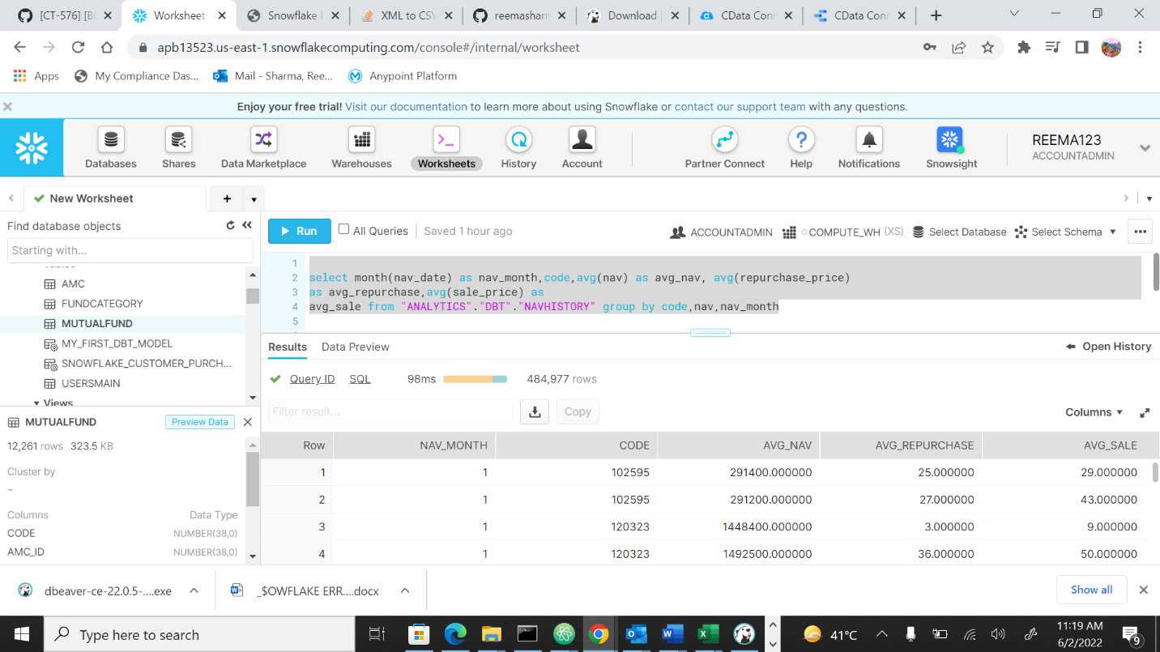

**DBT RUN and DBT TEST**

2) Find out each scheme’s Max and Min NAV value and Date it occurred

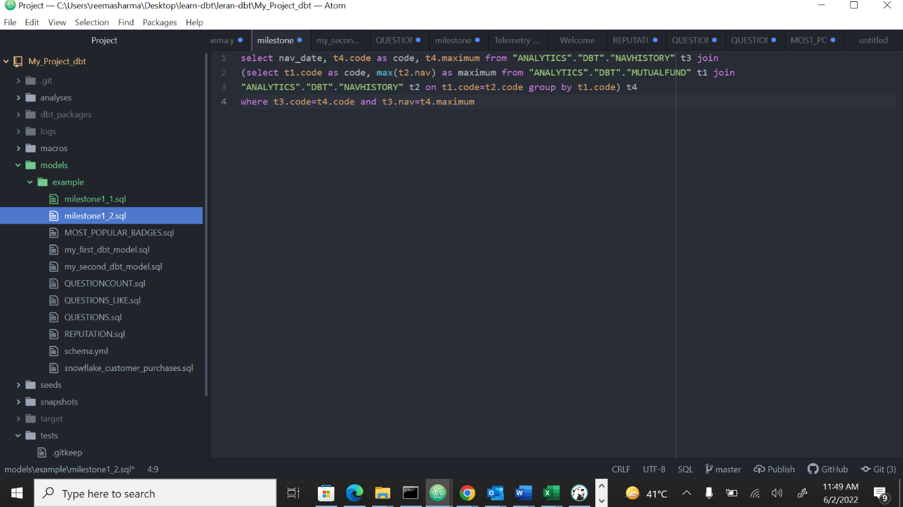

**DBT RUN and DBT Test**

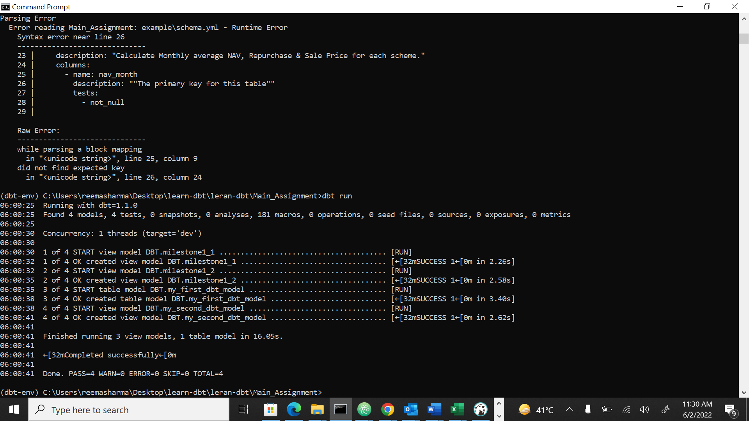

**MILESTONE 3**

Milestone 3_3

1. Distribution of latest mutual funds based on category. [pie]

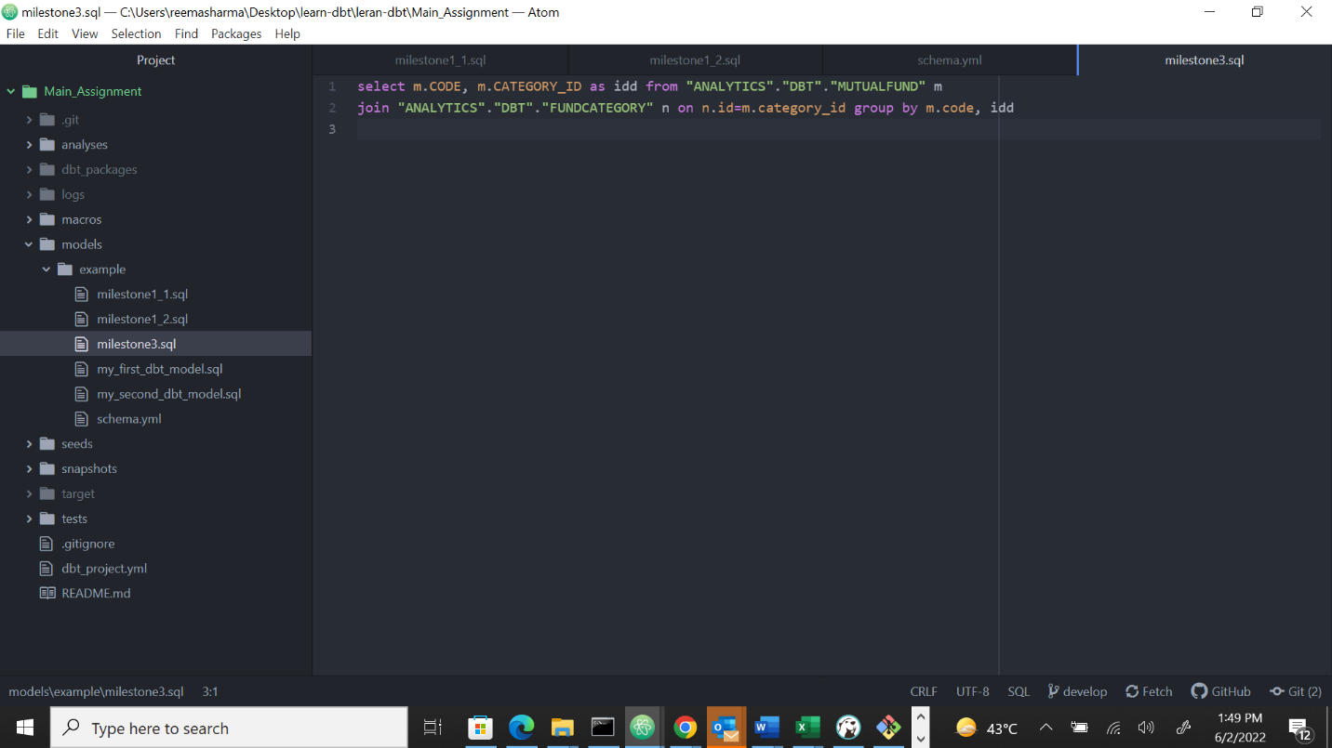

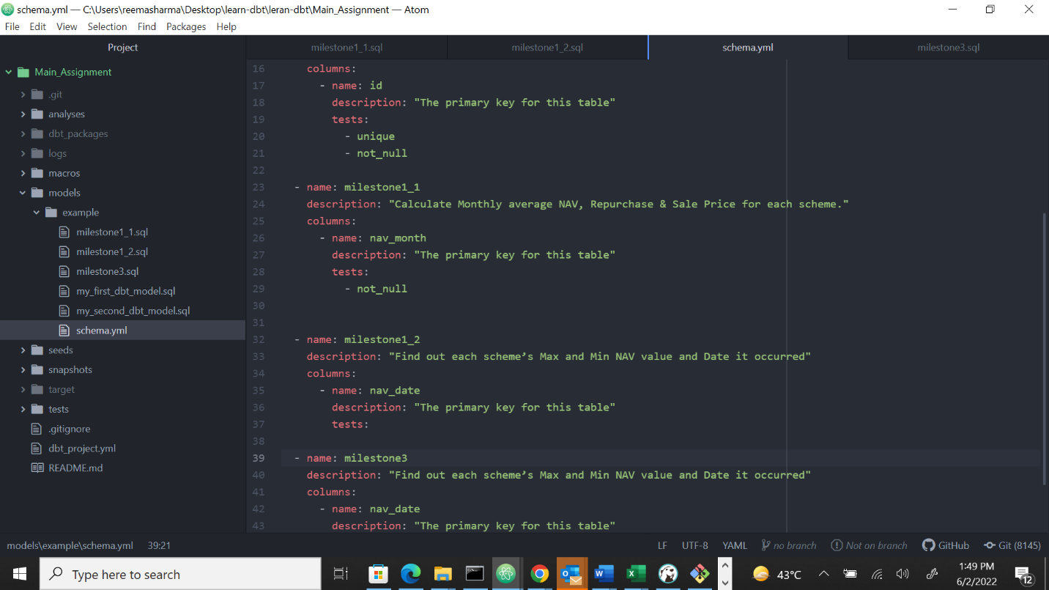

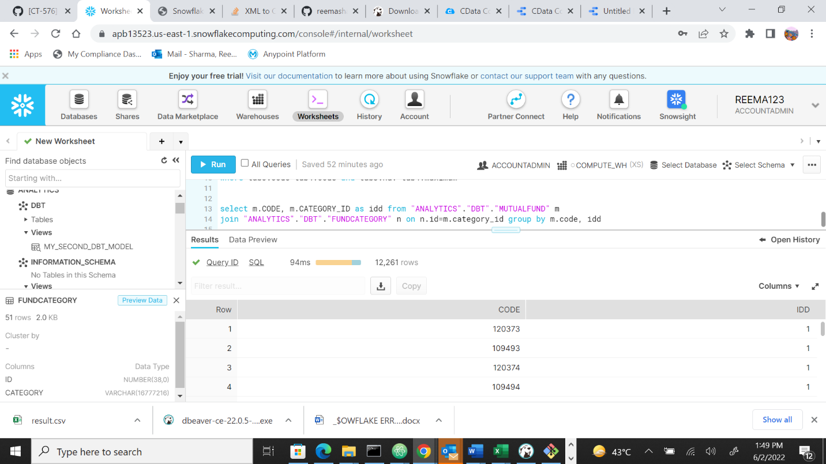

**Created a new table of name Milestone3_3 and then uploaded the downloaded table after running the**

**Sql queries and then through the datacloud connection with snowflake imported the table**

