Data Discovery & Analysis
Jupyter Notebook Analysis Documentation

Overview
This report documents the exploratory data analysis performed in the discovery notebook. The analysis includes various visualizations and statistical computations to understand the patterns, trends, and characteristics of the sales data. Each visualization and statistical measure is described in detail below.

1. Sales Over Time - Line Plot

Visualization Type:
Time series line plot showing sales values across sequential days

Description:
Purpose: This line chart displays the temporal evolution of sales for a specific product-store combination. It provides a high-level view of sales patterns over the entire observation period.
Visual Elements: The x-axis represents time in days, while the y-axis shows sales quantities. The blue line connects consecutive daily sales values, revealing the overall trajectory and volatility of demand.
Key Features to Observe: This visualization helps identify: overall trends (increasing, decreasing, or stable), presence of seasonality or cyclical patterns, volatility levels, outliers or unusual spikes, and periods of zero or low sales.
Analytical Value: This is typically the first visualization in time series analysis, providing context for all subsequent analyses. It helps determine whether the series is stationary, whether transformations are needed, and what types of patterns might be present.
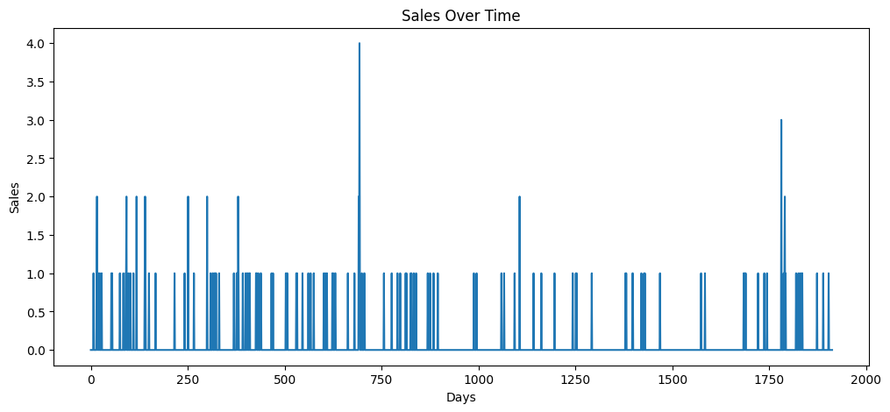

2. Rolling Statistics - Mean and Standard Deviation

Visualization Type:
Multi-line plot showing original series with rolling mean and standard deviation

Description:
Purpose: This visualization overlays the original sales data with its rolling 30-day mean and standard deviation. It is used to assess stationarity and identify time-varying patterns in both the central tendency and variability of the series.
Visual Components: Three lines are displayed:
• Original (blue): The raw sales data
• Mean (orange): 30-day rolling average, smoothing out short-term fluctuations
• Std (green): 30-day rolling standard deviation, showing volatility over time
Window Size Selection: The 30-day rolling window is chosen to balance smoothness with responsiveness. It removes daily noise while preserving meaningful monthly and seasonal patterns. Shorter windows would be more responsive but noisier; longer windows would be smoother but less sensitive to changes.
Stationarity Assessment: This plot is crucial for testing stationarity assumptions:
• Stationary series: Rolling mean stays relatively flat, rolling std remains constant
• Non-stationary series: Rolling mean shows clear trends or drift, rolling std may change
• Heteroscedastic series: Rolling std varies significantly over time
Analytical Insights: Analysts examine whether the mean and variance change over time. If the rolling mean shows an upward or downward trend, the series has drift. If the rolling std fluctuates widely, the series exhibits time-varying volatility (heteroscedasticity), which may require transformation or specialized modeling techniques
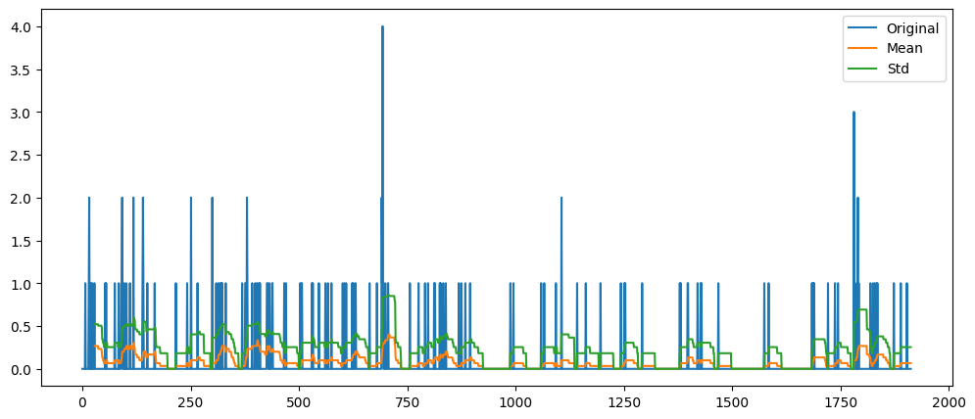

3. Sales Distribution - Histogram

Visualization Type:
Histogram with 30 bins showing frequency distribution of sales values

Description:
Purpose: The histogram displays the frequency distribution of sales values, showing how often different sales quantities occur. This reveals the underlying probability distribution of demand.
Visual Structure: The x-axis shows sales quantity ranges (bins), while the y-axis shows the frequency (count) of observations falling into each bin. The 30-bin configuration provides sufficient granularity to see the distribution shape without excessive detail.
Distribution Characteristics: Key aspects to analyze include:
• Shape: Is it symmetric (normal), skewed (left or right), bimodal, or uniform?
• Central tendency: Where do most values cluster?
• Spread: How wide is the distribution?
• Outliers: Are there isolated bars far from the main distribution?
• Zero-inflation: Is there a large spike at zero sales?
Modeling Implications: The distribution shape guides model selection. Normal distributions suit linear models, skewed distributions may need transformation or GLMs (Generalized Linear Models), and zero-inflated distributions require specialized model

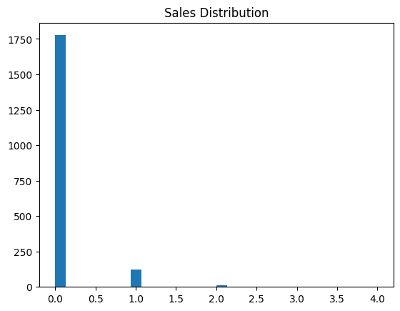
.



4. Average Sales by Day of Week - Bar Chart

Visualization Type:
Grouped bar chart showing mean sales for each day of the week

Description:
Purpose: This bar chart aggregates sales data by day of week (Monday through Sunday) and displays the average sales for each day. It reveals weekly seasonality patterns and identifies which days typically have higher or lower demand.
Calculation Method: The analysis uses groupby() on the weekday field, computing the mean sales value across all occurrences of each weekday. This averages out other factors (holidays, promotions, trends) to isolate the pure day-of-week effect.
Visual Interpretation: Each bar represents one day of the week (1=Monday, 2=Tuesday, ... 7=Sunday). Bar height indicates average sales volume. Higher bars indicate days with typically stronger demand; lower bars show weaker demand days.
Common Weekly Patterns: Different retail contexts show distinct patterns:
• Grocery stores: Often peak on weekends (Saturday/Sunday) when families shop
• Household goods: May show mid-week peaks when restocking occurs
• Work-related items: Peak on weekdays, drop on weekends
• Entertainment items: Strong weekend demand
Forecasting Applications: Day-of-week patterns are crucial for short-term forecasting. Models can incorporate weekday dummy variables or seasonal indices to capture this cyclical behavior. Promotional planning also benefits from knowing baseline demand by weekday - promotions on naturally low-demand days may boost overall sales more effectively. 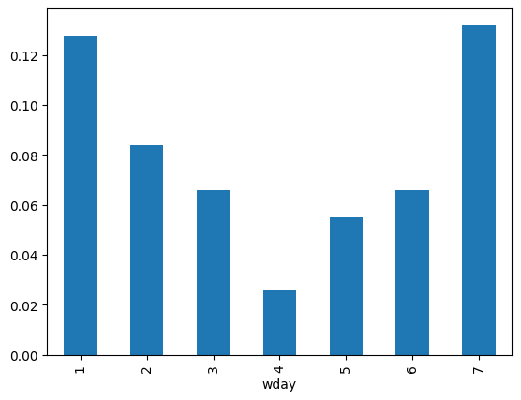

5. Average Sales by Month - Bar Chart

Visualization Type:
Grouped bar chart showing mean sales for each month of the year

Description:
Purpose: This bar chart aggregates sales by calendar month (January through December) and displays the average sales for each month. It identifies annual seasonality patterns and reveals which months have characteristically high or low demand.
Calculation Method: Sales data is grouped by month number (1-12), and the mean is computed across all years in the dataset. This creates a monthly seasonal profile that averages out year-to-year variations and other factors, isolating the pure monthly seasonal effect.
Visual Elements: Twelve bars represent the twelve months. Bar height shows average sales for that month across all years. Patterns of consecutive high or low bars indicate sustained seasonal effects rather than isolated monthly anomalies.
Typical Seasonal Patterns: Different product categories show distinct monthly patterns:
• Household goods: Often spike in January (New Year organization), May (spring cleaning), September (back-to-school)
• Food items: Peaks around holidays (November-December), summer cookouts (June-July)
• School supplies: Dramatic August-September peak
• Winter/summer products: Clear seasonal alignment
Year-over-Year Considerations: The monthly averages shown here smooth across multiple years. If the business is growing or declining, recent months may differ from historical averages. Analysts should also examine year-by-year monthly patterns to detect evolving seasonality or growth trends.
Strategic Planning Value: Understanding monthly patterns is essential for:
• Inventory planning: Stock up before high-demand months
• Staffing decisions: Adjust workforce for seasonal peaks
• Marketing campaigns: Time promotions with natural demand revenue accurately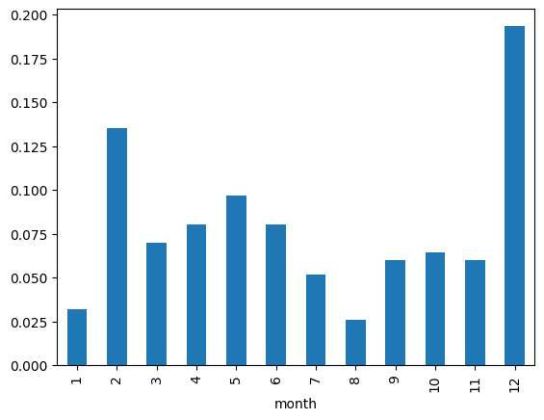

6. Autocorrelation Function (ACF) Plot

Visualization Type:
Stem plot showing autocorrelation coefficients at lags 1 through 30

Description:
Purpose: The ACF plot measures how correlated the time series is with itself at different time lags. It answers the question: "If sales are high today, what does that tell us about sales N days from now?" This is fundamental for understanding temporal dependencies and selecting appropriate forecasting models.
Visual Structure: The x-axis shows lag values (1 to 30 days), while the y-axis shows correlation coefficients ranging from -1 to +1. Vertical lines (stems) extend from zero to the correlation value at each lag. A shaded blue region represents the 95% confidence interval - correlations outside this region are statistically significant.
Interpretation Guidelines: Key patterns to identify:
• Lag 1 correlation: Indicates day-to-day persistence
• Slow decay: Suggests non-stationarity or strong trend
• Fast decay to zero: Indicates stationarity and weak memory
• Periodic spikes: Reveal seasonality (e.g., spike at lag 7 suggests weekly pattern)
• Values within confidence bands: Statistically insignificant correlations
Common ACF Patterns: Different patterns indicate different processes:
• Gradual linear decay: Non-stationary series with trend
• Exponential decay: AR (autoregressive) process
• Cut-off after lag q: MA(q) (moving average) process
• Sinusoidal pattern: Seasonal component
• Spike at lag 7, 14, 21...: Weekly seasonality
Modeling Implications: The ACF directly informs ARIMA model specification:
• If ACF decays slowly: Differencing needed (d > 0)
• If ACF cuts off after lag q: MA(q) component appropriate
• Seasonal spikes: Seasonal ARIMA model required
The ACF is typically examined alongside the PACF to determine optimal AR and MA
. 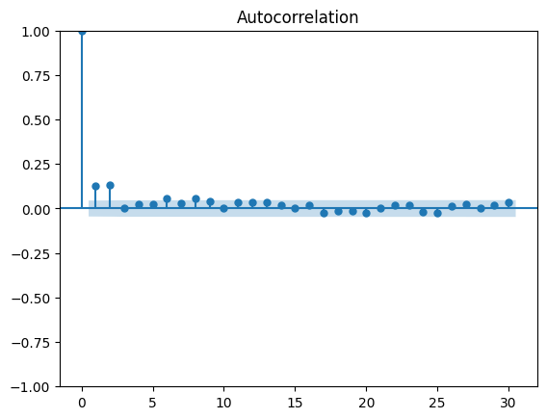

7. Partial Autocorrelation Function (PACF) Plot

Visualization Type:
Stem plot showing partial autocorrelation coefficients at lags 1 through 30

Description:
Purpose: The PACF measures the direct correlation between the time series and its lag, controlling for the influence of all shorter lags. Unlike ACF which shows total correlation, PACF shows only the unique contribution of each lag. This is critical for determining the autoregressive (AR) order in time series models.
Conceptual Difference from ACF: Example: Sales today might correlate with sales 7 days ago (lag 7). ACF would show this correlation, but it includes indirect effects through lags 1-6. PACF shows only the direct effect after removing the influence of intermediate lags. This reveals the true causal structure.
Visual Structure: Similar layout to ACF: x-axis shows lags (1-30), y-axis shows partial correlation coefficients (-1 to +1), vertical stems indicate coefficient values, and the blue shaded region is the 95% confidence interval for statistical significance.
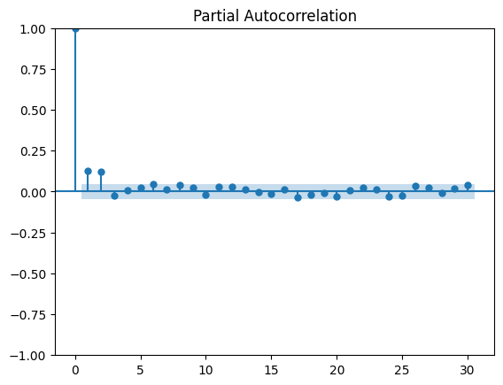
Interpretation Guidelines: Key patterns to identify:
• Significant spike at lag k, then cut-off: Suggests AR(k) process
• Gradual decay: Suggests MA (moving average) component
• Multiple significant spikes: May need higher-order AR or mixed ARMA
• Spike at lag 7 only: Direct weekly effect without intermediate dependencies
• No significant spikes: Series may be white noise or pure MA
Common PACF Patterns: Different patterns indicate different model structures:
• Cut-off after lag p: AR(p) process
• Exponential/sinusoidal decay: MA process
• Both ACF and PACF decay: ARMA process needed
• Seasonal spike at lag s: Seasonal AR term
Model Selection Process: AR order determination:
• PACF cuts off after lag p → AR(p)
• Significant spikes at lags 1, 2, 3 → Test AR(1), AR(2), AR(3)
• Compare with ACF: If ACF decays and PACF cuts off → AR model
• If ACF cuts off and PACF decays → MA model
• If both decay → ARMA model
This diagnostic, combined with ACF, guides initial ARIMA(p,d,q) specification.

8. Seasonal Decomposition

Visualization Type:
Four-panel plot showing decomposition of time series into components

Description:
Purpose: Seasonal decomposition separates the time series into four distinct components: observed (original), trend, seasonal, and residual. This decomposition helps understand the relative importance of each component and reveals patterns that may be obscured in the original series.
Decomposition Method: The statsmodels seasonal_decompose function is used with period=7, indicating weekly seasonality. The method can use either additive (Y = T + S + R) or multiplicative (Y = T × S × R) decomposition. Additive is appropriate when seasonal fluctuations are roughly constant; multiplicative when they grow with the level of the series.
Panel 1: Observed: The top panel shows the original, unmodified time series. This provides context for interpreting the decomposed components below. All variations visible here are explained by the combination of trend, seasonal, and residual components.
Panel 2: Trend: The trend component represents the long-term movement in the series after removing seasonal effects and noise. It is typically extracted using a moving average filter. The trend reveals:
• Overall direction: Increasing, decreasing, or stable demand
• Growth rate: Speed of increase/decrease
• Structural changes: Shifts in baseline demand level
• Cyclical patterns: Longer than seasonal but not purely linear
Panel 3: Seasonal: The seasonal component shows the repeating pattern at the specified period (7 days = weekly). This component:
• Repeats identically every 7 days
• Shows which days in the week have above/below average sales
• Has zero mean by construction
• Amplitude indicates strength of seasonal effect
A strong, consistent pattern indicates predictable weekly cycles useful for forecasting.
Panel 4: Residual: The residual (or remainder) is what remains after removing trend and seasonal components. It represents:
• Random noise and unpredictable variations
• Effects not captured by trend or seasonality (promotions, holidays, stockouts)
• Model inadequacy: Systematic patterns here suggest missing components
Ideally, residuals should look like white noise (random scatter around zero with constant variance). Patterns in residuals indicate the decomposition is incomplete or the model needs refinement.
Analytical Value: Decomposition serves multiple purposes:
• Understanding: Quantifies how much variation comes from trend vs. seasonality
• Forecasting: Separately model each component, then recombine
• Anomaly detection: Outliers appear clearly in residuals
• Data quality: Identifies periods with unusual behavior
• Seasonal adjustment: Remove seasonality to see underlying trends clearly
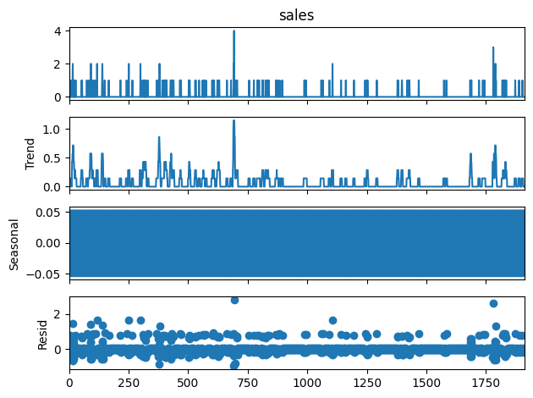

9. Zero Sales Proportion - Statistical Calculation
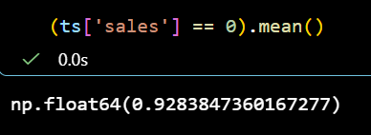

Calculation Type:
Proportion of days with zero sales

Description:
Purpose: This statistic calculates what percentage of days in the series have exactly zero sales. It is computed as: (Number of days with sales = 0) / (Total number of days). The result, 0.9284 (92.84%), indicates that the vast majority of days have no sales for this particular product-store combination.
Calculation Method: The computation uses: (ts["sales"] == 0).mean()
• (ts["sales"] == 0) creates a boolean array: True where sales are zero, False otherwise
• .mean() on a boolean array gives the proportion of True values
• Result is a decimal between 0 and 1 (0.9284 = 92.84%)
Interpretation: A zero-sales proportion of 92.84% is extremely high and indicates:
• Intermittent demand: This is a slow-moving or rarely purchased item
• Sparse data: Most days provide no information about demand level
• Lumpy demand: When sales occur, they may come in larger batches
• Store-product mismatch: This product may not be appropriate for this store
Implications for Analysis: High zero-inflation affects analysis in multiple ways:
• Distribution: Heavily right-skewed with a large spike at zero
• Standard forecasting: Traditional methods struggle with so many zeros
• Model assumptions: Normality assumption is severely violated
• Evaluation metrics: RMSE and MAE may be dominated by the many zero days
Implications for Forecasting: Intermittent demand requires specialized techniques:
• Croston's method: Separately model demand intervals and demand sizes
• TSB (Teunter-Syntetos-Babai): Extension of Croston for smoother estimates
• Zero-inflated models: Two-part models (probability of sale + amount if sold)
• Classification + regression: Predict if sale occurs, then predict amount
• Inventory optimization: Focus on service levels rather than point forecasts
Business Context: The extremely high zero proportion suggests:
• Product rationalization: Consider discontinuing this item at this store
• Assortment optimization: Replace with faster-moving items
• Aggregation strategy: Forecast at category or store-level rather than item-store
• Inventory policy: Use min-max or periodic review rather than perpetual systems
• Promotional focus: When running promotions, this product shows potential upsid

