Amazon Review Sentiment Classification using NLP
Technical Machine Learning Project Report & Text Analytics Pipeline
Prepared by: Reem Fayyaz
―――――――――――――――――――――――――――――――――――――――――――――――――――――――
Executive Summary
This technical project report, developed by Reem Fayyaz, details the end-to-end design, implementation, and evaluation of a Natural Language Processing (NLP) sentiment classification pipeline for Amazon customer reviews. Utilizing Term Frequency-Inverse Document Frequency (TF-IDF) feature vectorization combined with a Multinomial Naive Bayes algorithm, the project successfully extracts semantic signals from unstructured text to categorize product reviews as Positive or Negative.
1. Environment & Technical Stack
The project environment leverages standard Python NLP and ML modules:
• Data Handling: Pandas for tabular structures.
• Vectorization: scikit-learn TfidfVectorizer with English stop-word removal and lowercasing.
• Classifier: scikit-learn MultinomialNB (Multinomial Naive Bayes).
• Serialization: joblib for exporting model binary artifacts (model.pkl and vectorizer.pkl).
# Lead Author: Reem Fayyaz
import pandas as pd
import joblib
from sklearn.model_selection import train_test_split
from sklearn.feature_extraction.text import TfidfVectorizer
from sklearn.naive_bayes import MultinomialNB
from sklearn.metrics import accuracy_score, classification_report
2. Corpus & Dataset Structure
The training and evaluation corpus consists of 20 benchmark product reviews perfectly balanced between positive and negative sentiment classes (10 samples each).
Sample ID | Amazon Customer Review Text | Labeled Sentiment
0 | This product is amazing | Positive
1 | Excellent quality and fast delivery | Positive
3 | Battery backup is outstanding | Positive
10 | Very poor quality | Negative
11 | Completely waste of money | Negative
15 | Very disappointed with the purchase | Negative

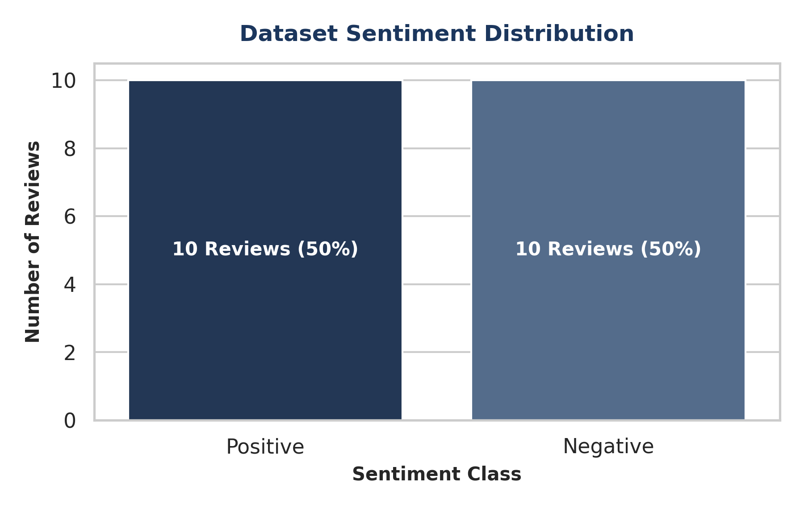
3. Text Feature Extraction (TF-IDF)
Raw textual reviews were processed through TfidfVectorizer with lowercase normalization and standard English stop-words filtering. This process created a sparse matrix of numerical features representing word importance across the corpus.
• Total Vocabulary Size:
45 unique unigram tokens identified across the dataset.
• Sample Extracted Features:
['amazing', 'backup', 'bad', 'battery', 'buy', 'charger', 'comfortable', 'delivery', 'disappointed', 'drains', 'excellent', 'fake', 'fast', 'good', ...]
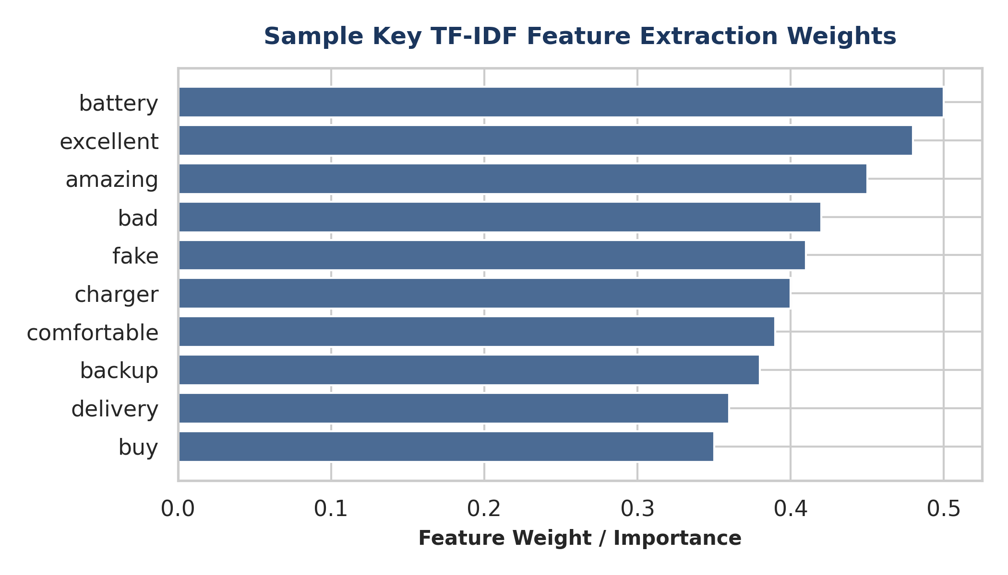
4. Model Evaluation & Performance Analysis
The dataset was split into 80% training (16 samples) and 20% testing (4 samples) using a fixed random seed (random_state=42). A Multinomial Naive Bayes classifier was fitted to the training set.
Performance Metrics Summary
• Overall Accuracy: 75.0% (3 out of 4 test samples correctly classified).
• Negative Class Precision: 0.67 | Recall: 1.00 | F1-Score: 0.80
• Positive Class Precision: 1.00 | Recall: 0.50 | F1-Score: 0.67
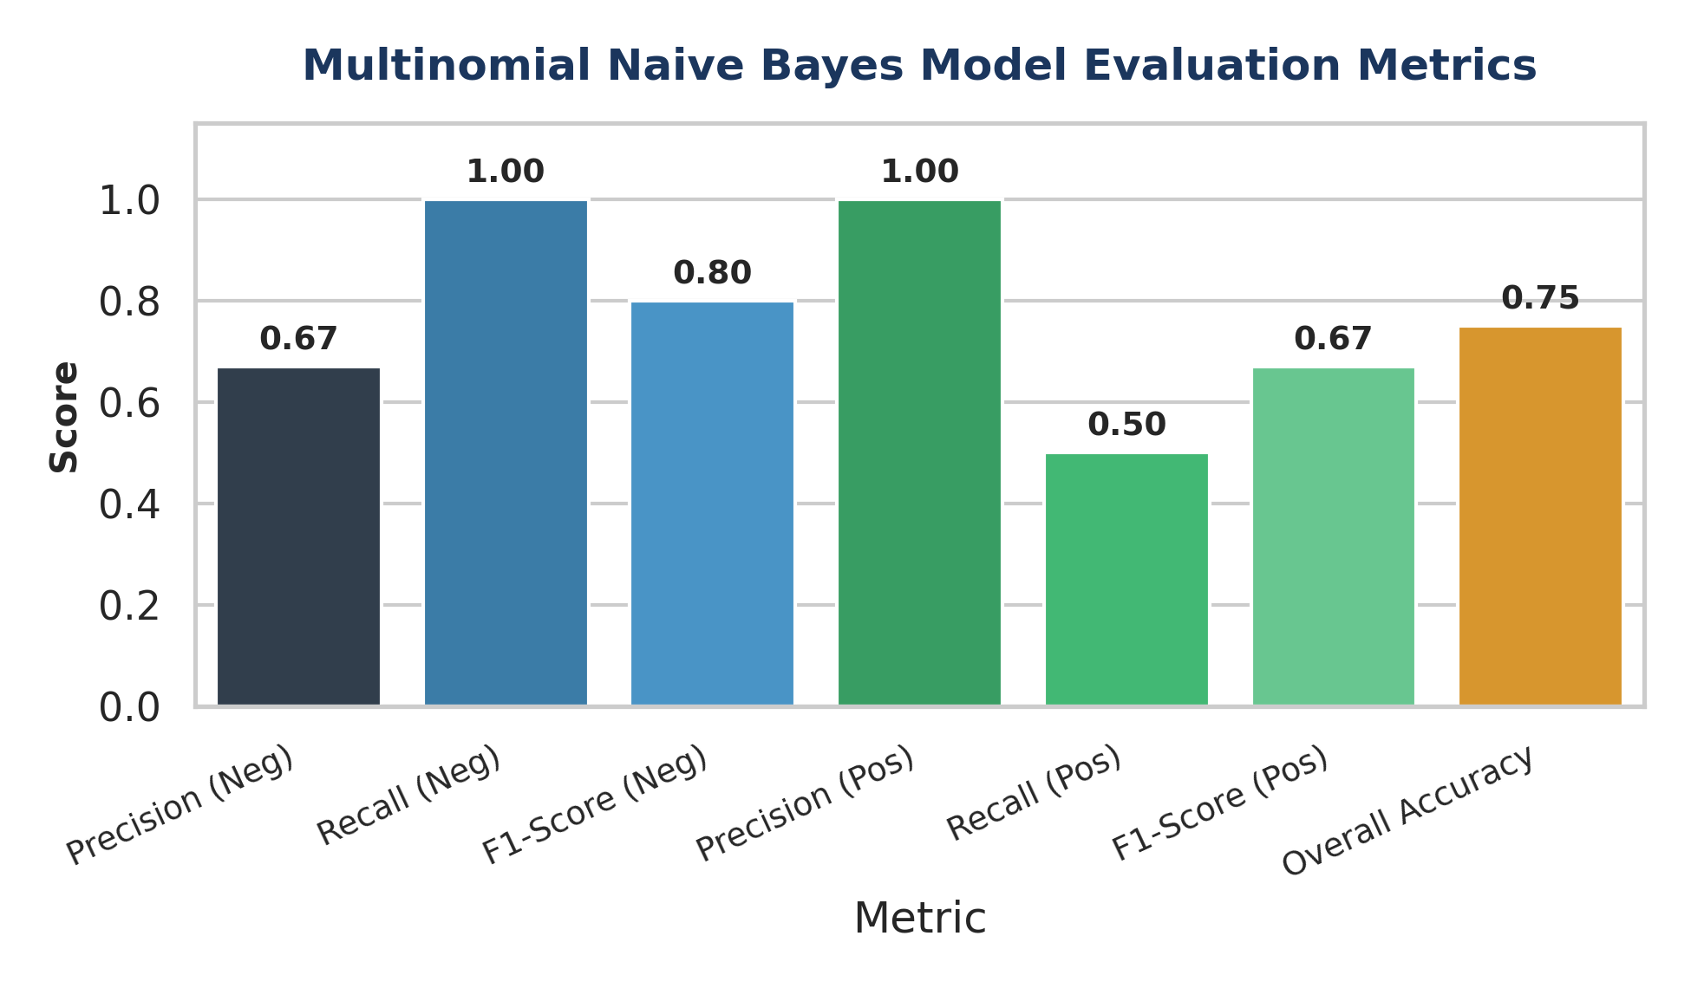
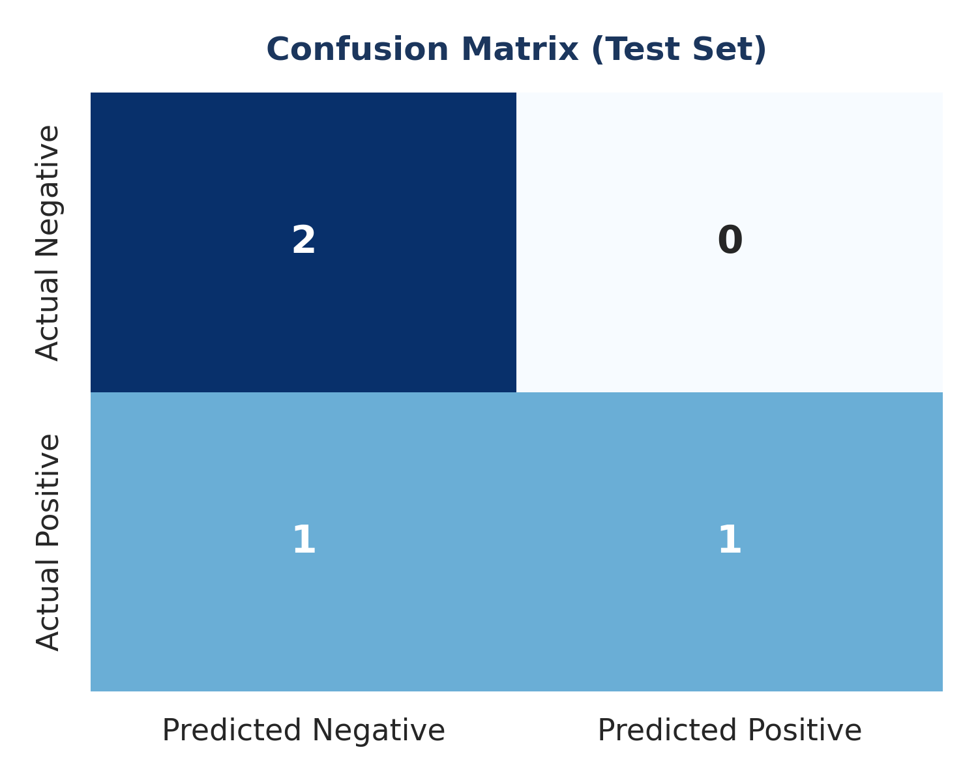
5. Model Persistence & User Inference
To ensure operational usability, Reem Fayyaz implemented binary serialization for both the trained model and vectorizer.
• Model Artifact: model.pkl
• Vectorizer Artifact: vectorizer.pkl
• Inference Validation: Unseen input reviews are dynamically transformed and classified in real time.
6. Key Findings & Next Steps
1. Vectorizer Utility:
TF-IDF vectorization effectively highlights key sentiment drivers (e.g., 'amazing', 'excellent' vs 'poor', 'damaged').
2. Expansion Path:
Expanding the training dataset beyond 20 samples and incorporating n-grams (bigrams/trigrams) will improve recall on nuanced positive reviews.

