



**Software Engineering**

**Software Requirements Specification**

**(SRS) Document**

**Prepared to: Dr.Fahad Alshsmmari.**

**By: Reem alossimi.**

|  |
| --- |
| **Contents** |

1. Introduction 3

1.1 Introduction 3

1.2 Objective 3

1.3 Scope of the document 3

1.4 Overview 3

1.5 Business Context 3

2. General Description 4

2.1 Perspective 4

2.2 User Charactristic 4

2.3 General Constrints 4

2.4 Assumptions and Dependencies 4

3. Functional Requirements 5

3.1 System features 5

4. Non-functional Requirements 6

4.1 Performance 6

4.2 Security 6

4.3 Reliability 6

4.4 Availability 6

4.5 Maintainability 6

4.6 Supportability 6

4.7 Resource Utilization 6

5. UML Diagrams 7

5.1 Use case diagram 7

5.2 Entity relationship diagram 8

5.3Sequence diagram 9

5.4 Activity diagram 10

6.References 11

1. **Introduction**
   1. **Introduction**

The purpose of this document is to define and describe the requirements of the project and to spell out the system’s functionality and its constraints.

* 1. **Objective**

The purpose of this source is to describe SAR reservation system which provides the train timing details, reservation, billing, and cancellation.

* 1. **Scope of this Document**

Software engineering students.

* 1. **Overview**

SAR serve society and customers by delivering safe, sustainable and technologically advanced transport and logistics solutions, and create value for shareholders.

* 1. **Business Context**
* Create shareholder value and reduce government dependency by becoming profitable by 2025.
* Support KSA business and increase local.
* Strive to avoid all accidents and optimize the carbon footprint.
* Deliver service excellence to the satisfaction of our customer.
* Attract and retain the best talent in the kingdom.
* Develop best in class railway infrastructure in KSA.

## **2.** **General Description**

**2.1 Perspective:**

Before automation, the system suffered from following Drawbacks:

* A lot of paper work and calculation and therefore may beerrors*,* this led to inconsistency and inaccuracy in the maintenance of data.
* The data which is stored on paper only, may be lost, stolen, or destroyed due to natural calamity like fire or water.
* Manual system is slow causing inconvenience to both customers and staff.
* Due to manual nature, it is difficult to update, delete, add, or view the data.
* The absence of a link between SAR stations lead to lack of coordination and communication.

Hence SAR system is proposed with following:

* Reduce a lot of paper work.
* The machine performs all calculation; hence chances of error are nail.
* Customer, reservation, cancellation list can be easily retrieved and any required addition, deletion or updating can be performed.
* The system provides user-ID validation; hence unauthorized access is prevented.

**2.2 User Characteristic**

***Technical Expertise:*** User should be comfortable using general purpose applications on the computer system.

**2.3 General Constraints**

Constraints include an easy-to-use interface for the program through forms, a Windows platform,

IOS, or Android.

**2.4 Assumptions and Dependencies:**

1. The staff should have a valid user name and password to access the system.
2. The staff should have complete knowledge of SAR system.
3. System is dependent on access to the internet.

**3.Functional Requirements**

**3.1 System Features**

Relatively simple to use, the scope of SAR encompasses:

***Search:*** This function allows customer to search for tickets that are available between two travel “cities” stations, The system initially prompts for the departure and arrival city, the date preferred of the departure and arrival, and number of passengers with their classification (Adult, youth, child, infant).

It then displays a list of train available between designated cities on the specified date to choose preferred time.

***Selection:*** This function allows a particular train to be selected from the departure and arrival all details of

The trains are shown:

1. Train number.
2. Time, and place of departure.
3. Time, and place of arrival.
4. Price of the ticket per head.
5. Economy or business class.

***Traveler information:*** It asks for the details for all passengers supposed to travel including:

1. Document type.
2. Document number.
3. Title.
4. First and last name.
5. Nationality.
6. Date of birth.
7. Concession type.
8. Email
9. Phone number

***Seat selection:*** You can choose an available seat in your chosen category*.*

***Payment:*** with various methods:

1. Credit card.
2. Mada card.
3. Apple pay.

***Cancellation:*** The system allows passengers to cancel an existing reservation.

This function registers the information regarding a passenger who has required cancellation. It includes entries pertaining to train No., Conformation No., Name, date of Journey, price deducted.

## **4.Non- Functional Requirements**

**4.1 Performance:** Response Time: Search results should populate within acceptable time limits.User satisfaction: Helping user appropriately to fill in the mandatory fields, in case of invalid input. And System accepts payments via different payment methods, like PayPal, wallets, cards, etc. also, System visually confirms as well as send booking confirmation to the user's contact.

**4.3 Security:** The system use SSL (secured socket layer) in all transactions that include any confidential customer information. The system must automatically log out all customers after a period of inactivity. The system should not leave any cookies on the customer's computer containing the user's password. The system's back-end servers shall only be accessible to authenticated management.

**4.3 Reliability:** Back-ups made regularly so that restoration with minimal data loss is possible in the event of unforeseen events. The system also thoroughly tested by all team members to ensure reliability.

**4.4 Availability*:*** The system should be always available, meaning the user can access it using a web browser, only restricted by the down time of the server on which the system runs. A customer friendly system which is in access of people around the world should work 24 hours. In case of a of a hardware failure or database corruption, a replacement page will be shown. Also in case of a hardware failure or database corruption, backups of the database should be retrieved from the server and saved by the Organizer. Then the service will be restarted. It means 24 x 7 availability.

**4.5 Maintainability*:*** A commercial database is used for maintaining the database and the application server takes care of the site. In case of a failure, a re-initialization of the project will be done. Also the software design is being done with modularity in mind so that maintainability can be done efficiently.

**4.6 *Supportability:*** The code and supporting modules of the system will be well documented and easy to understand. Online User Documentation and Help System Requirement.

**4.7 Resource Utilization*:*** The resources used in the creation of this system include: Saudi Railway Company (SAR).

**5.UML Diagrams**

**5.1 Use-Case:**

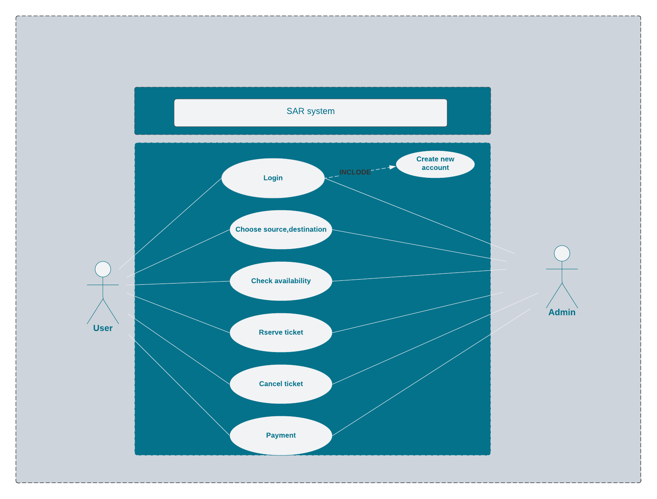

**5.2 Entity relationship:**

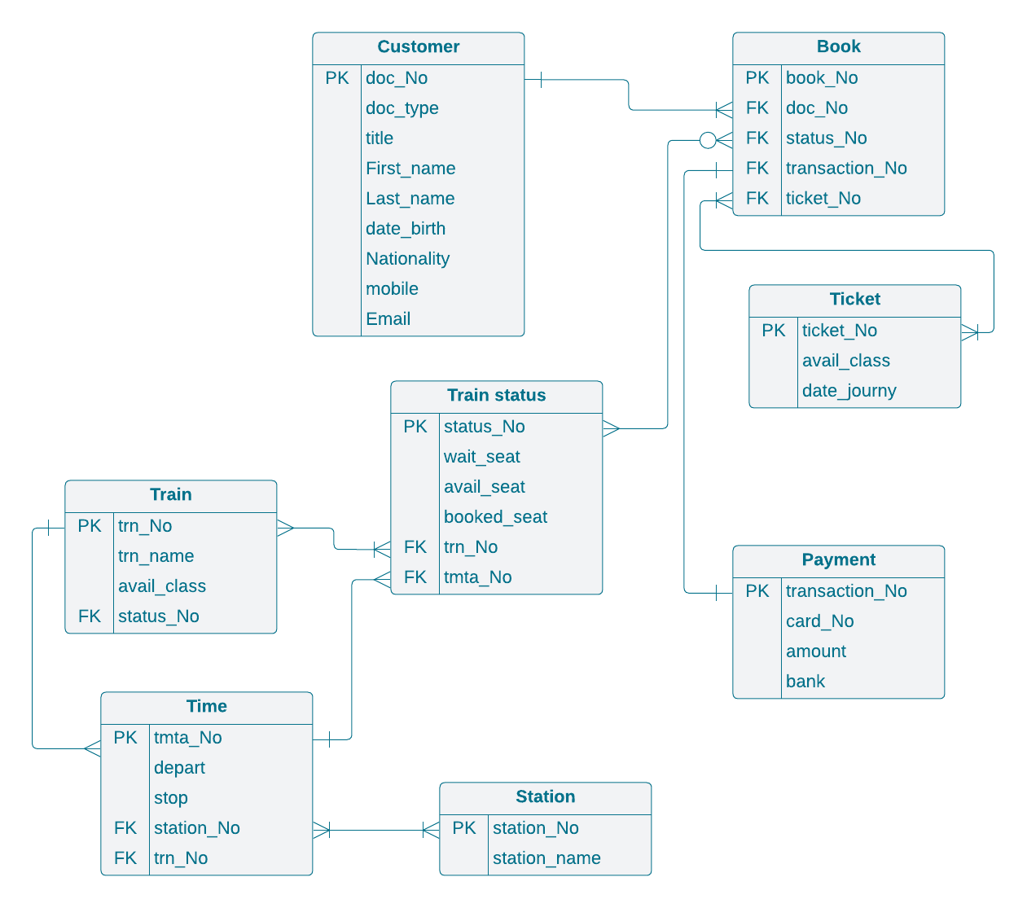

* 1. **Sequence:**

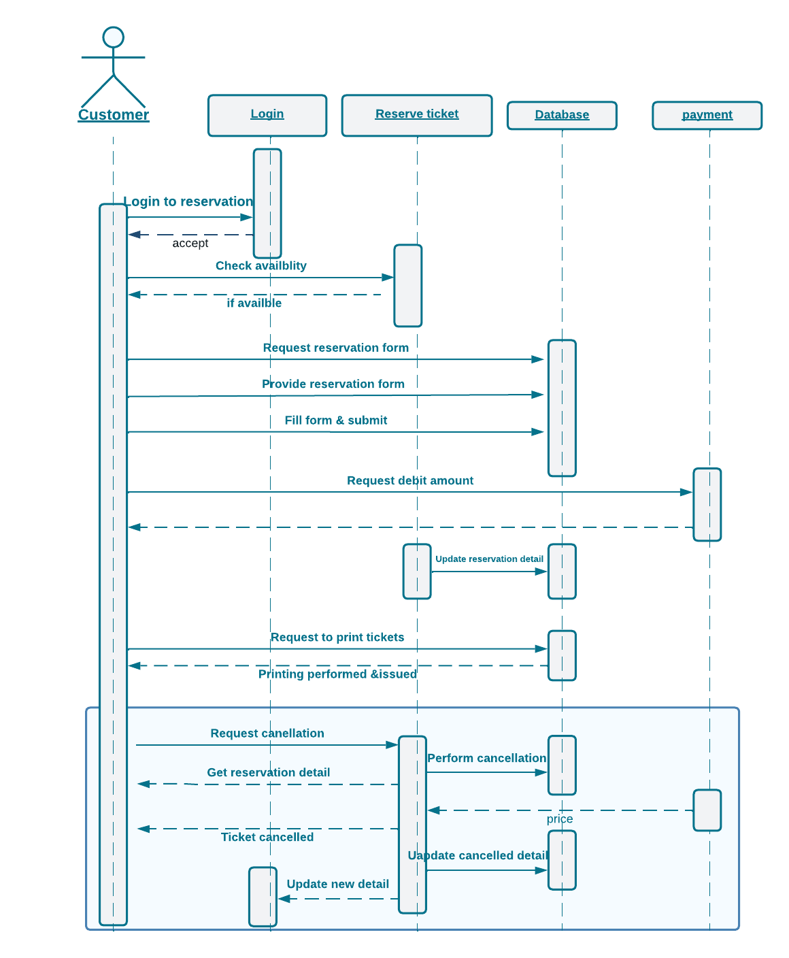

* 1. **Activity:**

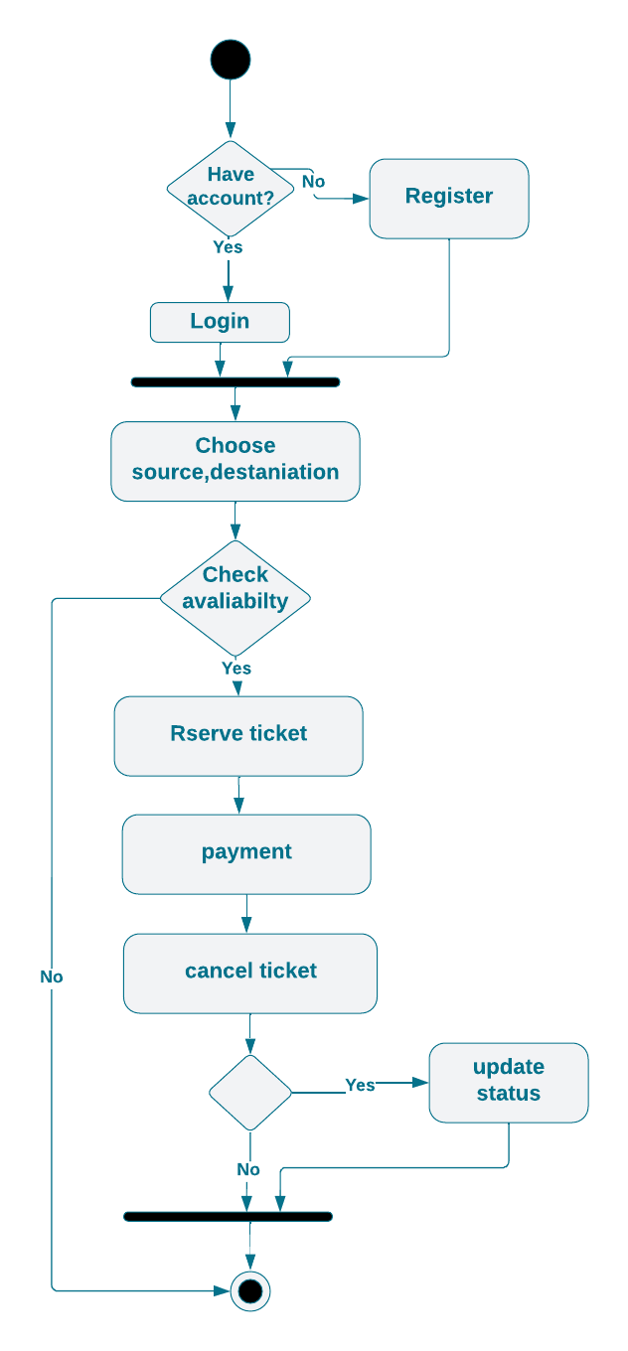

## **References**

IEEE SRS format

[www.sar.com.sa](http://www.sar.com.sa)

www.google.com