Lab 9 Python Profiling and Optimization
Reem Saab
Software Tools Lab | Fall 2026–2027 | 9 November 2026
This lab measures the supplied Python workload with cProfile, line_profiler, memory_profiler and coverage.py. The optimized version replaces the small sum-of-squares loop with an exact formula. The results below compare both versions and explain the remaining performance and coverage limits.

Measured comparison
Measurement | Before | After
Small function median | 30.742 us | 0.244 us
Small function Python allocation peak | 116 bytes | 56 bytes
Largest reported process RSS | 20.6 MiB | 20.4 MiB
Whole cProfile run | 5.047 s | 5.693 s
Coverage statements | 23 | 26
Coverage executed statements | 22 | 25
Statement coverage | 96% | 96%
The small function was 125.93 times faster in a repeated benchmark with 7 repeats of 20,000 calls. This gain applies to the small function. It does not establish a comparable speedup for the complete program, whose two-second delay and large loop remain.
The Python allocation peaks are measured separately with tracemalloc. The RSS values report process resident memory in MiB. These are different measurements and should not be compared directly.

Environment and evidence
3.10.11 (tags/v3.10.11:7d4cc5a, Apr 5 2023, 00:38:17) [MSC v.1929 64 bit (AMD64)]. Windows-10-10.0.19045-SP0.
Package versions are pinned in requirements.txt. Commands and their complete outputs are saved in results. The images are readable snapshots typeset from those transcripts, rather than desktop screenshots. Each includes the project name lab9_Reem_Saab and the command used.

Analysis of profiling results
cProfile identifies the ten-million-iteration memory_intensive_function and time.sleep as the major contributors to elapsed time. tottime measures time inside a function excluding subcalls; cumtime includes those subcalls. The sleep is therefore reported separately from the Python work in slow_function.
The whole cProfile run changed from 5.047 to 5.693 seconds. This run does not demonstrate a whole-program speedup. The small function contributes too little time to outweigh variability in the unchanged large loop and operating-system scheduling.
The line profiler shows that slow_function spends almost all its measured time in time.sleep(2). In the large function, the loop and the exponentiation/accumulation line execute ten million times. In the original fast_function, the arithmetic line executes 100 times; the optimized function evaluates its formula once. Tracing overhead means these timings should be compared within the same tool, rather than treated as bare execution times.
Despite its name, memory_intensive_function does not build a list of ten million values. It keeps a running integer total and a range iterator. Process memory can stay nearly flat while the CPU repeatedly computes new integer values. The optimization removes the small loop but does not remove a large retained object, so a large RSS reduction is not expected.
The first Mem usage entry includes the already running Python process and imported libraries. It is not memory allocated by that line. On frequently repeated lines, memory_profiler can print very large negative accumulated Increment values. Those repeated RSS differences are not the amount of physical memory released. Interpret the Mem usage column and the small final RSS changes instead.

Coverage and missing lines
Before optimization: uncovered profiler.py lines are 34. The tests import the module, so its guarded main() entry-point call does not execute during unittest discovery. The dispatch test explicitly exercises main() with mocks, while the computational tests execute the real task functions.
After optimization: uncovered profiler.py lines are 40. The tests import the module, so its guarded main() entry-point call does not execute during unittest discovery. The dispatch test explicitly exercises main() with mocks, while the computational tests execute the real task functions.
Both variants include the complete htmlcov directory. Open its index.html locally for highlighted executed and missing lines. Coverage measures whether statements executed; it does not prove all inputs, timing behavior or mathematical results are correct. Exact-result assertions provide additional checks.

Cprofile results before optimization
The report is sorted by internal time. Compare the large-loop cost and the fixed sleep with the very small fast-function cost.
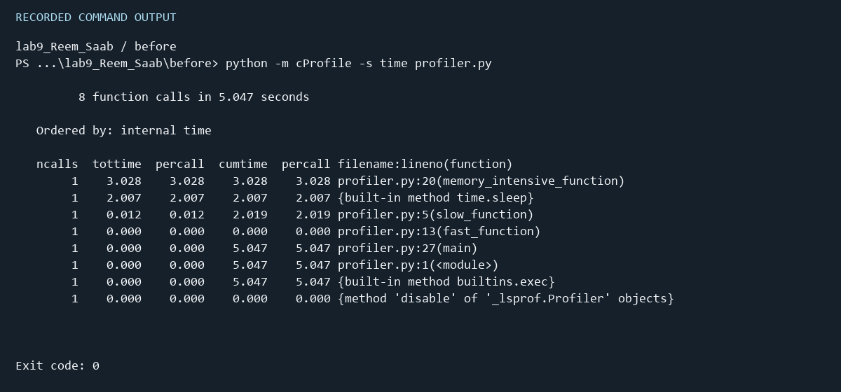
Recorded output snapshot. Full transcript: results/before_cprofile.txt.

Cprofile results after optimization
The report is sorted by internal time. Compare the large-loop cost and the fixed sleep with the very small fast-function cost.
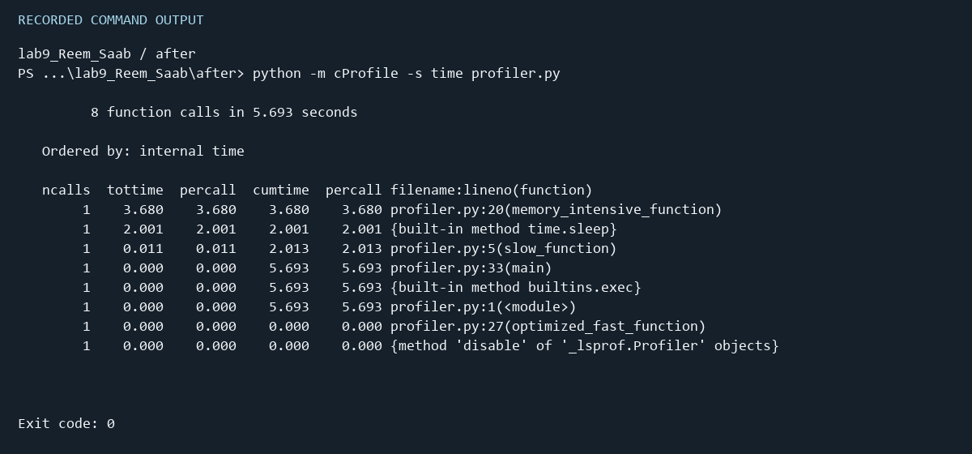
Recorded output snapshot. Full transcript: results/after_cprofile.txt.

Line results before optimization
The same task sizes are used in both versions. Hits gives the execution count; the formula replaces the 100 arithmetic iterations in the small function.
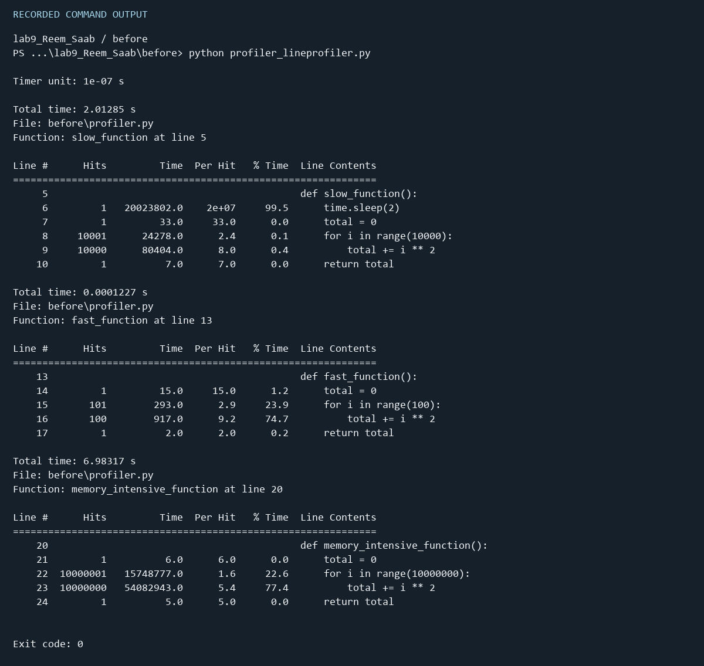
Recorded output snapshot. Full transcript: results/before_line.txt.

Line results after optimization
The same task sizes are used in both versions. Hits gives the execution count; the formula replaces the 100 arithmetic iterations in the small function.
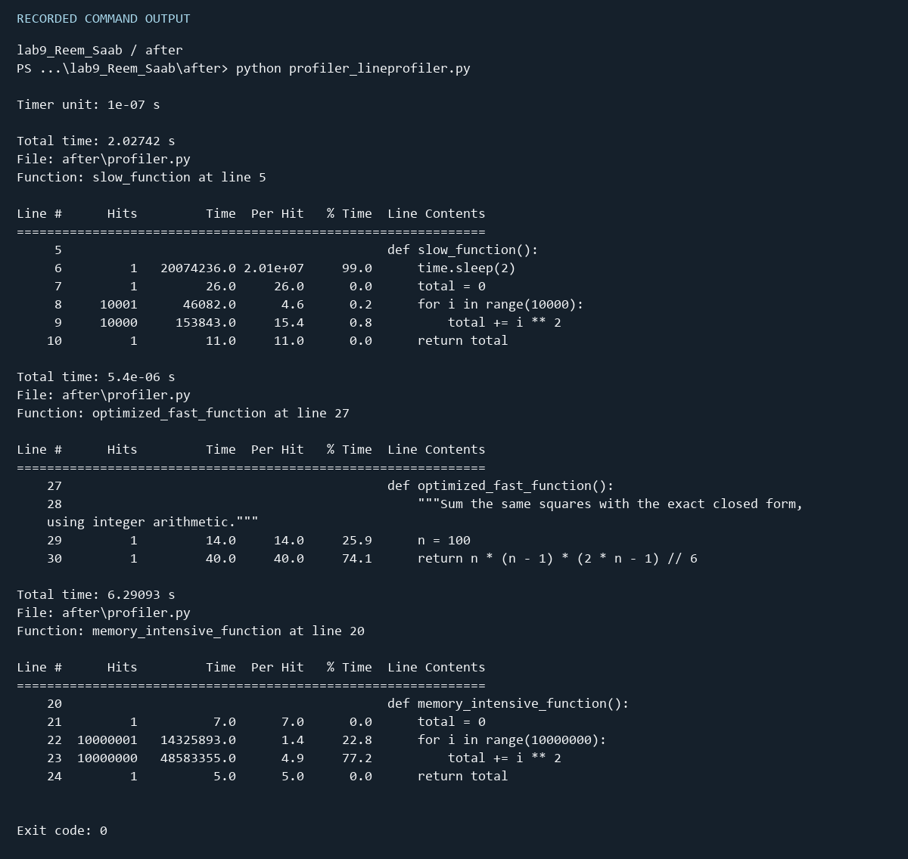
Recorded output snapshot. Full transcript: results/after_line.txt.

Memory results before optimization
RSS is process resident memory in MiB. The ten-million-item workload remains a streaming accumulation. Large repeated-line Increment values should not be read as total allocated or freed memory.
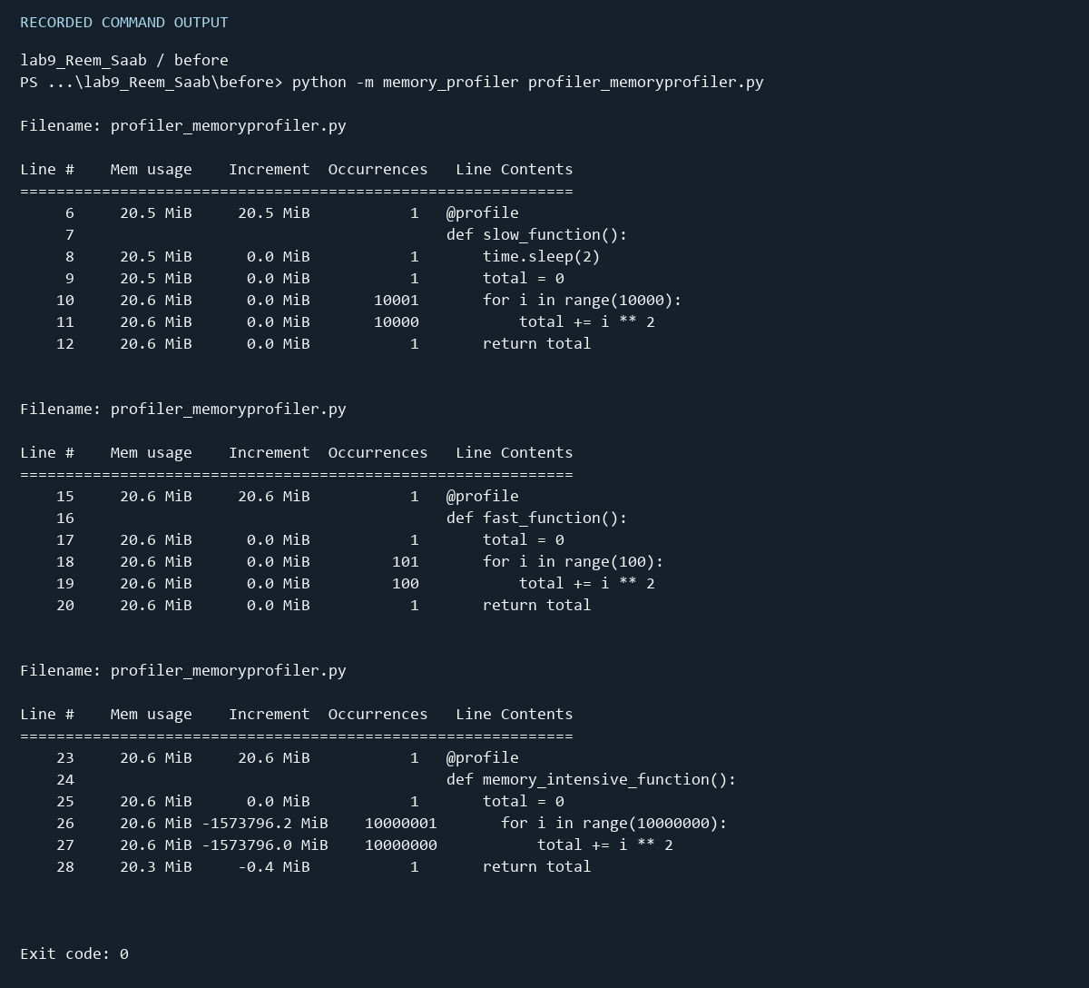
Recorded output snapshot. Full transcript: results/before_memory.txt.

Memory results after optimization
RSS is process resident memory in MiB. The ten-million-item workload remains a streaming accumulation. Large repeated-line Increment values should not be read as total allocated or freed memory.
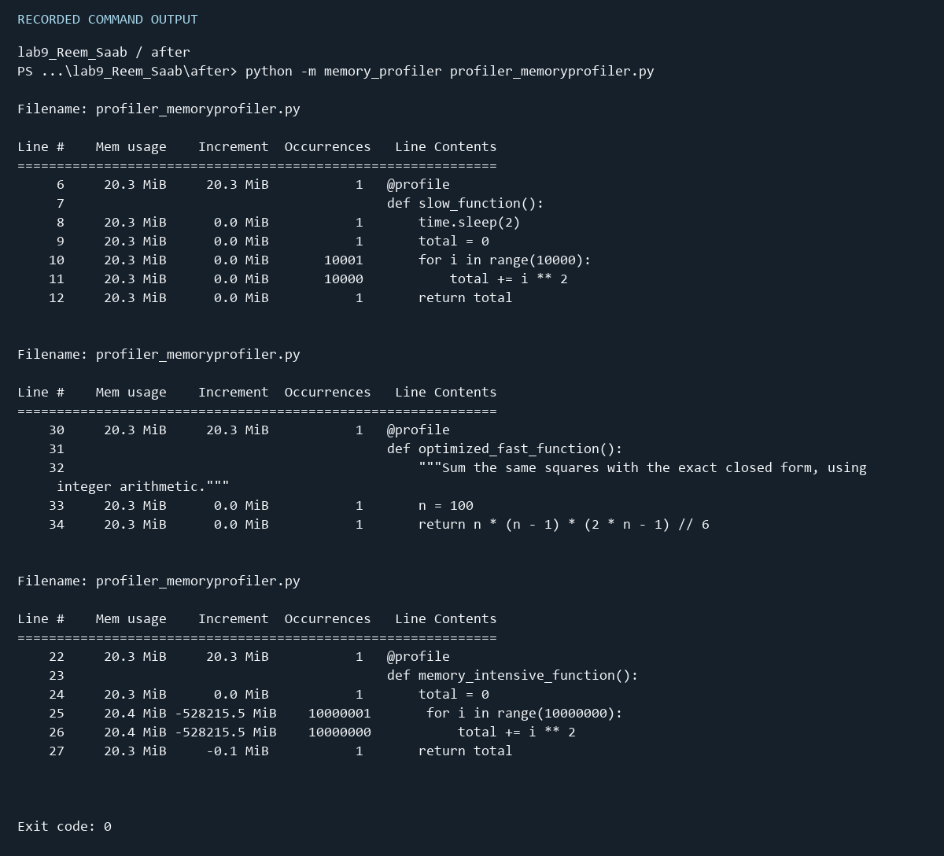
Recorded output snapshot. Full transcript: results/after_memory.txt.

Tests results before optimization
The suite checks exact totals, execution time, memory observations and main dispatch. The optimized suite also compares the legacy fast function with the exact formula.
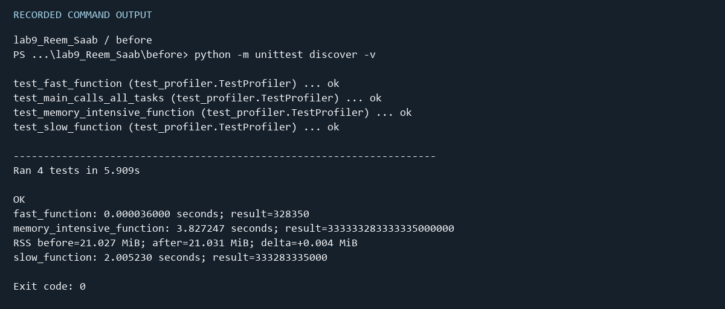
Recorded output snapshot. Full transcript: results/before_tests.txt.

Tests results after optimization
The suite checks exact totals, execution time, memory observations and main dispatch. The optimized suite also compares the legacy fast function with the exact formula.
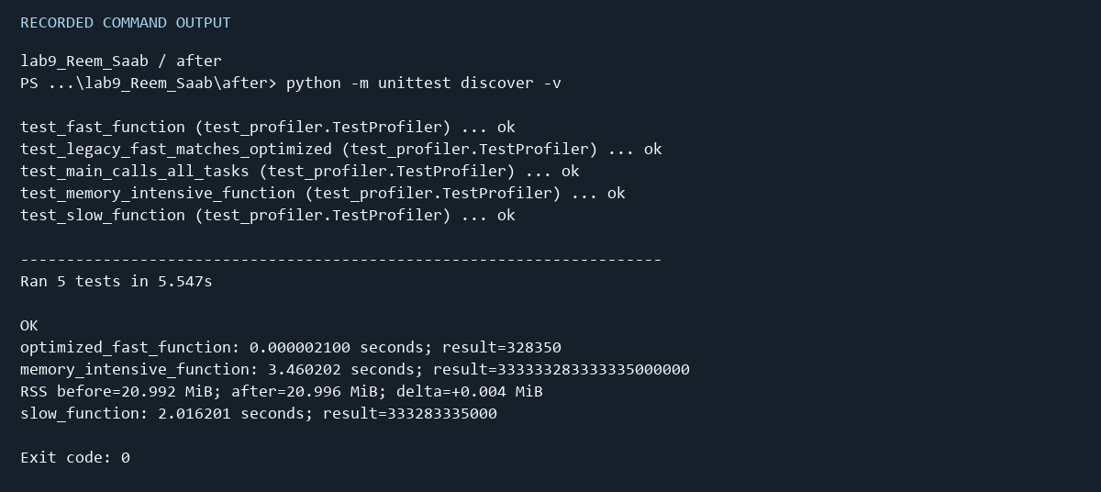
Recorded output snapshot. Full transcript: results/after_tests.txt.

Coverage results before optimization
Statement coverage is restricted to profiler.py, so test and instrumentation scripts do not inflate the application coverage percentage.
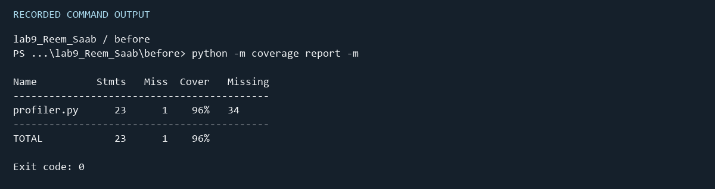
Recorded output snapshot. Full transcript: results/before_coverage.txt.

Coverage results after optimization
Statement coverage is restricted to profiler.py, so test and instrumentation scripts do not inflate the application coverage percentage.
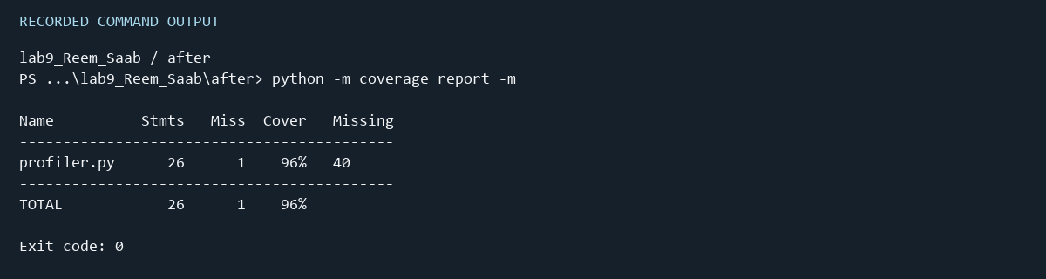
Recorded output snapshot. Full transcript: results/after_coverage.txt.

Optimization and validation
The original function computes the sum of i squared for i from 0 through 99. The identity for this range is n(n−1)(2n−1)/6, with n equal to 100. Integer floor division preserves the exact integer result 328350. The formula uses a fixed number of arithmetic operations instead of a loop. Both implementations use constant auxiliary storage for the fixed workload.
The optimized main function, line-profiler registration, decorated memory workload and fast-function test call optimized_fast_function. The original fast_function remains in the optimized module so an additional test can verify equivalence. The large workload and slow workload retain the supplied behavior to isolate the requested fast-function optimization.
The handout contains duplicated code and damaged indentation. These were corrected while keeping return statements inside their functions and outside their loops. The supplied memory test was adjusted because RSS is allowed to stay the same or fall after temporary objects are freed. It records before/after RSS and checks exact arithmetic results instead of requiring a post-call increase.
The handout timing limits are retained for normal execution. When coverage installs a trace hook, the large-loop test permits up to thirty seconds because tracing adds substantial overhead. This avoids interpreting instrumentation cost as a correctness defect. Run measurements sequentially on an otherwise idle machine; wall-clock limits remain sensitive to hardware and system load.

Repeated benchmark evidence
Median before: 30.742045 microseconds per call. Median after: 0.244125 microseconds per call. Speedup: 125.93 times. Measurement order alternates across repeats. All raw samples are in results/benchmark.json.

Reproducing the submission
Install requirements.txt in a virtual environment. Run python run_lab.py, then python run_lab.py memory, then python benchmark.py from the project root. Individual lab commands and coverage viewer instructions are listed in README.md. Profiling the full memory workload takes several minutes because every loop line is monitored.
The before and after folders each contain profiler.py, profiler_lineprofiler.py, profiler_memoryprofiler.py, test_profiler.py and htmlcov/index.html with its supporting assets. The repository also includes the transcripts, snapshots and this combined report.

Tool references
Python profiling documentation: https://docs.python.org/3.10/library/profile.html
Memory Profiler documentation and source: https://github.com/pythonprofilers/memory_profiler
Coverage report documentation: https://coverage.readthedocs.io/en/latest/commands/cmd_report.html

