***PIM-SM***

***Functional Test Plan***

***Revision History***

|  |  |  |  |
| --- | --- | --- | --- |
| Revision Date | Document Versions | Revisions | Author |
| 09/15/2021 | 1.0 | Initial draft | Kumaran Somu |
| 05/27/2022 | 1.1 | Incorporated System Test comments | Kumaran Somu |
|  |  |  |  |
|  |  |  |  |

**Table Of Contents**

1.0 Introduction 3

1.1. Risk Assessment 3

2.0 Description 3

3.0 Test Sections 4

3.1 Configuration 4

3.2 Functionality 4

3.3 Monitoring and Debugging 4

3.4 Interoperability 4

3.5 Scalability 5

3.6 Negative Testing 5

4.0 Test Topologies 5

4.1 PIM-SM Test Topology-1 5

4.2 PIM-SM Test Topology-2 (DR and NON-DR) 6

4.3 PIM-SM Test Topology-3 (PIM Assert) 7

4.4 PIM-SM Test Topology-4 (ECMP) 8

5.0 Resource Requirements 8

5.1 Hardware Requirements 8

5.2 Software Requirements 8

6.0 Test Cases 9

7.0 References 15

# 1.0 Introduction

The purpose of this document is to describe the specific test cases that feature development test team will run in order to assess the readiness of the product from a functionality perspective.

## 1.1. Risk Assessment

If applicable, provide a brief list of possible issues that may affect the successful completion of this testing.

# 2.0 Description

This document describes the test plan specification for Protocol Independent Multicast – Sparse Mode (PIM-SM) implementation for Dell Technologies SONiC platforms.

The Protocol Independent Multicast-Sparse Mode is designed to establish distribution tree for multicast routing across wide-area internets, where many groups are sparsely represented and where bandwidth is not uniformly abundant. It uses routing information provided by any unicast routing protocol such as OSPF, iBGP/eBGP, etc. Hence the name “protocol independent”.

PIM-SM uses explicit JOINS that propagate hop-by-hop from members' directly connected switches towards the distribution tree, which originally as a shared tree centered at the Rendezvous Point, and then can be switched to a source-specific tree if data traffic from the source warrants it.

The below are the features that are supported as part of SONiC Release 4.1,

* PIM-SM using Static-RP
* PIM Over BFD
* PIM SPT Switchover

# 3.0 Test Sections

The purpose of functional test is to exercise the various features of the product and verify their functionality as defined in product requirements and the Functional Specification. The test scenarios may involve simulating small and medium sized networks to verify the correct working of the product in a real-world environment.

Following are a few key areas of testing that may apply to the feature.,

## 3.1 Configuration

Testing the ability to configure the product and/or the feature using all configuration methods (CLI, REST API/GNMI). Usability should be considered from end-user perspective.

## 3.2 Functionality

This section tests the general working of the product and/or the feature under test to verify its compliance with the product requirement, functional specification, associated RFCs’, etc.

## 3.3 Monitoring and Debugging

Testing the availability of monitoring and debugging capabilities of the feature. This includes show, RESTAPI/GNMI and even bcmsh commands. Usability should be considered from Customer Support and/or Systems Engineering perspective.

## 3.4 Interoperability

Interoperability verifies that the Product functions properly with earlier versions of the SONiC platforms, other Dell Technologies equipment’s and as well as with other vendors equipment.

## 3.5 Scalability

Scalability testing determines the limits of dynamic information such as multicast routes, pim neighbors and interfaces configurable using static-rp support. that may be suitable for specific test and memory configurations.

## 3.6 Negative Testing

Here are some of the types of tests that may be performed in this section:

1. Disconnect/reconnect interface cables
2. Disabling/enabling base configurations
3. Intentionally misconfiguring feature

# 4.0 Test Topologies

## 4.1 PIM-SM Test Topology-1

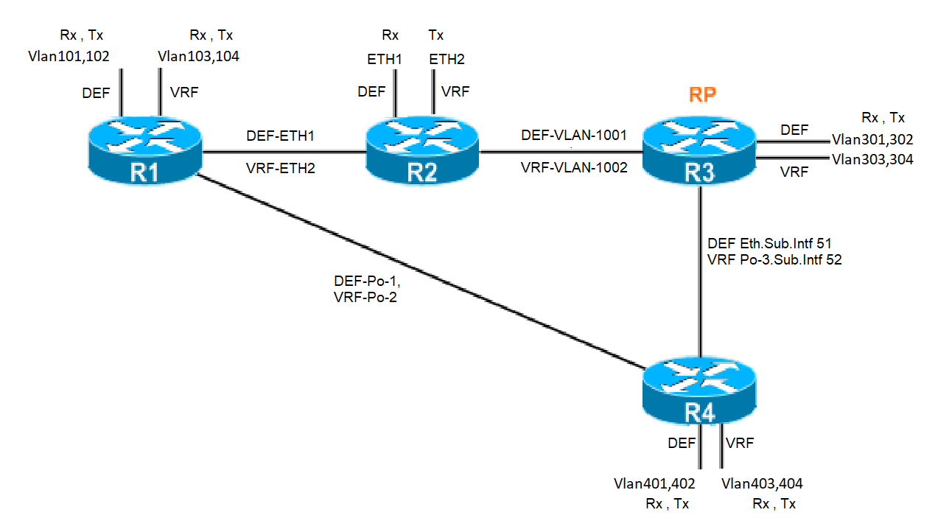

## 4.2 PIM-SM Test Topology-2 (DR and NON-DR)

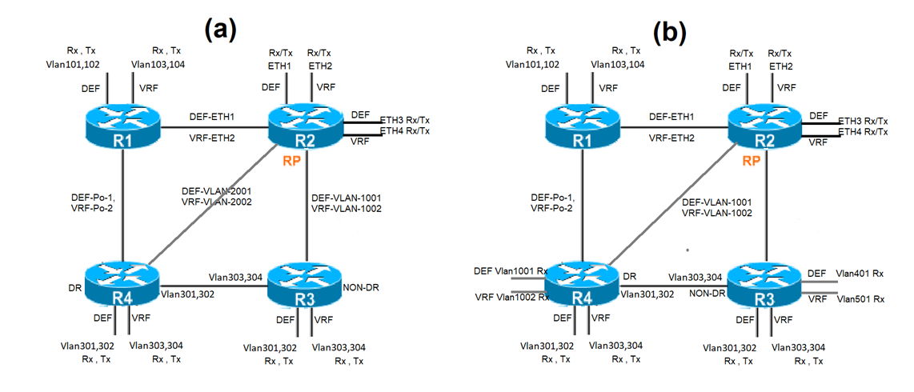

## 4.3 PIM-SM Test Topology-3 (PIM Assert)

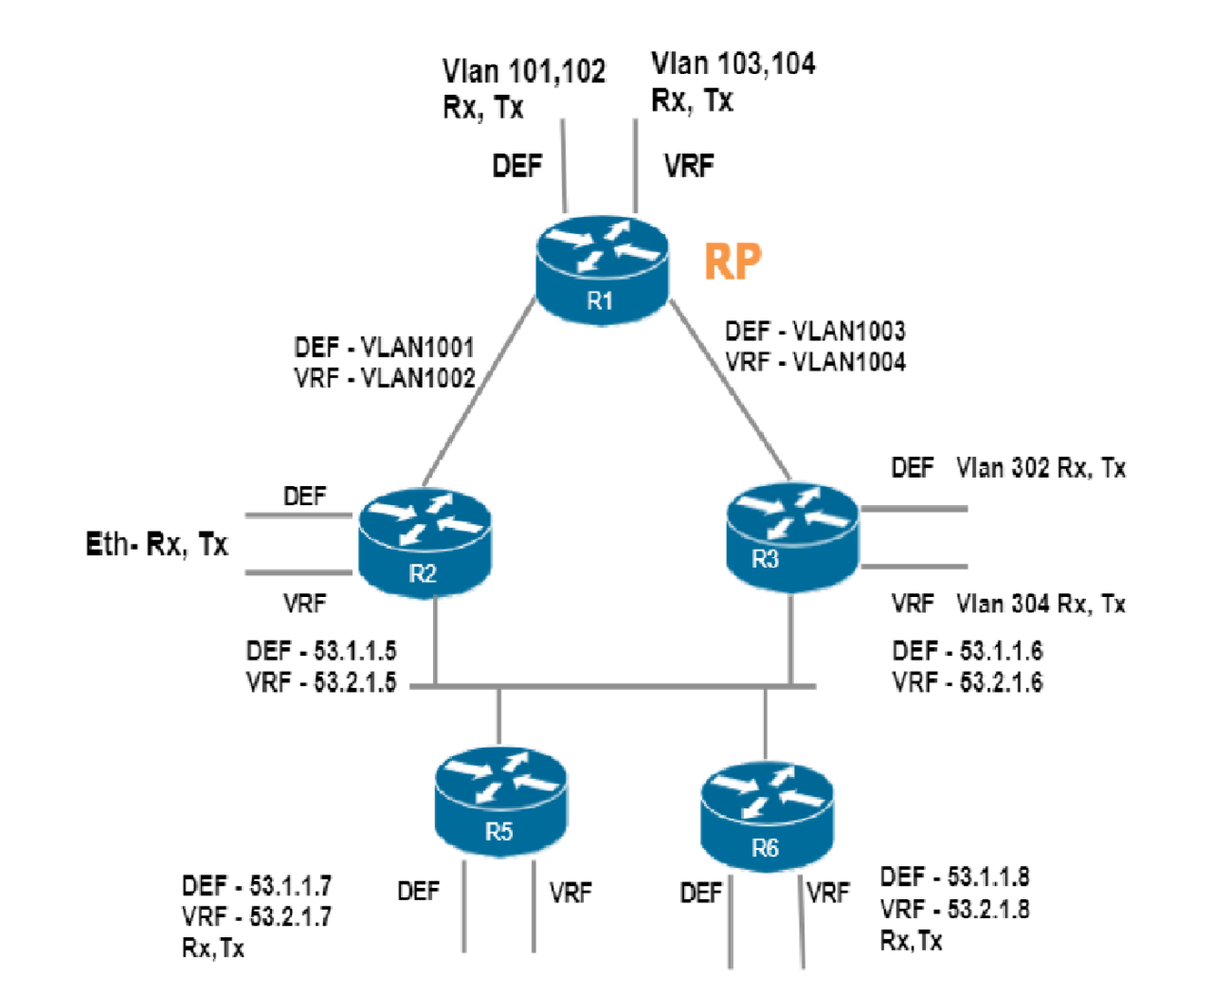

## 4.4 PIM-SM Test Topology-4 (ECMP)

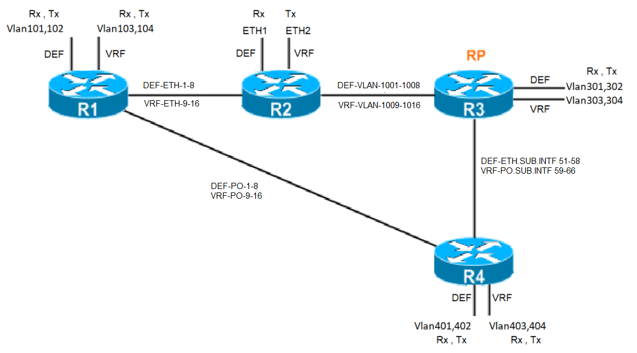

# 5.0 Resource Requirements

## 5.1 Hardware Requirements

The below equipment’s needed for performing the tests:

1. Dell Technologies SONiC with PIM supported Platforms (Feature Testing)
2. Cisco/Dell OS10 devices which supports PIM-SM for Interop testing
3. IxExplorer / IxNetworks for protocol simulation and for generating traffic.

## 5.2 Software Requirements

Enterprise SONiC OS 4.1 and above

# 6.0 Test Cases

|  |  |  |
| --- | --- | --- |
| **Test ID** | **Test Case Description** | **Topology** |
| ***Configuration*** | | |
| PIM-SM.001 | PIM Configuration availability and help check | PIM-SM-Topology-2 |
| PIM-SM.004 | Add/delete a valid static rp without group-address on local and remote | PIM-SM-Topology-2 |
| PIM-SM.005 | Add/delete a valid static rp with empty access-list on local and remote switch | PIM-SM-Topology-2 |
| PIM-SM.006 | Add/delete a valid static rp with group entries in access-list on local and remote switch | PIM-SM-Topology-2 |
| PIM-SM.007 | Add/delete persistent static-rp with prefix-list combination on a network. | PIM-SM-Topology-2 |
| PIM-SM.008 | Static RP address becomes unreachable | PIM-SM-Topology-2 |
| PIM-SM.009 | Add static rp with short and long group address and check rp functionality | PIM-SM-Topology-2 |
| ***Functionality*** | | |
| PIM-SM.002 | Verify that router with highest dr-priority value assigned to an interface becomes the designated router. | PIM-SM-Topology-2 |
| PIM-SM.003 | Verify that interface with highest ip-address gets elected as DR when dr-priority value assigned to an interfaces are equal. | PIM-SM-Topology-2 |
| PIM-SM.011 | (*,G) state between the last-hop router and the RP when IGMP memberships come in. | PIM-SM-Topology-2 |
| PIM-SM.012 | (*,G) state between the last-hop router and the RP is cleared when IGMPv2 leave is received on LHR node. | PIM-SM-Topology-2 |
| PIM-SM.013 | (*,G) state between the last-hop router and the RP is cleared when IGMPv2 membership timed-out on LHR node. | PIM-SM-Topology-2 |
| PIM-SM.014 | (*,G) state between the last-hop router and the RP is cleared when IGMPv2 membership deleted due to link down. | PIM-SM-Topology-2 |
| PIM-SM.015 | Configure igmp static-receiver for *, G and check shared tree is created between lhr and rp node. | PIM-SM-Topology-2 |
| PIM-SM.016 | Unconfigure igmp static-receiver for *, G and check shared tree is cleared between lhr and rp node. | PIM-SM-Topology-2 |
| PIM-SM.017 | Configure igmp static-receiver for S, G and check SPT path is created between lhr and source node. | PIM-SM-Topology-2 |
| PIM-SM.018 | Unconfigure igmp static-receiver for S, G and check SPT path is cleared between lhr and source node. | PIM-SM-Topology-2 |
| PIM-SM.019 | Reboot while streams present, but no local IGMP membership. | PIM-SM-Topology-2 |
| PIM-SM.020 | Sending Register message. | PIM-SM-Topology-2 |
| PIM-SM.021 | Receiving Register-stop from RP. | PIM-SM-Topology-2 |
| PIM-SM.022 | Verify NULL register message with and without shared tree exists on RP. | PIM-SM-Topology-2 |
| PIM-SM.023 | Maintain Register-Suppression-timer | PIM-SM-Topology-2 |
| PIM-SM.024 | (S,G) state creation and maintenance on the RP with and without receivers. | PIM-SM-Topology-2 |
| PIM-SM.025 | (S,G) state creation and maintenance on the Intermediate switch | PIM-SM-Topology-2 |
| PIM-SM.026 | (S,G) state creation and maintenance on the last-hop | PIM-SM-Topology-2 |
| PIM-SM.027 | (S,G) state creation and maintenance on the first-hop router. | PIM-SM-Topology-2 |
| PIM-SM.028 | RP is the only sender (fhr/rp-lhr) | PIM-SM-Topology-2 |
| PIM-SM.029 | RP is the only receiver (fhr---Interm---rp/lhr) | PIM-SM-Topology-2 |
| PIM-SM.030 | Check shared tree on intermediate router for (rp---interm---lhr) scenario. | PIM-SM-Topology-1 |
| PIM-SM.031 | Intermediate switch is the only receiver (fhr---interm---rp) | PIM-SM-Topology-1 |
| PIM-SM.032 | RP in the middle( fhr---rp---lhr ). | PIM-SM-Topology-1 |
| PIM-SM.033 | Inverse topology (lhr---fhr---rp). | PIM-SM-Topology-1 |
| PIM-SM.034 | Typical topology (fhr---interm---RP---interm---lhr ). |  |
| PIM-SM.035 | Typical topology (fhr (dr)-----lhr (non-dr)----interm---RP). | PIM-SM-Topology-2 |
| PIM-SM.036 | Typical topology (fhr (non-dr)-----lhr (dr)----interm---RP). | PIM-SM-Topology-2 |
| PIM-SM.037 | Check (s,g) creation on rpt path when shared and spt tree on same path. | PIM-SM-Topology-1 |
| PIM-SM.038 | Switching from RP-tree to SP-tree | PIM-SM-Topology-2 |
| PIM-SM.039 | Reboot Intermediate router after SPT switchover. | PIM-SM-Topology-2 |
| PIM-SM.040 | Deleting a (*,G) state when ssm range is configured with sm range. | PIM-SM-Topology-3 |
| PIM-SM.041 | IPMC entry update on non-DR. | PIM-SM-Topology-2 |
| PIM-SM.042 | Verify that router generating an Assert with the lowest Administrative distance is elected as forwarder. | PIM-SM-Topology-3 |
| PIM-SM.043 | Verify that best unicast routing metric is used to break a tie if the AD are the same. | PIM-SM-Topology-3 |
| PIM-SM.044 | Verify that device with the highest IP Address will be elected as the PIM Forwarder if the AD and metrics are same. | PIM-SM-Topology-3 |
| PIM-SM.045 | Assertion for ( S.G ) entry. | PIM-SM-Topology-3 |
| PIM-SM.046 | Assertion for ( *,G ) entry. | PIM-SM-Topology-3 |
| PIM-SM.047 | (S, G) Assert takes higher precedence over (*, G) assert. | PIM-SM-Topology-3 |
| PIM-SM.048 | (S, G) Asserts and changes in the assert winner due to metric change. | PIM-SM-Topology-3 |
| PIM-SM.049 | Assertion timer: 180 sec default. | PIM-SM-Topology-3 |
| PIM-SM.050 | J/P refresh Interval: random start, 60 default, persistency, join/leave latency. | PIM-SM-Topology-1 |
| PIM-SM.051 | J/P Holdtime: 3.5* default, oif time out, state time out | PIM-SM-Topology-1 |
| PIM-SM.052 | Data-Timeout: 3.5* default, for silent (S,G) | PIM-SM-Topology-1 |
| PIM-SM.053 | Register-Suppression-Timeout: 60 default | PIM-SM-Topology-1 |
| PIM-SM.054 | Hello-Period: 30 default | PIM-SM-Topology-1 |
| PIM-SM.055 | Hello-Holdtime: 105 sec default | PIM-SM-Topology-1 |
| PIM-SM.056 | Check IIF and OIF combinations | PIM-SM-Topology-1 |
| PIM-SM.057 | Check S,G expiration | PIM-SM-Topology-1 |
| PIM-SM.058 | Verify RPF check with secondary IP configured. | PIM-SM-Topology-1 |
| PIM-SM.059 | Verify multicast traffic with LAG members and check for lag hashing. | PIM-SM-Topology-1 |
| PIM-SM.060 | Testing (S, G, RPT) prune and join when RP and FHR are different. | PIM-SM-Topology-1 |
| PIM-SM.061 | With IGMPv3/v2 reports (with EXCL none and INCL none) coming from LHR. | PIM-SM-Topology-1 |
| PIM-SM.062 | With IGMPv3/v2 reports (with EXCL none and INCL none) coming from LHR from the same vlan but from different ports | PIM-SM-Topology-1 |
| PIM-SM.063 | With IGMPv3/v2 reports with SSM configured and PIM enabled on the vlan and reports coming on the SSM enabled | PIM-SM-Topology-1 |
| PIM-SM.064 | Verify IGMPv3 report learning on non-SSM range and check s, g gets programmed in ipmc table. | PIM-SM-Topology-1 |
| PIM-SM.065 | Verify IGMPv3 reports learning in SSM range but PIM not enabled and later gets enabled on lhr interface. | PIM-SM-Topology-1 |
| PIM-SM.066 | Single source on single switch, multiple receiver on single VLAN, single switch | PIM-SM-Topology-1 |
| PIM-SM.067 | Single source on single switch, multiple receiver on multiple VLANs, single switch | PIM-SM-Topology-1 |
| PIM-SM.068 | Single source on single switch, multiple receiver on single VLAN, multiple switches | PIM-SM-Topology-1 |
| PIM-SM.069 | Single source on single switch, multiple receiver on multiple VLANs, multiple switches. | PIM-SM-Topology-1 |
| PIM-SM.070 | Multiple sources on single switch, multiple receiver on multiple VLANs, single switch. | PIM-SM-Topology-1 |
| PIM-SM.071 | Multiple sources on multiple switches, multiple receiver on multiple VLANs, multiple switches. | PIM-SM-Topology-1 |
| PIM-SM.072 | Multiple sources for a single group as "known source." | PIM-SM-Topology-1 |
| PIM-SM.073 | Memory leaking when pim is enabled with multicast traffics. | PIM-SM-Topology-1 |
| PIM-SM.074 | With FHR sending traffic and RP failover (without receivers configured) | PIM-SM-Topology-1 |
| PIM-SM.075 | With FHR sending traffic and RP failover (with receivers configured) | PIM-SM-Topology-1 |
| PIM-SM.076 | With FHR sending traffic with RP becomes unreachable | PIM-SM-Topology-1 |
| PIM-SM.077 | Tree switching and route change. | PIM-SM-Topology-1 |
| PIM-SM.078 | Tree switching between FHR and RP | PIM-SM-Topology-1 |
| PIM-SM.079 | With multiple downstream with one router sending (*, G) and other router sending (S, G). | PIM-SM-Topology-1 |
| PIM-SM.080 | Downstream router sending (*, G) join to the Assert Winner | PIM-SM-Topology-2 |
| PIM-SM.081 | When FHR=LHR, then we could directly send (S, G, RPT) prune towards RP. | PIM-SM-Topology-1 |
| PIM-SM.082 | SSM entries should not be affect because of RP change. | PIM-SM-Topology-1 |
| PIM-SM.083 | (S, G) entries in IR should not be affected by RP change. | PIM-SM-Topology-1 |
| PIM-SM.084 | (S, G) entries in FHR should be affected by RP change for non SSM range and should not be affected by SSM. | PIM-SM-Topology-1 |
| PIM-SM.085 | (S, G) entries should not be affected because of the DR change. | PIM-SM-Topology-1 |
| PIM-SM.086 | (*, G) prune should not be forwarded to the upstream if we have Rx in upstream. | PIM-SM-Topology-1 |
| PIM-SM.087 | (S, G, RPT) prune should not be sent for SSM range groups. | PIM-SM-Topology-1 |
| PIM-SM.088 | When IR becomes RP, it should create the (S, G) entry immediately. | PIM-SM-Topology-1 |
| PIM-SM.089 | RP vlan is not enabled for PIM SM, later it gets enabled | PIM-SM-Topology-1 |
| PIM-SM.090 | RP vlan not enabled for PIM SM, RP changes to new Vlan which is not enabled for PIM SM, route to RP to a new VLAN which is enabled for PIM SM | PIM-SM-Topology-1 |
| PIM-SM.091 | Check igmpv3 join with exclude and include source for the same or different group in the same vlan and make sure *,G entry is created for the join. | PIM-SM-Topology-1 |
| PIM-SM.092 | Verify local receivers on PIM-Assert winner and loser node on different l3 interface. | PIM-SM-Topology-3 |
| PIM-SM.093 | Verify pim assert-winner gets elected correctly with igp/egp protocols configured. | PIM-SM-Topology-3 |
| PIM-SM.094 | Check that multicast packets gets dropped on interface that originated on the wrong RPF interface from a source/RP. | PIM-SM-Topology-1 |
| PIM-SM.095 | Check pim-sm/ssm functionality on non-default vrf context with overlapping address across VRFs for source and / or group addresses. | PIM-SM-Topology-1 |
| PIM-SM.096 | VLAN replication | PIM-SM-Topology-1 |
| PIM-SM.097 | Jumbo frames validation | PIM-SM-Topology-1 |
| PIM-SM.098 | Verify igmpv2 and v3 reports are handled correctly on untagged interface and pim joins created accordingly. | PIM-SM-Topology-1 |
| PIM-SM.099 | Verify untagged multicast frames are handled correctly and pim registers states created accordingly. | PIM-SM-Topology-1 |
| PIM-SM.100 | BFD sessions using PIM as client on shared and shortest path tree. | PIM-SM-Topology-1 |
| PIM-SM.101 | BFD sessions using PIM as client after flapping the connected links | PIM-SM-Topology-1 |
| PIM-SM.102 | BFD sessions using PIM as client after flapping the port-channel member links | PIM-SM-Topology-1 |
| PIM-SM.103 | BFD sessions using PIM as client after flapping the vlan member links | PIM-SM-Topology-1 |
| PIM-SM.104 | BFD sessions using PIM as client after flapping the sub-interface member links | PIM-SM-Topology-1 |
| PIM-SM.105 | BFD sessions using PIM as client after disabling/enabling pim | PIM-SM-Topology-1 |
| PIM-SM.106 | BFD sessions using PIM as client after unconfiguring/reconfiguring ip-address. | PIM-SM-Topology-1 |
| PIM-SM.107 | Reset tests | PIM-SM-Topology-1 |
| PIM-SM.108 | Reload tests | PIM-SM-Topology-3 |
| PIM-SM.109 | Clear commands | PIM-SM-Topology-2 |
| PIM-SM.110 | Repeat all pim-sm test cases in non-default vrf context. | PIM-SM-Topology-1, 2 and 3 |
| PIM-SM.111 | Verify that igmp snooping entries are programed correctly when pim sparse mode is enabled on snooping vlan. | PIM-SM-Topology-3 |
| PIM-SM.112 | Verify that igmp snooping + pim entries are programed correctly after IFM triggers. | PIM-SM-Topology-3 |
| PIM-SM.115 | Verify PIM entries after removing and adding IP address on DR and non-DR | PIM-SM-Topology-2 |
| PIM-SM.116 | Shut SPT path and verify shared & source tree aligned on same path and try no shut & check SPT tree is created. | PIM-SM-Topology-2 |
| PIM-SM.117 | Verify that pim enabled router on a multiaccess network defer sending join/prune messages to an upstream router when it receives identical join on the same network. | PIM-SM-Topology-2 |
| PIM-SM.118 | Verify that CPU bit set when shared tree is created and reset after SPT switchover. | PIM-SM-Topology-1 |
| PIM-SM.125 | Verify that LHR node stops creating source tree for all the groups when spt-threshold infinity is set globally | PIM-SM-Topology-1 |
| PIM-SM.126 | Verify that LHR node stops creating source tree for all the groups mentioned in prefix-list when spt-threshold infinity is set globally with prefix-list. | PIM-SM-Topology-1 |
| PIM-SM.127 | Verify that LHR node starts creating source tree for all the source and groups after unconfiguring spt-threshold infinity and check spt-threshold infinity has no impact on other nodes. | PIM-SM-Topology-1 |
| PIM-SM.128 | Verify  that LHR node stops creating source tree for all the groups when switching from spt-threshold infinity with prefix-list to spt-threshold infinity without prefix-list and vice-versa | PIM-SM-Topology-1 |
| PIM-SM.129 | Verify that PIM ECMP works as intended on SPT path between LHR-FHR with 8 equal cost multi-path links and flapping of members should not affect the multicast traffic flow. Try the same with ECMP rebalance. | PIM-SM-Topology-4 |
| PIM-SM.130 | Verify that PIM ECMP works as intended on SPT path between LHR-INTERM-FHR with 8 equal cost multi-path links and flapping of members should not affect the multicast traffic flow. Try the same with ECMP rebalance. | PIM-SM-Topology-4 |
| PIM-SM.131 | Verify that PIM ECMP works as intended on RPT path between RP-LHR with 8 equal cost multi-path links and flapping of members should not affect the multicast traffic flow. Try the same with ECMP rebalance. | PIM-SM-Topology-4 |
| PIM-SM.132 | Verify that PIM ECMP works as intended on SPT path between LHR-INTERM-RP with 8 equal cost multi-path links and flapping of members should not affect the multicast traffic flow. Try the same with ECMP rebalance. | PIM-SM-Topology-4 |
| PIM-SM.133 | Verify that PIM ECMP works as intended on SPT path between LHR-RP-FHR with 8 equal cost multi-path links and flapping of members should not affect the multicast traffic flow. Try the same with ECMP rebalance. | PIM-SM-Topology-4 |
| PIM-SM.134 | Verify that multicast traffic recovery after disabling and enabling PIM ECMP on routers. | PIM-SM-Topology-4 |
| PIM-SM.135 | Verify that multicast traffic recovery after disabling and enabling PIM ECMP rebalance on routers. | PIM-SM-Topology-4 |
| PIM-SM.136 | Verify that multicast traffic recovery after save and reload with PIM ECMP enabled. Repeat the same for ecmp rebalance scenario. | PIM-SM-Topology-4 |
| PIM-SM.137 | Verify multicast traffic recovery after disabling and enabling pim on ecmp members. | PIM-SM-Topology-4 |
| PIM-SM.138 | Verify multicast traffic recovery after making source/rp route unreachable and reachable with pim ecmp enabled. | PIM-SM-Topology-4 |
| PIM-SM.139 | Verify that multicast traffic with jumbo frame works as expected when pim ecmp is configured between spt path. | PIM-SM-Topology-4 |
| PIM-SM.140 | Verify that S, G entry is created & registered with RP when single multicast packet is received on FHR node and LHR receives that single packet with any loss. | PIM-SM-Topology-4 |
| PIM-SM.141 | Verify that no first packet loss is seen with minimal multicast route entries when pim ecmp is configured. | PIM-SM-Topology-4 |
| PIM-SM.142 | Verify that no first packet loss is seen with minimal multicast route entries with and without pim ecmp rebalance enabled. | PIM-SM-Topology-4 |
| PIM-SM.143 | Verify Unknown multicast data is lifted in right copp queue with default policy settings. | PIM-SM-Topology-1 |
| PIM-SM.144 | Verify Unknown multicast data is lifted in right copp queue with non-default policy settings. | PIM-SM-Topology-1 |
| PIM-SM.145 | Verify that known multicast data is lifted in right copp queue with default policy settings. | PIM-SM-Topology-1 |
| PIM-SM.146 | Verify that known multicast data is lifted in right copp queue with non-default policy settings. | PIM-SM-Topology-1 |
| PIM-SM.147 | Verify that igmp/mld/pim control packets lifted in right copp queue with default policy settings. | PIM-SM-Topology-1 |
| PIM-SM.148 | Verify that igmp/mld/pim control packets lifted in right copp queue with non-default policy settings. | PIM-SM-Topology-1 |
| PIM-SM.149 | Verify PIM Join/Prune bundling with default MTU size and check system bundles more number of groups based non-default MTU size set on interface. | PIM-SM-Topology-1 |
| PIM-SM.150 | Verify whether PIM/Kernel fragments the register packet when FHR receives multicast data with frame size equal to interface MTU size. | PIM-SM-Topology-1 |
| PIM-SM.151 | Verify IGMPv3 joins with multiple sources or groups packed together and crossing 1500 byte frame size. | PIM-SM-Topology-1 |
| PIM-SM.152 | Verify that updating prefix-list (add/delete rules) after the prefix-list is mapped to RP-address | PIM-SM-Topology-1 |
| PIM-SM.153 | Verify that updating prefix-list (add/delete rules) after the prefix-list is mapped to SPT-threshold. | PIM-SM-Topology-1 |
| PIM-SM.156 | Verify that clearing of S,G state is possible on LHR with live traffic after SPT threshold is set to infinity for that group range. | PIM-SM-Topology-1 |
| PIM-SM.157 | Verify PIM register state is removed on FHR once the group is added as part of SSM range, previously it was in SM range. | PIM-SM-Topology-1 |
| PIM-SM.158 | Verify PIM-SM works as expected when FHR and LHR are on same node, but RP is on remote node | PIM-SM-Topology-1 |
| PIM-SM.159 | Verify no Initial packet loss in the below test scenarios,  - FHR/LHR/RP - Same node    - FHR-Node1, RP-Node2, LHR-Node3    - FHR/RP-Node1, LHR-Node2    - FHR-Node1, RP/LHR-Node2    - FHR/LHR-Node1, RP-Node2 | PIM-SM-Topology-1 |
| PIM-SM.160 | Verify that RP (or source) is resolved using default route in absence of more specific route. when "ip nht resolve-via-default" is configured. | PIM-SM-Topology-1 |
| PIM-SM.161 | Verify that PIM should choose PIM enabled paths for data forwarding, which has PIM neighbors from the available list of ECMP paths in Unicast-routing table. | PIM-SM-Topology-1 |
| PIM-SM.163 | Verify multicast traffic convergence time on both FHR and LHR cases when DR goes down and up with bfd enabled. | PIM-SM-Topology-1 |
| PIM-SM.164 | Verify that PIM upstream or downstream neighbor expiry scenario with presence of multicast traffic and joins. | PIM-SM-Topology-1 |
| PIM-SM.165 | Verify that PIM join (prune override) is sent by interested receiver when prune is received on multi-access links/topology. | PIM-SM-Topology-3 |
| PIM-SM.168 | Verify shared-tree and shortest-path-tree is formed after reloading RP and LHR node with live traffic. | PIM-SM-Topology-1 |
| PIM-SM.169 | Verify that device removes the member-port from multicast forwarding entry when igmp leave is received with fast-leave configured on an interface. Try this test in point-to-point and multi-access-links. | PIM-SM-Topology-3 |
| ***Monitoring and Debugging*** | | |
| PIM-SM.113 | Verify PIM configurations using REST API/GNMI commands | PIM-SM-Topology-3 |
| PIM-SM.114 | Verify PIM show using REST API/GNMI commands | PIM-SM-Topology-3 |
| ***Scalability*** | | |
| PIM-SM.119 | Maximum Number of configurable PIM interfaces | PIM-SM-Topology-1 |
| PIM-SM.120 | Multicast Group Scaling (using access-list) with PIM Static-RP's | PIM-SM-Topology-1 |
| PIM-SM.121 | Scale Maximum Number of PIM Static RP's on a DUT | PIM-SM-Topology-1 |
| PIM-SM.122 | Maximum Number of PIM Neighbors Supported | PIM-SM-Topology-1 |
| PIM-SM.123 | Maximum Number of multicast routes/pim group entries supported | PIM-SM-Topology-1 |
| PIM-SM.124 | Scale Max supported PIM OIFs on DUT | PIM-SM-Topology-1 |
| ***Interoperability*** | | |
| PIM-SM.162 | Verify SONiC system behavior upon receiving BSR advertisement from 3rd party devices. | PIM-SM-Topology-1 |
| PIM-SM.170 | Verify PIM Shared and SPT tree creation when 3rd party device is configured as static-rp. | PIM-SM-Topology-1 |
| PIM-SM.171 | Verify PIM register works as expected when 3rd party device is FHR and SONiC is configured as static-rp. |  |
| PIM-SM.172 | Verify PIM shared-tree creation when SONiC is configured as static-rp and 3rd party device is LHR. |  |
| ***Negative Cases*** | | |
| PIM-SM.010 | Check Static RP address is configurable with multicast address. | PIM-SM-Topology-2 |
| PIM-SM.166 | Verify RP functionality works as intended after unconfiguring/re-configuring IP address on loopback/RP interface. | PIM-SM-Topology-1 |
| PIM-SM.167 | Verify RP functionality works as expected after changing/changing-back RP with different address. | PIM-SM-Topology-1 |
| PIM-SM.154 | Verify that RP functionality works as intended once after removing pim sparse-mode on loopback interface and re-adding | PIM-SM-Topology-1 |
| PIM-SM.155 | Verify that RP functionality works as intended once after removing loopback interface and re-configuring. | PIM-SM-Topology-1 |
| PIM-SM.173 | Verify that multicast traffic switches to RPT path when SPT links are unplugged and vice versa. | PIM-SM-Topology-1 |

# 7.0 References

For more information refer PIM-SM High Level Design document: [https://github.com/project-arlo/SONiC/pull/136](https://github.com/project-arlo/SONiC/pull/136%20)