Stress PFE Counterparty Tearsheet
Strategy One — Build Instructions (User README)
Step-by-step instructions to reconstruct each visualization on the tearsheet, the field renames performed, and the model prerequisites.
How to use this README. Each card on the tearsheet has its own numbered section below with the same anatomy: Purpose · Data · Visualization · Shelves · Filter · Sort · Format · Prerequisite · Gotcha. Build the Prerequisites (Section 2) first — the views and model objects — then follow the card sections in order. Running example: counterparty AGNC Investment Corp., line CP_(TDBK)_(AMCQ_C2C).
Contents
1. How this tearsheet is structured
2. Prerequisites (views, model objects, the Line↔Line Expiry relationship)
3. Field renames performed
4. Layout overview
5. Card-by-card build instructions
6. Cascading Borrower ↔ Line filters
7. Outstanding / parked enhancements

1. How this tearsheet is structured
The tearsheet is a single Strategy One dashboard page ("Stress PFE | Chapter 1 | Page 1") built on the Mosaic semantic model "Stress PFE Data Model" over Databricks. It is per-line (one line at a time), driven by cascading Borrower→Line selectors. Each visualization answers one business question; the cards and their questions are summarized in the layout in Section 4.
Two design choices recur throughout and are worth stating once. Dollars aggregate as Sum, ratios/percentages as Max (summing a percentage is meaningless). And the wide→long unpivot view (vw_asts_bucket_pivot) is what makes the maturity-profile charts possible — it turns the six bucket columns into a Time Bucket attribute and a Series attribute, which is what the charts put on their axes and colour-by.

2. Prerequisites
Build these before any visual. Most cards simply place objects that must already exist in the model.

2.1 Databricks views / tables
- `vw_asts_bucket_pivot` — wide→long unpivot. Emits: line, long_name, business_date, scenario, series, time_bucket, bucket_order, value, current_value, change_vs_current (and limit_value once the Limit-line tweak in 5.5 is applied).
- `vw_asts_largest_breach` — one row per line: bucket_of_largest_breach, scenario_of_largest_breach, stressed_exposure, limit, current_exposure, excess_amount, excess_pct. (Line Expiry Date is not in this view — it is sourced from the `asts` table via the model relationship in §2.3.)
- `scenario_display_xref` — maps engine codes to descriptive scenario names (blueprint placeholder; validate against the scenario dictionary).
- `breach_commentary` — Delta table for the write-back commentary (Section 5.8). You will create this.
(Full SQL for the first three lives in the separate build-notes document; the new pieces are inline in Sections 5.5 and 5.8.)

2.2 Model objects to confirm
- Attributes: Line (the hub), Long Name, Worst Rating, Line Type, Line Currency, Time Bucket (with a bucket_order sort form), Series, Scenario, Business Date, Line Expiry Date.
- Metrics: the eight scenario-max metrics (renamed — see Section 3), Value (agg MAX), current_value, change_vs_current, limit_value, Max of All, Percentage of Impact, and the breach-grid fields from vw_asts_largest_breach.
- Aggregation: dollar metrics → Sum for portfolio roll-up; ratios/percentages → Max; Value is MAX on the single-line views.
- Time Bucket sort: Forms tab → add bucket_order as a form of Time Bucket → Display & Sort → sort by Bucket Order ascending. (Cleanest: make bucket_order the ID form and time_bucket the description form.) Without this the x-axis sorts alphabetically (0-3, 1-2, 10-50, 2-5…).

2.3 The Line ↔ Line Expiry relationship (avoids the Cartesian)
The breach grid shows Line Expiry. The earlier Cartesian/fan-out came from pulling it off the many-rows-per-line asts table with no join path, while the grid is one-row-per-line. The fix is to model the join and source Line Expiry Date from the actual `asts` table — not from a view, and without adding any `line_expiry` column to `vw_asts_largest_breach`. The views stay untouched; the relationship carries the expiry across.
- What to do: make Line a single logical attribute mapped to both the view and the asts table, and define Line Expiry Date as an attribute related to Line (1:1) whose source is the `asts` table. Strategy then joins asts to the view on Line and resolves one expiry per line (an attribute lookup runs a SELECT DISTINCT), so there is no Cartesian and the visualization-level dedupe is unnecessary.
- *What not to do:* don't add line_expiry into vw_asts_largest_breach, and don't build a separate lookup view. Keep the views as they are and let the model relationship bring the expiry across from asts.
Why this works without fan-out: because Line Expiry Date is modelled as an attribute of Line sourced from asts, Strategy pulls a distinct Line→Expiry mapping for the lookup and joins the fact rows on Line — the many scenario rows per line collapse to one expiry. Caveat: this assumes asts holds a single expiry per line; if data-quality variants make that untrue, resolve them at source — the model cannot choose between two different expiries for the same line.

2.3.1 Detailed model steps — Line Expiry Date (sourced from asts)
Both options source Line Expiry Date from the `asts` table itself and let the Line relationship carry it onto the grid — no view change, no lookup view. asts stores the expiry as a YYYYMMDD integer, so convert it inside the form/attribute expression (an ApplySimple expression), e.g. to_date(cast(Line_Expiry as string),'yyyyMMdd').

*Option B1 — Line Expiry Date as an attribute form of Line (simplest; no separate join):*
- Open the "Stress PFE Data Model" in Workstation (or Architect).
- Select the Line attribute → Edit.
- Forms tab → Add a form, name it Expiry Date; set its data type / format to Date.
- Map the form's expression to `asts`'s expiry column with the conversion to_date(cast(Line_Expiry as string),'yyyyMMdd') (ApplySimple), and set its source table to `asts`.
- Set the form category to a descriptor (not ID). Save the model.
- In the breach grid, display Line's Expiry Date form. Being a form of Line it travels with Line — there is no separate join, so no fan-out is even possible.
Why this is cleanest: a form is 1:1 with the attribute ID by definition, so there is literally nothing to fan out.
Option B2 — Line Expiry Date as a separate attribute related 1:1 to Line (use only if you need to filter or group by expiry as its own object):
- Create a new attribute Line Expiry Date; set its ID form to the converted expiry to_date(cast(Line_Expiry as string),'yyyyMMdd'), sourced from the `asts` table.
- Set the attribute's lookup table to `asts` — Strategy's attribute lookup runs a SELECT DISTINCT, collapsing the many scenario rows per line to one expiry.
- Define the relationship: Line = parent, Line Expiry Date = child, cardinality one-to-one (each Line resolves to exactly one expiry). In Architect, draw the relationship Line → Line Expiry Date and set it 1:1; in Workstation, add it on the attribute's Parents / Children.
- Confirm both Line and Line Expiry Date map to the same lookup so Strategy joins them on Line. Save.
After either option, remove any visualization-level "remove duplicates" rule on the breach grid — it is no longer needed. Gotcha: asts must hold a single expiry per line; the SELECT DISTINCT lookup will collapse identical rows, but if a line genuinely has two different Line_Expiry values (a data-quality variant), resolve it at source — otherwise the 1:1 assumption breaks.

2.4 Measure types, aggregation & methodology
(a) Aggregation per metric (the "measure type"). Set each metric's aggregation function as below — the rule of thumb is dollars Sum, ratios / percentages Max:
Metric(s) | Aggregation | Why
Dollar exposures rolled to a portfolio (summing across lines) | Sum | Additive across counterparties / lines.
Value, current_value, change_vs_current, limit_value (single-line views) | Max | One value per line × bucket × series; Max is null-safe and collapses any leftover duplicate rows.
Percentage of Impact, excess_pct (ratios / %) | Max | Never sum a percentage.
On the per-line tearsheet the dollar metrics behave as Max too (one line at a time); Sum is what matters when you roll up to a portfolio page.
(b) Methodology — the "largest breach" ranking. vw_asts_largest_breach ranks breaches by excess amount (stressed − limit, the dollar overage) descending and keeps the top one per line. If your methodology defines "largest breach" by excess % instead, change the ROW_NUMBER() ORDER BY from (stressed_exposure - limit_value) DESC to excess_pct DESC. That single line is the methodology switch — set it deliberately, because it changes which bucket / scenario the grid reports.

2.5 Adding a view to the model — attribute merges & the Scenario fan-out trap
When you add vw_asts_bucket_pivot (or the breach view) to the model, Strategy asks how each incoming column maps. Get these right:
- Merge into existing attributes: Line (the join hub — must be the same attribute), Business Date (so one global date filter governs the page), Long Name (description of Line).
- Keep NEW / standalone: Series, Time Bucket, and the Value metric — don't merge them into anything.
- Do NOT merge Scenario. Fan-out trap: the bucket-pivot view is ~60 rows/line (6 buckets × ~10 series) while detailed asts is 8 rows/line. Joined on Line alone they cross-multiply (~60×8). Keep the hero chart sourced purely from bucket-pivot objects (Time Bucket, Series, Value) so Strategy queries one table — no join, no fan-out.

3. Field renames performed
These renames were applied during the build (they are local display aliases unless noted):
Object | Original / raw | Display name | Where
Header card title | "stress PFE" (placeholder) | Counterparty Tearsheet | Header card
Scenario metric | Cartor Maximum | Base | Scenario-maxima bars (Viz 1)
Scenario metric | Zero… | Zero-Corr | Viz 1
Scenario metrics | Correlation 0.25 / 0.75 | 0.25 / 0.75 | Viz 1
Scenario metrics | STRMARKETC75 / Corr 1.0 / Prod / STRMPR025 | STR75 / 1.0 / Prod / STRMPR025 | Viz 1
Series (in data) | engine codes (ZeroCorrelation…) | descriptive names (Volatility & Correlation-0/-1, …) | via scenario_display_xref
KPI metric | Percentage of Impact = 1489.469405 | "1,489%" (0 dp + % sign) or 14.9× | KPI tile format
Time Bucket | alphabetical order | sorted by Bucket Order (1–6) | Time Bucket attribute
The descriptive Series names in scenario_display_xref are a blueprint placeholder read off the sample legend and not yet validated against the scenario dictionary. ZeroCorrelation → Correlation-0 and Correlation_1.0 → Correlation-1 are confident; the 0.25/0.75 → Intermediate-Market labels and ProdCorrelation → Market Correlation are guesses to confirm.

4. Layout overview
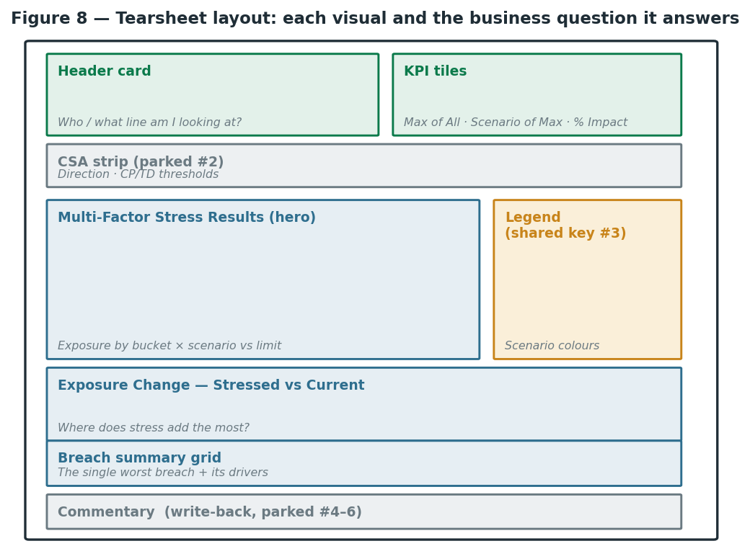
The tearsheet layout — each card and the business question it answers.

5. Card-by-card build instructions

5.1. Header card
- Purpose: Who and what line am I looking at?
- Data: Long Name (as Borrower), Line, Worst Rating (as Rating), Line Type (as Exposure Type), Line Currency. No metrics.
- Visualization: Grid.
- Shelves: Put the five attributes on the grid, then Swap Rows/Columns (Transpose) to make it vertical.
- Filter: Driven by the Borrower→Line cascading selectors (Section 6).
- Format: Rename the card title from the placeholder "stress PFE" to Counterparty Tearsheet.
- Gotcha: The page is per-line, not per-borrower — a borrower can have several lines.

5.2. KPI tiles
- Purpose: The headline numbers.
- Data: Max of All, Scenario of Max, Percentage of Impact.
- Visualization: KPI widget for the metrics; a small Grid or text tile for Scenario of Max.
- Shelves: Max of All and Percentage of Impact go on the KPI widget.
- Format: Format Percentage of Impact as 1,489% (0 decimals + % sign) or 14.9× — not the raw 1489.469405.
- Gotcha: Max of All ≡ Max Scenario Exposure (same number by definition) — don't show both; pair Max of All with Scenario of Max instead so the tile tells a story. Scenario of Max is an attribute (text), which the KPI widget won't take — use a small grid/text tile for it.
- Alternative: You can also show Max of All as a reference line on the scenario-maxima bars instead of a tile.

5.3. Scenario-maxima bars (companion panel)
- Purpose: Which stress scenario binds for this line?
- Data: The eight scenario-max metrics (Base, Zero-Corr, 0.25, 0.75, STR75, 1.0, Prod, STRMPR025).
- Visualization: Horizontal bar chart (long scenario names read cleanly to the left of each bar).
- Shelves: Metric Names on the category axis; the eight metrics as the values.
- Format: Rename each metric to its friendly name (right-click in the Vertical zone → Rename). Turn on data labels.
- Gotcha: Because each bar is a separate metric (not one metric split by a Scenario attribute), Strategy cannot auto-sort by value or auto-highlight the max — bar order follows the drag order and colour is per-metric. Fine for a single-line tearsheet; manually drag into descending order and colour the base bar muted.

5.4. Multi-Factor Stress Results (hero)
- Purpose: How does exposure behave across the maturity curve, per scenario, vs the limit?
- Prerequisite: vw_asts_bucket_pivot; Time Bucket (sorted by bucket_order), Series, Value (MAX).
- Visualization: Bar chart (clustered).
- Shelves: Horizontal (category) = Time Bucket; Vertical (value) = Value; Color By = Series.
- Filter: Keep the page Line filter active (one counterparty).
- Sort: Time Bucket by Bucket Order (see 2.2) so buckets run 0-3 → 10-50, not alphabetical.
- Format: Set categorical Series colours (not the default sequential green ramp), matched to the other charts (Section 5.9). Remove Break By if it duplicates Color By.
- Gotcha: If only ~4 series show, categorical colours reveal whether Limit/Current Exposure nulled out (a cast/line_rep issue). BASE draws nothing (its exposure lives in Current Exposure) — you can hide it in the legend.

5.5. Limit line (new)
- Purpose: Show the Limit as a ceiling line over the exposure bars.
- Why it needs work: Limit is currently a Series element, not a metric — and shape is set per metric, so toggling 'line' turns every bar into a line. To make only Limit a line, Limit must be its own metric.
Recommended — give Limit its own metric via a small view tweak. Add a limit_value column to vw_asts_bucket_pivot (per-bucket limit on every row), then render it as a separate line:
-- Add to vw_asts_bucket_pivot so the Limit line is its own metric.
-- New CTE: per-bucket limit on every row.
limit_long AS (
SELECT line, business_date, bucket_order,
TRY_CAST(REPLACE(value_str, ',', '') AS DOUBLE) AS limit_value
FROM (
SELECT Line AS line, business_date,
stack(6, 1,Limit_3_mo, 2,Limit_1_Yr, 3,Limit_2_Yr,
4,Limit_5_Yr, 5,Limit_10_Yr, 6,Limit_50_Yr -- positional bucket map!
) AS (bucket_order, value_str)
FROM line_rep
)
)
-- In the final SELECT: LEFT JOIN limit_long l ON (line, business_date, bucket_order)
-- and add l.limit_value as a new column.

- Model: Add Limit Value as a metric (aggregation MAX).
- Build: On the hero chart, add Limit Value to the Vertical axis; switch the visualization to Combo; set Value = bars, Limit Value = line; keep Color By = Series. (Or build it as a separate overlay visual sharing the Time Bucket axis.)
- Alternative: No view change: create two conditional derived metrics — Limit Value = value where series='Limit' and Exposure Value = value where series<>'Limit' — and combo them. Works, but the metric-filter UI is fiddlier than the view edit.

5.6. Exposure Change — Stressed vs Current
- Purpose: Where along the maturity curve does stress add the most exposure?
- Prerequisite: current_value and change_vs_current columns in vw_asts_bucket_pivot; add both as metrics (MAX).
- Visualization: Line chart.
- Shelves: Horizontal = Time Bucket; Vertical = Change vs Current; Color By = Series.
- Filter: Filter Series to scenarios only — exclude Current Exposure (its delta is 0 by definition) and Limit (delta isn't meaningful). One clean line per scenario remains.

5.7. Breach summary grid
- Purpose: What is the single worst breach for this line, and what drives it?
- Prerequisite: vw_asts_largest_breach added to the model, joined on Line (+ Business Date) — one row per line, so it joins cleanly. Line Expiry Date is brought in separately as Line's attribute (sourced from asts, §2.3) — not from this view.
- Data: Bucket of Largest Breach, Limit, Current Exposure, Stressed Exposure, Scenario of Largest Breach — plus Line Expiry Date (Line's attribute, from asts).
- Visualization: Grid (or a transposed card like the header).
- Filter: Scoped to the current line by the page filter.
- Gotcha: Source the breach metrics from vw_asts_largest_breach, and bring Line Expiry Date as Line's attribute (from `asts`, §2.3) so the model relationship joins it on Line — that is what prevents the Cartesian, without touching the view. Lines with no breach return no row (correct).

5.8. Commentary (write-back — new)
- Purpose: The analyst's narrative under the breach grid: Primary/Secondary Risk Drivers, Products Driving Exposure, Notes — there is no source feed, a human types it.
- Prerequisite: Create the breach_commentary Delta table (below).
CREATE TABLE IF NOT EXISTS `d4001-centralus-tdvip-creditrisk`.`xvala_xva`.`breach_commentary` (
line STRING, business_date STRING,
primary_risk_driver STRING, secondary_risk_driver STRING,
products_driving_exposure STRING, notes STRING,
updated_by STRING, updated_at TIMESTAMP
) USING DELTA;

- Build: Add a Grid bound to breach_commentary. Enable Transaction on it (Strategy SQL Transaction Forms — set the editable cells and the insert/update binding).
- Join: LEFT JOIN it 1:1 to the breach grid on line + business_date, and place it beneath the breach grid so the commentary shows for the current line.
- Governance: Make the fields permission-scoped and audited — populate updated_by / updated_at on write.
- Gotcha: Confirm Transaction-Forms write-back is enabled for the Databricks SQL warehouse connection (a newer capability).

5.9. Shared legend + colour-lock
- Purpose: One colour key that describes every chart, like the sample's separate legend box (annotation #3).
- Colour-lock first: Set categorical Series colours so each scenario/Limit/Current Exposure is the same colour across all charts on the page. Lock them on the Series attribute (or match them per-viz). This is the prerequisite for a single valid shared legend.
- Shared box: Strategy has no floating shared-legend object, so emulate it: keep one chart's legend positioned to the side and hide the others; or build a tiny dummy bar-chart 'legend' viz.
- Labels: The legend reads the Series values — apply scenario_display_xref so it shows the descriptive names (blueprint until the dictionary is confirmed).

6. Cascading Borrower ↔ Line filters
- Add a Borrower selector (on Long Name) and a Line selector (on Line).
- Make them cascade: selecting a Borrower filters the Line list to that borrower's lines; selecting a Line drives every visualization on the page.
- Target all cards (header, KPI, hero, exposure change, breach grid, commentary) so the whole tearsheet scopes to one line at once.

7. Outstanding / parked enhancements
- Descriptive scenario names — validate scenario_display_xref against the authoritative scenario dictionary (placeholder in place).
- Rank "Number" (#7) — a derived Rank([Max of All]) descending; mostly meaningful on a portfolio/ranked-breach page rather than this single-line page.
- CSA strip (#2) — CSA Direction + CP/TD Thresholds, sourced from clients_report (agreement block) / SCREAM netting_xref.csv (per counterparty; join Line→Counterparty via the embedded CP code).
- Lending Manager → IHMS (#1) — external feed.
- Data-quality (fix at source in `asts`): 35 duplicate rows, Long_Name variants, null Limit on the BASE row.

End of build instructions — a living document; extend it as the parked items are completed and as the scenario dictionary and CSA feeds are confirmed.

