**Introduction:**

Interactions among people in which they create,share,and exchange information and ideas in virtual communities and networks.

**Purpose:**

Social media purpose of sharing,learing,interating,and marketing.

**Empathy map:**

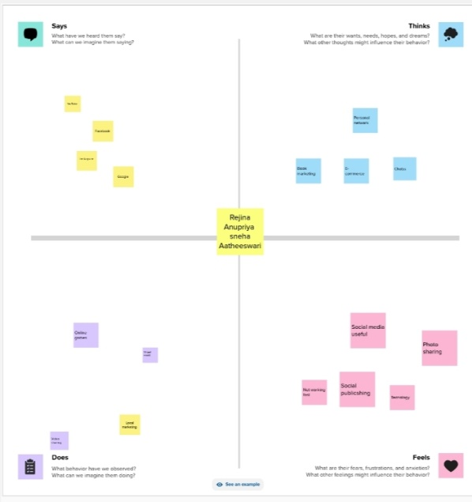

**Brianstroming map:**

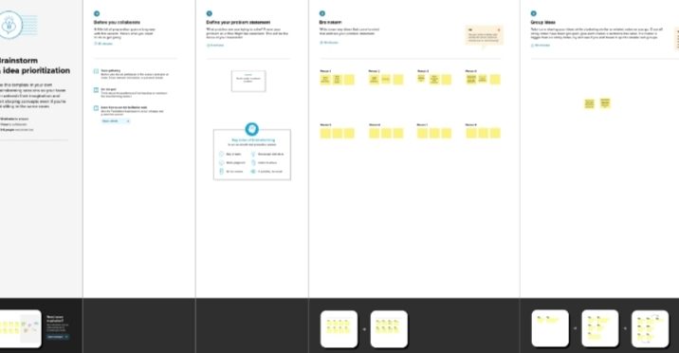

**Result:**

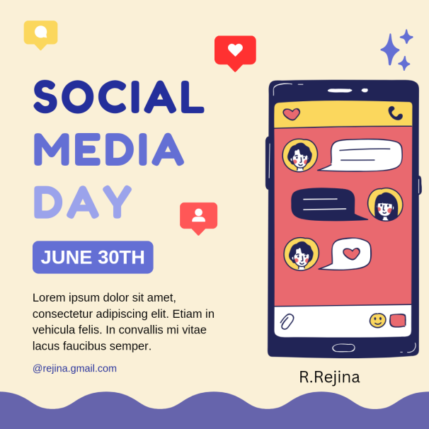

**Advantages:**

Useful for educational purpose:social media allows you to reach a large audience and build your brand.you can share relevant information or content with this audience,which is helpful if you want people to follow you can social media.

**Disadvantages:**

Spending a lot of time on social media:social media is addictive and can consume your time if you don’t have any other interests.It would help if you kept up with your studies and hobbies to stay productive.

**Application:**

Every web based application that supports information publishing and sharing,the building of personal profiles,connecting within the community is considered as a social media application.

**Conclusion:**

Social media has plenty of good uses as it allows stories or events enhance locally to gain a global or worldwide attention.