AIM
To Create and stimulate a Kanban workflow using Jira or Trello
PROCEDURE
1.Login to Jira/Trello
2.Create a new kanban board
3.Create Coloumns:To Do,In Progress,Done
4.Add 2 to 3 tasks
5.Move tasks across coloumn to stimulate workflow
6.Observe task progress
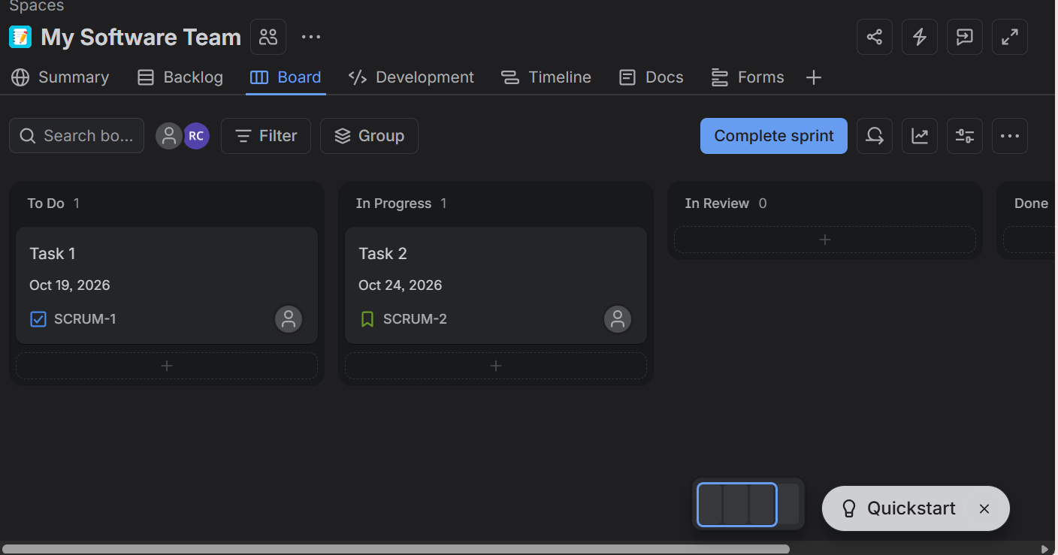

SsRESULT: Thus Kanban board has created successfully and stimulated workflow by moving tasks across stages

