**DAILY ONLINE ACTIVITIES SUMMARY**

|  |  |  |  |  |  |  |  |
| --- | --- | --- | --- | --- | --- | --- | --- |
| **Date:** | | **19/5/2020** | | | | | |
| **Name of the Faculty** | | **REENA LOBO** | | | | | |
| **No. of Students Allotted for monitoring** | | | | | **19** | | |
| **Progress** | | | | | **60% students submitted on time.** | | |
| **Whether collected report from all the allotted students** | | | | | **11-submitted**  **8-not submitted** | | |
| **Online Test Summary** | | | | | | | |
| **Subject** |  | | | | | | |
| **Semester** |  | | | **Duration** | |  | |
| **No. of students Taken** | | |  | **Passing %** | |  | |
| **Certification Course Summary** | | | | | | | |
| **Course** | | **Database concepts** | | | | | |
| **Certificate Provider** | | **ALLISION** | | | **Duration** | | **2hrs** |
| **Coding Challenges** | | | | | | | |
| **Problem Statement:** | | | | | | | |
| **Status:** | | | | | | | |
| **Uploaded the report in Github** | | | | |  | | |
| **If yes Repository name** | | | | |  | | |
| **Uploaded the report in slack** | | | | |  | | |

Certification Course Details: (Attach the snapshot and briefly write the report for the same)

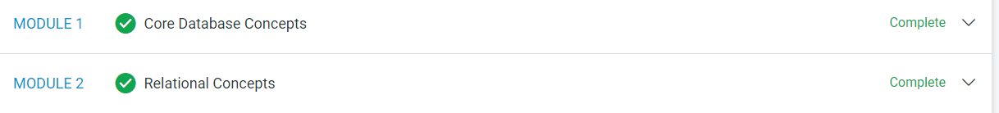

Certification Course Details: Finished an online course on Core Database

concepts.

STUDENTS REPORT:

ROHAN MAHAVEER:

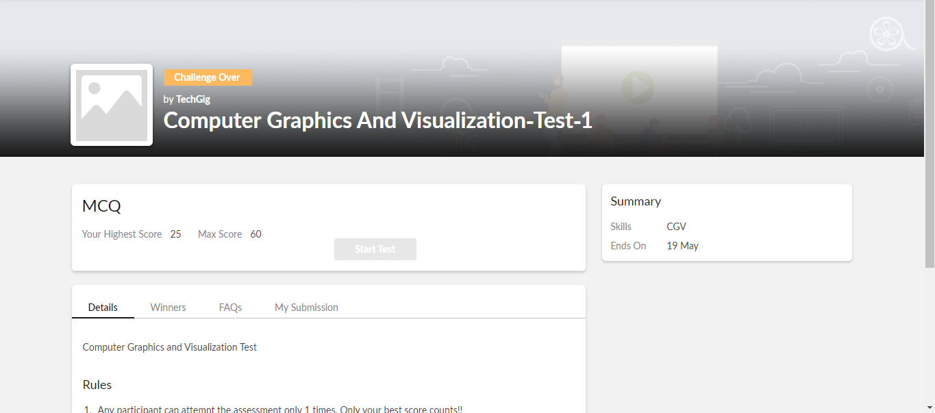

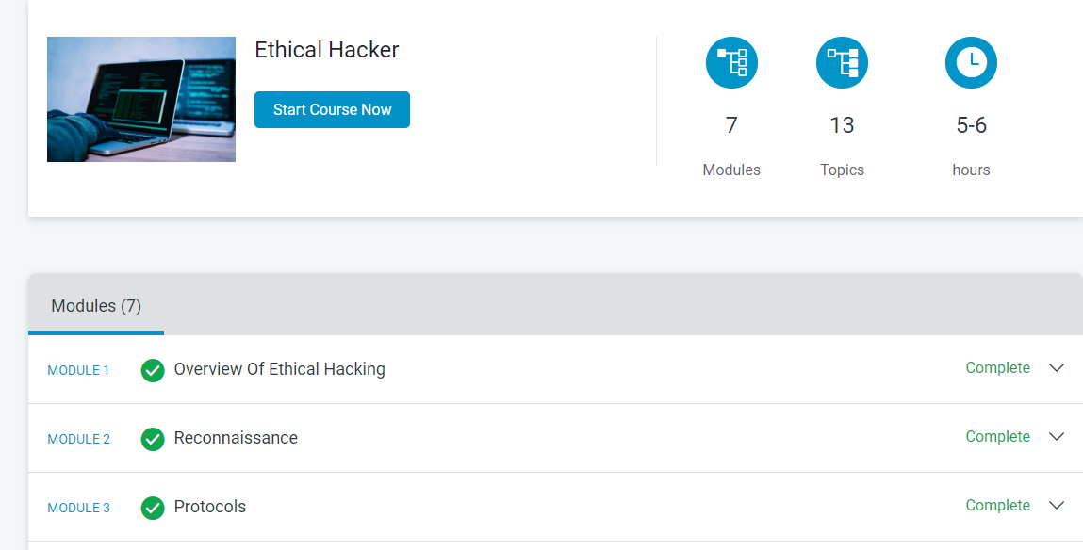

ATISH: 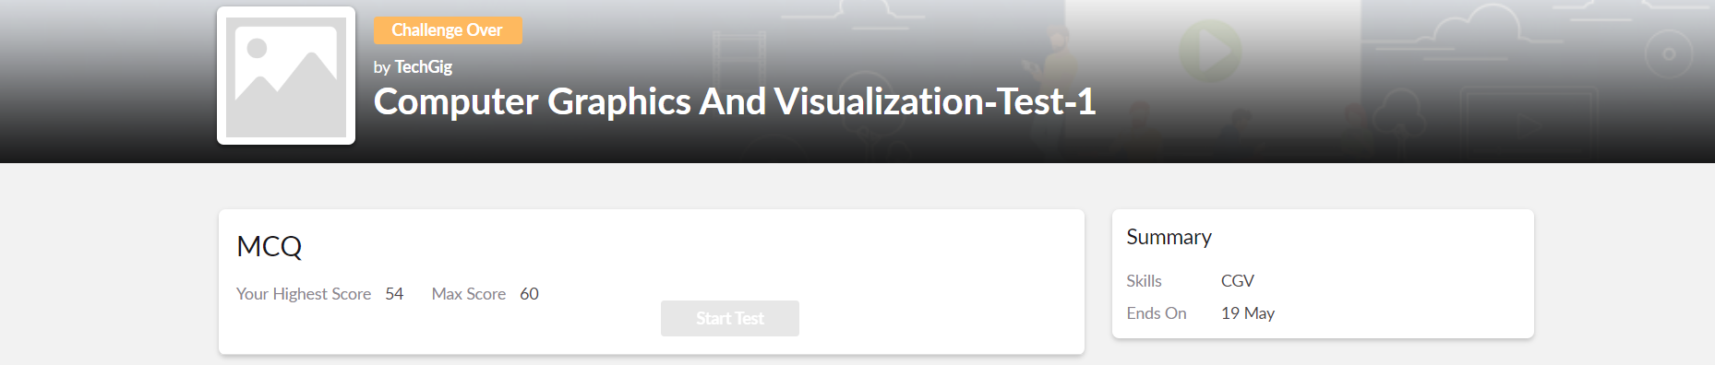

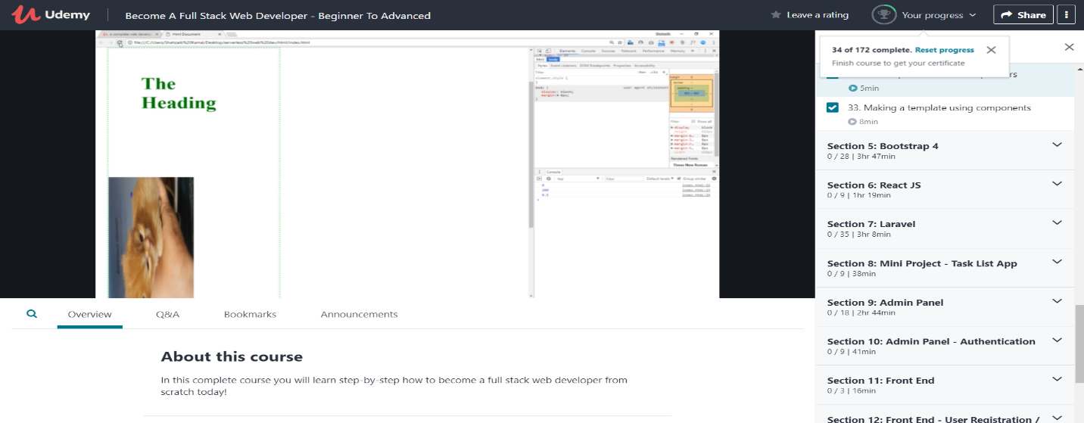

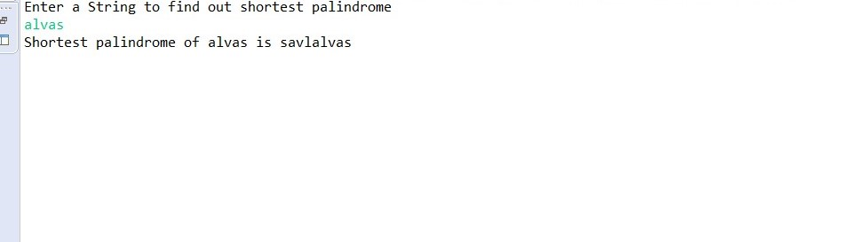

**Shah Dhruvil Amit:**

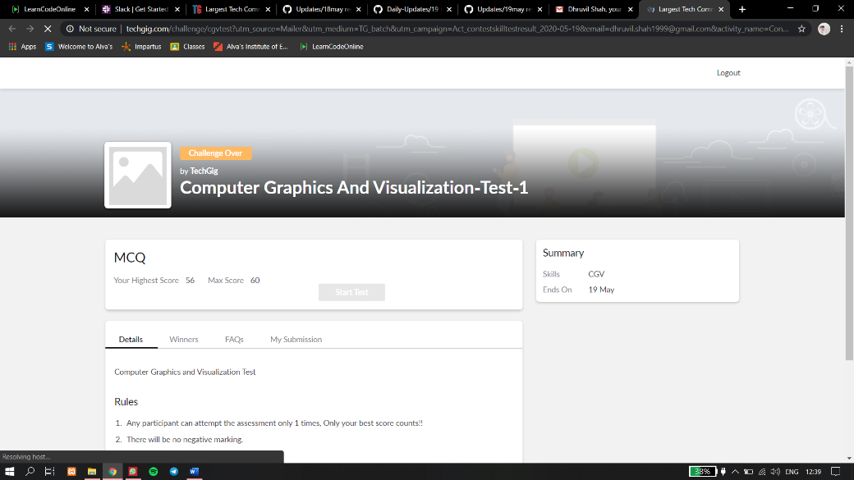

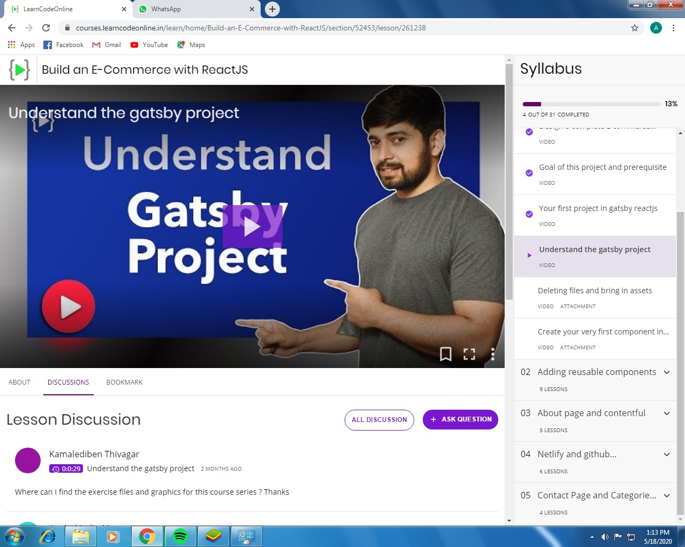

**Raksha S:**

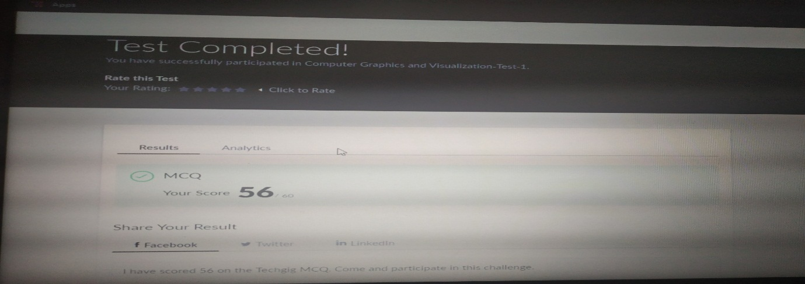

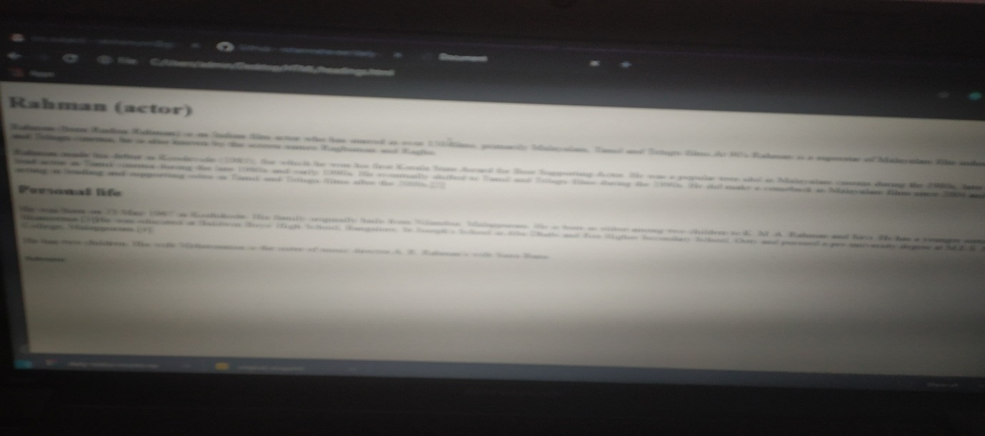

**Preethi:**

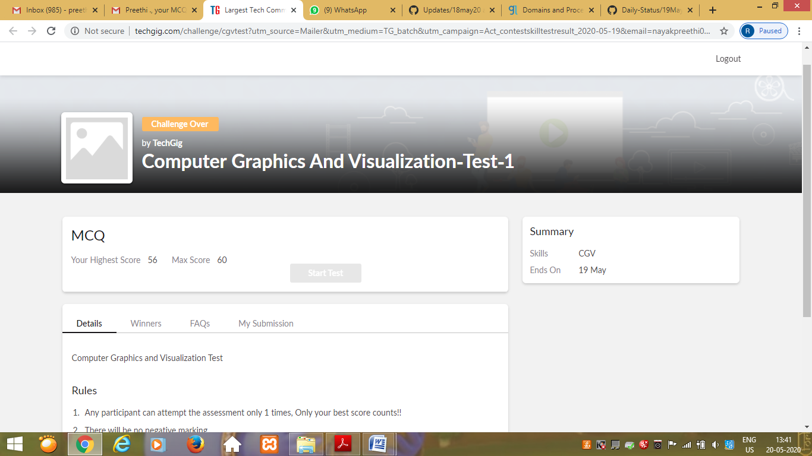

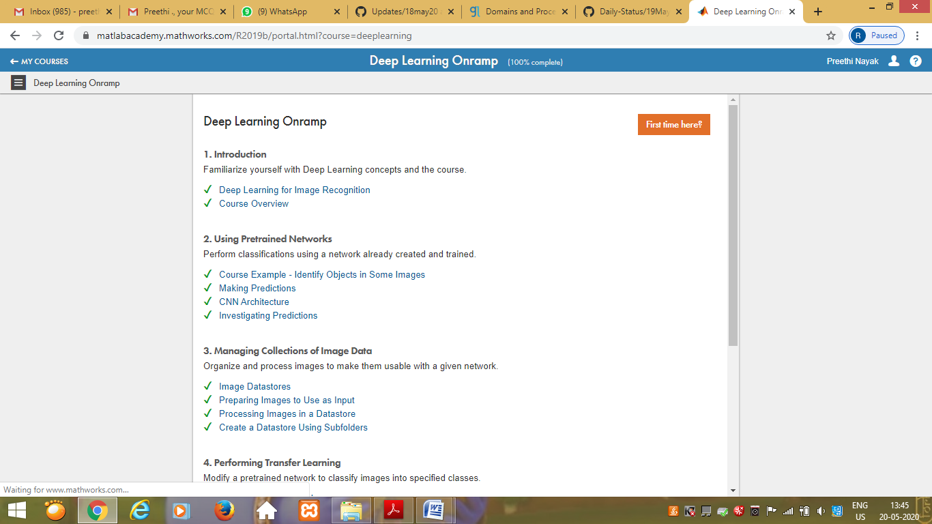

Rohan vasista:

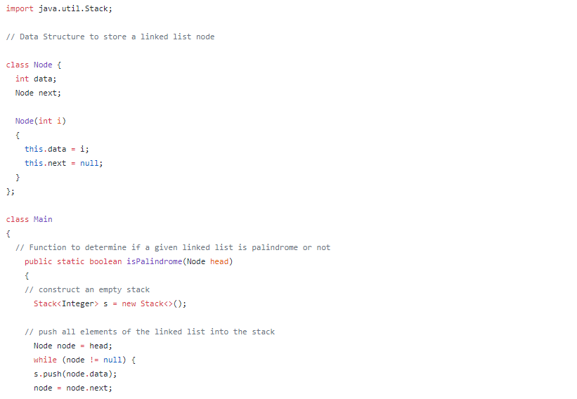

Rani:

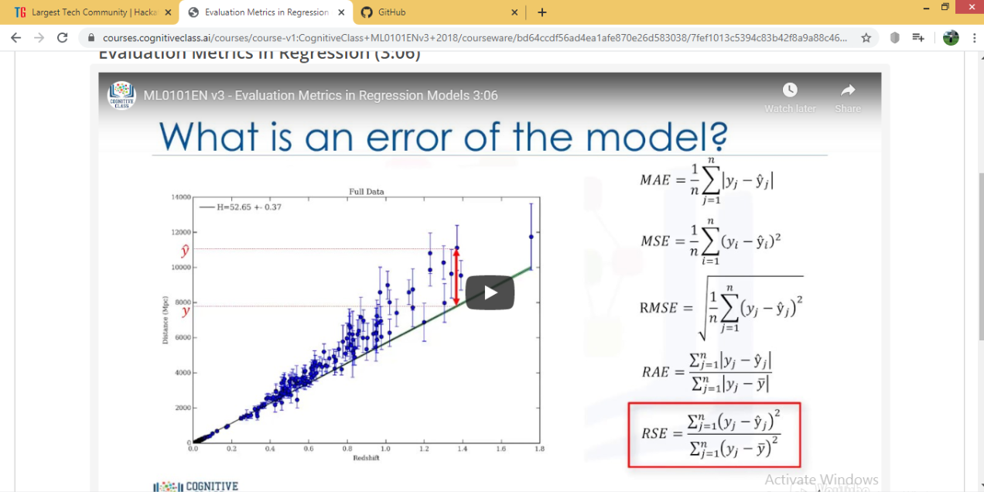

**Pranav L M:**

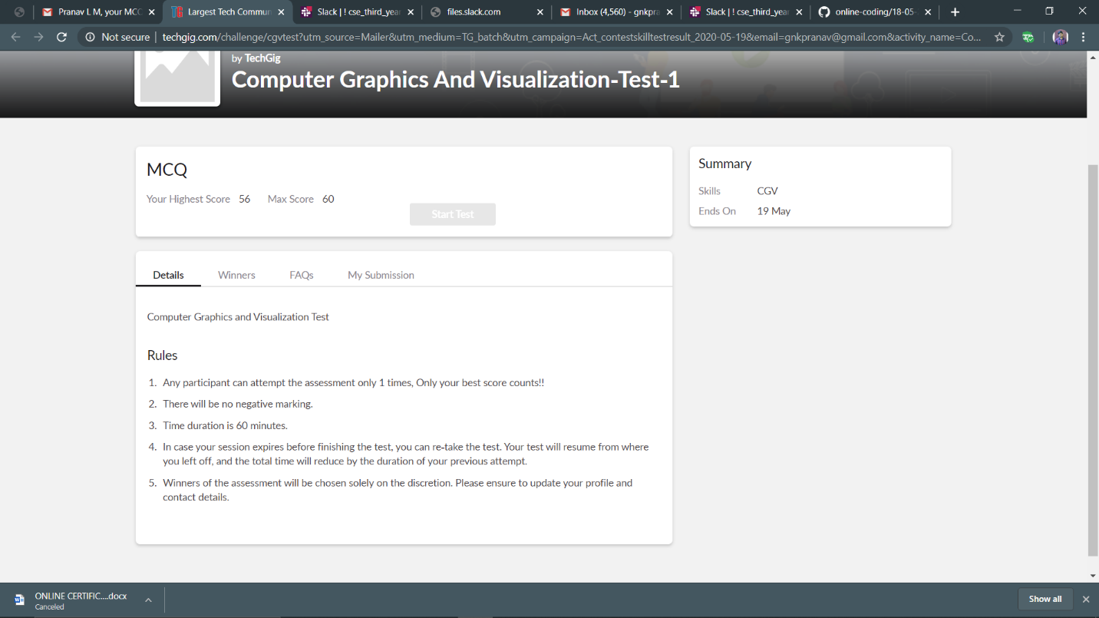

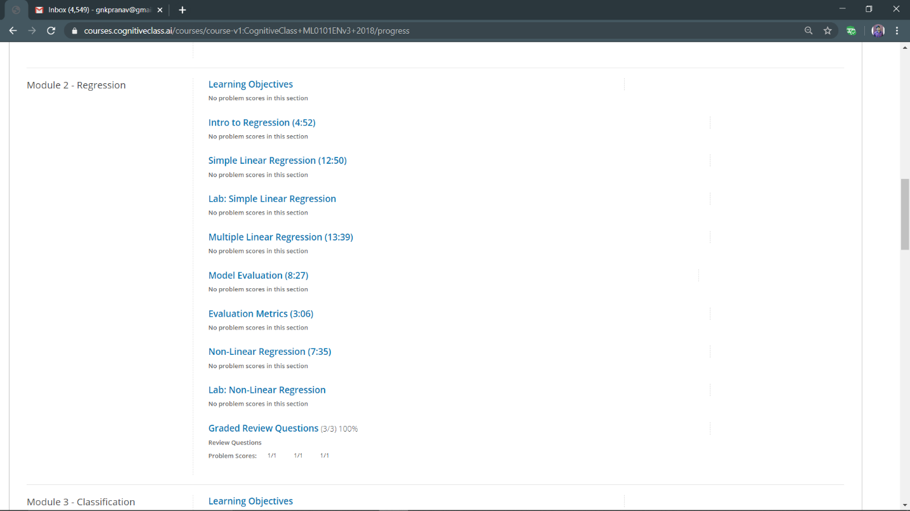

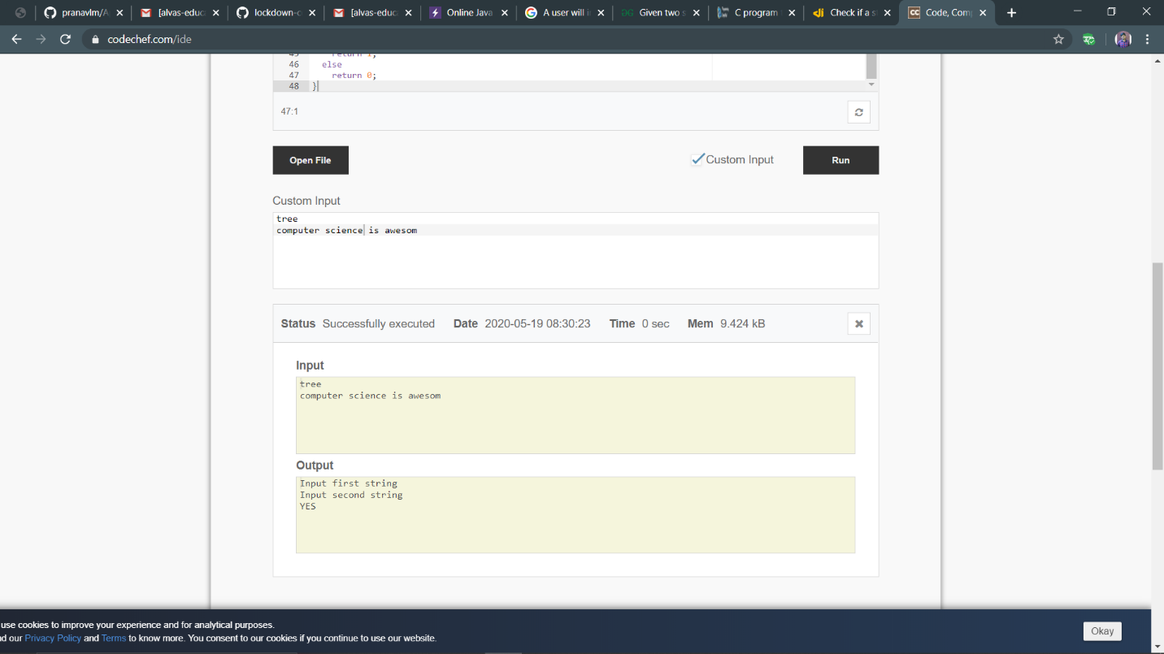

**Priyanka Killedar:**

