**DAILY ONLINE ACTIVITIES SUMMARY**

|  |  |  |  |  |  |  |  |
| --- | --- | --- | --- | --- | --- | --- | --- |
| **Date:** | | **20/5/2020** | | | | | |
| **Name of the Faculty** | | **REENA LOBO** | | | | | |
| **No. of Students Allotted for monitoring** | | | | | **19** | | |
| **Progress** | | | | | **GOOD** | | |
| **Whether collected report from all the allotted students** | | | | | **16** | | |
| **Online Test Summary** | | | | | | | |
| **Subject** | **OPERATING SYSTEM-PRCTICE TEST** | | | | | | |
| **Semester** | **6** | | | **Duration** | | **15MIN** | |
| **No. of students Taken** | | | **45** | **Passing %** | | **100** | |
| **Certification Course Summary** | | | | | | | |
| **Course** | | **Database concepts** | | | | | |
| **Certificate Provider** | | **ALLISION** | | | **Duration** | | **2hrs** |
| **Coding Challenges** | | | | | | | |
| **Problem Statement:** | | | | | | | |
| **Status:** | | | | | | | |
| **Uploaded the report in Github** | | | | |  | | |
| **If yes Repository name** | | | | |  | | |
| **Uploaded the report in slack** | | | | |  | | |

Certification Course Details: (Attach the snapshot and briefly write the report for the same)

Certification Course Details: Finished an online course on Core Database

concepts.

STUDENTS REPORT:

ROHAN MAHAVEER:

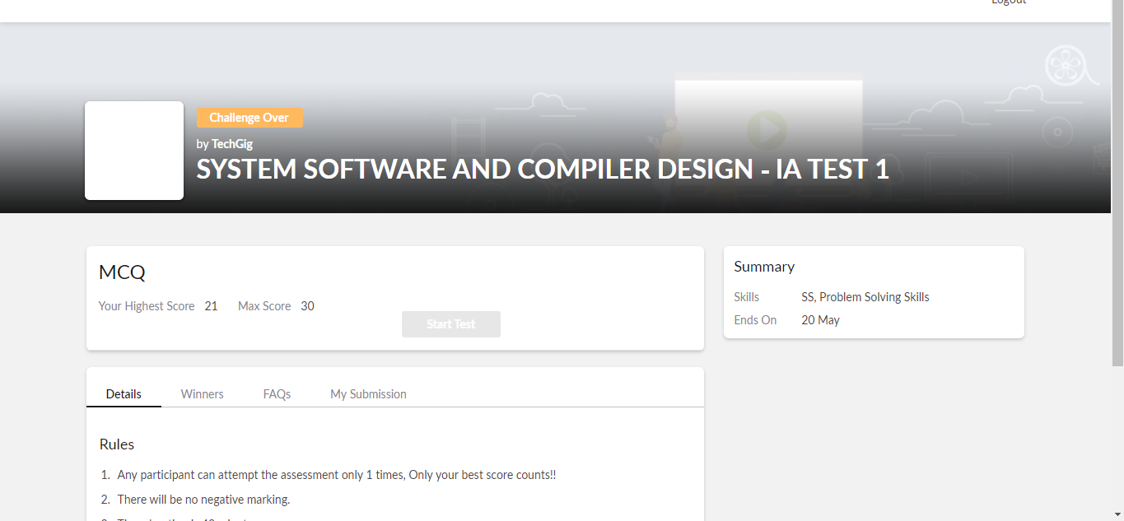

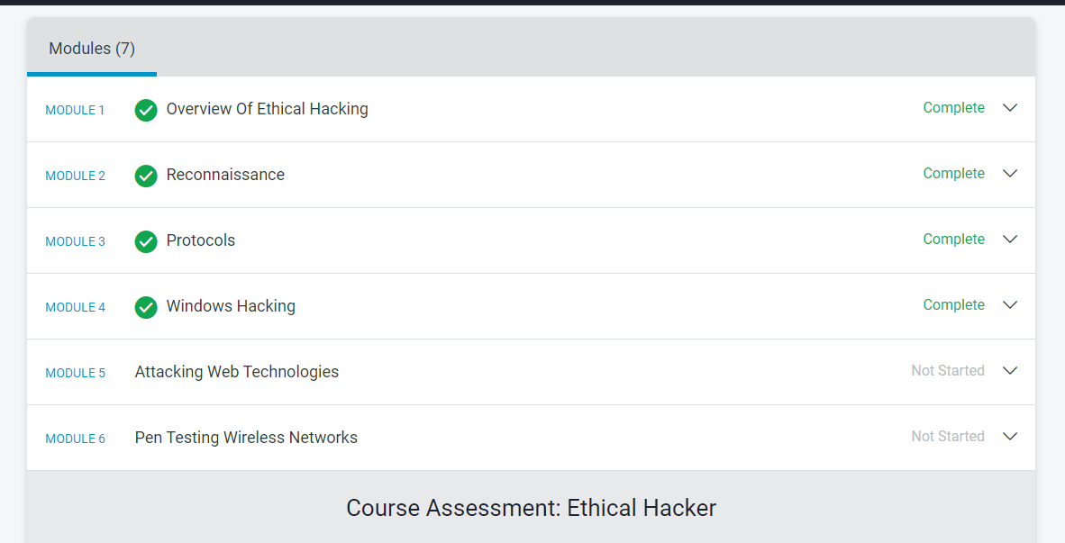

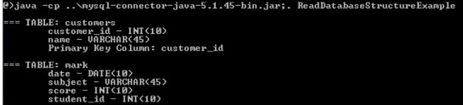

ATISH:

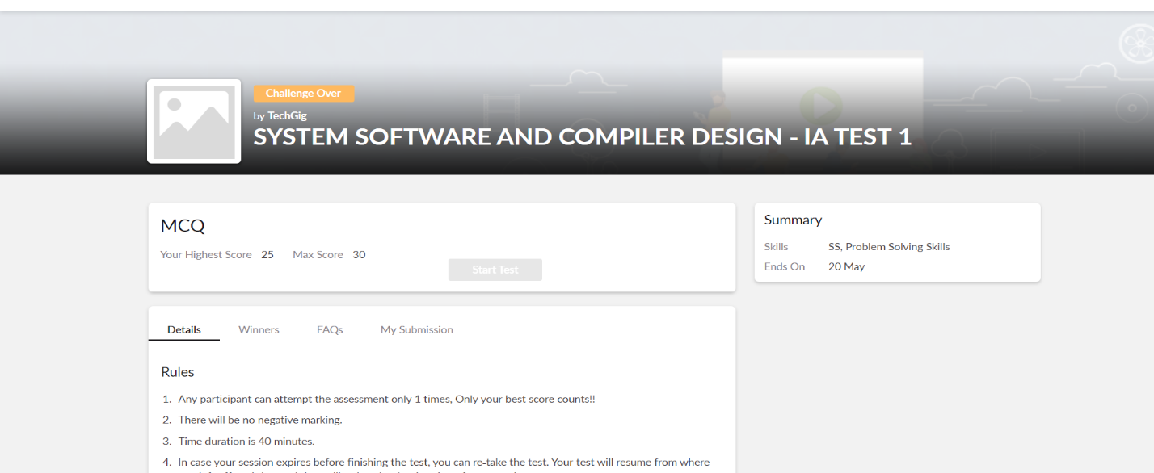

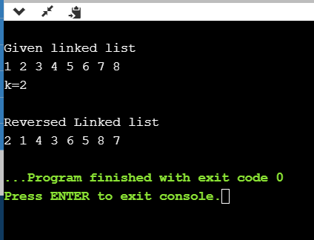

**Shah Dhruvil Amit:**



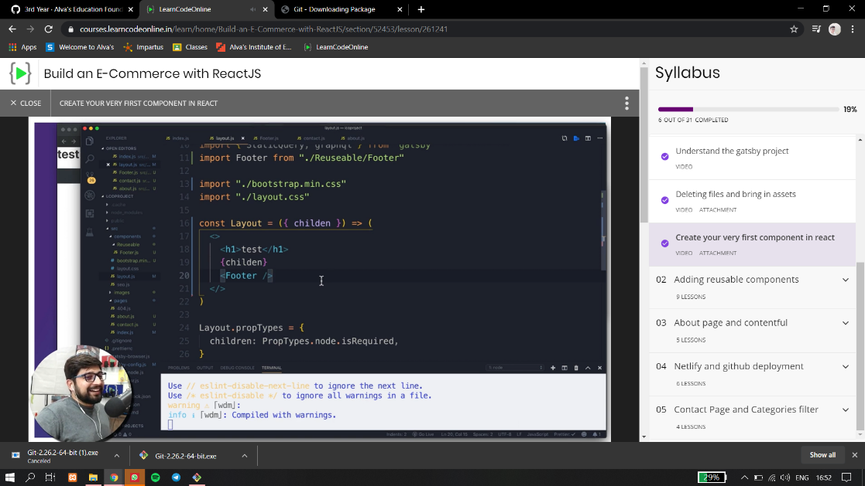

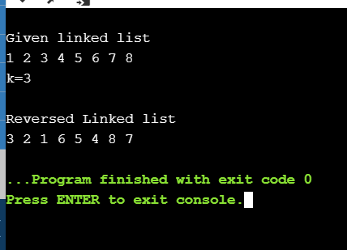

**Raksha S:**

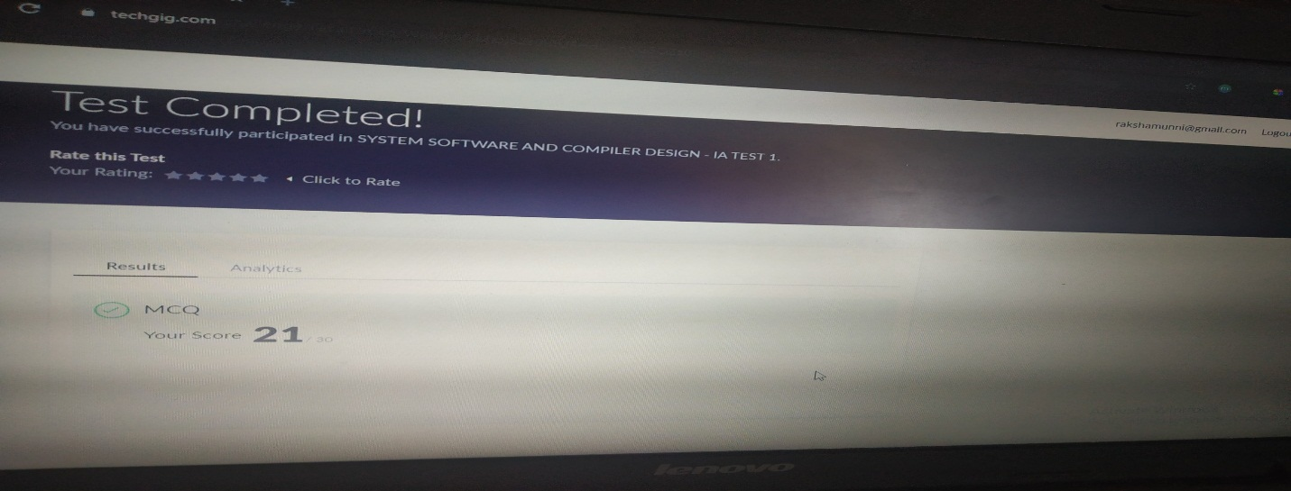

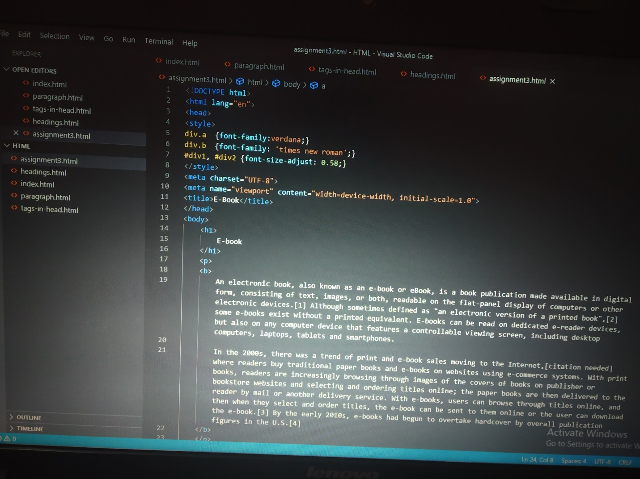

**Preethi:**

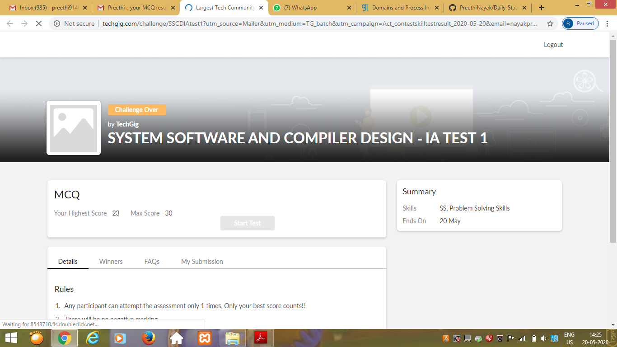

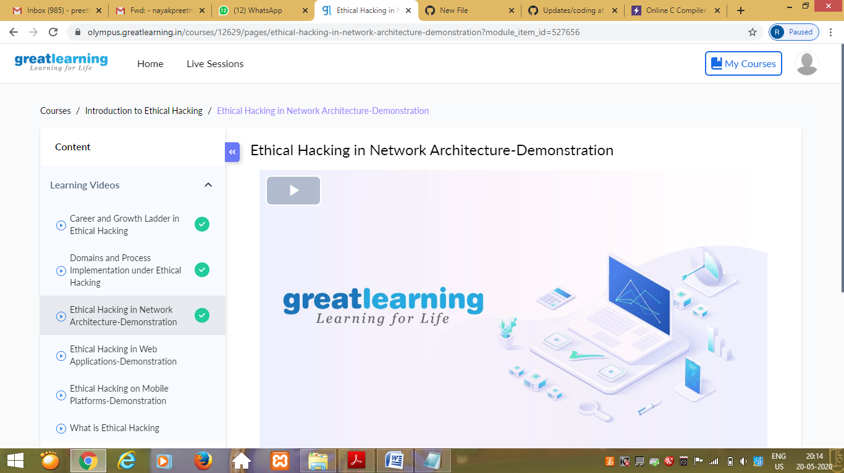

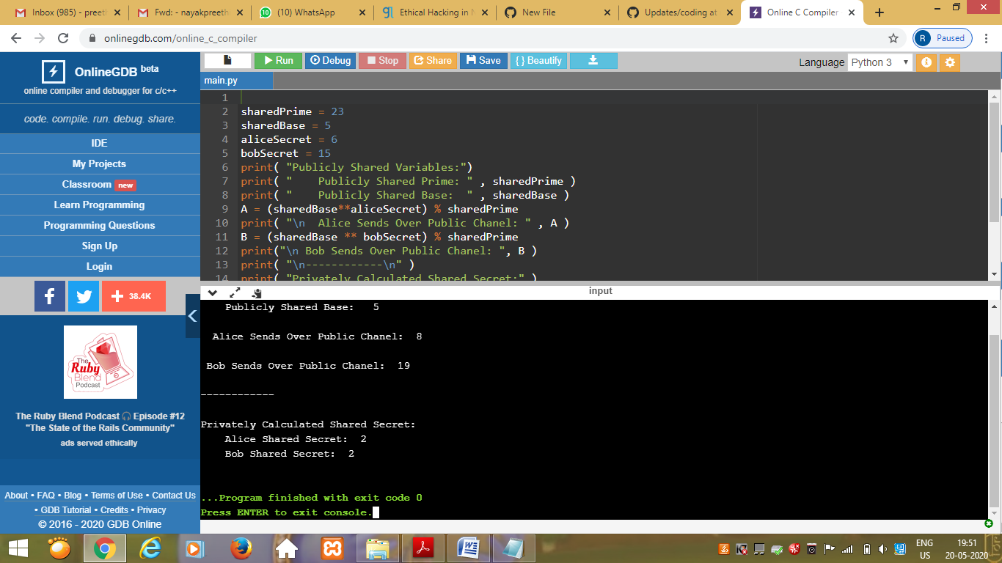

Rohan vasista:

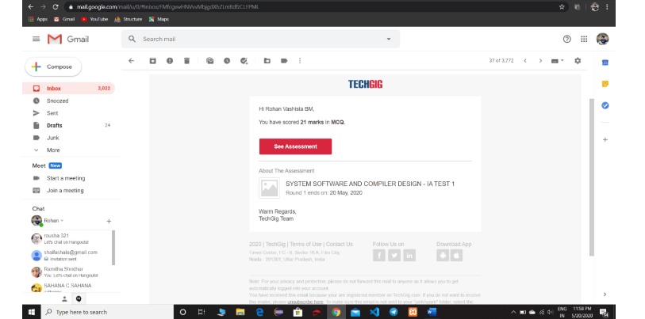

Rani:

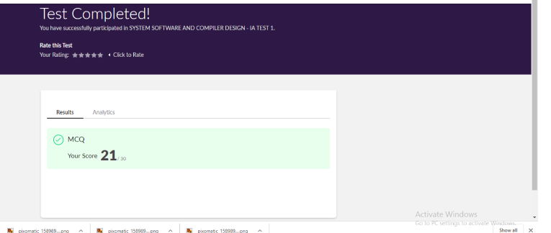

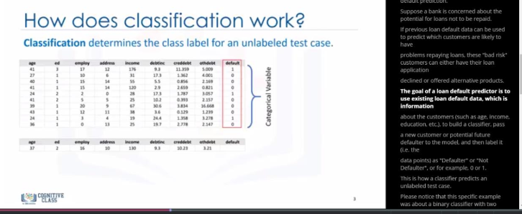

**Pranav L M:**

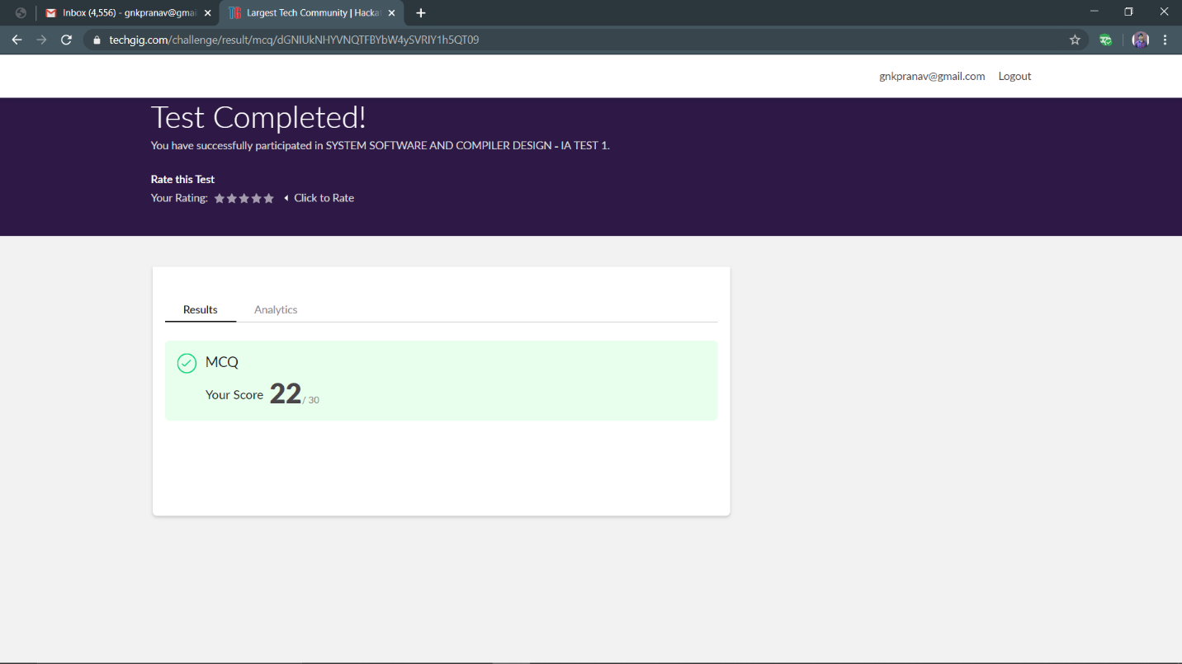

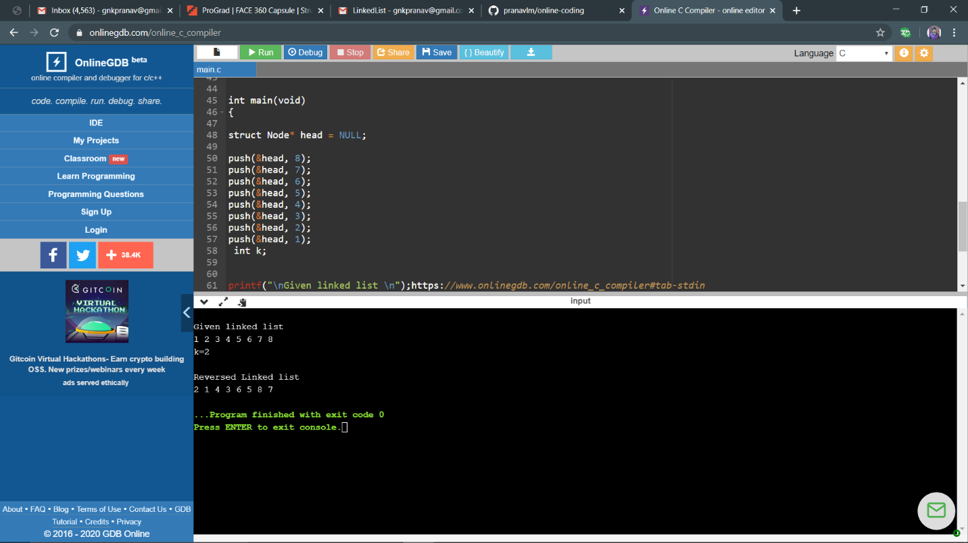

**Priyanka Killedar:**

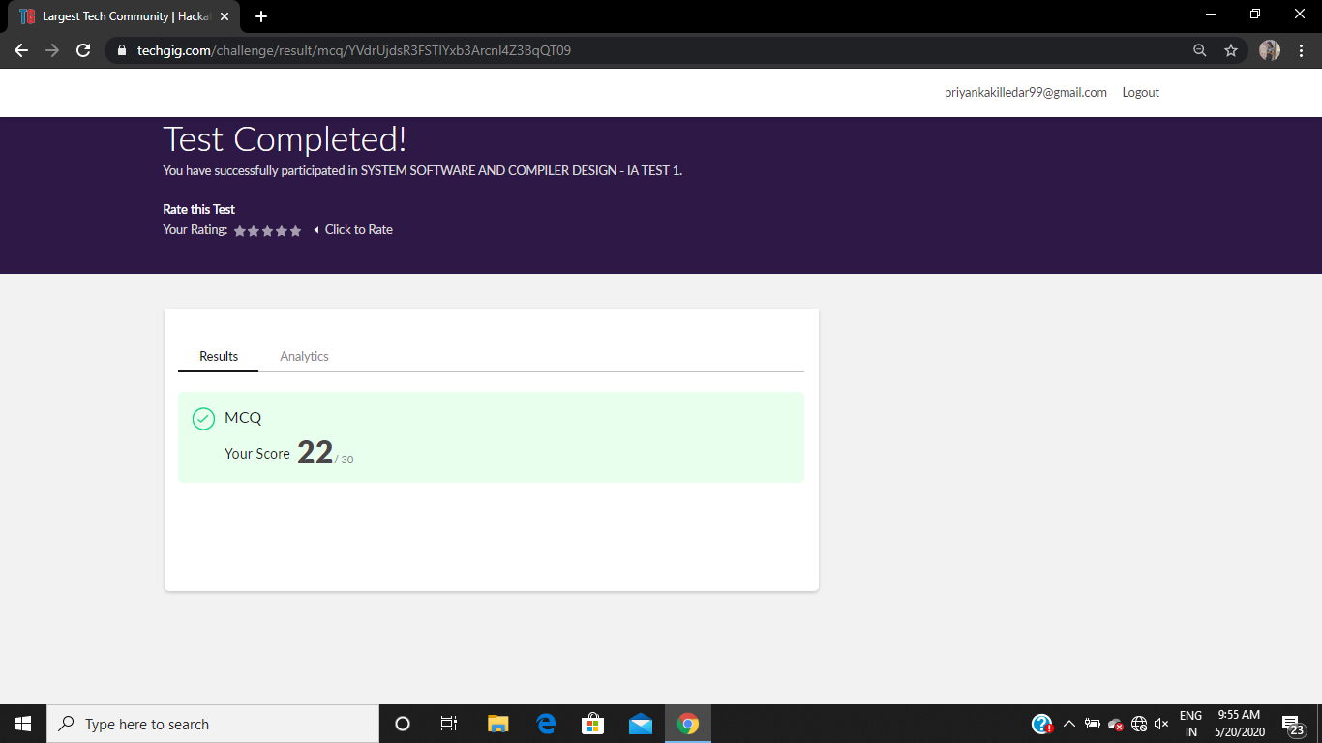

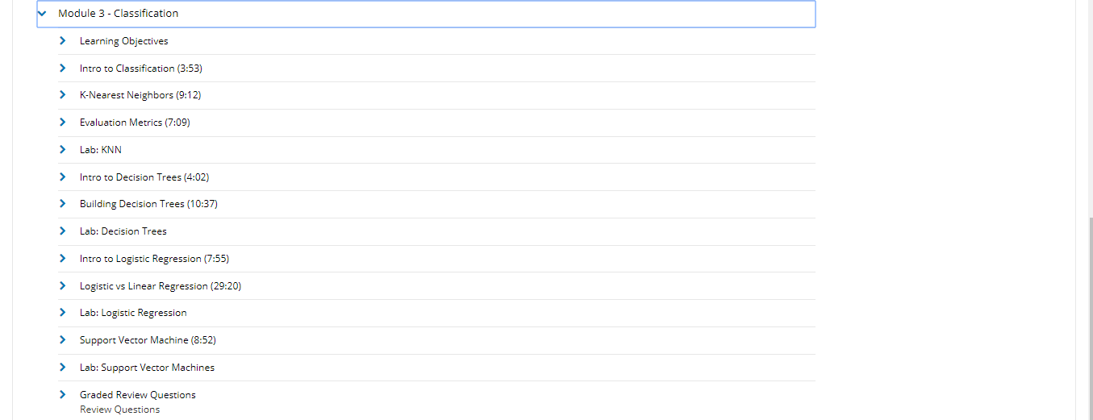

RAVALI:

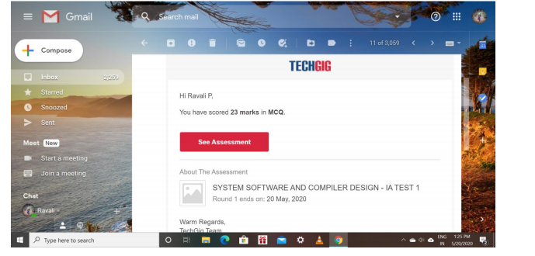

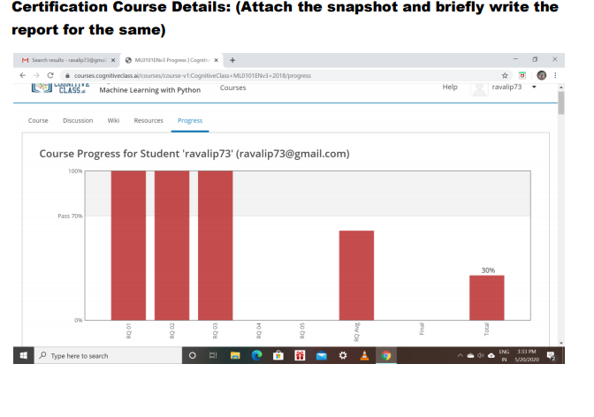

PRAVEEN KUMAR:

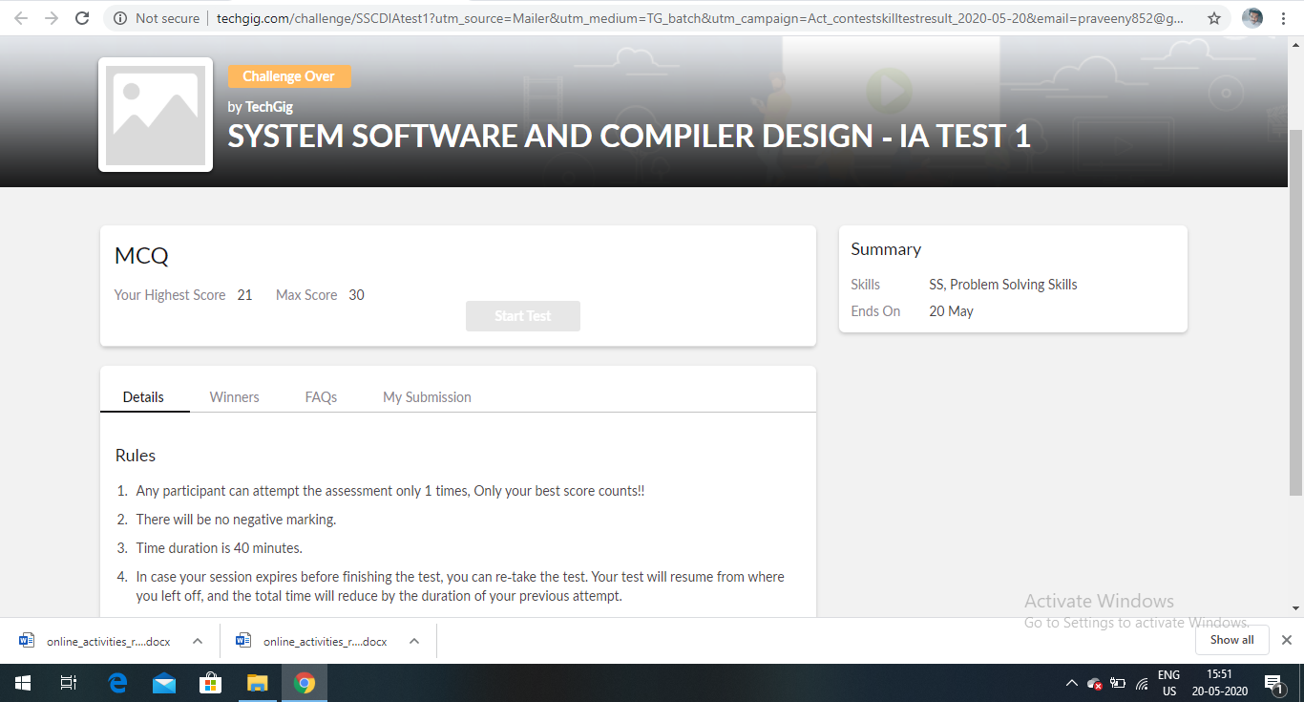

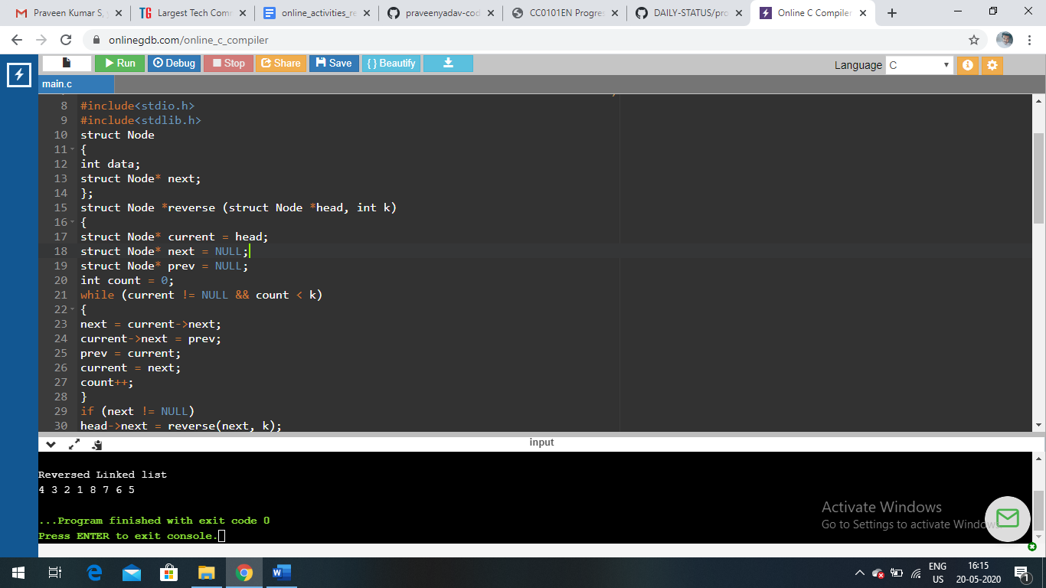

SANA:

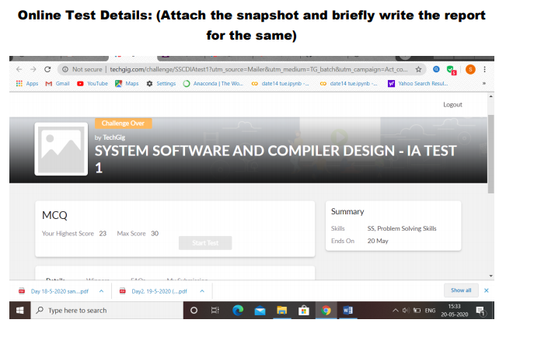

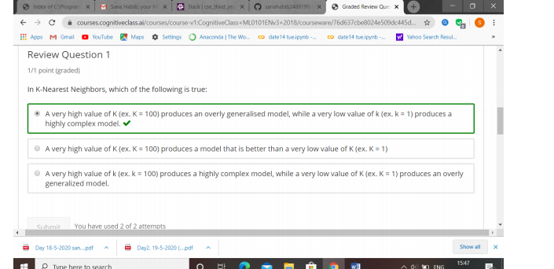

ROUSHA:

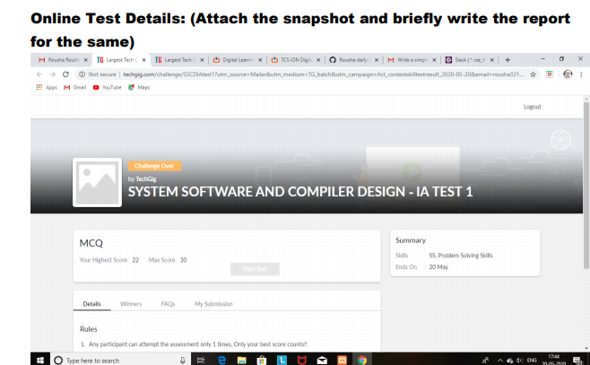

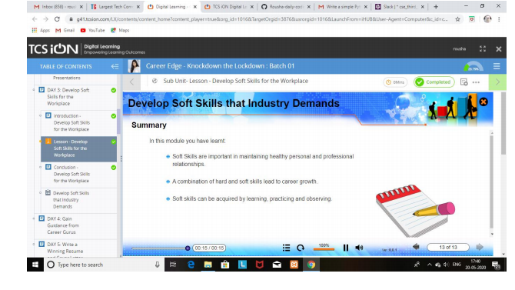

SHAIFA:

