**DAILY ONLINE ACTIVITIES SUMMARY**

|  |  |  |  |  |  |  |  |
| --- | --- | --- | --- | --- | --- | --- | --- |
| **Date:** | | **21/5/2020** | | | | | |
| **Name of the Faculty** | | **REENA LOBO** | | | | | |
| **No. of Students Allotted for monitoring** | | | | | **19** | | |
| **Progress** | | | | | **GOOD** | | |
| **Whether collected report from all the allotted students** | | | | | **14** | | |
| **Online Test Summary** | | | | | | | |
| **Subject** | **OPERATING SYSTEM-IA1** | | | | | | |
| **Semester** | **6** | | | **Duration** | | **40MIN** | |
| **No. of students Taken** | | | **105** | **Passing %** | | **98** | |
| **Certification Course Summary** | | | | | | | |
| **Course** | | **PYTHON FOR DATA SCIENCE** | | | | | |
| **Certificate Provider** | | **COGNITIVE CLASS** | | | **Duration** | | **5hr-Completed 2 modules** |
| **Coding Challenges** | | | | | | | |
| **Problem Statement:java program o implement round robin algorithm** | | | | | | | |
| **Status:completed** | | | | | | | |
| **Uploaded the report in Github** | | | | | **yes** | | |
| **If yes Repository name** | | | | | <https://github.com/reenalobo/ONLINE-ACTIVITY-REPORT/upload/master> | | |
| **Uploaded the report in slack** | | | | | **yes** | | |

**Online test summary**

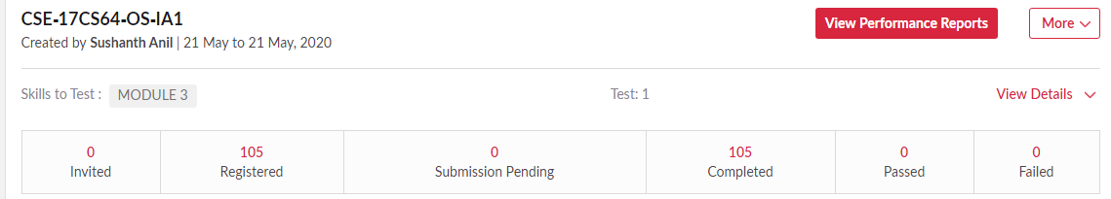

Conducted test for 6th sem students.Out of 110 students 105 students registered and completed the test.

Certification Course Details: (Attach the snapshot and briefly write the report for the same)

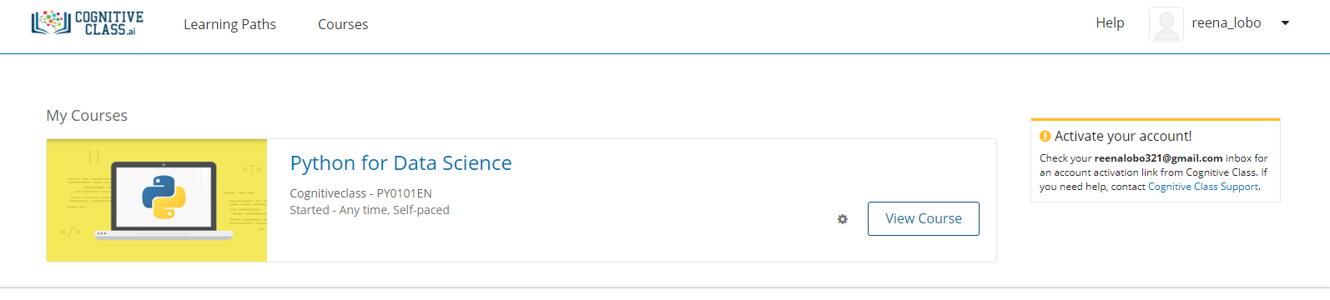

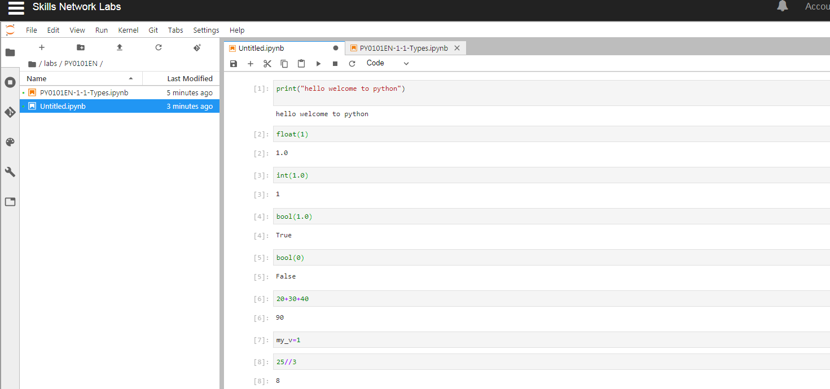

Joined certification course-python for data science and completed two modules.

STUDENTS REPORT:

ROHAN MAHAVEER:

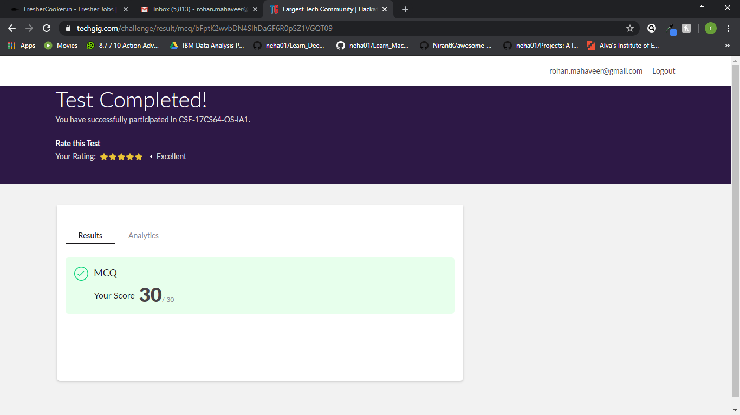

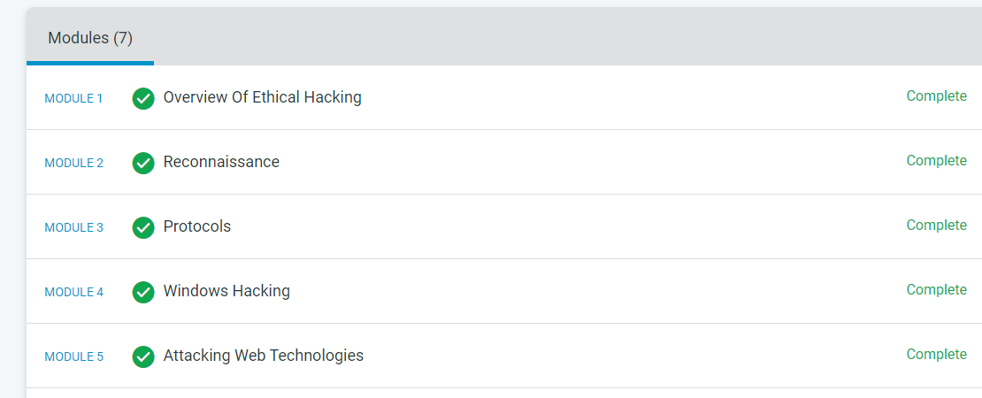

ATISH:

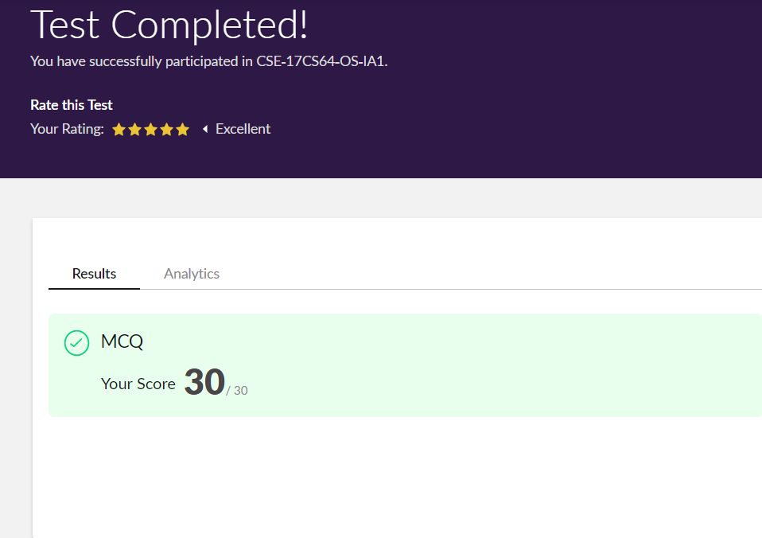

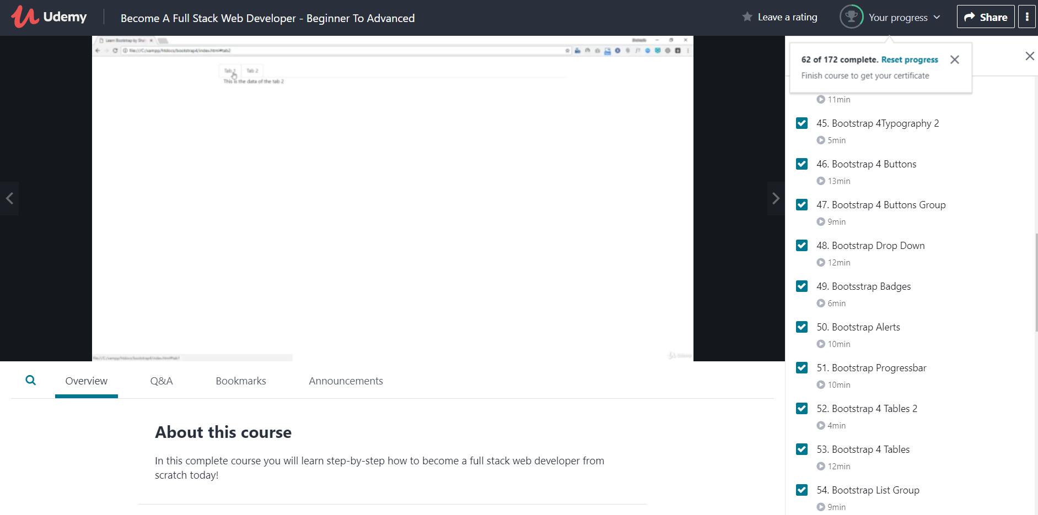

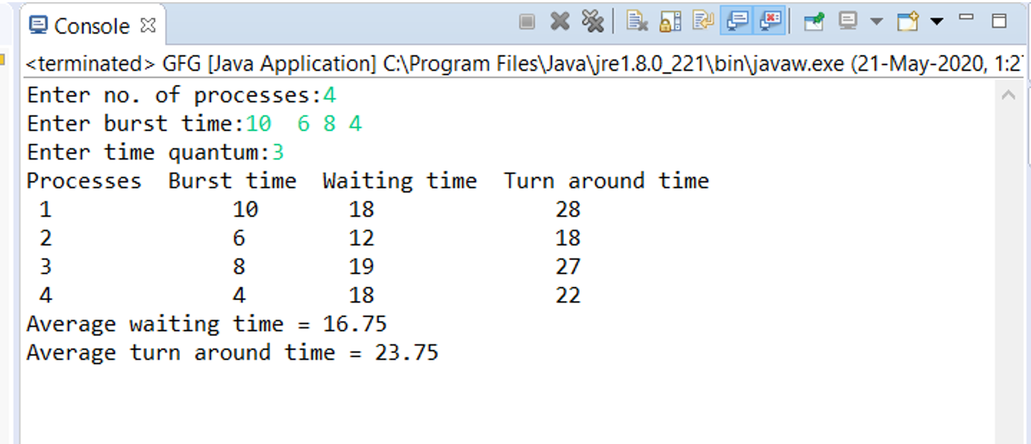

**Shah Dhruvil Amit:**



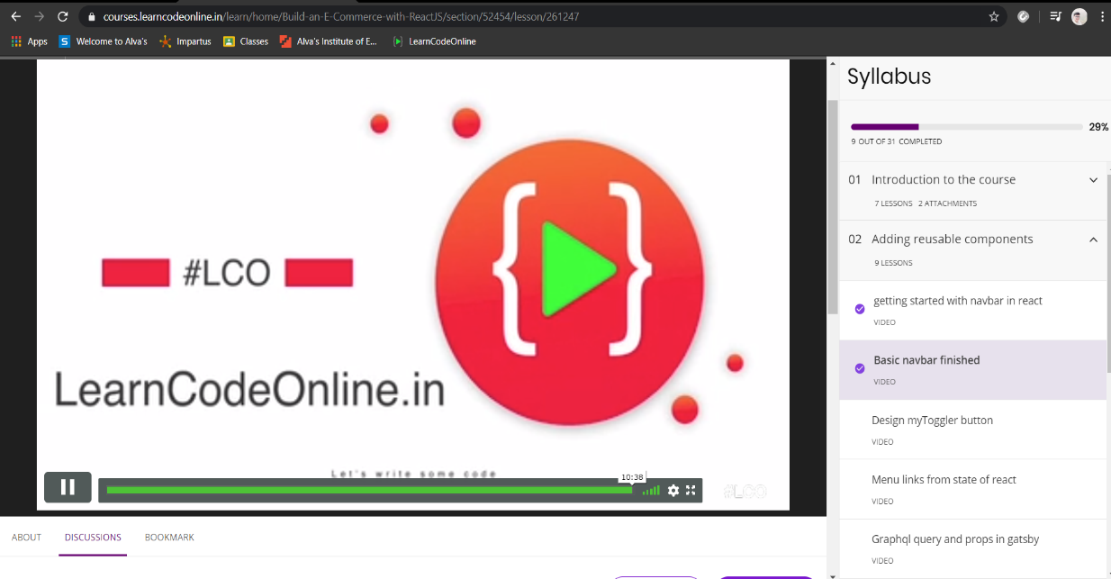

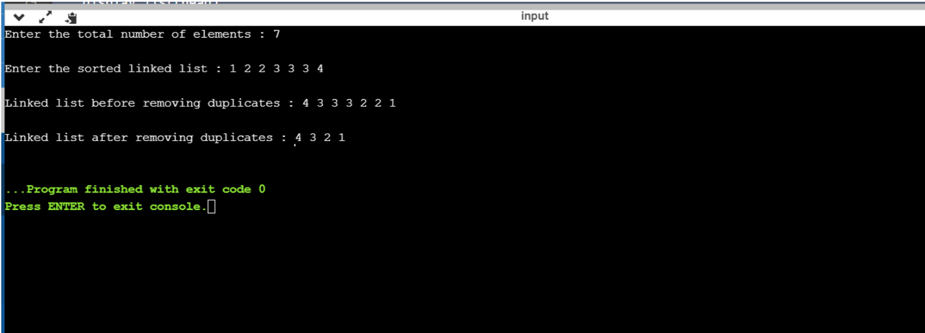

**Raksha S:**

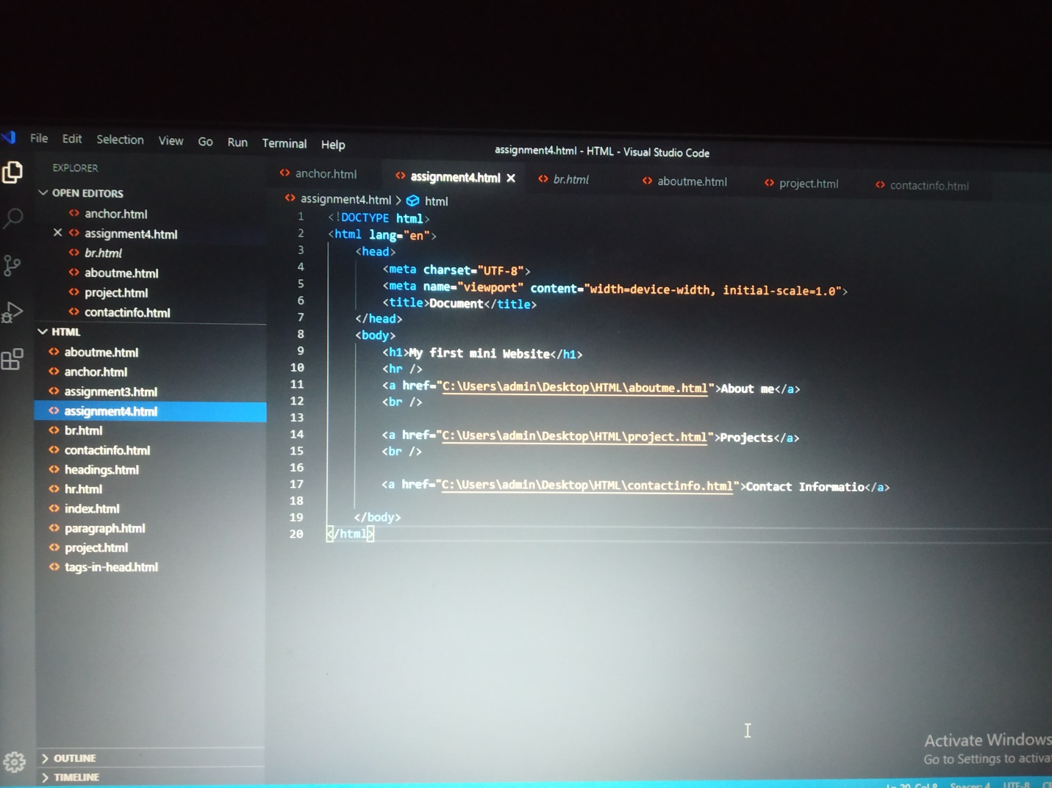

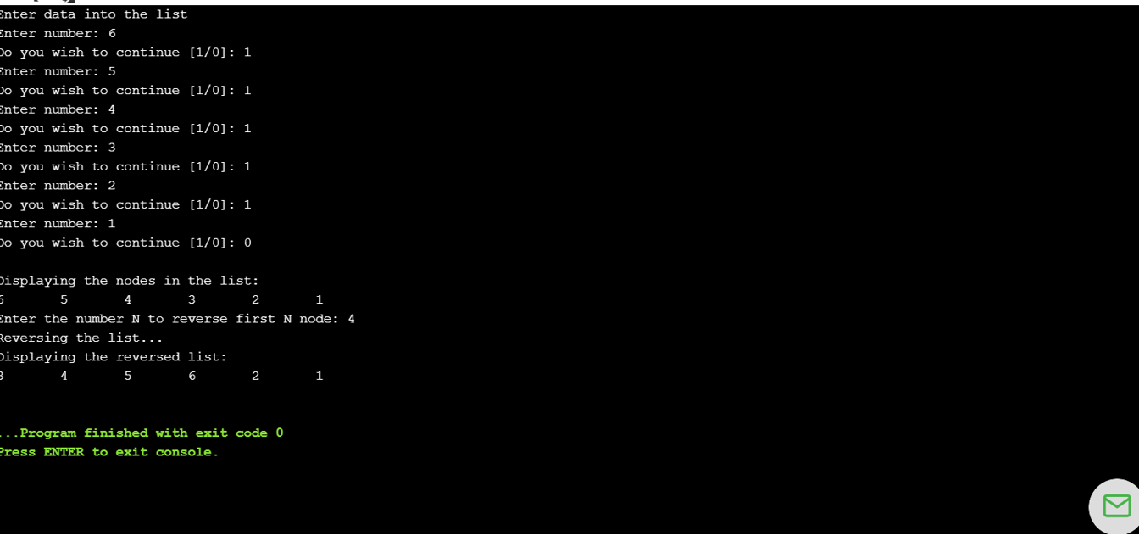

**Preethi:**

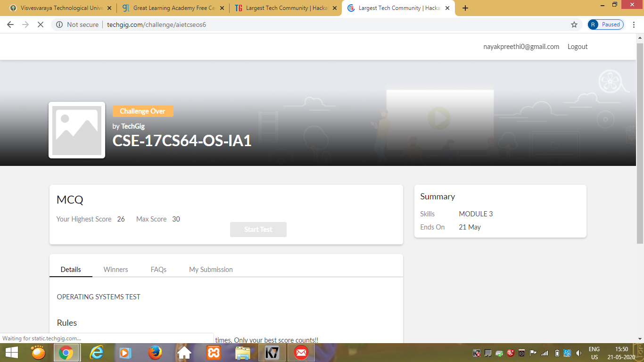



Rani:

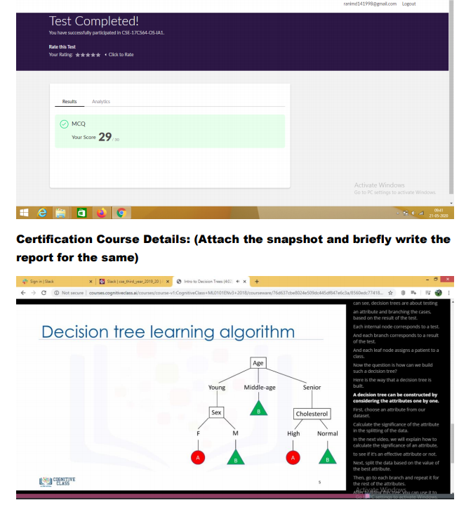

**Pranav L M:**

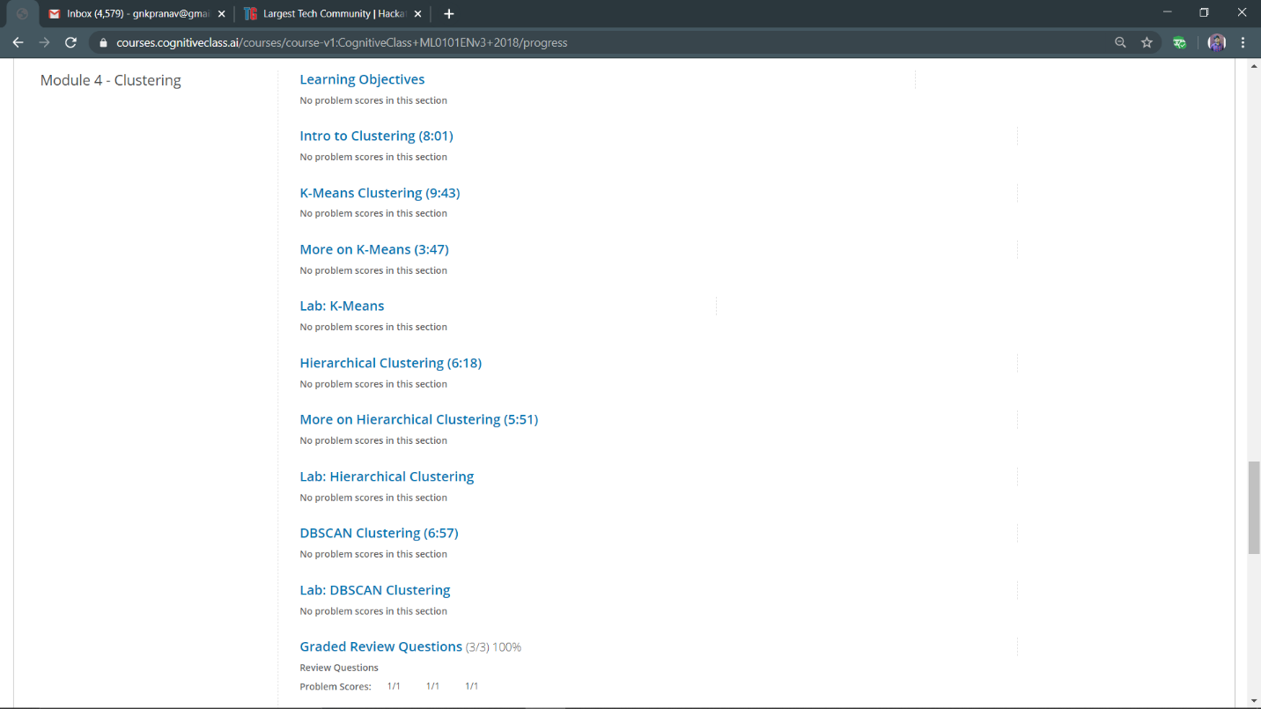

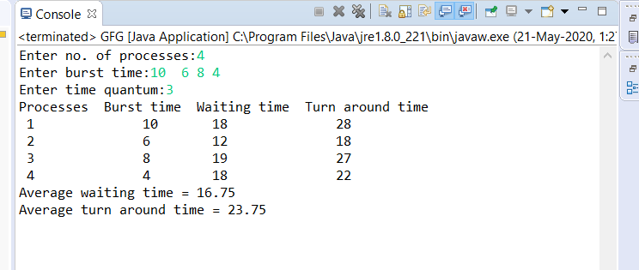

**Priyanka Killedar:**

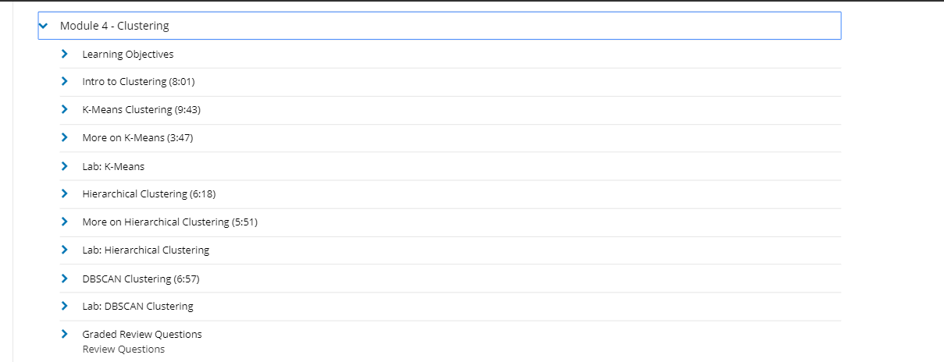

RAVALI:

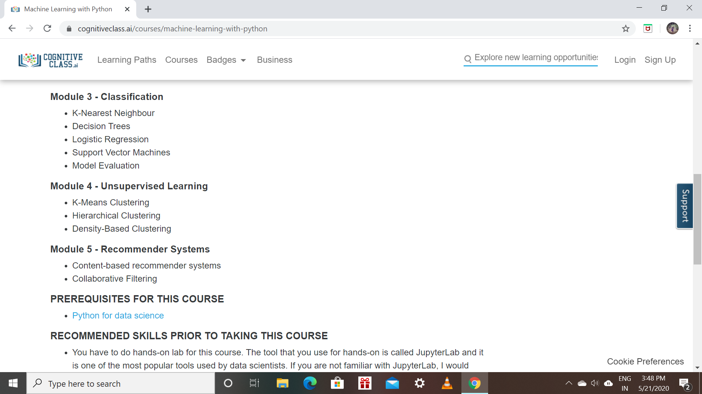

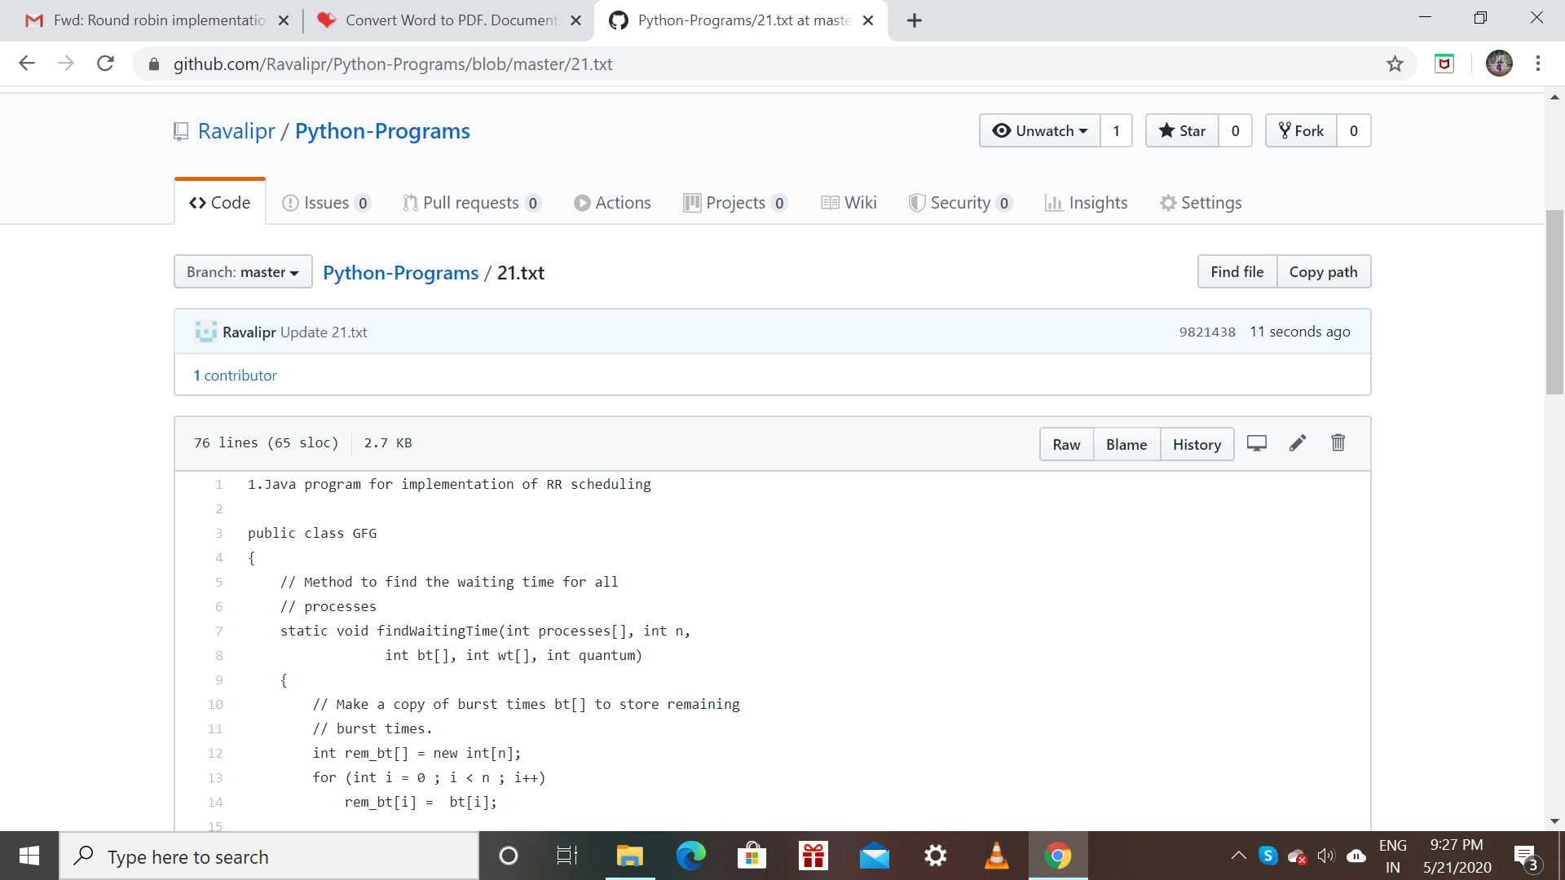

PRAVEEN KUMAR:

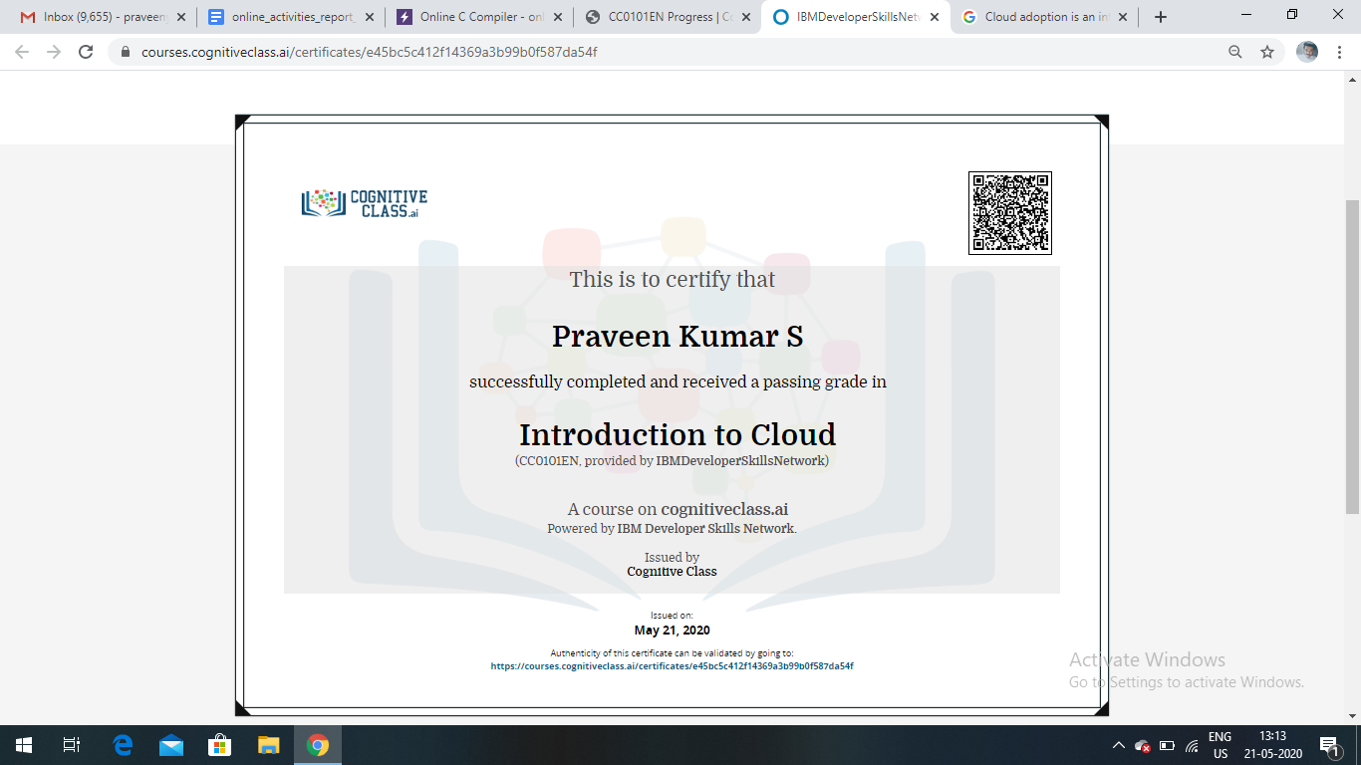

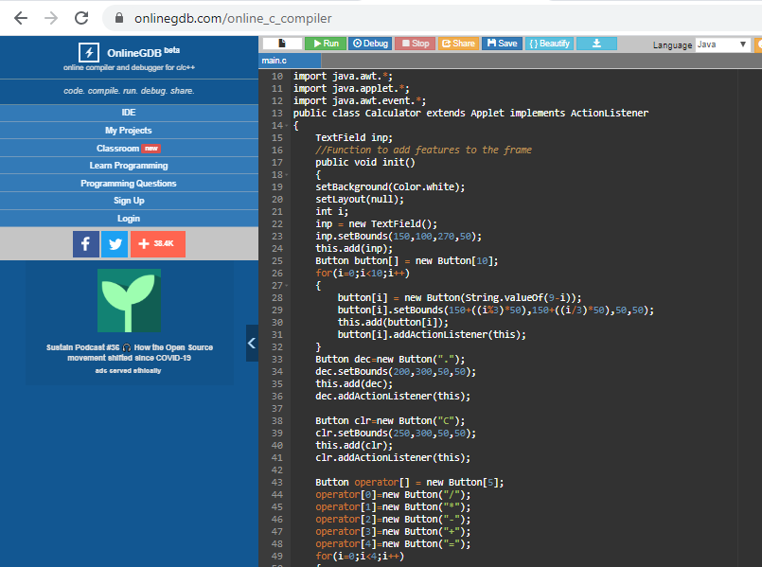

ROUSHA:

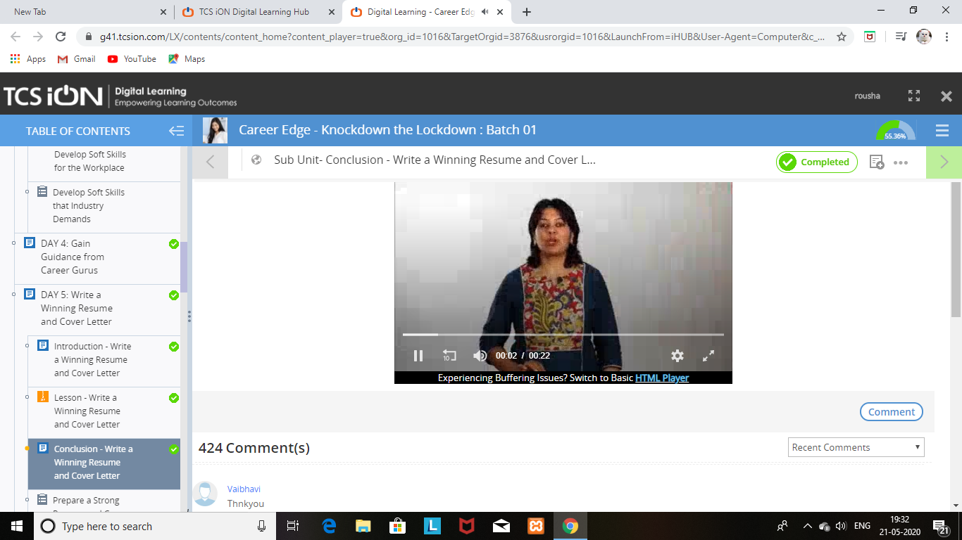

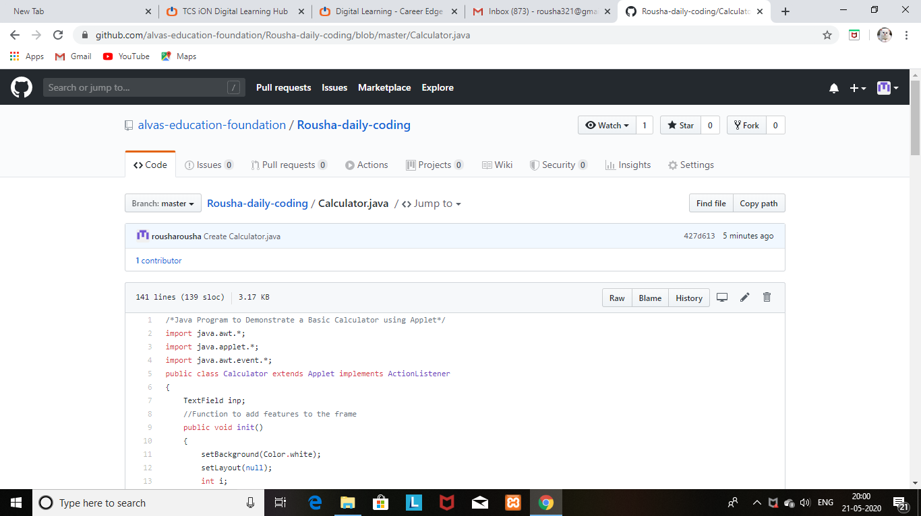

SHAIFA:

