**DAILY ONLINE ACTIVITIES SUMMARY**

|  |  |  |  |  |  |  |  |
| --- | --- | --- | --- | --- | --- | --- | --- |
| **Date:** | | **31/5/2020** | | | | | |
| **Name of the Faculty** | | **REENA LOBO** | | | | | |
| **No. of Students Allotted for monitoring** | | | | | **19** | | |
| **Progress** | | | | | **GOOD** | | |
| **Whether collected report from all the allotted students** | | | | | **17** | | |
| **Online Test Summary** | | | | | | | |
| **Subject** |  | | | | | | |
| **Semester** |  | | | **Duration** | |  | |
| **No. of students Taken** | | |  | **Passing %** | |  | |
| **Certification Course Summary** | | | | | | | |
| **Course** | | ..Completed one module of python for data science **Certification provider: cognitive class**  **Duration :5hrs** | | | | | |
| **Certificate Provider** | |  | | | **Duration** | |  |
| **Coding Challenges** | | | | | | | |
|  | | | | | | | |
| **Status:** | | | | | | | |
| **Uploaded the report in Github** | | | | | **yes** | | |
| **If yes Repository name** | | | | | <https://github.com/reenalobo/ONLINE-ACTIVITY-REPORT/upload/master> | | |
| **Uploaded the report in slack** | | | | | **yes** | | |

Certification Course Details: (Attach the snapshot and briefly write the report for the same)

**COMPLETED MODULE 4 OFPYTHON FOR DATA SCIENCE COURSE**

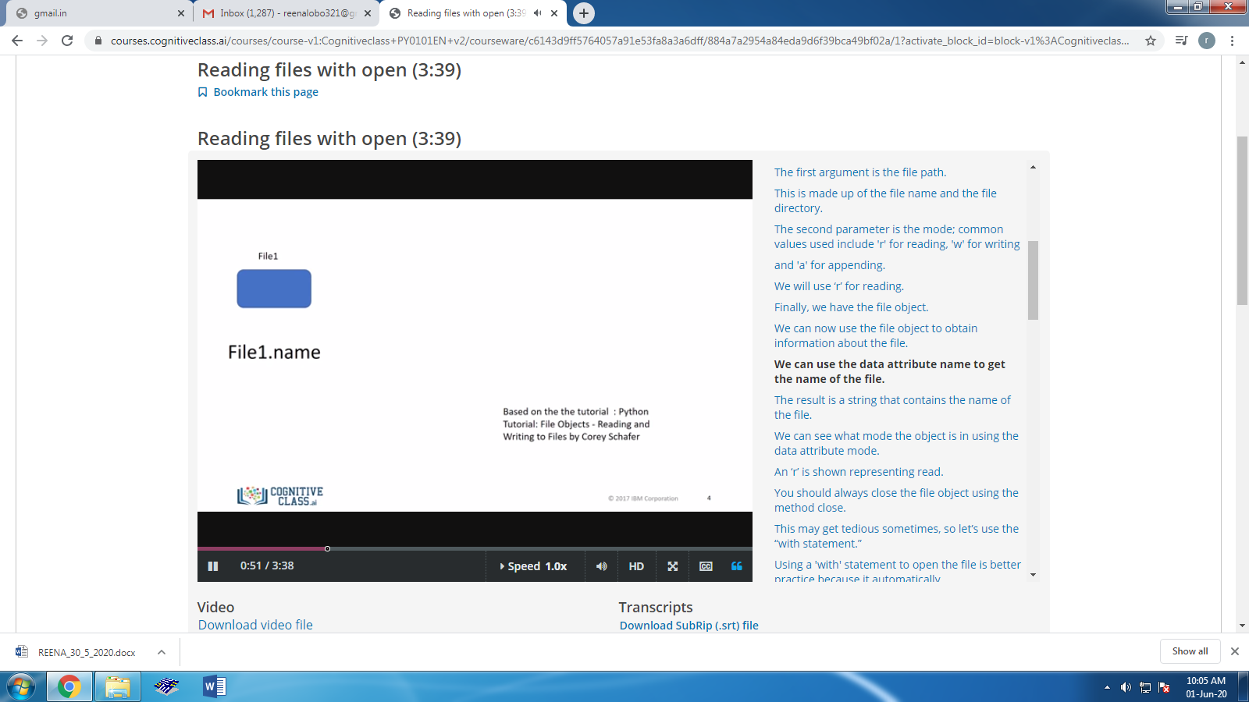

STUDENTS REPORT:

ROHAN MAHAVEER:

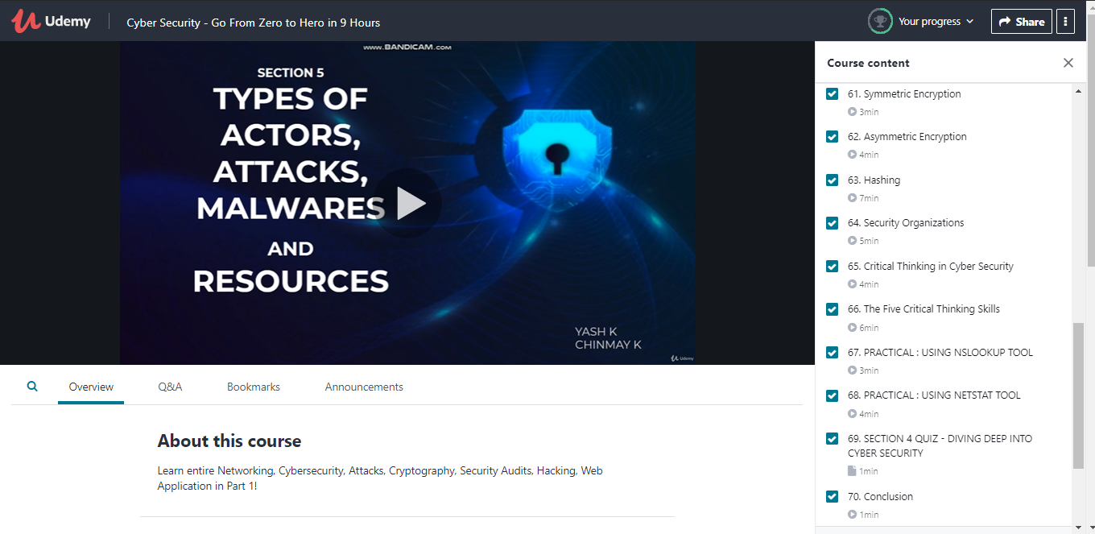

The above course is being taken up by me is based on cyber security. Today in online course I studied about the symmetric encryption and hashing. The details of the course and certificate provider are mentioned in the above form.

Coding Challenges Details:

Program1:

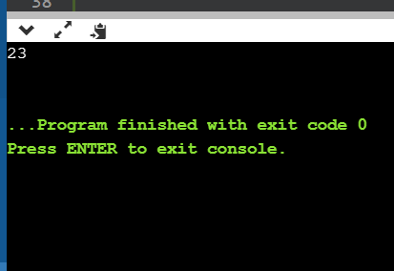

ATISH:

Certification Course Details:

Report

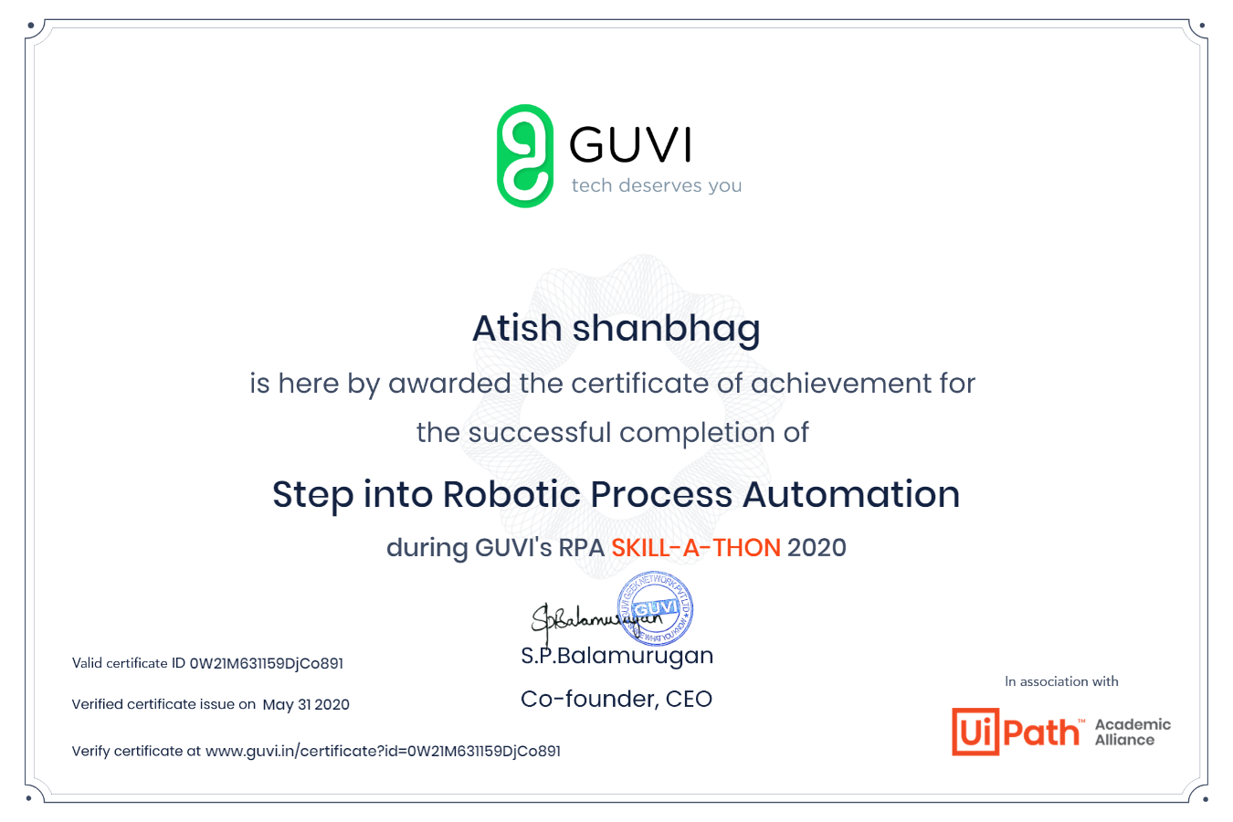

In today’s session for online certification successfully completed the course of Robotic Process Automation by Guvi’s RPA skill-a-thon as it had basic concepts related to RPA and had activities as mcq.

Coding Challenges Details:

The below GitHub link for details

<https://github.com/atish-shanbhag/Updates>

P-1

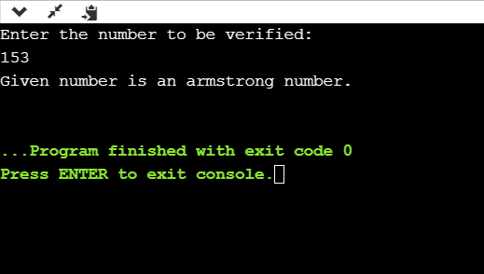

**Shah Dhruvil Amit:**

Report

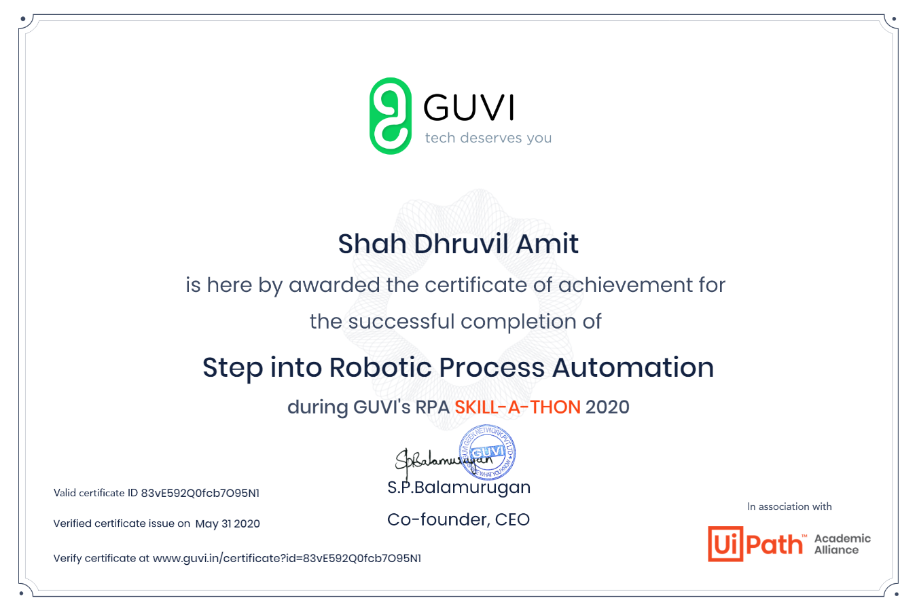

In today’s session for online certification successfully completed the course of Robotic Process Automation by Guvi’s RPA skill-a-thon which included youtube videos and also mcq as the activity to progress further.

Coding Challenges Details:

The below GitHub link for details

<https://github.com/DhruvilShah99/Daily-Updates>

P-1



**Java program to check whether given is Armstrong or not.**

**Raksha S:**

Certification Course Details:

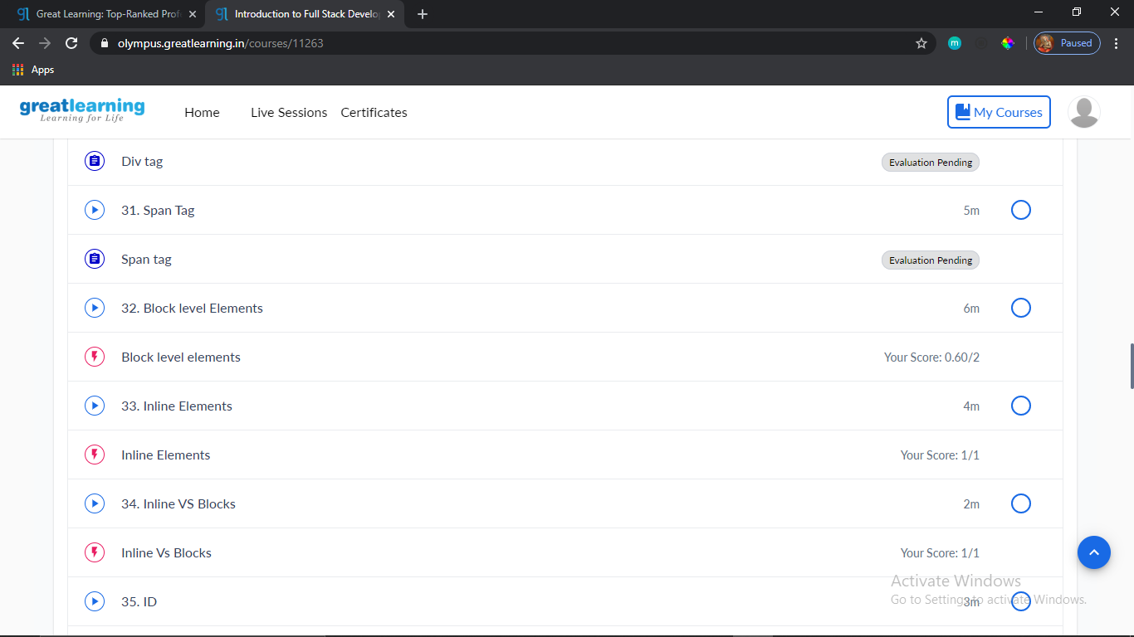

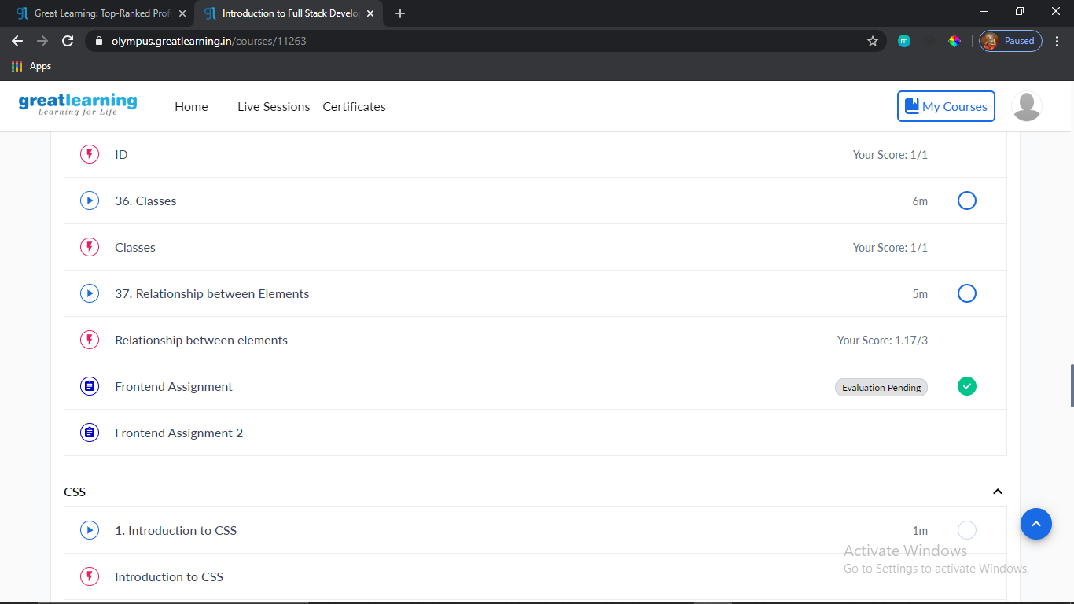

**Preethi:**

Certification Course Details: (Attach the snapshot and briefly write the report for the same)

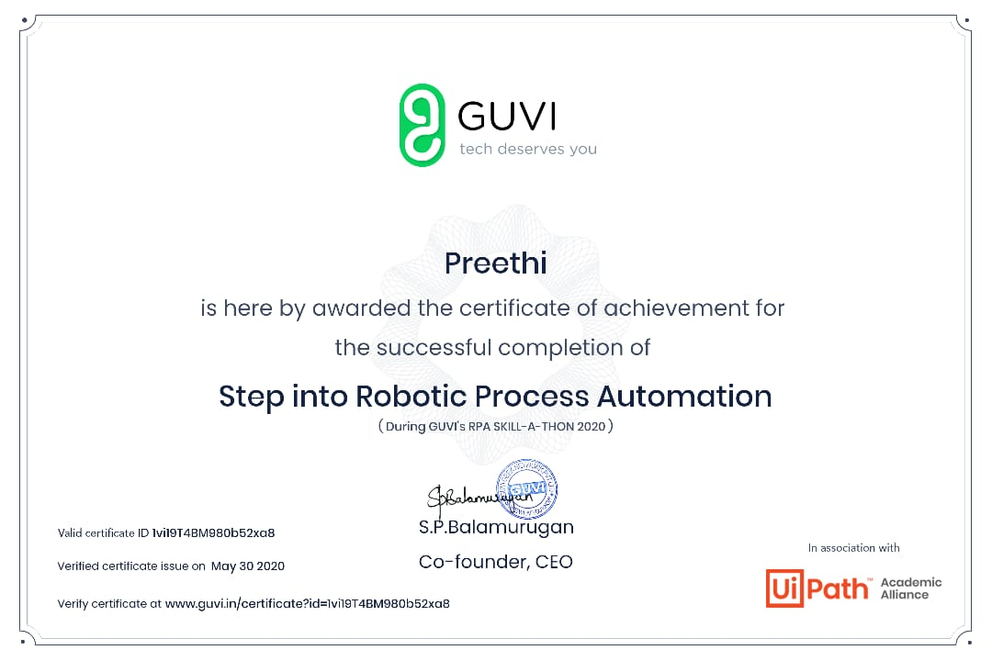

Today I completed the course of Robotic Process Automation by Guvi’s RPA skill-a-thon about basic concepts of RPA.

Coding Challenges Details: (Attach the snapshot and briefly write the report for the same)

Program 1

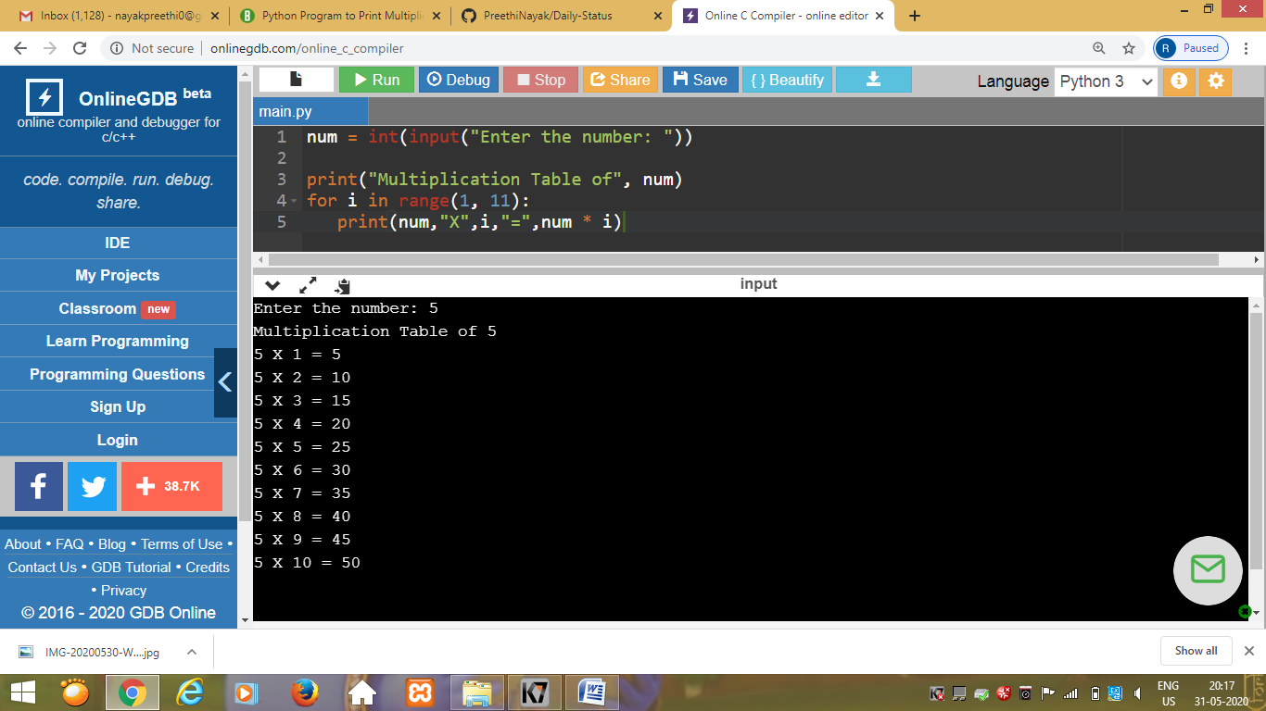

Rani:

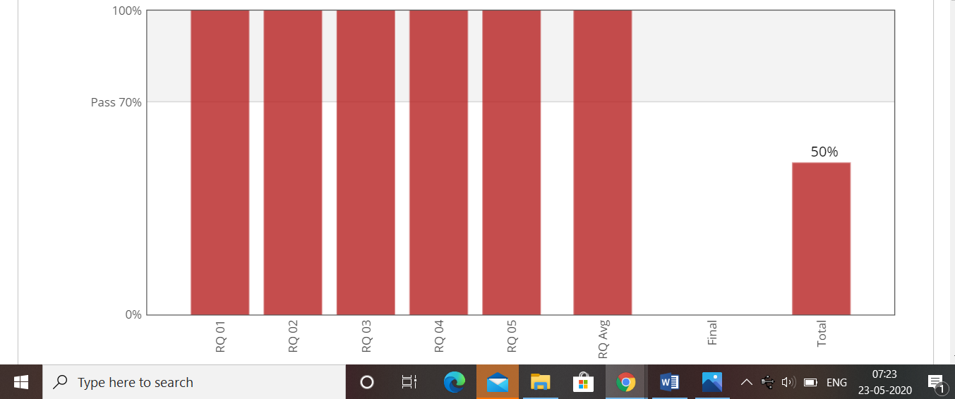

**Pranav L M:**

Certification Course Details

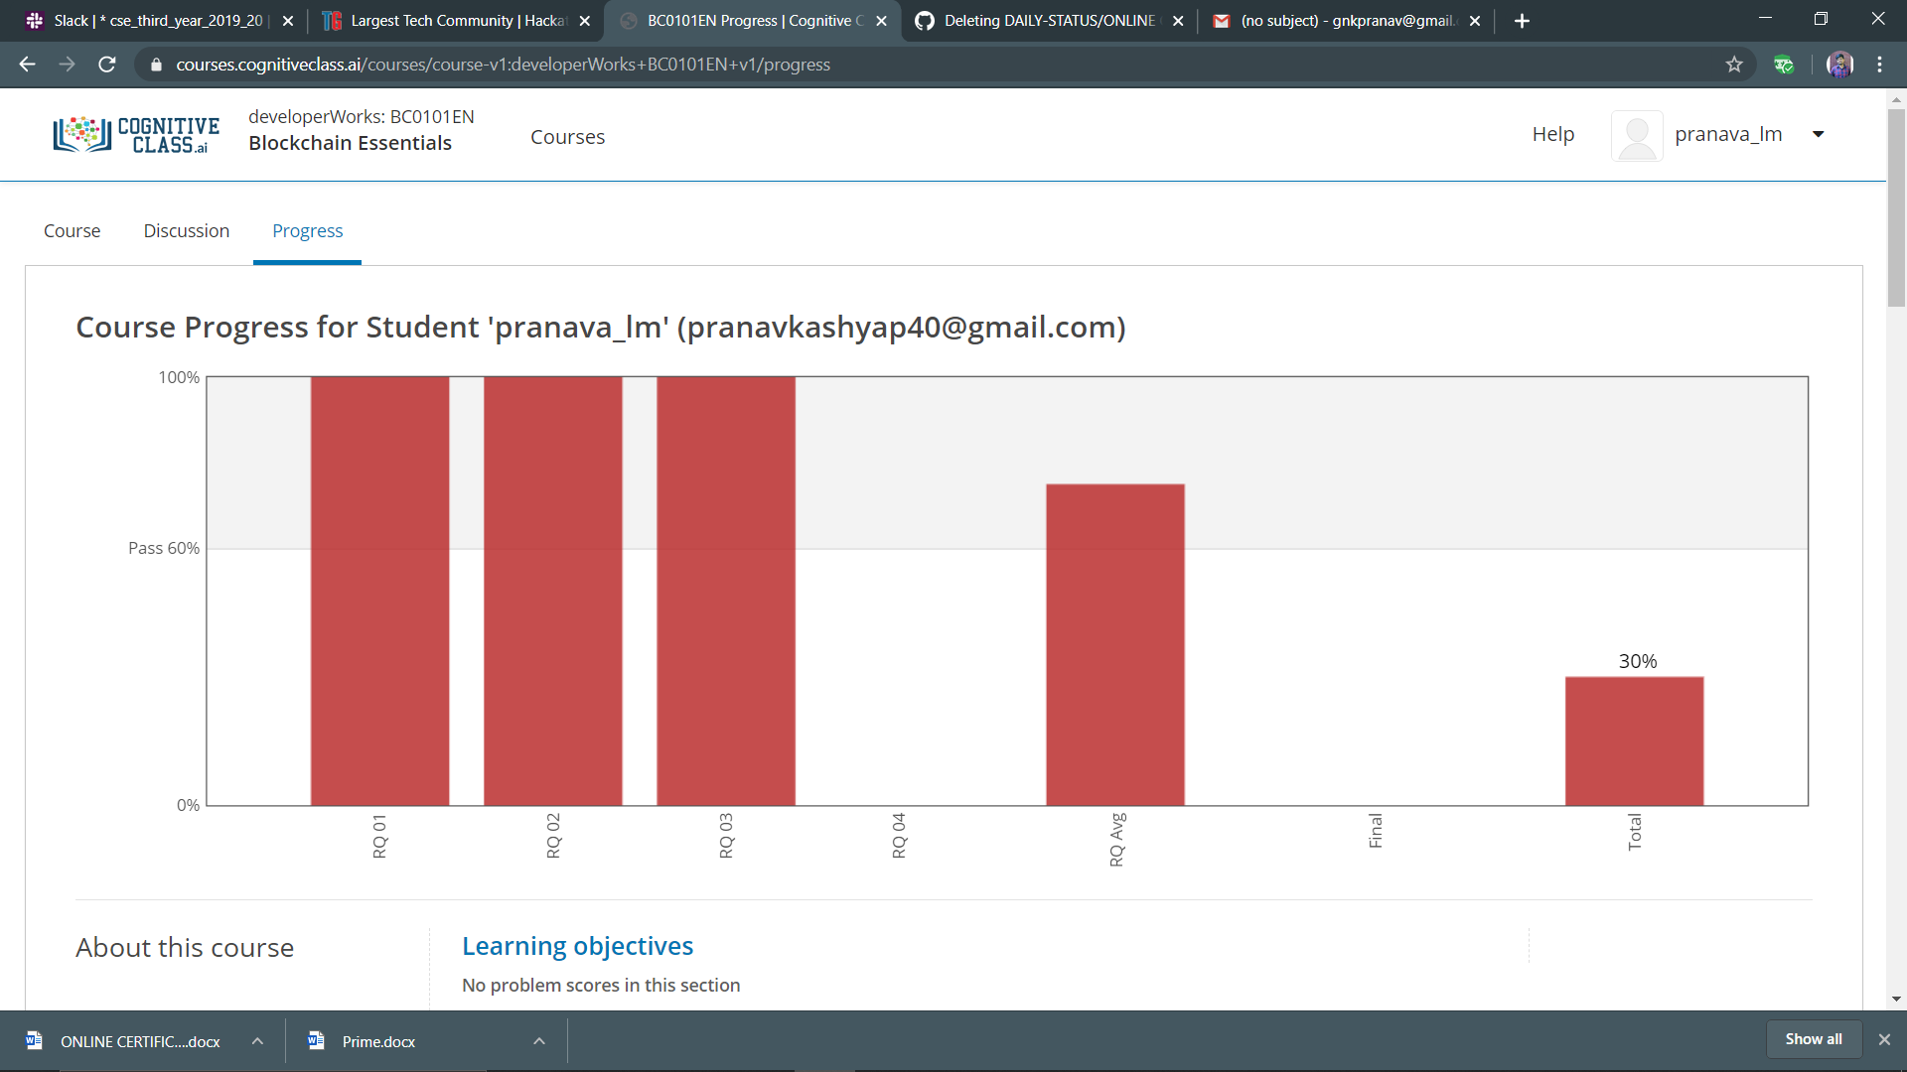

Program output

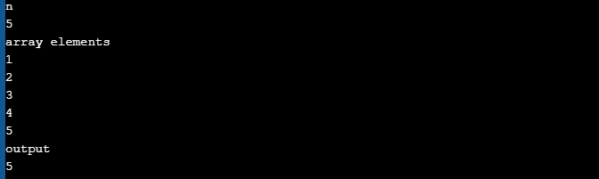

RAVALI:

report for the same)

* Today’s topic on certification course is about Robotic Process Automation (RPA).
* Its about 3Hrs course where they specified about the advantages of the robotics in the growing economy.
* In future generation how the robotics plays an important role etc…

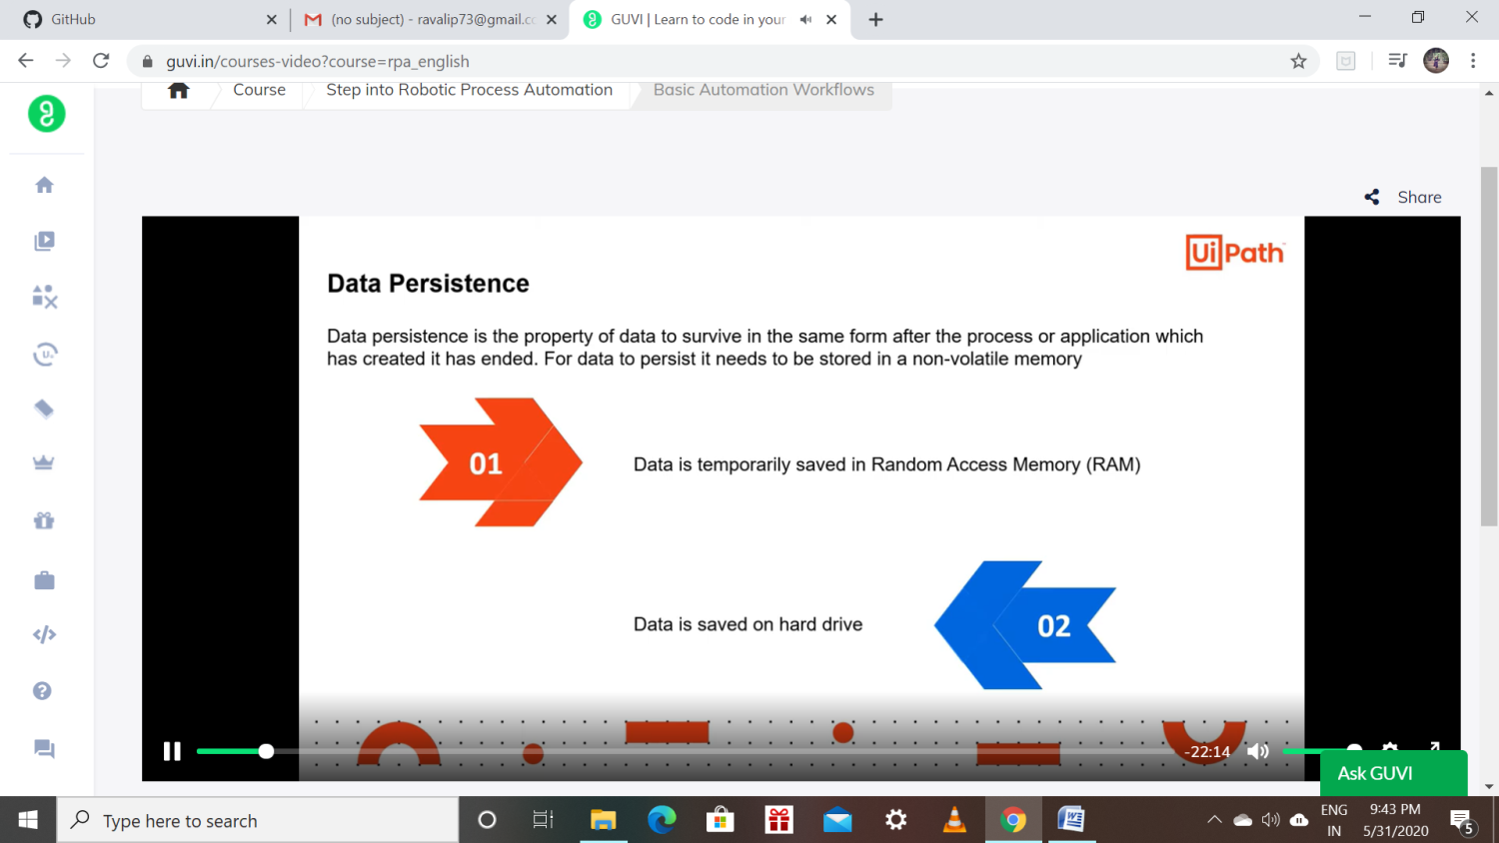

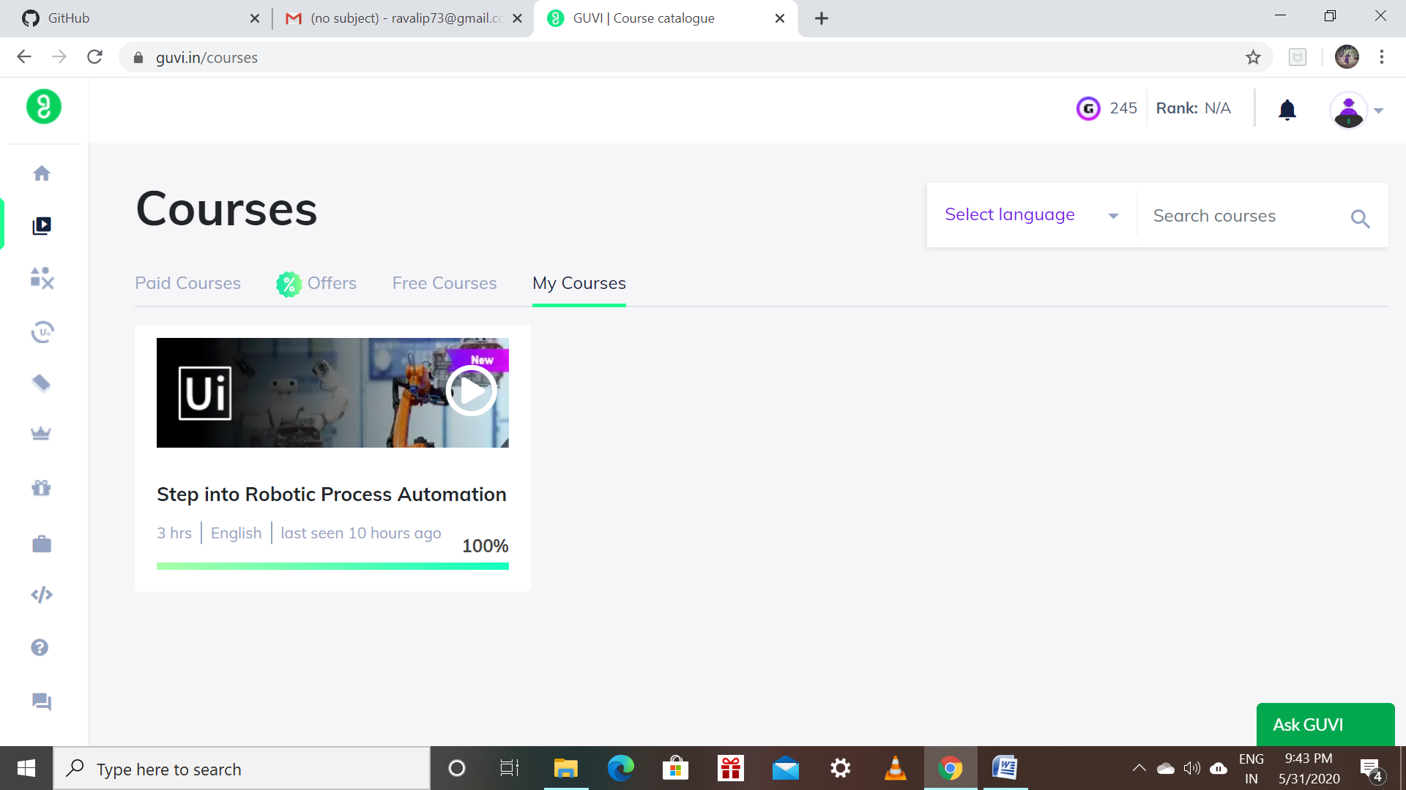

Priyanka:

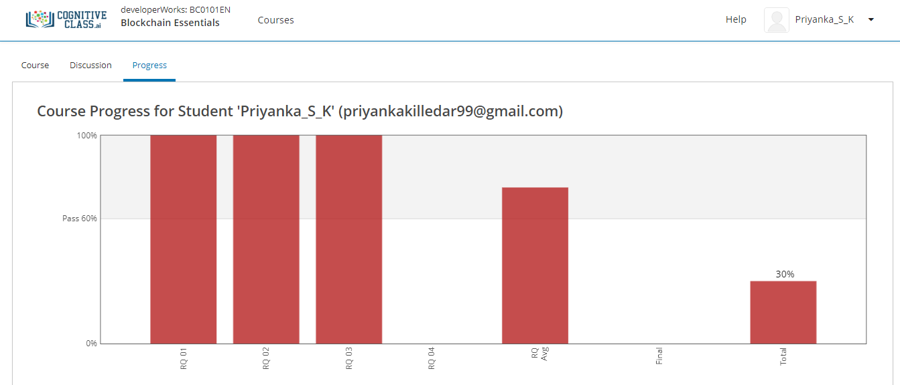

I solved the review question on module 3 and above screenshot is the progress of 3rd module .

**Coding Challenges Details:**

Refer the github link for detail information :<https://github.com/Priya-s-k/Online-coding-updates>

Solved all the problems and the solutions are uploaded in github account.

The same report is also available in github: <https://github.com/Priya-s-k/online-activity-updates>

Rousha:

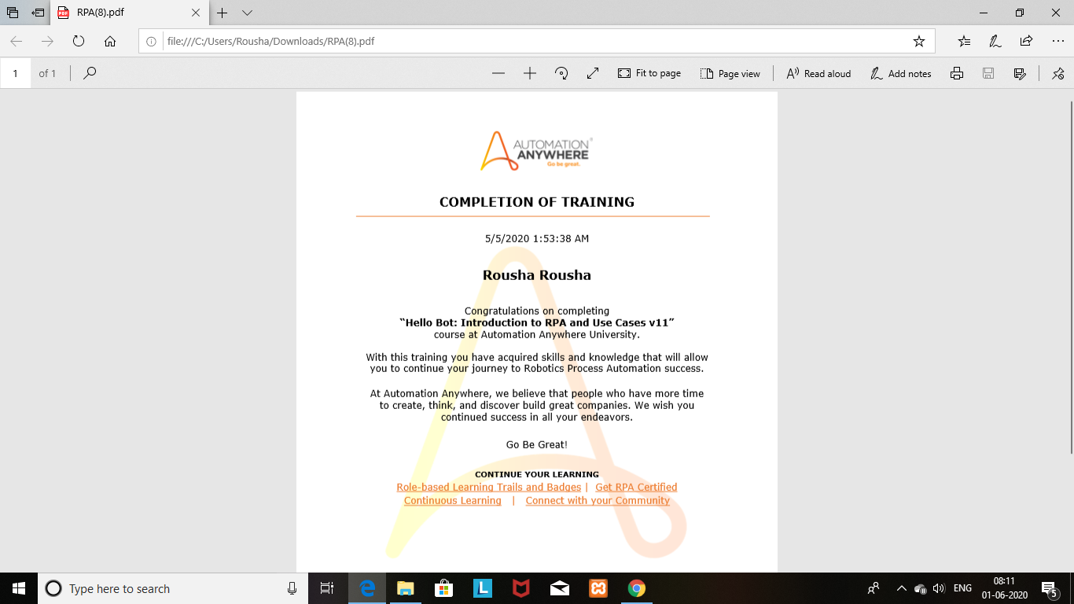

Rani:



Sana:

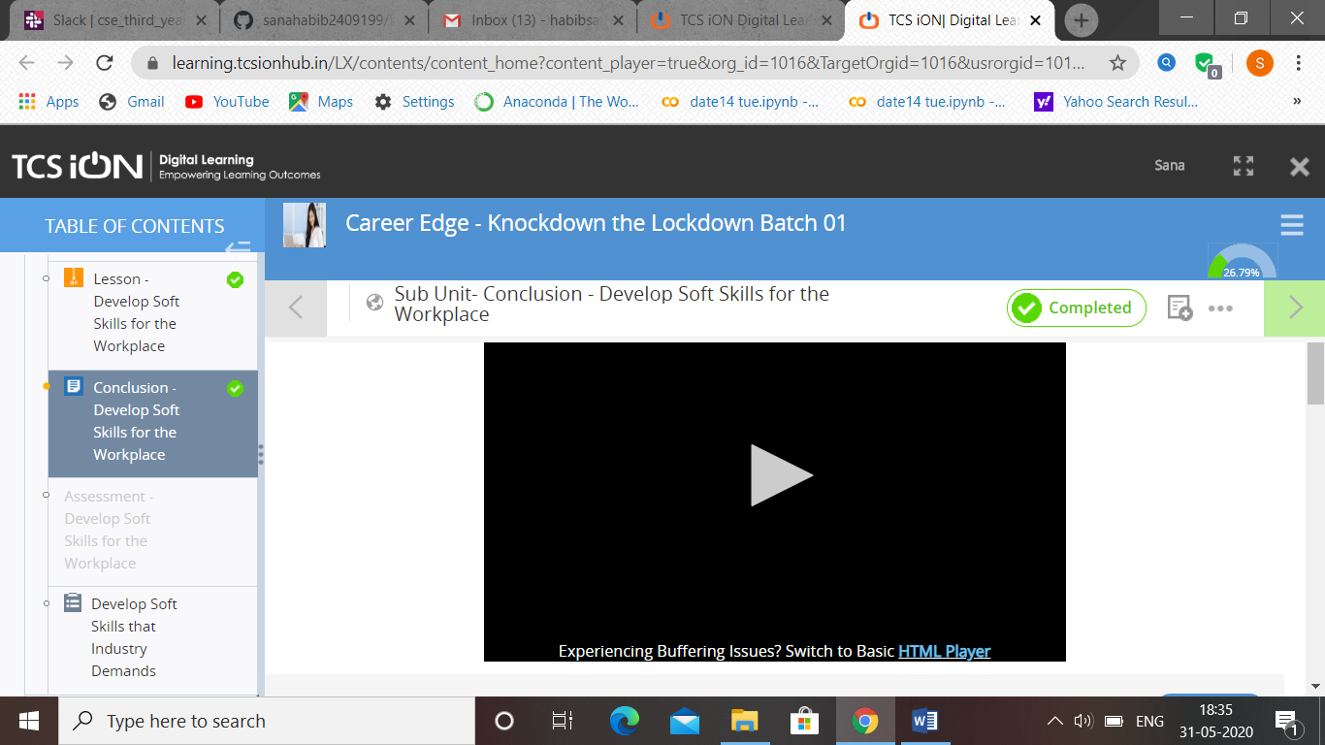

(31-05-2020)-TCS –Career Edge. Develop soft skills for the work place.