**DAILY ONLINE ACTIVITIES SUMMARY**

|  |  |  |  |  |  |  |  |
| --- | --- | --- | --- | --- | --- | --- | --- |
| **Date:** | | **6/6/2020** | | | | | |
| **Name of the Faculty** | | **REENA LOBO** | | | | | |
| **No. of Students Allotted for monitoring** | | | | | **19** | | |
| **Progress** | | | | | **GOOD** | | |
| **Whether collected report from all the allotted students** | | | | | **18,NOT SUBMITTED RAMITHA** | | |
| **Online Test Summary** | | | | | | | |
| **Subject** |  | | | | | | |
| **Semester** |  | | | **Duration** | |  | |
| **No. of students Taken** | | |  | **Passing %** | |  | |
| **Certification Course Summary** | | | | | | | |
| **Course** | | **1.Attended webinar on  cloud models**  **Certification provider: ICT Academy**  **Duration:1hr**  **2.attended webinar on BRAIN controlled robot design**  **Certification provider:pantech soluton** Duration:1hr | | | | | |
| **Certificate Provider** | |  | | | **Duration** | |  |
| **Coding Challenges** | | | | | | | |
| **Write a Java Program to find the second-highest number in an array.**  **Language used for solving: JAVA**  **Whether posted in Github: YES**  **Link:** <https://github.com/orgs/alvas-education-foundation/teams/2nd-year/discussions/105> | | | | | | | |
| **Status: COMPLETED** | | | | | | | |
| **Uploaded the report in Github** | | | | | **yes** | | |
| **If yes Repository name** | | | | | <https://github.com/reenalobo/ONLINE-ACTIVITY-REPORT/upload/master> | | |
| **Uploaded the report in slack** | | | | | **yes** | | |

Certification Course Details: (Attach the snapshot and briefly write the report for the same)

**Attended webinar on cloud models:**

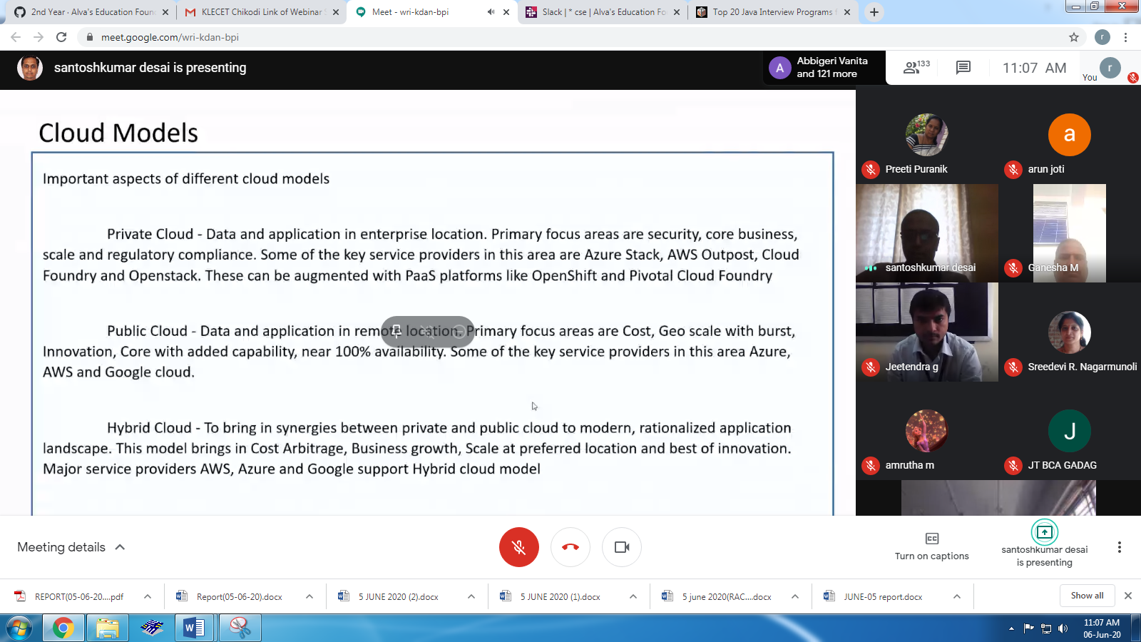

Coding challenge:

Write a Java Program to find the second-highest number in an array.

<https://github.com/orgs/alvas-education-foundation/teams/2nd-year/discussions/105>

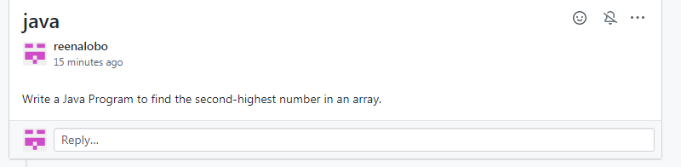

Webinar on brain controlled robot design

PANTECH SOLUTION

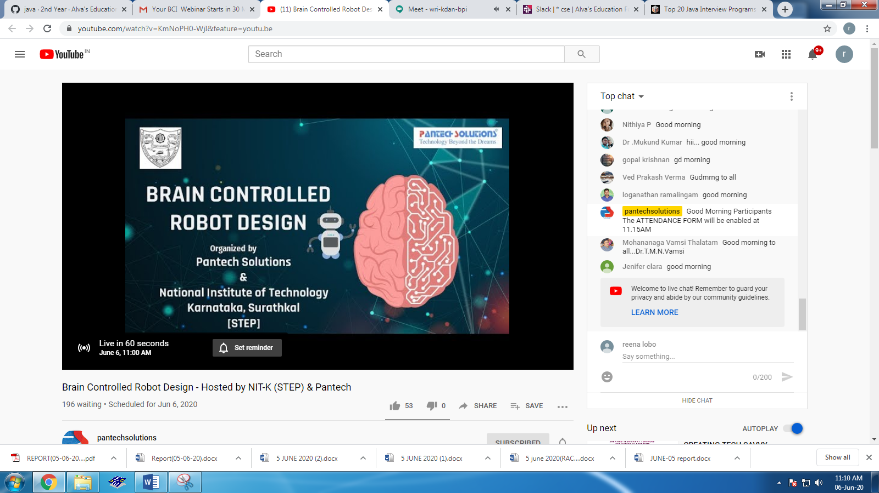

STUDENTS REPORT:

ROHAN MAHAVEER:

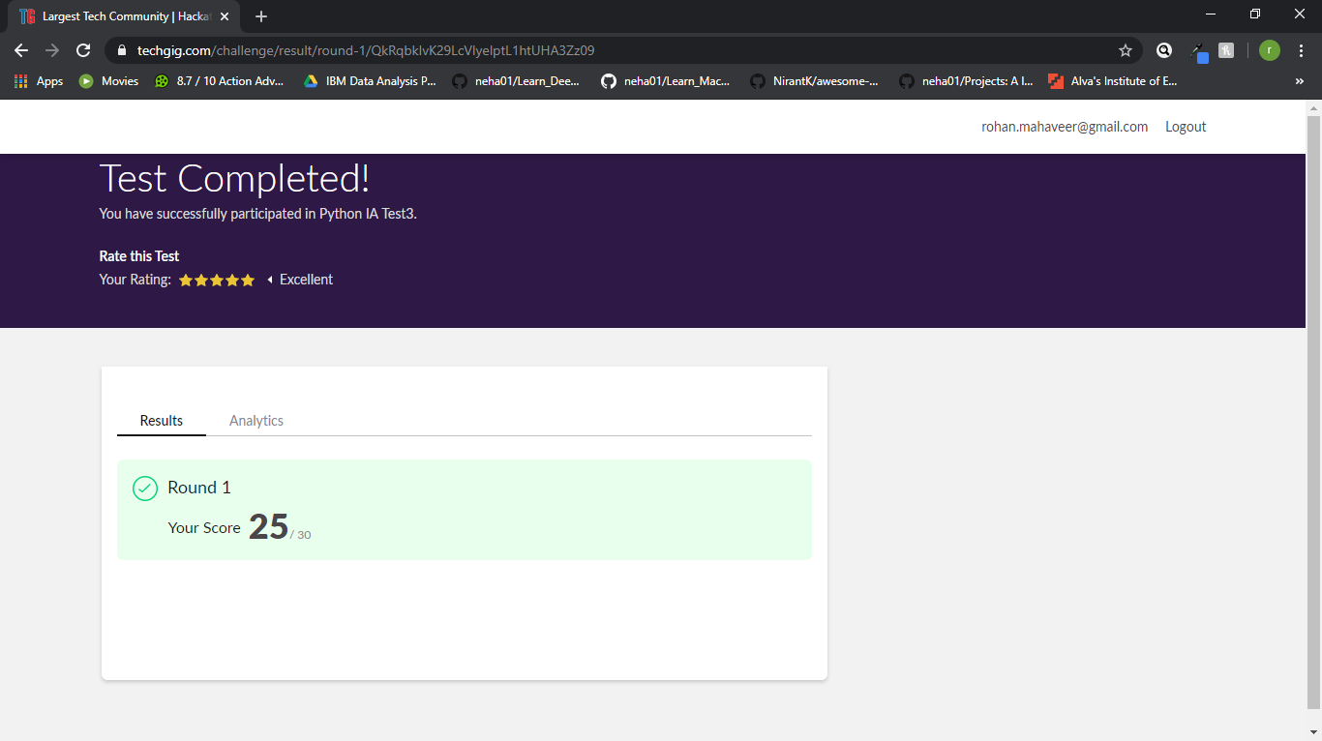

Scored 25 out of 30 in Python Test

Certification Course Details:

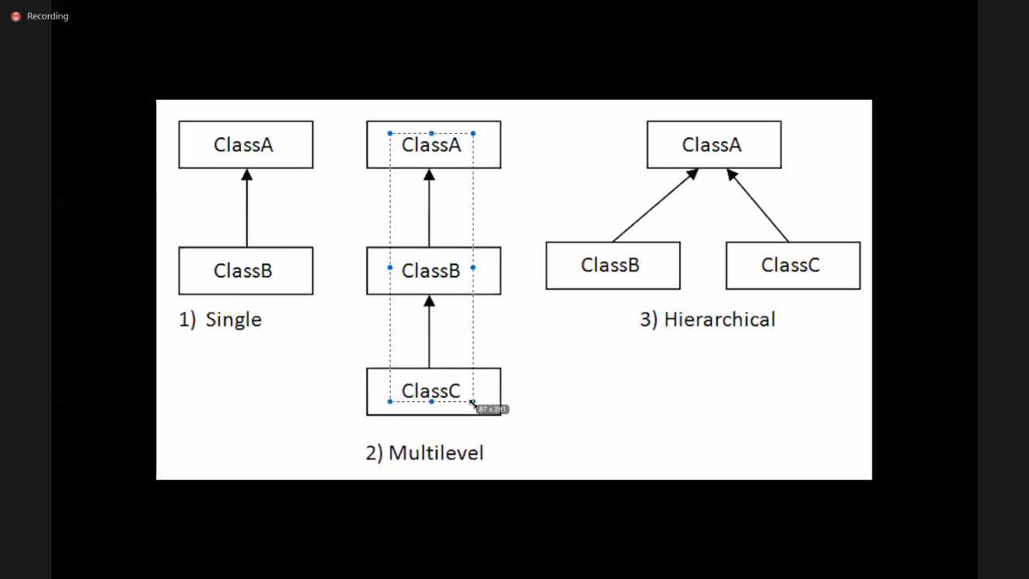

Today in certification I have attended online Java session in EBOX as mentioned above. I learnt about Inheritance, method overloading etc.

Coding Challenges Details:

Program1:

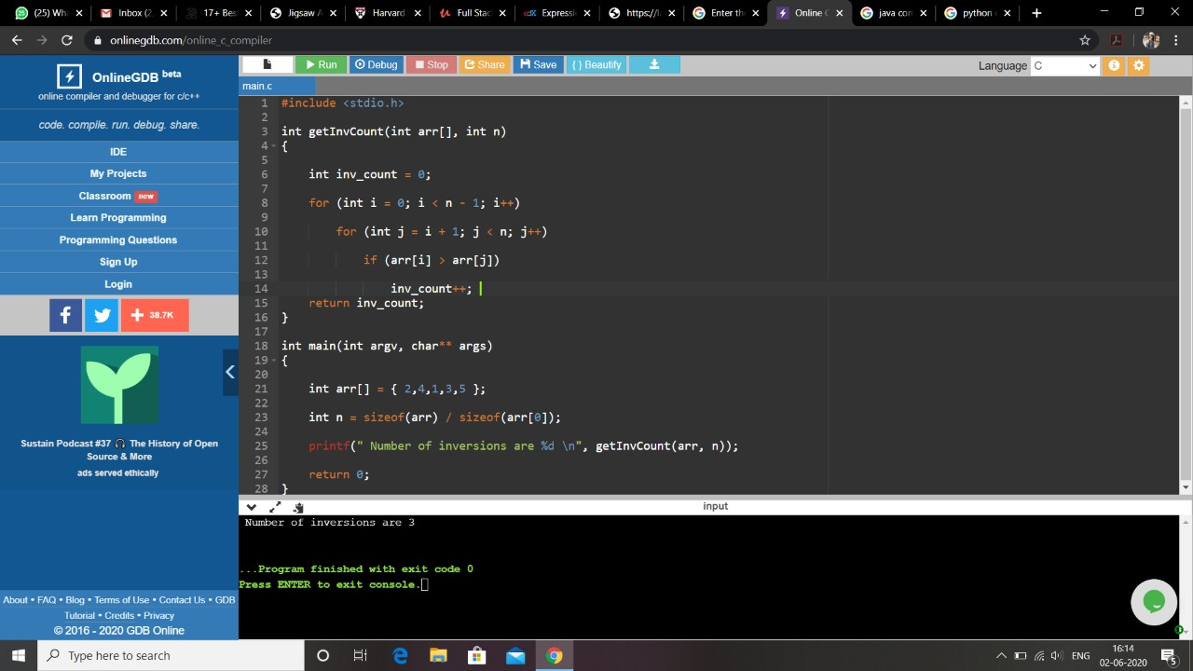

Program2:

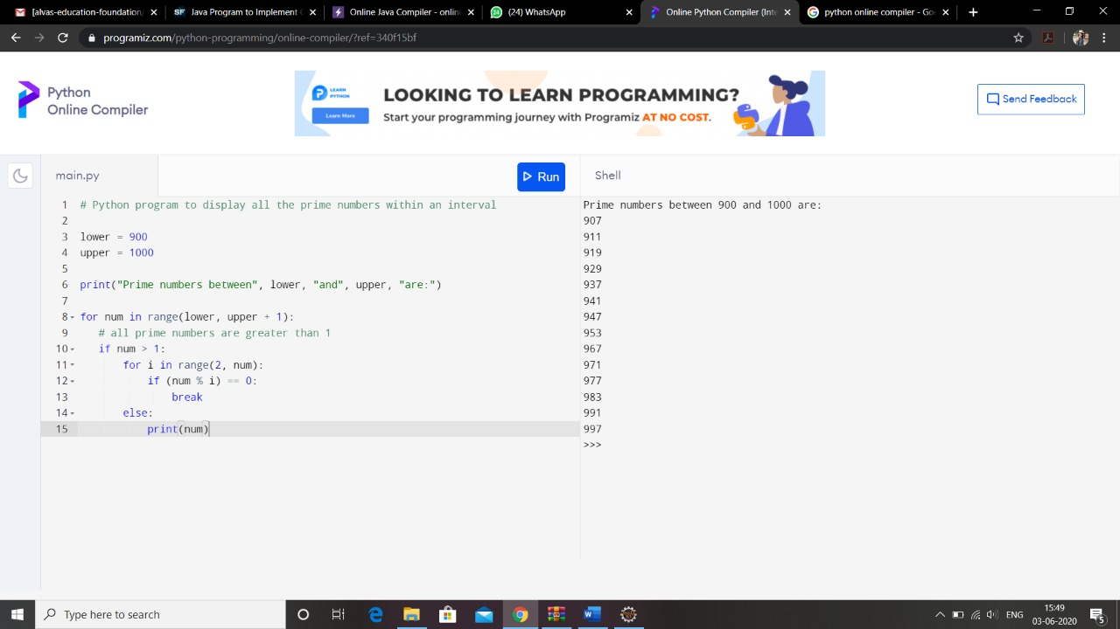

pranav lm:

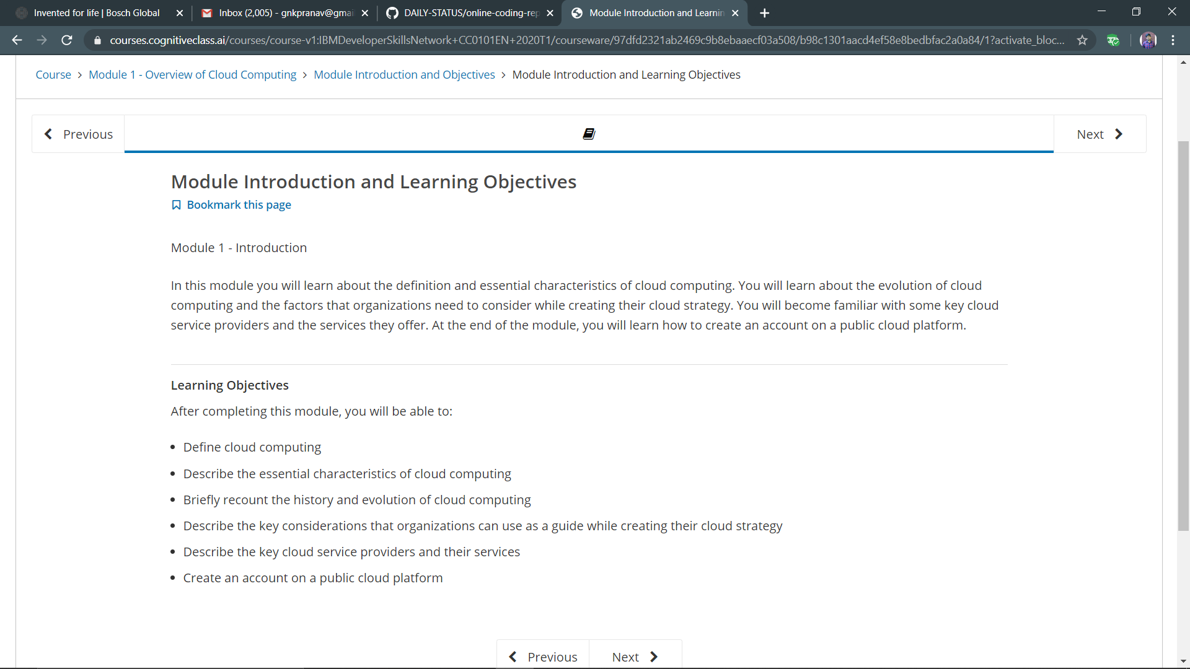

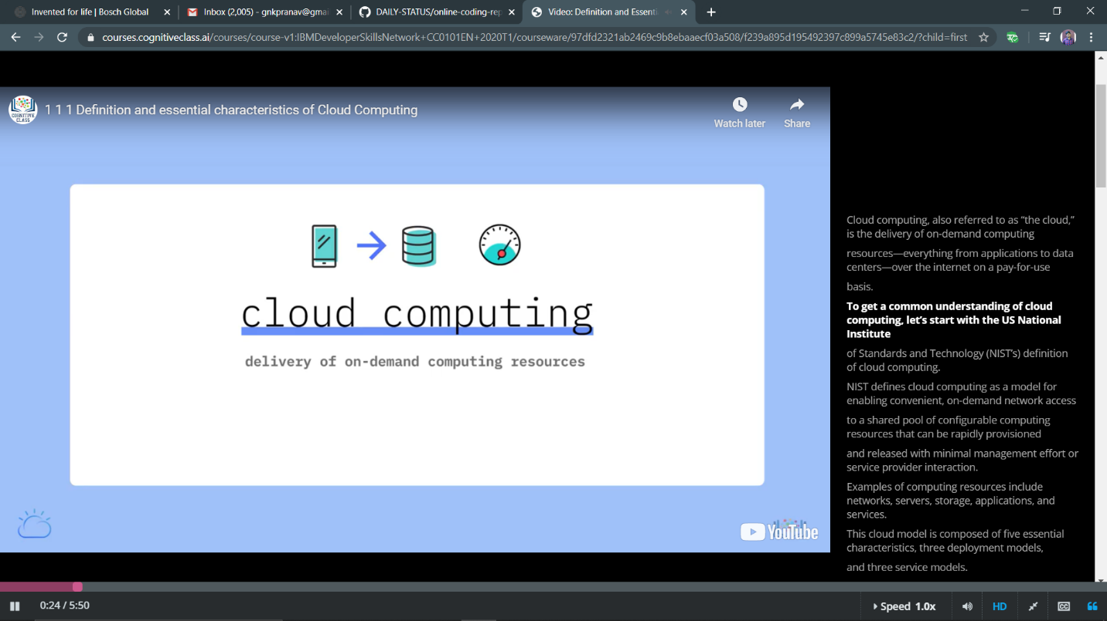

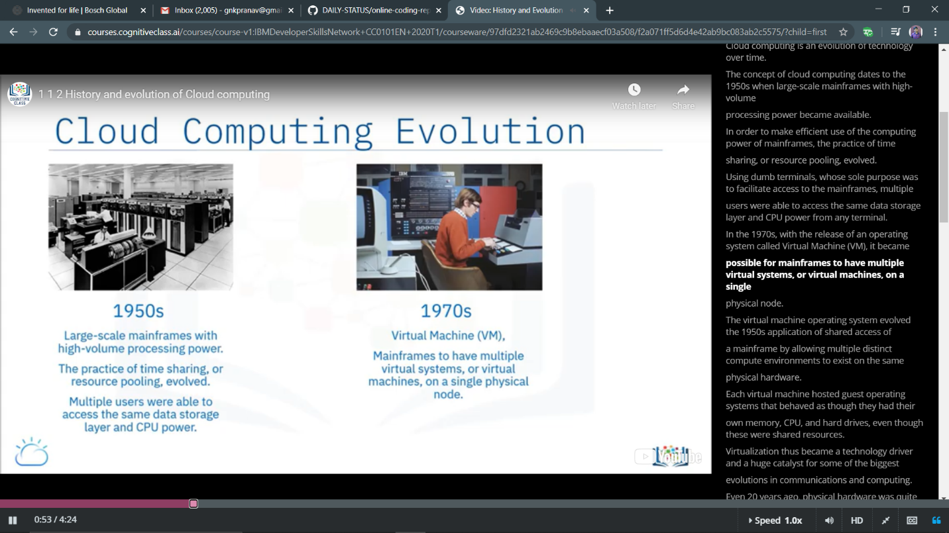

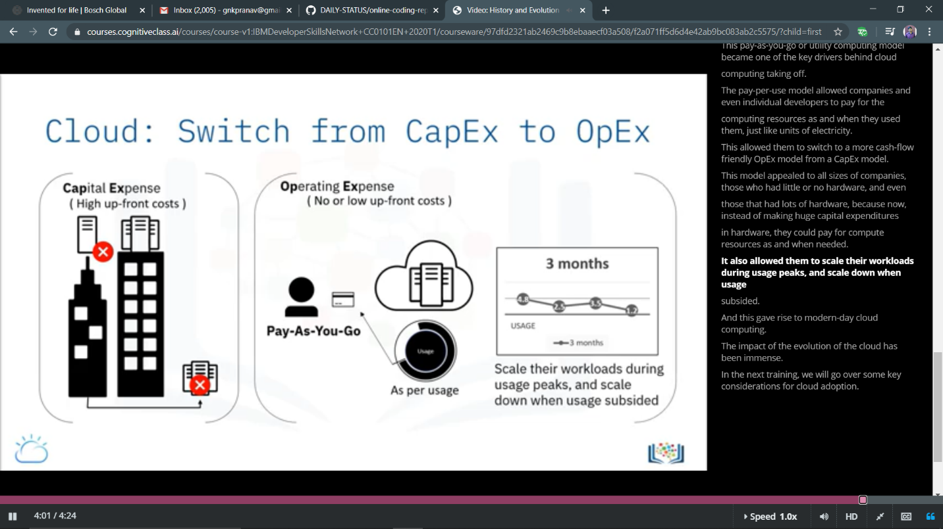

ONLINE TEST DETAILS

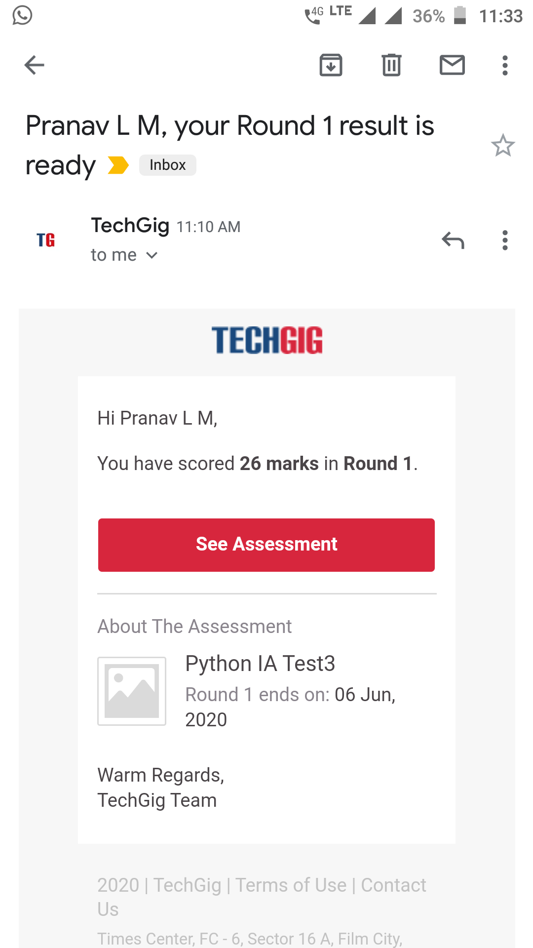

atish:;

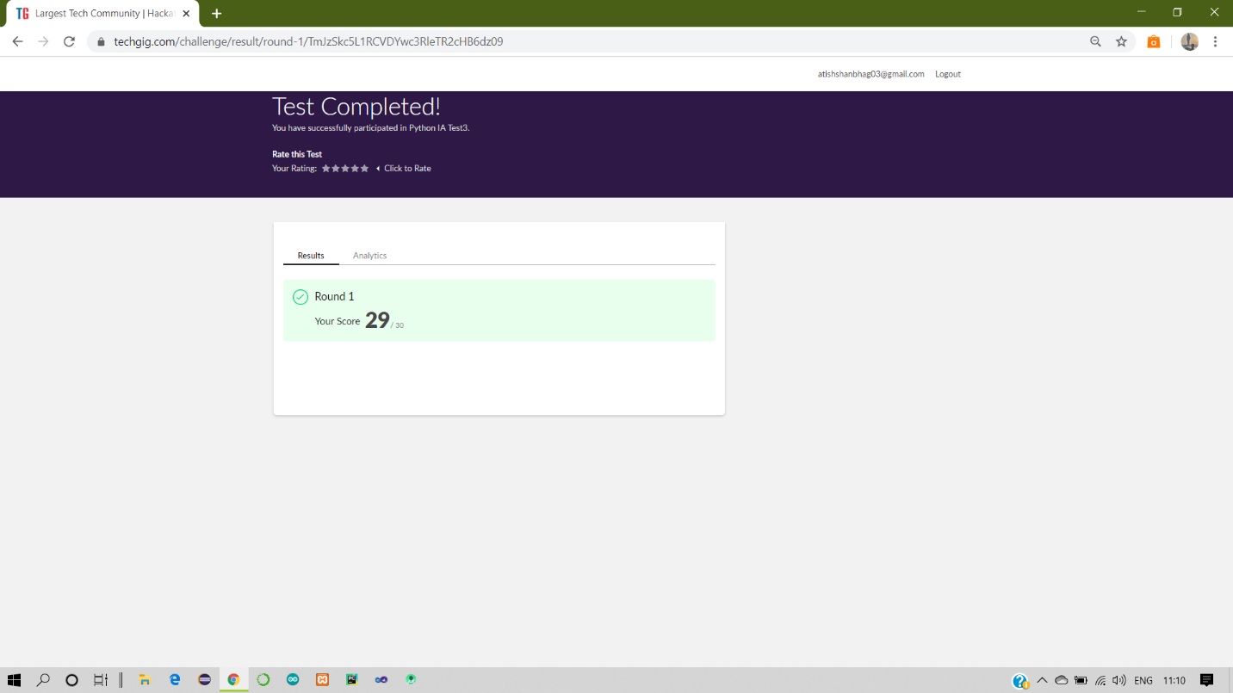

Certification Course Details:

Report

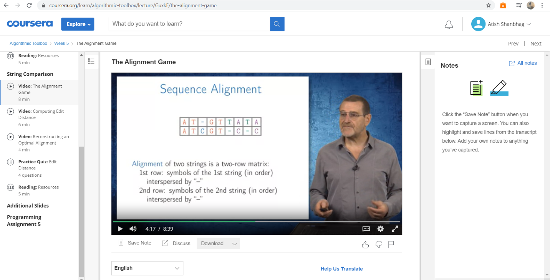

In today online certification session, I have studied topics related to string comparison in dynamic programming and implementation with various worked examples and assignments.

Coding Challenges Details:

The below GitHub link for details

<https://github.com/atish-shanbhag/Updates>

P-1

**Python program count string from list**

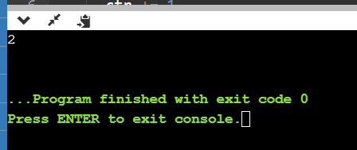

**P-2**

**Python program to implement CRC**

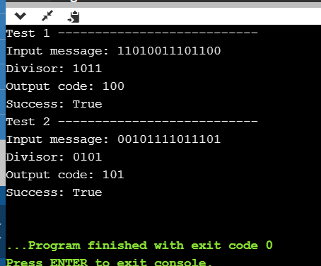

Priyanka:

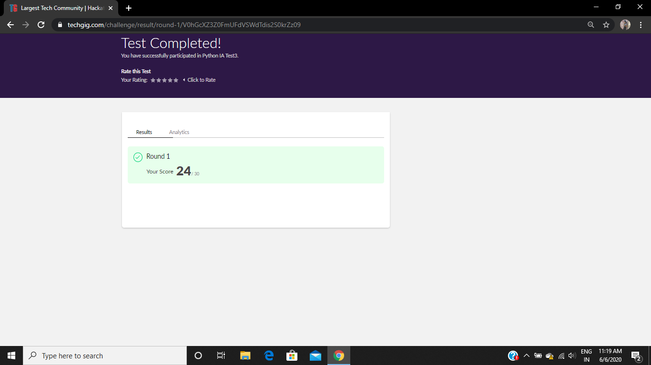

**Certification Course Details:**

**E-Box Classes:**

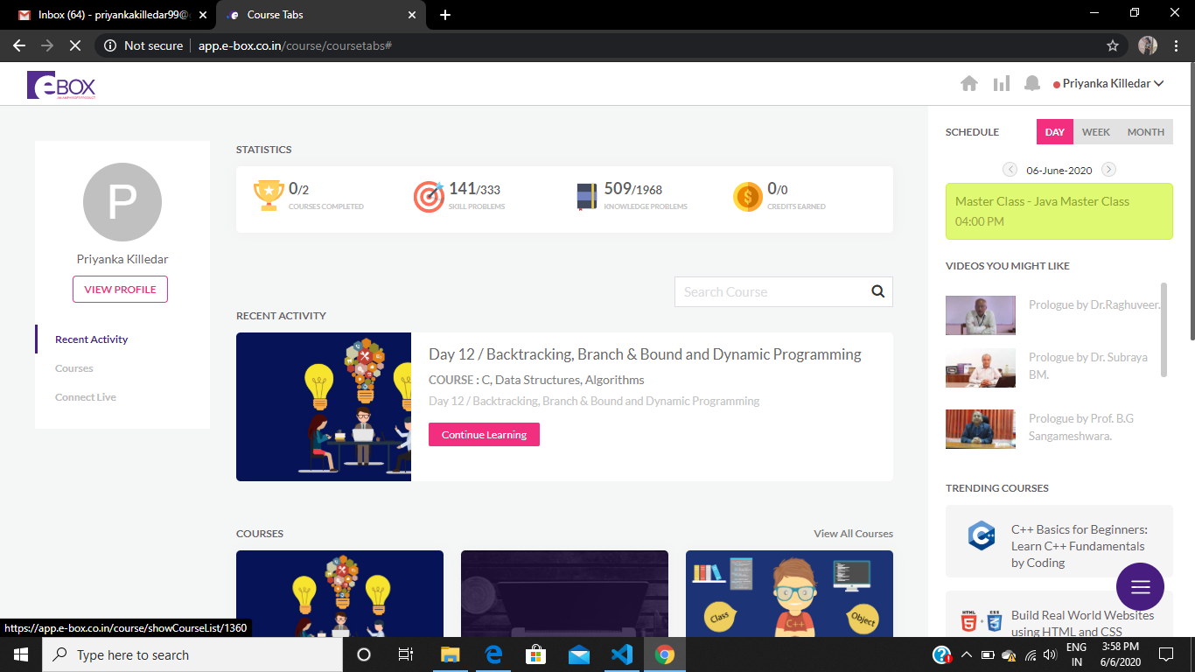

* **JAVA CLASS**

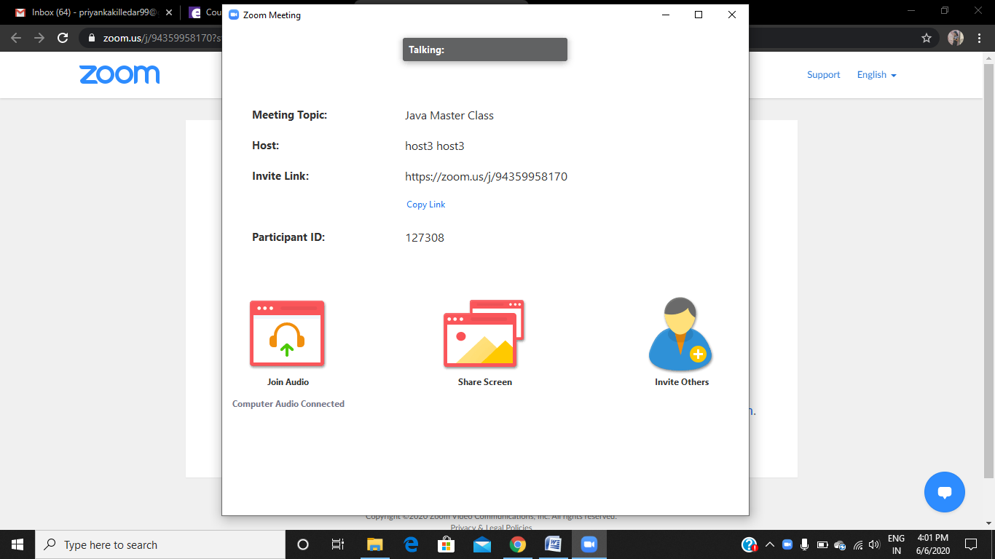

TOPIC: Inheritance

Method overloading

Method overriding

TIME: 4pm to 5.30pm

**Coding Challenges Details:**

Refer the github link for detail information :<https://github.com/Priya-s-k/Online-coding-updates>

Solved all the problems and the solutions are uploaded in github account.

The same report is also available in github: <https://github.com/Priya-s-k/online-activity-updates>