

**Name : Reena Qureshi**

**Reg No: 2023-BSE-052**

**Section: V-B**

**Cloud Computing: Assignment#01**

Task 1: Run Gitea in Codespace and Create an Initial Repo

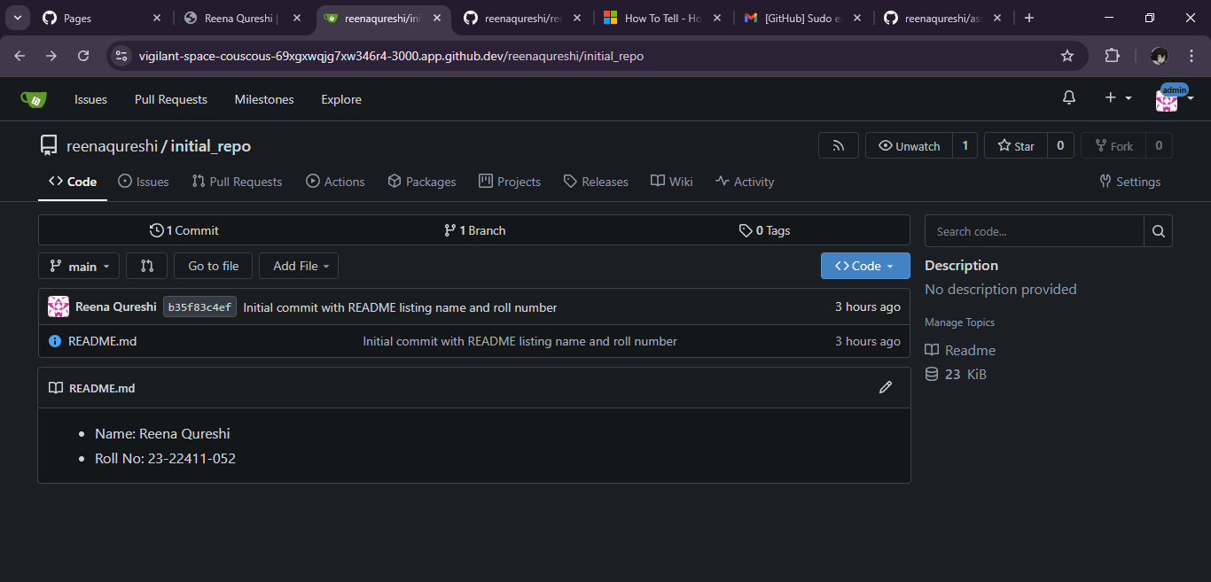

Task 2: Mirror README.md from Gitea to GitHub

Link: <https://github.com/reenaqureshi/assignment-1>

Task 3: Use Git LFS for Large Files

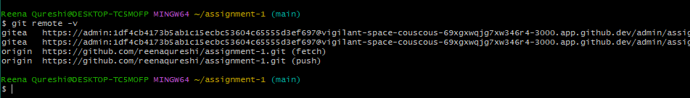

Task 4: Create a Portfolio/CV with GitHub Pages

Link: <https://reenaqureshi.github.io/>