Name : Reena Qureshi
Reg No : 2023-BSE-052
Section : V-B

Lab 11

Task 1 — Provider & Basic variable (variable precedence)
In Codespace create main.tf:
touch main.tf
Edit main.tf and add provider:
provider "aws" {
shared_config_files = ["~/.aws/config"]
shared_credentials_files = ["~/.aws/credentials"]
}
Initialize:
terraform init
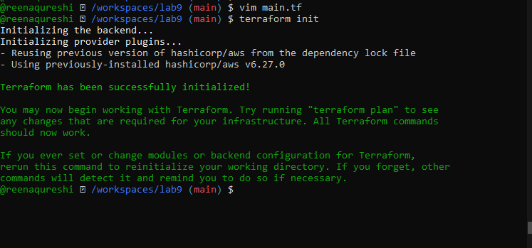
Define a variable and output:
variable "subnet_cidr_block" {
type = string
}

output "subnet_cidr_block_output" {
value = var.subnet_cidr_block
}
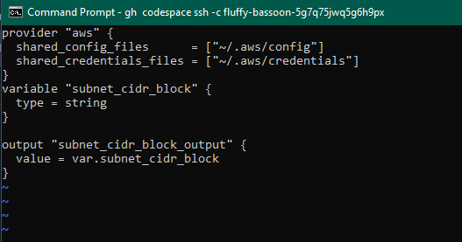
Run:
terraform apply -auto-approve

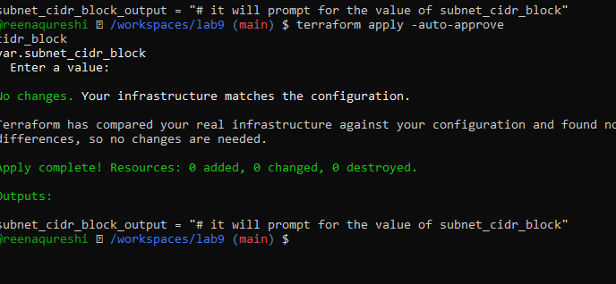
Export environment variable in Codespace shell:
export TF_VAR_subnet_cidr_block=10.0.20.0/24
terraform apply -auto-approve
# output should show environment value
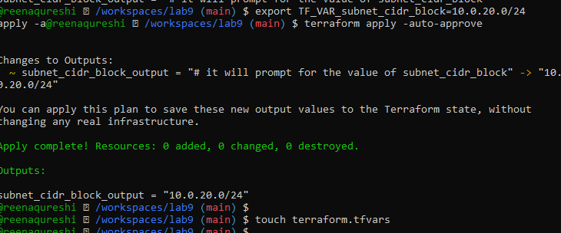
Create terraform.tfvars overriding values:
touch terraform.tfvars
# inside terraform.tfvars:
subnet_cidr_block = "10.0.30.0/24"
terraform apply -auto-approve
# terraform.tfvars has priority over default and env

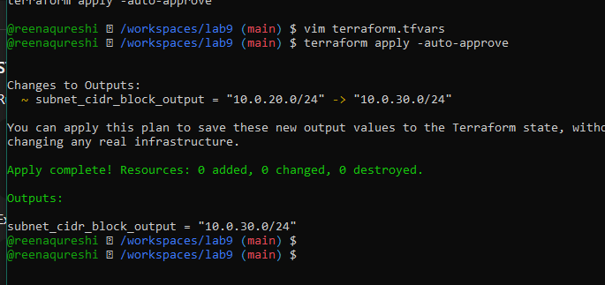
Override with -var:
terraform apply -auto-approve -var "subnet_cidr_block=10.0.40.0/24"

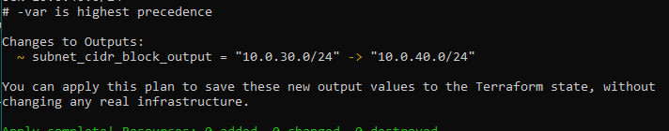
Show and unset env var:
printenv | grep TF_VAR_
unset TF_VAR_subnet_cidr_block
printenv | grep TF_VAR_
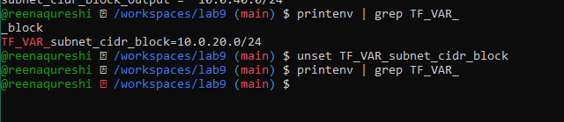

Task 2 — Variable validation & sensitive / ephemeral variables
Replace subnet_cidr_block variable with this (validation included):
variable "subnet_cidr_block" {
type = string
default = ""
description = "CIDR block to assign to the application subnet"
sensitive = false
nullable = false
ephemeral = false

validation {
condition = can(regex("^([0-9]{1,3}\\.){3}[0-9]{1,3}/[0-9]+$", var.subnet_cidr_block))
error_message = "The subnet_cidr_block must be a valid CIDR notation string, such as 10.0.0.0/24."
}
}
Test validation failure:

terraform apply -auto-approve -var "subnet_cidr_block=10.0.0"
# should show validation error
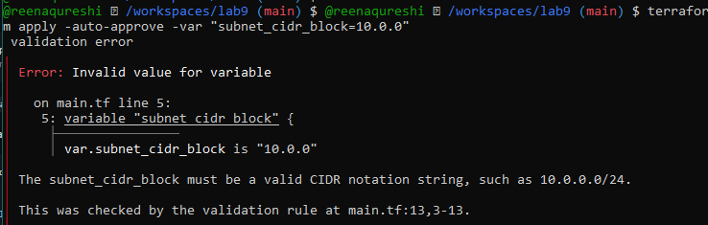
Create a sensitive variable api_session_token and output (sensitive):
variable "api_session_token" {
type = string
default = ""
description = "Short-lived API session token used during apply operations"
sensitive = true
nullable = false
ephemeral = false

validation {
condition = can(regex("^[A-Za-z0-9-_]{20,}$", var.api_session_token))
error_message = "The API session token must be at least 20 characters and contain only letters, numbers, hyphens, or underscores."
}
}

output "api_session_token_output" {
value = var.api_session_token
sensitive = true
}

Run with -var to observe sensitive output behavior:
terraform apply -auto-approve -var "api_session_token=my_API_session_Token"
# output will be marked sensitive; check terraform.tfstate for outputs
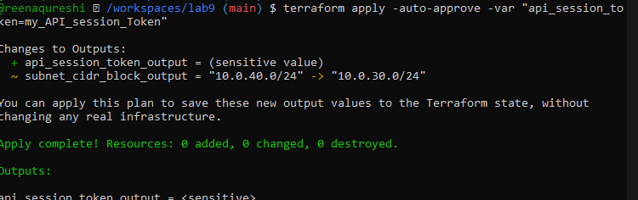v
Check terraform.state for the sensitive output:
You should find an outputs section similar to:
"api_session_token_output": {
"value": "my_API_session_Token",
"type": "string",
"sensitive": true
}

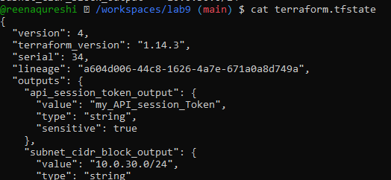

Make variable ephemeral to hide from state:
variable "api_session_token" {
...
ephemeral = true
...
}

Run again:
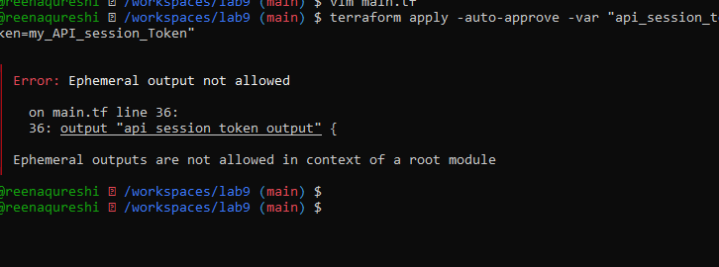
Set default to test local default:
variable "api_session_token" {
default = "my_API_session_Token"
sensitive = true
ephemeral = false
...
}
terraform apply -auto-approve
# works and stored in state (but output remains sensitive)

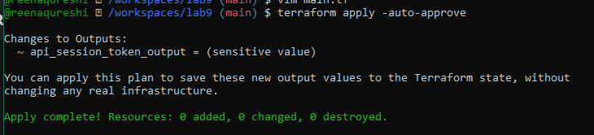
Task 3 — Project-level variables, locals, and outputs
Add variables to main.tf:
variable "environment" {}
variable "project_name" {}
variable "primary_subnet_id" {}
variable "subnet_count" {}
variable "monitoring" {}
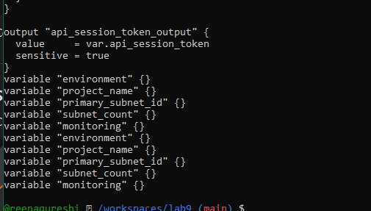
Populate terraform.tfvars after discovering actual subnet id for availability zone me-central-1a:
aws ec2 describe-subnets \
--filters "Name=availability-zone,Values=me-central-1a" \
--query "Subnets[].SubnetId" \
--output text
Set values in terraform.tfvars:
environment = "dev"
project_name = "lab_work"
primary_subnet_id = "<subnet-id-of-me-central-1a>"
subnet_count = 3
monitoring = true

Create locals.tf with:
locals {
resource_name = "${var.project_name}-${var.environment}"
primary_public_subnet = var.primary_subnet_id
subnet_count = var.subnet_count
is_production = var.environment == "prod"
monitoring_enabled = var.monitoring || local.is_production
}
Add outputs to main.tf:
output "resource_name" {
value = local.resource_name
}
output "primary_public_subnet" {
value = local.primary_public_subnet
}
output "subnet_count" {
value = local.subnet_count
}
output "is_production" {
value = local.is_production
}
output "monitoring_enabled" {
value = local.monitoring_enabled
}
Run:
terraform apply -auto-approve
# will show all the output values
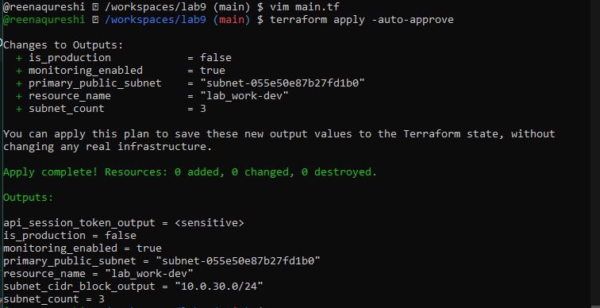

Task 4 — Maps and Objects
Map variable in main.tf:
variable "tags" {
type = map(string)
}

output "tags" {
value = var.tags
}
In terraform.tfvars:
tags = {
Environment = "dev"
Project = "sample-app"
Owner = "platform-team"
}
Run:
terraform apply -auto-approve
# check tags output
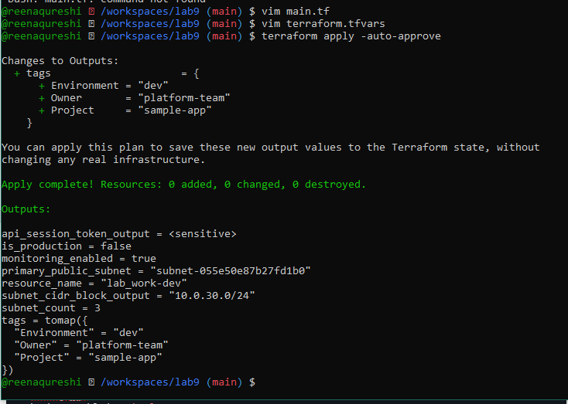
Define object variable:
variable "server_config" {
type = object({
name = string
instance_type = string
monitoring = bool
storage_gb = number
backup_enabled = bool
})
}

output "server_config" {
value = var.server_config
}
In terraform.tfvars:
server_config = {
name = "web-server"
instance_type = "t3.micro"
monitoring = true
storage_gb = 20
backup_enabled = false
}
Run:
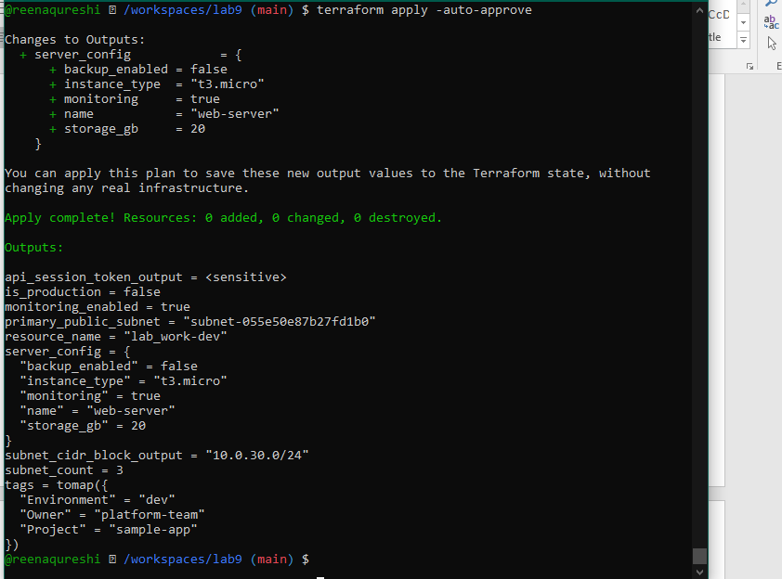

Task 5 — Collections: list, tuple, set & mutation via locals
In this task you will define collection variables (list, tuple, set), observe their behavior, then perform mutations via locals and compare results.
Feature | List | Tuple | Set
Order preserved | ✅ | ✅ | ❌
Allows duplicates | ✅ | ✅ | ❌
Mixed types | ❌ | ✅ | ❌
Fixed size | ❌ | ✅ | ❌
Mutable | ✅ | ❌ | ✅
Best for | Flexible sequences | Structured records | Unique collections
In main.tf define:
variable "server_names" {
type = list(string)
default = ["web-2", "web-1", "web-2"]
}

variable "server_metadata" {
type = tuple([string, number, bool])
default = ["web-1", 4, true]
}

variable "availability_zones" {
type = set(string)
default = ["me-central-1b", "me-central-1a", "me-central-1b"]
}

output "compare_collections" {
value = {
list_example = var.server_names
tuple_example = var.server_metadata
set_example = var.availability_zones
}
}
Run:

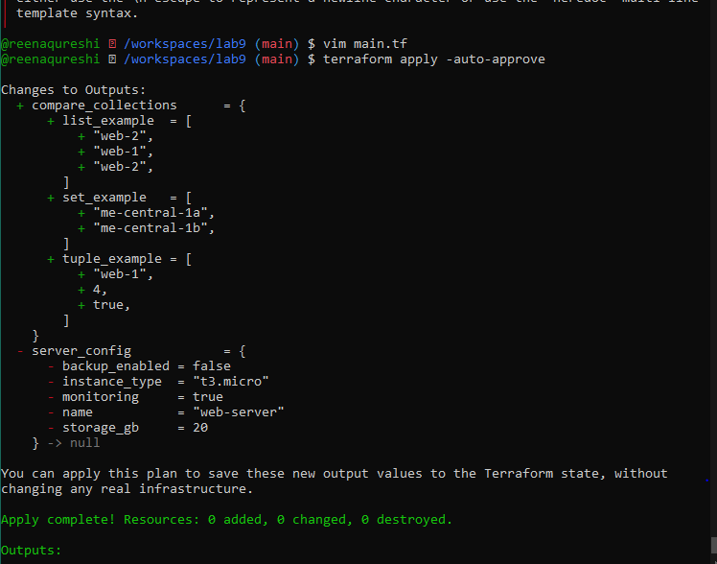
In locals.tf add mutations: Create or edit locals.tf and add the following locals to demonstrate mutation behavior. Note: tuples are immutable in Terraform's type system, but many operations convert them to lists for evaluation.
Add comparison output in main.tf:
output "mutation_comparison" {
value = {
original_tuple = var.server_metadata
mutated_tuple = local.mutated_tuple
}
}
Run:
terraform apply -auto-approve

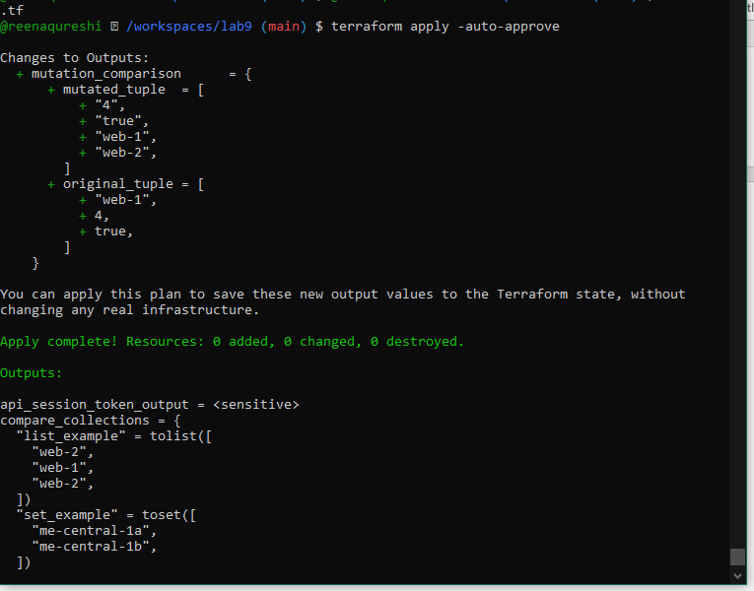
Task 6 — Null, any type & dynamic values
Null variable:
variable "optional_tag" {
type = string
description = "A tag that may or may not be provided"
default = null
}

Merge tags in locals.tf:
locals {
server_tags = merge(
{ Name = "web-server" },
var.optional_tag != null ? { Custom = var.optional_tag } : {}
)
}
Output:
output "optional_tag" {
value = local.server_tags
}
Run:
terraform apply -auto-approve

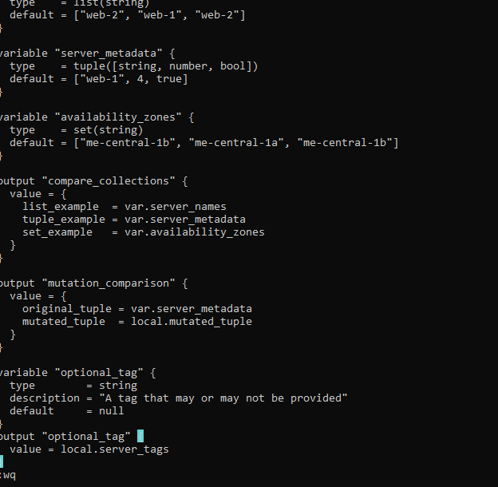

Run:
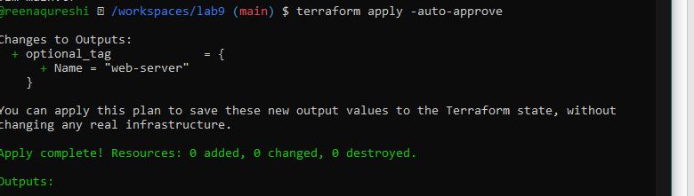
Task 7 — Git ignore
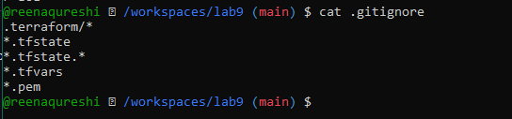

Task 8 — Clean-up then build real infra (VPC, Subnet, IGW, routing, default route table)
In this task you will clean previous example values and build a simple VPC + Subnet, attach an Internet Gateway, and configure routing (first with a custom route table and association, then switch to the default route table).
Perform all commands inside your Codespace shell.
Clean previous files
Remove all variable assignments from terraform.tfvars (empty the file or delete it).
Remove all content from locals.tf (delete or empty the file).
Replace main.tf contents with only the provider block below (start fresh).
Provider block to put in main.tf:
provider "aws" {
shared_config_files = ["~/.aws/config"]
shared_credentials_files = ["~/.aws/credentia
}
Define variables in main.tf Add these variable declarations to main.tf (below the provider block):
variable "vpc_cidr_block" {}
variable "subnet_cidr_block" {}
variable "availability_zone" {}
variable "env_prefix" {}
Create VPC in main.tf Add the VPC resource to main.tf:
resource "aws_vpc" "myapp_vpc" {
cidr_block = var.vpc_cidr_block
tags = {
Name = "${var.env_prefix}-vpc"
}
}
Create Subnet in the VPC Add the subnet resource to main.tf:
resource "aws_subnet" "myapp_subnet_1" {
vpc_id = aws_vpc.myapp_vpc.id
cidr_block = var.subnet_cidr_block
availability_zone = var.availability_zone
tags = {
Name = "${var.env_prefix}-subnet-1"
}
}

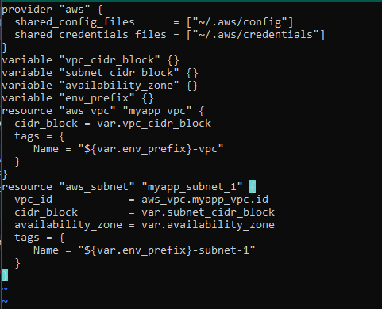
Populate terraform.tfvars In terraform.tfvars add:
vpc_cidr_block = "10.0.0.0/16"
subnet_cidr_block = "10.0.10.0/24"
availability_zone = "me-central-1a"
env_prefix = "dev"

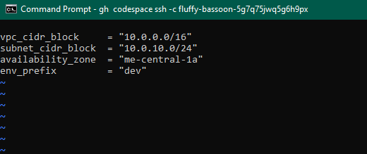
Apply to create VPC and Subnet Initialize (if needed) and apply:
terraform init
terraform apply -auto-approve

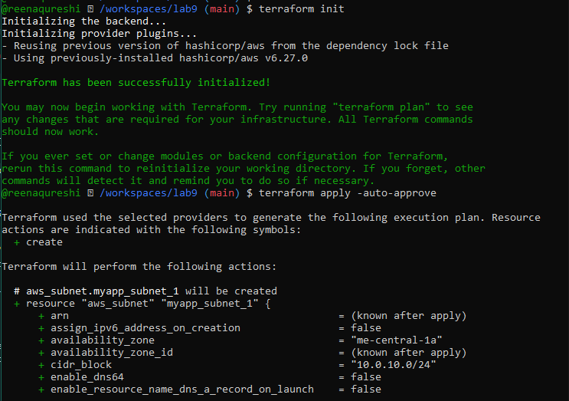
Create Internet Gateway and Route Table (custom) Add the Internet Gateway and a custom Route Table to main.tf:
resource "aws_internet_gateway" "myapp_igw" {
vpc_id = aws_vpc.myapp_vpc.id
tags = {
Name = "${var.env_prefix}-igw"
}
}

resource "aws_route_table" "myapp_route_table" {
vpc_id = aws_vpc.myapp_vpc.id

route {
cidr_block = "0.0.0.0/0"
gateway_id = aws_internet_gateway.myapp_igw.id
}

tags = {
Name = "${var.env_prefix}-rt"
}
}
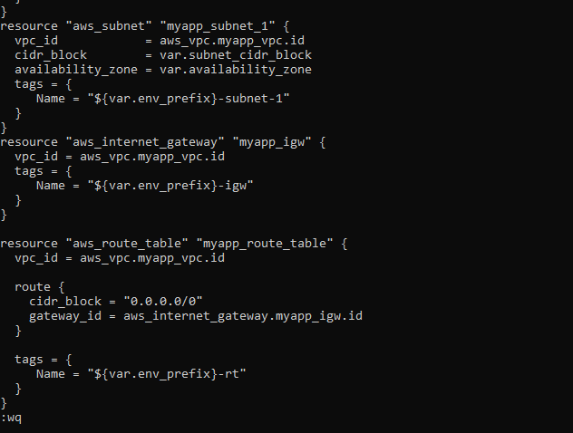
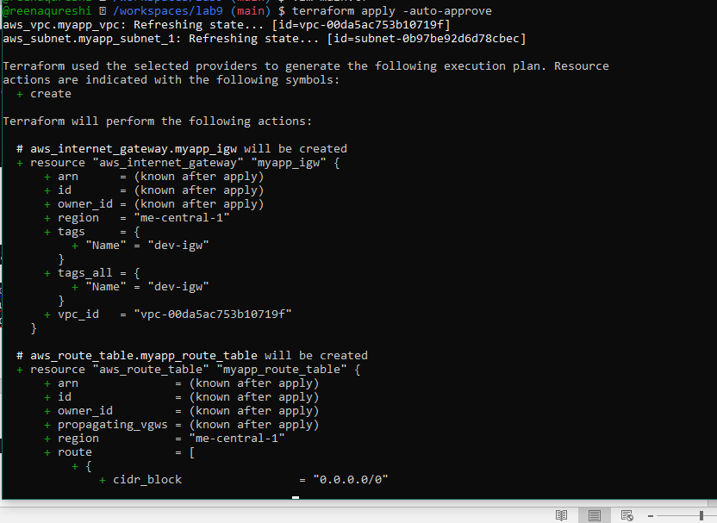

ssociate the Route Table with the Subnet Add the association resource to main.tf:
resource "aws_route_table_association" "a_rtb_subnet" {
subnet_id = aws_subnet.myapp_subnet_1.id
route_table_id = aws_route_table.myapp_route_table.id
}

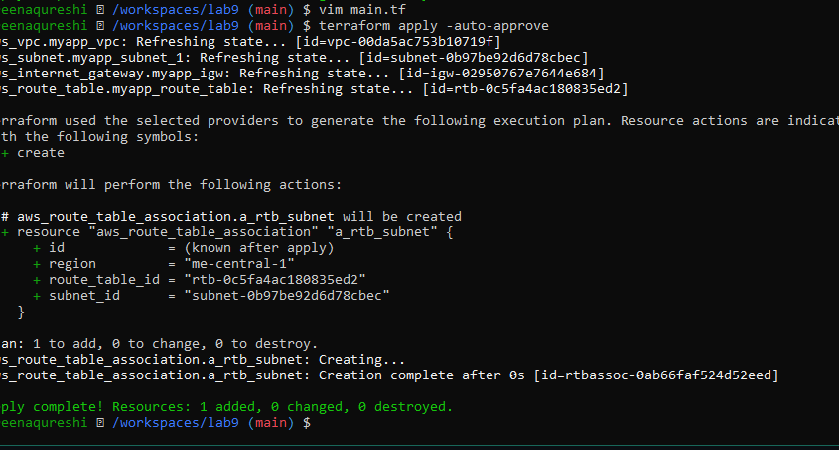
Switch to default route table (use VPC default route table) Now remove (or comment out) the custom route table and association resources from main.tf
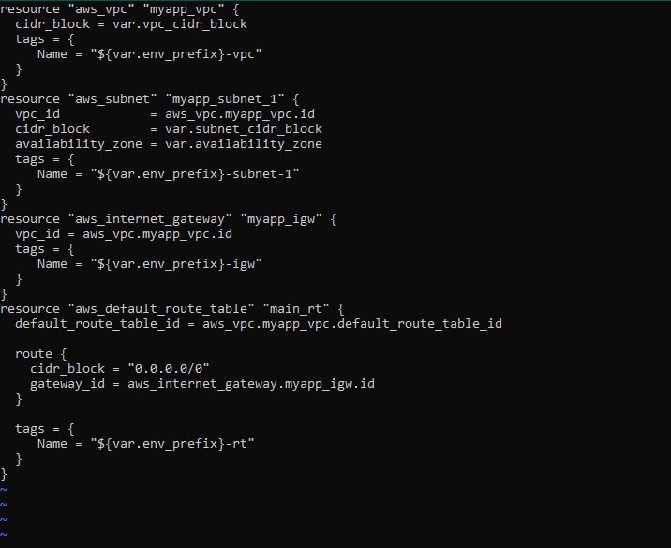
Apply:
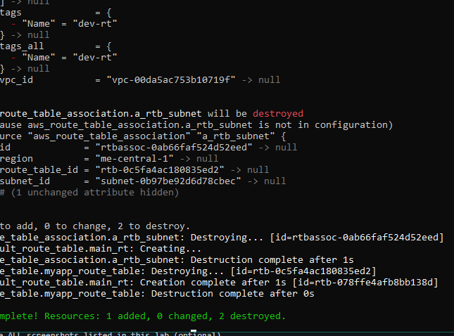

Task 9 — Security Group, Key Pair, EC2 Instance, user_data & nginx
This task walks you through creating a security group, creating an EC2 key pair, launching an EC2 instance, verifying SSH access, and installing nginx via user_data (inline and from a script). Perform all commands from your Codespace shell.
Add variables to main.tf Add these variables to your main.tf:
variable "my_ip" {}

curl icanhazip.com
Create the Security Group (main.tf)
Run apply:
terraform apply -auto-approve

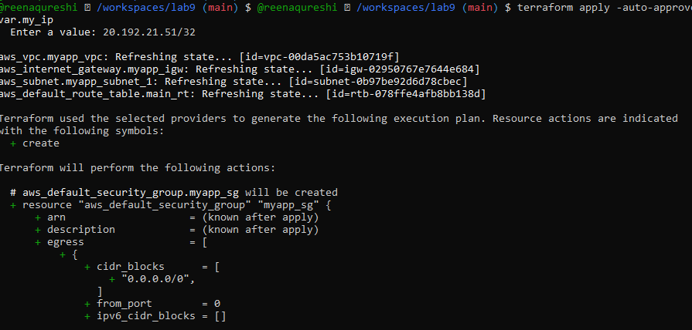

Create an AWS key pair and save locally Create a key pair and store the private key in your Codespace. Do NOT commit the .pem file.
aws ec2 create-key-pair \
--key-name MyED25519Key \
--key-type ed25519 \
--key-format pem \
--query 'KeyMaterial' \
--output text > MyED25519Key.pem

chmod 600 MyED25519Key.pem
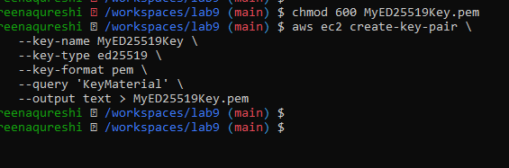
Add EC2 instance resource (initial) Add the instance resource to main.tf (initially using the created key name)
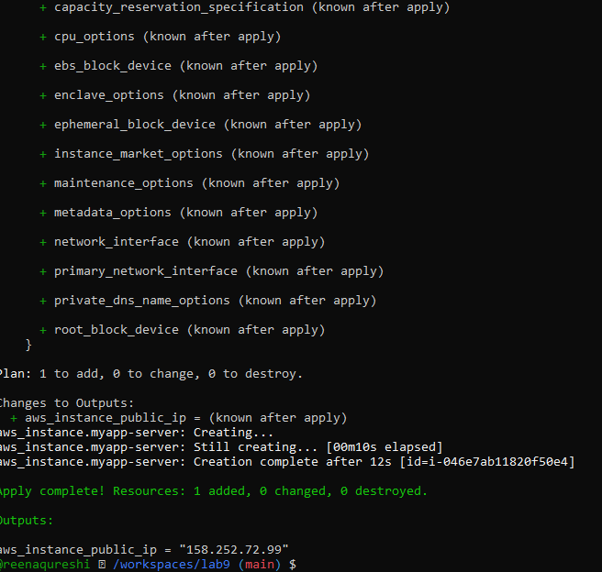
SSH into the instance (using MyED25519Key) From the Codespace:

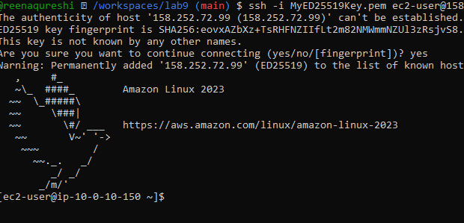
Generate a local SSH keypair and register it in AWS via Terraform On your Codespace, generate an SSH key pair (accept defaults or specify path):
ssh-keygen -t ed25519 -f ~/.ssh/id_ed25519 -N ""
]
Add a Terraform resource in main.tf to register the public key:
resource "aws_key_pair" "ssh_key" {
key_name = "serverkey"
public_key = file("~/.ssh/id_ed25519.pub")
}
Update the EC2 resource to use the Terraform-managed key:
resource "aws_instance" "myapp-server" {
...
# replace key_name = "MyED25519Key" with:
key_name = aws_key_pair.ssh_key.key_name
...
}
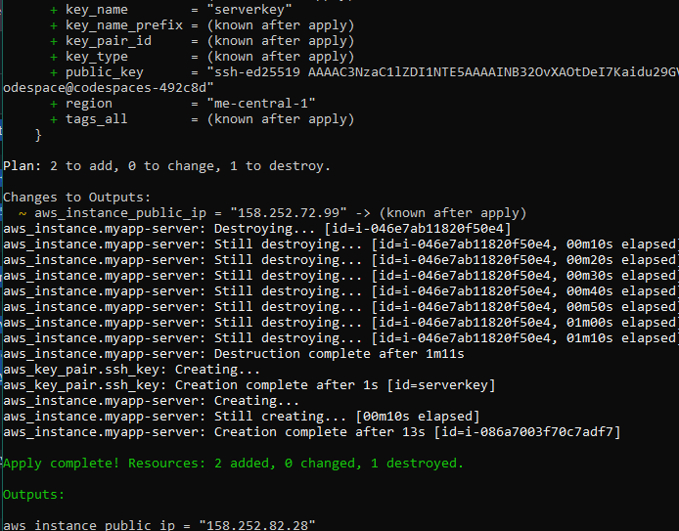

SSH using the newly registered key Now SSH with your generated private key (the default ssh client will pick up ~/.ssh/id_ed25519):
ssh ec2-user@<public-ip>

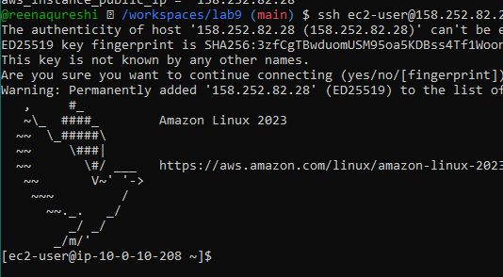

Install nginx via inline user_data Modify the aws_instance resource to include inline user_data:
resource "aws_instance" "myapp-server" {
...
user_data = <<-EOF
#!/bin/bash
yum update -y
yum install -y nginx
systemctl start nginx
systemctl enable nginx
EOF
tags = {
Name = "${var.env_prefix}-ec2-instance"
}
}
Apply:
terraform apply -auto-approve
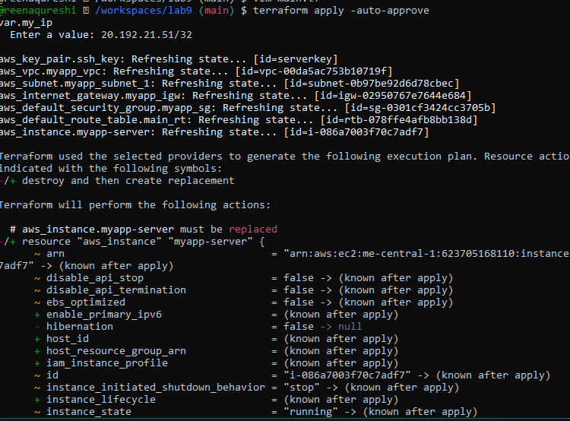
SSH in and run:
curl localhost

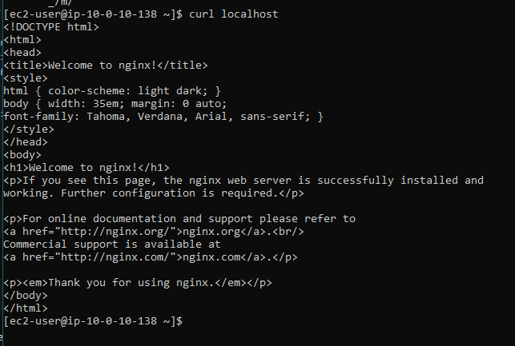
Open http://<public-ip>in a browser — you should see the nginx default page.
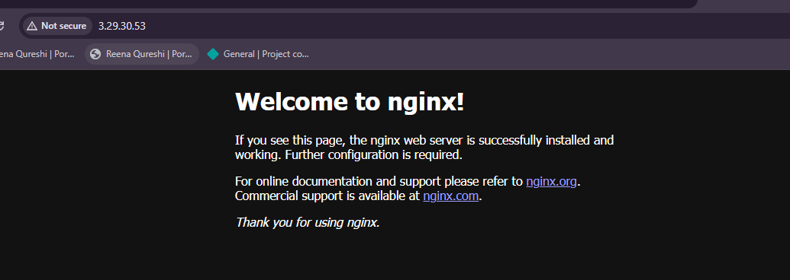
Use an external script for user_data Create a script file in the Codespace:
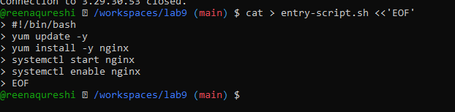
Cleanup
