Name : Reena Qureshi
Reg No: 2023-BSE-052
Section: V-B
LAB 8
Task 1 — Create an AWS account and enable UAE (me-central-1)
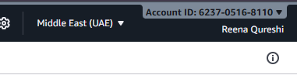

Task 2 — Create IAM Admin and Lab8User with console access
Open IAM via Console search (Alt+S → "IAM").
Create the Admin user: IAM → Users → Create user. Fill: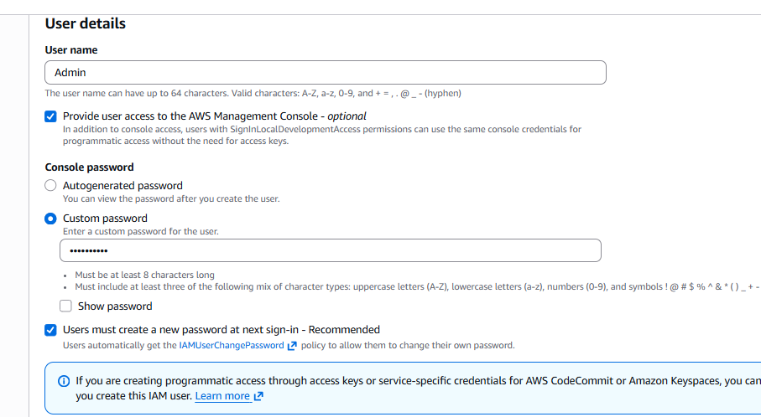
Attach policies directly → AdministratorAccess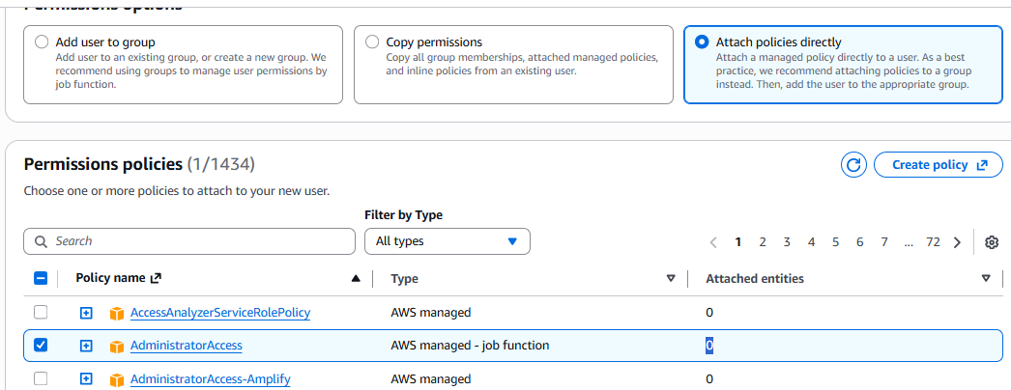

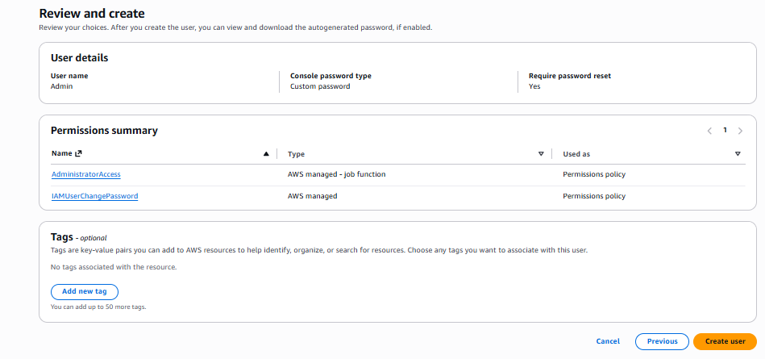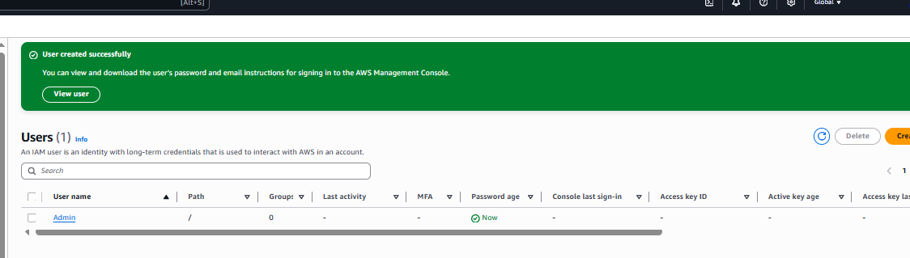

Download the Admin .csv and show its presence on your Windows host (do not display the password text):

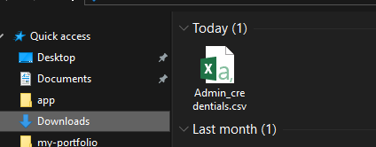
Sign out of root, then sign in using the Admin account (use the signin URL from the .csv). Capture after successful Admin login:

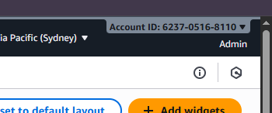

While logged in as Admin, create Lab8User:

IAM → Users → Create user

Username: Lab8User

Provide user access to the AWS Management Console

Attach AdministratorAccess policy
Capture the create-user success screen:

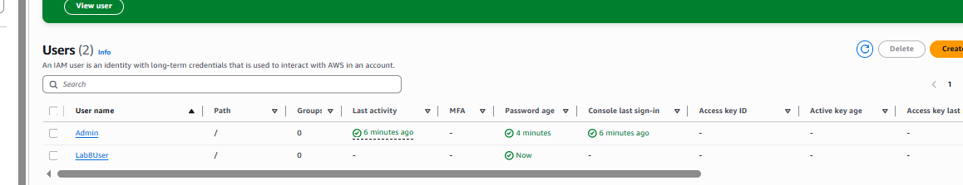

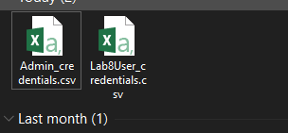

Logout Admin and login as Lab8User (use the Lab8User signin URL and credentials). Capture after login:

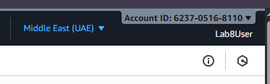

Task 3 — Inspect VPC resources (in UAE me-central-1)

View VPCs list.

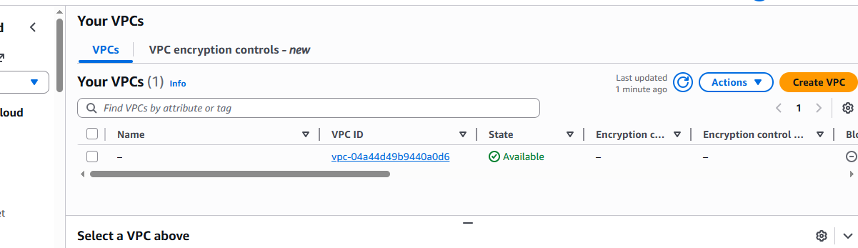

View Subnets list. Capture

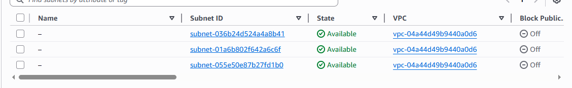

View Route Tables list.

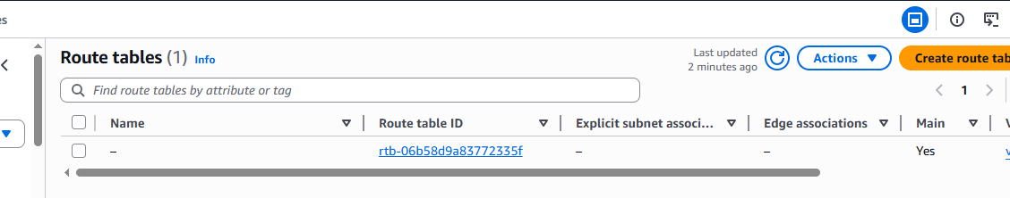

View Network ACLs list.

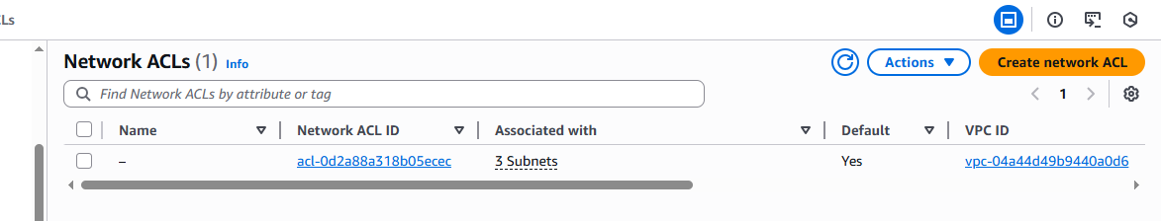

Task 3 summary (combine evidence):

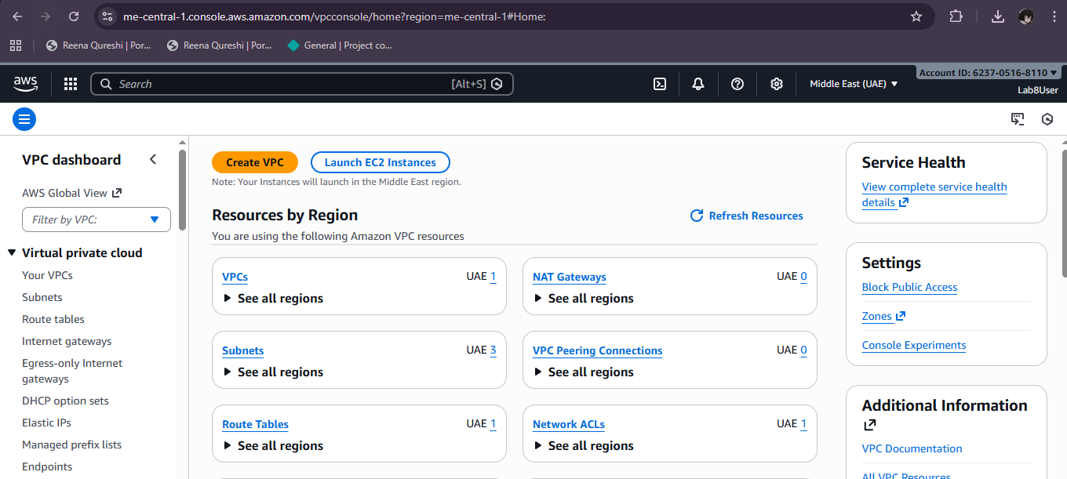

Task 4 — Launch EC2, SSH, install Docker & Docker Compose, deploy Gitea

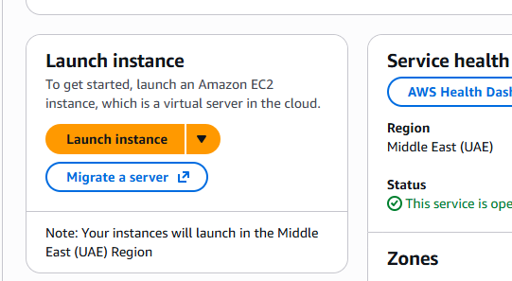

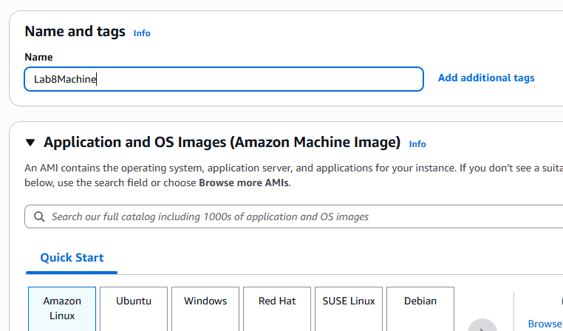

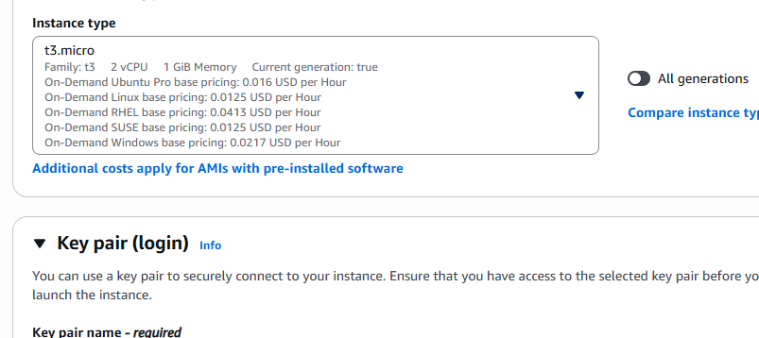

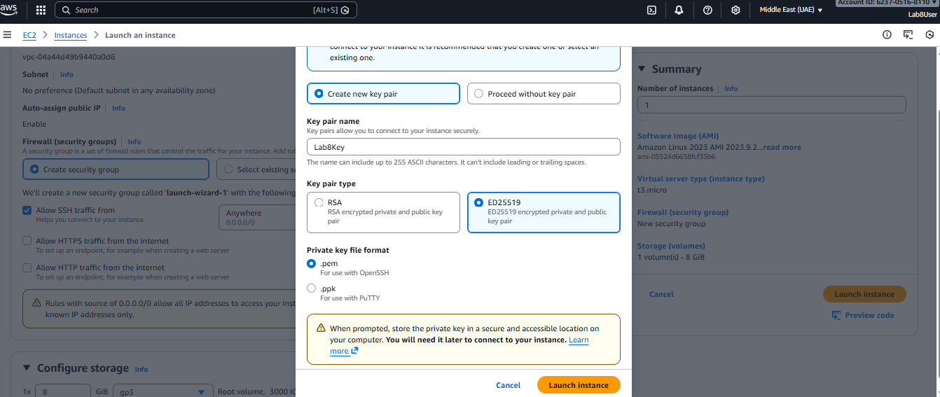

After launch, EC2 Instances list showing Lab8Machine in "running" state and public IPv4 visible.

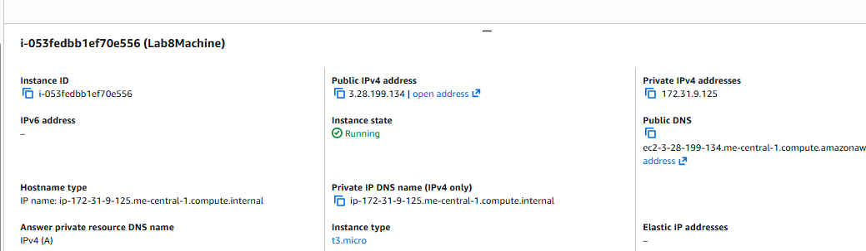

On Windows host, run SSH using the downloaded .pem (PowerShell/Git Bash/Windows Terminal):

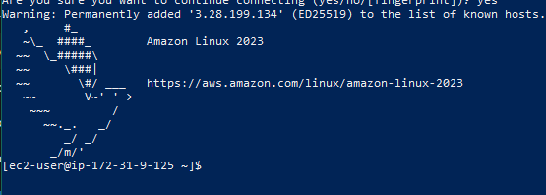

Run the install commands on the EC2 shell:

Verified Compose.yml:

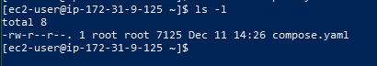

Add ec2-user to docker group, show groups before re-login, exit and reconnect, show groups after reconnect:

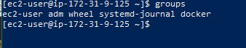

Run docker compose up -d from the directory with compose.yaml:

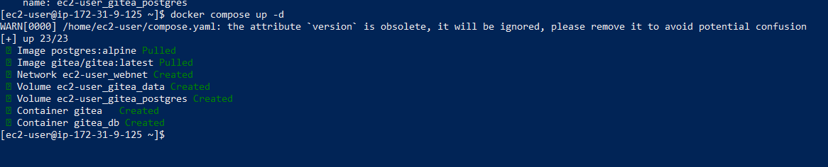

Edit the security group Lab8SecurityGroup inbound rules in the EC2 console: add Custom TCP rule port 3000 source 0.0.0.0/0 and save. Capture the inbound rules after saving

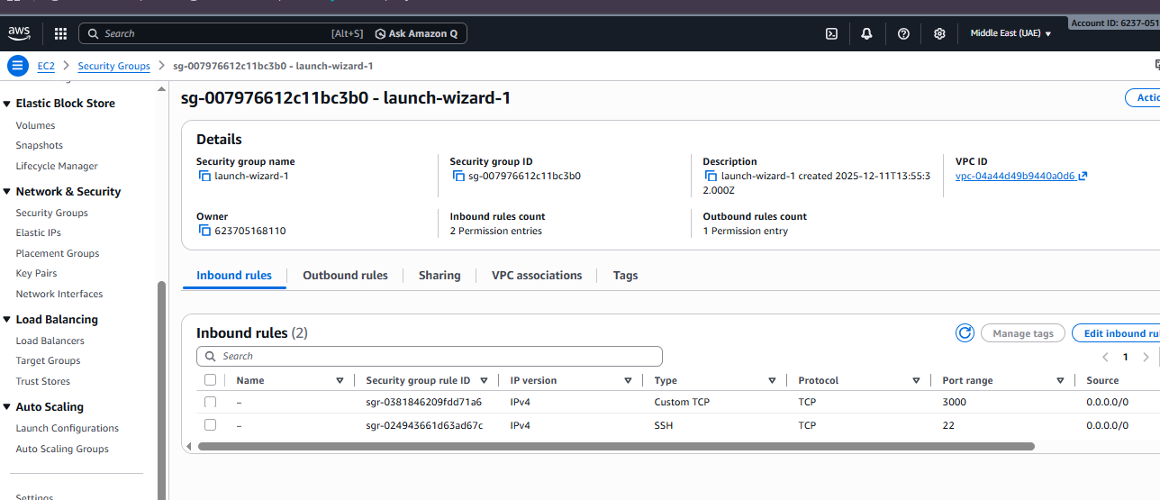

Open Gitea in your browser

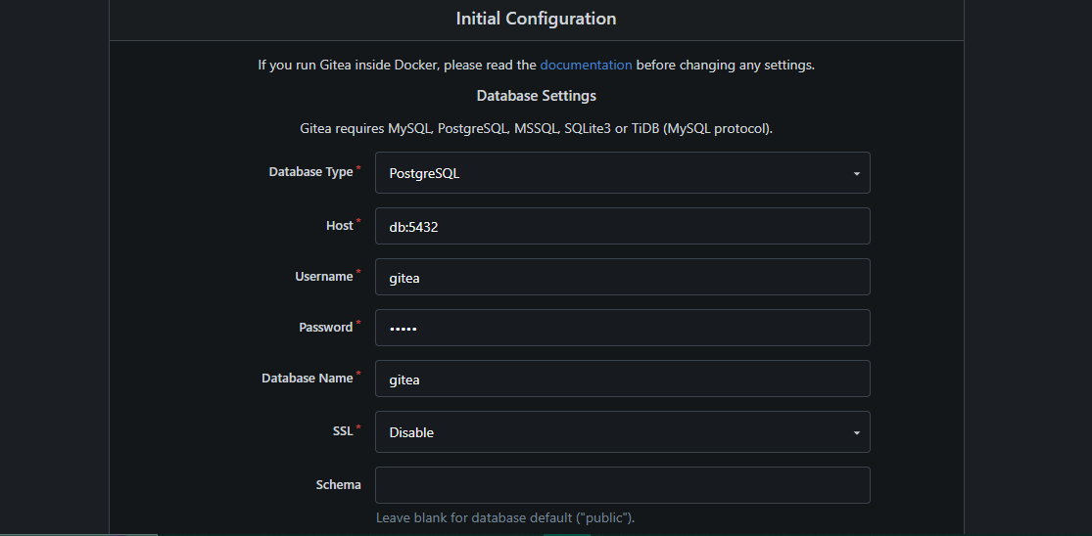

Complete initial Gitea setup (create admin user, create a repo) and capture Gitea showing the created repository

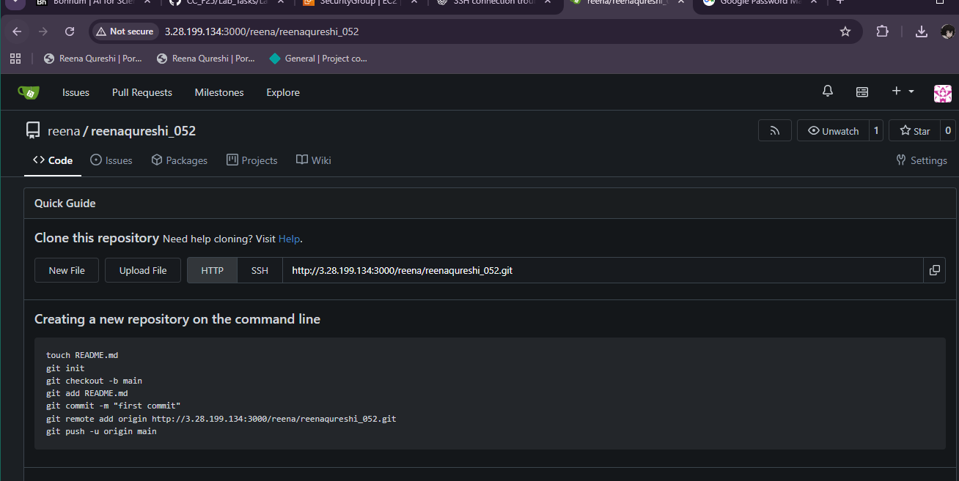

Cleanup — Remove resources to avoid charges

