

Name: Reena Qureshi
Roll Number: 2023-BSE-052
Section: V-B
Course: Cloud Computing

Lab Project Report

Contents
Lab Project Report 2
Executive Summary 3
1. Project Overview 3
1.1 Objectives 3
1.2 Learning Outcomes Achieved 3
1.3 Technologies Used 3
2. Architecture Design 4
2.1 Network Architecture 4
2.2 Compute Architecture 4
2.3 File Structure 5
3. Implementation Details 5
3.1 Terraform Infrastructure 5
3.2 Ansible Configuration Management 7
6. Challenges & Solutions 16
Challenge 1: Ansible Version Compatibility 16
Challenge 2: SSH Key Path Issues 16
Challenge 3: Nginx Package Installation 17
Challenge 4: Dynamic Backend IP Passing 17
7. Conclusion 17
7.1 Project Success 17
7.2 Key Learnings 17
8. References 18
Documentation 18

Executive Summary
This lab project demonstrates the design and implementation of a highly available multi-tier web infrastructure on AWS using Infrastructure as Code (IaC) principles. The project successfully integrates Terraform for infrastructure provisioning and Ansible for automated configuration management, showcasing modern DevOps practices.

1. Project Overview

1.1 Objectives
The primary objective of this project was to demonstrate proficiency in:
- Designing multi-tier AWS infrastructure using Terraform
- Implementing configuration management using Ansible roles
- Configuring high-availability load balancing with Nginx
- Integrating IaC tools for end-to-end automation

1.2 Learning Outcomes Achieved
- Infrastructure as Code: Translated architecture requirements into Terraform configurations
- Configuration Management: Separated concerns using Ansible role-based structure
- High Availability: Implemented active-backup load balancing pattern
- Automation: Achieved zero-touch deployment with integrated Terraform-Ansible workflow
- Best Practices: Followed industry standards for code organization and documentation

1.3 Technologies Used
Technology | Version | Purpose
Terraform | ~> 5.0 | Infrastructure provisioning
Ansible | 2.15.12 | Configuration management
AWS | - | Cloud infrastructure provider
Amazon Linux 2 | Latest | Operating system for EC2 instances
Nginx | 1.x | Load balancer and reverse proxy
Apache HTTPD | 2.4.x | Backend web servers

2. Architecture Design

2.1 Network Architecture

VPC Configuration
- VPC CIDR Block: 10.0.0.0/16
- Public Subnet: 10.0.15.0/24
- Availability Zone: us-east-1a
- Internet Gateway: Enabled for public internet access
- Route Table: Default route (0.0.0.0/0) to Internet Gateway

Security Groups
Web Security Group:
- Inbound Rules:
  - SSH (port 22): Restricted to developer's IP address
  - HTTP (port 80): Open to internet (0.0.0.0/0)
  - Internal VPC traffic: All protocols allowed within VPC CIDR
- Outbound Rules:
  - All traffic allowed (0.0.0.0/0)

2.2 Compute Architecture

Instance Configuration
Instance Type | Count | Role | Purpose
t2.micro | 1 | Frontend | Nginx load balancer
t2.micro | 3 | Backend | Apache HTTPD web servers
Load Balancing Strategy:
- Normal Operation: Round-robin between Backend-0 and Backend-1
- Failover Mode: Backend-2 activates when primaries are unavailable
- Health Checks: Nginx automatically detects failed backends

2.3 File Structure
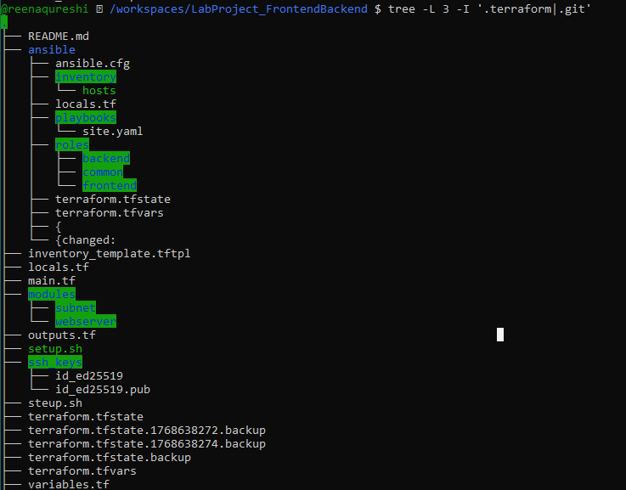

3. Implementation Details

3.1 Terraform Infrastructure

Key Components Implemented
1. VPC and Networking (main.tf)
hcl
- VPC with DNS support enabled
- Public subnet with auto-assign public IP
- Internet Gateway for internet connectivity
- Route table with default route to IGW
- Security group with appropriate firewall rules

2. EC2 Instances
hcl
- Frontend instance: Single Nginx load balancer
- Backend instances: 3 Apache HTTPD servers (using count)
- SSH key pair: Automated key deployment
- Tags: Meaningful naming for resource identification
3. Automation Integration
hcl
- Inventory generation: Dynamic Ansible inventory from Terraform
- Wait mechanism: Ensures EC2 instances are ready before configuration
- Automatic execution: null_resource triggers Ansible playbook

Variables Configuration
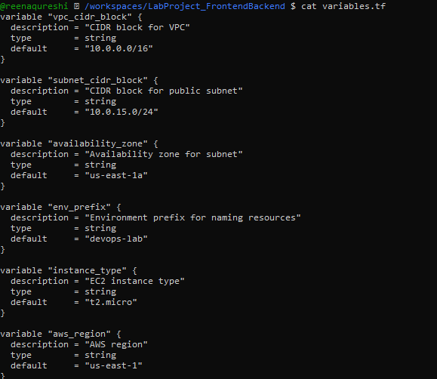

3.2 Ansible Configuration Management

Backend Role (roles/backend/)

Purpose: Configure Apache HTTPD web servers with distinct content
Tasks Implemented:
- Install Apache HTTPD package
- Ensure HTTPD service is running and enabled
- Deploy custom HTML page using Jinja2 template
- Configure service handlers for automatic restart
Template Features:
- Displays backend server hostname
- Shows private IP address
- Unique identification for each backend
- Professional HTML/CSS styling

Frontend Role (roles/frontend/)
Purpose: Configure Nginx as reverse proxy load balancer
Tasks Implemented:
- Install Nginx via amazon-linux-extras
- Start and enable Nginx service
- Deploy custom Nginx configuration
- Configure upstream with HA settings
Nginx Upstream Configuration:
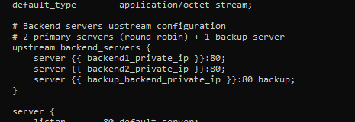

Main Playbook (playbooks/site.yaml)
Playbook Structure:
- Play 1: Ensure Python 3 availability on all hosts
- Play 2: Configure backend HTTPD servers (role: backend)
- Play 3: Gather backend facts for frontend configuration
- Play 4: Configure frontend Nginx (role: frontend) with dynamic backend IPs
4. Testing & Validation
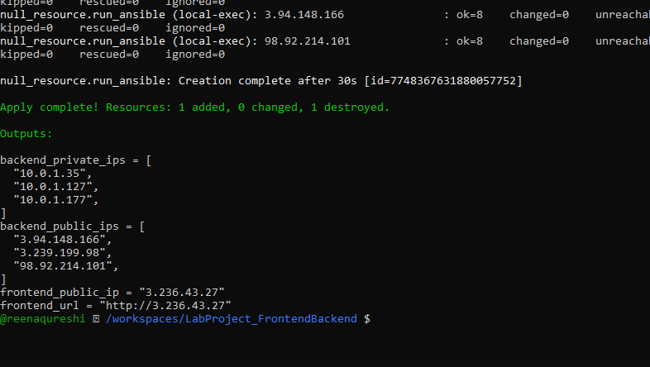
Terraform Outputs:
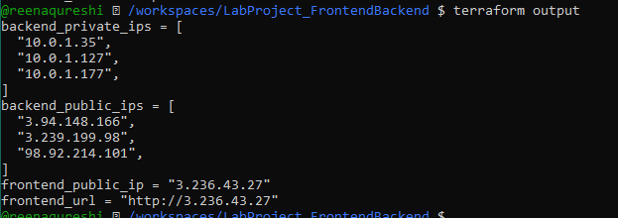

Individual Backend Testing:
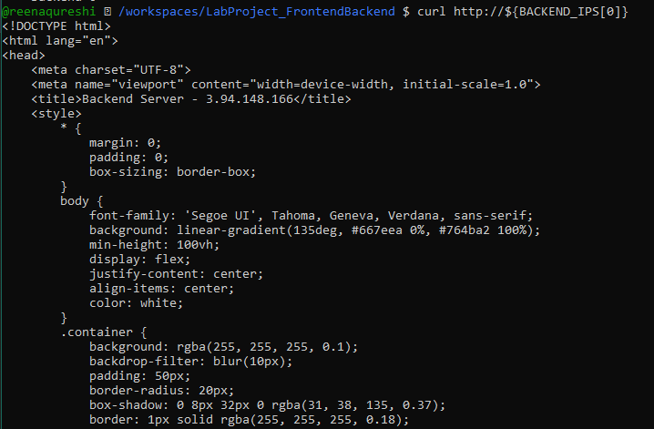
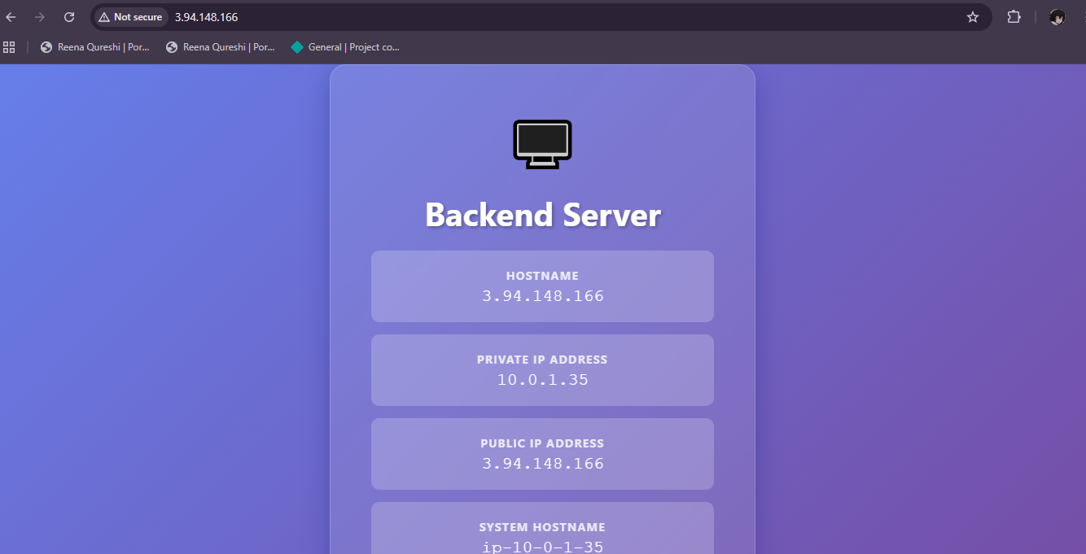
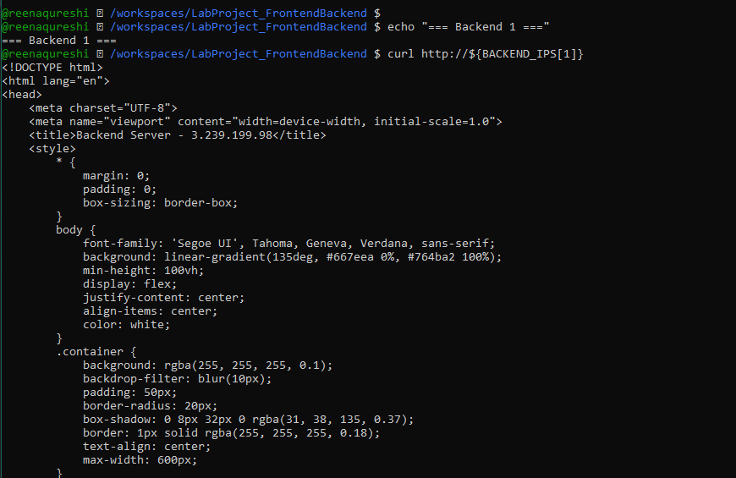
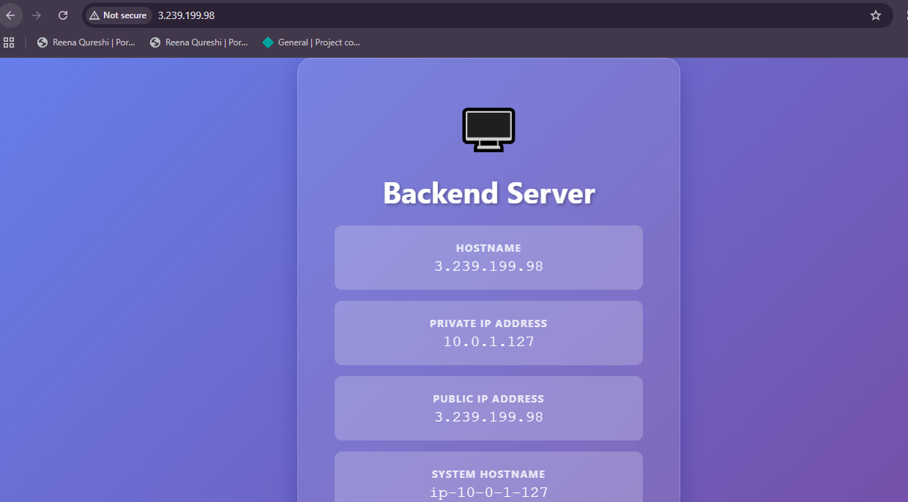

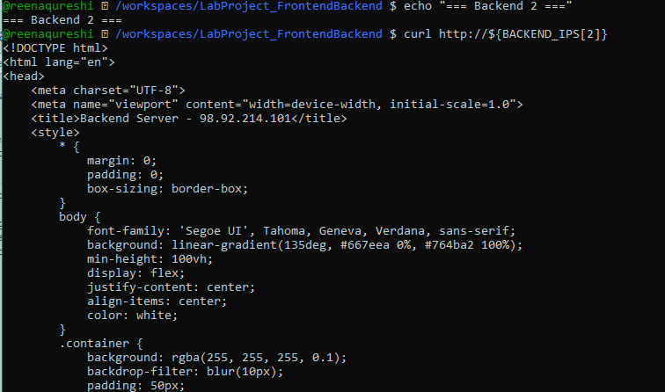
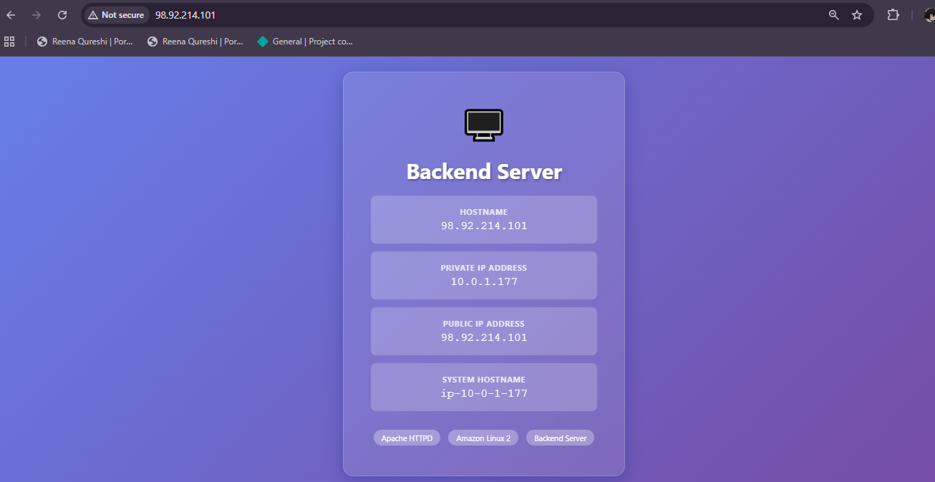

Load Balancer Testing (Normal Operation)
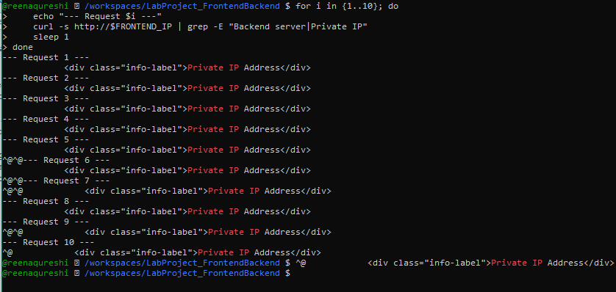
Browser Testing:
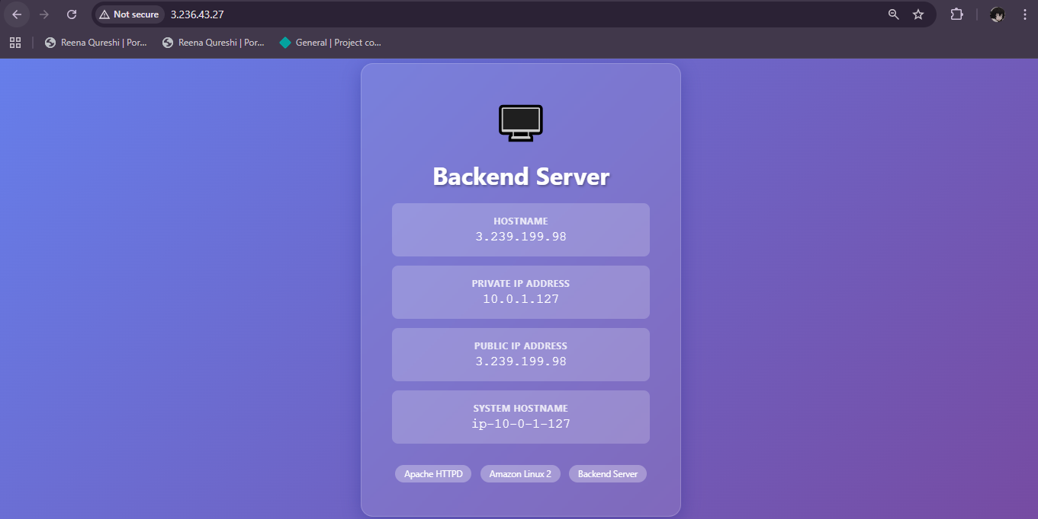
After Refreshing it few times:
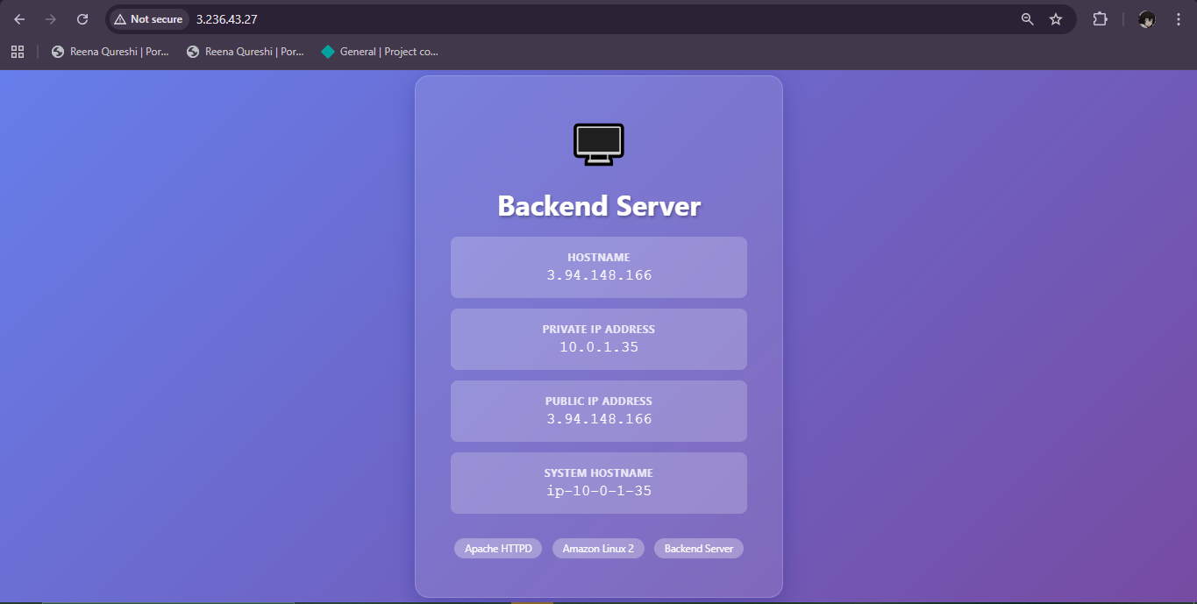
Backup Server Testing
Stopping Backend 0 and 1 server to use the backup server:
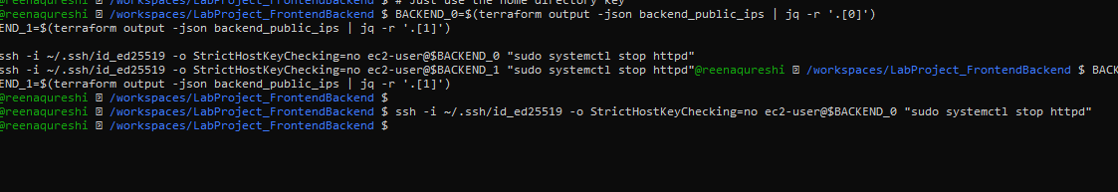
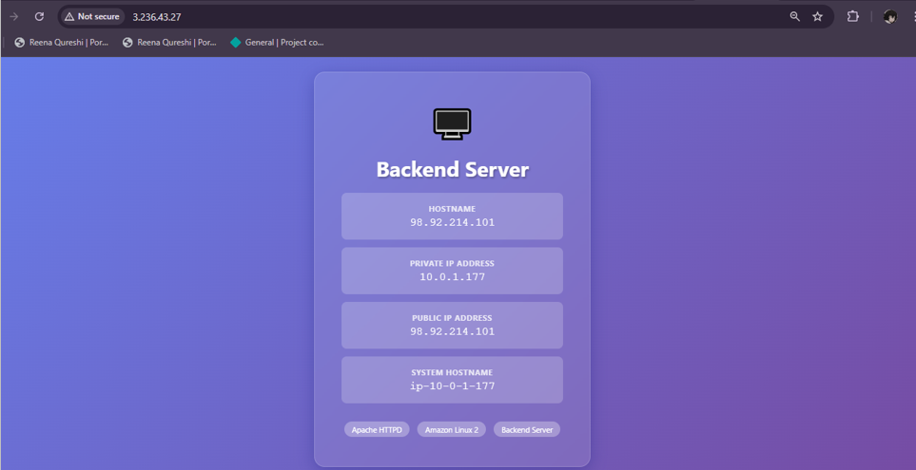
Restarted the backend servers:
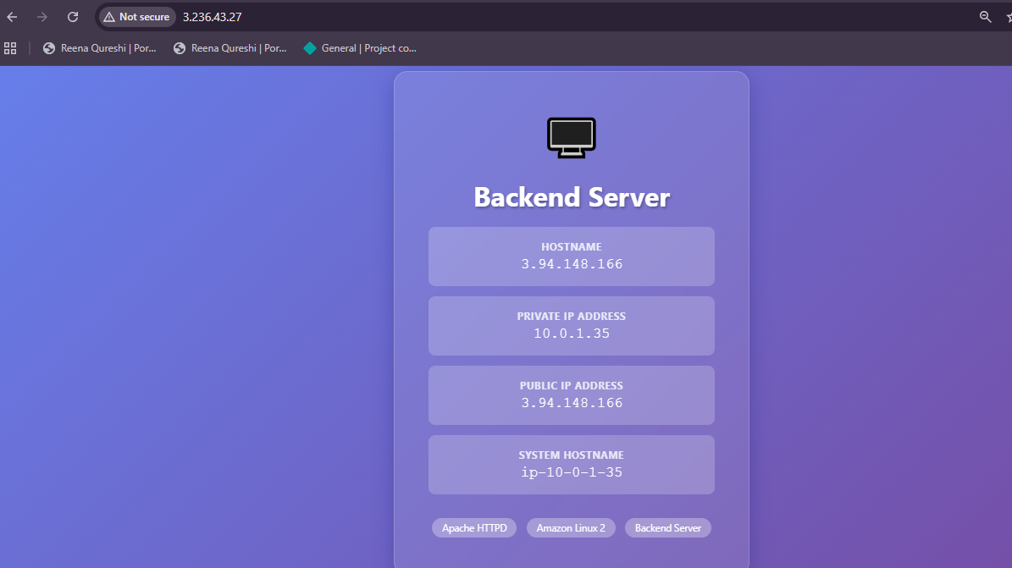
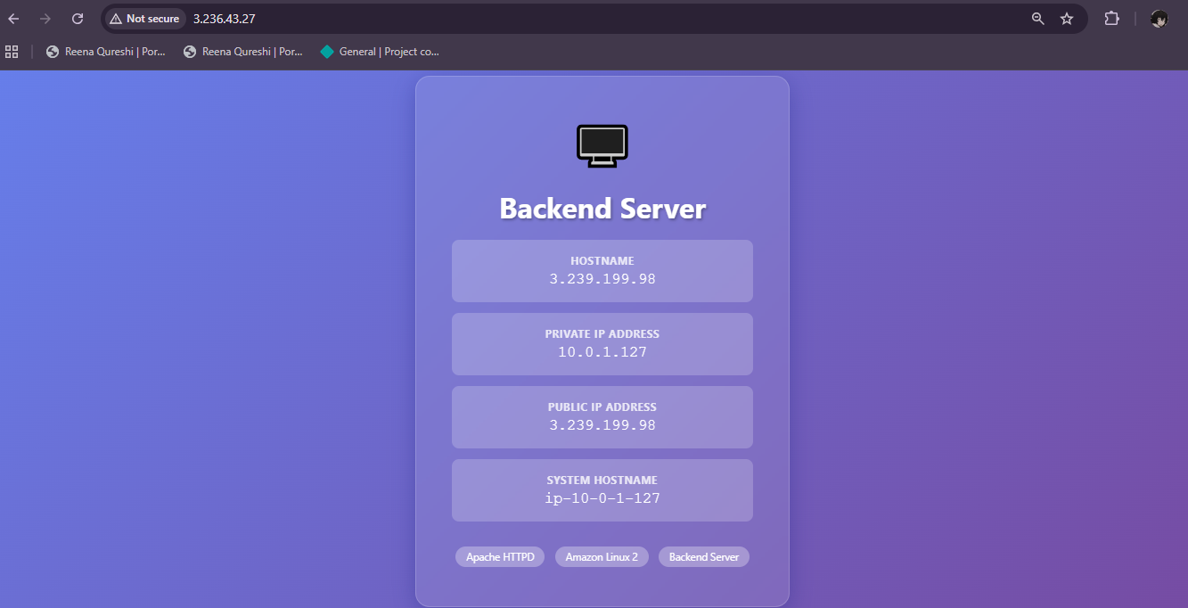
Nginx Configuration
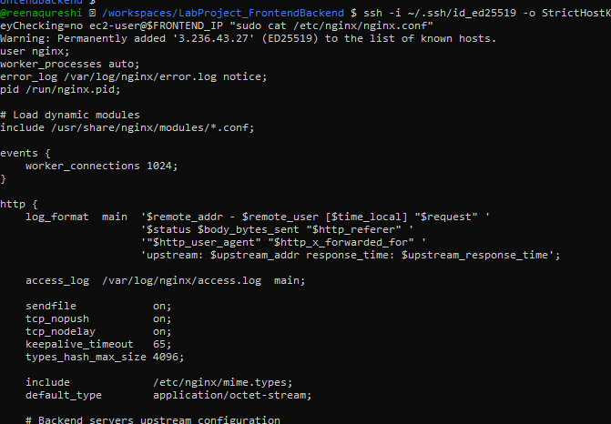
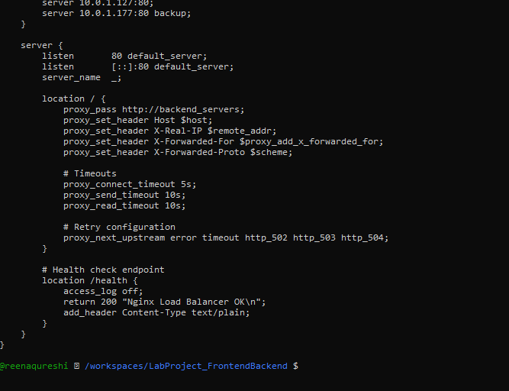
Ansible Playbook Execution
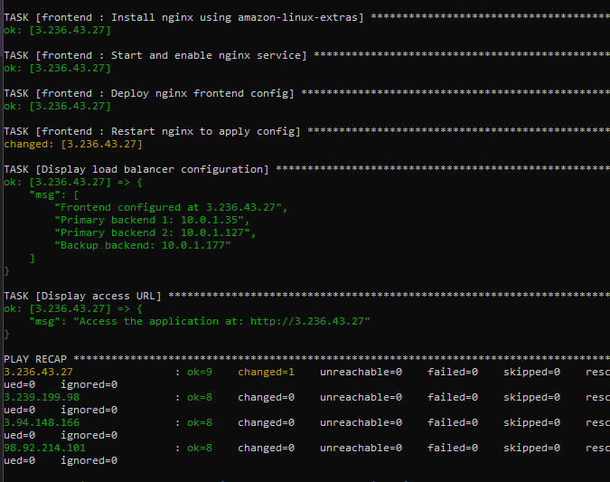

6. Challenges & Solutions

Challenge 1: Ansible Version Compatibility
Problem: Ansible 2.17+ uses Python 3.8+ syntax features, incompatible with Amazon Linux 2's Python 3.7
Solution:
- Downgraded Ansible to version 2.15.12
- Verified compatibility with Python 3.7
- Documented version requirements in README

Challenge 2: SSH Key Path Issues
Problem: Mismatch between SSH key locations in Terraform and actual key files
Solution:
- Created dedicated ssh_keys/ directory in project root
- Updated locals.tf to use project-relative paths
- Added ssh_keys/ to .gitignore to prevent committing private keys

Challenge 3: Nginx Package Installation
Problem: Nginx not available via standard yum install nginx on Amazon Linux 2
Solution:
- Used amazon-linux-extras install nginx1 -y command
- Modified Ansible frontend role to use shell module
- Added idempotency check with creates parameter

Challenge 4: Dynamic Backend IP Passing
Problem: Frontend Nginx needed backend private IPs that are only known after backend instances are created
Solution:
- Used Ansible's hostvars and groups to dynamically retrieve backend IPs
- Implemented fact gathering play before frontend configuration
- Passed IPs as variables to frontend role

7. Conclusion

7.1 Project Success
This lab project successfully demonstrates the implementation of a production-ready, highly available web infrastructure using modern Infrastructure as Code and Configuration Management tools. All objectives were met:
Infrastructure Design: VPC, subnets, security groups, and EC2 instances correctly provisioned Ansible Roles: Modular, reusable roles for frontend and backend configuration High Availability: Nginx load balancer with 2 active + 1 backup backend configuration Automation: Single-command deployment with Terraform-Ansible integration Best Practices: Clean code structure, proper documentation, secure credential handling

7.2 Key Learnings
- Infrastructure as Code Benefits:
  - Repeatable, consistent deployments
  - Version-controlled infrastructure
  - Reduced manual configuration errors
- Separation of Concerns:
  - Terraform handles infrastructure provisioning
  - Ansible manages configuration
  - Clear boundaries improve maintainability
- High Availability Patterns:
  - Active-backup configuration provides resilience
  - Automatic failover ensures service continuity
  - Load balancing improves performance and reliability
- Automation Value:
  - Single-command deployment saves time
  - Idempotent operations prevent configuration drift
  - Integrated workflows reduce human error

8. References

Documentation
- Terraform AWS Provider Documentation
- Ansible Documentation
- Nginx Upstream Module
- Amazon Linux 2 User Guide
- Apache HTTP Server Documentation

