Name : Reena Qureshi
Reg No : 2023-BSE-052
Section : V-B
LAB 13

Task 1 — Create IAM Group and Output Details
In this task, you will create an IAM group named "developers" and output its details.
Create the initial project structure:
mkdir -p ~/Lab13
cd ~/Lab13
Create the main Terraform file:
touch main.tf
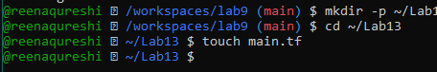
Create main.tf with AWS provider configuration:
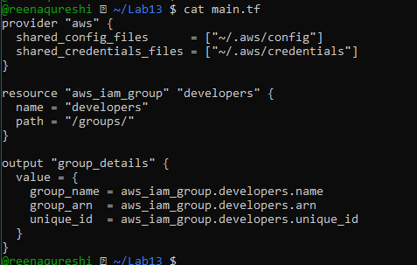
Initialize Terraform:
terraform init
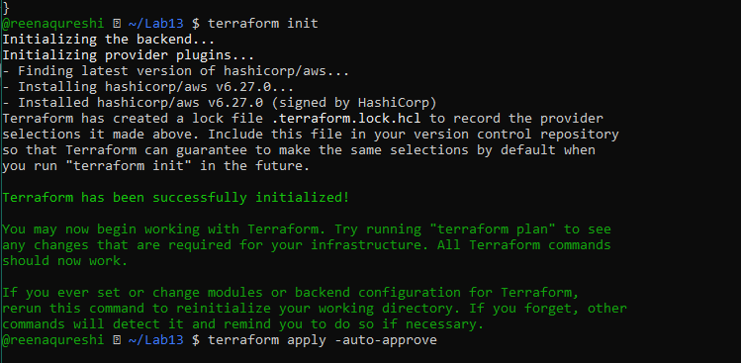
Apply the configuration:
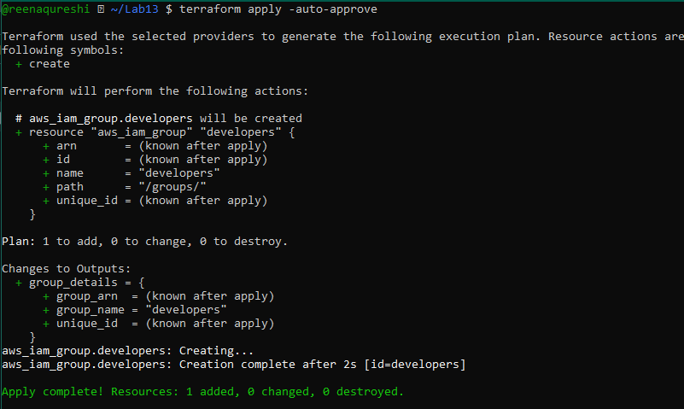
Display the output:

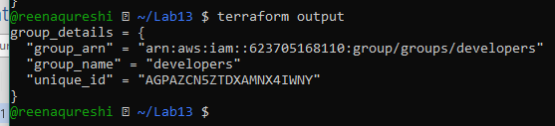

Task 2 — Create IAM User with Group Membership

Update main.tf to add the IAM user resource:
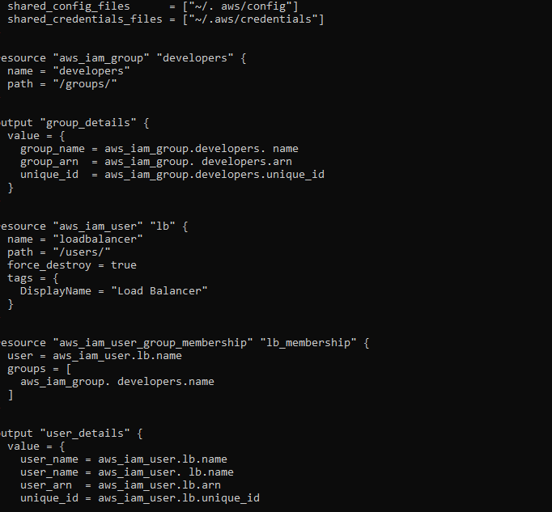
Apply the configuration:
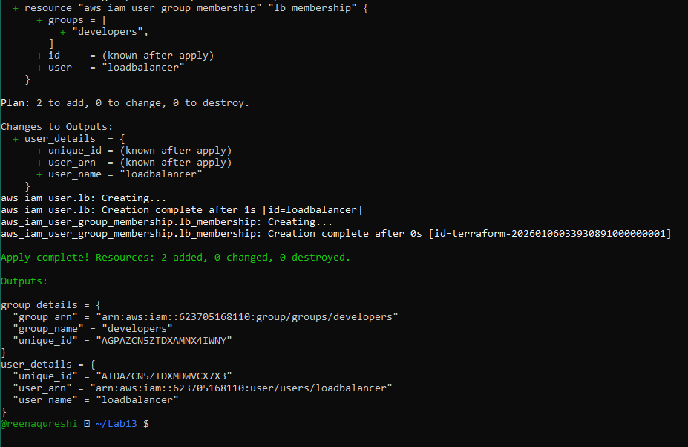
Display the outputs:

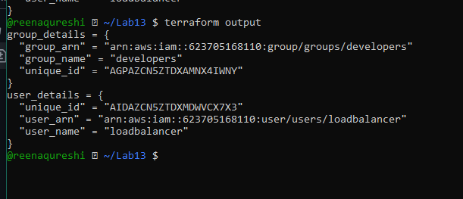
Verify on AWS:
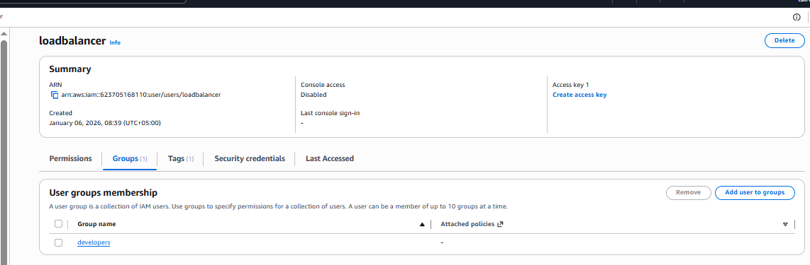
Task 3 — Attach Policies to IAM Group

Update main.tf to add policy attachments:

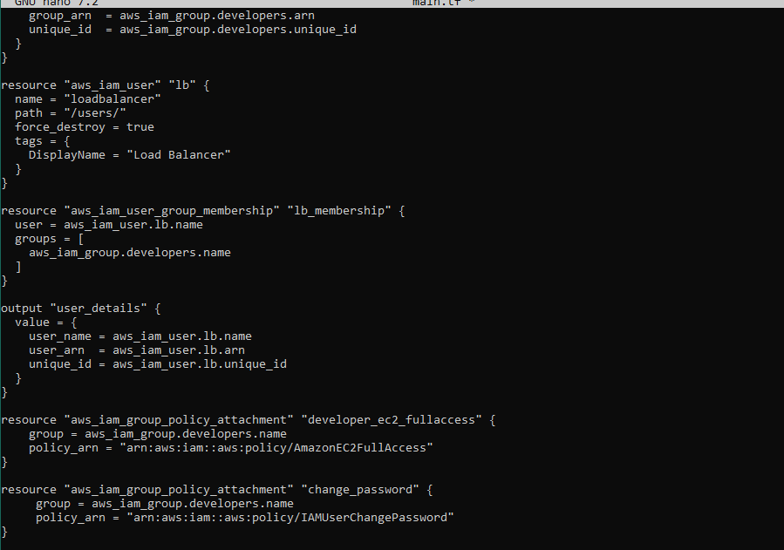
Apply the configuration:

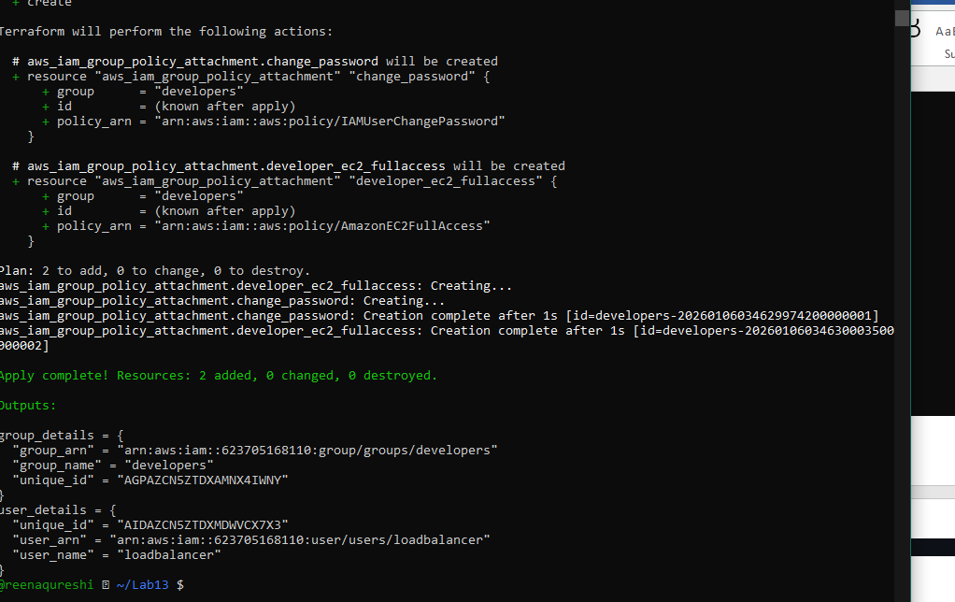
Output:
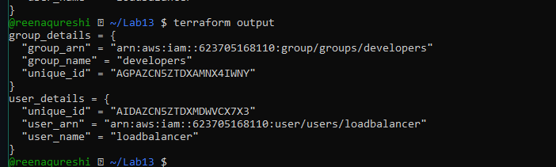
Task 4 — Create Login Profile for IAM User

Create variables.tf file:

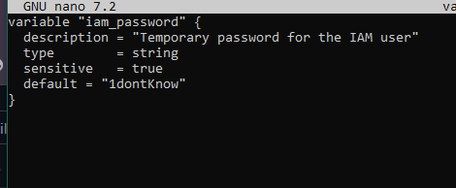
Create the bash script create-login-profile.sh:

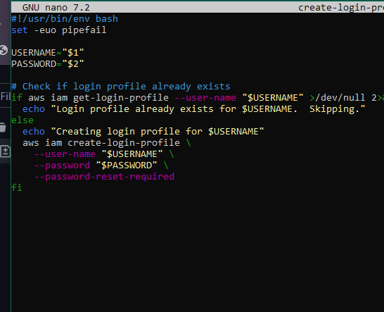
Make the script executable:
Update main.tf to add the null_resource provisioner:
Add this resource after the user creation:

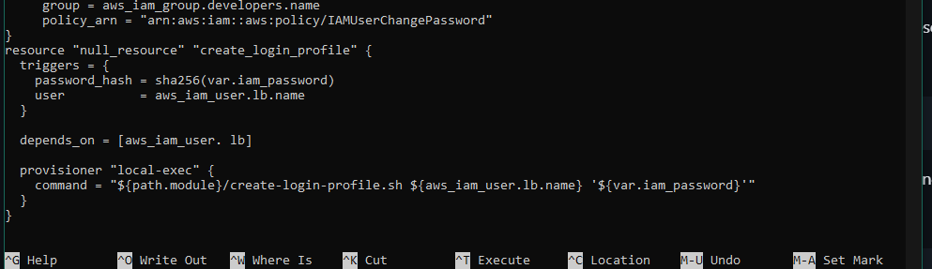
Apply the configuration with a custom password:
terraform apply -auto-approve -var="iam_password=MySecurePass123!"

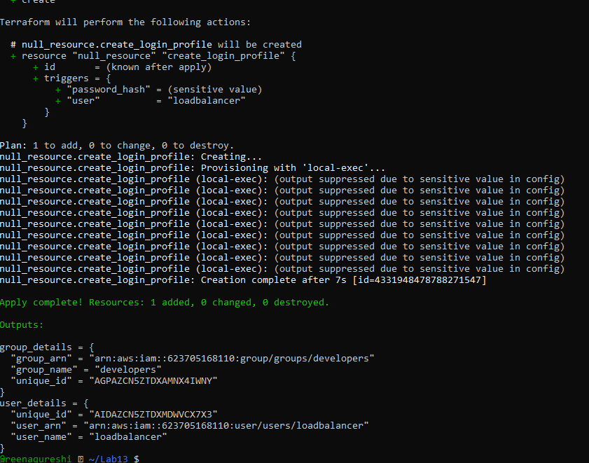
Output:
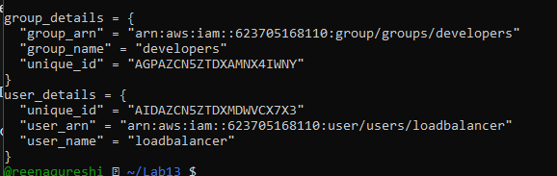
Verify login profile creation:
aws iam get-login-profile --user-name loadbalancer
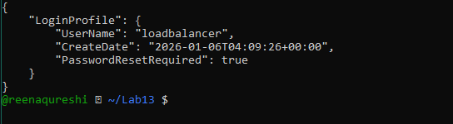’
Test login in AWS Console:
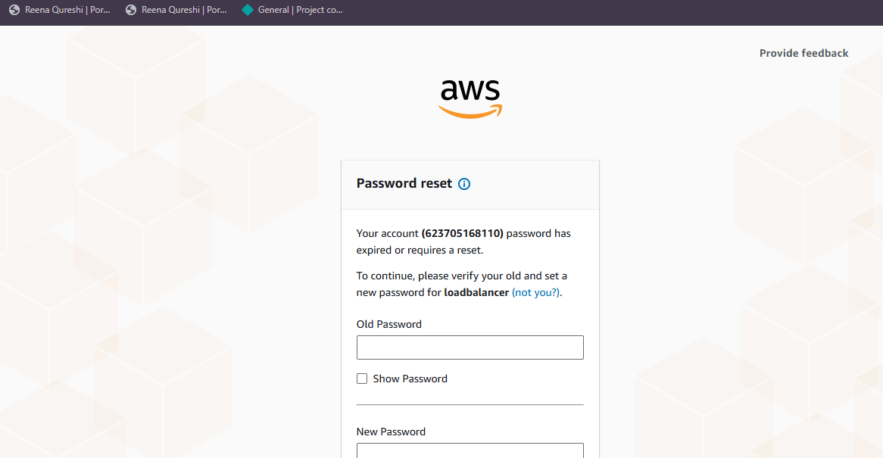
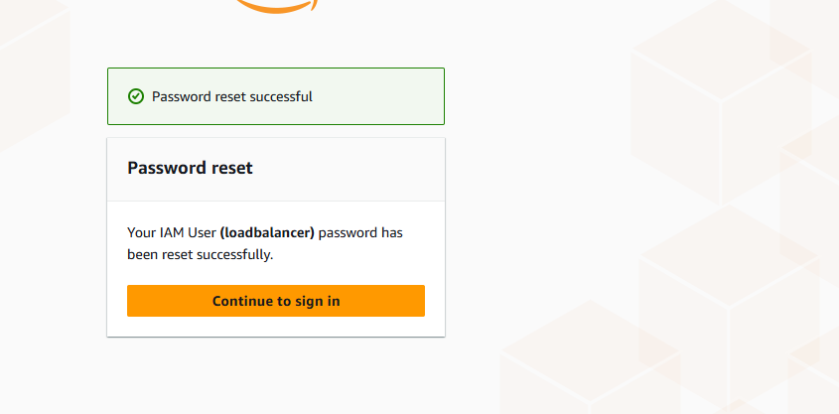
Task 5 — Generate Access Keys for IAM User

Update main.tf to add access key resource and outputs:

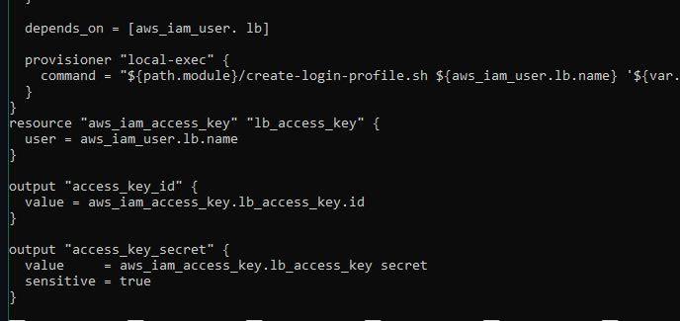
Apply the configuration:

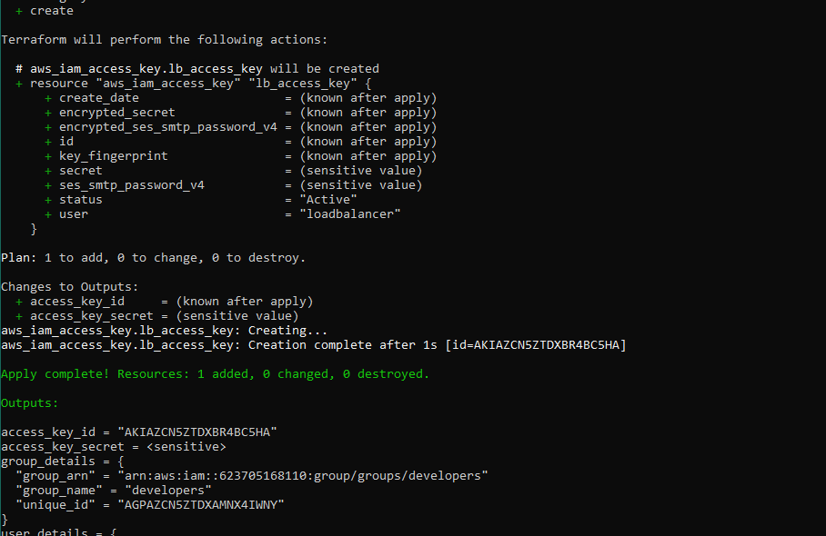
Display outputs:
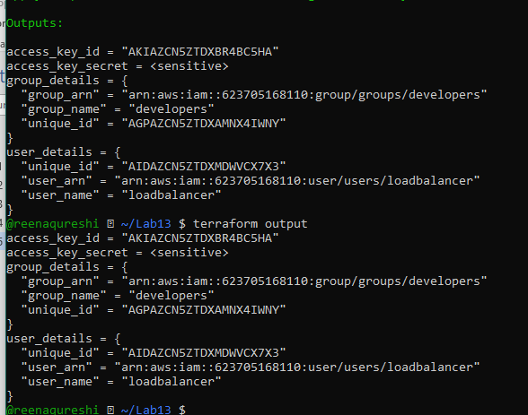
View the secret in terraform state:

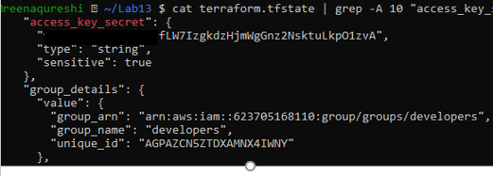
Verify access key in AWS Console:
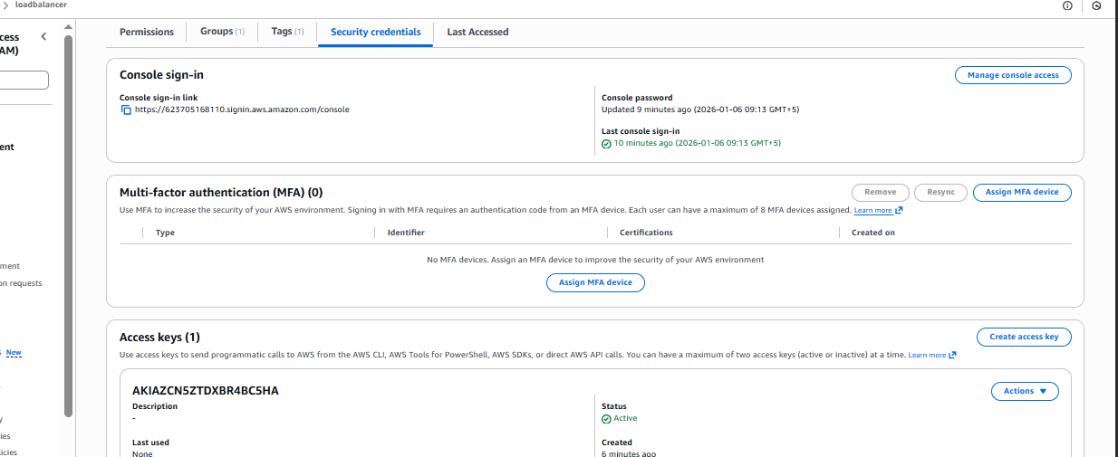

Task 6 — Implement Terraform Remote State with S3

Create S3 bucket in AWS Console:
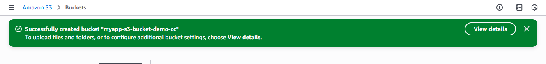
Update main.tf to add S3 backend configuration:

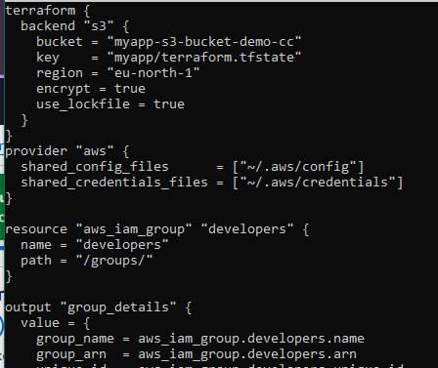
Reinitialize Terraform with the backend:

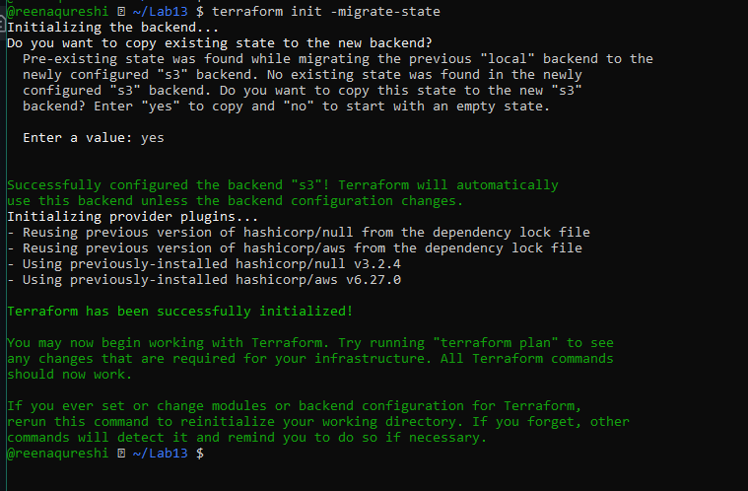

Apply the configuration:
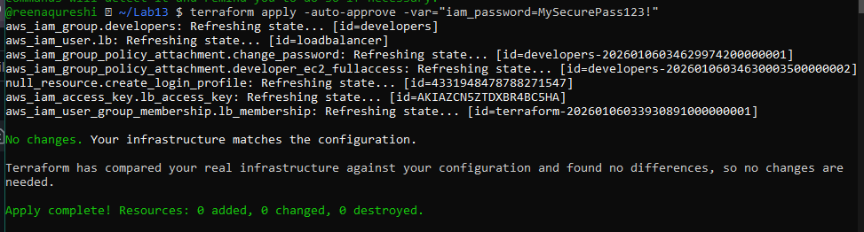
Output:
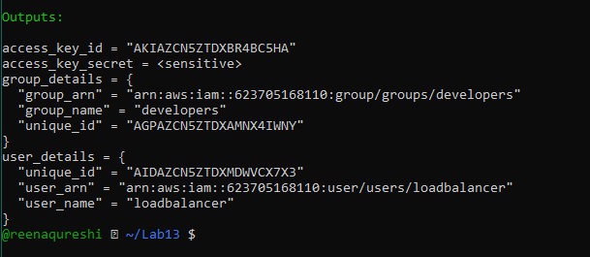
Verify state file in S3:

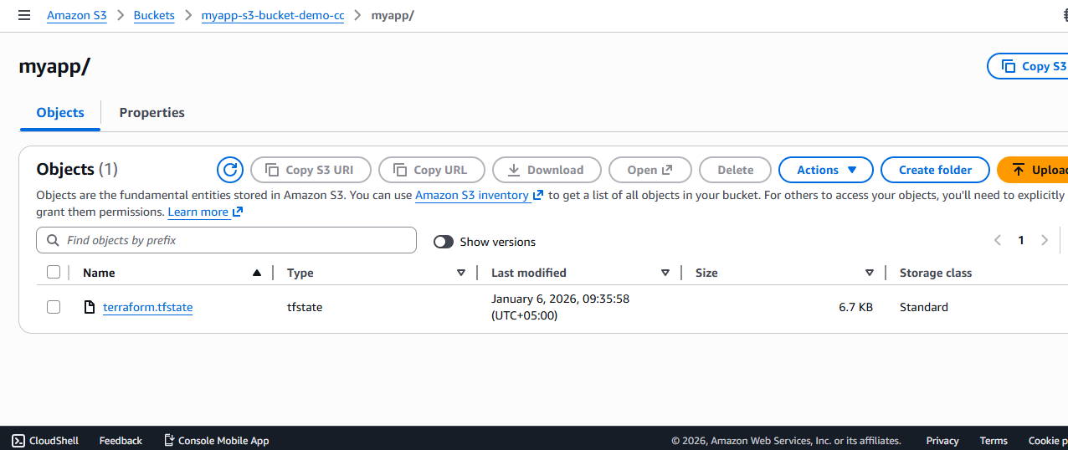
Check local state file:

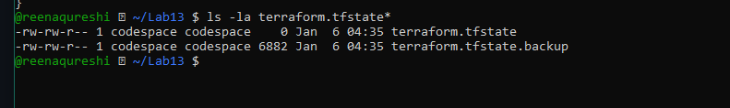
Destroy resources and verify state change:
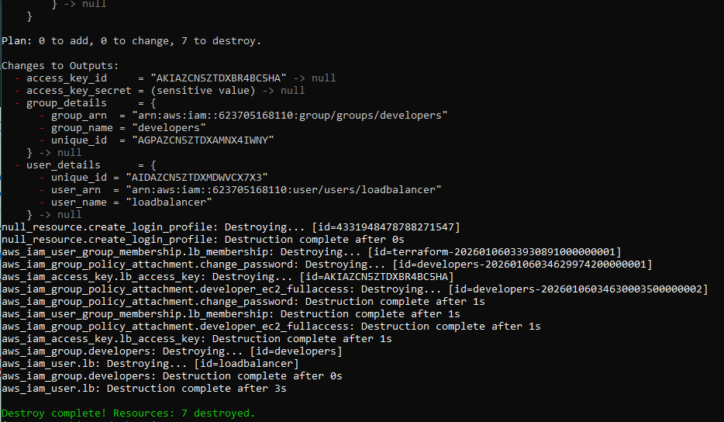
Verify updated state in S3:
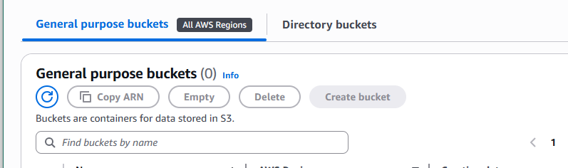
Task 7 — Create Multiple Users from CSV File

Create locals.tf file:

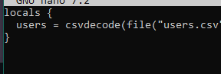
Create users.csv file:
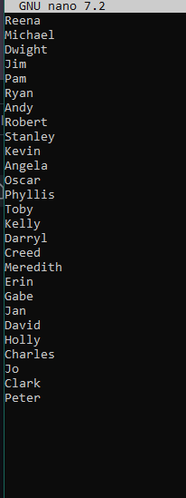
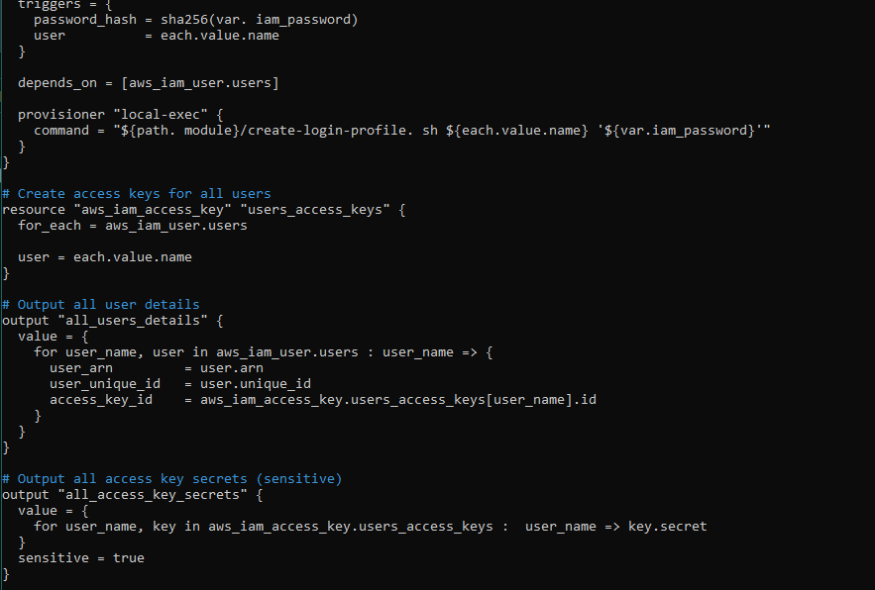

Reinitialize Terraform (since we changed the configuration significantly):
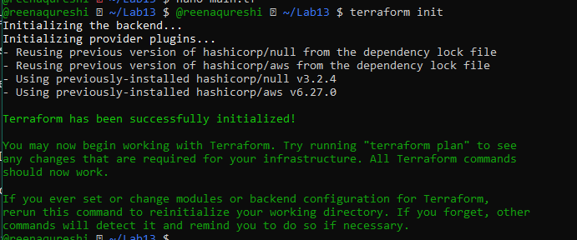
Apply the configuration to create all users:

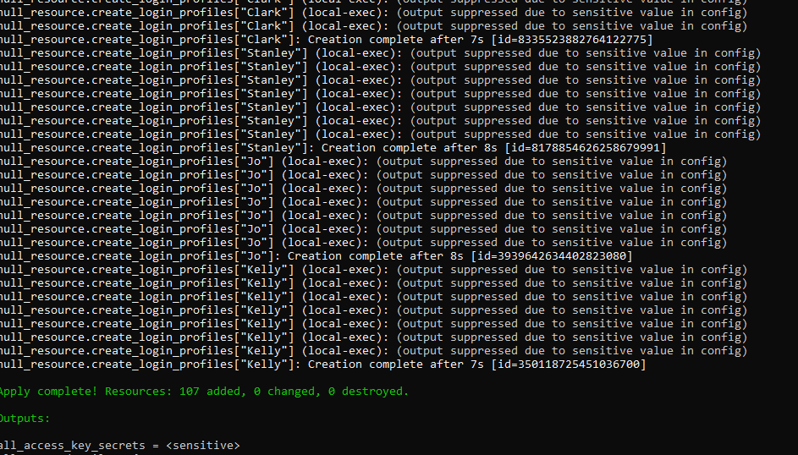
Output:
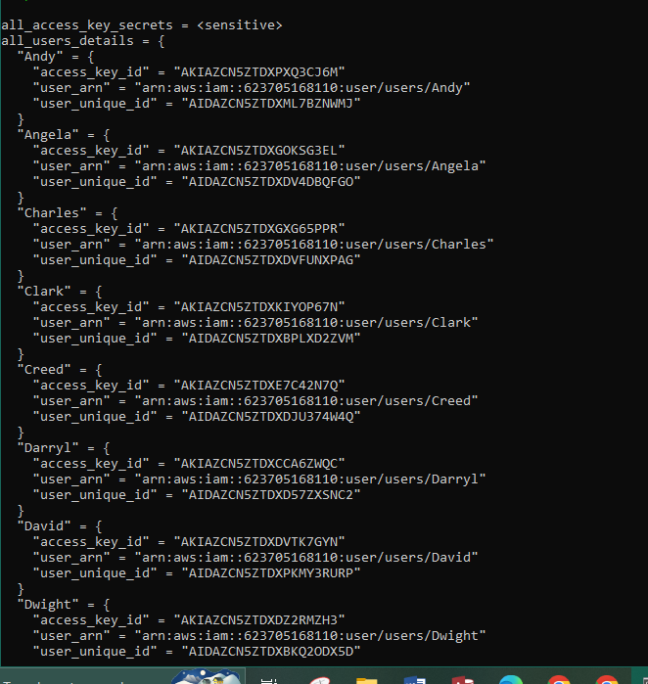

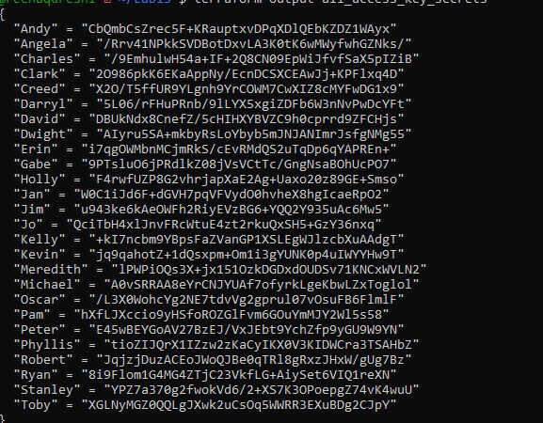
Verify all users in AWS Console:

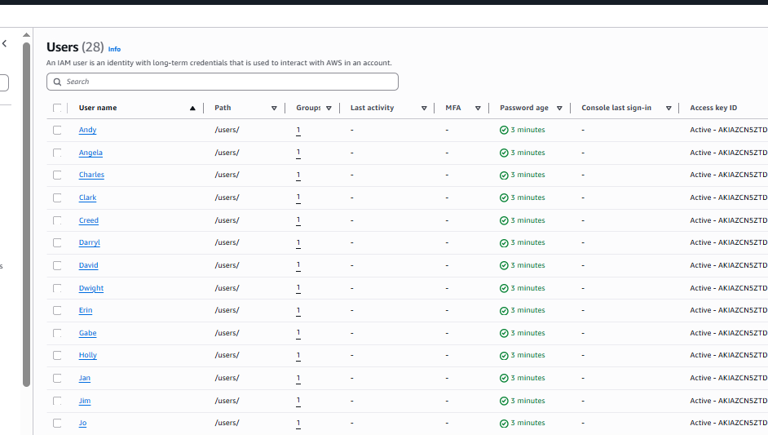
Verify group membership:
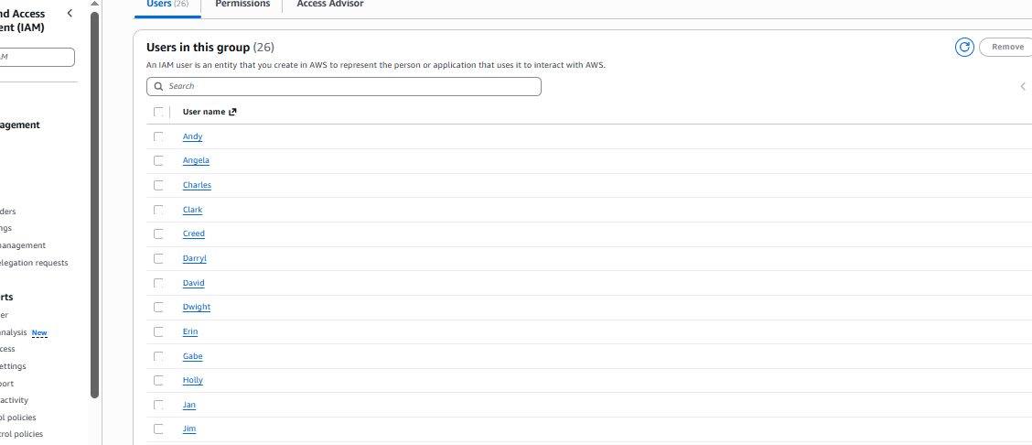
Verify one user's access keys:
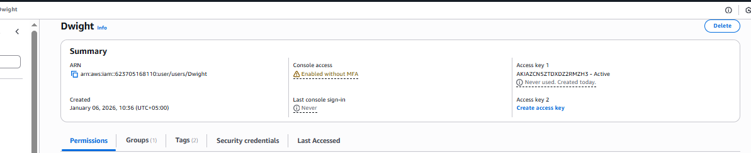
Check terraform state in S3:

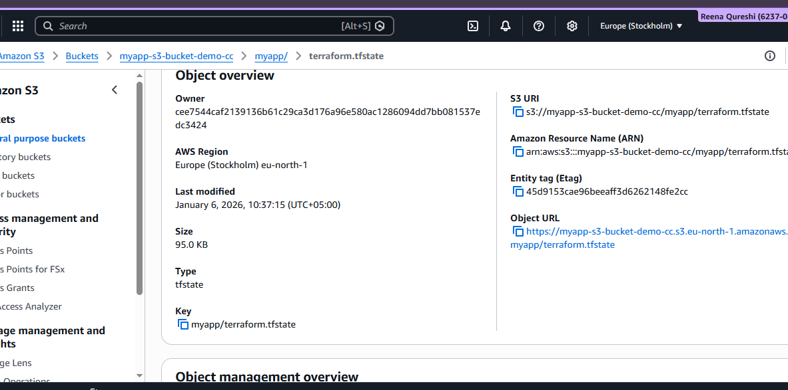
Cleanup

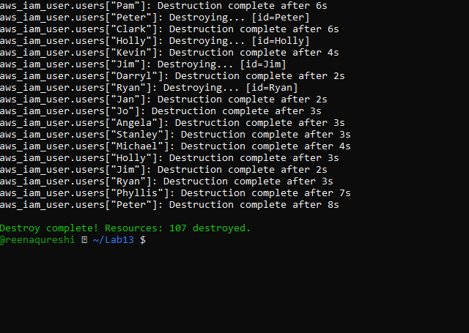
Verify users deleted in AWS Console
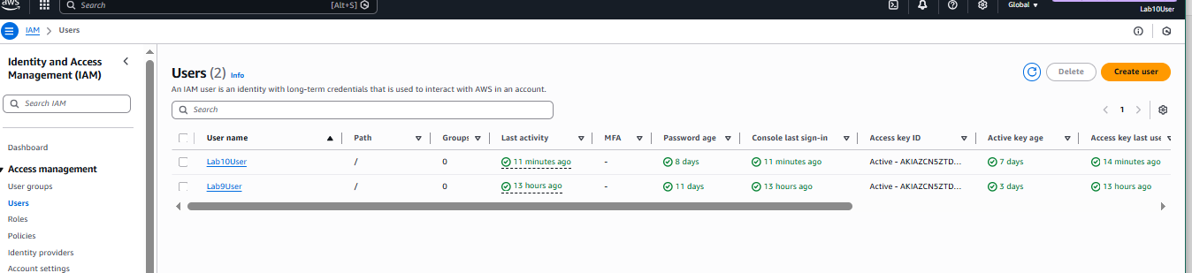
Bucket deleted
