Name : Reena Qureshi
Reg No : 2023-BSE-052
Section: V-B
LAB 12
Task 1 — Organize Terraform code into separate files
Create the initial project structure:
mkdir -p ~/Lab12
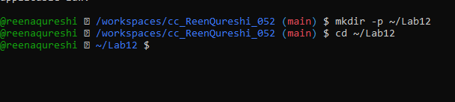

Create all required files:
touch main.tf variables.tf outputs.tf locals.tf terraform.tfvars entry-script.sh
Create variables.tf with the following content

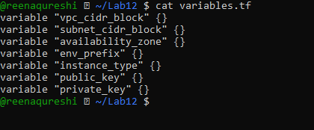

Create outputs.tf with the following content:
output "aws_instance_public_ip" {
value = aws_instance.myapp-server.public_ip
}
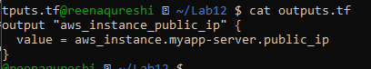

Create locals.tf with the following content:
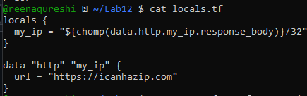

Create terraform.tfvars with the following content:
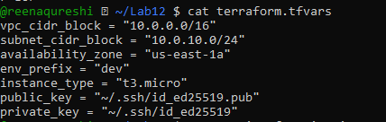

Create main.tf with the following content:
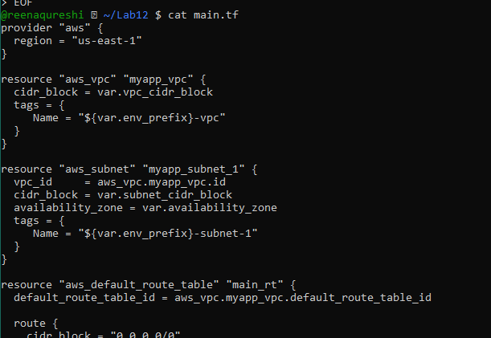
Create entry-script.sh with the following content:
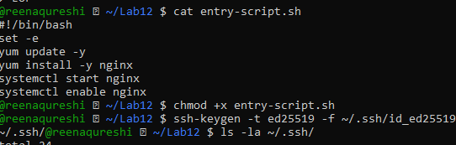
Initialize Terraform:

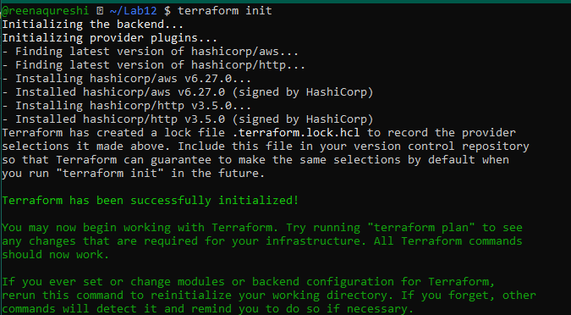
Apply the configuration:

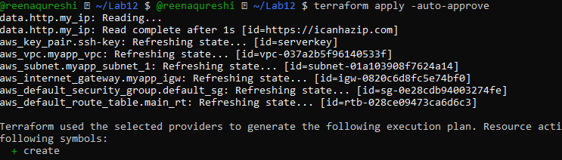
Display the output:

Test nginx in browser:
Open browser and navigate to http://<public-ip>


Destroy:
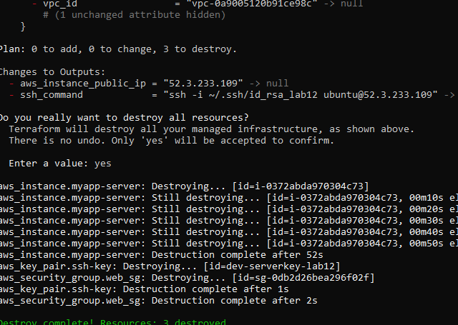

Task 2 — Use remote-exec provisioner
Modify the aws_instance resource in main.tf to use remote-exec provisioner:

Apply the configuration:
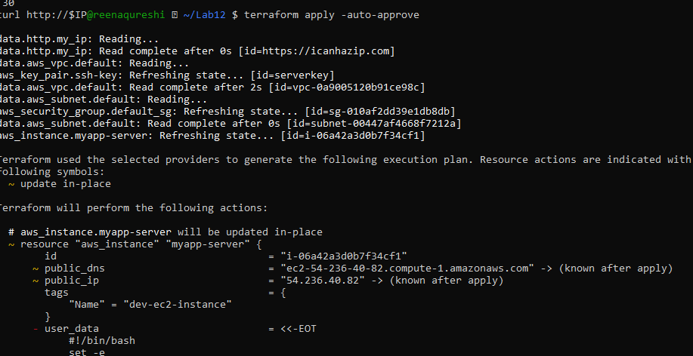

Display the output:
terraform output

Test nginx in browser:
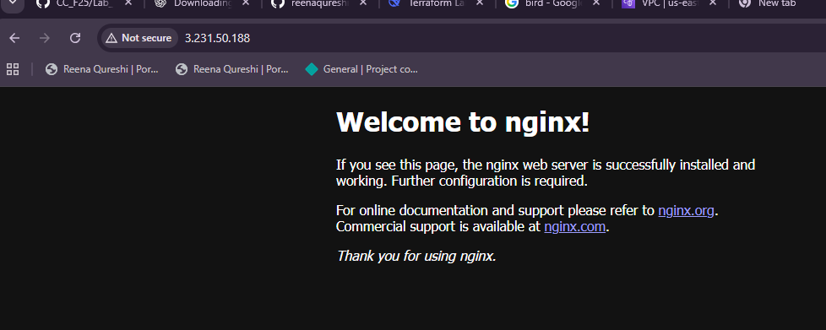

Task 3 — Use file and local-exec provisioners

Modify the aws_instance resource in main.tf to include all three provisioners
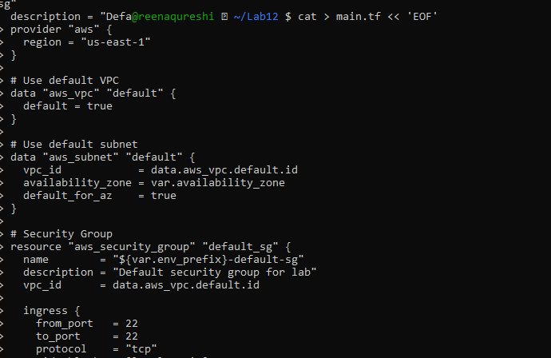
Apply the configuration:

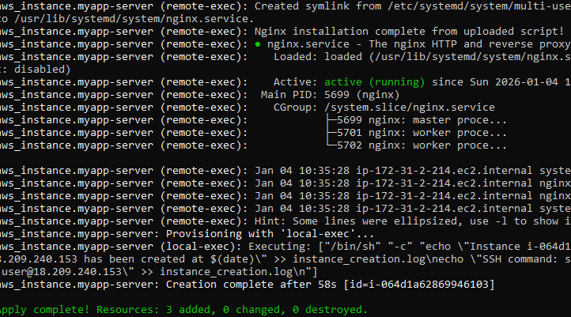
Display the output:
terraform output

Test nginx in browser:
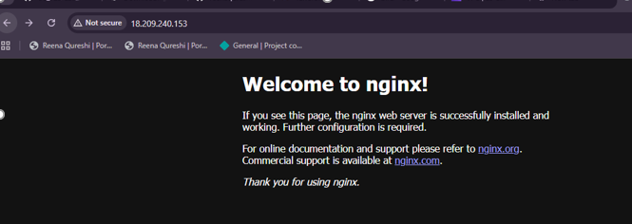
Destroy the resources:

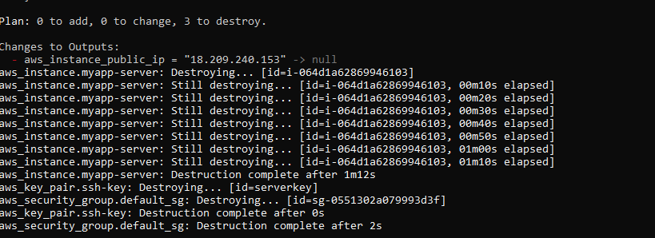

Task 4 — Create Terraform modules (subnet module)
In this task, you will create a reusable subnet module to organize your infrastructure code better.
Create the module directory structure:
mkdir -p modules/subnet
touch modules/subnet/main.tf
touch modules/subnet/variables.tf
touch modules/subnet/outputs.tf
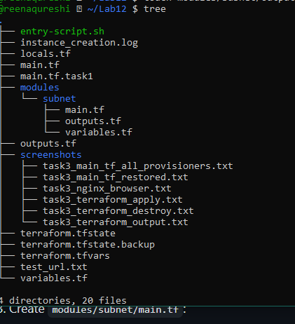
Create modules/subnet/variables.tf:
variable "vpc_id" {}
variable "subnet_cidr_block" {}
variable "availability_zone" {}
variable "env_prefix" {}
variable "default_route_table_id" {}
Create modules/subnet/outputs.tf
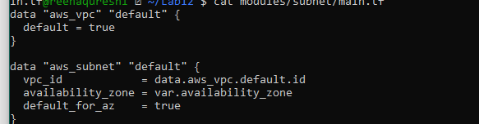
Initialize Terraform to download the module:
terraform init
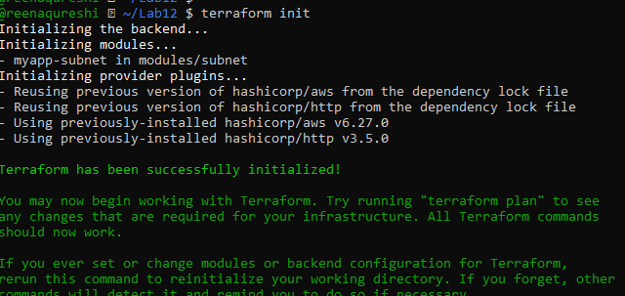
Configure it:
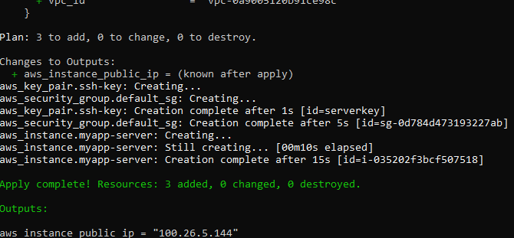
OutPut:
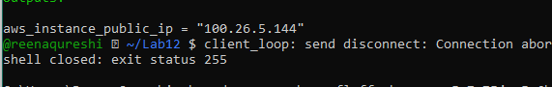

BROWSER:
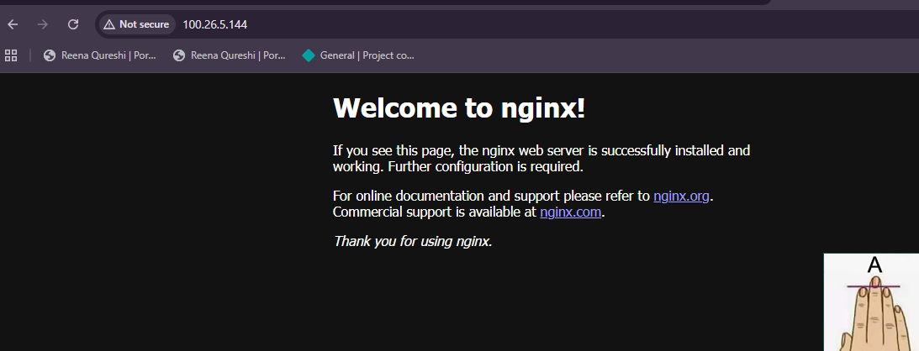

Task 5 — Create webserver module
In this task, you will create a reusable webserver module for EC2 instances.
Create the webserver module directory structure:
mkdir -p modules/webserver
touch modules/webserver/main.tf
touch modules/webserver/variables.tf
touch modules/webserver/outputs.tf

Modify the root main.tf:
Remove the security group, ke
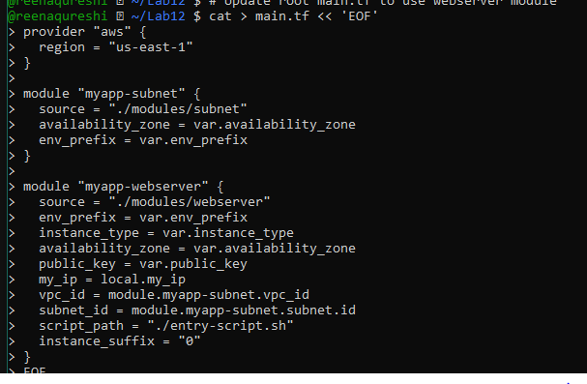
Configuring:
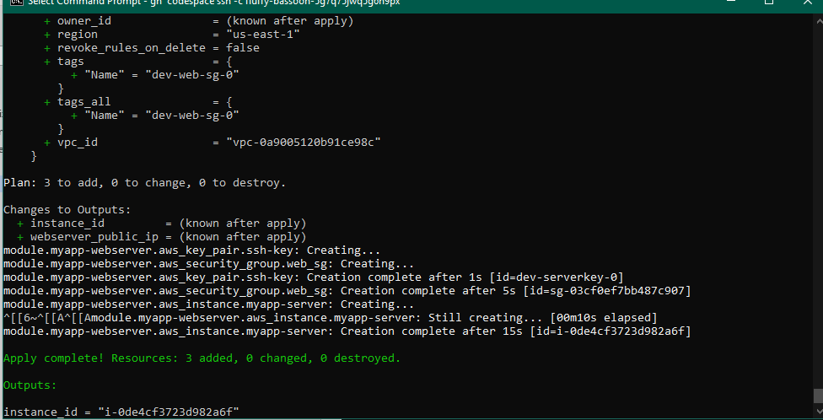

OutPut:
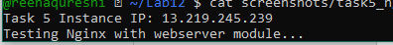
Browser test:
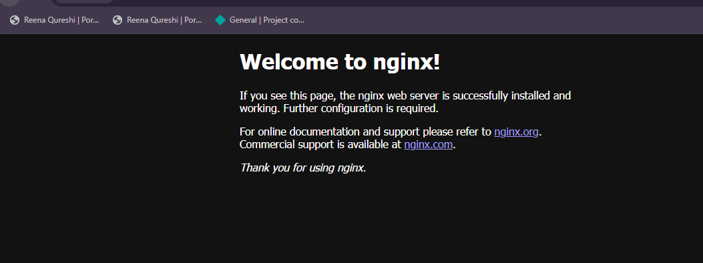
Destroying Resources:
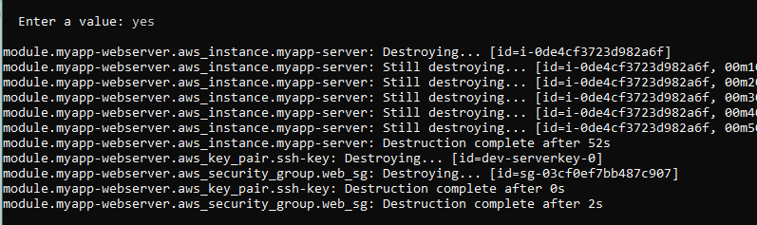

Task 6 — Configure HTTPS with self-signed certificates
In this task, you will configure Nginx to serve traffic over HTTPS using self-signed certificates.
Update entry-script.sh with SSL configuration:

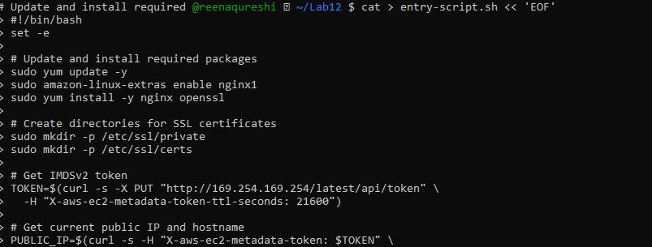
Apply the configuration:
terraform apply -auto-approve
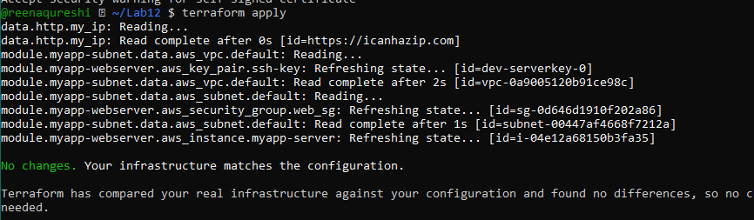
Outputs:
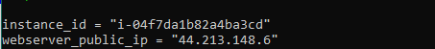
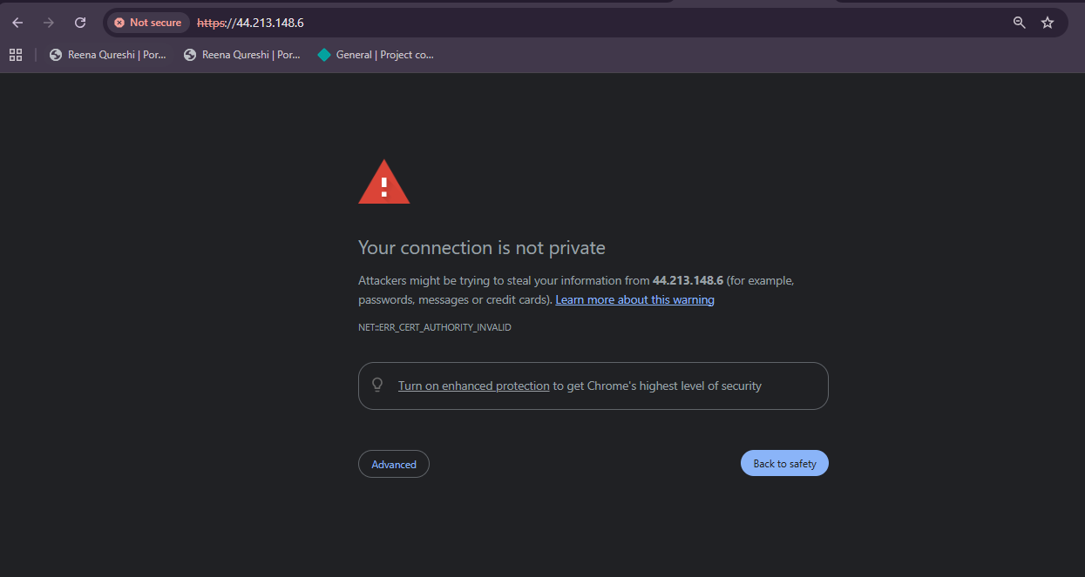
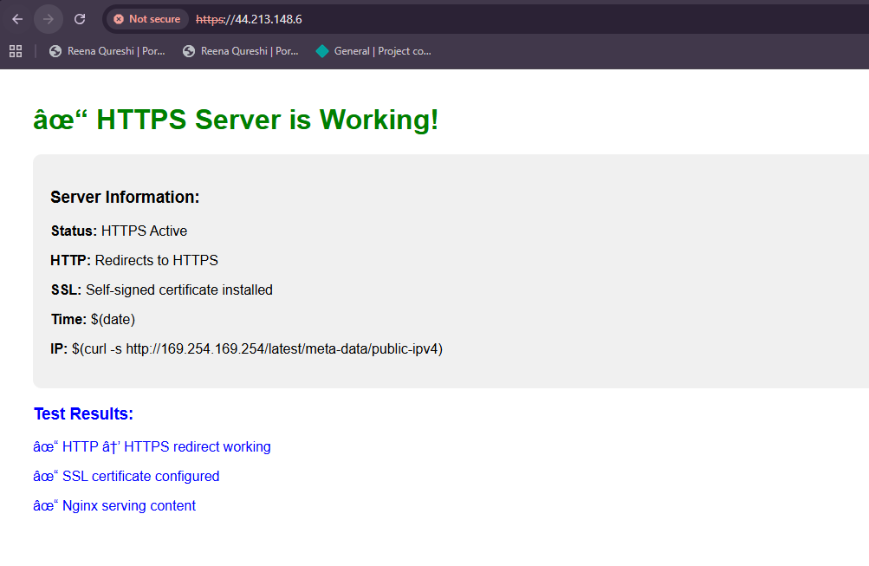
Task 7 — Configure Nginx as reverse proxy

Create apache.sh script for backend web server:
Apply the configuration:
terraform apply -auto-approve
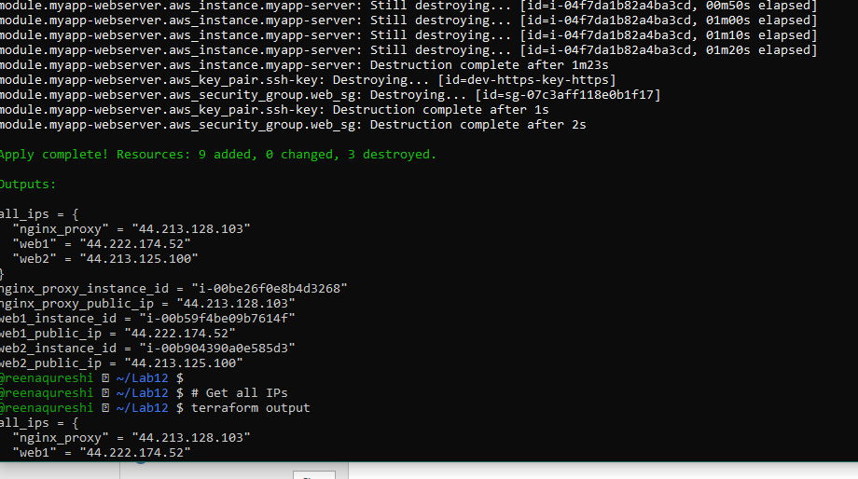
Get the outputs:
terraform output
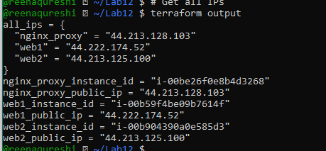
SSH into the webserver (Nginx proxy server)
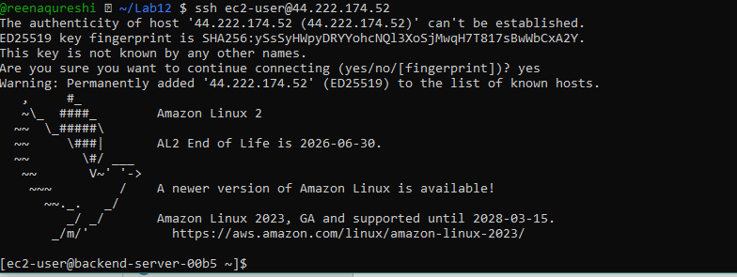
Edit the Nginx configuration:
sudo vim /etc/nginx/nginx.conf
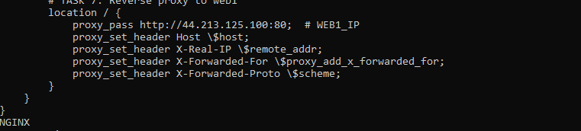
Restart Nginx:
sudo systemctl restart nginx
View Nginx logs and configuration files:
cat /var/log/nginx/error.log
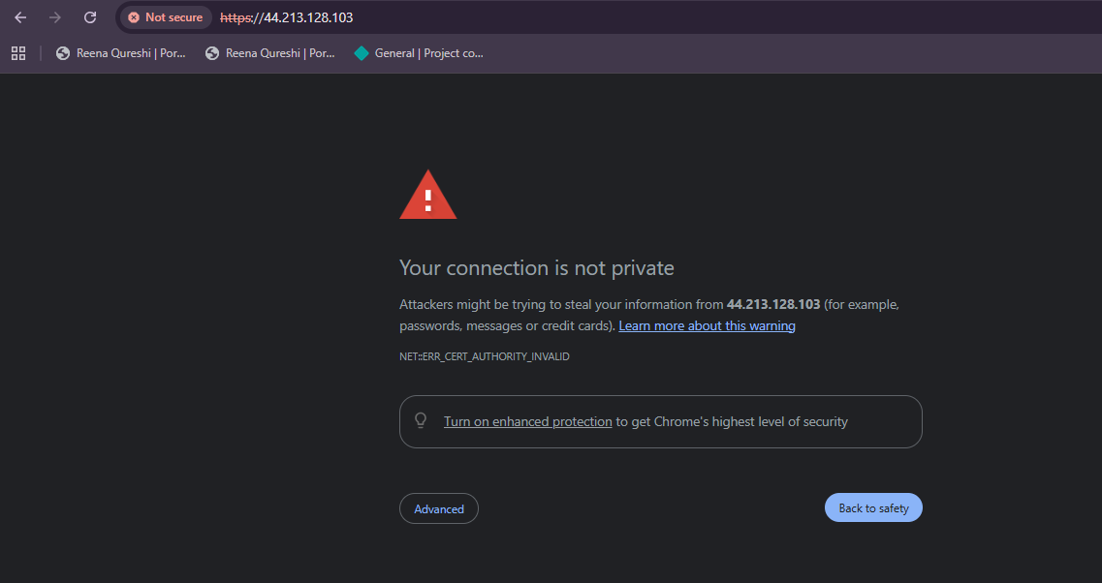
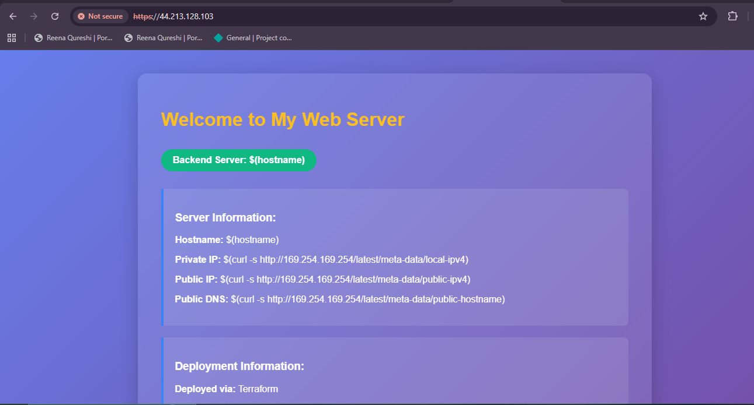
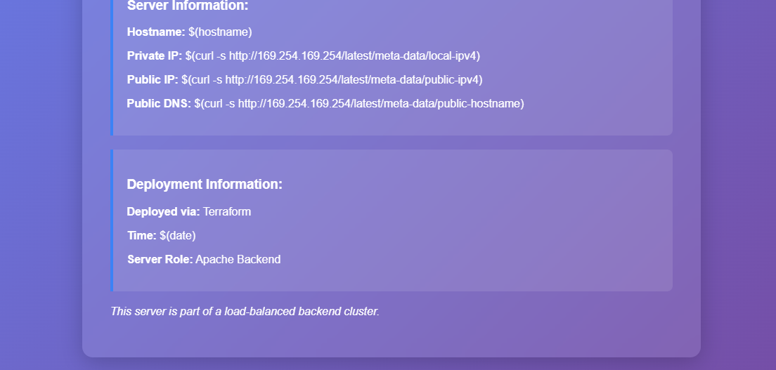
Task 8 — Configure Nginx as load balancer
In this task, you will add a second backend server and configure Nginx
Add the second web server module to main.tf:
Update outputs.tf:
Apply the configuration:

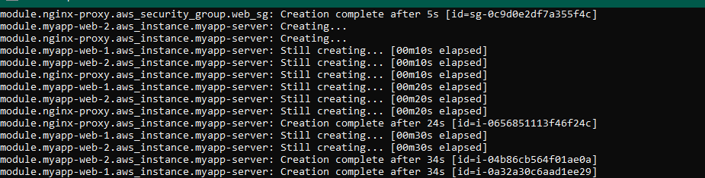
Get all outputs:
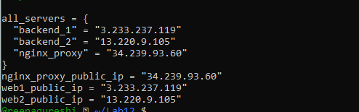
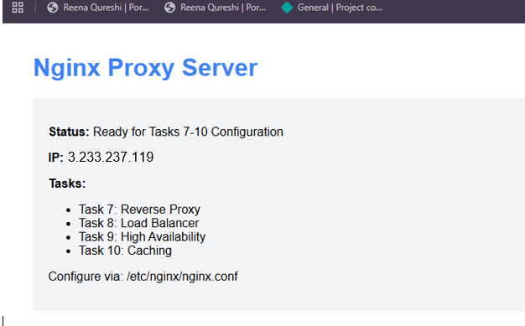
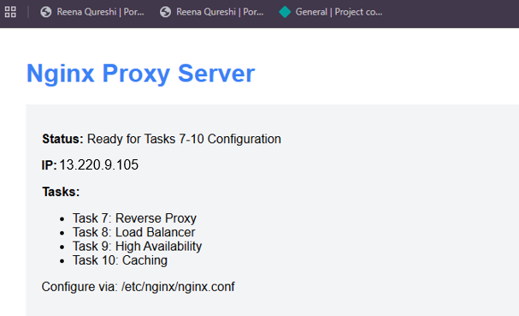

TASK 9: Configure high availability with backup servers

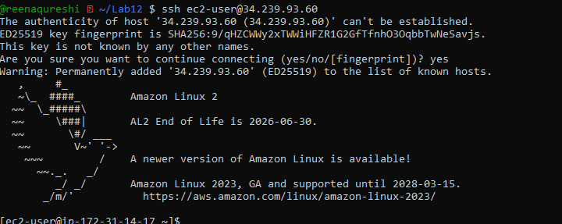
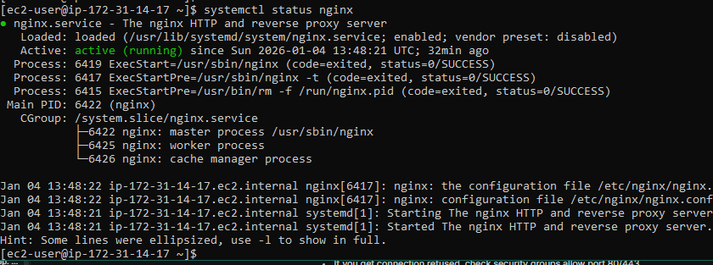
Server running ON web 2:

Task 10 — Enable Nginx caching
- SSH into the webserver:
ssh ec2-user@<webserver-public-ip>

