Name : Reena Qureshi
Reg No: 2023-BSE-052
Section: V-B
LAB EXAM

Q1 – AWS IAM Setup Using AWS CLI and Console Verification (10 marks)
Create IAM group softwareengineering using AWS CLI
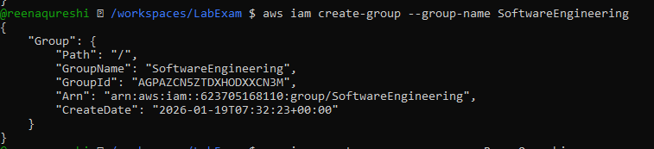

Create IAM user (your name) and view details
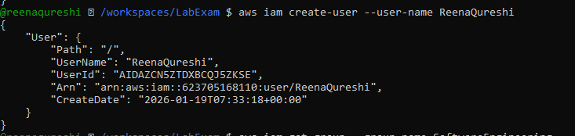
Add the IAM user to the softwareengineering group
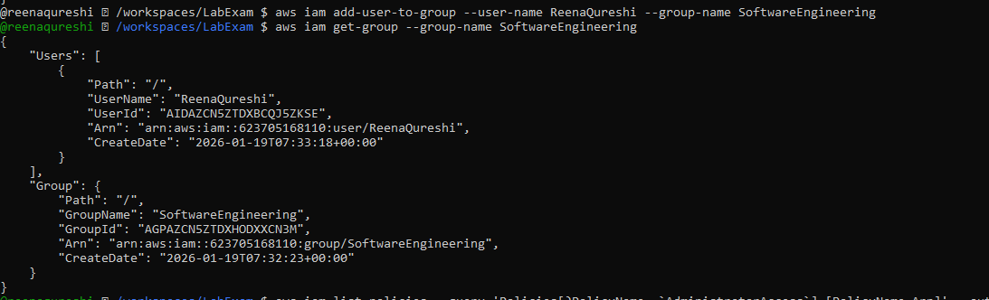
Attach administratoraccess managed policy to the softwareengineering group
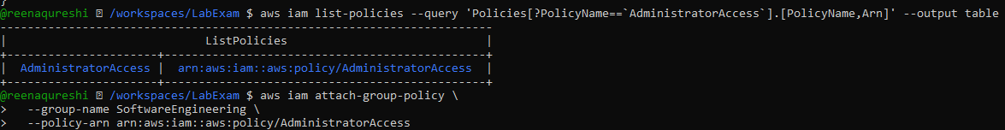
List attached policies of the softwareengineering group
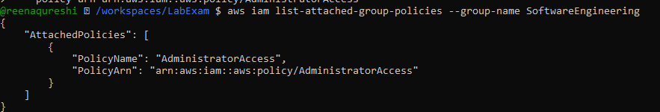
Verify IAM configuration in AWS Management Console
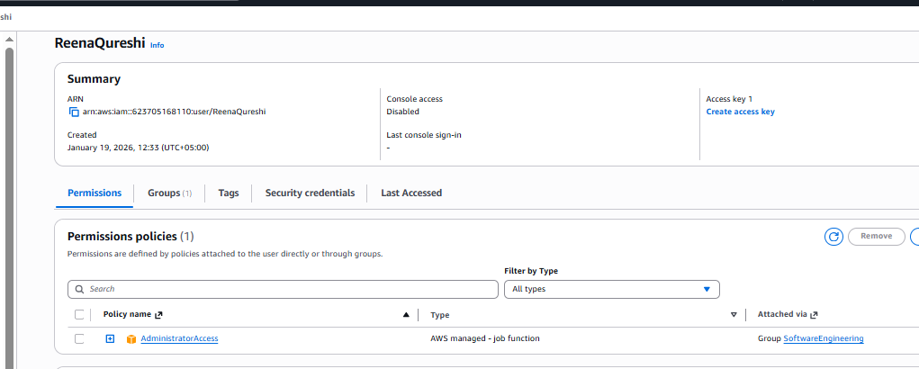
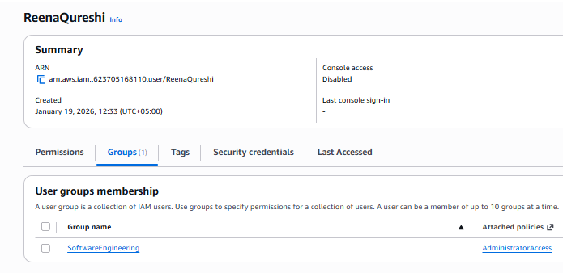
Q2 – Terraform Lab: Simple AWS Environment with Nginx over HTTPS (30 marks)
Configure the AWS provider
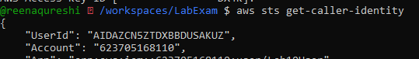
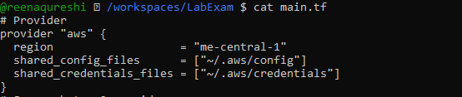
Define input variables
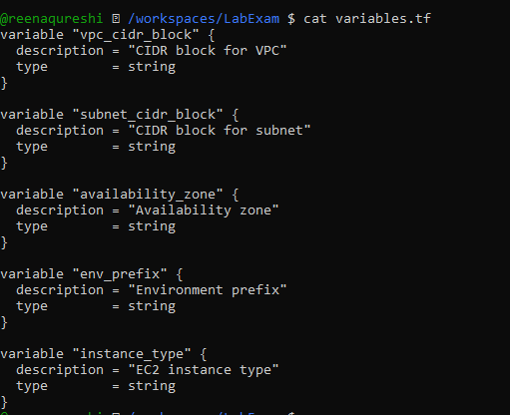
Create VPC and subnet
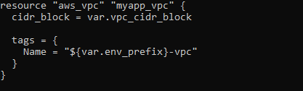
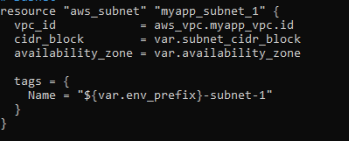
Create Internet Gateway and configure default route table
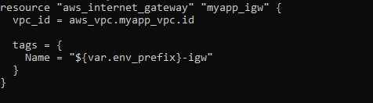
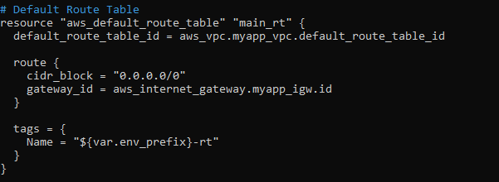
Discover public IP and compute /32 CIDR using data + locals

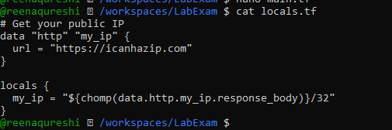
Configure the default security group in the VPC
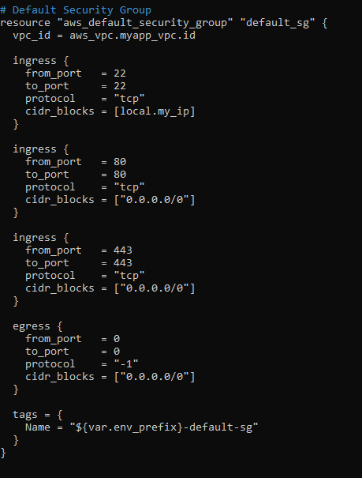
Create an AWS key pair for SSH
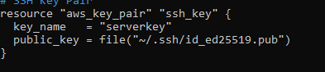
Create the EC2 instance resource
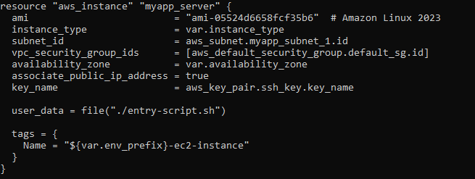
Create entry-script.sh to configure Nginx + HTTPS
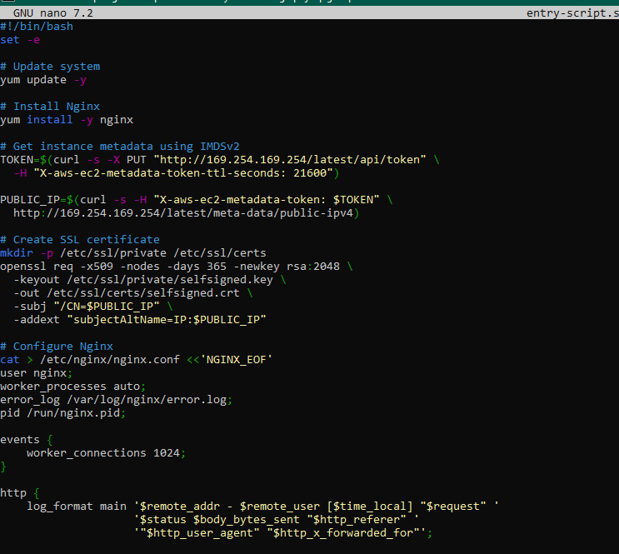
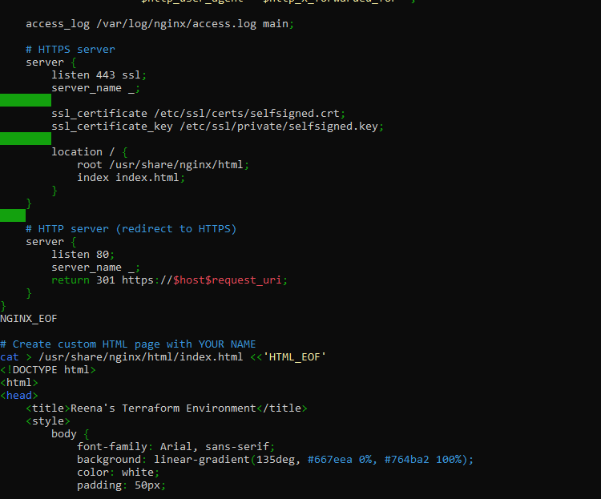
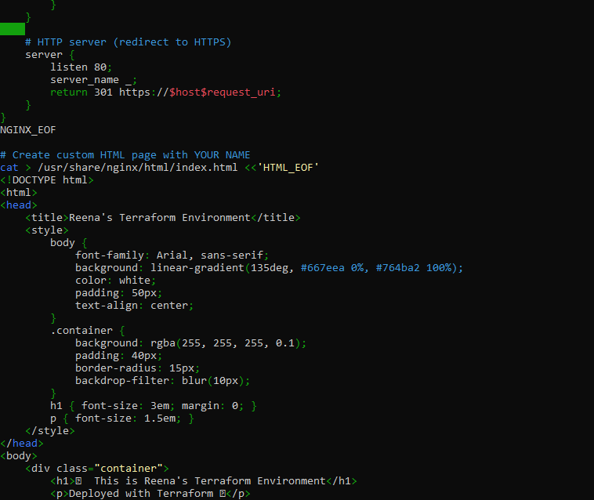
Add Terraform output for public IP
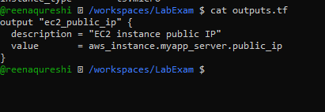
Set variable values for apply time
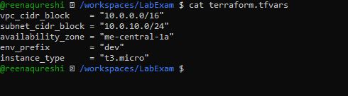
Run Terraform commands and capture outputs
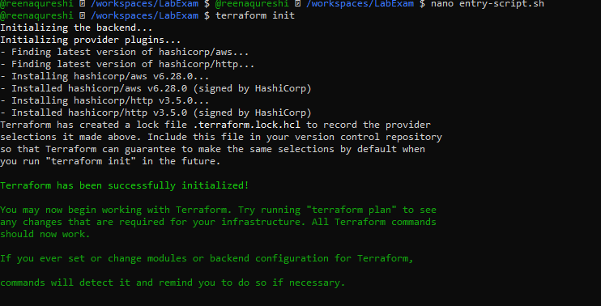
Terraform plan

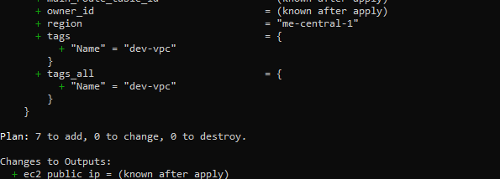
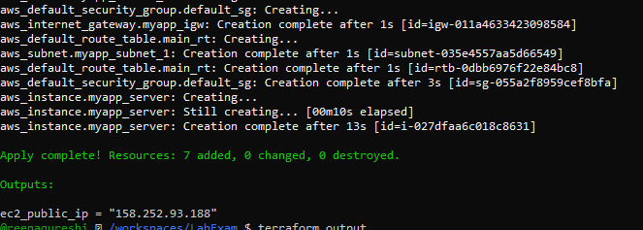
Terraform output
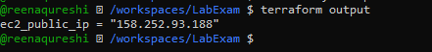

Verify HTTPS access from browser
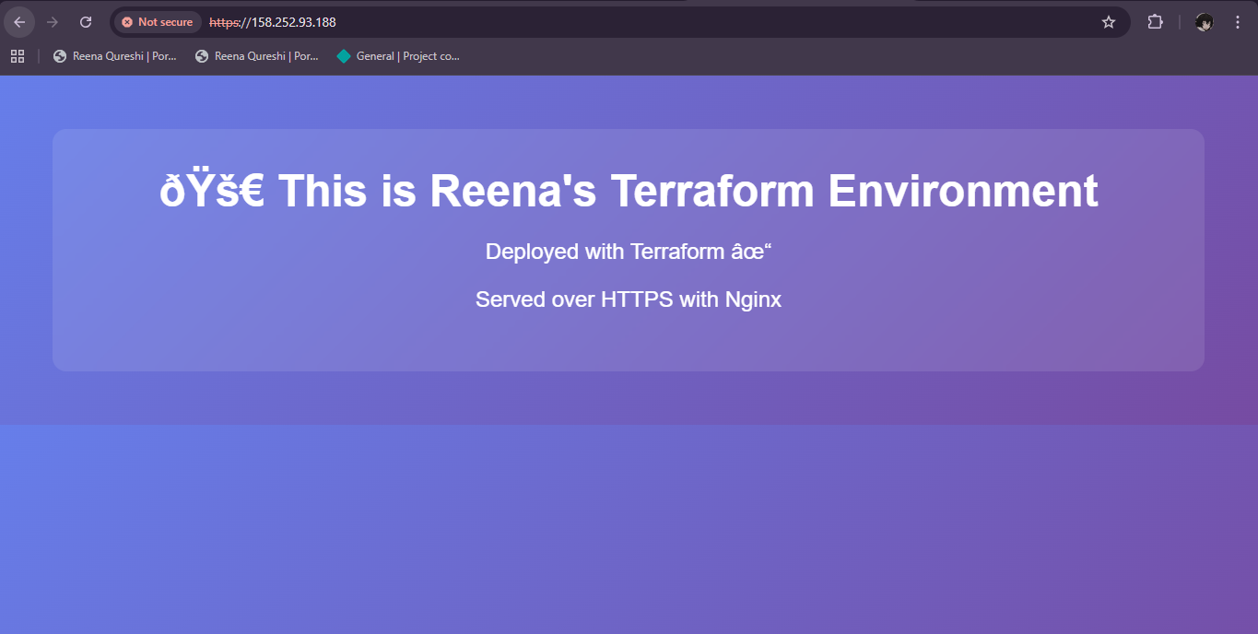

QNO3 Ansible Playbook for EC2 Web Server Using Q2 Instance (10 marks)

Create Ansible inventory file hosts
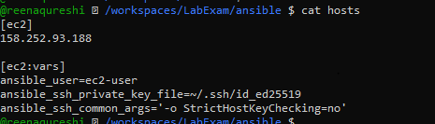

Create project-level ansible.cfg
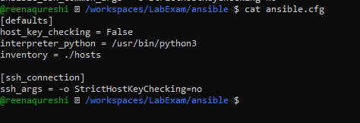
Create Ansible playbook (e.g. My-playbook.yml)

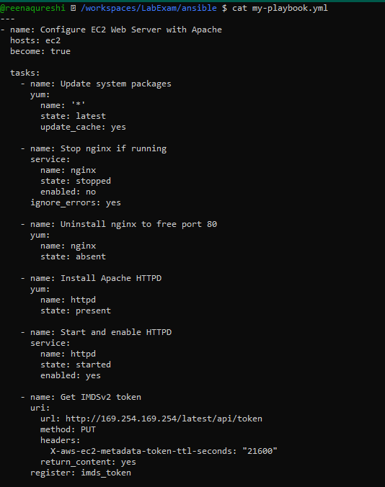
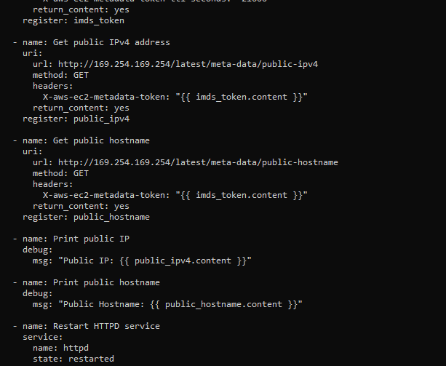
Run the Ansible playbook
Execute:

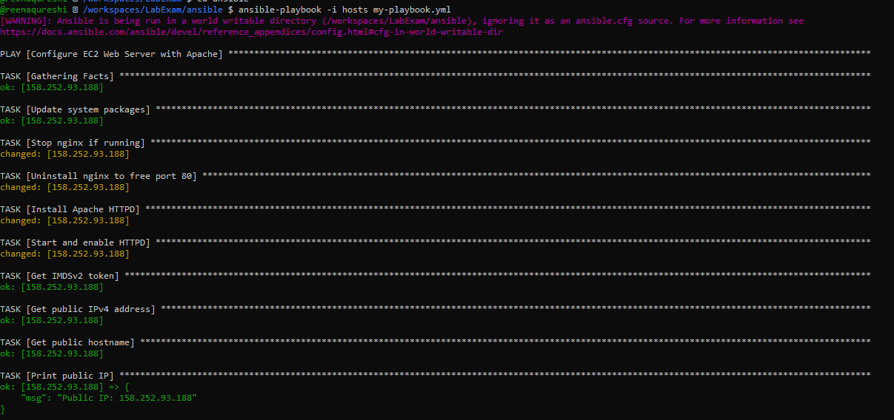
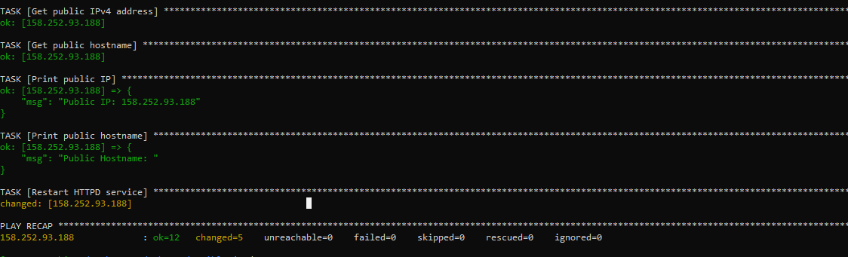
Verify HTTP access

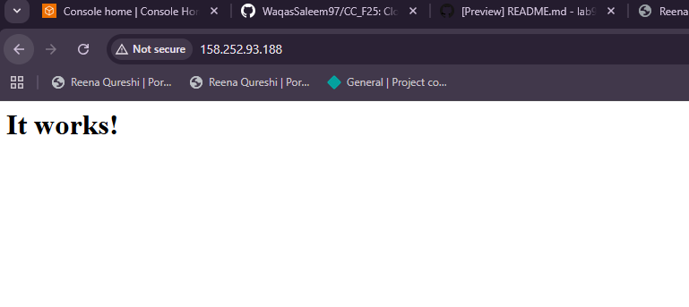
Cleanup (ungraded)
