Name : Reena Qureshi
Reg No: 2023-BSE-052
Section: V-B
LAB 9
Task 1 — GitHub CLI, Codespace setup and authentication
(Local desktop) Install GitHub CLI (Windows example via winget):
winget install --id GitHub.cli

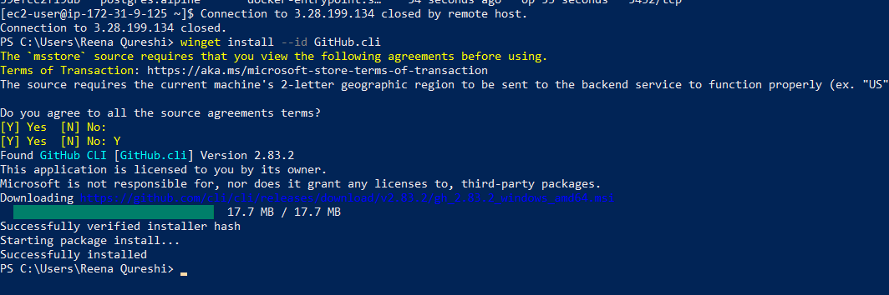
(Local) Authenticate GH CLI for Codespaces:
gh auth login -s codespace
When prompted, generate a GitHub Access Token (classic) in the browser with the following Token scopes:
admin:org
codespace
repo

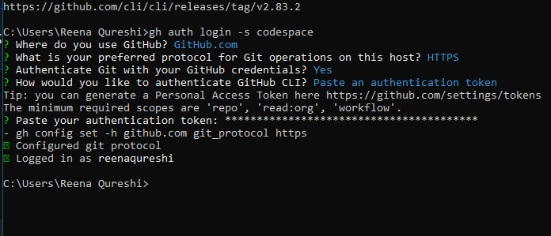

(Local) Create or connect to a Codespace. To create a new codespace from the current repo:
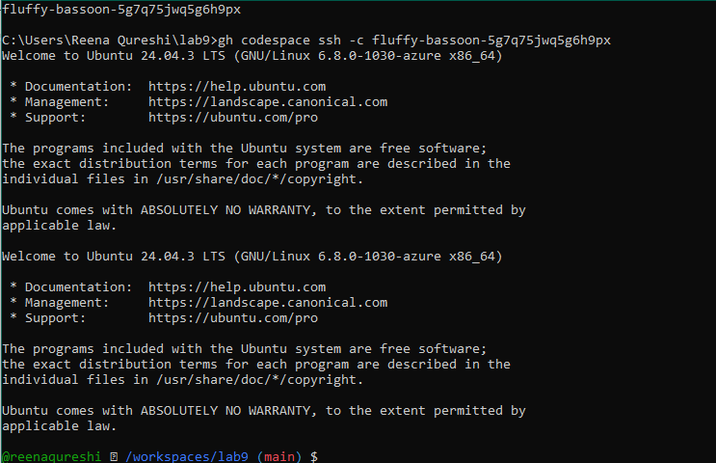

Task 2 — Install AWS CLI inside the Codespace and configure it
Goal: Install the AWS CLI in the Codespace and configure it to interact with your AWS account.
Inside the Codespace shell run:
Download and install AWS CLI:
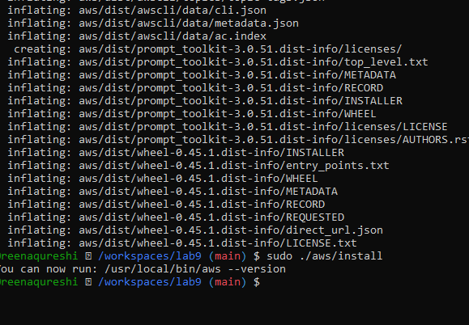
Verify installation:
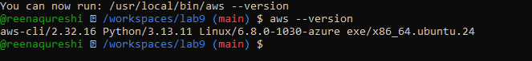
Configure the AWS CLI (you will provide Access Key ID and Secret Access Key for a user with permissions, or use root/IAM user you prepared for the lab):

Verify credentials/config files:
cat ~/.aws/credentials
cat ~/.aws/config
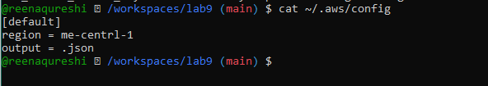
Verify connectivity (you should see a JSON result showing your caller identity):
aws sts get-caller-identity

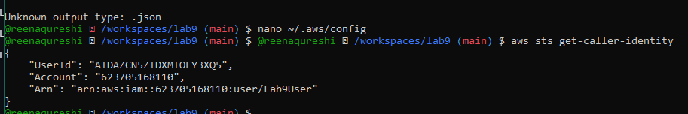
Task 3 — Create security group and add ingress rules using Codespace IP
Goal: Create an EC2 security group, inspect it, add an SSH rule for your Codespace public IP, and verify.
Steps (run in the Codespace shell):
Create a security group (substitute your VPC id):

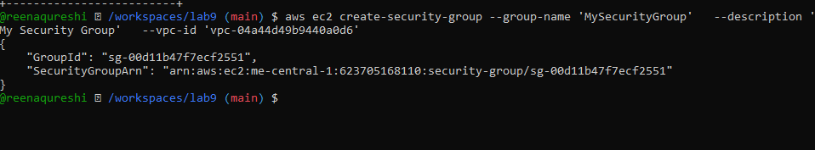
Inspect the security group (initially ingress will be empty or default):
aws ec2 describe-security-groups --group-ids sg-EXAMPLE1234567890

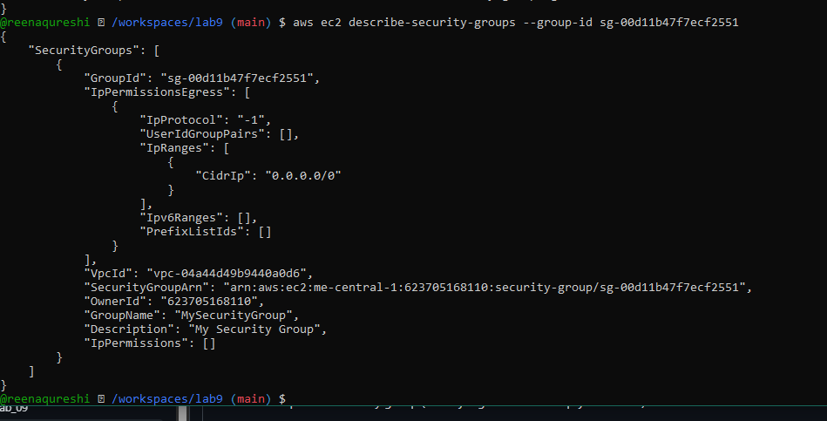
Get your Codespace public IP (from inside the Codespace):
curl icanhazip.com
Authorize SSH inbound on port 22 from your Codespace IP:
aws ec2 authorize-security-group-ingress \
--group-id sg-EXAMPLE1234567890 \
--protocol tcp \
--port 22 \
--cidr <XXX.XXX.XXX.XXX>/

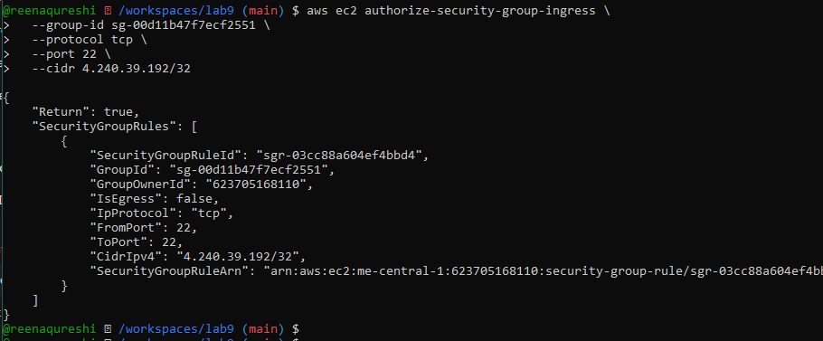

Verify ingress rule appears:
aws ec2 describe-security-groups --group-ids sg-EXAMPLE1234567890

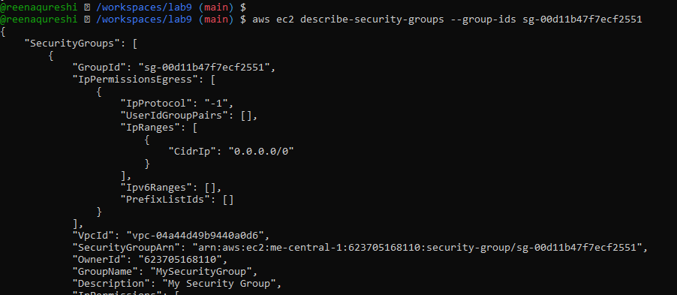
Add an HTTP rule (port 80) using ip-permissions JSON:
aws ec2 authorize-security-group-ingress \
--group-id 'sg-EXAMPLE1234567890' \
--ip-permissions '{"FromPort":80,"ToPort":80,"IpProtocol":"tcp","IpRanges":[{"CidrIp":"<XXX.XXX.XXX.XXX>/32"}]}'
Verify both ingress rules are present:
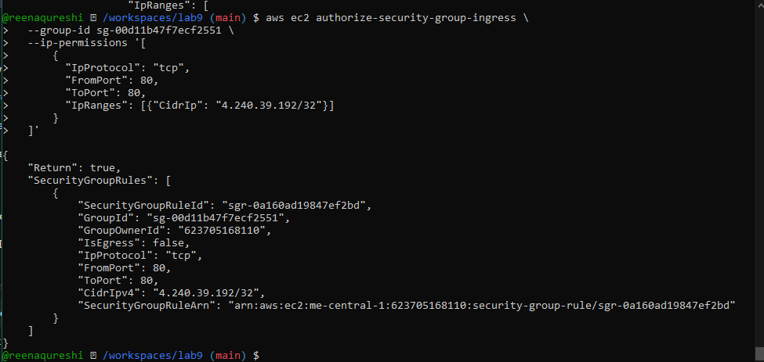
Task 4 — Create a key pair, describe key pairs, and launch EC2 instance
Goal: Create an ED25519 key pair, view it, and launch an EC2 instance using the key pair and the security group created earlier.
Steps:
Create the key pair and save the PEM file into the Codespace workspace:
aws ec2 create-key-pair \
--key-name MyED25519Key \
--key-type ed25519 \
--key-format pem \
--query 'KeyMaterial' \
--output text > MyED25519Key.pem

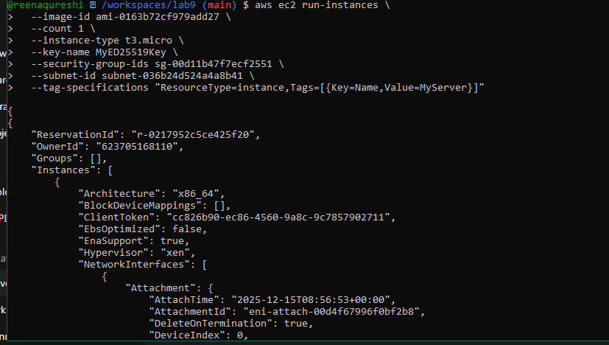
Attempt SSH into the instance from the Codespace or from a machine whose IP is allowed in the security group:
ssh -i MyED25519Key.pem ec2-user@<public-ip-address>
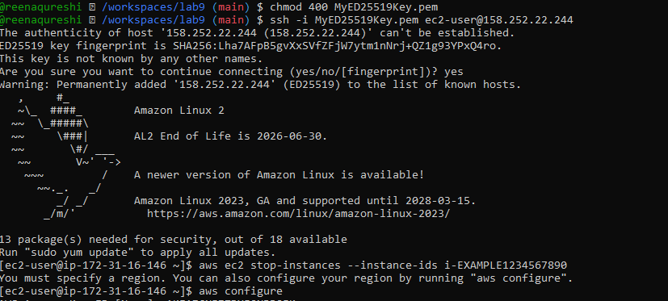
aws ec2 stop-instances --instance-ids i-EXAMPLE1234567890

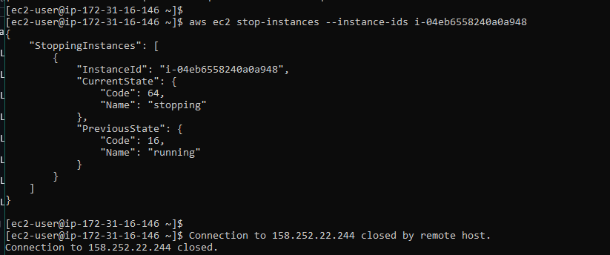
aws ec2 start-instances --instance-ids i-EXAMPLE1234567890

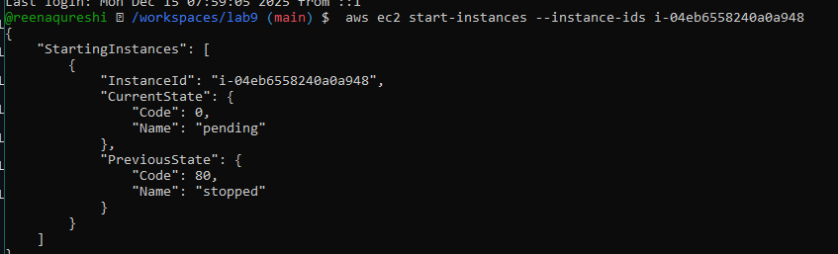
Task 5 — Understand AWS describe-* commands

Run and understand these commands (run each, then capture screenshot immediately after):
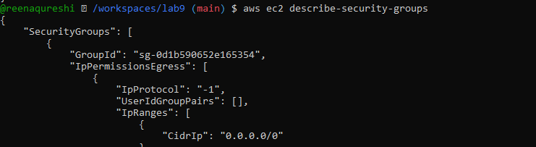
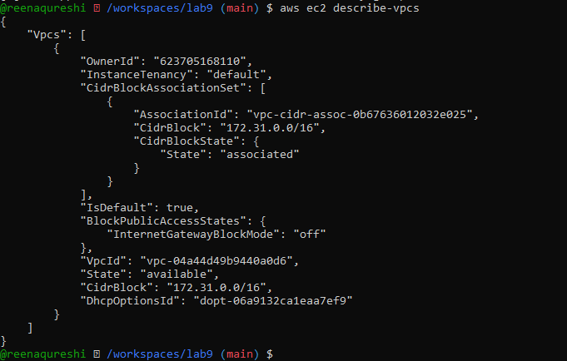
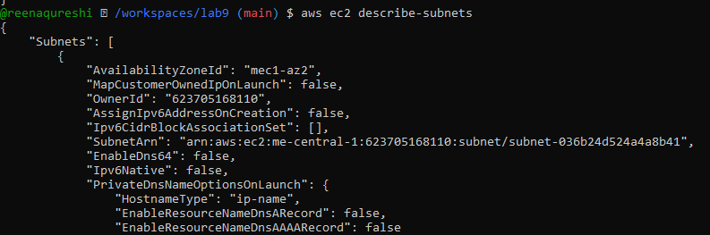
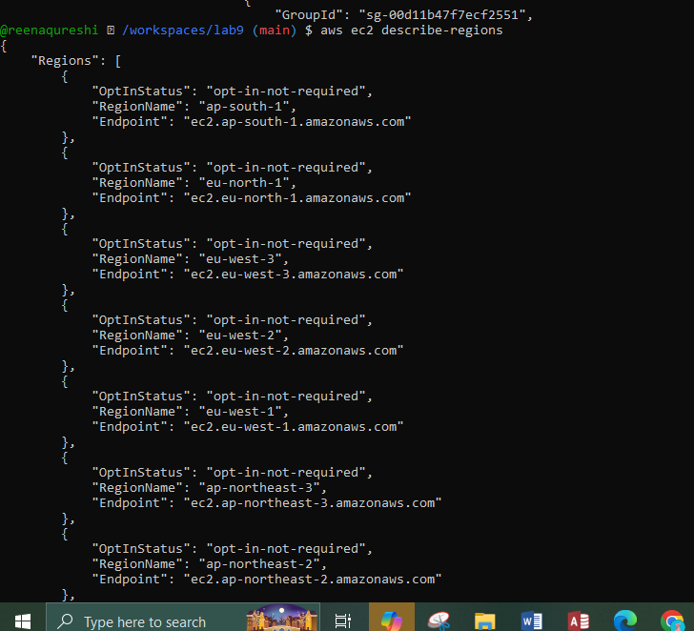
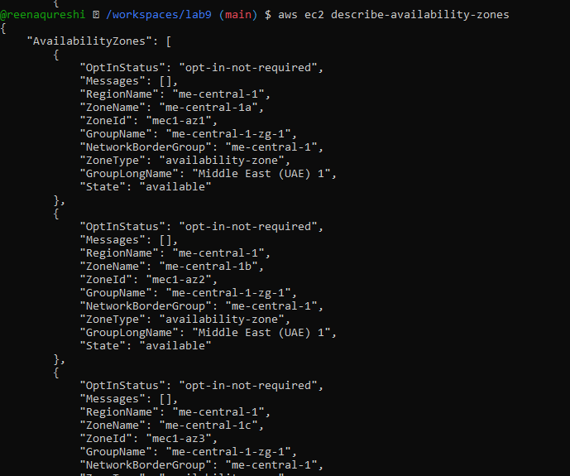
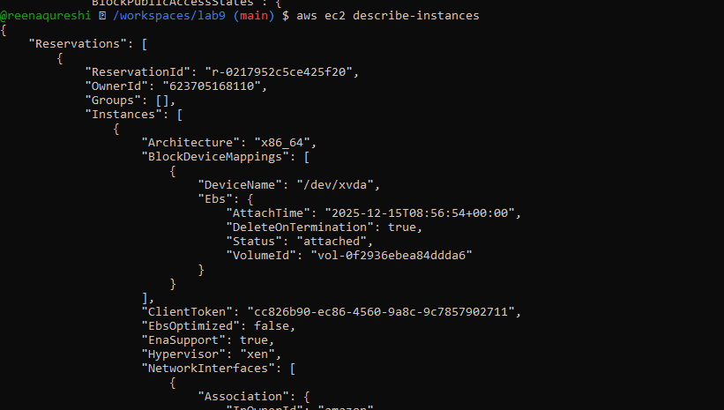

Task 6 — IAM: create group, user, attach policies, create console login & keys

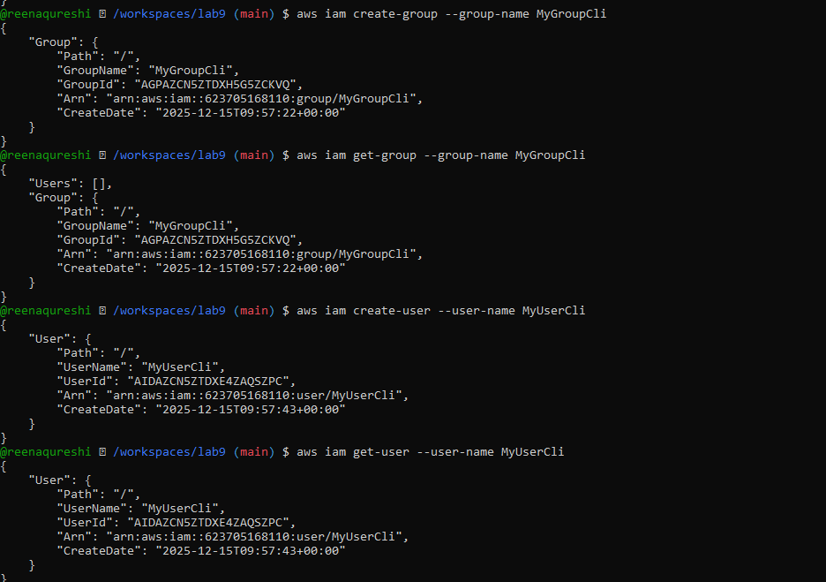
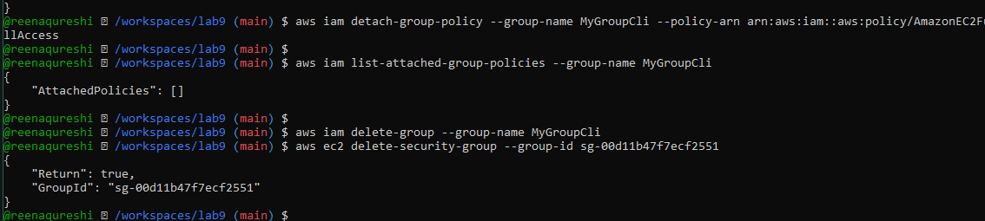

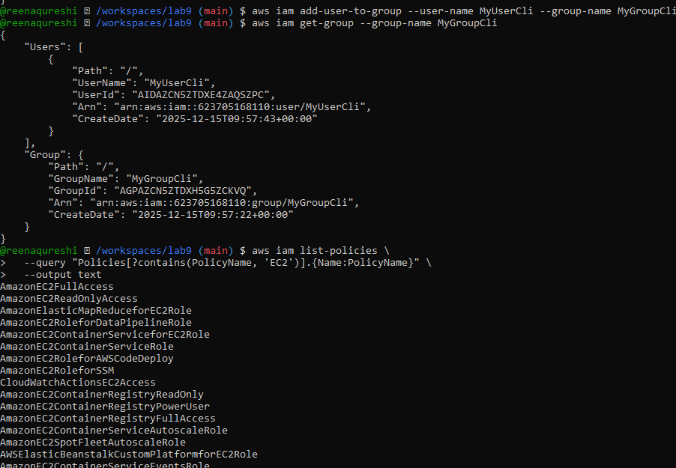
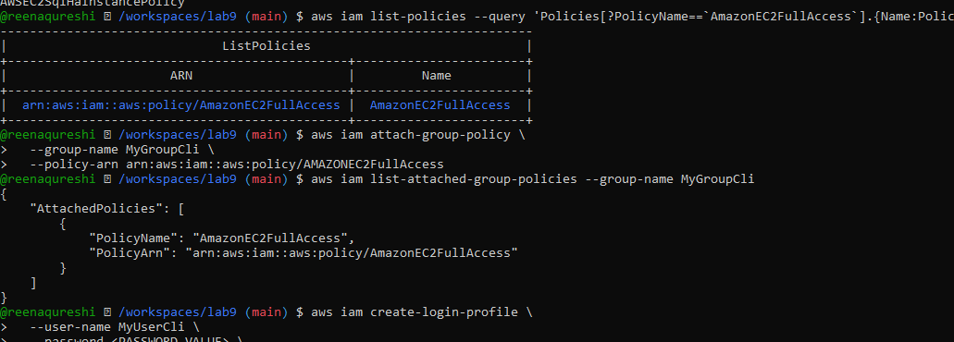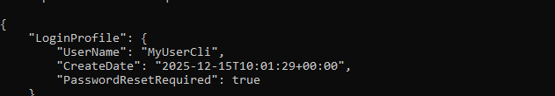
Create access keys for the user (save AccessKeyId and SecretAccessKey securely):
aws iam create-access-key --user-name MyUserCli
List access keys:
aws iam list-access-keys --user-name MyUserCli
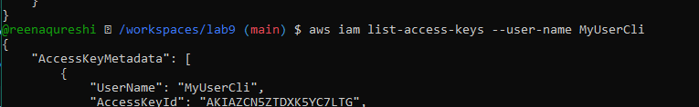
Task 7 — Filters: query with filters to find instances and their attributes
Examples (run each and take a screenshot immediately after)
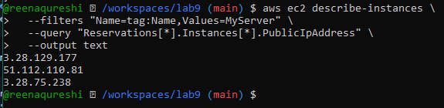
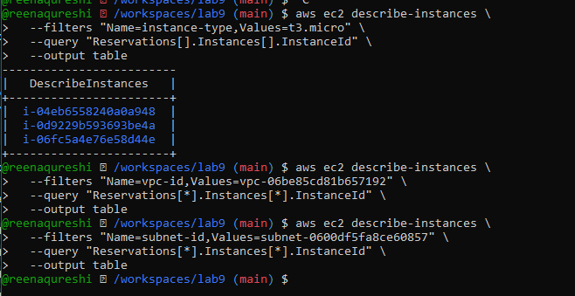
Task 8 — Use --query to format outputs for reporting
Goal: Extract useful fields in table format for reporting.
Examples (run each and take a screenshot immediately after)
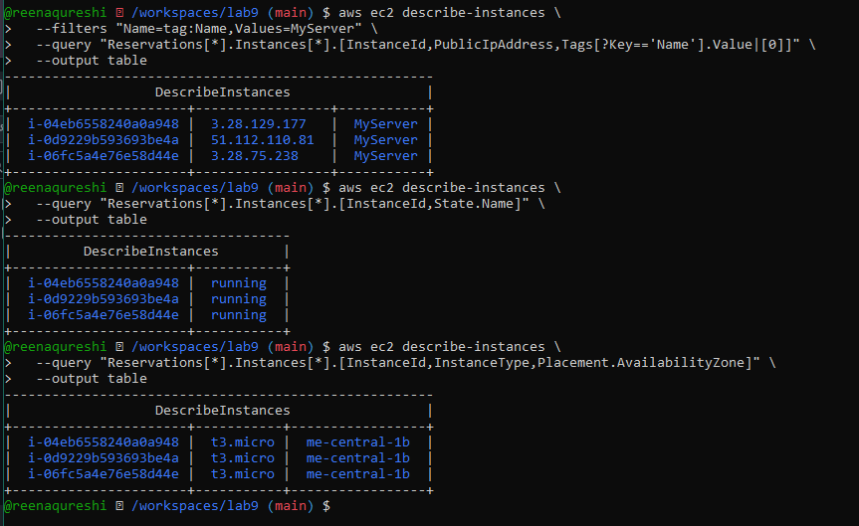

Cleanup — Remove resources to avoid charges
After verification, terminate and delete everything you created in AWS. Capture screenshots for each step.
Cleanup steps and required screenshots (take each screenshot immediately after running the command):
Terminate instances:
aws ec2 terminate-instances --instance-ids i-EXAMPLE1234567890

