Name : Reena Qureshi
Reg No : 2023-BSE-052
Section : V-B
LAB 10
Task 1 — GitHub CLI, Codespace setup and authentication
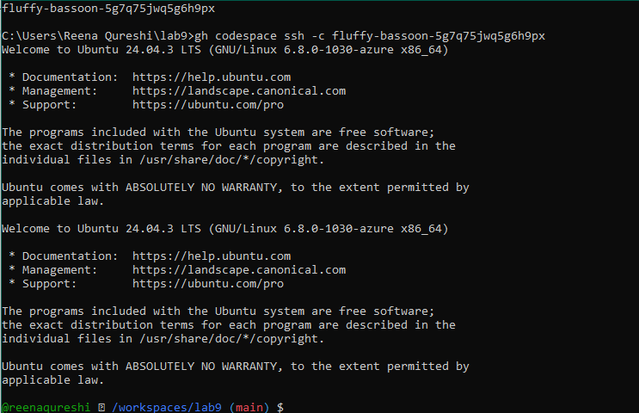

Task 2 — Install AWS CLI inside the Codespace and configure it
Aws installed.

Install Terraform CLI

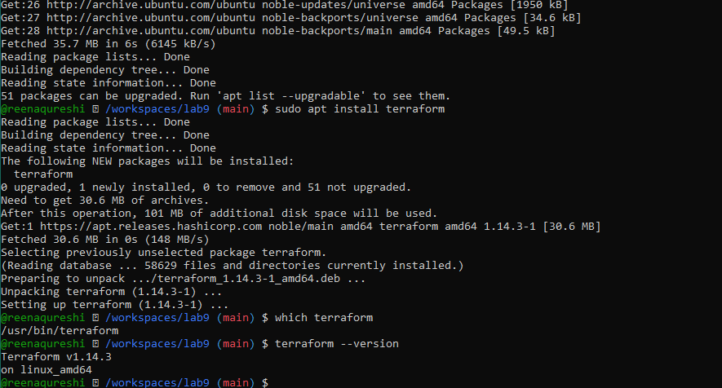

C. Provider Configuration (main.tf)

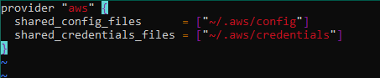

Initialize Terraform:

terraform init

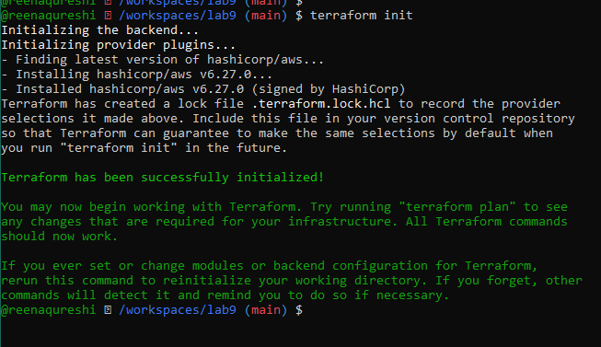

Show contents of .terraform.lock.hcl:

cat .terraform.lock.hcl

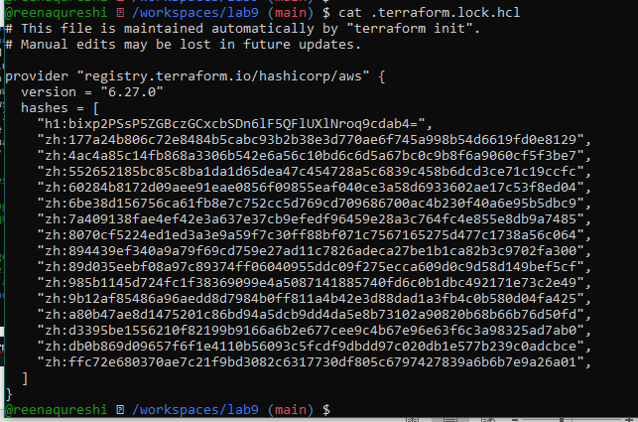
Show contents of .terraform/ directory:
ls .terraform/

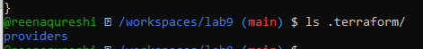

Task 3 — VPC/Subnet Creation, Initialization, Verification

Edit main.tf to add:

resource "aws_vpc" "development_vpc" {

cidr_block = "10.0.0.0/16"

}

resource "aws_subnet" "dev_subnet_1" {

vpc_id = aws_vpc.development_vpc.id

cidr_block = "10.0.10.0/24"

availability_zone = "me-central-1a"

}

Run:

terraform apply

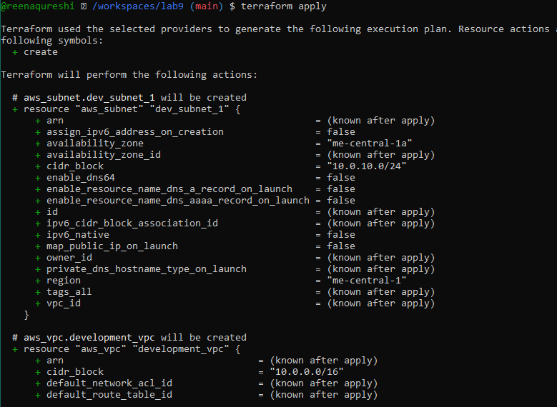

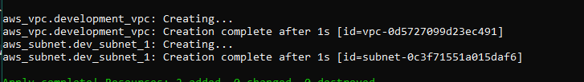

Verify resources using AWS CLI:

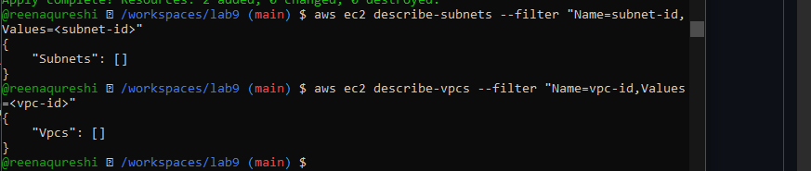

Task 4 — Data Source, Targeted Destroy, Tags

Data Source & Resource Creation

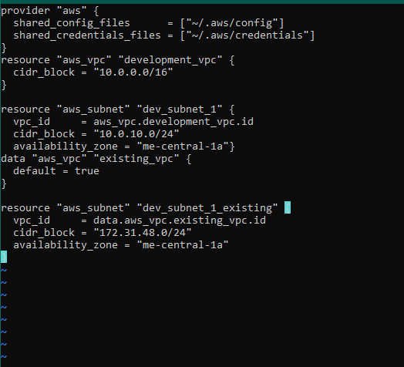

Apply configuration:

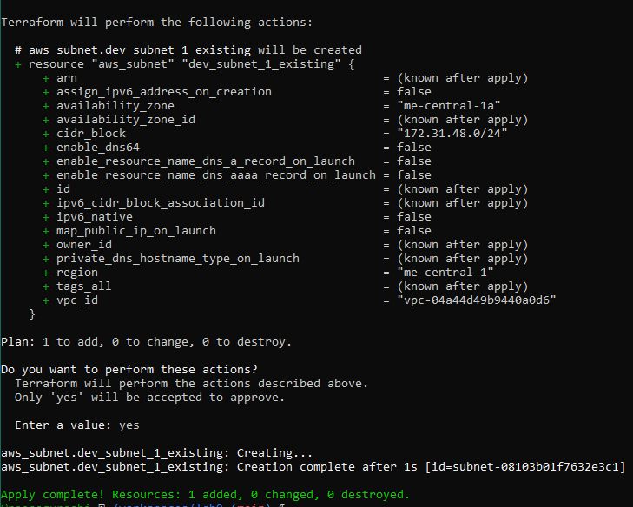

Targeted Destroy & Refresh

Destroy only one resource:

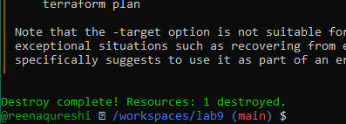

Refresh state:

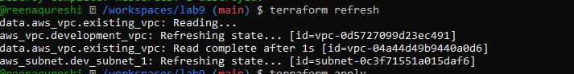

Re-apply configuration:

terraform apply

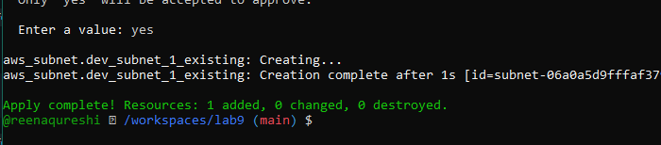

Destroy all resources:

terraform destroy

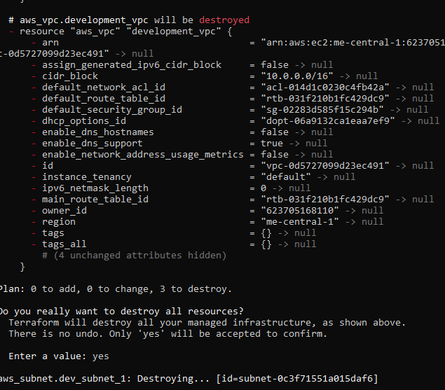

Apply again:

terraform apply

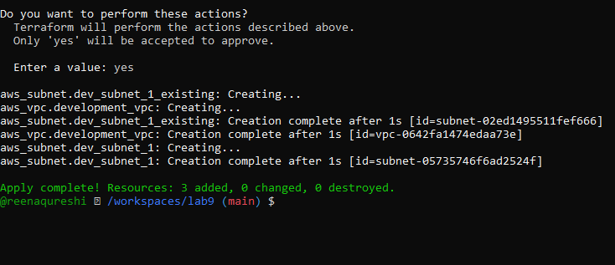

C. Tagging Resources

Modify main.tf to add tags:

resource "aws_vpc" "development_vpc" {

cidr_block = "10.0.0.0/16"

tags = {

Name: "development"

vpc_env = "dev"

}

}

resource "aws_subnet" "dev_subnet_1" {

vpc_id = aws_vpc.development_vpc.id

cidr_block = "10.0.10.0/24"

availability_zone = "me-central-1a"

tags = {

Name: "subnet-1-dev"

}

}

resource "aws_subnet" "dev_subnet_1_existing" {

vpc_id = data.aws_vpc.existing_vpc.id

cidr_block = "172.31.48.0/24"

availability_zone = "me-central-1a"

tags = {

Name: "subnet-1-default"

}

}

Use vim to update tags.

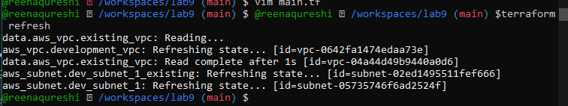

Recreate resources:

terraform apply

View state files:

Run:

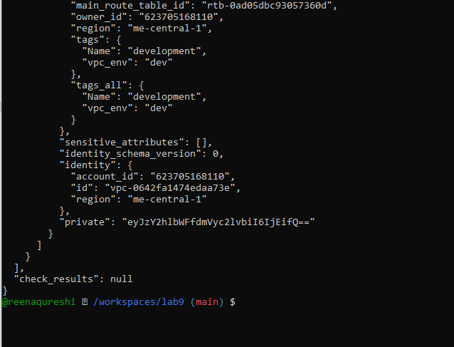

List resources:

terraform state list

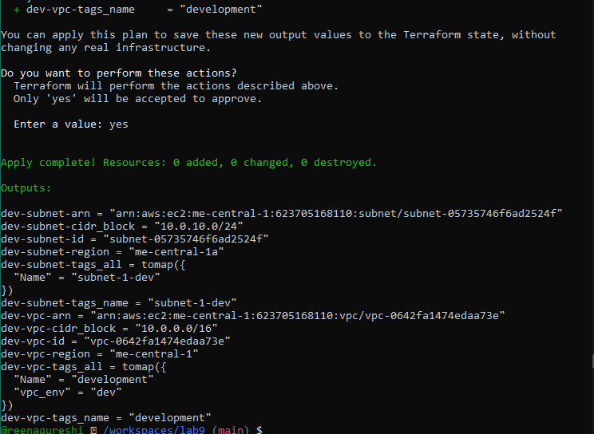
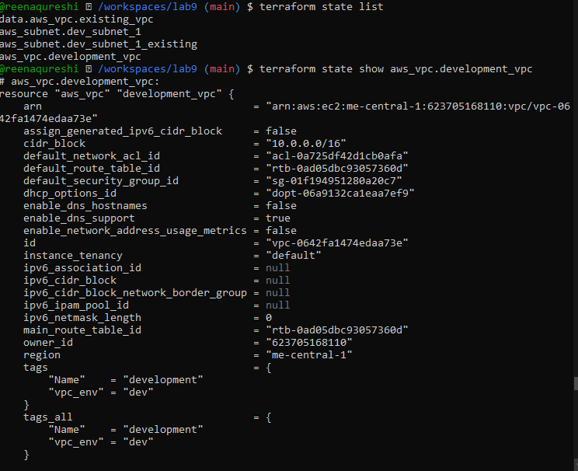
Task 6 — Terraform Outputs & Attributes Reporting
- Add outputs in main.tf:
- output "dev-vpc-id" {

- }
- output "dev-subnet-id" {
- value = aws_subnet.dev_subnet_1.id
- }
- output "dev-vpc-arn" {
- value = aws_vpc.development_vpc.arn
- }
- output "dev-subnet-arn" {
- value = aws_subnet.dev_subnet_1.arn
}

Expand output section in main.tf accordingly

Run terraform apply and record outputs.
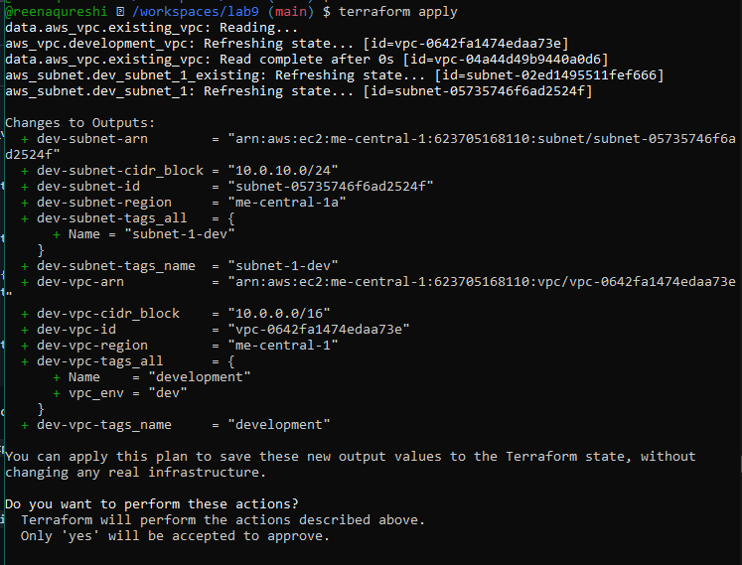

Cleanup — Delete Resources & State Verification

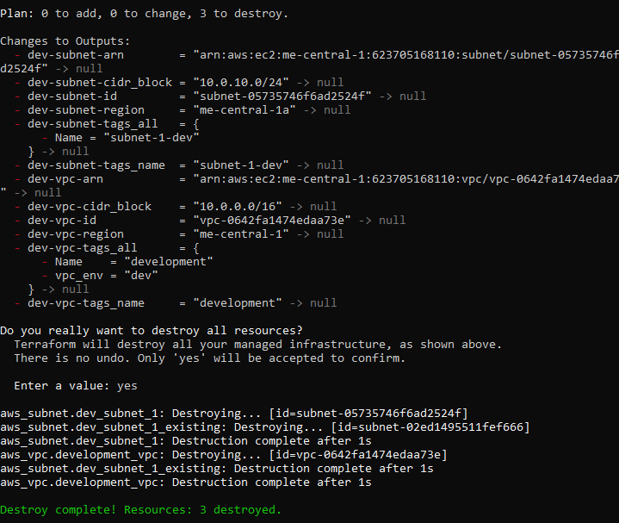
Inspect state files:
cat terraform.tfstate
cat terraform.tfstate.backup

