**Name : Reena Qureshi**

**Sem : V-B**

**Reg No : 2033-BSE-052**

**Lab 2**

**Task 1: Create Private GitHub Repository**

**Create a new private repository named**Lab2**on GitHub.**

Take a screenshot of your repo settings showing it's private.

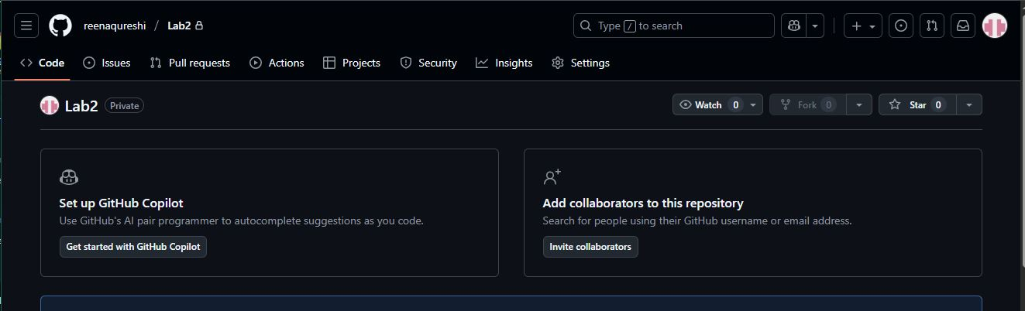

**Task 2: Connect Repository via SSH**

**Generate a new SSH key using PowerShell:**

ssh-keygen -t ed25519 -C "your_email@example.com"

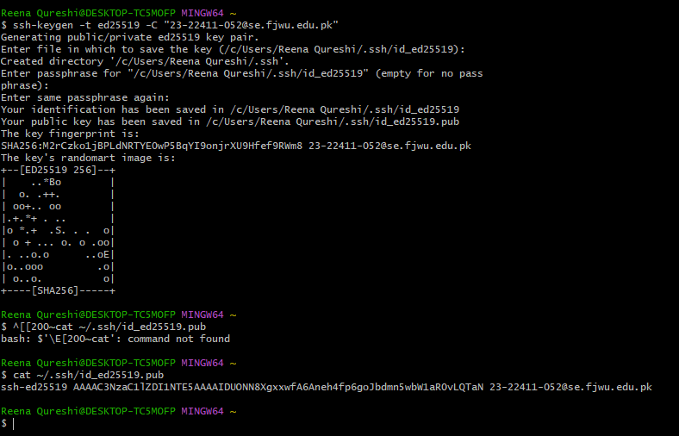

**2.Add your SSH public key to GitHub (Settings > SSH and GPG keys).**

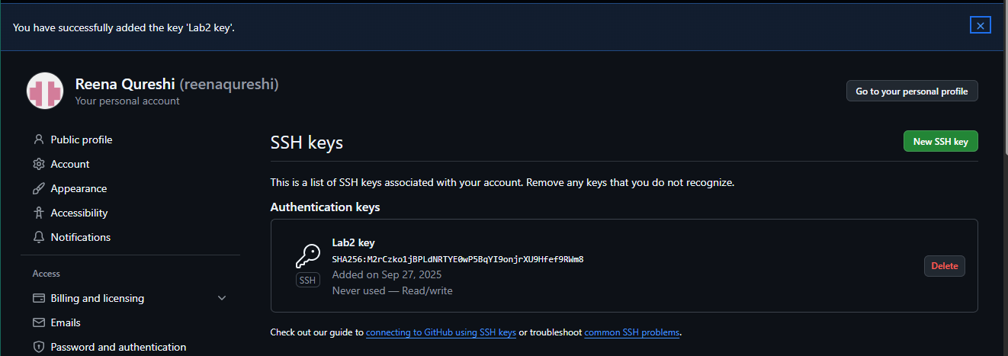

Clone your Lab2 repo using SSH.

git clone git@github.com:<yourusername>/Lab2.git

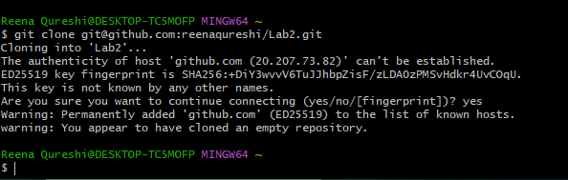

**Task 3: Configure Git Username and Email**

**Set up your Git identity (this ensures all commits are linked to you):**

git config --global user.name "Your Name"

git config --global user.email [your_email@example.com](mailto:your_email@example.com)

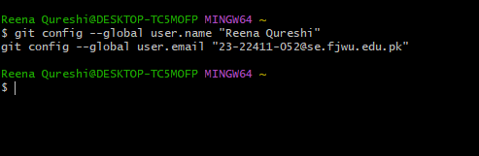

**Verify your configuration:**

git config --list

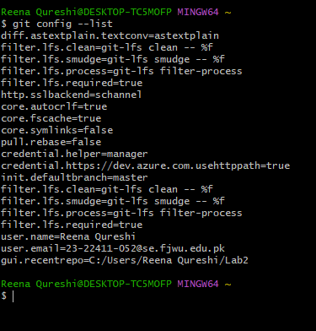

**Task 4: Explore the .git Folder**

Navigate into your cloned repository folder.

Show hidden files and locate the .git directory.

Explore what’s inside using:

**ls -a .git**

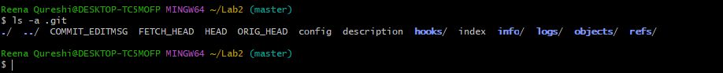

**Task 5: Local Repository Management**

**Delete the existing .git folder from your cloned repo using Git Bash:**

**rm -rf .git**

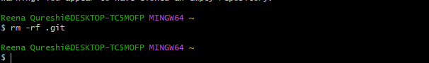

Re-initialize the local git repository

**git init**

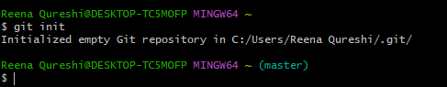

Add a file named README.md and commit it:

**echo "# Lab2 Git Practice" > README.md**

**git add README.md**

**git commit -m "Initial commit"**

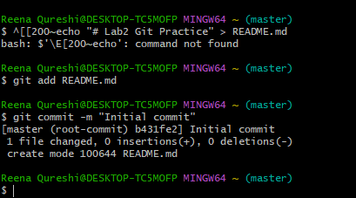

**Connect your local repo to GitHub and push:**

**git remote add origin git@github.com:<yourusername>/Lab2.git**

**git push -u origin main**

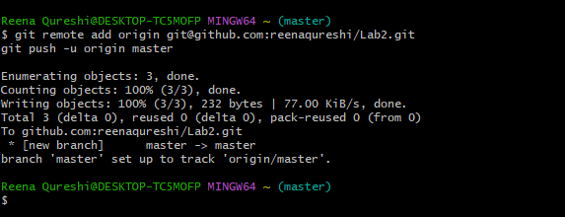

**Task 6: File Status & Staging**

**Create a new file notes.txt and write a note.**

**Check status**

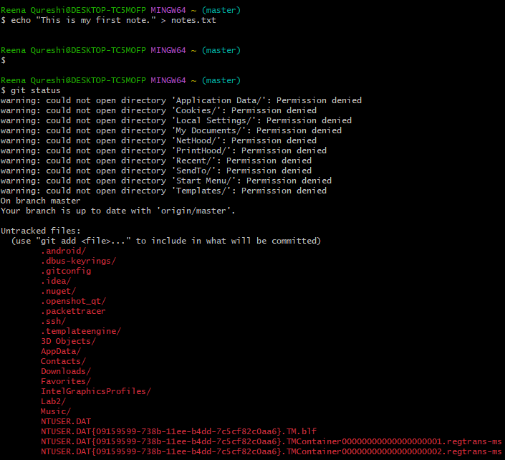

**Stage and commit:**

**git add notes.txt**

**git commit -m "Add notes.txt"**

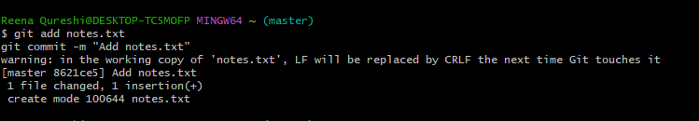

**Task 7: Branch Creation Using GitHub GUI**

**On GitHub (web interface), create a branch named**bugfix/user-auth-error**.**

**Pull the branch to your local repository to sync.**

git pull origin bugfix/user-auth-error

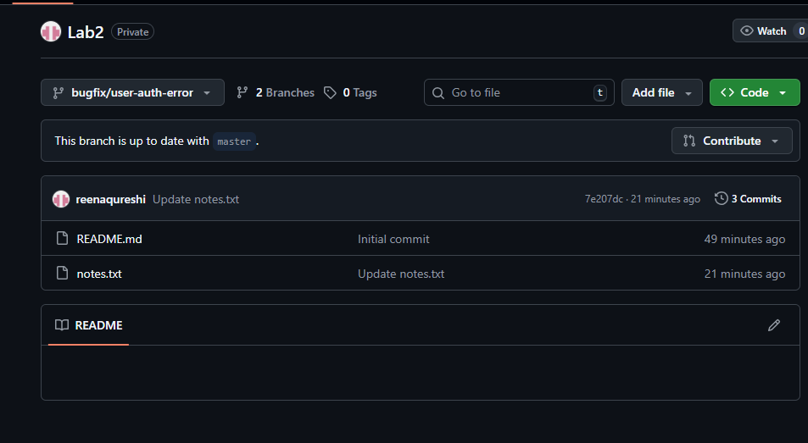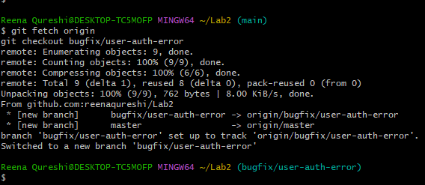

**Task 8: Branch Creation and Push Using Git Bash**

**Create a branch named feature/db-connection using Git Bash:**

**git checkout -b feature/db-connection**

**Push the branch to the remote repository:**

**git push origin feature/db-connection**

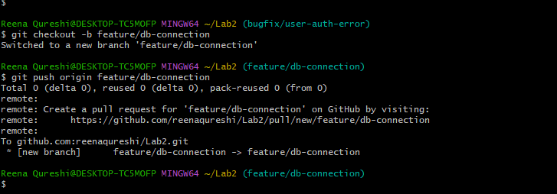

**Task 9: Branching & Merging**

**Create and switch to a branch feature-1:**

**git checkout -b feature-1**



**Modify main.py (add a function) and commit.**

**git add main.py**

**git commit -m "Add new function to main.py"**

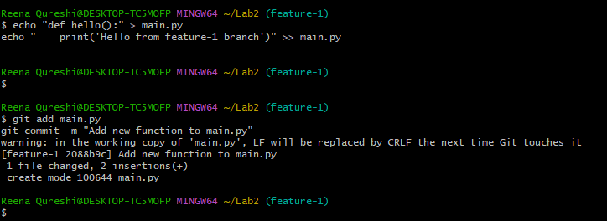

Switch back to main and merge:

**git checkout main**

**git merge feature-1**

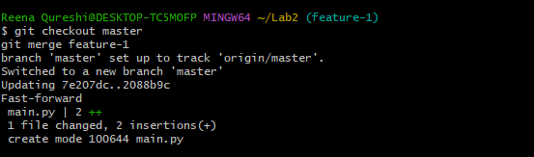

Push all branches:

**git push origin main**

**git push origin feature-1**

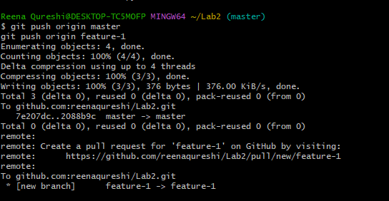

**Task 10: Pull Request and Branch Review (GitHub GUI)**

**On GitHub, create a Pull Request from the branch feature/db-connection to main.**

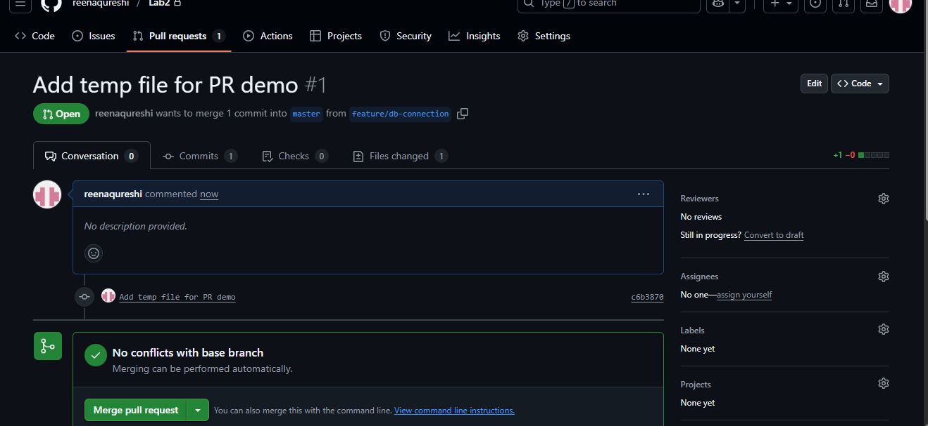

**Review the Pull Request and merge it using the GitHub GUI.**

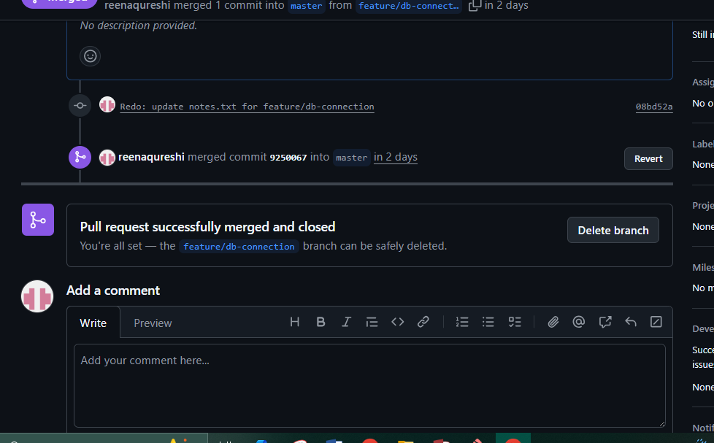

After merging, delete the feature/db-connection branch using the GitHub GUI.

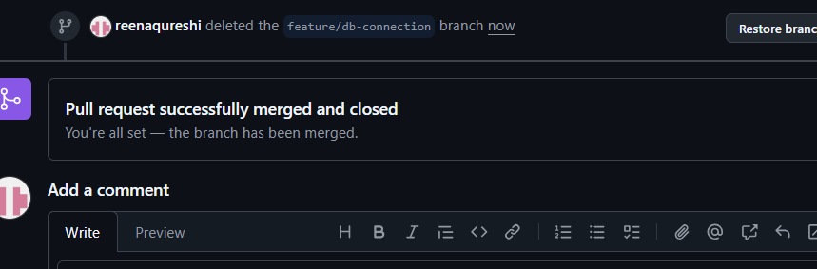

**Task 11: Detailed Branch Strategy (Develop/Staging)**

**Create the following branches** to simulate a professional branching strategy:

develop

staging

feature/*

bugfix/*

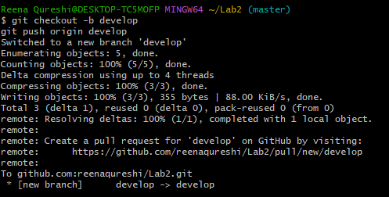

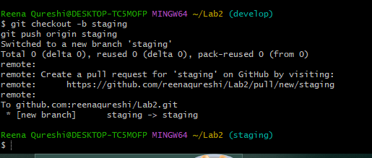

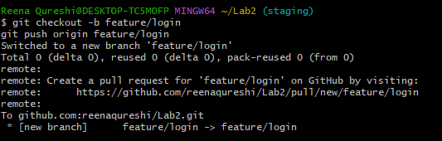

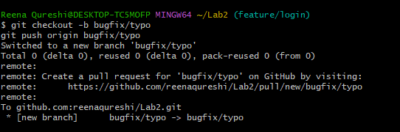

**Example Workflow:**

Developers work on feature/* and bugfix/* branches.

Merge completed work into develop.

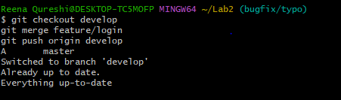

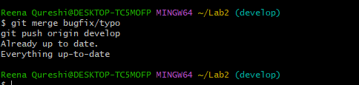

**Merge develop into staging for testing.**

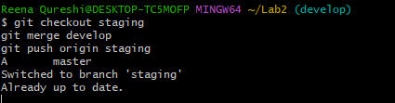

**Finally, merge staging into main (production).**

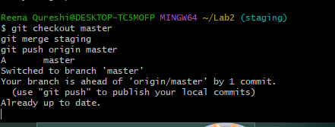

**Task 12: Code Review Workflow**

**Create a Pull Request (PR) / Merge Request (MR):**

From a feature branch into main.

Add a clear title and description summarizing the changes.

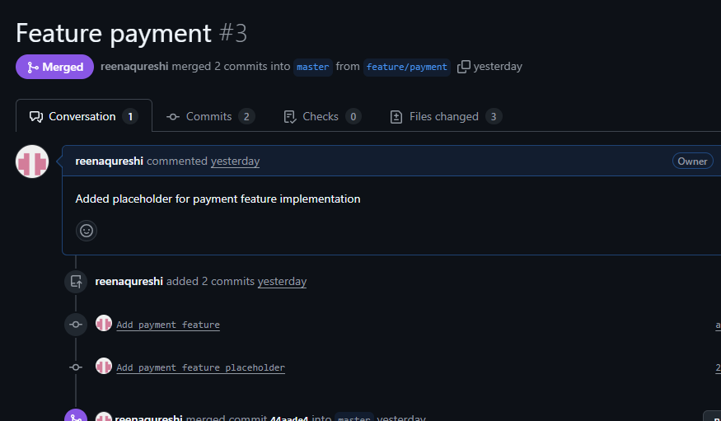

Assign a reviewer (teammate or second account).

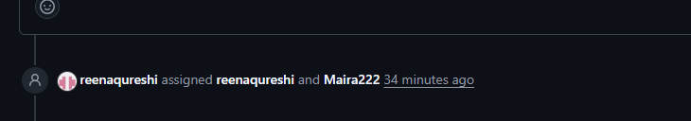

Reviewer Actions

##### 

Merge the PR:

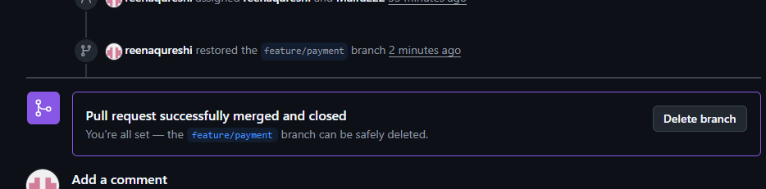

**Task 13: Branch Cleanup Best Practices**

Delete Remote Branch After Merge:

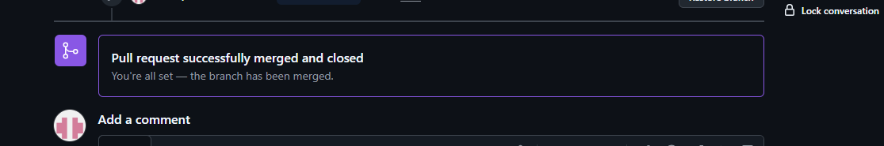

**Update Local Repository:**

**git checkout main**

**git pull origin main**

**git branch -d <branch-name>**

**git branch**

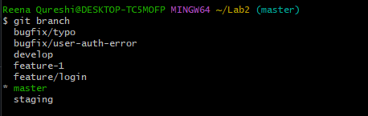

**Branch “feature/payment deleted”**

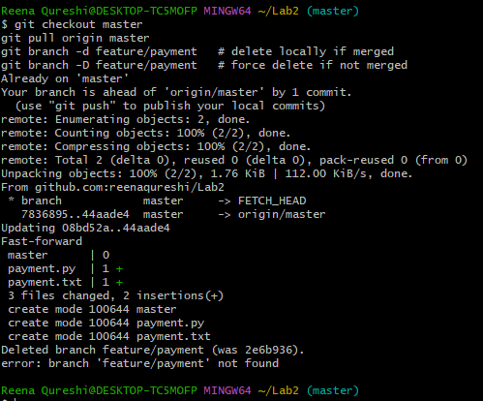

Exam Evaluation Questions

**Advanced Branching & Merge Verification**

**Create a new branch in your repository**

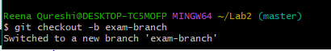

**Make a small change in a file and commit it.**

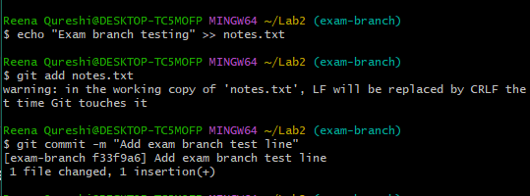

**Merge this branch back into the main branch**

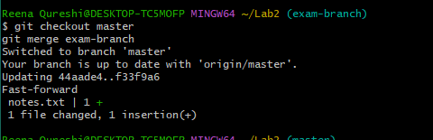

**Show the history of commits in a way that verifies the merge**

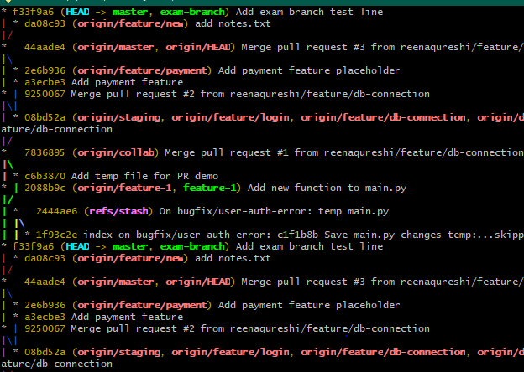

**Multi-Stage Workflow Simulation**

**Set up a branching workflow with three branches: main, develop, and staging.**

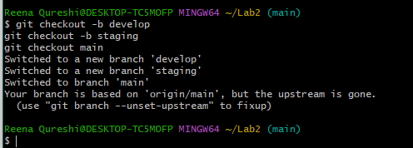

**Create a feature branch from develop, make changes, and commit them**

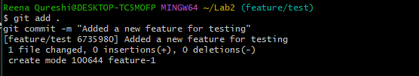

**Merge the feature branch into develop**

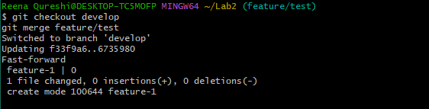

**Merge develop into staging**

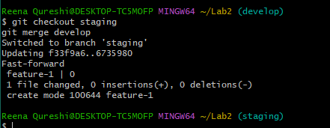

**Merge staging into main**

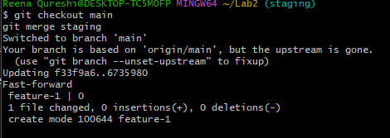

**Provide proof that each stage contains the updated changes before it reaches main**

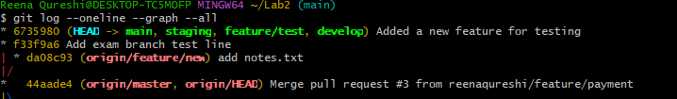

**Collaboration & Conflict Resolution**

**Work with a collaborator: both contributors should modify the same file but in separate branches**

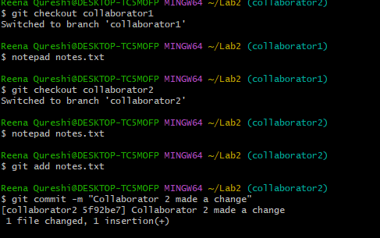

**Attempt to merge the branches and capture the conflict.**

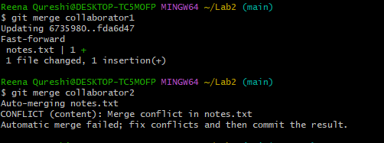

**Resolve the conflict so that both contributions are preserved**

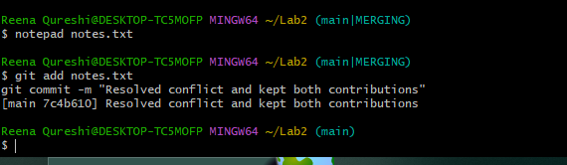

**Provide evidence that the final version of the file contains both collaborators’ changes**

