Project Title:

TRAFFIC MANAGEMENT SYSTEM

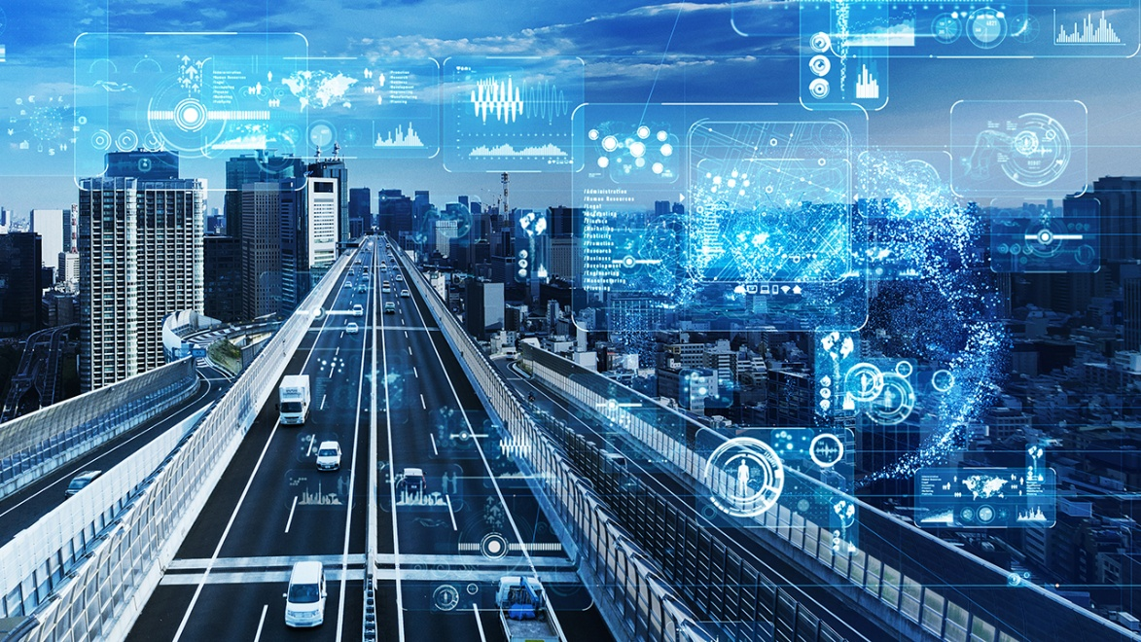

Overview:

Creating an IoT (Internet of Things) traffic management system involves several components and

technologies. Here's an outline of how you can create such a system

Hardware Components:

Traffic Sensors: Deploy various sensors (e.g., cameras, radar, ultrasonic) at key intersections and road

segments to monitor traffic conditions.

Traffic Lights: Use smart traffic lights that can be controlled remotely based on real-time traffic data.

Data Processing Units: Install processing units (e.g., microcontrollers, Raspberry Pi) to collect and

process data from sensors.

Connectivity:

Establish a network infrastructure using technologies like Wi-Fi, cellular, or LoRa to connect sensors and

processing units to the central system.

Data Collection:

Sensors collect data on vehicle presence, speed, and traffic congestion.

Send this data to the central system in real-time.

Data Processing:

Analyze incoming data to detect traffic jams, congestion, and traffic flow.

Use machine learning algorithms to predict traffic patterns.

Central Control System:

Develop a central server or cloud-based platform to collect and process data from all sensors.

Implement an intelligent traffic management algorithm to optimize traffic flow.

Provide a user interface for monitoring and control.

Traffic Control:

Based on real-time data and predictions, adjust traffic light timings and patterns to reduce congestion

and improve traffic flow.

Use remote control capabilities to change traffic light configurations as needed.

Emergency Response:

Integrate emergency vehicle detection systems to give priority to ambulances and fire trucks.

User Interface:

Create a user-friendly dashboard for traffic management personnel to monitor the system and make

manual adjustments if necessary.

Develop a mobile app for commuters to access real-time traffic information.

Data Storage and Analysis:

Store historical traffic data for analysis and optimization.

Continuously improve traffic management algorithms based on the collected data.

Security:

Implement robust security measures to protect the system from cyber threats.

Maintenance and Updates:

Regularly maintain hardware and software components.

Update algorithms and software to adapt to changing traffic conditions.

Scalability:

Design the system to be scalable, so it can handle additional sensors and traffic lights as the city grows.

Compliance:

Ensure compliance with local traffic regulations and standards.

Public Awareness:

Educate the public about the system's benefits and how to access real-time traffic information.

Testing and Optimization:

Thoroughly test the system under various traffic scenarios and optimize it for maximum efficiency.

Feedback Loop:

Establish a feedback loop to gather input from users and traffic management personnel to continuously

improve the system.

Remember that creating an IoT traffic management system is a complex project that requires

collaboration with various stakeholders, including local authorities, traffic experts, and

Self.green_duration = 10 # Initial green light duration in seconds

Self.red_duration = 5 # Initial red light duration in seconds

Self.current_signal = “green”

Def run(self):

While True:

If self.current_signal == “green”:

Print(“Green light for cars.”)

Time.sleep(self.green_duration)

Self.current_signal = “yellow”

Elif self.current_signal == “yellow”:

Print(“Yellow light for cars.”)

Time.sleep(2) # Yellow light duration is fixed at 2 seconds

Self.current_signal = “red”

Else:

Print(“Red light for cars.”)

Time.sleep(self.red_duration)

Self.current_signal = “green”

If __name__ == “__main__”:

Traffic_signal = TrafficSignal()

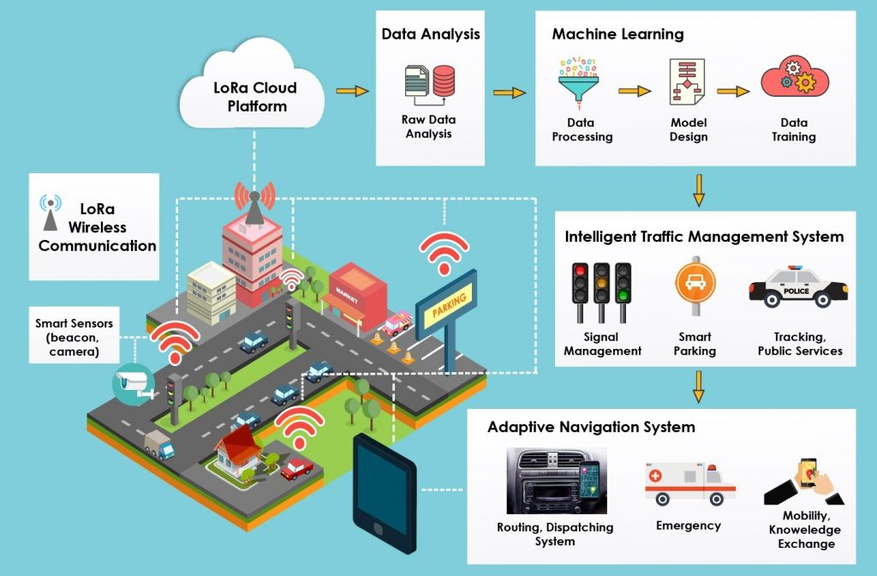

Creating an innovative traffic management system would involve several key components and technologies:

1. **Smart Sensors**: Implement a network of smart sensors (e.g., cameras, lidar, radar) at intersections and along roadways to continuously monitor traffic conditions in real-time.
2. **Data Analytics**: Utilize advanced data analytics and machine learning algorithms to process the data collected from sensors. This can include traffic flow prediction, congestion detection, and anomaly identification.
3. **Traffic Light Optimization**: Implement adaptive traffic signal control systems that adjust signal timings based on real-time traffic conditions to optimize traffic flow and reduce congestion.
4. **Vehicle-to-Infrastructure (V2I) Communication**: Enable vehicles to communicate with the traffic management system, providing information about their location, speed, and intended routes. This data can be used to optimize traffic flow and provide real-time alerts to drivers.
5. **Dynamic Route Guidance**: Develop a smartphone app or in-car navigation system that provides drivers with real-time route recommendations based on current traffic conditions, helping to distribute traffic more evenly.
6. **Public Transportation Integration**: Integrate public transportation data into the system, allowing for real-time updates on bus and train schedules, as well as seamless coordination between public transit and traffic flow.
7. **Emergency Vehicle Priority**: Implement a priority system that can quickly clear a path for emergency vehicles during emergencies.
8. **User-Friendly Interface**: Create a user-friendly interface for both traffic management personnel and the general public to access real-time traffic information, report incidents, and receive alerts.
9. **Energy Efficiency**: Design the system to minimize energy consumption through the use of energy-efficient traffic signals and sensor technologies.
10. **Data Privacy and Security**: Ensure robust data privacy and security measures to protect sensitive information and prevent cyberattacks on the system.
11. **Public Engagement**: Involve the community in the planning and decision-making process by soliciting feedback and ideas, and educating the public about the benefits of the system.
12. **Future-Proofing**: Design the system with scalability in mind to accommodate future technologies like autonomous vehicles and evolving urban infrastructure.
13. **Partnerships**: Collaborate with local governments, transportation agencies, technology companies, and research institutions to leverage expertise and resources.

Implementing such a system would require a substantial investment and collaboration between various stakeholders, but it has the potential to greatly improve traffic management, reduce congestion, and enhance overall transportation efficiency.

Developing a traffic management system involves several key steps:

1. **Planning and Requirements Gathering**: Understand the specific needs and requirements of the system, such as monitoring traffic flow, optimizing signal timings, and providing real-time updates to drivers.
2. **Technology Selection**: Choose the appropriate technologies for data collection, processing, and communication. This may include sensors, cameras, GPS, communication protocols, and software platforms.
3. **Data Collection and Sensors**: Install sensors and data collection devices at strategic locations to monitor traffic conditions. These can include cameras, loop detectors, RFID tags, and GPS systems.
4. **Data Processing and Analysis**: Develop algorithms to process and analyze the data collected. This includes tasks like vehicle counting, speed detection, congestion identification, and pattern recognition.
5. **Traffic Control Algorithms**: Implement algorithms to optimize traffic flow. This may involve adjusting traffic signal timings, rerouting traffic, and managing congestion.
6. **Real-time Communication**: Set up a communication infrastructure to provide real-time information to drivers. This can include electronic message boards, mobile apps, and website updates.
7. **Integration with Existing Systems**: Ensure compatibility with existing transportation infrastructure and systems, such as traffic lights, road signs, and emergency services.
8. **Safety and Security Measures**: Implement measures to ensure the system’s security and reliability. This includes data encryption, backup systems, and measures to prevent tampering.
9. **User Interface and Accessibility**: Develop user interfaces for both traffic operators and end-users (such as drivers). These interfaces should be intuitive and easy to use.
10. **Testing and Validation**: Thoroughly test the system to ensure it functions correctly under various conditions. This includes simulations, controlled experiments, and real-world trials.
11. **Regulatory Compliance**: Ensure the system complies with local and national regulations, including privacy laws and safety standards.
12. **Maintenance and Updates**: Establish a plan for ongoing maintenance, monitoring, and regular updates to adapt to changing traffic patterns and technology advancements.

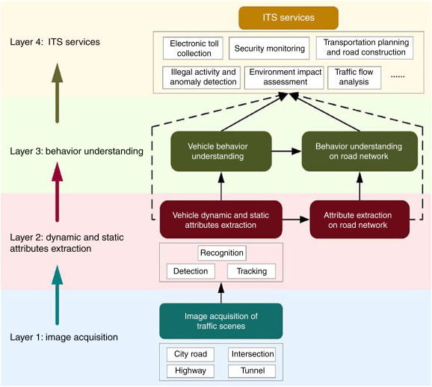

Remember, collaboration with traffic engineers, urban planners, and local authorities is crucial for a successful traffic management system. It’s also important to conduct thorough research on the specific needs and challenges of the targeted area.

Sure, here’s a high-level overview of an IoT-based traffic management system project:

Project Name: IoT Traffic Management System

Components:

1. Traffic Cameras: Install IoT-enabled cameras at intersections and major roads to capture real-time traffic conditions.
2. Vehicle Detection Sensors: Use sensors like inductive loops or radar detectors to identify the presence of vehicles at various points on the road.
3. Traffic Lights Control System: Implement an IoT-controlled traffic light system that can dynamically adjust signal timings based on traffic conditions.
4. Data Processing Unit: Set up a central processing unit to collect data from cameras and sensors and analyze it in real-time.
5. Communication Network: Establish a reliable and secure communication network to transmit data from the devices to the central processing unit. This can be through Wi-Fi, cellular, or a dedicated IoT network.
6. Traffic Data Storage: Store historical traffic data in a database for future analysis and planning.
7. User Interface: Create a web-based or mobile app interface for users, such as traffic management authorities and the public, to access real-time traffic information and control traffic lights (authorized personnel only).

Functionality:

1. Real-time Traffic Monitoring: The system constantly monitors traffic flow, detects congestion, and records traffic violations through cameras and sensors.
2. Dynamic Traffic Light Control: Adjust traffic signal timings based on real-time data, prioritizing congested routes and improving traffic flow.
3. Traffic Data Analytics: Analyze historical data to identify patterns and optimize traffic management strategies.
4. User Interaction: Provide a user-friendly interface for traffic management authorities to manually control traffic lights if necessary.

Benefits:

1. Traffic Optimization: Reduces congestion and improves traffic flow, which can lead to reduced travel times and fuel consumption.
2. Safety: Helps in reducing accidents by monitoring and managing traffic more efficiently.
3. Data-Driven Decision-Making: Authorities can make data-driven decisions for road maintenance and expansion.
4. Public Awareness: Provide real-time traffic information to the public, allowing them to make informed travel decisions.
5. Environmental Impact: Reduced idling and smoother traffic can lead to lower emissions and improved air quality.

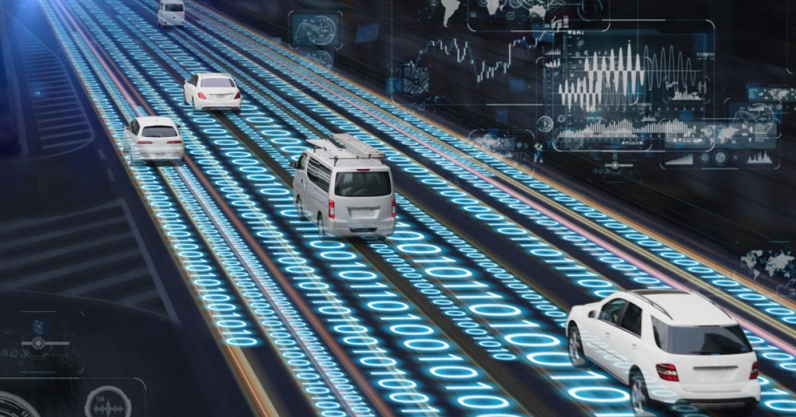

Challenges:

1. Privacy and Security: Ensure that the collected data is handled securely and that privacy concerns are addressed.
2. Cost: Implementing IoT devices and maintaining the infrastructure can be expensive.
3. Integration: Ensuring that all components work together seamlessly can be a technical challenge.
4. Regulatory Compliance: Comply with local and national regulations regarding traffic management and data privacy.

This project can be a significant step towards improving traffic management and road safety through the power of IoT and data-driven decision-making.