DSC520_Week6_Assignment01

Reenie Christudass

2022-07-17

All the following is sourced from Lander (2014),Field, Miles, and Field (2012)

if(!require('pander')) {  
 install.packages('pander')  
 library('pander')  
}

## Loading required package: pander

## Warning: package 'pander' was built under R version 4.2.1

if(!require('ggplot2')) {  
 install.packages('ggplot2')  
 library('ggplot2')  
}

## Loading required package: ggplot2

## Warning: package 'ggplot2' was built under R version 4.2.1

if(!require('knitr')) {  
 install.packages('knitr')  
 library('knitr')  
}

## Loading required package: knitr

if(!require('tinytex')) {  
 install.packages('tinytex')  
 library('tinytex')  
}

## Loading required package: tinytex

## Favorite Foods

**Pizza**

## Images

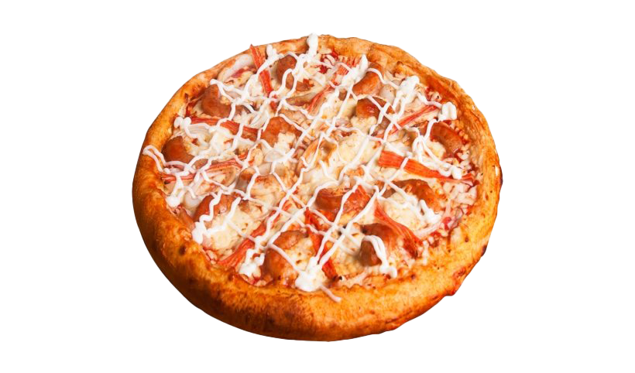

## Quote

**One day at a time**

## Equation

**E = mc^2**

## Citations

Field, Miles, and Field (2012),Lander (2014)

# Inline Code

## NY Times COVID-19 Data

## NY Times COVID-19 Data  
covid_df <- read.csv("C:/Users/chris/dsc520/data/nytimes/covid-19-data/us-states.csv")  
ny_df <- covid_df[ which( covid_df$state == "New York"), ]  
head(ny_df)

## date state fips cases deaths  
## 247 2020-03-01 New York 36 1 0  
## 262 2020-03-02 New York 36 1 0  
## 277 2020-03-03 New York 36 2 0  
## 294 2020-03-04 New York 36 11 0  
## 314 2020-03-05 New York 36 22 0  
## 339 2020-03-06 New York 36 44 0

## R4DS Height vs Earnings

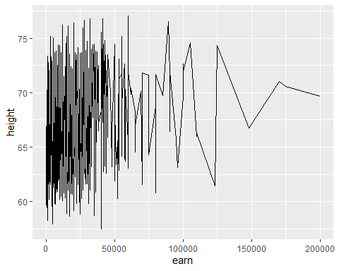

# Tables

# Tables  
name <- c("Aragon", "Bilbo", "Frodo", "Galadriel", "Sam", "Gandalf", "Legolas", "Sauron", "Gollum")  
race <- c("Men", "Hobbit", "Hobbit", "Elf", "Hobbit", "Maia", "Elf", "Maia", "Hobbit")  
in_fellowship <- c(TRUE, FALSE, TRUE, FALSE, TRUE, TRUE, TRUE, FALSE, FALSE)  
ring_bearer <- c(FALSE, TRUE, TRUE, FALSE, TRUE, TRUE, FALSE, TRUE, TRUE)  
age <- c(88, 129, 51, 7000, 36, 2019, 2931, 7052, 589)  
  
characters_df <- data.frame(name,race,in_fellowship,ring_bearer,age)  
head(characters_df)

## name race in_fellowship ring_bearer age  
## 1 Aragon Men TRUE FALSE 88  
## 2 Bilbo Hobbit FALSE TRUE 129  
## 3 Frodo Hobbit TRUE TRUE 51  
## 4 Galadriel Elf FALSE FALSE 7000  
## 5 Sam Hobbit TRUE TRUE 36  
## 6 Gandalf Maia TRUE TRUE 2019

## Knitr Table with Kable

## Knitr Table with Kable  
knitr::kable(head(characters_df), "simple")

| name | race | in_fellowship | ring_bearer | age |
| --- | --- | --- | --- | --- |
| Aragon | Men | TRUE | FALSE | 88 |
| Bilbo | Hobbit | FALSE | TRUE | 129 |
| Frodo | Hobbit | TRUE | TRUE | 51 |
| Galadriel | Elf | FALSE | FALSE | 7000 |
| Sam | Hobbit | TRUE | TRUE | 36 |
| Gandalf | Maia | TRUE | TRUE | 2019 |

## Pandoc Table

## Pandoc Table  
cars <- characters_df[, 1:3]  
cars <- head(cars)  
pandoc.table(cars, style = "grid")

##   
##   
## +-----------+--------+---------------+  
## | name | race | in_fellowship |  
## +===========+========+===============+  
## | Aragon | Men | TRUE |  
## +-----------+--------+---------------+  
## | Bilbo | Hobbit | FALSE |  
## +-----------+--------+---------------+  
## | Frodo | Hobbit | TRUE |  
## +-----------+--------+---------------+  
## | Galadriel | Elf | FALSE |  
## +-----------+--------+---------------+  
## | Sam | Hobbit | TRUE |  
## +-----------+--------+---------------+  
## | Gandalf | Maia | TRUE |  
## +-----------+--------+---------------+

# References

Field, A., J. Miles, and Z. Field. 2012. *Discovering Statistics Using r*. SAGE Publications. <https://books.google.com/books?id=wd2K2zC3swIC>.

Lander, J. P. 2014. *R for Everyone: Advanced Analytics and Graphics*. Addison-Wesley Data and Analytics Series. Addison-Wesley. <https://books.google.com/books?id=3eBVAgAAQBAJ>.