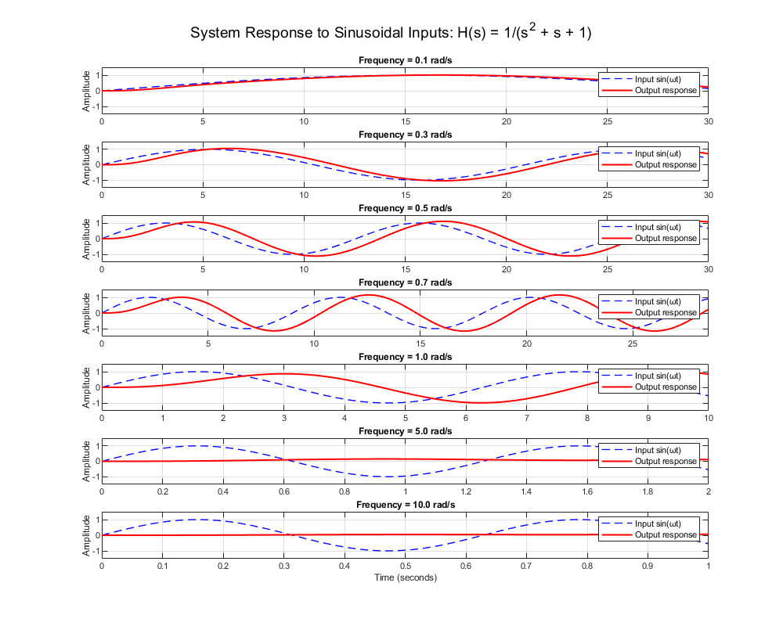

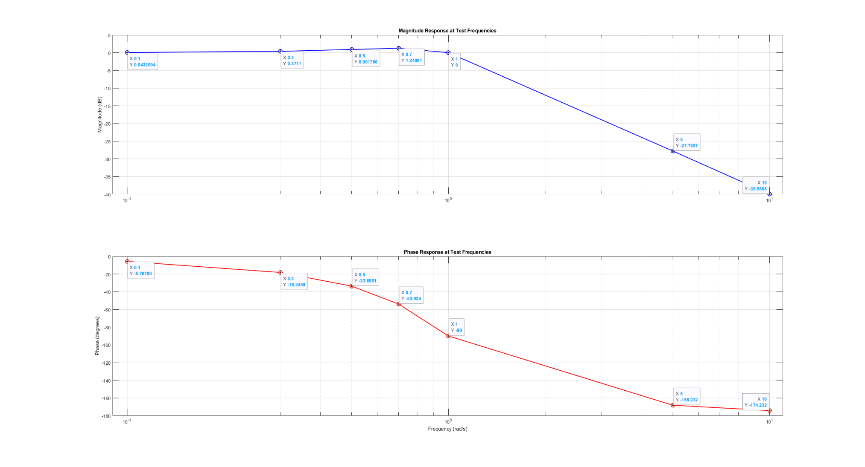

|  |  |  |  |
| --- | --- | --- | --- |
| Frequency (rad/s) | Magnitude (abs) | Magnitude (dB) | Phase (deg) |
| 0.1 | 1.0050 | 0.0432 | -5.77 |
| 0.3 | 1.0437 | 0.3711 | -18.25 |
| 0.5 | 1.1094 | 0.9018 | -33.69 |
| 0.7 | 1.1546 | 1.2488 | -53.92 |
| 1.0 | 1.0000 | 0.0000 | -90.00 |
| 5.0 | 0.0408 | -27.7887 | -168.23 |
| 10.0 | 0.0100 | -39.9568 | -174.23 |