**Problem 1. For the right figure**

 

Find 

Answer



Where , then 



Then, the matrix  is obtained as



Finally, the result is calculated as below



**Problem 2.**

1, when plate ABCD is rotated about y-axes by 60 and then, rotated about x-axes by 30 (Fixed angle rotation), describe the coordinates of the points A, C.

, where 

Then 

, where 

Then 

Because of fixed coordinate, therefore, position of A and C are calculated as





2, When plate ABCD is rotated by 45 about , Answer the corresponding coordinates of B, D.



Then 

From equivalent vector and rotation angle, the rotation matrix is obtained as



The position of B and D after rotating are given as





**Problem 3.**

For {A} -> {B}. Find transformation matrix , where 

Answer:

Easy to get



Cross product of 2 vector is given as





**Problem 4: For the following Puma 560 Manipulator, Assign the required coordinate frames, and gill out the corresponding DH parameter table up to wrist center point**

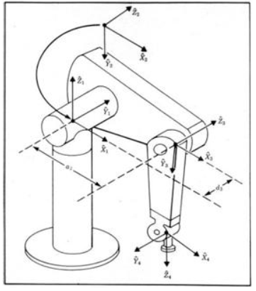

**Answer**

(1). DH parameter table

|  |  |  |  |  |
| --- | --- | --- | --- | --- |
|  | $$α_{i-1}$$ | $$a_{i-1}$$ | $$d_{i}$$ | $$θ_{i}$$ |
| 1 | 0 | 0 | 0 | $$θ_{1}$$ |
| 2 | $$-90$$ | 0 | 0 | $$θ_{2}$$ |
| 3 | 0 | $$a_{2}$$ | $$d_{3}$$ | $$θ_{3}$$ |
| 4 | $$-90$$ | $$a_{3}$$ | $$d_{4}$$ | $$θ_{4}$$ |

(2). When . Find the position of the 3rd coordinate original point with respect to the {0}-coordinate frame

Answer:

Generalized formula is given as





Then 

Therefore, the position of 3rd coordinate origin point with respect to {0} is



(3). When . Find the second column (6x1) of the Jacobian (6x3) about the wrist center point with respect to the {0} coordinate frame

**Answer**

Applying velocity propagation









(4).

**Problem 5**



(1). Do trajectory planning with a cubic polynomial for this joint control

**Answer:**

Trajectory planning equation with a cubic polynomial is given as



Derivative of is given as



Then, below equations are obtained



Solution is



Finally, the result is as



**Problem 6. Robot Dynamic Equation is given as . For the desired joint trajectory , the desired cartesian trajectory **

**(1). Draw the block diagram for independent joint PID control**

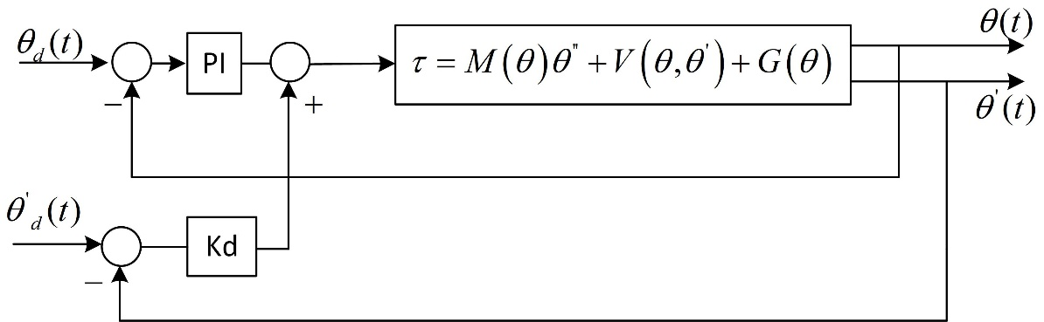

**Error dynamic equation:** 

**(2). Draw the block diagram of computed torque control**

**(a). Knowing exactly system model**

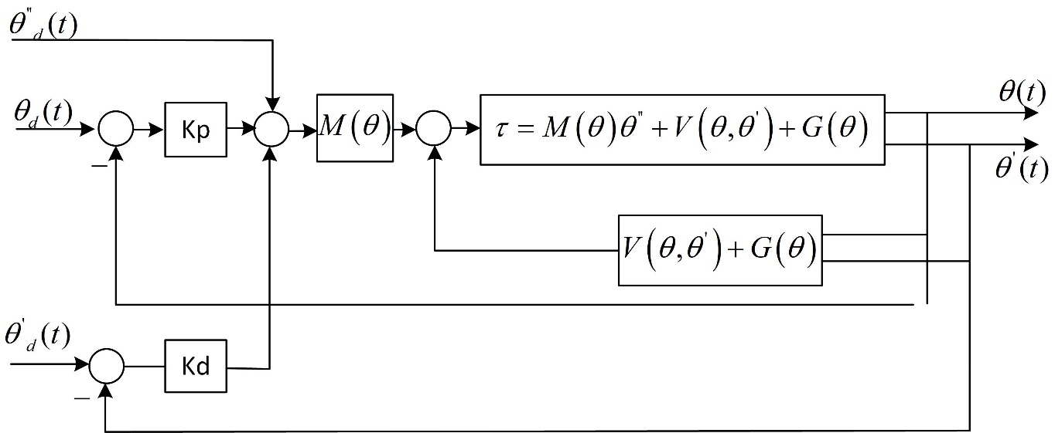

Manipulator dynamic equation:



**Control law**



**Then, we have**





Finally error dynamic equation as, 

Tuning  and , at steady-state **e** become to zero

**(b). In case of uncertainty parameter**





Finally error dynamic equation as



(3). For cartesian based control, Find equivalent model 